# ICS 340 Programming Project, Deliverable A

***Specification:***

Start with the given Java program “prog340”, which lets you select a file to read from your computer, reads the file, and interprets that file as the specification of a graph.[1] Read a file of the name “F[<whatever>]a.txt, which will correspond to an undirected graph. Then calculate a vertex cover of the graph using the algorithm below, and print out the names of the nodes in your vertex cover in the order in which you add those nodes to the cover.

A vertex cover of an undirected graph is a subset of nodes in the graph such that every edge is incident on at least one node in the cover.

**Algorithm*:***

Begin with all edges uncovered. Find the node that covers the most uncovered edges. If two or more nodes are tied for covering the most uncovered edges, pick the one whose name comes first in the alphabet. Mark all edges incident on that vertex as covered. Repeat until all edges are covered. Print out the names of the nodes in the vertex cover in the order in which you added them to the cover.

**Some Details*:***

The “prog340” handout describes the format of the input file for this and all program deliverables.

As will always be the case in this class, the program must be written in Java and must run on the University Windows computer systems. To ensure this I strongly recommend that you:

1. Use only Oracle Java 13 SE and earlier constructs, and
2. Test it on the University systems before submission if you have any doubts about its ability to run on the University Windows.

Submit the Java source code to the open Deliverable A submission folder. You may submit either the source code or a full Eclipse package.

**Output:**

Here is sample output for one graph:

Graph – pictorial:

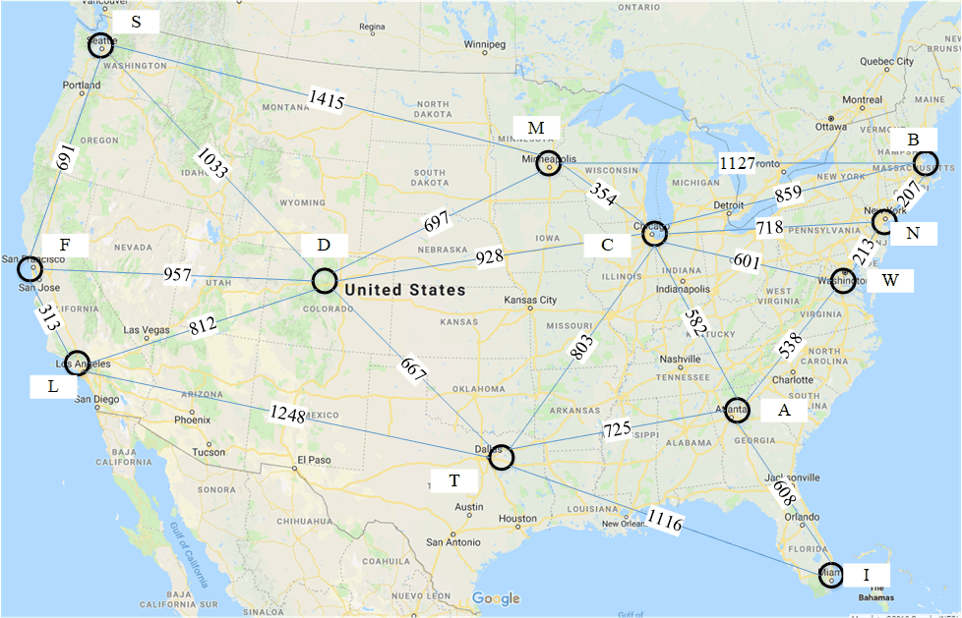

Graph – input file:

~ val A B C T D L X M N F S W

Atlanta ~ ~ ~ 581 725 ~ ~ 608 ~ ~ ~ ~ 538

Boston ~ ~ ~ 859 ~ ~ ~ ~ 1127 207 ~ ~ ~

Chicago ~ 581 859 ~ 803 928 ~ ~ 354 718 ~ ~ 601

Dallas ~ 725 ~ 803 ~ 667 1248 1116 ~ ~ ~ ~ ~

Denver ~ ~ ~ 928 667 ~ 812 ~ 697 ~ 957 1033 ~

LosAngeles ~ ~ ~ ~ 1248 812 ~ ~ ~ ~ 313 ~ ~

Miami ~ 608 ~ ~ 1116 ~ ~ ~ ~ ~ ~ ~ ~

Minneapolis ~ ~ 1127 354 ~ 697 ~ ~ ~ ~ ~ 1415 ~

NewYork ~ ~ 207 718 ~ ~ ~ ~ ~ ~ ~ ~ 213

SanFrancisco ~ ~ ~ ~ ~ 957 313 ~ ~ ~ ~ 691 ~

Seattle ~ ~ ~ ~ ~ 1033 ~ ~ 1415 ~ 691 ~ ~

Washington ~ 538 ~ 601 ~ ~ ~ ~ ~ 213 ~ ~ ~

Yields output:

Chicago, Denver, Atlanta, Boston, Dallas, SanFrancisco, Minneapolis, NewYork

**Submit:**

Submit your code as an Eclipse package, or submit all the “.java” source files in a zipped archive. Do not include test files.

**Test Files:**

Test files will be uploaded by Thursday.

**Grading:**

This deliverable is worth 40 points: Correctness will be assessed for 5 files at 6 points per file, including at least three test files I gave you, and at least one file that I did not. There will be 5 additional points each for design and documentation.

**Due Dates:**

The program is due on Tuesday, May 25th at 11:59 PM for full credit in the D2L “Deliverable A” dropbox. Submissions up to 2 hours late are accepted with 1-point-per-hour penalty. For 80% of credit earned, you may (re)submit it by Tuesday, June 15th before or with your first submission of Deliverable B. The time of submission is the time that D2L lists the file as submitted.

1. See the “prog340.doc” file for details