**Research and Specs for Sam’s Website**

* Website is for Sugar Rings embroidery items

**Examples of similar sites**

**HOOP AND FRAME**

<https://hoopandframe.co.uk/?gclid=CjwKCAjwj8eJBhA5EiwAg3z0mx72Z_zggcTLI2VVIoRtDgMLB6MTlA5JAIwvcUOmoVkmhms0RIMrBRoC47IQAvD_BwE>

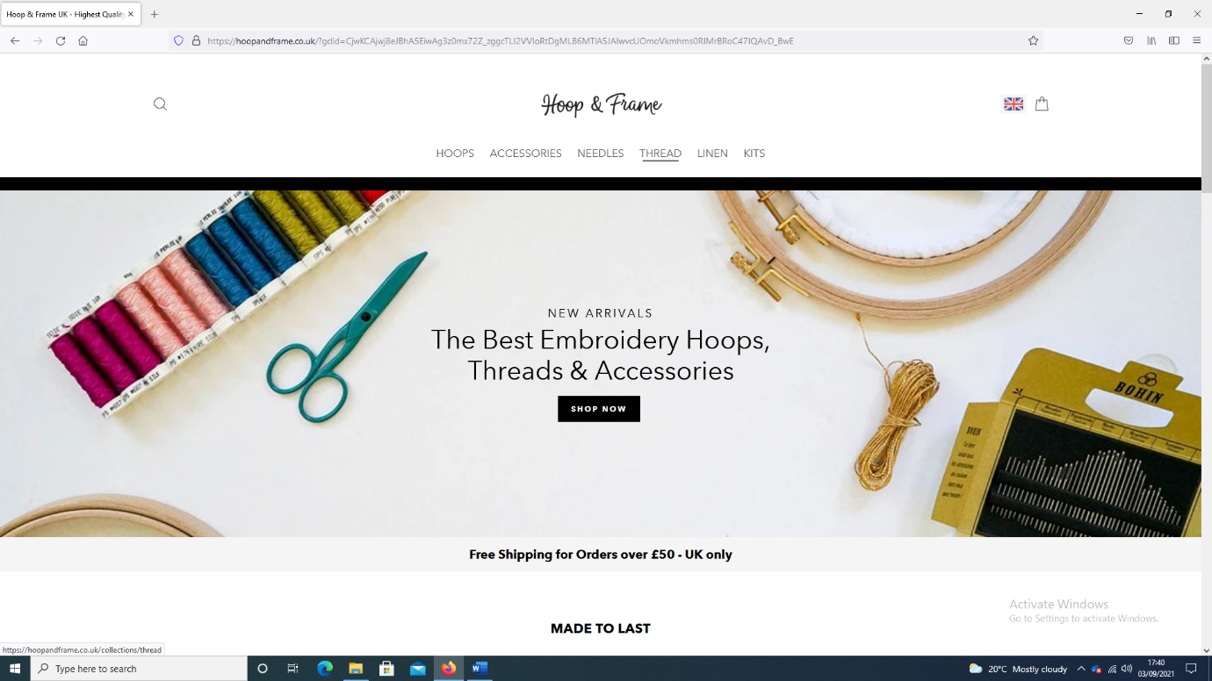

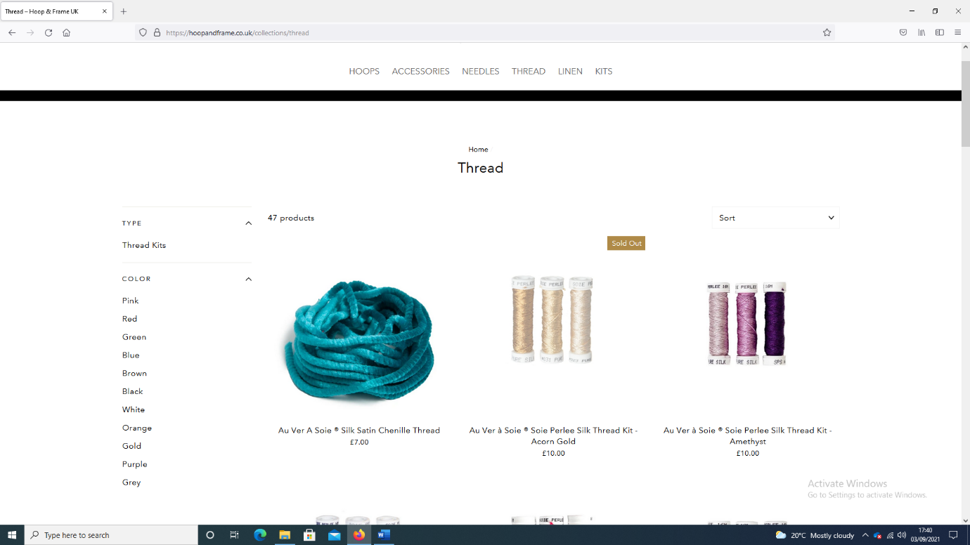

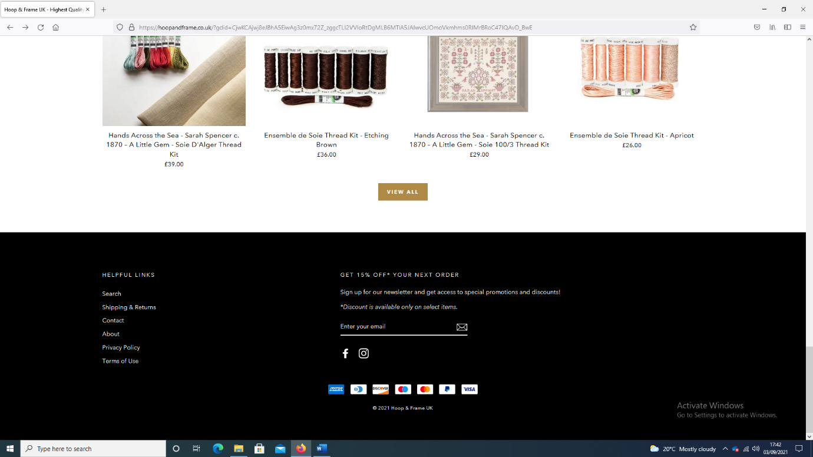

**LOVECRAFTS**

<https://www.lovecrafts.com/en-gb/l/cross-stitch-and-embroidery/cross-stitch-and-embroidery-supplies/cross-stitch-and-embroidery-accessories/cross-stitch-and-embroidery-hoops-frames-and-stands?gclid=CjwKCAjwj8eJBhA5EiwAg3z0m8ZnTo1TEXY5ktzkZdTAij3beHg9awMK-tMjEuYrhOrYCgbeL2TdWhoCLN0QAvD_BwE&amp;ef_id=CjwKCAjwj8eJBhA5EiwAg3z0m8ZnTo1TEXY5ktzkZdTAij3beHg9awMK-tMjEuYrhOrYCgbeL2TdWhoCLN0QAvD_BwE:G:s&amp;gclid=CjwKCAjwj8eJBhA5EiwAg3z0m8ZnTo1TEXY5ktzkZdTAij3beHg9awMK-tMjEuYrhOrYCgbeL2TdWhoCLN0QAvD_BwE&gclid=CjwKCAjwj8eJBhA5EiwAg3z0m8ZnTo1TEXY5ktzkZdTAij3beHg9awMK-tMjEuYrhOrYCgbeL2TdWhoCLN0QAvD_BwE&gclid=CjwKCAjwj8eJBhA5EiwAg3z0m8ZnTo1TEXY5ktzkZdTAij3beHg9awMK-tMjEuYrhOrYCgbeL2TdWhoCLN0QAvD_BwE&utm_source=google&utm_medium=cpc&utm_campaign=12758812058&utm_term=hoop%20art%20embroidery>

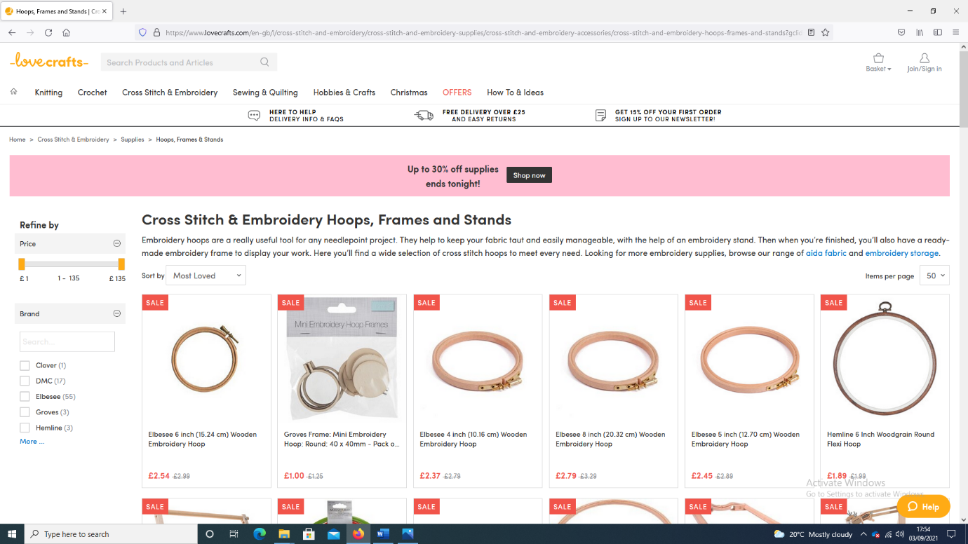

**PAULETPAULA**

<https://www.pauletpaula.com/embroidery-hoop-art-childrens-room/>

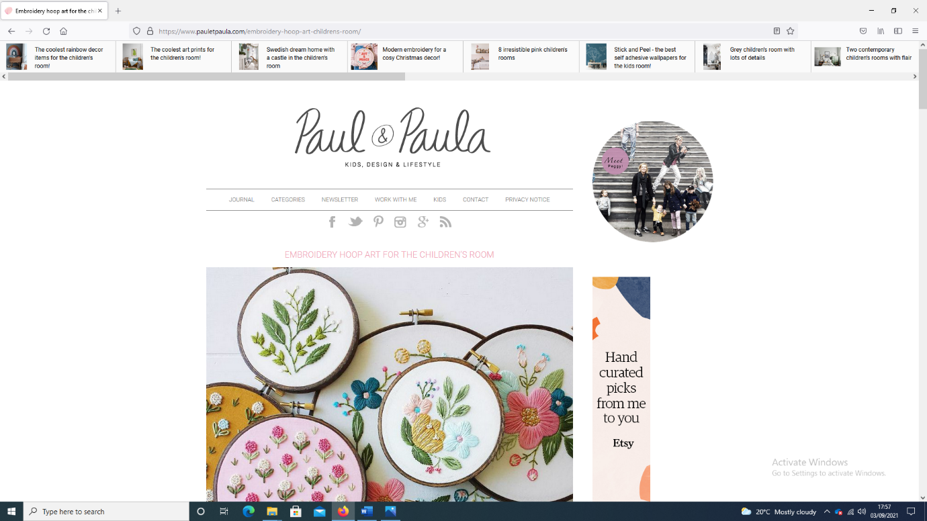

<https://blog.folksy.com/2018/06/07/embroidery-hoop-art>

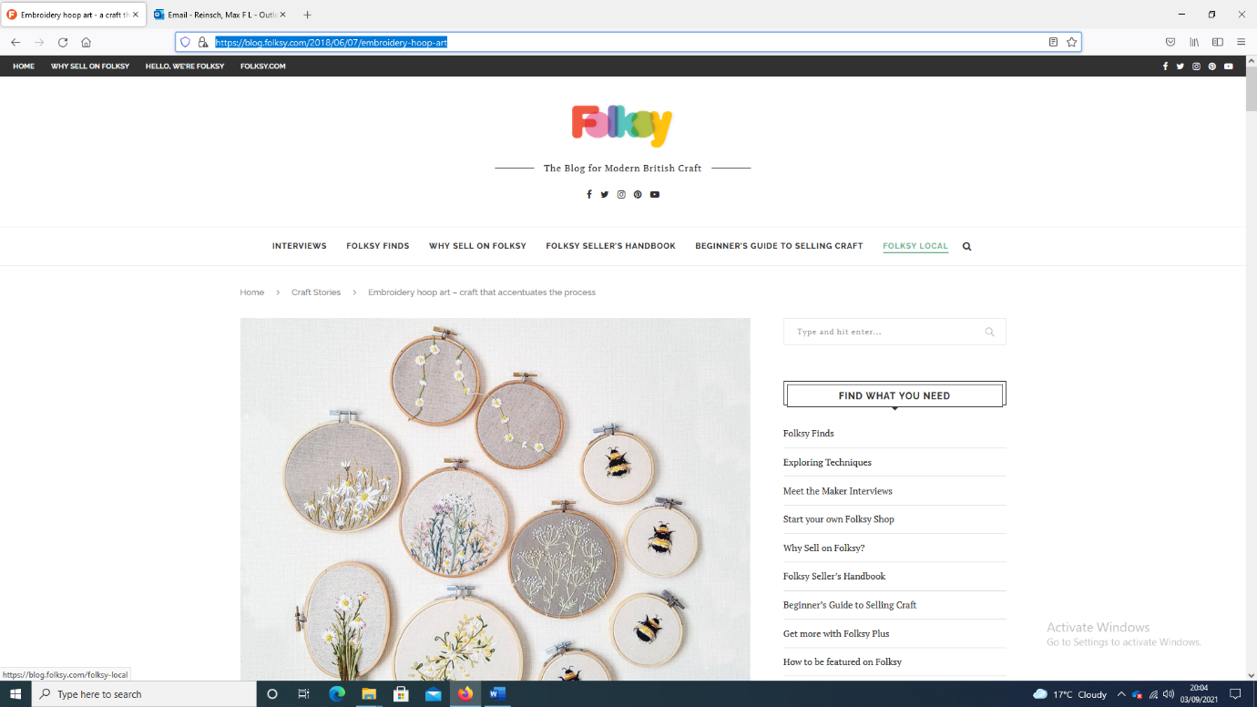

**Specifications for clients**

* Must……
* …….
* ……..
* ……..
* …….
* ……..

**User stories**