1

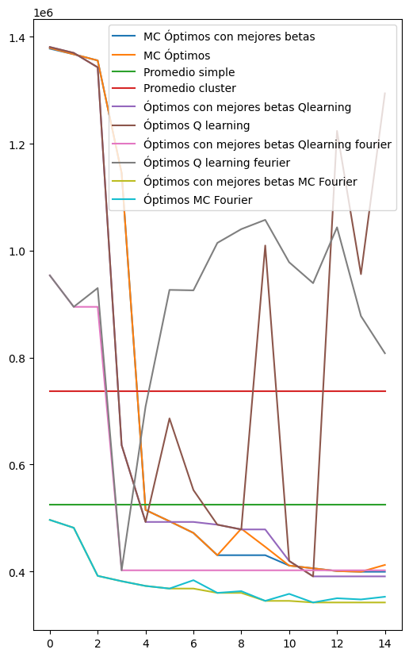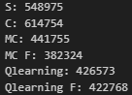
episodios= 1500, epsilon = 0.05, learning_rate = 0.001, gamma = 0.9, max_i=5
episodios = 1500, epsilon=0.05, learning_rate=0.0001, max_i= 5
episodios = 1500, epsilon=0.15, learning_rate=0.0001

2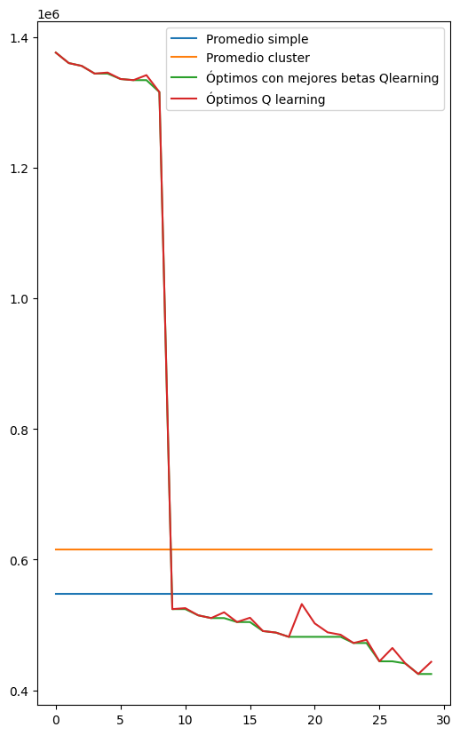episodios = 3000, epsilon = 0.05, learning_rate = 0.001, gamma = 0.98
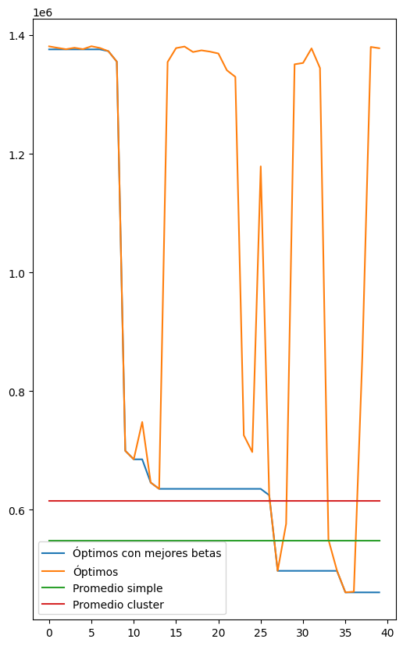episodios = 4000, epsilon=0.05, learning_rate=0.0001

Instancia 2 Q learning normal 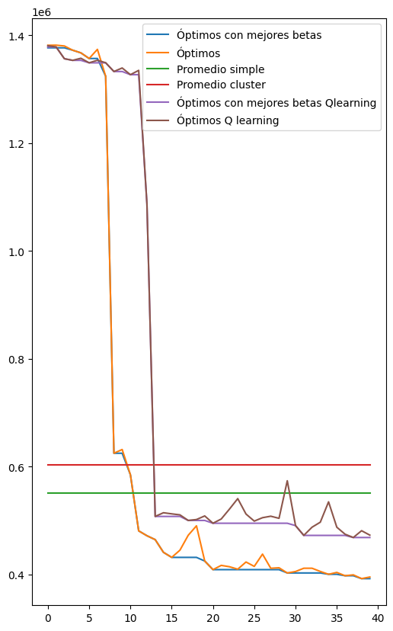epsilon = 0.05, learning_rate = 0.001, gamma = 0.99
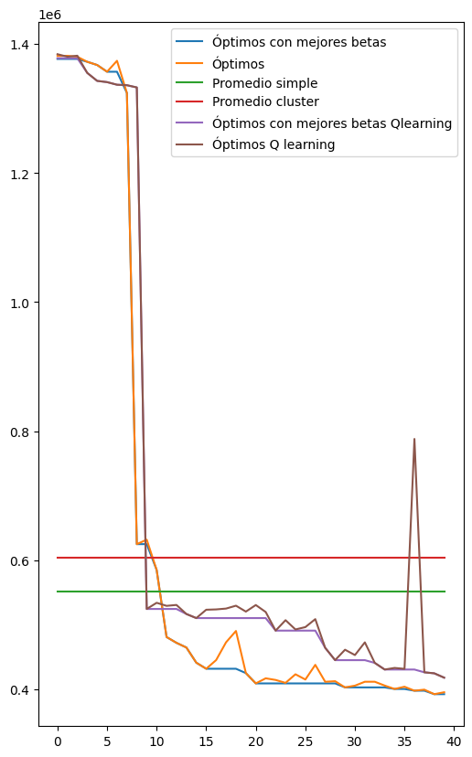 epsilon = 0.05, learning_rate = 0.001, gamma = 0.98
epsilon=0.05, learning_rate=0.0001

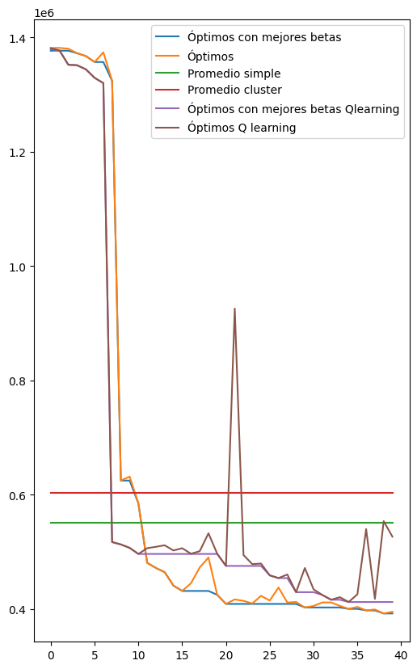0.97
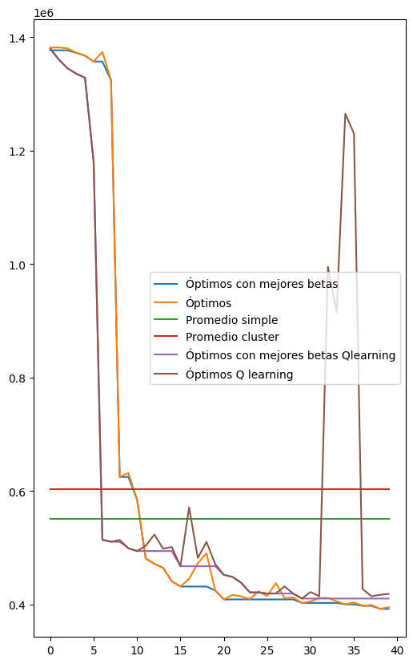0.96
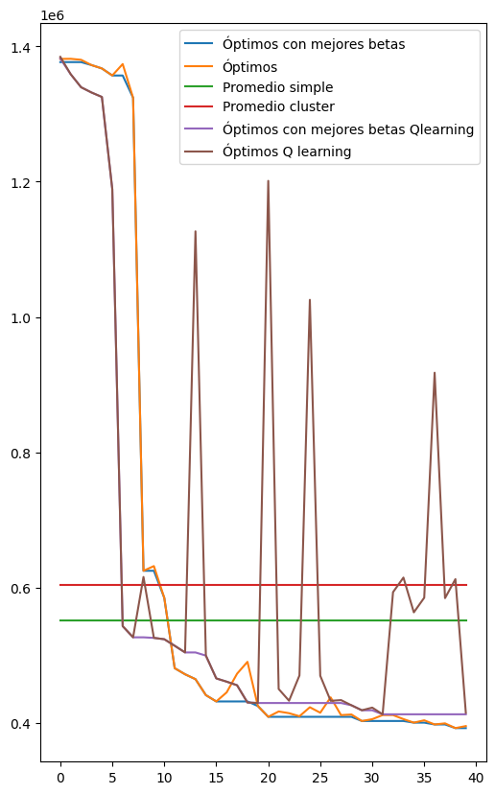0.95
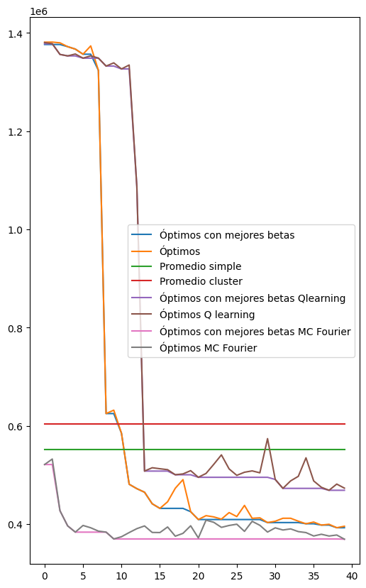Con fourier extra GAMMA= 0.99

