CS3009 - Software Engineering
Employee Management System
Deliverable 2 — Sprint 2 Documentation

Team Members
Muhammad Faheem | Irtaza Kazmi | Humayun Bilal

1. Introduction
Sprint 2 extended the EMS foundation established in Sprint 1 by adding leave management, attendance tracking, and employee search. These features strengthened the system by enabling day-to-day HR workflow automation while preserving the role-based access boundaries introduced earlier. Sprint 2 moved the project from core setup into active operational use for managers and employees.

2. Project Vision
The project vision remained centered on a secure and integrated HR management system, but Sprint 2 refined it by emphasizing workflow automation and department-level control. The updated vision is to support role-scoped HR operations, improve accuracy in leave and attendance handling, and provide managers with controlled visibility into their teams.

3. Intended Use of the System

3.1 Who Will Use the System
- Administrator: oversees the system and manages higher-level organizational actions.
- Manager: handles department-scoped employee operations and approvals.
- Employee: uses self-service features for leave and attendance.

3.2 How the System Will Be Used
- Users log in with role-based credentials.
- Managers work only within their department scope.
- Employees submit leave requests, mark attendance, and review their own records.
- Admin users can access broader employee search scope as defined by the application.

3.3 Updated Stakeholder Needs for Sprint 2

Manager
- Approve or reject leave requests from employees in their own department.
- View attendance records for their team filtered by date.
- Search employees within the allowed scope.

Employee
- Submit leave requests.
- Mark daily attendance.
- View recent attendance history.

4. Features Functionality

4.1 Sprint 1 Completed Features
- User authentication and session management.
- Role-based access control.
- Department creation and manager assignment.
- Employee add/update and deactivation workflow.

4.2 Sprint 2 New Features
- Leave request submission by employees.
- Leave approval and rejection by managers.
- Attendance check-in/check-out by employees
- Attendance check-in/check-out tracking.
- Employee search with role-based scope.

4.3 How Sprint 2 Improved the System Capability
Sprint 2 added practical HR operations to the base system. Employees gained self-service leave and attendance functionality, managers gained approval and monitoring capabilities, and the system became more useful for daily workforce management rather than only setup and administration.

5. User Stories
The following table summarizes all Sprint 2 user stories:

Story ID | Role | User Story
US07 | Employee | As an employee, I want to submit a leave request specifying the type and dates so that my manager can review and approve it.
US08 | Manager | As a manager, I want to approve or reject leave requests from my department employees so that leave is managed fairly.
US09 | Employee | As an employee, I want to mark my attendance each day so that my working hours are recorded accurately.
US10 | Manager | As a manager, I want to view attendance records for my team on a selected date so that I can monitor punctuality.
US11 | Manager | As a manager, I want to search for employees in my department by ID, name, or department so that I can quickly find employee information.

Sprint 1 leftover stories completed in Sprint 2: None.

6. Non-Functional Requirements

Performance
- Leave, attendance, and search operations should complete quickly for normal dataset sizes.
- Daily attendance and leave review actions should remain responsive in the desktop interface.

Usability
- Forms should guide users with clear fields and simple validation messages.
- Date pickers and pre-filled values should reduce input mistakes.
- Role-based visibility should hide irrelevant actions from users.

Reliability
- Leave balance updates should remain consistent when approvals are processed.
- Attendance check-in and check-out should prevent duplicate or invalid same-day entries.
- Search and approval workflows should return predictable results within the user's scope.

Security
- Role checks should prevent users from accessing data outside their permissions.
- Department-level scoping should be enforced in queries and controllers.

Scalability
- The leave, attendance, and search modules should remain manageable as employee records grow.
- The database design should support later expansion without breaking existing workflows.

7. Iteration 2 Implementation Screenshots
The following screenshots illustrate the Sprint 2 features in the implemented system:

Figure 1: Leave application screen
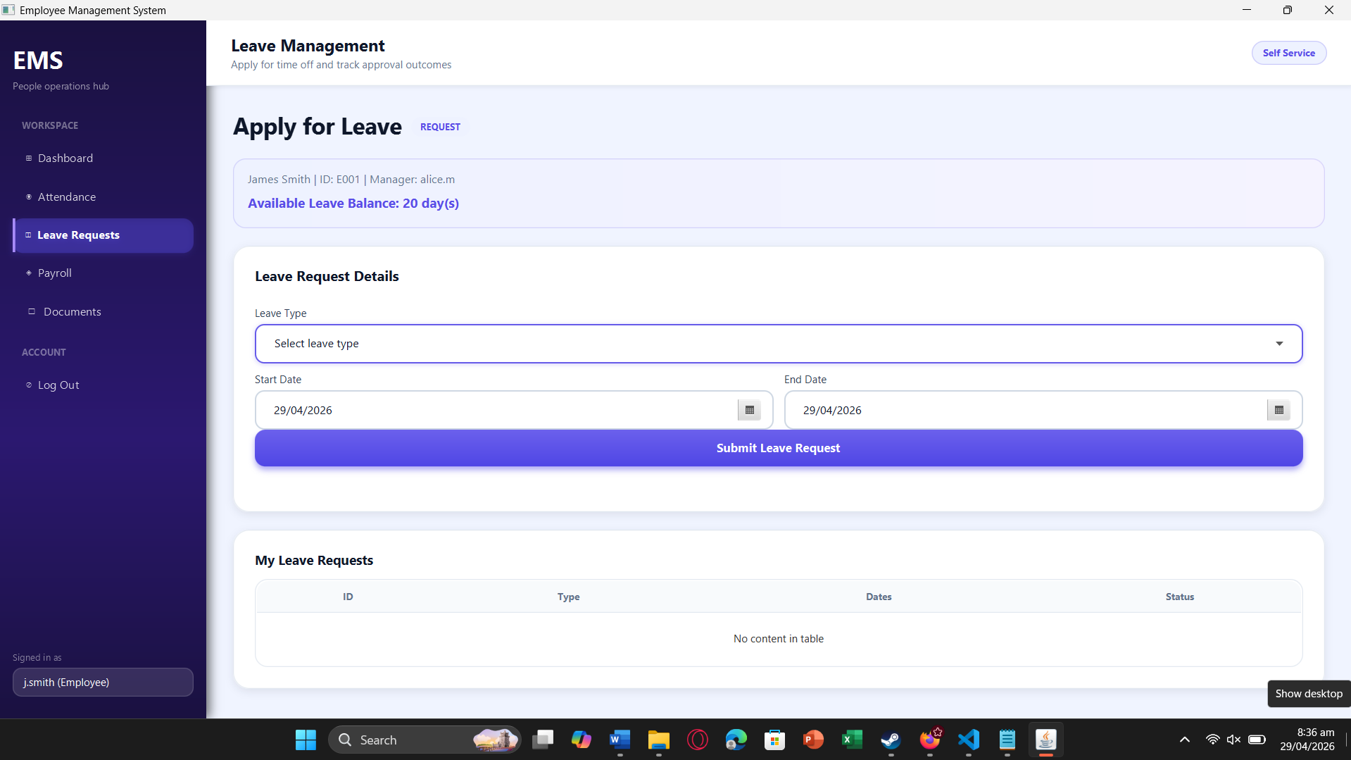
employee submits a leave request.

Figure 2: Leave approvals/rejections screen
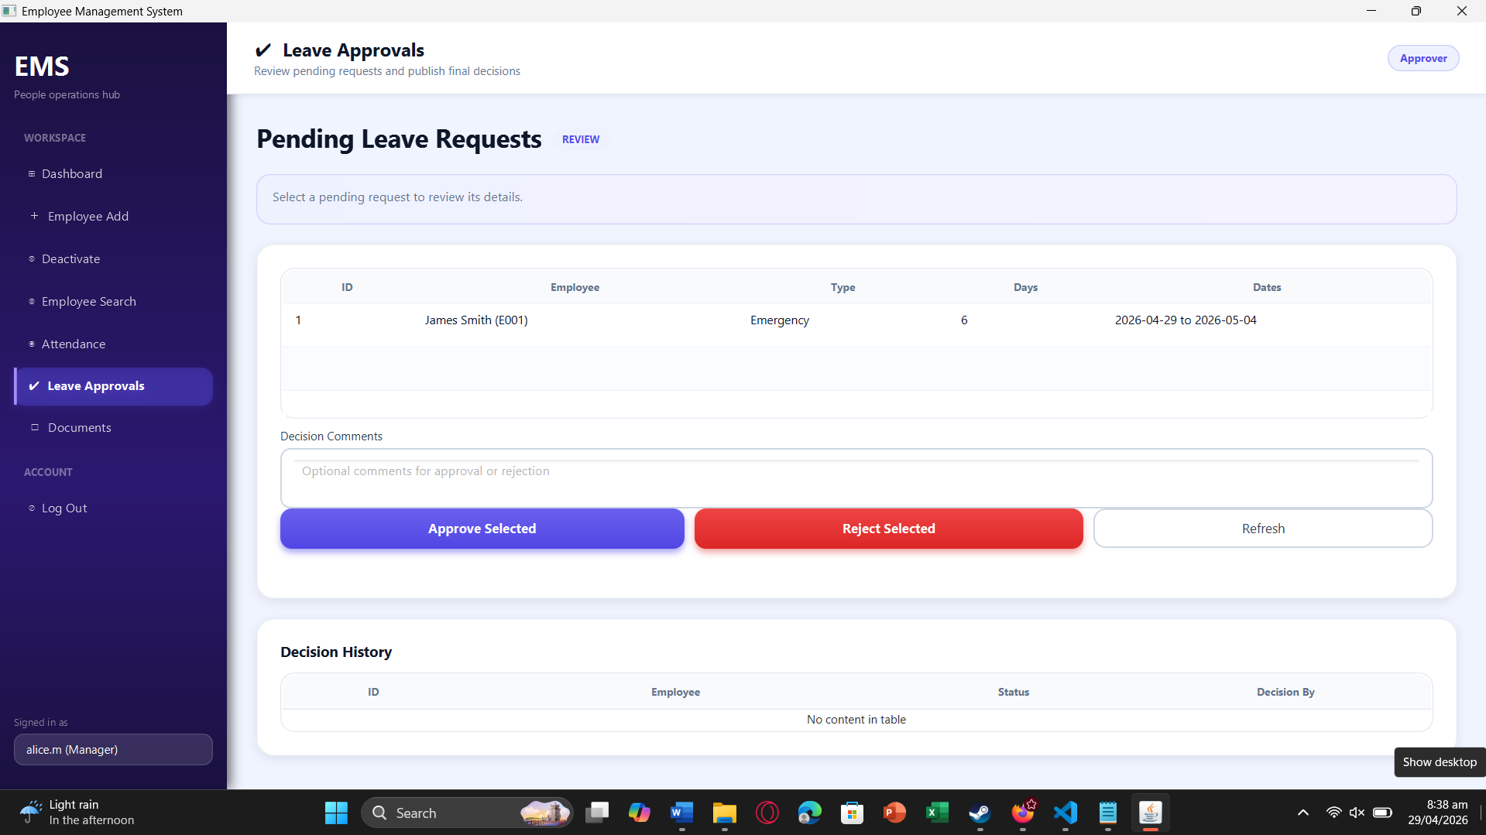
manager reviews and processes leave requests.

Figure 3: Attendance screen
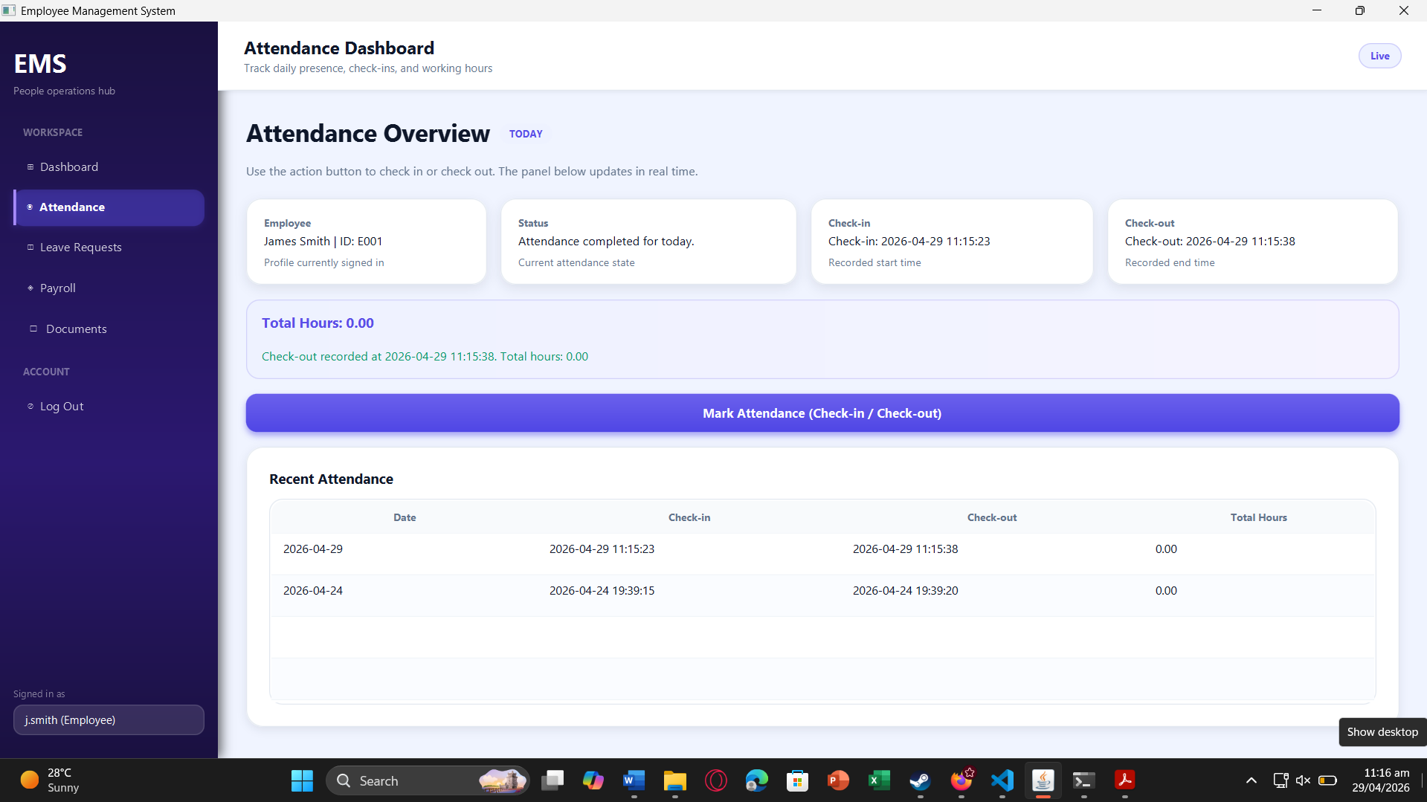
Figure 4: Attendance screen
employee marks check-in/check-out and views recent history.
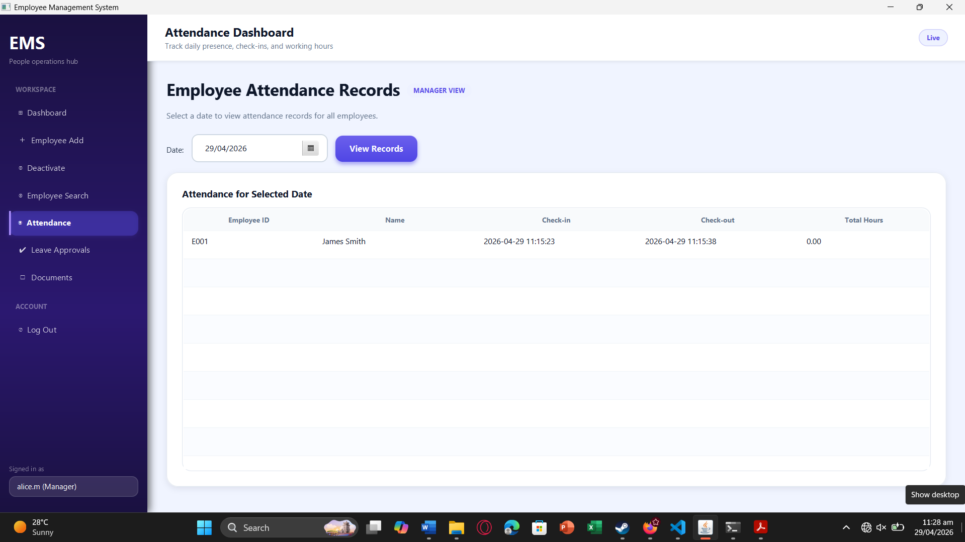
manager views team daily attendance for monitoring punctuality.
Figure 5: Employee search screen
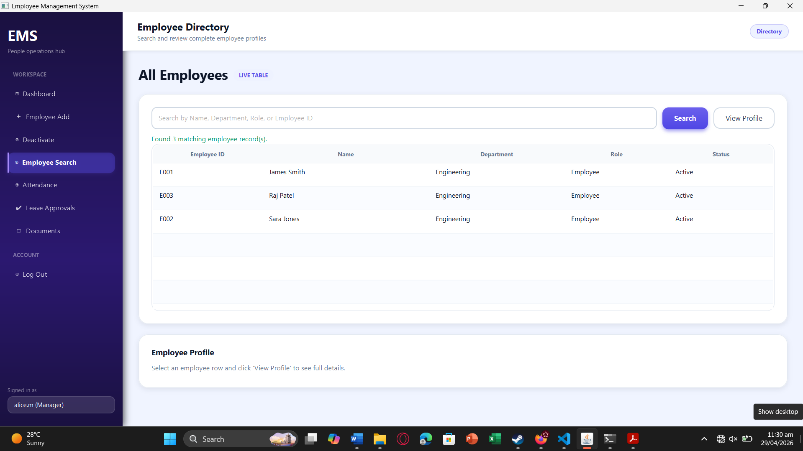
manager searches employees within allowed scope.

8. Work Division for Sprint 2
Team Member | Responsibilities
Muhammad Faheem | Leave management service and approval workflow logic. Leave balance deduction and request handling.
Irtaza Kazmi | Attendance service implementation. Employee search scoping and related repository logic.
Humayun Bilal | UI for leave application, leave approvals, attendance, and employee search screens. Layout and interface adjustments for Sprint 2.

