CS3009 - Software Engineering
Employee Management System
Deliverable 3 — Sprint 3 Documentation (Final)

Team Members
Muhammad Faheem | Irtaza Kazmi | Humayun Bilal

1. Introduction
Sprint 3 completed the EMS project by delivering the remaining high-impact modules: payroll processing, document management, role-specific dashboards, and department deletion controls. Sprint 1 established authentication, role-based access control, department setup, and employee lifecycle flows. Sprint 2 added leave, attendance, and employee search with department-level scoping. Sprint 3 integrated financial operations and document workflows into this foundation, resulting in a complete end-to-end business management system with role-aware boundaries.

2. Project Vision
The project vision was refined through Sprints 2 and 3 to emphasize operational automation plus decision support:
- Automate HR operations across attendance, leave, employee lifecycle, payroll, and documents.
- Enforce role-based data boundaries (Administrator, Manager, Employee).
- Provide reliable, actionable dashboards for organizational monitoring.
- Reduce manual paperwork and improve record traceability.
- Deliver a maintainable desktop system suitable for local organizational deployment.

3. Intended Use of the System

3.1 Who Will Use the System
- Administrator: Oversees organizational structure and high-authority operations.
- Manager: Handles department-level people operations.
- Employee: Uses self-service features for attendance, leave, documents, and payroll history.
- Secondary stakeholders: HR, Finance, IT Support, and management consuming reports.

3.2 How the System Is Used
- Users authenticate through role-based login.
- Navigation and feature visibility are dynamically scoped by role.
- Managers operate only within assigned department context.
- Employees operate only on their own records where applicable.

3.3 Updated Stakeholder Needs in Sprint 3

Administrator
- Generate payroll records with controlled inputs and duplicate-period blocking.
- Auto-fill payroll hours using attendance totals.
- Delete departments when no active staff remain in those departments.
- View organization-wide dashboard totals and department breakdown.

Manager
- Review department employee documents, approve or delete as needed.
- Monitor team KPIs (team size, pending leaves, attendance, payroll due count).
- Continue approvals and search within department scope.

Employee
- Upload and open own documents.
- View own payroll history only.
- View personal profile, leave balance, and latest pay indicators on dashboard.

4. Features Functionality

4.1 Sprint 1 Completed Features
- User authentication and session management.
- Role-based access control and role-aware sidebar rendering.
- Department creation and manager assignment.
- Employee add/update and deactivation request workflow.

4.2 Sprint 2 Completed Features
- Leave request submission and manager approval/rejection.
- Attendance check-in/check-out with total hour computation.
- Role-scoped employee search.

4.3 Sprint 3 New Features
- Payroll generation (Admin authority), including attendance-based hour auto-fill.
- Employee payroll history view (employee sees own records).
- Document workflow: upload (Employee), approve/delete (Manager), open file (Employee).
- Role-specific dashboards for Admin, Manager, and Employee.
- Department deletion (Admin), with active-employee guard and manager unassignment update.

4.4 Sprint 3 Capability Improvements and Integration Impact
Sprint 3 connected operational modules into a full integrated product:
- Financial integration: Payroll now uses attendance-derived input support.
- Compliance and review flow: Documents have pending-to-approved lifecycle with manager control.
- Better visibility: Dashboards provide role-specific operational summaries.
- Data integrity and governance: Deletion and approval workflows enforce business constraints.

5. User Stories (Sprint 3)
The following table summarizes all Sprint 3 user stories with their acceptance criteria:

Story ID | User Story | Acceptance Criteria
US12 | As an administrator, I want to generate payroll for an employee so that salary is calculated accurately and stored for reporting. | Admin provides employee, period, and salary components. System computes gross and net salary. Duplicate payroll for same employee/month/year is blocked. Employee last net salary is updated.
US13 | As an administrator, I want payroll hours to be auto-filled from attendance so payroll reflects recorded work history. | On employee + month + year input, auto-fill loads summed attendance hours.
US14 | As an employee, I want to upload documents to my own profile for manager review. | Supported extensions only. File is stored under employee document path. Record is created with status Pending. Upload to another employee profile is blocked.
US15 | As a manager, I want to approve department employee documents so verified records are tracked. | Manager sees only department documents. Approve updates document status to Approved.
US16 | As a manager, I want to delete invalid employee documents. | Selected document record is removed. Physical file deletion is attempted.
US17 | As an employee, I want to open my uploaded document to verify content. | File opens using OS default app. Error shown when file is missing on disk.
US18 | As an administrator, I want global employee KPIs and department breakdown. | Dashboard shows total and active employee KPIs. Department table shows manager and headcount values.
US19 | As a manager, I want department KPIs and pending leave visibility. | Team size, pending approvals, attendance count, payroll due count displayed.
US20 | As an employee, I want personal profile and salary/leave summary. | Profile fields, attendance status, and pay/leave summary are shown.
US21 | As an employee, I want to view only my own payroll records. | Employee sees own payroll history only. Cross-employee payroll access is blocked.
US22 | As an administrator, I want to delete a department when it is no longer needed. | Deletion is blocked if active employees exist in that department. On success, department record is removed and manager assignment state is updated.

Sprint 2 leftover stories completed in Sprint 3: None (Sprint 2 user stories were completed in Sprint 2).

6. Non-Functional Requirements (NFR)

Performance
- Typical UI-triggered database operations should complete within 3 seconds on lab-standard hardware.
- Dashboard tables and KPI computations should render without noticeable delay for normal dataset sizes.

Usability
- Role-based navigation should hide irrelevant actions to reduce user error.
- Forms should provide clear validation feedback for missing or invalid input.
- Payroll and document screens should expose straightforward action flows for their target roles.

Reliability
- Payroll persistence and salary-summary update should execute atomically using transactions.
- Attendance records should prevent duplicate same-day entries per employee.
- Deactivation and deletion workflows should preserve consistency of related records.

Security
- Service-layer checks should enforce role authorization for payroll/document/deletion actions.
- Users should only access data within their role scope and organizational context.

Scalability
- Schema and module separation should support future expansion (additional HR features/reports).
- Query design should remain maintainable and adaptable as employee records grow.

7. Testing and Quality Assurance

7.1 Test Plan
Testing validated functional correctness, access-control enforcement, data integrity, and regression safety across Sprint 3 modules.

7.2 Black-Box Test Cases
Test Case | Expected Result | Status
Payroll valid input | Record saved, salary computed, profile net pay updated | PASS
Payroll duplicate period | Blocked with user-facing error | PASS
Non-admin payroll generation attempt | Denied | PASS
Document upload unsupported extension | Rejected | PASS
Upload to non-owner profile | Denied | PASS
Open missing file | Error displayed | PASS
Department deletion with active employees | Blocked | PASS
Employee payroll view | Only own records visible | PASS

7.3 White-Box Testing Evidence
- Payroll service branch paths covered: invalid role, invalid period, inactive employee, duplicates, negatives.
- Document upload validation paths covered: extension, ownership, file existence.
- Attendance month-hour aggregation path verified for payroll auto-fill.
- Department deletion guard branch validated (has active employees vs no active employees).

7.4 Bug Report Summary
- Payroll filter visibility issue for employee scope: fixed.
- Manager dashboard global KPI leakage: fixed.
- Document reject/delete UX confusion: resolved by standardized approve/delete flow.
- Add-manager role-field UI inconsistency: fixed.

7.5 Test Results and Observations
- Core Sprint 3 workflows passed expected behaviors under role constraints.
- Errors surfaced with actionable messages in major failure scenarios.
- Integration across attendance-payroll-dashboard modules behaved consistently.

7.6 How Testing Improved System Quality
Testing reduced authorization gaps, improved reliability of financial writes, validated document lifecycle behavior, and improved overall user trust by catching role-scope and UI consistency issues before final submission.

8. Iteration 3 Implementation Screenshots
Figure 1: Admin Dashboard
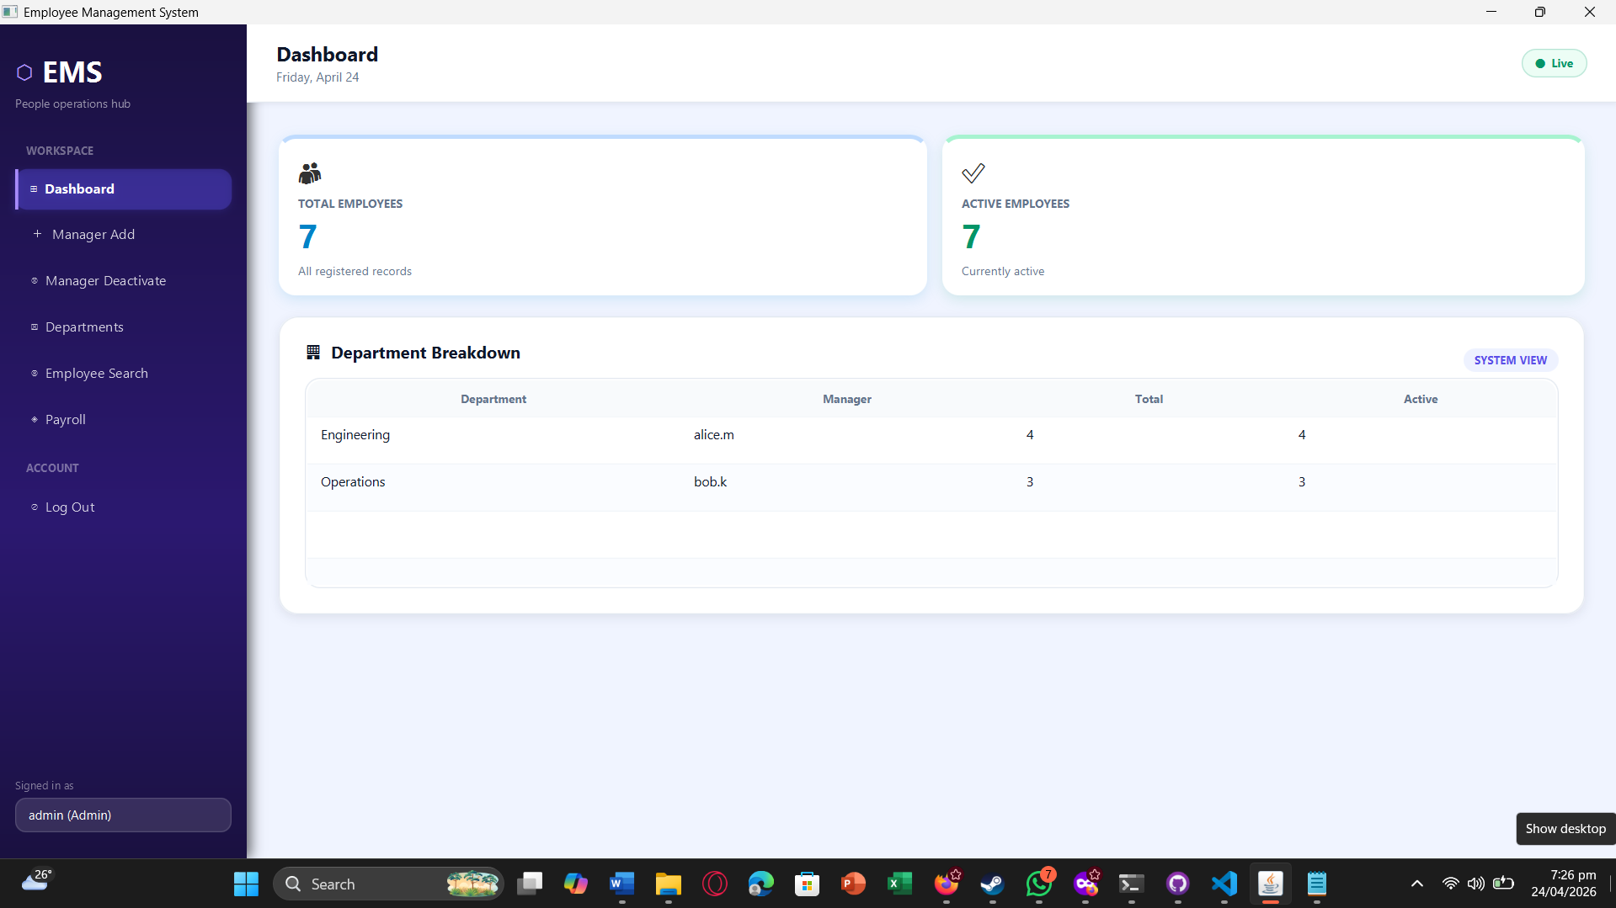
Figure 2: Payroll Generation Screen
Admin Dashboard: Organization-wide department breakdown with manager assignments are displayed for strategic monitoring.

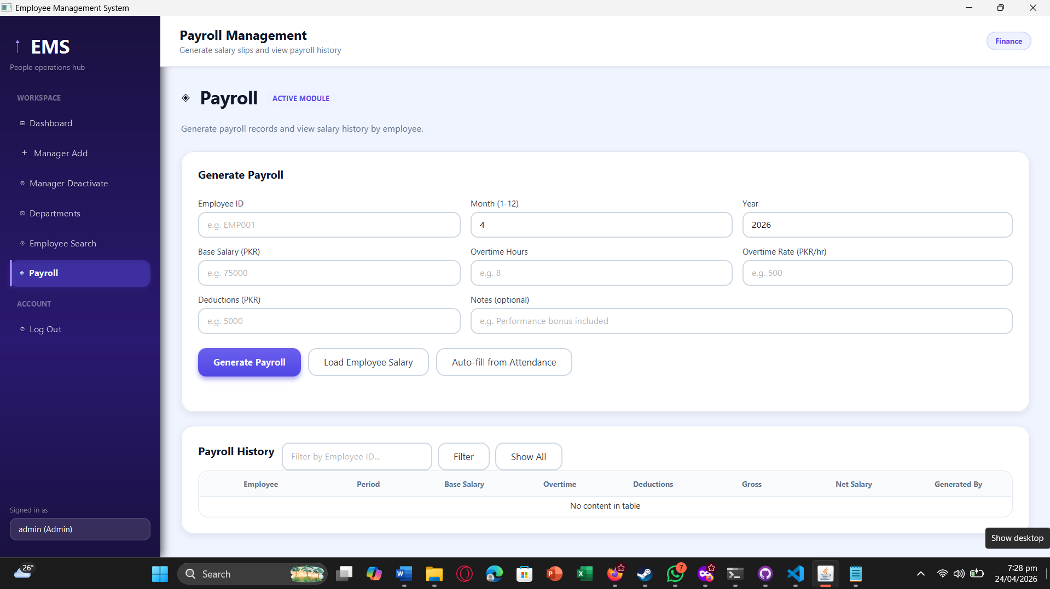
Figure 3: Payroll Auto-Fill from Attendance Result
Payroll Generation: Administrator generates payroll using employee period inputs, salary components, and validation checks.

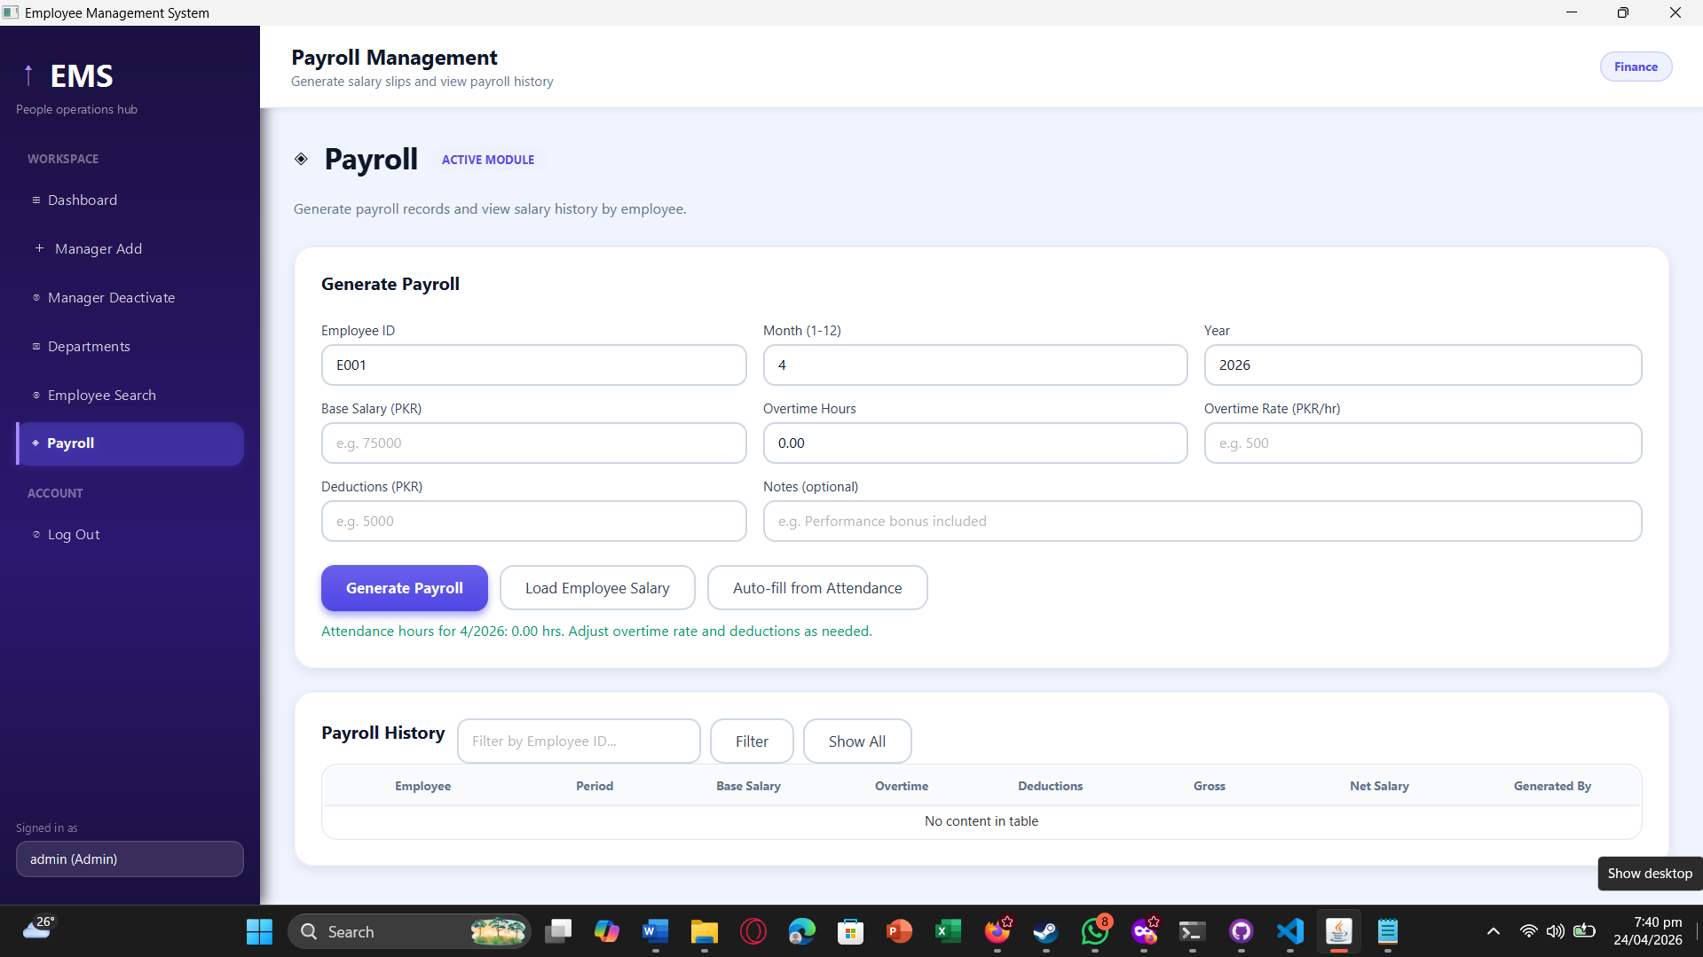
Figure 4: Department Deletion Screen
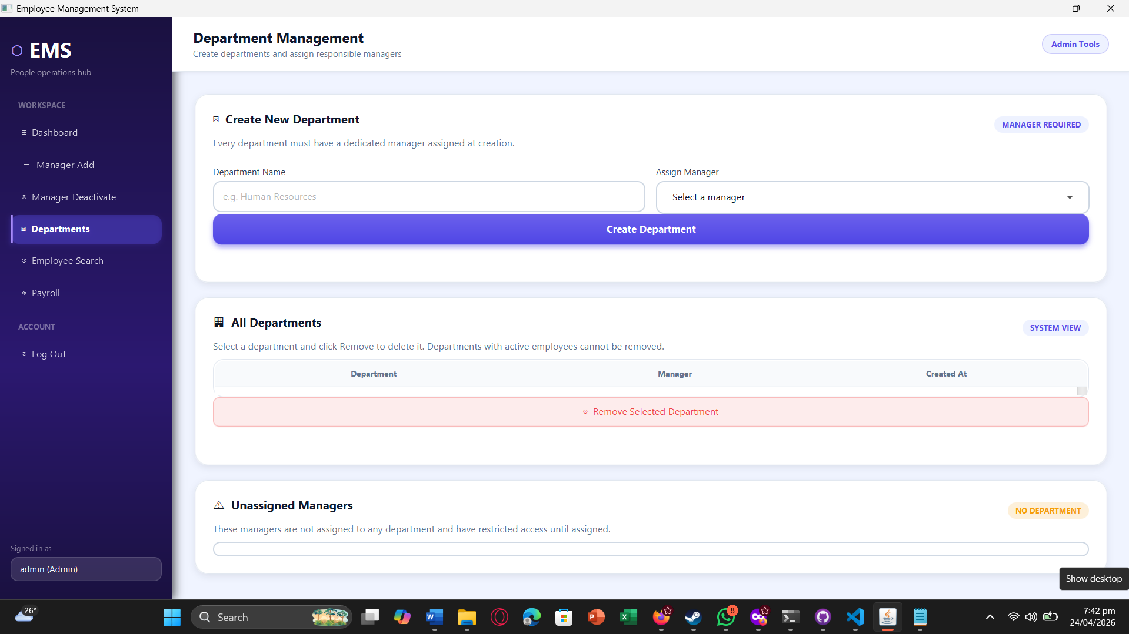
Figure 5: Manager Dashboard
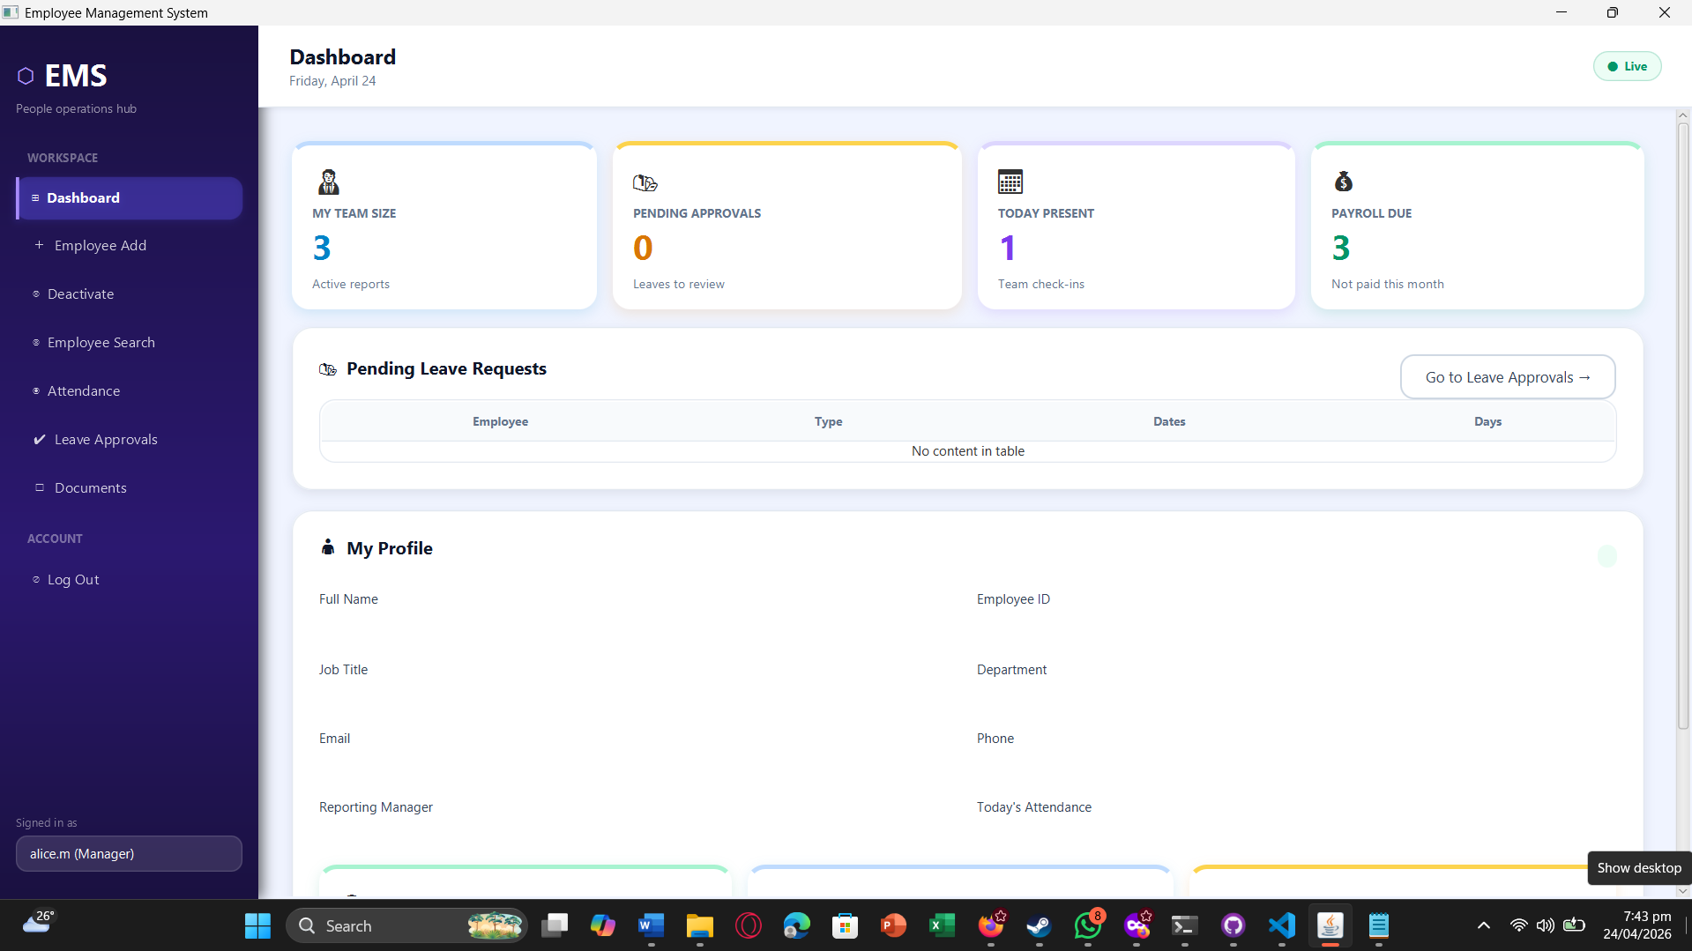
Figure 6: Document Upload Screen
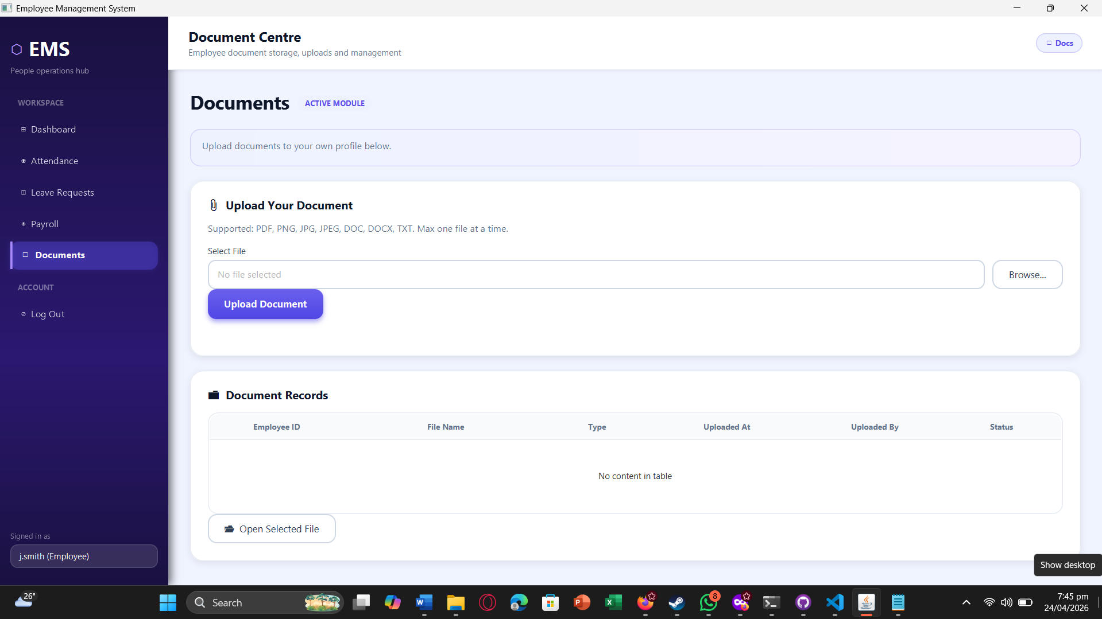
Figure 7: Document Approve/Delete Screen
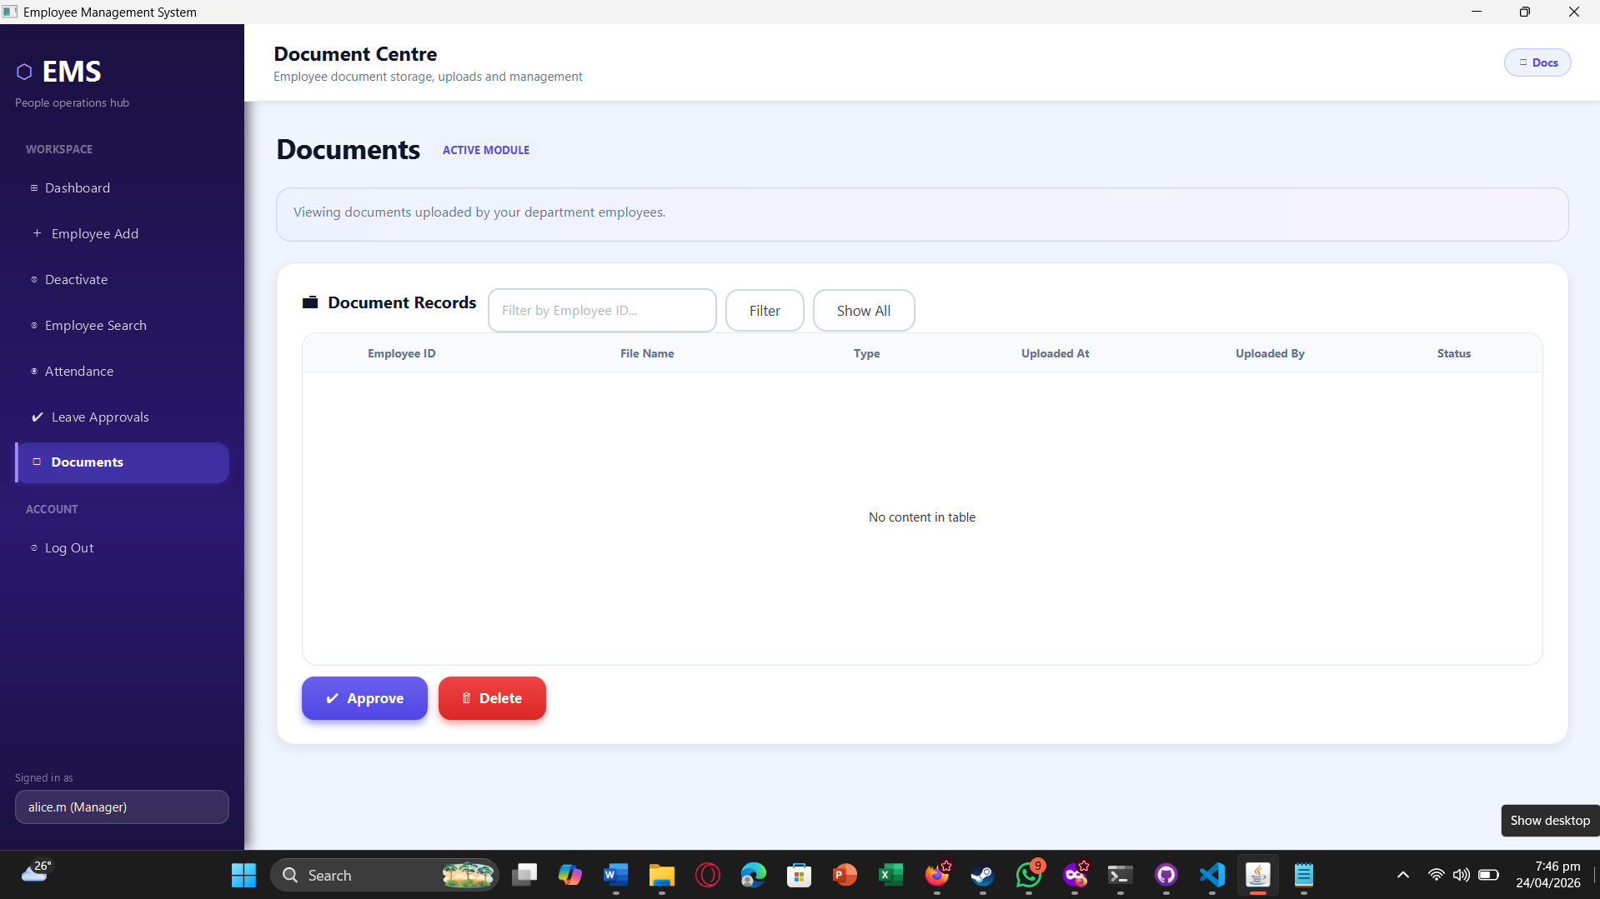
Department Deletion: Administrator deletes a department only when no active employees are assigned, enforcing structural consistency.

Payroll Auto-fill: Attendance-based hour totals are auto-filled to improve payroll accuracy and reduce manual entry.

Manager Dashboard: Department-scoped KPIs show team size, pending approvals, attendance status, and payroll due indicators.

Document Upload: Employee uploads a supported document to their own profile with default Pending status.

Document Approval/Deletion: Manager reviews department documents and performs approve or delete actions based on verification.

Figure 8: Employee Document Open/View Screen

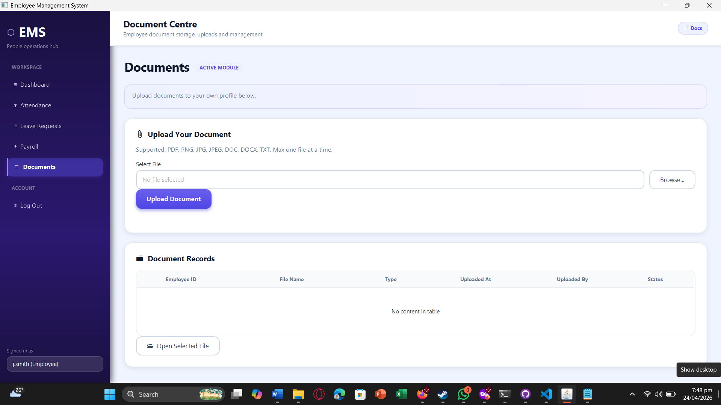
Figure 9: Employee Payroll History Screen
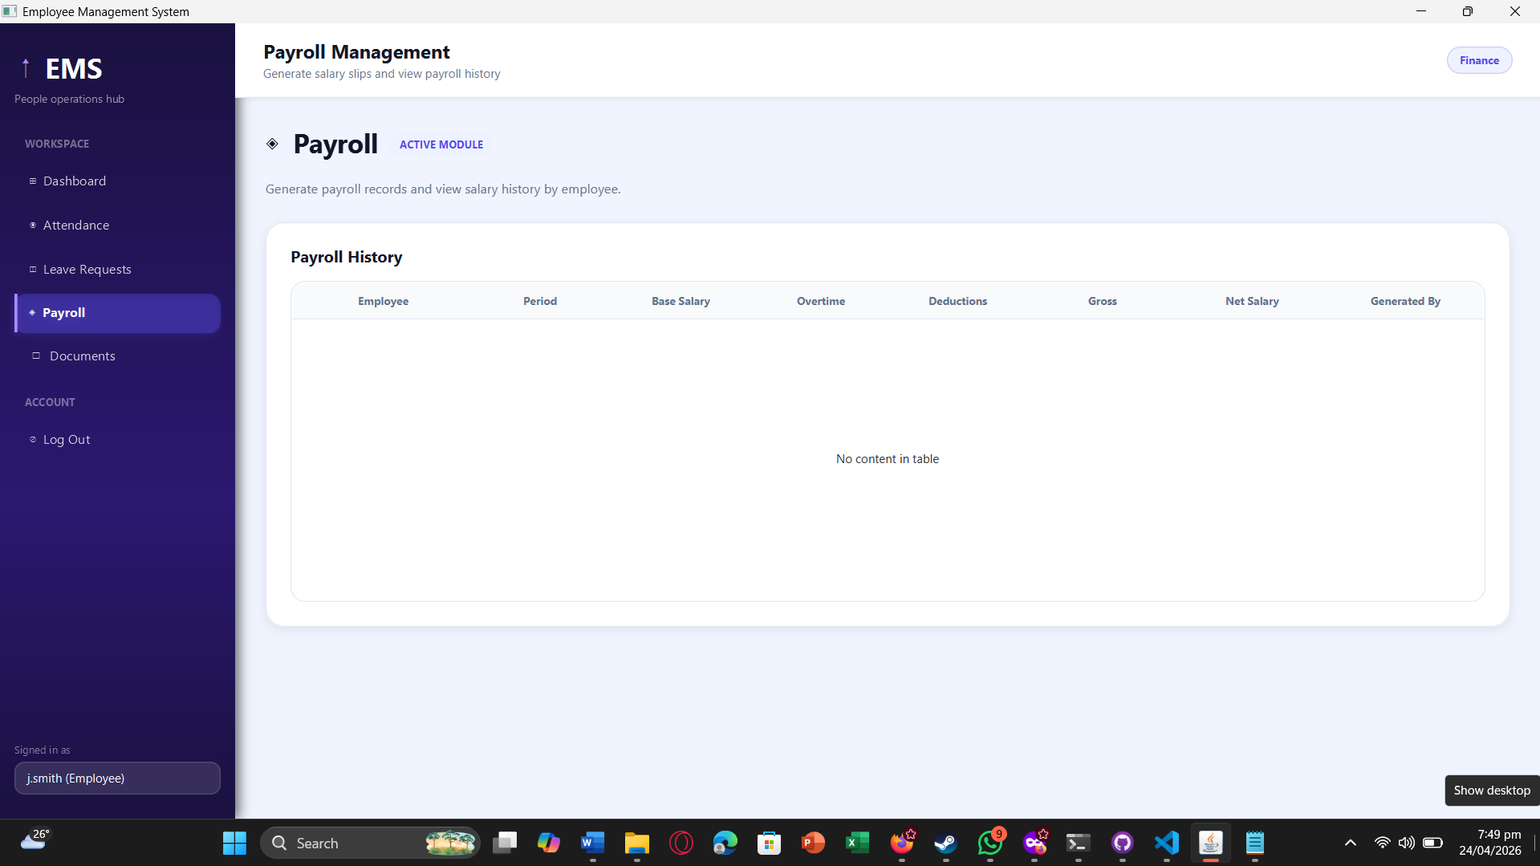
Employee Payroll View: Employee can view only their own payroll history with role-based access restrictions applied.

Document Open/View: Employee opens an uploaded document through the system using the default OS file handler.

9. Work Division for Sprint 3
Team Member | Responsibilities
Muhammad Faheem | Payroll service and payroll controller workflow. Attendance-to-payroll auto-fill integration. Sprint planning and integration support.
Irtaza Kazmi | Document service and document controller implementation. Department-scoped document queries and document status handling. Department deletion flow implementation support.
Humayun Bilal | Dashboard UI and role-specific dashboard behavior. Payroll/document screen UI refinement. Testing execution, bug tracking, and quality-report preparation.

10. Final System Summary
The final EMS product combines Sprint 1 foundations (authentication, RBAC, employee lifecycle, departments), Sprint 2 operational workflows (leave, attendance, scoped search), and Sprint 3 completion modules (payroll, documents, dashboards, department deletion) into one integrated business system. The final system enforces a clear three-role hierarchy, protects role boundaries, centralizes employee operations, and delivers both operational automation and management visibility in a single desktop application.

