add the deposit to safe
- It is not possible to select an employee
- After clicking on an create, it goes to View safe but does not display data for the current month. Data for the current month should be displayed.
add payoutns from safe

- It is not possible to select an employee
- The order of entering data is different than in add the deposit to safe
- After clicking on an create, it goes to View safe but does not display data for the current month. Data for the current month should be displayed.

add expense

- After clicking on an create, it goes to View expense but does not display data for the current month. Data for the current month should be displayed.
- When i click create with file i have screen
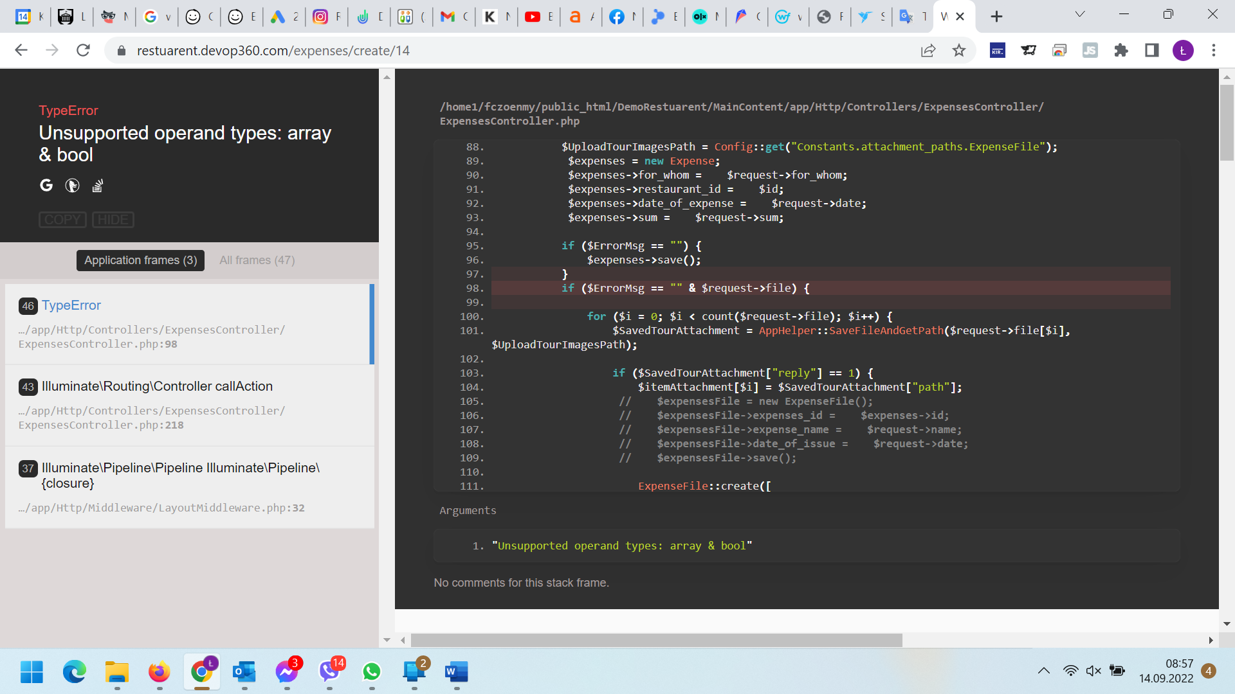

add salary

- After clicking on an create, it goes to View safe but does not display data for the current month. Data for the current month should be displayed.

add daily report
- It is not possible to select an employee
- If I do not fill in the uber, bolt, volt, pyszne, glovo fields - cash is not calculated - no data should be treated as entered 0
- CASH = (Mathematical formula) Cash = Total income-Card transaction-Canceled sale - Sales Volume by suppliers-Today expense-Today paid salary in cash THIS FIELS only visible to the administrator currently not subtracting (Today expense-Today paid salary in cash )
- When i click „create” i see
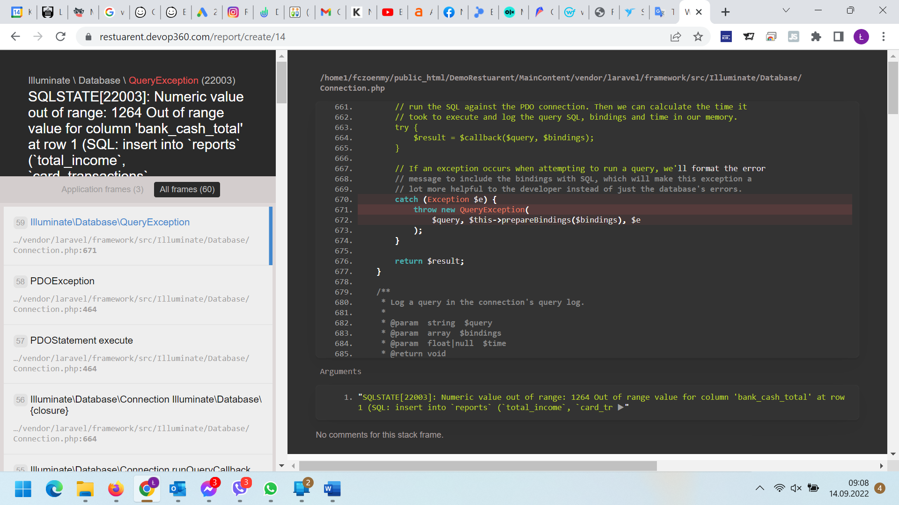

Should be:
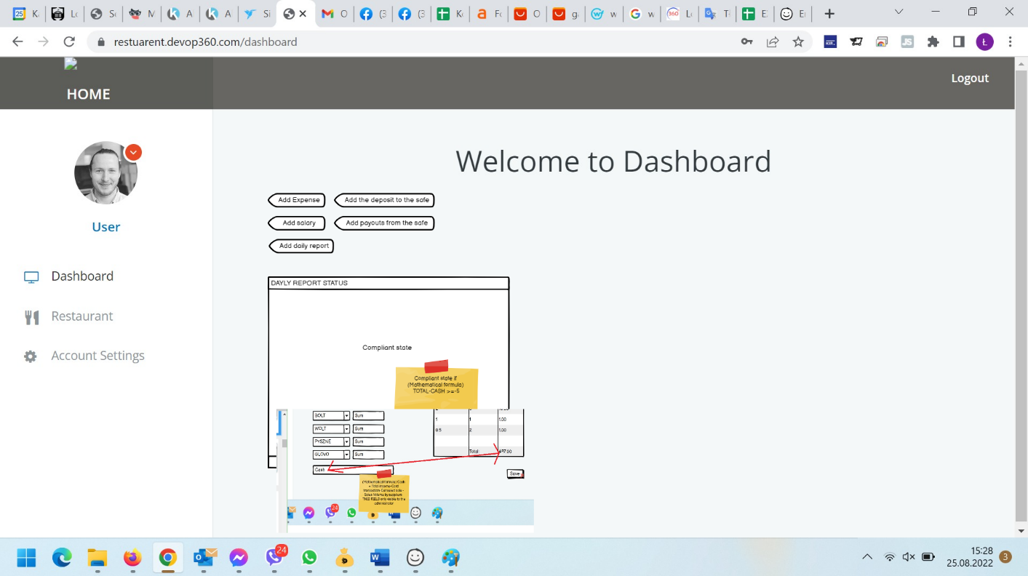

or
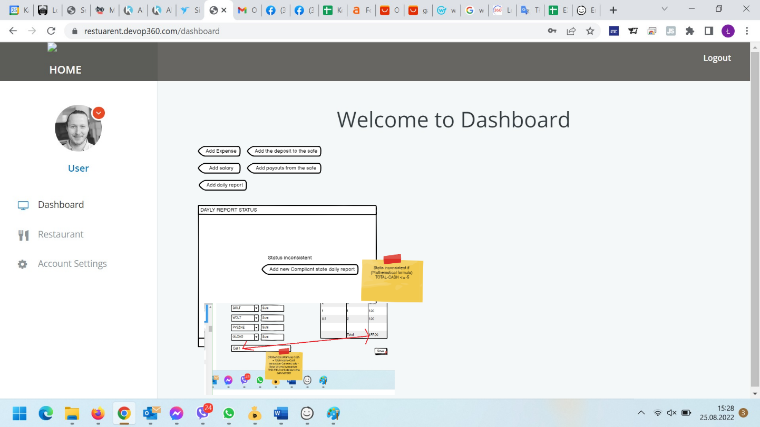

VIEW SAFE

- After clicking on VIEW SAFCE, it goes to View safe but does not display data for the current month. Data for the current month should be displayed.
- The most recent data should be displayed at the top and the older the lower. Sort by date descending
- The system counts badly, it should count chronologically with dates. Look below on 09/13/2022 added 1000 gives 1752 and should 1000 and then added 100 should give 1100 etc ...
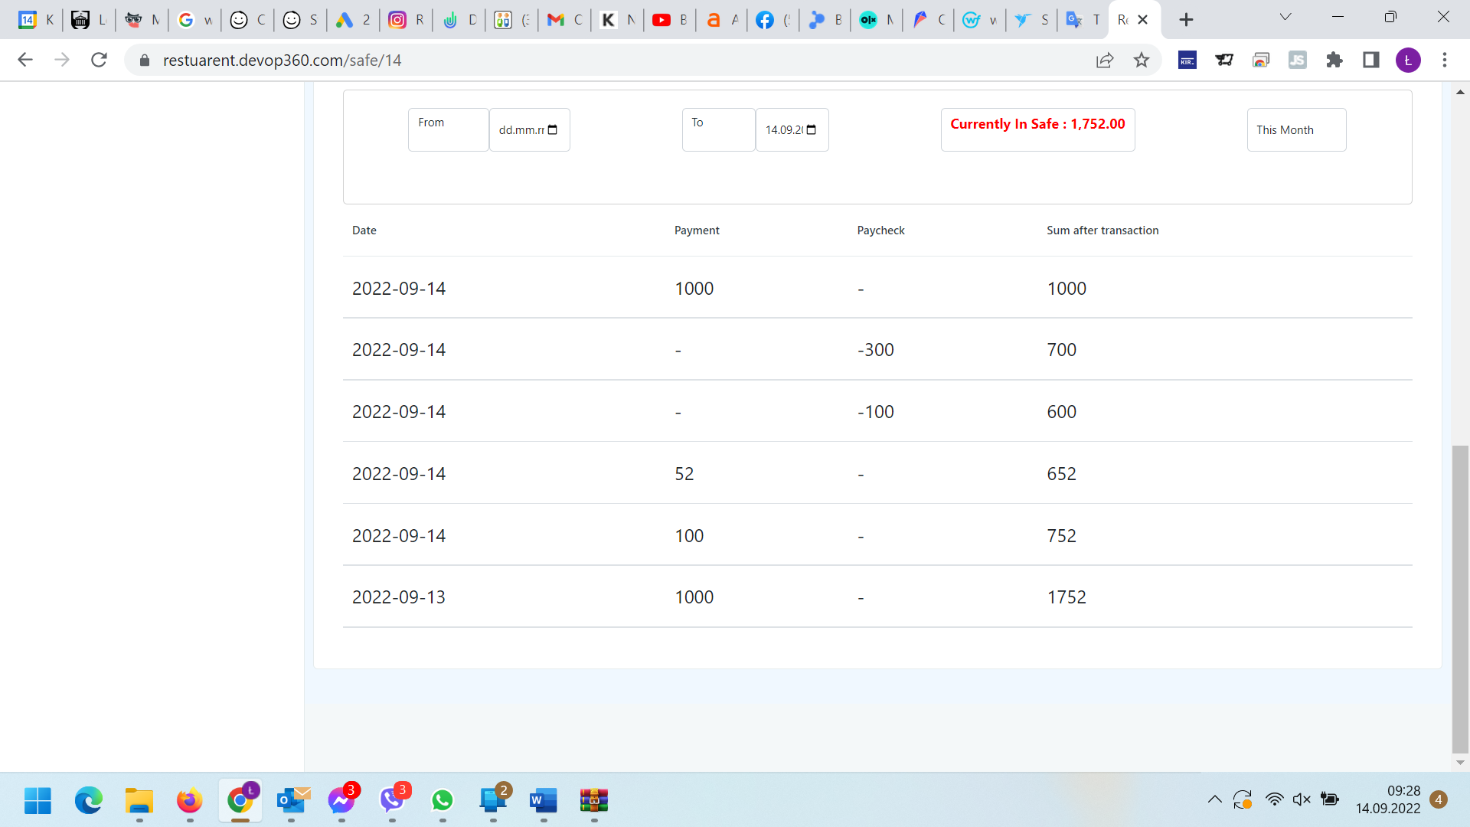
- There is no option to edit or delete the added item

VIEW EXPENSE

- After clicking on VIEW EXPENSE, it goes to View expense but does not display data for the current month. Data for the current month should be displayed.
- The most recent data should be displayed at the top and the older the lower. Sort by date descending
- There is no information about Expense Name in table
- There is no checkbox in table
- When I didn't add the file - the download file field should be inactive and now some html file is being downloaded
- There is no option to edit or delete the added item
- The add expense button does not work

VIEW SALARY

- After clicking on VIEW SALARYE, it goes to View SALARY but does not display data for the current month. Data for the current month should be displayed.
- "Null" is displayed instead of the employee's name
- The salaries of the same employee for a given period should add up and not be added as a separate item
- "Average for the hour" field missing
- Wrong data in "The sum for the Selected Period", for the example below it shows 593.34 and it should be 426.67 (= 130 + 296.67)

VIEW DAILY REPORT

- After clicking on VIEW SAILY REPORT, it goes to View daily but does not display data for the current month. Data for the current month should be displayed.
- Doesn't show any data - can't be checked

CREATE MANAGE USER

- Add/manage new user should be in the Restaurant Setting (Employee List) section and not as separate data
- In create user
  - User profile
    - Add fields:
      - Surname (text field)
      - Telephone number (text field)
      - Date of Employment
      - End of Work Date
      - Status
    - What is the order of the fields:
      - Status
      - Name
      - Surname
      - Restaurant Linked To
      - Date of Employment
      - End of Work Date
      - Hourly Salary
      - Telephone numer
      - Mail
      - Password
      - Confirm Password
  - BIO
    - Add fileds:
      - Place of birth (text field)
      - PESEL (text field)
      - ID number (text field)
      - Passport number (text field)
      - Country of issue (text field)
      - Mother's name (text field)
      - Mother's name (text field)
      - Father's name (text field)
      - Citizenship (text field)
      - Bank account number (text field)
      - Student / Student (checkbox)
      - Name of the University (text field)
      - until when the student (text field)

    - Delete fields:
      - Profile picture
      - Bio (brief intro)

    - What is the order of the fields:
      - Date of Birth
      - Place of birth
      - PESEL
      - ID number
      - Passport number
      - Country of issue
      - Mother's name
      - Mother's surname
      - Father's name
      - Country Birth
      - Bank account number
      - Student / Student
      - Name of the University
      - until when the student
  - ADDRESS
    - DELETE FIELD:
      - Gender
  - USER ROLE
    - Delete role
      - User
      - Deweloper
      - Waiter
      - Customer
      - Kitchen

DELETE USER
- I Can not edit, add, delete role

Restaurant Setting

- Employee List - by default, the active list will be displayed
- Is Active for this restaurant (Sales volume by suppliers) ? – do not work
Example when i click YES
Example when i click NO

- How many last days do employees see cash reports? – do not work
- When I click SAVE it should go back to restaurant setting
- There is no salary rate field
- There is no list of (Sales volume by suppliers) field

Welcome to Dashboard
no data - no possibility to check, it should be a dasboard as described above.
https://docs.google.com/spreadsheets/d/1-iQF-JdNdgoIadPrjzxSQGQDww9sjTIfEb0cOMbOnqs/edit#gid=1088221939 (Profile card)

To do list
no data - no possibility to check, it should be a dasboard as described above.
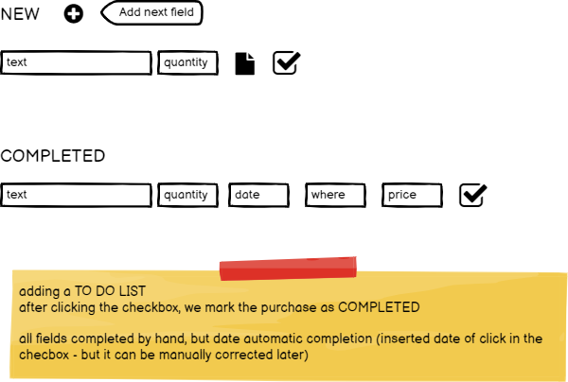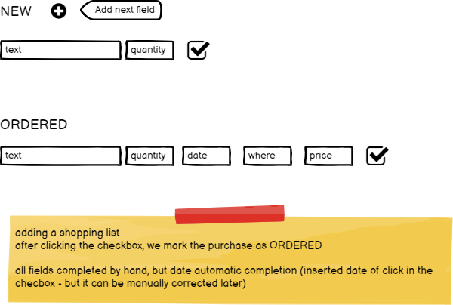

Shopping list
no data - no possibility to check, it should be a dasboard as described above.

if ({{auth()->user()->hasRole('developer') || auth()->user()->hasRole('admin')}}) {
// if ($user.roles().pluck('name').implode(', ') == 'developer') {
// if (user.roles().pluck('name').implode(', ') == 'developer') {

if (return_true() == true) {
console.log("if here");
$('tbody').append(
'<tr class="tr_remove" >\
<td>' + item_created_at + '</td>\
<td>' + item.total_income + '</td>\
<td>' + item.card_transactions + '</td>\
<td>' + item.canceled_sale + '</td>\
<td>' + item.UBER + '</td>\
<td>' + item.BOLT + '</td>\
<td>' + item.WOLT + '</td>\
<td>' + item.PYSZNE + '</td>\
<td>' + item.GLOVO + '</td>\
<td>' + item.supplier_cash + '</td>\
<td>' + item.cash + '</td>\
<td>' + item.bank_cash_total + '</td>\
<td>' + Compliant_status + '</td>\
</tr>'
)
} else {

console.log("else here");
$('tbody').append(
'<tr class="tr_remove" >\
<td>' + item_created_at + '</td>\
<td>' + item.total_income + '</td>\
<td>' + item.card_transactions + '</td>\
<td>' + item.canceled_sale + '</td>\
<td>' + item.UBER + '</td>\
<td>' + item.BOLT + '</td>\
<td>' + item.WOLT + '</td>\
<td>' + item.PYSZNE + '</td>\
<td>' + item.GLOVO + '</td>\
<td>' + item.supplier_cash + '</td>\
<td>' + item.cash + '</td>\
<td>' + item.bank_cash_total + '</td>\
<td>' + Compliant_status + '</td>\
</tr>'
)

}

