add the deposit to safe
- It is not possible to select an employee
- After clicking on create, it goes to View safe but does not display data for the current month. Data for the current month should be displayed. -> done

add payouts from safe

- It is not possible to select an employee
- The order of entering data is different than in add the deposit to safe. -> done
- After clicking on an create, it goes to View safe but does not display data for the current month. Data for the current month should be displayed. -> done

add expense

- After clicking on an create, it goes to View expense but does not display data for the current month. Data for the current month should be displayed. -> done
- When i click create with file i have screen
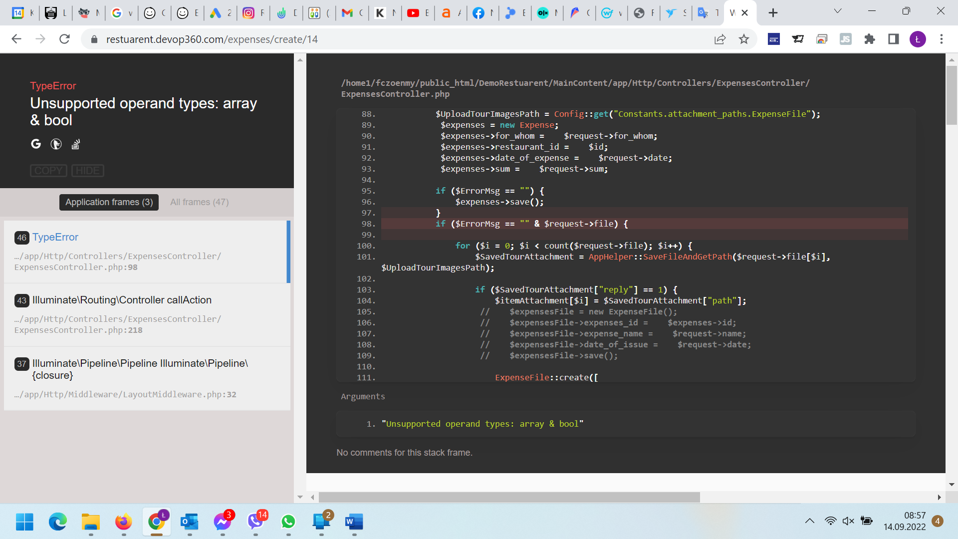

add salary

- After clicking on an create, it goes to View safe but does not display data for the current month. Data for the current month should be displayed. -> done

add daily report
- It is not possible to select an employee
- If I do not fill in the uber, bolt, volt, pyszne, glove fields - cash is not calculated - no data should be treated as entered 0 -> done
- CASH = (Mathematical formula) Cash = Total income-Card transaction-Canceled sale - Sales Volume by suppliers-Today expense-Today paid salary in cash THIS FILES only visible to the administrator currently not subtracting (Today expense-Today paid salary in cash ) -> done
- When i click „create” i see -> done
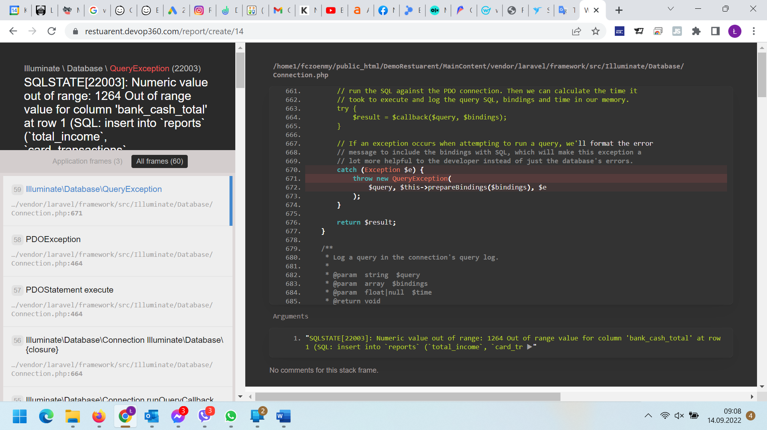

Should be:
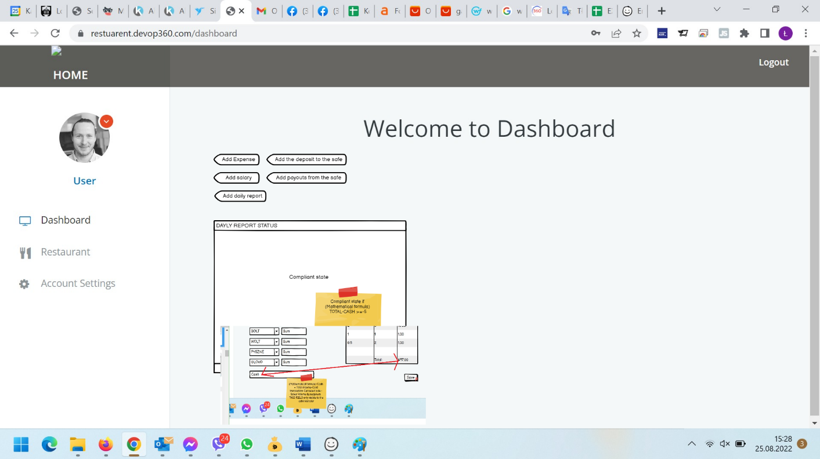

or
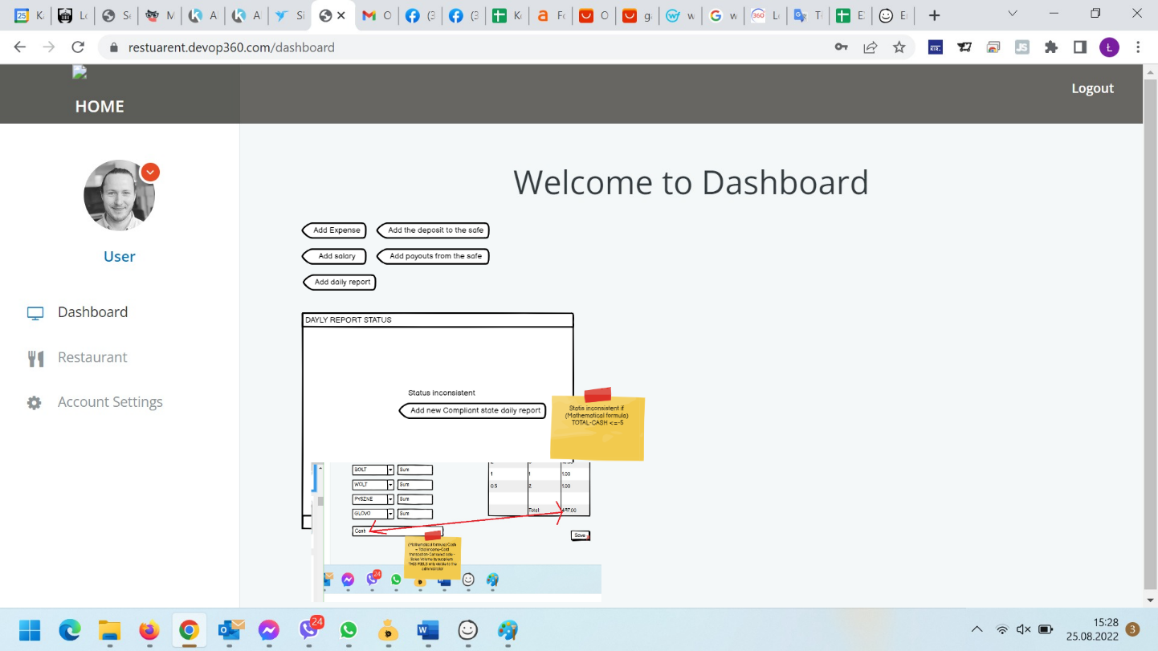

VIEW SAFE

- After clicking on VIEW SAFCE, it goes to View safe but does not display data for the current month. Data for the current month should be displayed. -> done
- The most recent data should be displayed at the top and the older the lower. Sort by date descending -> done
- The system counts badly, it should count chronologically with dates. Look below on 09/13/2022 added 1000 gives 1752 and should 1000 and then added 100 should give 1100 etc ... (for payout and deposit Date of Transaction is removed to get latest transactions) -> done

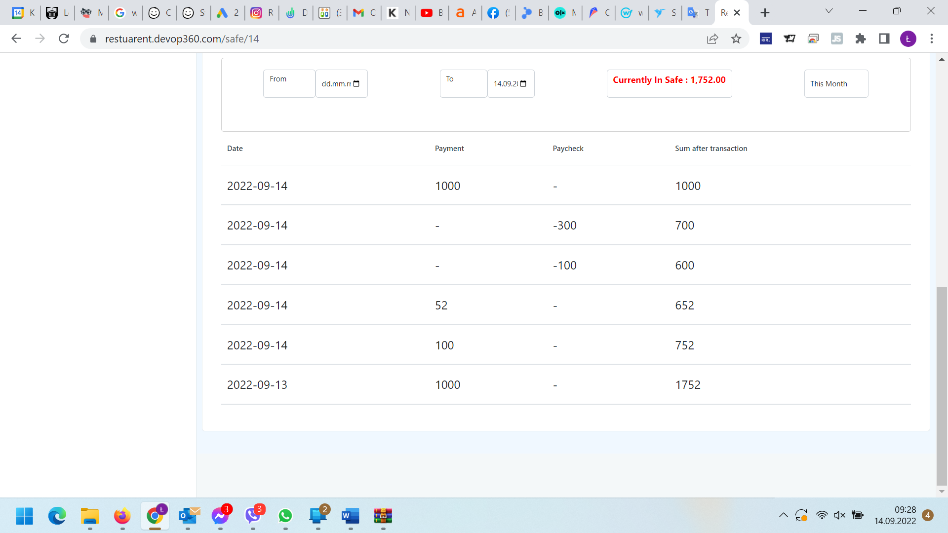
- There is no option to edit or delete the added item

VIEW EXPENSE

- After clicking on VIEW EXPENSE, it goes to View expense but does not display data for the current month. Data for the current month should be displayed. -> done
- The most recent data should be displayed at the top and the older the lower. Sort by date descending-> done

- There is no information about Expense Name in table-> done
- There is no checkbox in table (please tell what is its use or funtionality)
- When I didn't add the file - the download file field should be inactive and now some html file is being downloaded -> done
- There is no option to edit or delete the added item
- The add expense button does not work -> done

VIEW SALARY

- After clicking on VIEW SALARYE, it goes to View SALARY but does not display data for the current month. Data for the current month should be displayed. -> done
- "Null" is displayed instead of the employee's name -> done
- The salaries of the same employee for a given period should add up and not be added as a separate item
- "Average for the hour" field missing -> done
- Wrong data in "The sum for the Selected Period", for the example below it shows 593.34 and it should be 426.67 (= 130 + 296.67) -> done

VIEW DAILY REPORT

- After clicking on VIEW SAILY REPORT, it goes to View daily but does not display data for the current month. Data for the current month should be displayed. -> done
- Doesn't show any data - can't be checked -> done

CREATE MANAGE USER

- Add/manage new user should be in the Restaurant Setting (Employee List) section and not as separate data
- In create user
  - User profile
    - Add fields:
      - Surname (text field)
      - Telephone number (text field)
      - Date of Employment
      - End of Work Date
      - Status
    - What is the order of the fields:
      - Status
      - Name
      - Surname
      - Restaurant Linked To
      - Date of Employment
      - End of Work Date
      - Hourly Salary
      - Telephone numer
      - Mail
      - Password
      - Confirm Password
  - BIO
    - Add fileds:
      - Place of birth (text field)
      - PESEL (text field)
      - ID number (text field)
      - Passport number (text field)
      - Country of issue (text field)
      - Mother's name (text field)
      - Mother's name (text field)
      - Father's name (text field)
      - Citizenship (text field)
      - Bank account number (text field)
      - Student / Student (checkbox)
      - Name of the University (text field)
      - until when the student (text field)

    - Delete fields:
      - Profile picture
      - Bio (brief intro)

    - What is the order of the fields:
      - Date of Birth
      - Place of birth
      - PESEL
      - ID number
      - Passport number
      - Country of issue
      - Mother's name
      - Mother's surname
      - Father's name
      - Country Birth
      - Bank account number
      - Student / Student
      - Name of the University
      - until when the student
  - ADDRESS
    - DELETE FIELD:
      - Gender-> done

  - USER ROLE
    - Delete role
      - User
      - Deweloper
      - Waiter
      - Customer
      - Kitchen-> done

DELETE USER
- I Can not edit, add, delete role -> its development ->done

Restaurant Setting

- Employee List - by default, the active list will be displayed ->done
- Is Active for this restaurant (Sales volume by suppliers) ? – do not work
- How many last days do employees see cash reports? – do not work->done
- When I click SAVE it should go back to restaurant setting->done
- There is no salary rate field->done
- There is no list of (Sales volume by suppliers) field->done

Welcome to Dashboard
no data - no possibility to check, it should be a dasboard as described above.
https://docs.google.com/spreadsheets/d/1-iQF-JdNdgoIadPrjzxSQGQDww9sjTIfEb0cOMbOnqs/edit#gid=1088221939 (Profile card)

To do list
no data - no possibility to check, it should be a dasboard as described above.
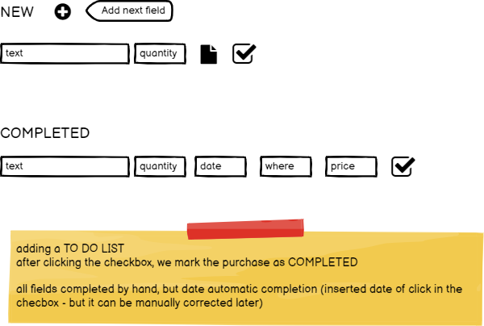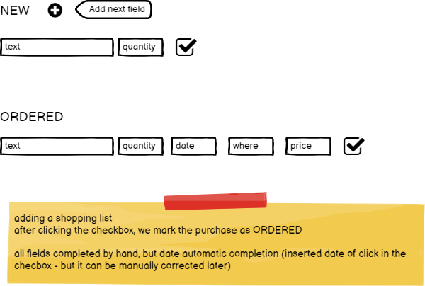

Shopping list
no data - no possibility to check, it should be a dasboard as described above.

