First, make me choose a restaurant after logging in, and then, after selecting it, I have these options and options for viewing the data of this restaurant - each restaurant has its own data not related to another restaurant.  
  
maybe after login just like this

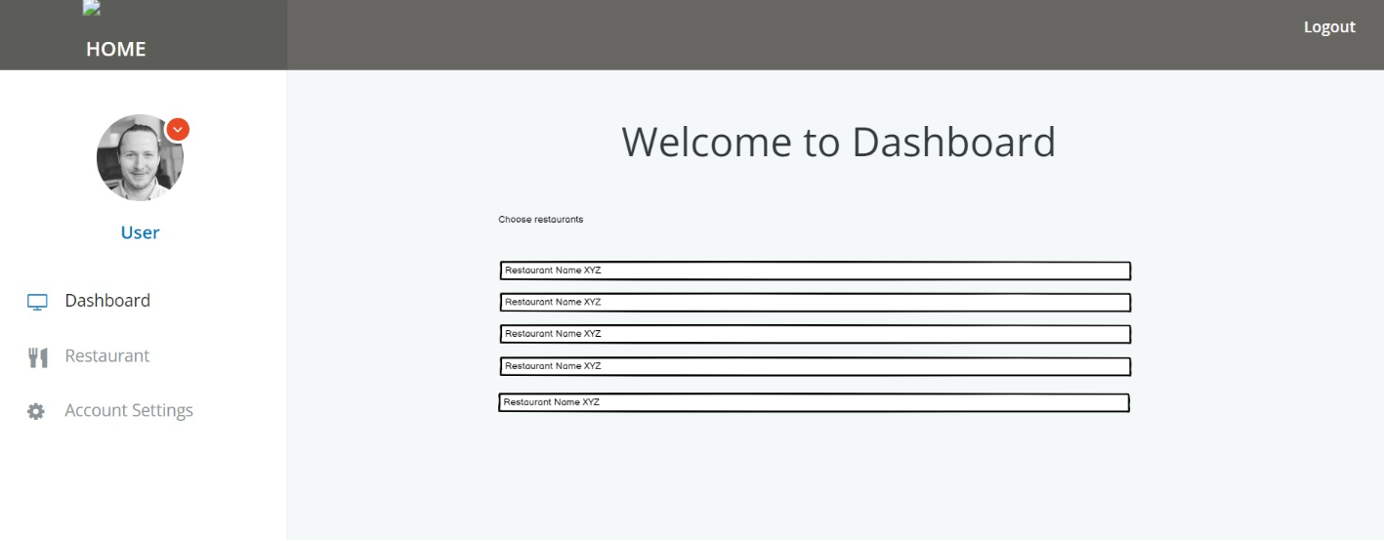

* **Done**

When i click on restaurant i see data of this restaurant:

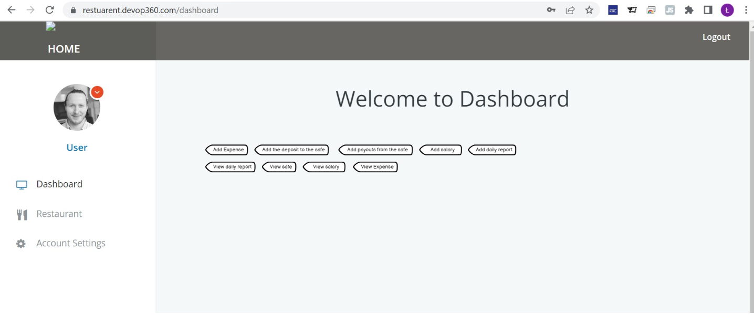

Delete it because I choose the restaurant first and then I only work on this restaurant - so here only the name of the restaurant that I chose "chose restaurant"

* **Done**

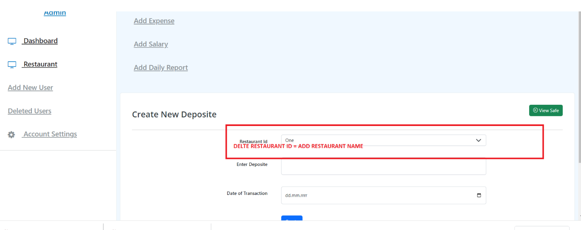

Date of Transaction - put today's date by default here, with the possibility of changing it to another one

Change it to follow the instructions

"View safe"

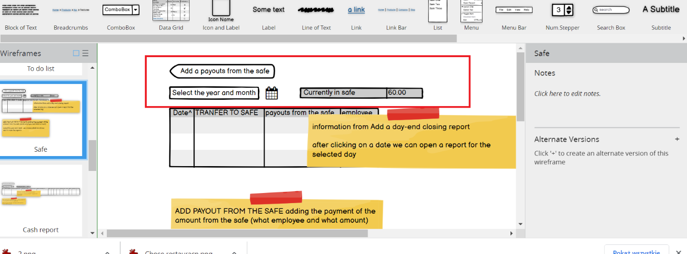

* **Done**

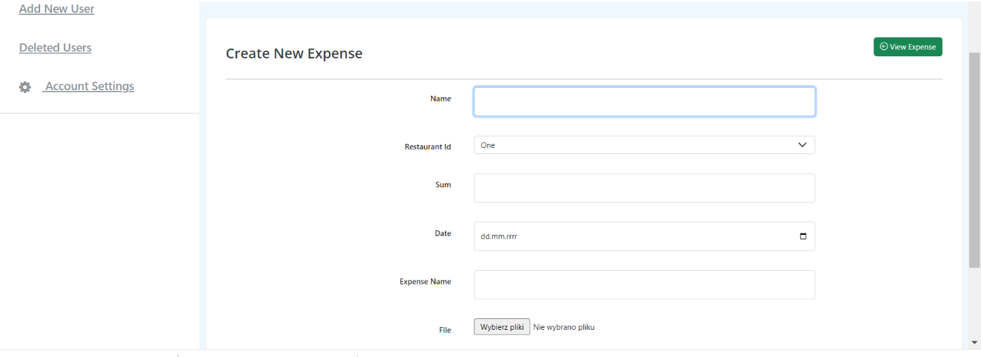

change this like in instruction

delete name

Restaurant Id change to restaurant name

The date is today by default, with the possibility of changing to another one.

VIEW EXPENSE

Changle like in instruction

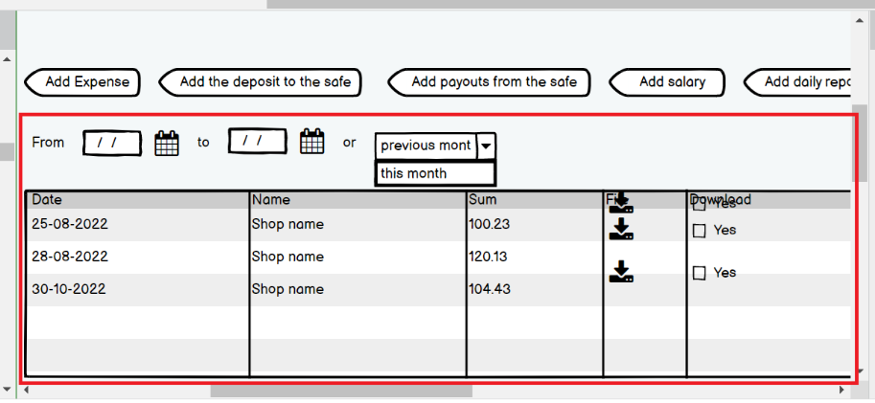

ADD SALARY

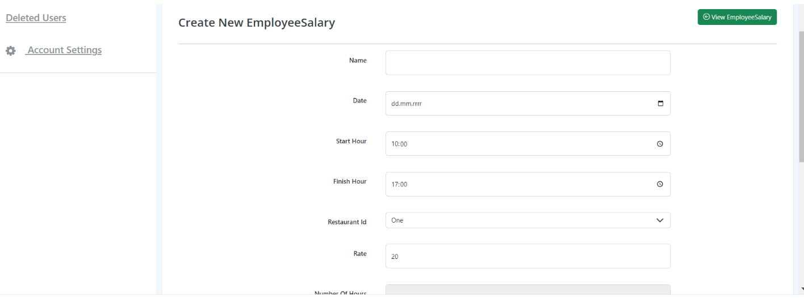

name is employee name

it should be selected - employee data from a database set up separately

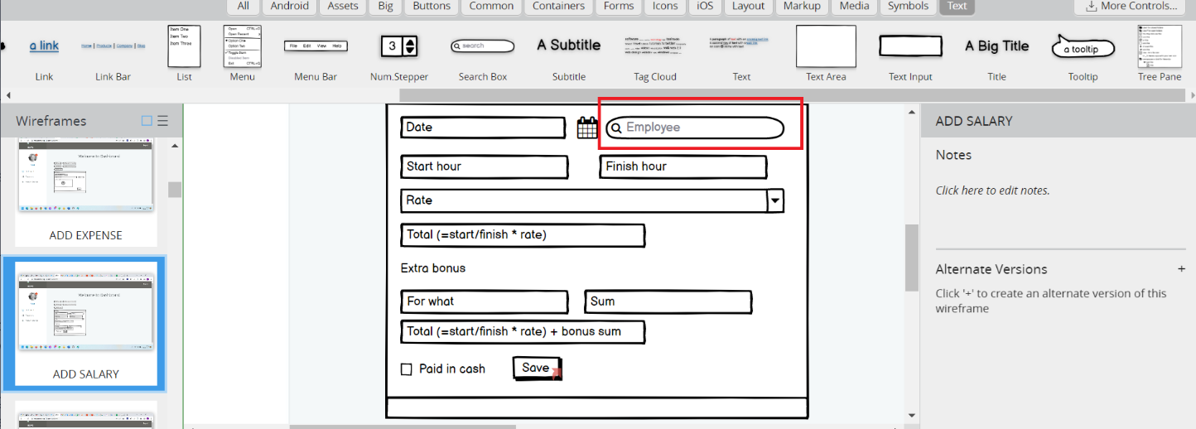

The date is today by default, with the possibility of changing to another one

Change the ID of the restaurant to the name of the currently selected restaurant

Number of hours and sum - calculated automatically with no buttons for that

VIEW SALARY just like in in instruction

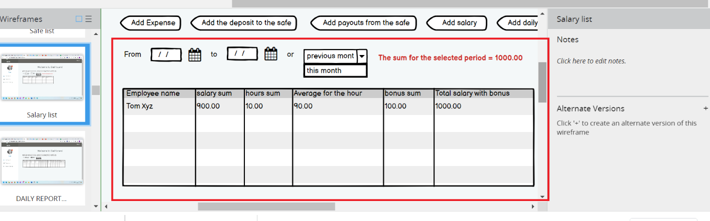

Create New Report

Bank note list: 200 100 50 20 10 5 2 1 0,5 0,2 0,1 0,05 0,02 0,01

Restaurant Id change for restaurant name

8:31 PM

These data are entered for each report separately - I must be able to enter them when making the report:

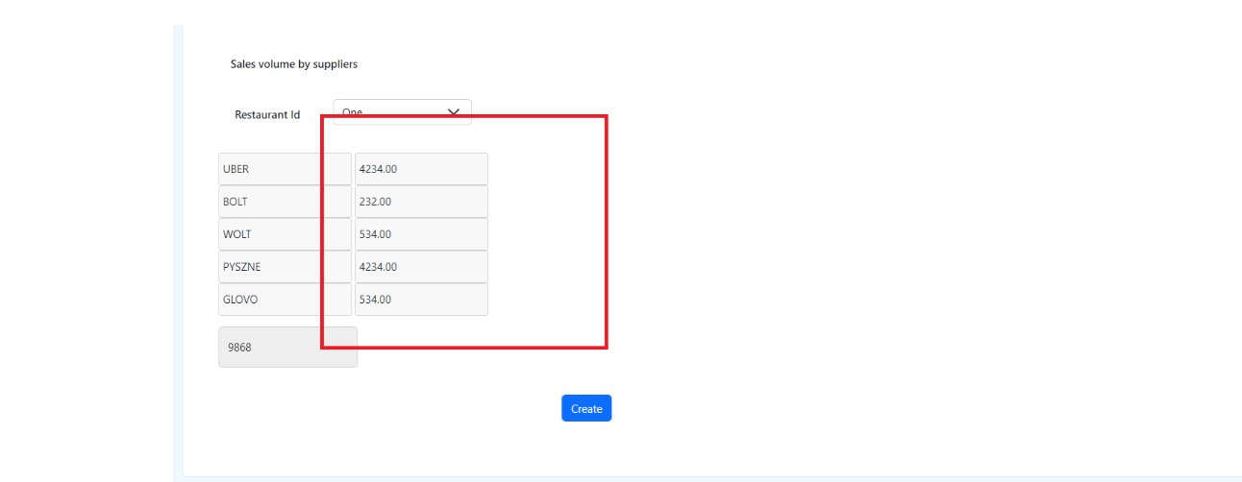

VIEW REPORT just like in instruction

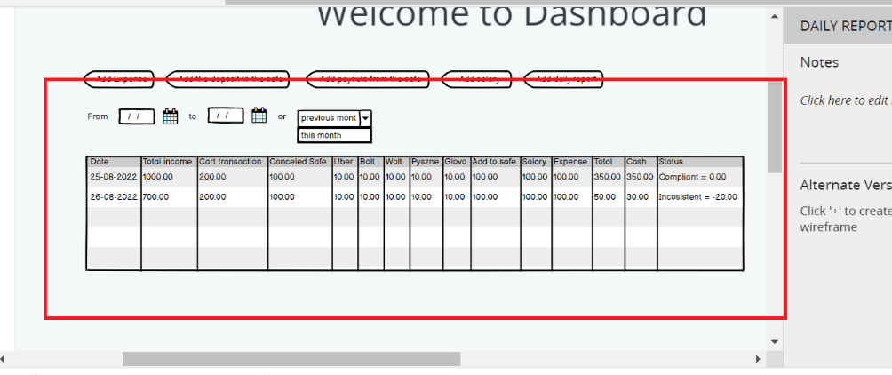

settings - for each restaurant are separate - as in the manual

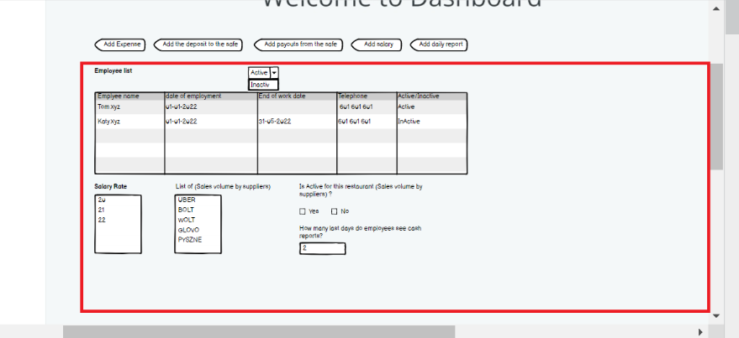

ONE MOMENT slightly smiling face emoji

add two options: - creating lists to for restuarations (each separately) - creating a shopping list for restaurants (each separately) here are the instructions and the view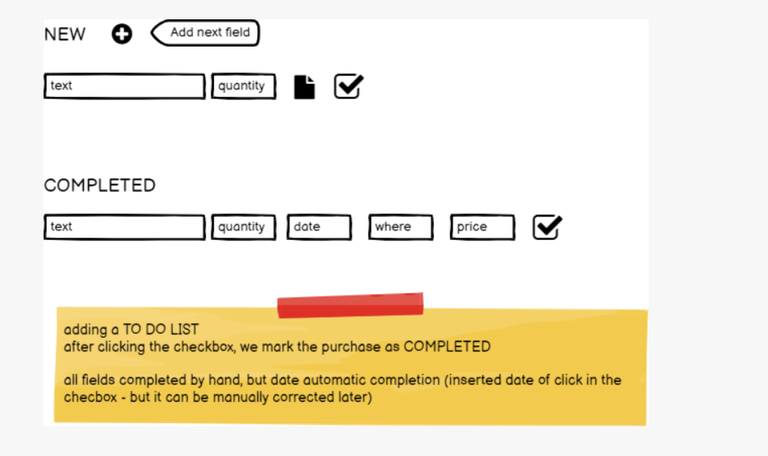

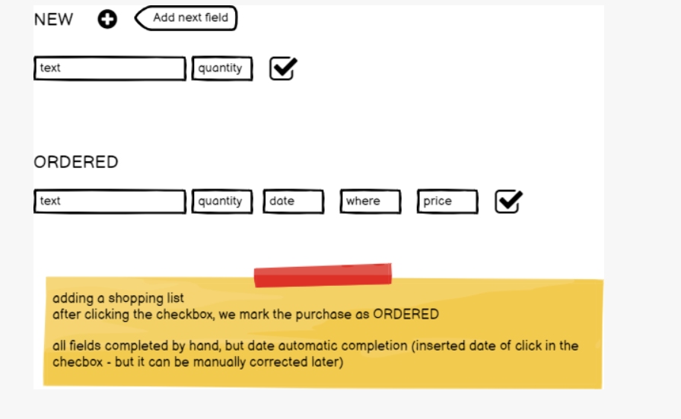

Where to add these Two Options?

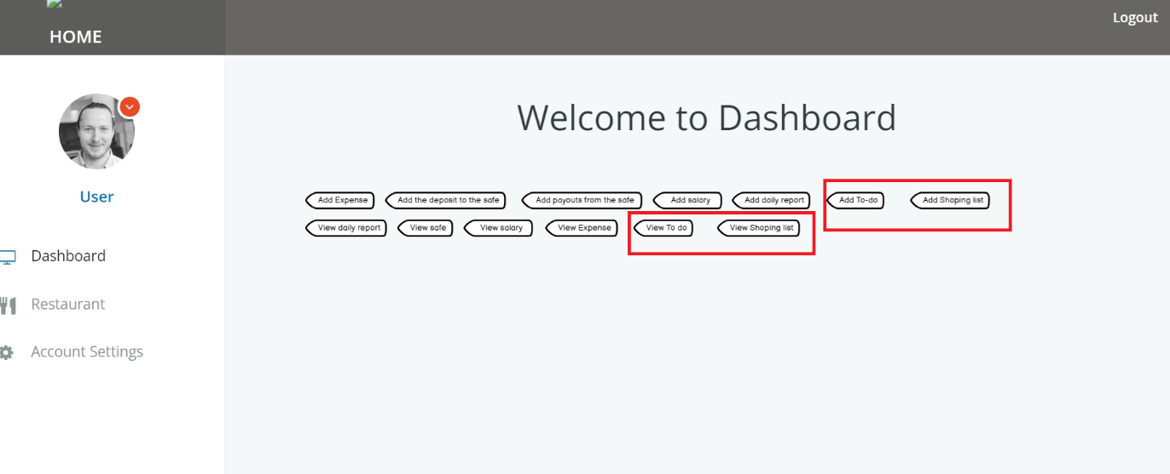

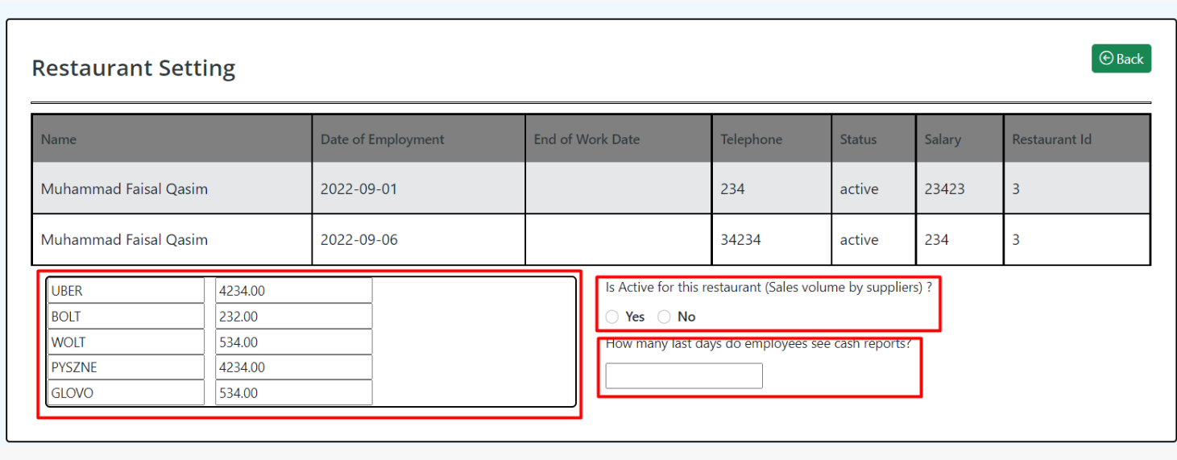

These options are separate for each restaurant. The employee has no influence on them. The staff list is different for each restaurant and options are different for each restaurant.

For each restaurant, we will do only 1 login common for all employees. One admin can see everything - and the employee login is one for one restaurant.

8:48 PM

Yes, the list of employees is separate for a each restaurant and these options are separate for each restaurant.

only admin can edit settings