**All**

1. **It is not possible to select an employee**

**add expense**

1. **When i click create with file i have screen**

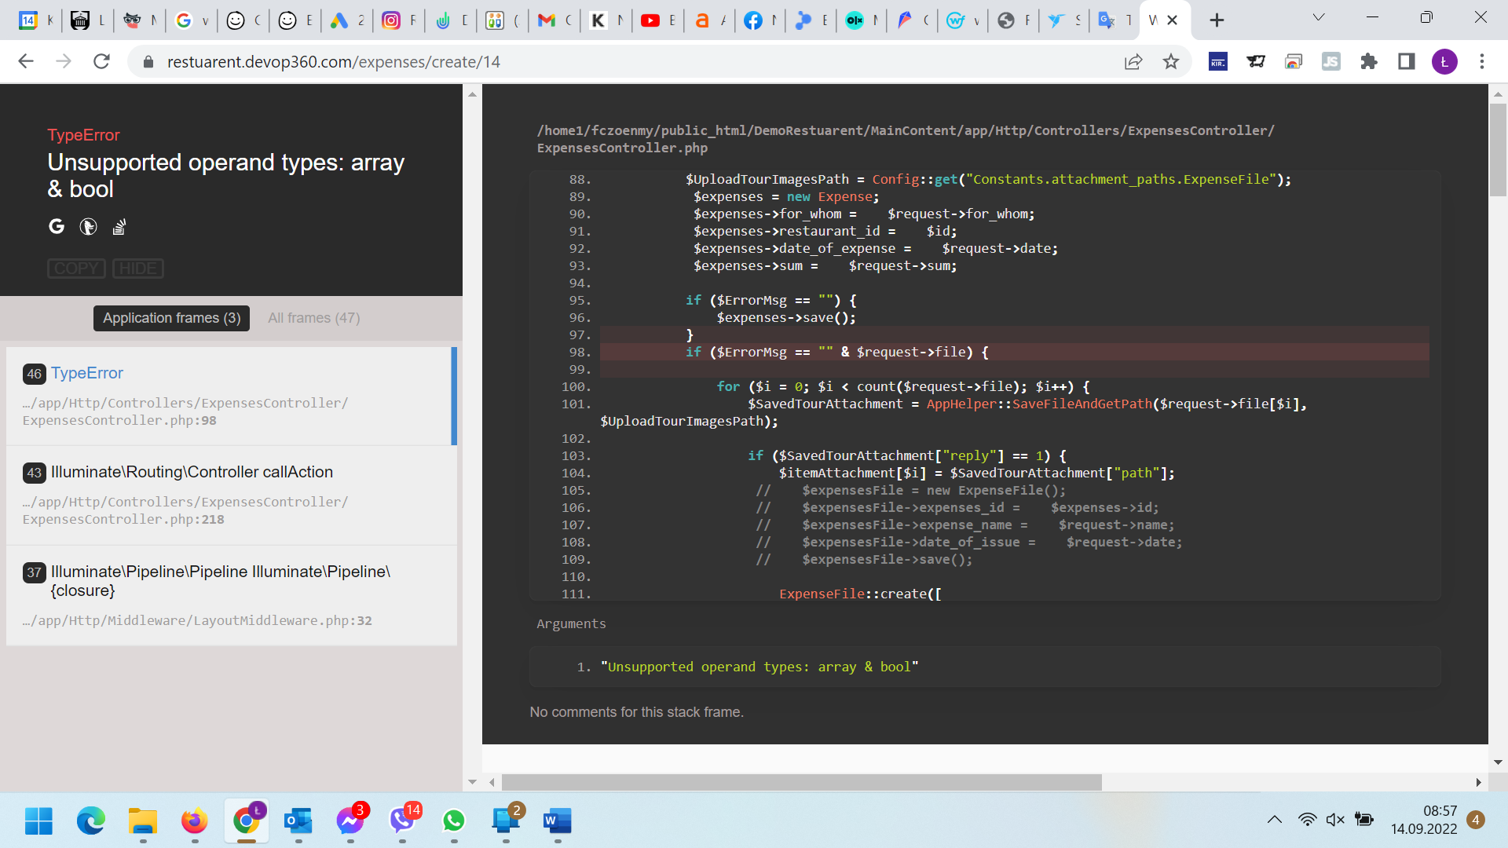

**VIEW EXPENSE/ SAFE**

1. **There is no checkbox in table (please tell what is its use or funtionality)**

**VIEW SAFE**

1. There is no option to edit or delete the added item

**CREATE MANAGE USER**

1. Add/manage new user should be in the Restaurant Setting (Employee List) section and not as separate data