**Foundation University**

**School of Science and Technology**

***Data Structure Name: Muhammad Faizan***

***Lab Manual Reg no: 074 Sec: B***

**LAB 01**

1. **Write a program to store 10 marks in an array and show 1st and 2nd highest marks on screen.**

**Code:**

#include <iostream>

using namespace std;

int main() {

int marks[10], first = 0, second = 0;

for (int i = 0; i < 10; i++) {

cin >> marks[i];

if (marks[i] > first) {

second = first;

first = marks[i];

} else if (marks[i] > second && marks[i] != first) {

second = marks[i];

}

}

cout << "1st Highest: " << first << endl;

cout << "2nd Highest: " << second << endl;

return 0;

}

**Output:**

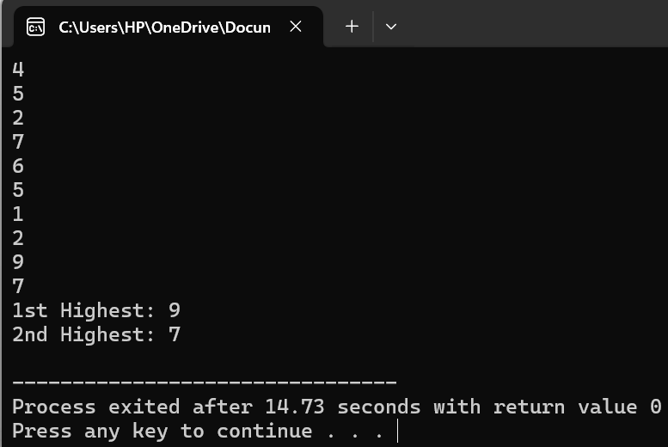

1. **Write a program to take size of an array from user and store elements in an array. Take any element from user and search either entered number exist in an array or not using binary search.**

**Code:**

#include <iostream>

#include <algorithm>

using namespace std;

int main() {

int n, key;

cout << "Enter size of array: ";

cin >> n;

int arr[n];

cout << "Enter " << n << " elements: ";

for (int i = 0; i < n; i++) {

cin >> arr[i];

}

sort(arr, arr + n);

cout << "Enter number to search: ";

cin >> key;

int low = 0, high = n - 1, mid;

bool found = false;

while (low <= high) {

mid = (low + high) / 2;

if (arr[mid] == key) {

found = true;

break;

} else if (arr[mid] < key) {

low = mid + 1;

} else {

high = mid - 1;

}

}

if (found)

cout << key << " found in array." << endl;

else

cout << key << " not found in array." << endl;

return 0;

}

**Output:**

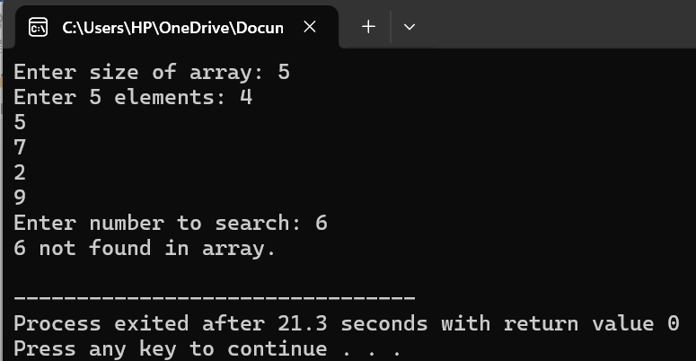

1. **Write a program to take marks of 6 subjects of students and calculate the average of his/her marks and show grades according to his/her average. E.g if the average is more than 90 show A+, more than 80 show A, more than 70 show B, more than 60 show C, more than 50 shows D otherwise show F.**

**Code:**

#include <iostream>

using namespace std;

int main() {

int marks[6];

float sum = 0, average;

for (int i = 0; i < 6; i++) {

cin >> marks[i];

sum += marks[i];

}

average = sum / 6;

if (average > 90)

cout << "Grade: A+" << endl;

else if (average > 80)

cout << "Grade: A" << endl;

else if (average > 70)

cout << "Grade: B" << endl;

else if (average > 60)

cout << "Grade: C" << endl;

else if (average > 50)

cout << "Grade: D" << endl;

else

cout << "Grade: F" << endl;

return 0;

}

**Output:**

