**Name: Muhammad Faizan**

**Roll no: 074**

**Section: B**

**DSA LAB: 04**

**Instructor: Sir Sharjeel**

**Question 1:**

**CODE:**

#include <iostream>

#include <string>

using namespace std;

int main() {

int n;

cout <<"Enter total number of antique items"<<endl;

cin >> n;

int serialNumbers[100];

cout <<"Enter serial numbers of the antique items"<<endl;

for(int i = 0; i < n; i++) {

cout << "Item " << i + 1 << ": ";

cin >> serialNumbers[i];

}

int searchSerial;

cout << "Enter the serial number of the vintage pocket watch to search"<<endl;

cin >> searchSerial;

bool found = false;

for (int i = 0; i < n; i++) {

if (serialNumbers[i] == searchSerial) {

cout <<"Pocket watch found at position " << i + 1 << " in the inventory"<<endl;

found = true;

break;

}

}

if (found) {

cout << "Pocket watch not found in the inventory"<<endl;

}

return 0;

}

**Output**:

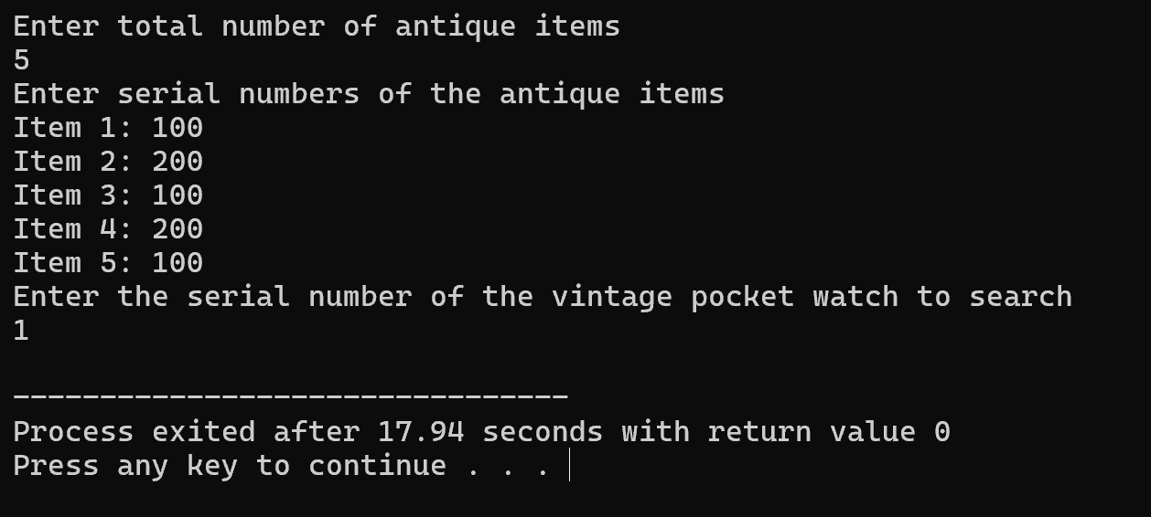

**Question 3:**

**CODE:**

#include <iostream>

#include <string>

using namespace std;

int main() {

const int n = 10;

int studentIDs[n]={10,11,17,15,20,15,30,35,14,45};

string studentNames[n] = {

"Talha","Bilal","Hanan","Shayan","Usman",

"Sanan","Ahmad","Raza","Ali","Zarar"

};

int searchID;

cout<<"Enter the student ID to search"<<endl;

cin>>searchID;

int low = 0, high = n - 1;

bool found = false;

while (low <= high) {

int mid = (low + high) / 2;

if(studentIDs[mid] == searchID) {

cout<<"Student found"<<endl;

cout<<"ID"<<studentIDs[mid]<<endl;

cout<<"Name"<<studentNames[mid]<<endl;

found = true;

break;

}

else if (studentIDs[mid] < searchID) {

low = mid + 1;

}

else {

high = mid - 1;

}

}

if (found) {

cout <<"Student with ID"<<searchID<<"not found"<<endl;

}

return 0;

}

**Output**:

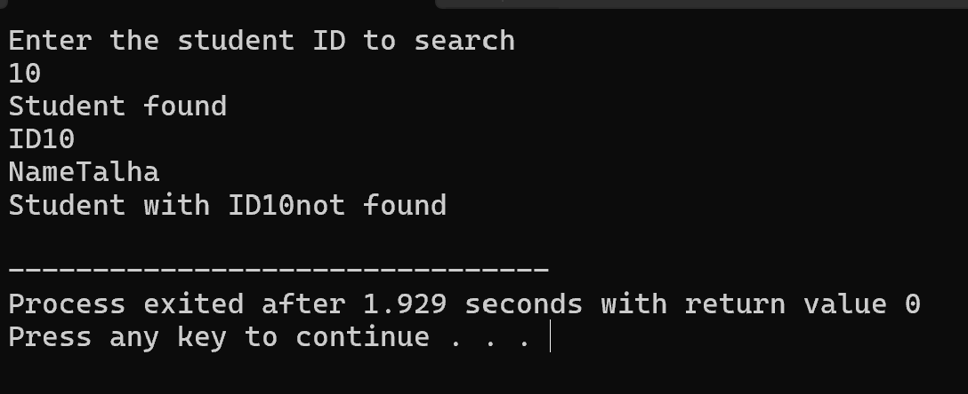

**Question 3:**

**CODE**:

#include <iostream>

using namespace std;

int main() {

const int n = 15;

int scores[n];

cout<<"Enter scores of"<< n <<"students"<<endl;

for (int i = 0; i < n; i++) {

cout << "Score of student " << i + 1 << ": ";

cin >> scores[i];

}

for (int i = 0; i < n - 1; i++) {

for (int j = 0; j < n - i - 1; j++) {

if (scores[j] > scores[j + 1]) {

int temp = scores[j];

scores[j] = scores[j + 1];

scores[j + 1] = temp;

}

}

}

cout<<"Scores arranged in ascending order"<<endl;

for (int i = 0; i < n; i++) {

cout << scores[i] << " ";

}

cout << endl;

return 0;

}

**Output:**

