**Data Structure lab:**

**Name: Muhammad Faizan**

**Reg no: 074**

***Assignment 03:***

**Question 1:**

#include <iostream>

using namespace std;

#define SIZE 5

int queue[SIZE];

int front = -1, rear = -1;

void Enqueue() {

if (rear == SIZE - 1) {

cout << "Queue is full!\n";

return;

}

int value;

cout << "Enter a number: ";

cin >> value;

if (front == -1) front = 0;

rear++;

queue[rear] = value;

cout << value << " added to queue.\n";

}

void Dequeue() {

if (front == -1 || front > rear) {

cout << "Queue is empty!\n";

return;

}

cout << queue[front] << " removed from queue.\n";

front++;

}

void Display() {

if (front == -1 || front > rear) {

cout << "Queue is empty!\n";

return;

}

cout << "Queue: ";

for (int i = front; i <= rear; i++)

cout << queue[i] << " ";

cout << endl;

}

int main() {

int choice;

do {

cout << "\n=== Queue Menu ===\n";

cout << "1. Enqueue\n";

cout << "2. Dequeue\n";

cout << "3. Display\n";

cout << "4. Exit\n";

cout << "Enter choice: ";

cin >> choice;

if (choice == 1) Enqueue();

else if (choice == 2) Dequeue();

else if (choice == 3) Display();

else if (choice == 4) cout << "Goodbye!\n";

else cout << "Invalid choice! Try again.\n";

} while (choice != 4);

return 0;

}

**Output:**

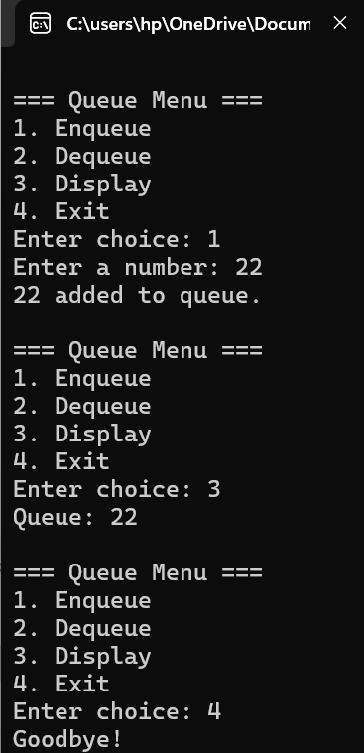

**Question 2:**

#include <iostream>

#include <queue>

#include <sstream>

using namespace std;

int main() {

string input;

cout << "Enter a string: ";

getline(cin, input);

stringstream ss(input);

string word;

int qNum = 1;

while (ss >> word) {

queue<char> q;

for (char c : word) {

q.push(c);

}

cout << "Q" << qNum << " = ";

while (!q.empty()) {

cout << q.front();

q.pop();

if (!q.empty())

cout << " → ";

}

cout << endl;

qNum++;

}

return 0;

}

**Output:**

