Dashboards for Clicker Data
  - INFO 4100 Learning Analytics
[[Team Night Owl, Kayla Runkel (kmr227), Gianna Ou (gyo4), Shiwen Zhao (sz752), Theo Berk (tb547), Maisha Farzana (maf372), and Steven Xie (jx453)]]
This project is about developing a learning analytics dashboard based on clicker data. You will work as a team to learn how to make a dashboard using R Shiny (official page with several tutorials: https://shiny.rstudio.com/tutorial/).
Learning Objectives
- Understand the structure of clicker data
- Create multiple different visualizations
- Design and implement an instructor and student dashboard
- Critically evaluate your own dashboard design
You are given aggregated clicker records for a CS course taught at Cornell. There are two datasets: the experience dataset and the quiz dataset.
Scenario
You are approached by a college instructor who uses iClickers in her CS class on Business Intelligence. She would like to gain insights about her students and how they are engaging/performing in order to better help them in class. She would also like to better support students by giving them feedback at scale about where they stand and perhaps how they compare to others in the class.
You offer to build a prototype of a dashboard using her clicker data: this is a dashboard for the instructor which offers an overview of the class characteristics, engagement, and performance; and it is a dashboard for students which offers a specific student an overview of their engagement and performance (and how it compares to others).
Data
The experience dataset contains one record per student who completed the CS course between 2016-2018. There are two sources to this dataset: Faculty Center and a Skills Survey (administered via the Blackboard LMS) where students self reported their skill level for various skills the first week of class. This data has been de-identified. Name, netid, emplid, major have all been removed and replaced with a unique numeric identifier. Note that not all students completed the skills survey, they will have null values for the survey result fields.
Attribute Name | Data Type | Definition
student_key | numeric Unique key | Assigned as part of de-identification process. Uniquely identifies student records for this data set only.
year | numeric | Four digit year student was enrolled in BI Class.
prog | character Values (GRAD, UGRAD) | Indicates whether the student was a graduate or undergraduate student when they were enrolled in BI course.
database_score | numeric (0-5) | Self reported experience level with database technology prior to taking course. 0= no experience, 5= expertise
sql_score | numeric (0-5) | Self reported experience level with SQL prior to taking course. 0= no experience, 5=expertise
programing_score | numeric (0-5) | Self reported experience level with Any Programing language prior to taking course. 0=no experience, 5=expertise
stored_proc_score | numeric (0-5) | Self reported experience level with stored procedure languages prior to taking course. 0=no experience, 5=expertise
etl_score | numeric (0-5) | Self reported experience level with Extract Transform Load (ETL) development prior to taking course. 0=no experience, 5=expertise
data_vis_score | numeric (0-5) | Self reported experience level using data visualization tools prior to taking course. 0=no experience, 5=expertise
requirement_gather_score | numeric (0-5) | Self reported experience level gathering customer requirements prior to taking course. 0=no experience, 5=expertise
skill_survey_score | numeric | Sum of the self reported skill level scores.
The quiz dataset contains one record per student per class session held where iClickers were used. Sources used in the creation of this data set include: iClicker session xml files, Blackboard gradebook (for quiz scores), and the Blackboard class schedule (used to map iClicker session to related quiz scores). Note that in some cases there are multiple iClicker sessions / lectures associated with a single quiz. This dataset may be joined to the experience dataset by the student_key field.
Attribute Name | Data Type | Definition
Acad_date_key | numeric | Date key in the form of YYYYMMDD indicating the date the class session was held.
student_key | numeric | Unique identifier for students who took BI class 2016-2018. This key is the primary key for the experience_data file.
year | numeric | Four digit year class session was held.
session_number | numeric | Identifies the session number for a particular semester. Session number is assigned by iClicker.
quiz_number | numeric | There are 10 quizzes throughout the BI course. This attribute indicates which quiz is associated with the iClicker session(s).
attended | numeric (0,1) | Binary indicating whether the student attended that particular class session / lecture. 0=no, 1=yes.
total_possible_clicker | numeric | The total number of iClicker questions asked that session.
total_completed_clicker | numeric | The number of iClicker questions answered by student that session.
completed_q_clicker | numeric | The number of completed Quiz iClicker questions
correct_q_clicker | numeric | How many correct Quiz answers by student that session.
completed_t_clicker | number | How many Temperature questions answered by student that session. Temperature questions are 0-5, 0= bad, 5=great. There is no correct answer to Temperature questions, they are used to guage how students are feeling about a particular subject, assignment, etc.
avg_t_clicker | number | The average temperature answer by student for that session. An average of 1 or 2 would be generally negative, while 4 or 5 would be generally positive responses.
quiz_score | numeric | Quiz score out of 20 points possible.

Part 1: Planning / Sketching
Go through the planning / sketching process described in the reading about dashboards. While some dashboards are certainly better than others, there is not one correct solution here. However, spending enough time to make a concrete plan is essential for the success of your project. Everything you do to make the dashboards will be easier if you have a clear plan, especially because you will be splitting up the work and everyone needs to know what they should work on.
Question 1: You will make a student dashboard and a teacher dashboard. Carefully consider the implications of this for design and content. To plan, answer the following prompts once for the student dashboard and then for the teacher dashboard. The more concrete you are here the easier it will be later. Focus on the concrete ideas that you will implement in the next steps. You can iterate on this step and modify your responses as your ideas for the dashboard become clearer. You should explore the dataset in R for 5-10 minutes to get a good sense of what the dataset has to offer.
Planning for the student dashboard
- For whom? Who will use it and what is their background?
- The primary users will be undergraduate students enrolled in the BI course. These students will have have varying levels of prior experience (as captured by the skill_survey_score), ranging from beginners to more experienced learners. They are not expected to have advanced data analysis skills, so the dashboard must be intuitive, visually clear, and focused on personal performance insights. Additionally, students are likely to use this dashboard periodically (e.g., before quizzes or exams), so it should emphasize quick interpretation rather than deep technical exploration.
- Why? What is the goal? What questions to answer?
- The goal of the student dashboard is to support self-reflection, performance tracking, and behavioral awareness. It helps students understand how their engagement and perceptions relate to their outcomes.
Key questions include:
- How am I performing relative to the class?
- Is my quiz performance improving or declining over time?
- How does my engagement or “temperature” relate to my understanding?
- How does my prior experience (survey score) relate to my performance?
- Am I participating consistently in class activities?
- What? What data to show and what is its structure?
- For the student dashboard, the data will show combines of both the experience dataset and the quiz (iClicker) dataset to provide a personalized view of a student’s engagement and performance over time. The underlying structure is a longitudinal (panel) dataset, where each row represents a single student’s interaction in a specific class session. This allows the dashboard to track how an individual student’s behavior evolves across the semester.
- Key variables will include performance measures such as quiz_score and clicker accuracy (correct_q_clicker out of completed_q_clicker), engagement indicators like attendance and clicker participation rates (total_completed_clicker relative to total_possible_clicker), and sentiment data through avg_t_clicker, which captures how the student feels about the material. These are paired with background characteristics from the experience dataset, such as skill_survey_score and its components, to contextualize performance. In addition to individual-level data, the dashboard incorporates class-level aggregates, such as average quiz scores and score distributions, so that students can compare their performance to peers.
- How? How will visualizations support the goal?
- The selected visualizations will directly map to student decision-making with:
- Histogram of average class quiz grades + student marker
Helps students contextualize their performance within the distribution (norm-referenced understanding).
- Line plot of individual quiz scores over time
Reveals trends (improvement, stagnation, decline), encouraging behavioral adjustments.
- Line chart of avg_t_clicker over time
Allows students to reflect on how their perceived understanding evolves and whether confusion predicts lower performance.
- Histogram of completed_t_clicker
Highlights participation levels and whether a student is under-engaging compared to the class.
Planning for the teacher dashboard
- For whom? Who will use it and what is their background?
- The teacher dashboard is mainly meant for the professor of the Business Intelligence class. It could also provide insight to TAs who may be working with students to help improve that student’s performance in the class. Currently, the professor has access to the students’ self reported skill level for a variety of skills that will appear in the class and the results from each iClicker session during lecture. The problem is that this data provides no use when it’s not in an interpretable form that the professor can digest and find patterns between the teaching and the students’ understanding.
- Why? What is the goal? What questions to answer?
- The goal is for the professor of the BI class to gain insights about the students of the class and how they are engaging and performing in the class. With that information, the professor hopes to be able to better help the students in class. If the professor understands the performance of her class, she can also provide feedback about where her students stand in relation to other students in the class.
- What? What data to show and what is its structure?
- The dashboard will include fast facts like the classes average quiz score and average attendance. It will also combine both the experience dataset and the quiz (iClicker) dataset in visualizations that display how students are performing in the class and how statistics like attendance and performance might change across the different weeks. By combining the two datasets, we can display how previous experience might affect a student’s learning in the course. By analyzing the data across the weeks, the professor can understand where students might struggle or if there needs to be extra steps to ensure student participation and engagement.
- The combined dataset will contain one record per student per class session (sometimes multiple per lecture). There will likely be visualizations where we aggregate data by lecture. The experience data will be joined onto the quiz data. For the teacher dashboard, some of the key variables with include skill_survery_score for comparing the impact that prior experience has on a student’s performance, quiz_score to compare performance across all students, and avg_t_clicker to understand the students’ comfortability each lecture.
- How? How will visualizations support the goal?
- The selected visualizations will provide insights on class performance and engagement:
- • Lineplot of class attendance overtime compared for different levels of prior experience
- Allows the professor to understand which students are coming to class and how prior experience affects engagement.
- • Histogram of average class quiz grades
- Gives an understanding of how well students tend to perform on the iClicker questions in class.
- • Lineplot of avg_t_clicker scores across each week for the whole class
- Exposes what material might be more difficult or be harder for students to understand.
- • Scatterplot of survery scores versus average quiz scores with a line of best fit
- Highlights how overall class performance may be skewed by prior skill experience.
Question 2: Based on your plan above, make a sketch of what the dashboard would look like. See this week’s readings for examples. Be detailed about what kinds of data points and visualizations you want to see in different parts of the page. Consider the user experience and how you should position more general information compared to more specific information, and where you may need some additional explanation to help the viewer understand a graphic, for example. In your sketch, it is useful to give labels to different objects, because in the steps below you can split up work between team members and the labels will help you connect the UI with the data objects. Show your sketches in section to get feedback from the teaching team.
Each dashboard should contain at least 4 data visualizations. You may include any additional summary statistics (e.g. key percentages or tables).
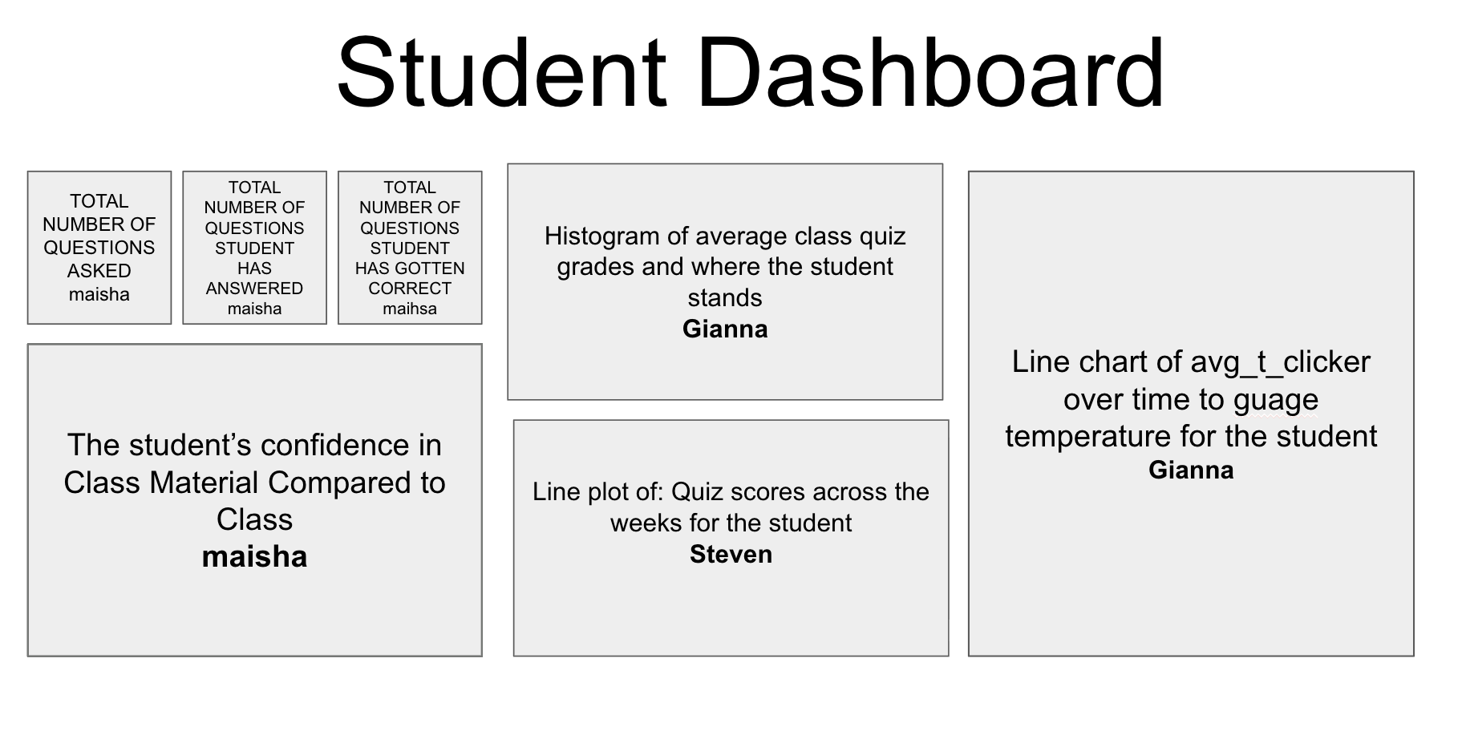
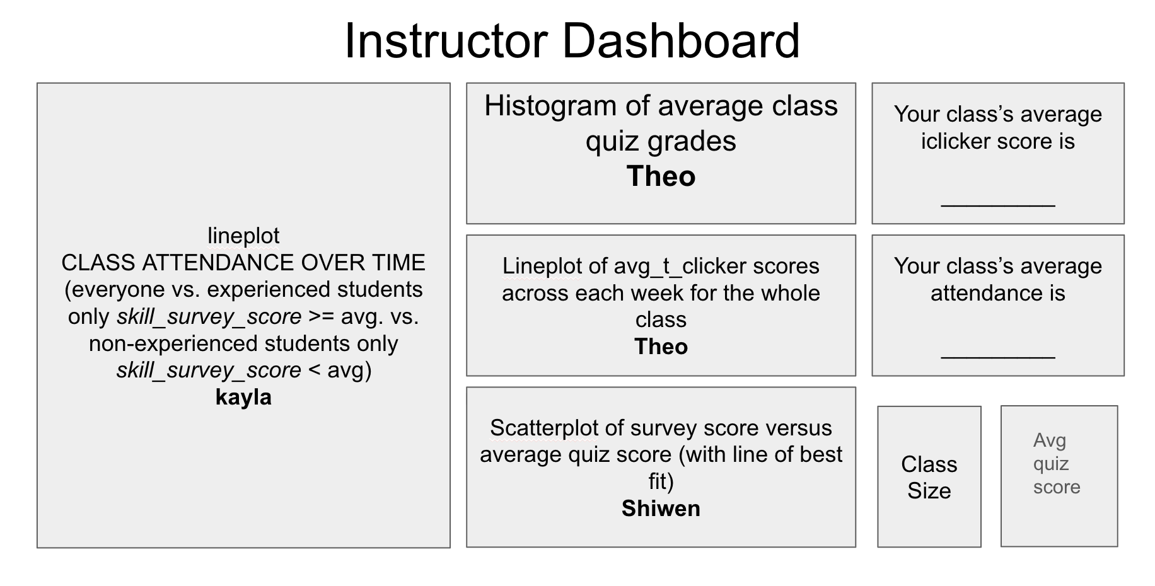

Part 2: Dashboard Wire-frame Implementation
This is where you generate the dashboard layout. You are given a very basic wire frame example for the dashboard below. For more information on how R Shiny Dashboards work, look at https://rstudio.github.io/shinydashboard/get_started.html and https://rstudio.github.io/shinydashboard/structure.html. You can add different types of content into a fuidRow(). In the starter code, there are 2 rows of content: the first has two little info boxes; the second has two larger viz boxes. You can add more rows and change what is in them as you wish. Follow the naming convention, e.g. inst.info1 is the first info box for instructors.
Your team can split up the tasks. Some work on creating the UI (this part), while others work on pre-processing the data and creating the statistics and visualizations that will populate the UI (next part).
Question 3: Create the layout for the dashboard tabs. You can have as many “tabs” as you like. Each tab is the content displayed when the user clicks on one of the menu items (so it is the page content). Here you are just specifying the wire frame i.e. what goes where on the pages, not what goes into it.
#######################################
####### BEGIN INPUT: Question 3 #######
#######################################
# Example of a tab (i.e. page)
instructor_dash = tabItem(
tabName = "instructor",
h2("Instructor Dashboard"),
# Dynamic infoBoxes
# fluidRow(
# infoBoxOutput("attendance_across_lecture"),
# infoBoxOutput("inst.info2")
# ),
# visualizations
fluidRow(
column(
width = 8,
box(
title = "Class Attendance by Lecture (by Skill Level)",
width = 12,
plotOutput("attendance_across_lecture", height = 250)
),
box(
title = "Avg Quiz Score per Student",
width = 12,
plotOutput("inst_quiz_hist", height = 250)
),
box(
title = "Class Temperature Across Lectures",
width = 12,
plotOutput("inst_temp_weekly", height = 250)
),
box(
title = "Survey Score vs Average Quiz Score",
width = 12,
plotOutput("survey_vs_quiz", height = 250)
)
),
column(
width = 4,
infoBoxOutput("percent_clicker_correct", width = 12),
infoBoxOutput("average_quiz_score", width = 12),
infoBoxOutput("average_attendance", width = 12),
infoBoxOutput("class_size", width = 12)
)
)
)
# Another empty tab
student_dash = tabItem(
tabName = "student",
h2("Student Dashboard"),
fluidRow(
selectInput("student_id", "Select Student",
choices = sort(unique(quiz$STUDENT_KEY)),
selected = 105)
),
fluidRow(
box(
title = "Your Average Quiz Score vs Class",
width = 12,
plotOutput("student_hist")
)
),
fluidRow(
box(
title = "Your Temperature (Engagement) Over Time",
width = 12,
plotOutput("student_temp_trend")
)
),
fluidRow(
box(
title = "Your Confidence in Class Material Compared to Class",
width = 12,
plotOutput("temp_clicker")
)
),
fluidRow(
box(
title = "Your Quiz Scores Over Time",
width = 12,
plotOutput("student_quiz_trend")
)
),
fluidRow(
infoBoxOutput("total_asked", width = 4),
infoBoxOutput("total_answered", width = 4),
infoBoxOutput("total_correct", width = 4)
),
fluidRow(
infoBoxOutput("weeks_above_avg", width = 12)
)
)
#######################################
#######################################

Part 3: Data Pre-processing
Get the data ready for use in the dashboard. Before the next stage, you want to have the data ready in the right format for simple computations and plotting. To do this effectively, you need to know by now what you want to display in each dashboard. However, this is also an iterative process. Once you have completed a first iteration of the design, you can come back to this step and add further pre-processing for more visualizations you like to add. This step is also an opportunity to better understand the structure of the datasets.
The instructor dashboard should show information for all students. The student dashboard is typically focused on an individual student. You can either pick a student (at random or intentionally) and use them as the “reference student” for the student dashboard. Or, a bit more ambitious but also more rewarding to try out, you can create an interactive dashboard in which you select the student and then the dashboard updates to show the information for that student. I would recommend you start with the simpler version and get that to work before you try to make it dynamic.
Use the space below to be ready for your information visualizations in the dashboards.
#######################################
####### BEGIN INPUT #######
#######################################
# combine quiz and experience datasets by STUDENT_KEY and YEAR
df <- left_join(quiz, experience, by = c("STUDENT_KEY", "YEAR"))
head(df)
## ACAD_DATE_KEY STUDENT_KEY YEAR SESSION_NUMBER QUIZ_NUMBER ATTENDED
## 1 20170905 105 2017 8 3 1
## 2 20170912 32 2017 10 4 1
## 3 20170825 68 2017 5 1 1
## 4 20180906 103 2018 5 4 1
## 5 20170824 68 2017 2 1 1
## 6 20170914 12 2017 12 4 1
## TOTAL_POSSIBLE_CLICKER TOTAL_COMPLETED_CLICKER COMPLETED_Q_CLICKER
## 1 5 4 4
## 2 2 1 1
## 3 1 1 0
## 4 6 3 1
## 5 3 2 3
## 6 4 4 2
## CORRECT_Q_CLICKER COMPLETED_T_CLICKER AVG_T_CLICKER QUIZ_SCORE PROG
## 1 3 1 4.0 20 GRAD
## 2 0 0 0.0 20 UGRAD
## 3 0 1 2.0 18 GRAD
## 4 0 2 3.0 17 GRAD
## 5 0 0 0.0 18 GRAD
## 6 0 2 2.5 17 GRAD
## DATABASE_SCORE SQL_SCORE PROGRAMING_SCORE STORED_PROC_SCORE ETL_SCORE
## 1 1 1 3 0 1
## 2 NA NA NA NA NA
## 3 1 1 2 1 1
## 4 3 4 4 3 4
## 5 1 1 2 1 1
## 6 NA NA NA NA NA
## DATA_VIS_SCORE REQUIREMENT_GATHER_SCORE SKILL_SURVEY_SCORE
## 1 0 0 6
## 2 NA NA NA
## 3 0 0 6
## 4 2 0 20
## 5 0 0 6
## 6 NA NA NA
# creates dataframe grouped by lecture
# for some lectures, there are multiple iClicker sessions
# the grouping combines the sessions into one per lecture
df_by_lecture <- df %>%
group_by(STUDENT_KEY,
ACAD_DATE_KEY,
YEAR,
QUIZ_NUMBER,
ATTENDED,
PROG,
DATABASE_SCORE,
SQL_SCORE,
PROGRAMING_SCORE,
STORED_PROC_SCORE,
ETL_SCORE,
DATA_VIS_SCORE,
REQUIREMENT_GATHER_SCORE,
SKILL_SURVEY_SCORE) %>%
summarise(SESSION_NUMBER = min(SESSION_NUMBER),
TOTAL_POSSIBLE_CLICKER = sum(TOTAL_POSSIBLE_CLICKER),
TOTAL_COMPLETED_CLICKER = sum(TOTAL_COMPLETED_CLICKER),
COMPLETED_Q_CLICKER = sum(COMPLETED_Q_CLICKER),
CORRECT_Q_CLICKER = sum(CORRECT_Q_CLICKER),
COMPLETED_T_CLICKER = sum(COMPLETED_T_CLICKER),
AVG_T_CLICKER = mean(AVG_T_CLICKER),
QUIZ_SCORE = mean(QUIZ_SCORE, na.rm = TRUE)) %>%
arrange(STUDENT_KEY, ACAD_DATE_KEY)
## `summarise()` has grouped output by 'STUDENT_KEY', 'ACAD_DATE_KEY', 'YEAR',
## 'QUIZ_NUMBER', 'ATTENDED', 'PROG', 'DATABASE_SCORE', 'SQL_SCORE',
## 'PROGRAMING_SCORE', 'STORED_PROC_SCORE', 'ETL_SCORE', 'DATA_VIS_SCORE',
## 'REQUIREMENT_GATHER_SCORE'. You can override using the `.groups` argument.
# since we combined sessions where there were multiple per lecture,
# let's add a field to indicate each lecture by number
# LECTURE_NUMBER
df_by_lecture <- df_by_lecture %>%
group_by(STUDENT_KEY) %>%
arrange(SESSION_NUMBER, .by_group = TRUE) %>%
mutate(LECTURE_NUMBER = row_number()) %>%
ungroup()
head(df_by_lecture)
## # A tibble: 6 × 23
## STUDENT_KEY ACAD_DATE_KEY YEAR QUIZ_NUMBER ATTENDED PROG DATABASE_SCORE
## <int> <int> <int> <int> <int> <chr> <int>
## 1 1 20180828 2018 1 1 UGRAD 1
## 2 1 20180830 2018 2 1 UGRAD 1
## 3 1 20180904 2018 3 1 UGRAD 1
## 4 1 20180906 2018 4 1 UGRAD 1
## 5 1 20180911 2018 5 0 UGRAD 1
## 6 1 20180918 2018 6 1 UGRAD 1
## # ℹ 16 more variables: SQL_SCORE <int>, PROGRAMING_SCORE <int>,
## # STORED_PROC_SCORE <int>, ETL_SCORE <int>, DATA_VIS_SCORE <int>,
## # REQUIREMENT_GATHER_SCORE <int>, SKILL_SURVEY_SCORE <int>,
## # SESSION_NUMBER <int>, TOTAL_POSSIBLE_CLICKER <int>,
## # TOTAL_COMPLETED_CLICKER <int>, COMPLETED_Q_CLICKER <int>,
## # CORRECT_Q_CLICKER <int>, COMPLETED_T_CLICKER <int>, AVG_T_CLICKER <dbl>,
## # QUIZ_SCORE <dbl>, LECTURE_NUMBER <int>
#######################################
#######################################

Part 4: Prepare All Data Visualizations
This is where you create the content for the wire frames you created above. Again, you can refer to the examples and documentation in https://rstudio.github.io/shinydashboard/get_started.html and https://rstudio.github.io/shinydashboard/structure.html for guidance. You can also find many examples online just by searching with Google.
Question 4: For each of the pieces of content you planned for in the wire frames above, generate the relevant content. You need to assign them all to the output variable by referencing the name of the wire frame element you chose above like this output$name.of.element.
server = function(input, output) {
#######################################
####### BEGIN INPUT: Question 4 #######
#######################################
output$inst.info1 = renderInfoBox({
infoBox("Students total",
length(unique(quiz$STUDENT_KEY)),
icon = icon("list"), color = "purple")
})
output$inst.info2 = renderInfoBox({
infoBox("Attendance",
paste0(round(100 * mean(quiz$ATTENDED)), "%"),
icon = icon("list"), color = "yellow")
})
output$inst.plot1 = renderPlot({
hist(quiz$QUIZ_SCORE)
})
output$student_temp_trend = renderPlot({
student_data <- df_by_lecture %>%
filter(STUDENT_KEY == input$student_id)
ggplot(student_data, aes(x = LECTURE_NUMBER, y = AVG_T_CLICKER)) +
geom_line(color = "#2C7FB8", size = 1.5) +
geom_point(color = "#2C7FB8", size = 2) +
labs(
title = paste("Temperature Trend for Student", input$student_id),
x = "Lecture Number",
y = "Average Temperature (0–5)"
) +
ylim(0, 5) +
theme_classic()
})
# Steven (jx453): Line plot of quiz scores across the weeks of the
# semester for the selected student, with the class average overlaid so
# the student can see how they track against the class week by week.
output$student_quiz_trend = renderPlot({
# selected student's quiz scores, indexed by week of semester
student_quiz <- df_by_lecture %>%
filter(STUDENT_KEY == input$student_id, !is.na(QUIZ_SCORE)) %>%
mutate(LECTURE_DATE = as.Date(as.character(ACAD_DATE_KEY),
format = "%Y%m%d")) %>%
group_by(QUIZ_NUMBER) %>%
summarise(
LECTURE_DATE = min(LECTURE_DATE),
quiz_score = first(QUIZ_SCORE),
.groups = "drop"
) %>%
arrange(LECTURE_DATE) %>%
mutate(WEEK_OF_SEMESTER = as.numeric(
difftime(LECTURE_DATE, min(LECTURE_DATE), units = "weeks")
) + 1)
# class average per quiz for the same cohort year
student_year <- df_by_lecture %>%
filter(STUDENT_KEY == input$student_id) %>%
pull(YEAR) %>%
first()
class_quiz <- df_by_lecture %>%
filter(YEAR == student_year, !is.na(QUIZ_SCORE)) %>%
group_by(QUIZ_NUMBER) %>%
summarise(class_avg = mean(QUIZ_SCORE, na.rm = TRUE), .groups = "drop")
plot_data <- student_quiz %>%
left_join(class_quiz, by = "QUIZ_NUMBER")
# highlight the best and worst week for quick self-reflection
best_week <- plot_data %>% slice_max(quiz_score, n = 1, with_ties = FALSE)
worst_week <- plot_data %>% slice_min(quiz_score, n = 1, with_ties = FALSE)
ggplot(plot_data, aes(x = WEEK_OF_SEMESTER)) +
geom_line(aes(y = class_avg, color = "Class Avg"),
linewidth = 1, linetype = "dashed") +
geom_line(aes(y = quiz_score, color = "You"), linewidth = 1.5) +
geom_point(aes(y = quiz_score, color = "You"), size = 3) +
# best/worst week markers
geom_point(data = best_week, aes(y = quiz_score),
color = "#2CA02C", size = 5.5,
shape = 21, fill = "white", stroke = 2) +
geom_point(data = worst_week, aes(y = quiz_score),
color = "#D62728", size = 5.5,
shape = 21, fill = "white", stroke = 2) +
geom_text(data = best_week,
aes(y = quiz_score,
label = paste0("Best: ", round(quiz_score, 1))),
color = "#2CA02C", vjust = -1.2, fontface = "bold", size = 3.5) +
geom_text(data = worst_week,
aes(y = quiz_score,
label = paste0("Worst: ", round(quiz_score, 1))),
color = "#D62728", vjust = 2, fontface = "bold", size = 3.5) +
scale_color_manual(
name = "",
values = c("You" = "#2C7FB8", "Class Avg" = "#C97FA1")
) +
scale_y_continuous(limits = c(0, 20)) +
scale_x_continuous(breaks = scales::pretty_breaks()) +
labs(
title = paste("Quiz Scores Across the Weeks — Student",
input$student_id),
x = "Week of Semester",
y = "Quiz Score (out of 20)"
) +
theme_classic()
})
output$student_hist = renderPlot({
# average quiz score per student
avg_quiz_by_student <- df_by_lecture %>%
group_by(STUDENT_KEY) %>%
summarise(avg_quiz = mean(QUIZ_SCORE, na.rm = TRUE))
# selected student value
student_avg <- avg_quiz_by_student %>%
filter(STUDENT_KEY == input$student_id) %>%
pull(avg_quiz)
# class average
class_avg <- mean(avg_quiz_by_student$avg_quiz, na.rm = TRUE)
# max x value for positioning labels
max_x <- max(avg_quiz_by_student$avg_quiz, na.rm = TRUE)
ggplot(avg_quiz_by_student, aes(x = avg_quiz)) +
geom_histogram(binwidth = 4, fill = "#BCD8EC", color = "black") +
# vertical lines
geom_vline(xintercept = student_avg,
color = "blue",
size = 1.5) +
geom_vline(xintercept = class_avg,
color = "red",
linetype = "dashed",
size = 1.2) +
# labels on the right side
annotate("text",
x = max_x + 5,
y = Inf,
label = paste("You (", input$student_id, "): ", round(student_avg,1), sep = ""),
hjust = 0,
vjust = 2,
color = "blue",
fontface = "bold") +
annotate("text",
x = max_x + 5,
y = Inf,
label = paste("Class Avg: ", round(class_avg,1)),
hjust = 0,
vjust = 4,
color = "red",
fontface = "bold") +
labs(
title = "Distribution of Average Quiz Scores",
x = "Average Quiz Score",
y = "Number of Students"
) +
coord_cartesian(xlim = c(0, max_x + 15), clip = "off") +
theme_classic() +
theme(
plot.margin = margin(10, 80, 10, 10)
)
})
output$inst_quiz_hist = renderPlot({
student_avg_quiz <- df_by_lecture %>%
filter(!is.na(QUIZ_SCORE)) %>%
group_by(STUDENT_KEY) %>%
summarize(avg_quiz = mean(QUIZ_SCORE, na.rm = TRUE), .groups = "drop")
ggplot(student_avg_quiz, aes(x = avg_quiz)) +
geom_histogram(binwidth = 1, fill = "#BCD8EC", color = "white") +
labs(
title = "Distribution of Average Quiz Scores per Student",
subtitle = paste0("n = ", nrow(student_avg_quiz), " students"),
x = "Average Quiz Score (out of 20)",
y = "Number of Students"
) +
theme_classic()
})
output$inst_temp_weekly = renderPlot({
weekly_temp <- df_by_lecture %>%
filter(!is.na(AVG_T_CLICKER), LECTURE_NUMBER < 21) %>%
group_by(LECTURE_NUMBER) %>%
summarize(class_avg_t = mean(AVG_T_CLICKER, na.rm = TRUE), .groups = "drop")
ggplot(weekly_temp, aes(x = LECTURE_NUMBER, y = class_avg_t)) +
geom_line(color = "#2C7FB8", linewidth = 1) +
geom_point(color = "#2C7FB8", size = 2) +
scale_y_continuous(limits = c(0, 5)) +
scale_x_continuous(breaks = seq(1, 20, by = 1)) +
labs(
title = "Class Average Temperature by Lecture",
subtitle = "0 = negative, 5 = positive",
x = "Lecture Number",
y = "Class Average Temperature"
) +
theme_classic()
})
output$attendance_across_lecture = renderPlot({
# to compare class attendance per lecture,
# we need to group the data by lecture
attendance_per_lecture <- df_by_lecture %>%
group_by(LECTURE_NUMBER) %>%
summarise(TOTAL_AVG_ATTENDANCE = mean(ATTENDED))
avg_skill_survery_score <- mean(df_by_lecture$SKILL_SURVEY_SCORE, na.rm = TRUE)
less_skilled_attendance_per_lecture <- df_by_lecture %>%
filter(SKILL_SURVEY_SCORE < avg_skill_survery_score) %>%
group_by(LECTURE_NUMBER) %>%
summarise(LESS_SKILLED_AVG_ATTENDANCE = mean(ATTENDED))
more_skilled_attendance_per_lecture <- df_by_lecture %>%
filter(SKILL_SURVEY_SCORE >= avg_skill_survery_score) %>%
group_by(LECTURE_NUMBER) %>%
summarise(MORE_SKILLED_AVG_ATTENDANCE = mean(ATTENDED))
attendance_per_lecture <- attendance_per_lecture %>%
inner_join(less_skilled_attendance_per_lecture) %>%
inner_join(more_skilled_attendance_per_lecture)
attendance_per_lecture <- attendance_per_lecture %>%
pivot_longer(cols = c(TOTAL_AVG_ATTENDANCE,
LESS_SKILLED_AVG_ATTENDANCE,
MORE_SKILLED_AVG_ATTENDANCE),
names_to = "SKILL_LEVEL",
values_to = "AVG_ATTENDANCE")
# lineplot of class attendance each week given different prior experience levels
ggplot(attendance_per_lecture %>%
filter(LECTURE_NUMBER < 21),
aes(x = LECTURE_NUMBER,
y = AVG_ATTENDANCE,
color = SKILL_LEVEL)) +
geom_point(size = 2) +
geom_line(size = 1.5) +
scale_color_manual(
values = c(
"TOTAL_AVG_ATTENDANCE" = "#FFCBE1",
"LESS_SKILLED_AVG_ATTENDANCE" = "#F9E1A8",
"MORE_SKILLED_AVG_ATTENDANCE" = "#D6E5BD"
),
labels = c(
"TOTAL_AVG_ATTENDANCE" = "All Students",
"LESS_SKILLED_AVG_ATTENDANCE" = "Skills Below Average",
"MORE_SKILLED_AVG_ATTENDANCE" = "Skills Above Average"
),
name = "Skill Level"
) +
theme_classic()
})
output$survey_vs_quiz = renderPlot({
student_summary <- df_by_lecture %>%
group_by(STUDENT_KEY) %>%
summarise(
SKILL_SURVEY_SCORE = first(SKILL_SURVEY_SCORE),
AVG_QUIZ_SCORE = mean(QUIZ_SCORE, na.rm = TRUE)
) %>%
filter(!is.na(SKILL_SURVEY_SCORE))
ggplot(student_summary,
aes(x = SKILL_SURVEY_SCORE, y = AVG_QUIZ_SCORE)) +
geom_point(color = "#2C7FB8", size = 2, alpha = 0.7) +
geom_smooth(method = "lm", se = TRUE,
color = "#FFCBE1", fill = "#FFE3EF") +
labs(
title = "Prior Skill vs Average Quiz Performance",
x = "Skill Survey Score (self-reported prior experience)",
y = "Average Quiz Score (out of 20)"
) +
theme_classic()
})
# instructor dashboard - simple class statistics
output$percent_clicker_correct <- renderInfoBox({
percent_clicker_correct <-
(sum(df_by_lecture$CORRECT_Q_CLICKER) /
sum(df_by_lecture$COMPLETED_Q_CLICKER)) * 100
infoBox(
title = "Avg iClicker Score",
value = paste0(round(percent_clicker_correct, 2), "%"),
icon = icon("check-circle"),
color = "lime"
)
})
output$average_quiz_score <- renderInfoBox({
average_quiz_score <-
(mean(df_by_lecture$QUIZ_SCORE, na.rm = TRUE) / 20) * 100
infoBox(
title = "Avg Quiz Score",
value = paste0(round(average_quiz_score, 2), "%"),
icon = icon("edit"),
color = "purple"
)
})
output$average_attendance <- renderInfoBox({
average_attendance <- mean(df_by_lecture$ATTENDED) * 100
infoBox(
title = "Avg Attendance",
value = paste0(round(average_attendance, 2), "%"),
icon = icon("users"),
color = "light-blue"
)
})
output$class_size <- renderInfoBox({
class_size <- length(unique(df_by_lecture$STUDENT_KEY))
infoBox(
title = "Class Size",
value = class_size,
icon = icon("user-friends"),
color = "orange"
)
})
# maisha code
output$temp_clicker <- renderPlot({
student_avg_t <- quiz %>%
filter(STUDENT_KEY == input$student_id) %>%
summarise(avg_t = mean(COMPLETED_T_CLICKER, na.rm = TRUE)) %>%
pull(avg_t)
ggplot(quiz, aes(x = COMPLETED_T_CLICKER)) +
geom_bar(fill = "#BCD8EC", color = "white", width = 0.8) +
geom_vline(
xintercept = student_avg_t,
color = "#FFCBE1",
linewidth = 1.4,
linetype = "dashed"
) +
annotate(
"text",
x = student_avg_t + 0.15,
y = 850,
label = "Student average",
color = "#C97FA1",
hjust = 0,
size = 4
) +
scale_x_continuous(breaks = 0:6, limits = c(0, 6.8)) +
labs(
title = "Temperature Clicker Participation",
subtitle = "Class distribution with the selected student's average highlighted",
x = "Completed Temperature Clicker Questions",
y = "Number of Sessions"
) +
theme_minimal(base_size = 14) +
theme(
plot.title = element_text(face = "bold", size = 18, hjust = 0.5),
plot.subtitle = element_text(size = 11, hjust = 0.5),
axis.title = element_text(face = "bold"),
panel.grid.minor = element_blank()
)
})
# student statistics
output$total_asked <- renderInfoBox({
student_summary <- quiz %>%
filter(STUDENT_KEY == input$student_id) %>%
summarise(
total_asked = sum(TOTAL_POSSIBLE_CLICKER, na.rm = TRUE),
)
total_asked <- student_summary$total_asked
infoBox(
title = "Clickers Asked",
value = total_asked,
icon = icon("question"),
color = "purple"
)
})
output$total_answered <- renderInfoBox({
student_summary <- quiz %>%
filter(STUDENT_KEY == input$student_id) %>%
summarise(
total_answered = sum(TOTAL_COMPLETED_CLICKER, na.rm = TRUE),
)
total_answered <- student_summary$total_answered
infoBox(
title = "Clickers Answered",
value = total_answered,
icon = icon("exclamation"),
color = "olive"
)
})
output$total_correct <- renderInfoBox({
student_summary <- quiz %>%
filter(STUDENT_KEY == input$student_id) %>%
summarise(
total_correct = sum(CORRECT_Q_CLICKER, na.rm = TRUE)
)
total_correct <- student_summary$total_correct
infoBox(
title = "Clickers Correct",
value = total_correct,
icon = icon("check"),
color = "teal"
)
})
# Steven (jx453): summary stat showing how many weeks the student scored
# at or above the class average — complements the line plot above.
output$weeks_above_avg <- renderInfoBox({
student_year <- df_by_lecture %>%
filter(STUDENT_KEY == input$student_id) %>%
pull(YEAR) %>%
first()
student_quiz <- df_by_lecture %>%
filter(STUDENT_KEY == input$student_id, !is.na(QUIZ_SCORE)) %>%
group_by(QUIZ_NUMBER) %>%
summarise(student_score = first(QUIZ_SCORE), .groups = "drop")
class_quiz <- df_by_lecture %>%
filter(YEAR == student_year, !is.na(QUIZ_SCORE)) %>%
group_by(QUIZ_NUMBER) %>%
summarise(class_avg = mean(QUIZ_SCORE, na.rm = TRUE), .groups = "drop")
comparison <- student_quiz %>%
left_join(class_quiz, by = "QUIZ_NUMBER") %>%
filter(!is.na(class_avg))
weeks_above <- sum(comparison$student_score >= comparison$class_avg,
na.rm = TRUE)
total_weeks <- nrow(comparison)
infoBox(
title = "Weeks At or Above Class Avg",
value = paste0(weeks_above, " / ", total_weeks),
icon = icon("trophy"),
color = "green"
)
})
#######################################
#######################################
}

Part 5: Produce Dashboard and Reflect
You should be able to simply run the code below as is to see your dashboard.
Note: Unfortunately, you cannot knit this part into a pdf. So I added eval=FALSE to let the knitting run smoothly and you can submit your PDF.
#######################################
### This code creates the dashboard ###
#######################################
# Here we set up the Header of the dashboard
dhead = dashboardHeader(title = "Clicker Dashboard")
# Here set up the sidebar which has links to two pages
dside = dashboardSidebar(
sidebarMenu(
menuItem("Instructor View", tabName = "instructor", icon = icon("dashboard")),
menuItem("Student View", tabName = "student", icon = icon("th"))
)
)
# Here we set up the body of the dashboard
dbody = dashboardBody(
tabItems(
student_dash,
instructor_dash
)
)
# Combining header, sidebar, and body
ui = dashboardPage(dhead, dside, dbody)
# Generating a local instance of our dashboard
shinyApp(ui, server)
Question 5: Add screenshots of your group’s dashboards below using this syntax or simply add them to the Word document after knitting:
Instructor Dashboard
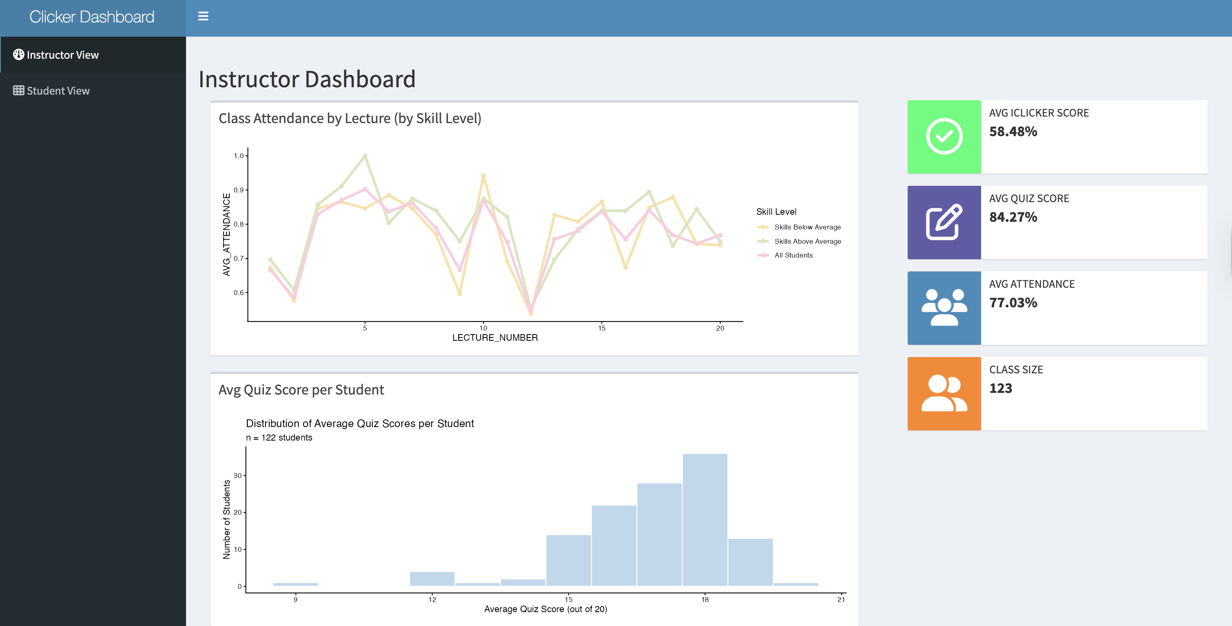
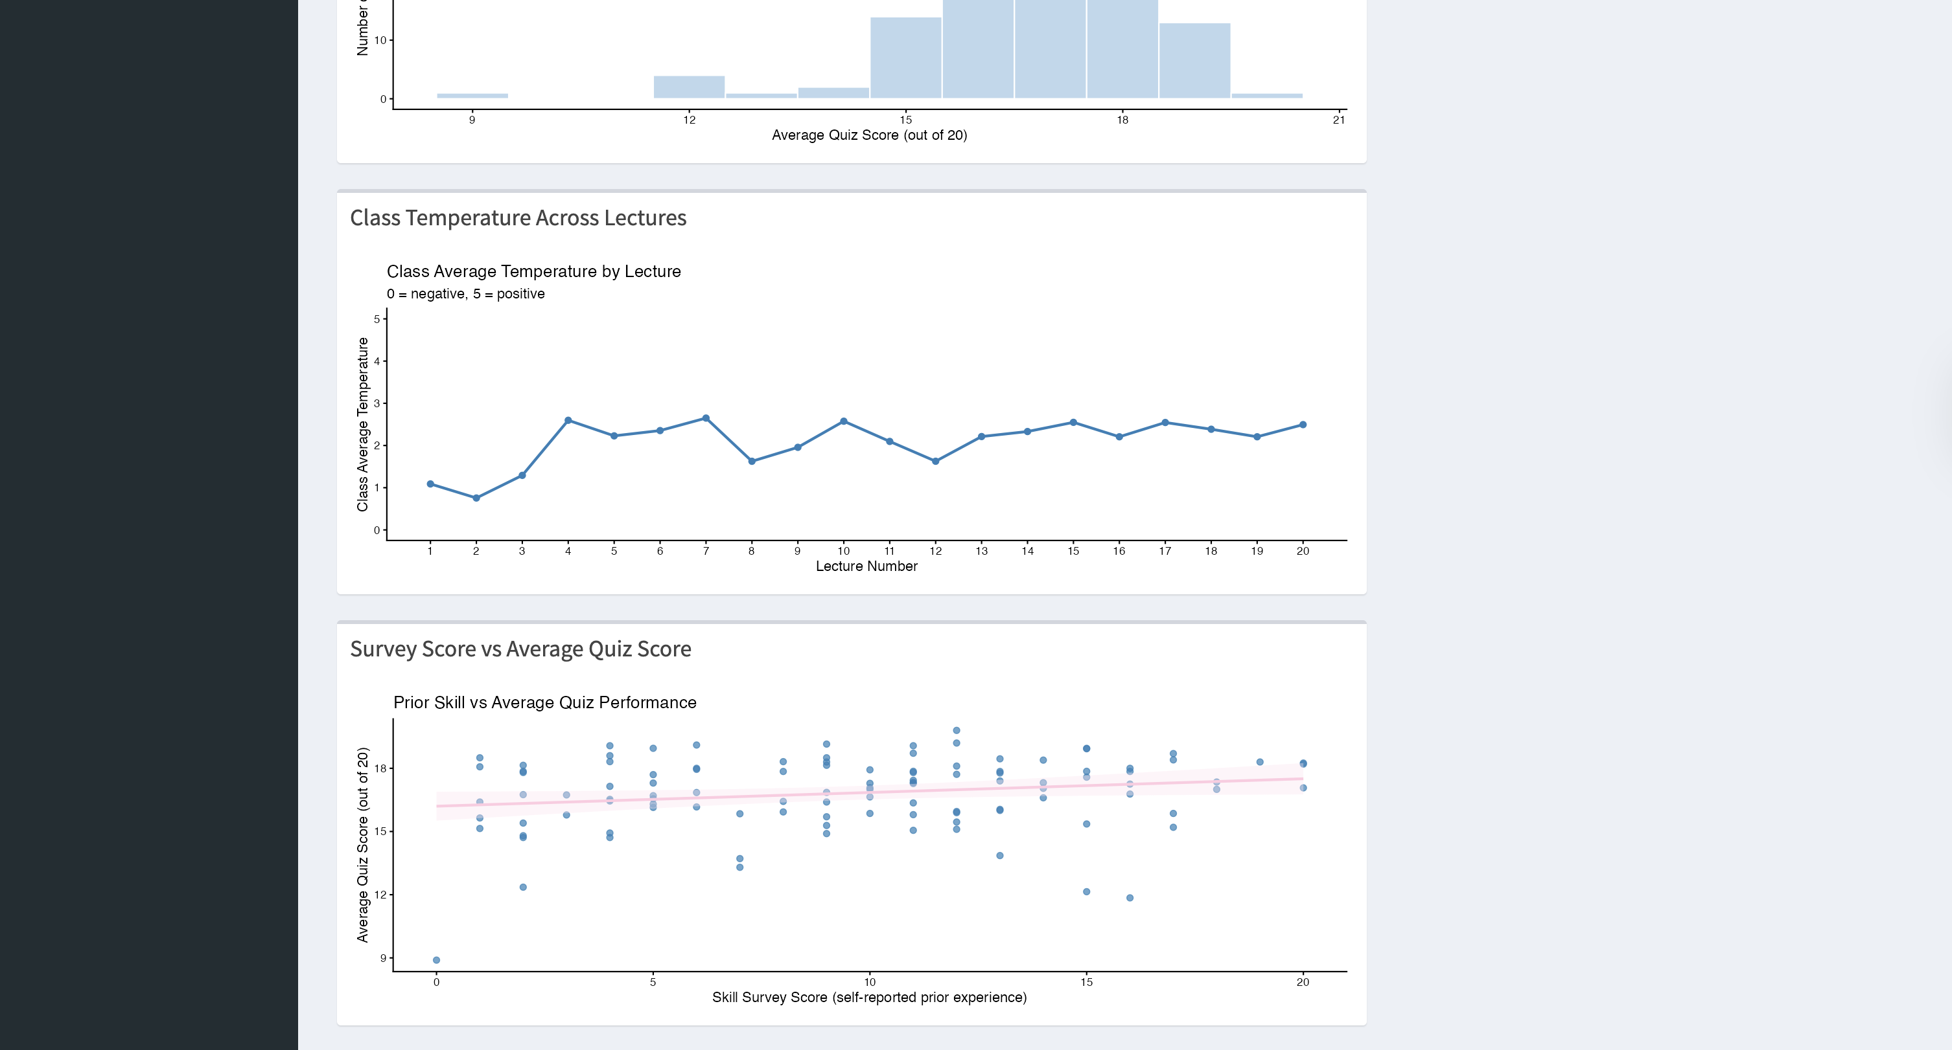
Student Dashboard
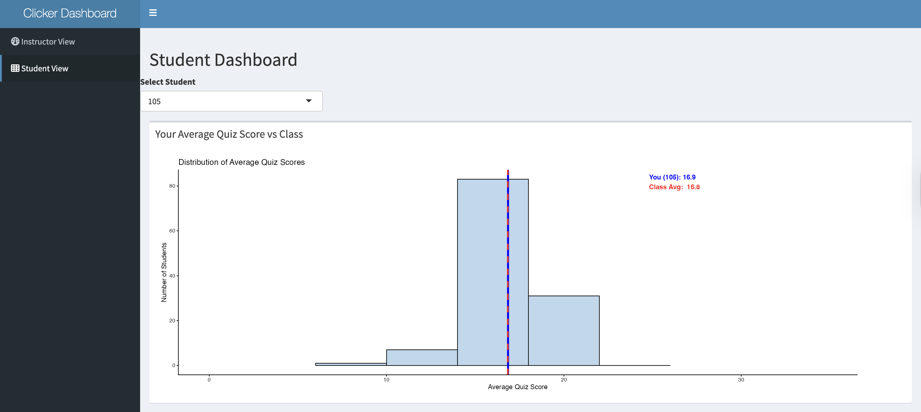
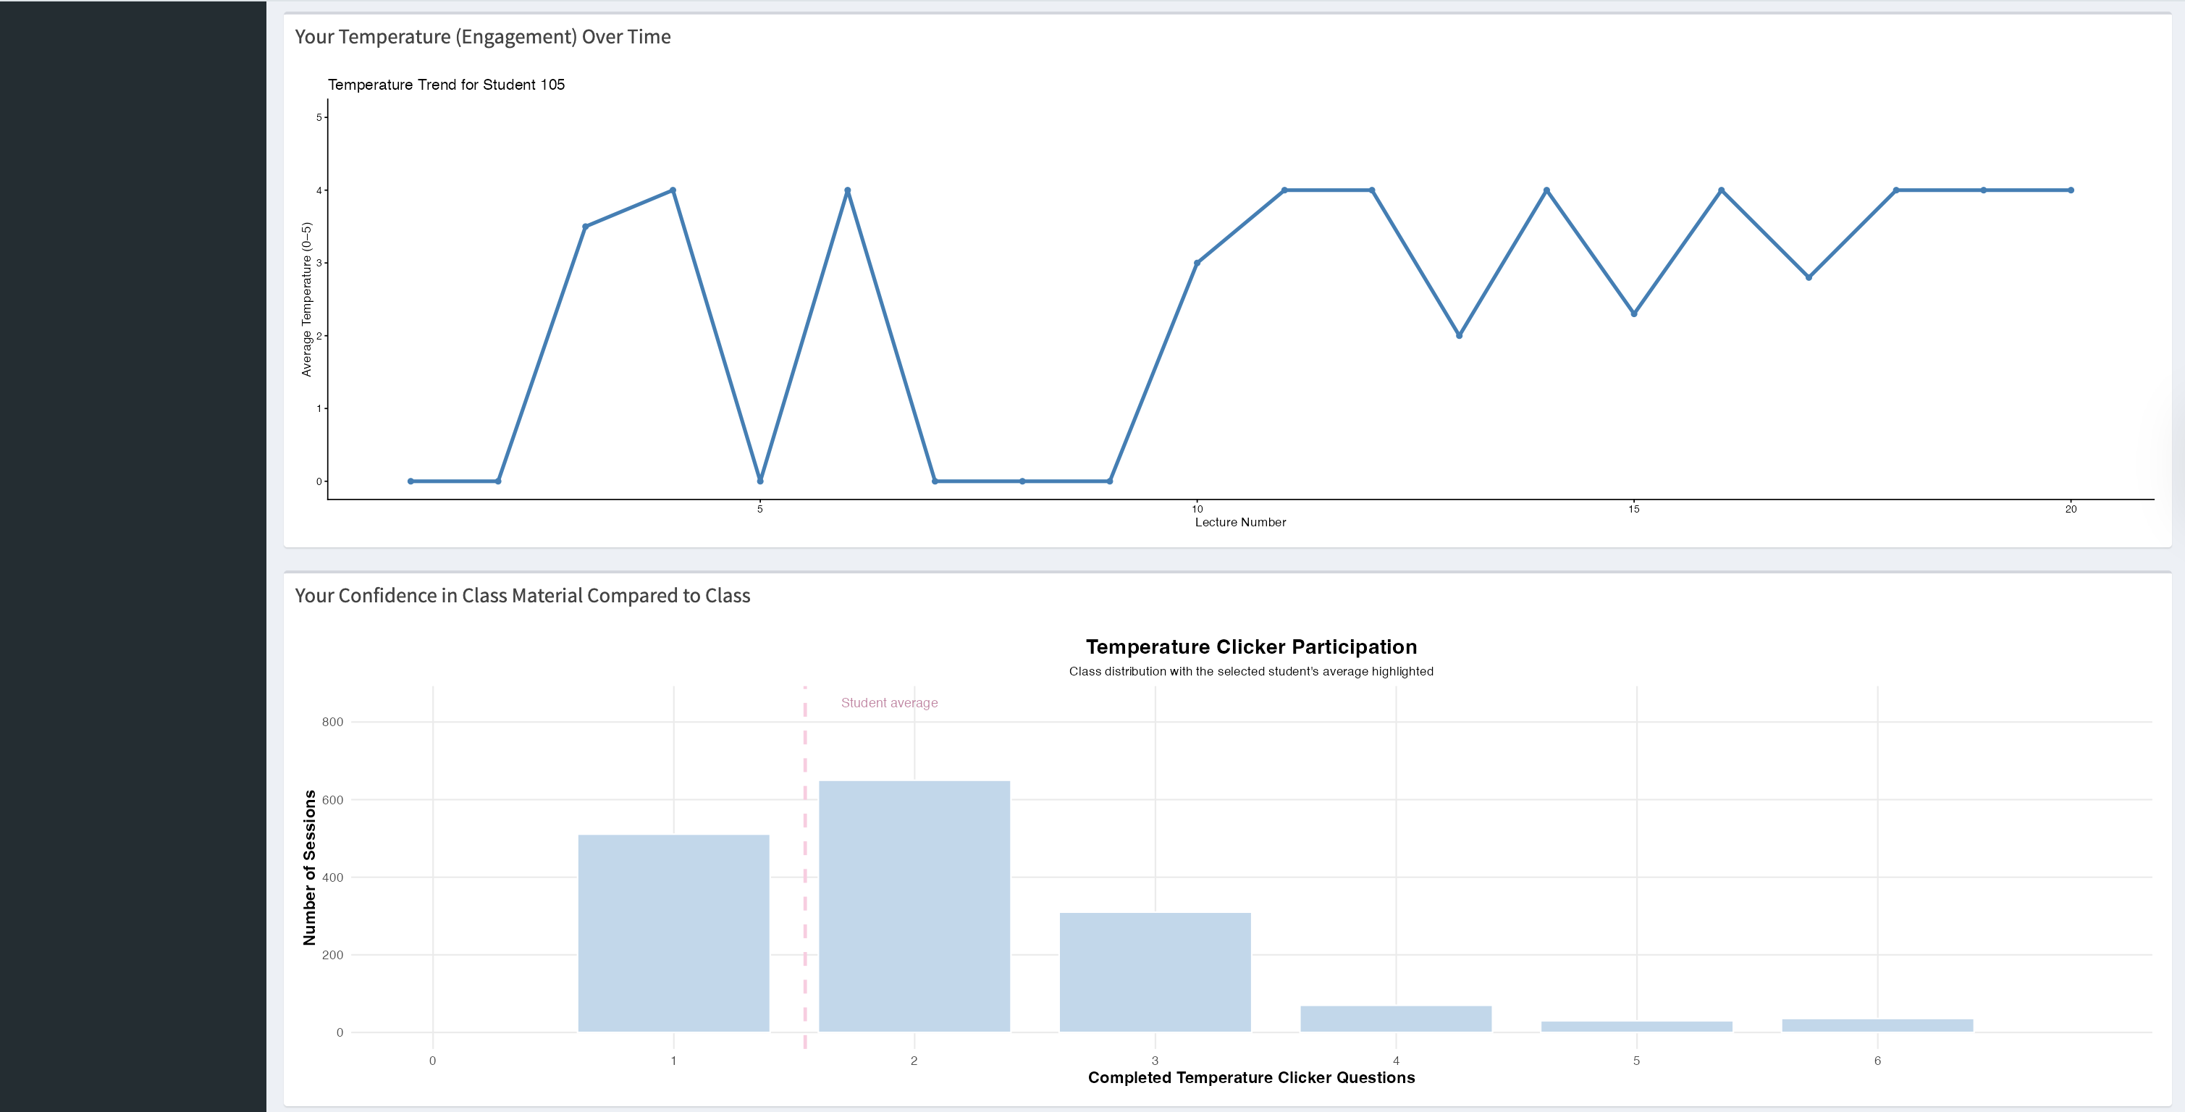
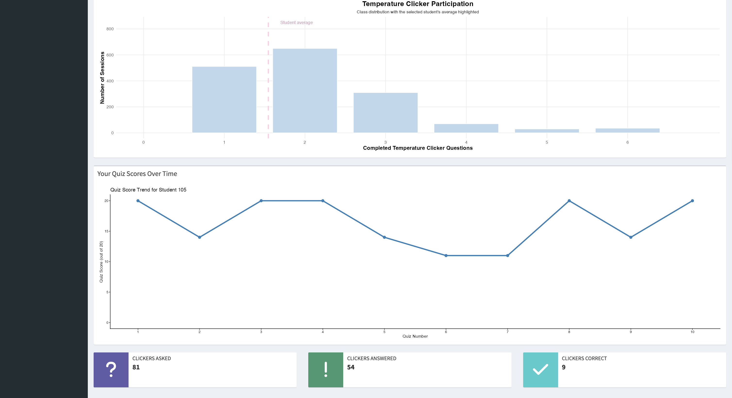
Question 6: Evaluate your group dashboard from the perspective of the instructor (teacher dashboard) and from the perspective of the student (student dashboard). What do you like about it, what would you change or add to it if you had more time?
Reflection for the student dashboard
- What do you like about it?
  - We like that the student dashboard we were able to make a feature that allowed results for different students. This was done by selecting the student ID at the top of the dashboard.
- What would you change or add to it if you had more time?
  - We would have liked to allow students to see something predictive about their course performance, such as a predicted probability of scoring certain final grades in the class.
- What was the biggest challenge you faced? How did you address it?
  - The biggest challenge we faced was deciding which data visualizations we wanted to implement. We addressed this by doing some research, looking on canvas, and seeing some example dashboards and how we can do something similar.
Reflection for the teacher dashboard
- What do you like about it?
  - We liked that we could show teachers a representation of students across skill level based on the course survey.
- What would you change or add to it if you had more time?
  - It would be interested to utilize an LLM API to conduct analysis of the data represented in the dashboard and suggest possible changes to the course like changing lecture content on a day with low attendance.
- What was the biggest challenge you faced? How did you address it?
  - Our biggest challenge was determining what types of data to show professors from the standpoint of seeking to give them a holistic view of a class of many students across multiple years.

Estimate time spent
We want to give students an estimate of how much time this homework will take. Please indicate how many hours you spent to complete this homework here.
- Shiwen Zhao (sz752): I spent about 1-2 hours.
- Gianna Ou (gyo4): I spent 2-3 hours.
- Theo Berk (tb547): I spent 1-2 hours
- Steven Xie (jx453): I spent about 2 hours.
Total for the group around 10 hours.

Generative AI usage
As stated in the course syllabus, using generative AI is allowed to help you as you complete this homework. We are interested in how it is being used and whether it is helpful for you.
- How much did you use generative AI (e.g., not at all, some, most, or all the questions) and which one did you use?
  - We used some AI assistance for some questions to refine and check our code for part four to prepare the visualizations.
- If you used generative AI, how did you use it and was it helpful?
- Shiwen Zhao (sz752): I used Claude for my assigned task (the scatterplot of survey score vs. average quiz score with a line of best fit). I came up with the implementation plan myself and then had Claude help me translate it into R/ggplot code and debug issues during testing. It was helpful for speeding up the coding and fixing small errors.
- Theo Berk (tb547): I used Claude for code review and to review the assignment before submission so make sure our group didn’t miss any parts of the project.
- Steven Xie (jx453): I used Claude to help implement my assigned visualization (the line plot of quiz scores across the weeks for the student). I planned the approach myself — using the lecture dates from ACAD_DATE_KEY to derive a “week of semester” axis, overlaying the class average so the student can see how they track against the class each week, highlighting the student’s best/worst weeks with color-coded markers and labels, and adding a “Weeks At or Above Class Avg” info box as a quick self-reflection summary. I then had Claude help me write the ggplot code and debug a couple of date-parsing and join issues. It was useful for speeding up the coding, but most of the design decisions were my own.

Submit Project
This is the end of the group project. Please Knit to Word (if you run into an issue, you can knit to PDF). The resulting file has to show both the R code and R output. Upload it on Canvas before the due date.

