Qwen3-Reranker-0.6B: Accelerator Latency & Price/Performance Benchmark
Real-time serving on vLLM | TPU v6e vs NVIDIA B200, H200, and G4 (RTX PRO 6000)

Executive summary
This report compares Qwen3-Reranker-0.6B served in real time on four single-chip accelerators, focusing on request latency and price/performance rather than offline batch throughput. All runs use vLLM with prefix caching disabled and freshly randomized content per request (so caching cannot inflate results), a standardized 512-token query+document pair, and a batch sweep from 1 to 64 pairs per request, plus a served concurrency sweep and a 1024-token long-context sweep.
Key findings at the batch-size-32 operating point (seq 512):
• TPU v6e (torchax): p50 latency 173.995 ms, 182.667 pairs/s, $2.4483/1M pairs, $0.07781/1000 requests.
• B200 (1 GPU): p50 latency 72.12 ms, 438.642 pairs/s, $4.4012/1M pairs, $0.13923/1000 requests.
• H200 (1 GPU): p50 latency 87.551 ms, 362.625 pairs/s, $2.9492/1M pairs, $0.09363/1000 requests.
• G4 RTX PRO 6000 (1 GPU): p50 latency 100.025 ms, 319.721 pairs/s, $2.702/1M pairs, $0.08641/1000 requests.
Bottom line: on raw per-request latency the ranking is B200 < H200 < G4 < TPU v6e; on price/performance (both USD/1M pairs and USD/1000 requests) the TPU v6e is the cheapest overall, followed by G4, then H200, then B200. At equal latency (matching a GPU's p50 with a smaller TPU batch) the TPU v6e serves the same SLA at roughly 2x-6x lower cost. Increasing sequence length from 512 to 1024 roughly doubles per-request latency on every chip but does not change the ranking.

Methodology
Model: Qwen/Qwen3-Reranker-0.6B (sequence-classification scoring head), served through vLLM's pooling score / rerank API.
Framework: vLLM torchax on TPU v6e; CUDA vLLM on the NVIDIA GPUs. One chip per device under test.
Rules: prefix caching disabled; each request uses freshly randomized token content so no KV/prefix reuse; synthetic pairs fixed at 512 tokens (plus a 1024-token long-context sweep); 50 timed iterations per batch size for the latency sweep.
Prices per chip-hour used throughout: TPU v6e $1.61, B200 $6.95, H200 $3.85, G4 $3.11.
Definitions:
• Request latency (p50/p90/p99): time for one score() request that contains N pairs; percentiles over the timed iterations.
• Throughput (pairs/s) = batch_size / mean request latency (s).
• Throughput price/perf = (price/hr / 3600) / pairs_per_s x 1,000,000 = USD per 1M pairs.
• Latency price/perf = (price/hr / 3600) x (p50 seconds) x 1000 = USD per 1000 requests.

Headline results (batch size 32, seq 512)
Device | p50 latency (ms) | p99 latency (ms) | pairs/s | $/1M pairs | $/1000 req
TPU v6e (torchax) | 173.995 | 187.747 | 182.667 | $2.4483 | $0.07781
B200 (1 GPU) | 72.12 | 78.676 | 438.642 | $4.4012 | $0.13923
H200 (1 GPU) | 87.551 | 98.34 | 362.625 | $2.9492 | $0.09363
G4 RTX PRO 6000 (1 GPU) | 100.025 | 101.605 | 319.721 | $2.702 | $0.08641

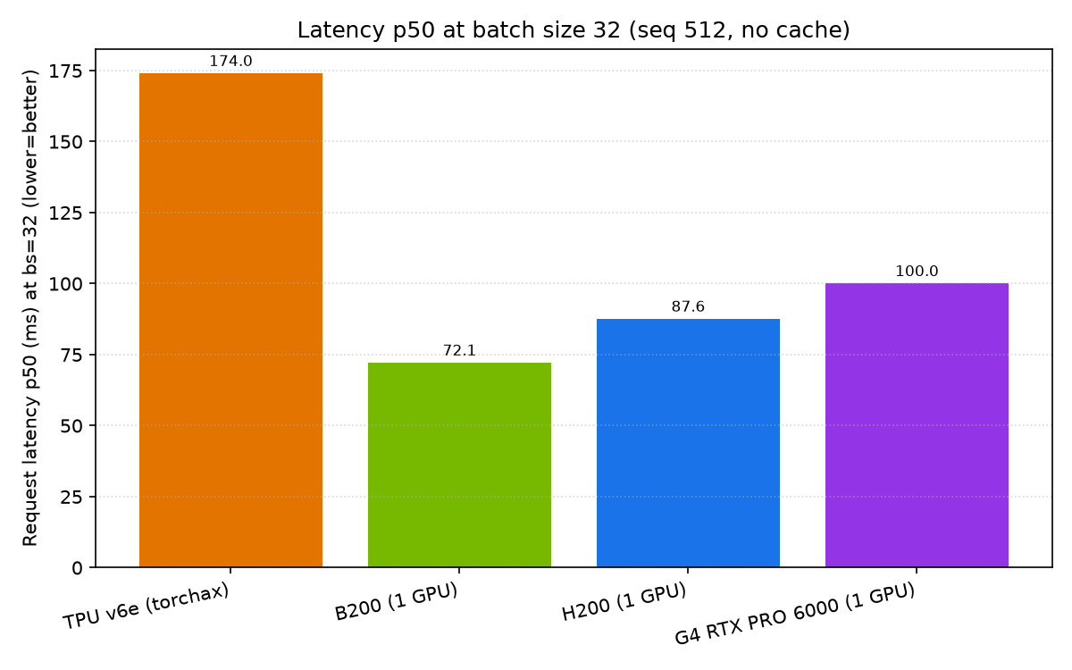
Request latency (p50) at batch size 32, all chips.
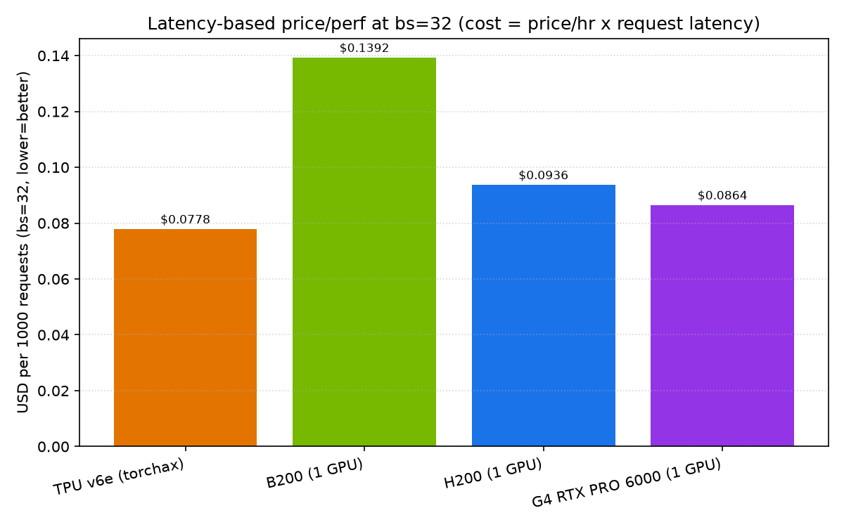
Latency-based price/performance at bs=32 (USD per 1000 requests, lower is better).
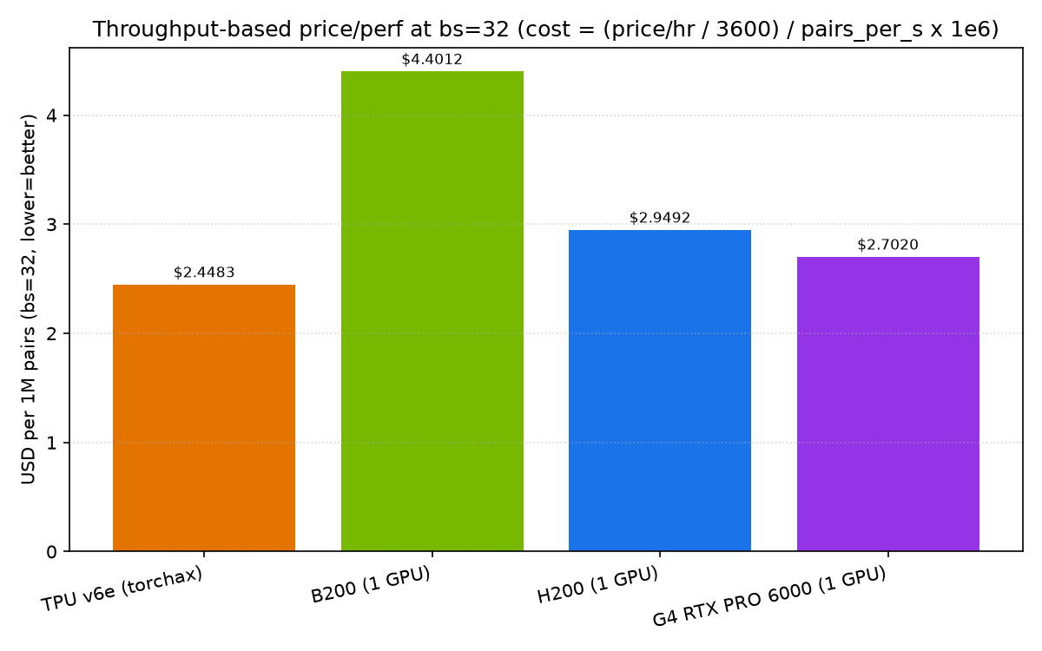
Throughput-based price/performance at bs=32 (USD per 1M pairs, lower is better).

Batch-size sweep (seq 512)
Request latency p50 (ms) by batch size:
Batch | TPU v6e (torchax) | B200 (1 GPU) | H200 (1 GPU) | G4 RTX PRO 6000 (1 GPU)
1 | 10.793 | 11.451 | 11.533 | 7.104
2 | 20.423 | 19.653 | 20.153 | 9.221
4 | 31.673 | 23.388 | 23.098 | 18.122
8 | 50.295 | 28.72 | 30.696 | 29.281
16 | 92.316 | 42.255 | 47.73 | 52.677
32 | 173.995 | 72.12 | 87.551 | 100.025
64 | 335.344 | 138.802 | 169.198 | 198.313
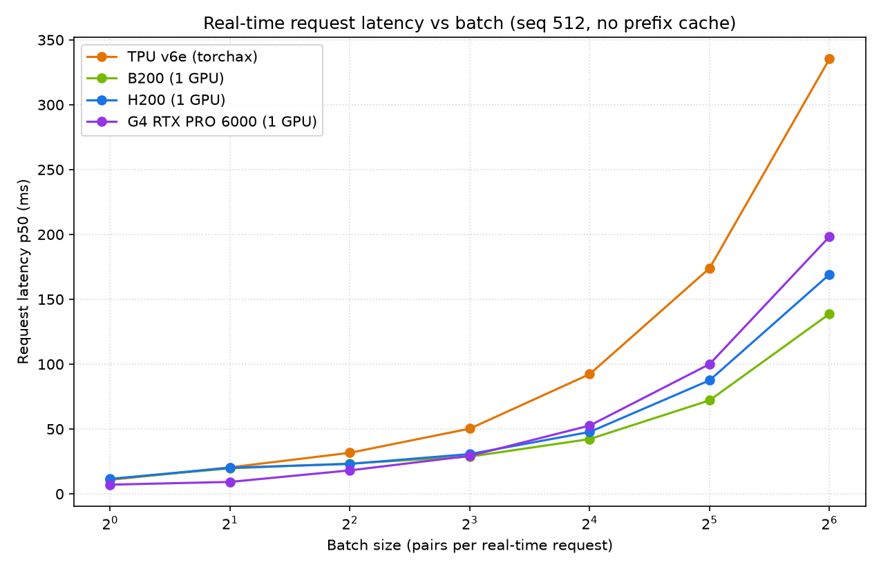
Request latency p50 vs batch size.
Throughput (pairs/s) by batch size:
Batch | TPU v6e (torchax) | B200 (1 GPU) | H200 (1 GPU) | G4 RTX PRO 6000 (1 GPU)
1 | 92.239 | 85.498 | 85.185 | 139.995
2 | 100.221 | 116.606 | 98.105 | 178.58
4 | 118.104 | 183.052 | 181.414 | 229.313
8 | 155.212 | 282.684 | 262.667 | 273.581
16 | 172.784 | 379.786 | 332.293 | 303.367
32 | 182.667 | 438.642 | 362.625 | 319.721
64 | 190.484 | 460.704 | 376.102 | 321.662
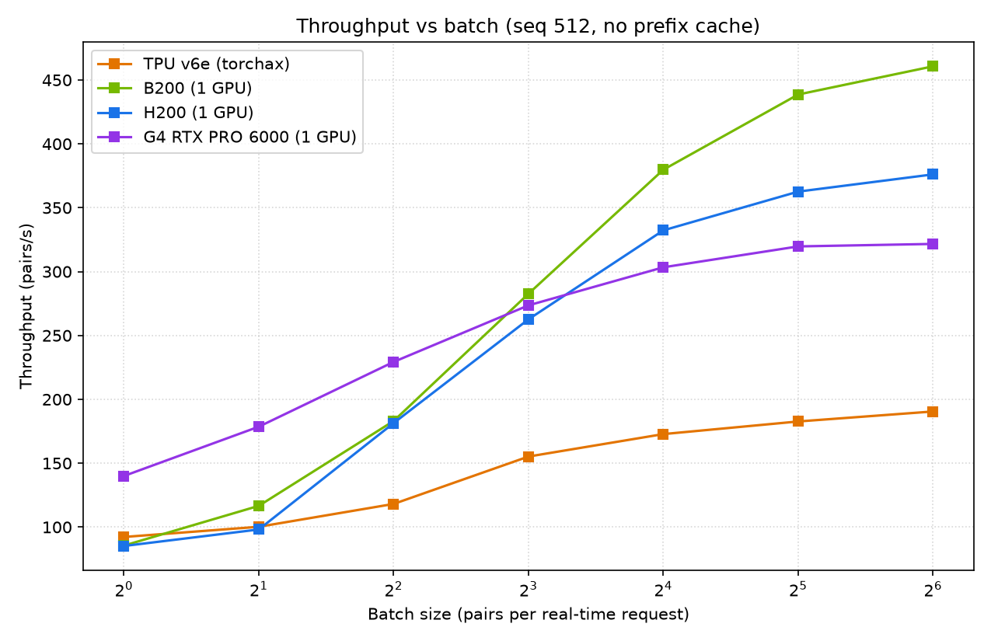
Throughput (pairs/s) vs batch size.

Matching a GPU with TPU v6e
Throughput-match (how many v6e chips equal one GPU's throughput, and the fleet cost):
vs B200 (1 GPU):
Batch | B200 (1 GPU) pairs/s | 1x v6e pairs/s | v6e chips | v6e fleet $/hr | B200 (1 GPU) $/hr | TPU cheaper?
1 | 85.498 | 92.239 | 1 | $1.61 | $6.95 | yes
2 | 116.606 | 100.221 | 2 | $3.22 | $6.95 | yes
4 | 183.052 | 118.104 | 2 | $3.22 | $6.95 | yes
8 | 282.684 | 155.212 | 2 | $3.22 | $6.95 | yes
16 | 379.786 | 172.784 | 3 | $4.83 | $6.95 | yes
32 | 438.642 | 182.667 | 3 | $4.83 | $6.95 | yes
64 | 460.704 | 190.484 | 3 | $4.83 | $6.95 | yes
vs H200 (1 GPU):
Batch | H200 (1 GPU) pairs/s | 1x v6e pairs/s | v6e chips | v6e fleet $/hr | H200 (1 GPU) $/hr | TPU cheaper?
1 | 85.185 | 92.239 | 1 | $1.61 | $3.85 | yes
2 | 98.105 | 100.221 | 1 | $1.61 | $3.85 | yes
4 | 181.414 | 118.104 | 2 | $3.22 | $3.85 | yes
8 | 262.667 | 155.212 | 2 | $3.22 | $3.85 | yes
16 | 332.293 | 172.784 | 2 | $3.22 | $3.85 | yes
32 | 362.625 | 182.667 | 2 | $3.22 | $3.85 | yes
64 | 376.102 | 190.484 | 2 | $3.22 | $3.85 | yes
vs G4 RTX PRO 6000 (1 GPU):
Batch | G4 RTX PRO 6000 (1 GPU) pairs/s | 1x v6e pairs/s | v6e chips | v6e fleet $/hr | G4 RTX PRO 6000 (1 GPU) $/hr | TPU cheaper?
1 | 139.995 | 92.239 | 2 | $3.22 | $3.11 | no
2 | 178.58 | 100.221 | 2 | $3.22 | $3.11 | no
4 | 229.313 | 118.104 | 2 | $3.22 | $3.11 | no
8 | 273.581 | 155.212 | 2 | $3.22 | $3.11 | no
16 | 303.367 | 172.784 | 2 | $3.22 | $3.11 | no
32 | 319.721 | 182.667 | 2 | $3.22 | $3.11 | no
64 | 321.662 | 190.484 | 2 | $3.22 | $3.11 | no

Latency-match (meet a GPU's per-request p50 with the fastest v6e batch, then compare cost per 1000 requests):
vs B200 (1 GPU):
GPU batch | B200 (1 GPU) p50 (ms) | B200 (1 GPU) $/1k | v6e config | v6e p50 (ms) | v6e $/1k | Cheaper at equal latency
1 | 11.451 | $0.02211 | v6e bs1 | 10.793 | $0.00483 | TPU
2 | 19.653 | $0.03794 | v6e bs1 | 10.793 | $0.00483 | TPU
4 | 23.388 | $0.04515 | v6e bs2 | 20.423 | $0.00913 | TPU
8 | 28.72 | $0.05545 | v6e bs2 | 20.423 | $0.00913 | TPU
16 | 42.255 | $0.08158 | v6e bs4 | 31.673 | $0.01416 | TPU
32 | 72.12 | $0.13923 | v6e bs8 | 50.295 | $0.02249 | TPU
64 | 138.802 | $0.26796 | v6e bs16 | 92.316 | $0.04129 | TPU
vs H200 (1 GPU):
GPU batch | H200 (1 GPU) p50 (ms) | H200 (1 GPU) $/1k | v6e config | v6e p50 (ms) | v6e $/1k | Cheaper at equal latency
1 | 11.533 | $0.01233 | v6e bs1 | 10.793 | $0.00483 | TPU
2 | 20.153 | $0.02155 | v6e bs1 | 10.793 | $0.00483 | TPU
4 | 23.098 | $0.0247 | v6e bs2 | 20.423 | $0.00913 | TPU
8 | 30.696 | $0.03283 | v6e bs2 | 20.423 | $0.00913 | TPU
16 | 47.73 | $0.05104 | v6e bs4 | 31.673 | $0.01416 | TPU
32 | 87.551 | $0.09363 | v6e bs8 | 50.295 | $0.02249 | TPU
64 | 169.198 | $0.18095 | v6e bs16 | 92.316 | $0.04129 | TPU
vs G4 RTX PRO 6000 (1 GPU):
GPU batch | G4 RTX PRO 6000 (1 GPU) p50 (ms) | G4 RTX PRO 6000 (1 GPU) $/1k | v6e config | v6e p50 (ms) | v6e $/1k | Cheaper at equal latency
1 | 7.104 | $0.00614 | none (v6e floor slower) | - | - | G4 RTX PRO 6000 (1 GPU)
2 | 9.221 | $0.00797 | none (v6e floor slower) | - | - | G4 RTX PRO 6000 (1 GPU)
4 | 18.122 | $0.01566 | v6e bs1 | 10.793 | $0.00483 | TPU
8 | 29.281 | $0.0253 | v6e bs2 | 20.423 | $0.00913 | TPU
16 | 52.677 | $0.04551 | v6e bs8 | 50.295 | $0.02249 | TPU
32 | 100.025 | $0.08641 | v6e bs16 | 92.316 | $0.04129 | TPU
64 | 198.313 | $0.17132 | v6e bs32 | 173.995 | $0.07781 | TPU

Concurrency sweep (served vLLM, real-time load)
Served via vLLM's HTTP rerank endpoint with C simultaneous in-flight requests; prefix caching off; fresh content per request. Each cell shows p50 / p90 / p99 latency (ms) | requests/s | USD per 1000 requests.
Single pair per request (seq 512):
Conc | TPU v6e (torchax) | B200 (1 GPU) | H200 (1 GPU) | G4 RTX PRO 6000 (1 GPU)
1 | 12.401/12.628/12.829 | 77.557 | $0.00555 | 11.125/11.768/13.186 | 87.157 | $0.02148 | 10.382/10.925/13.121 | 93.407 | $0.0111 | 6.739/6.893/7.288 | 142.863 | $0.00582
2 | 15.463/15.645/15.834 | 125.601 | $0.00692 | 14.108/14.413/16.836 | 137.654 | $0.02724 | 13.078/13.322/16.064 | 148.24 | $0.01399 | 8.481/8.539/8.607 | 229.461 | $0.00733
4 | 28.464/28.796/29.09 | 137.92 | $0.01273 | 14.793/17.387/21.289 | 253.296 | $0.02856 | 13.643/15.169/20.123 | 277.285 | $0.01459 | 11.702/11.835/14.63 | 332.305 | $0.01011
8 | 30.744/31.718/32.593 | 248.796 | $0.01375 | 15.54/22.025/24.238 | 453.719 | $0.03 | 14.873/21.244/28.049 | 456.949 | $0.01591 | 18.824/19.345/20.061 | 410.105 | $0.01626
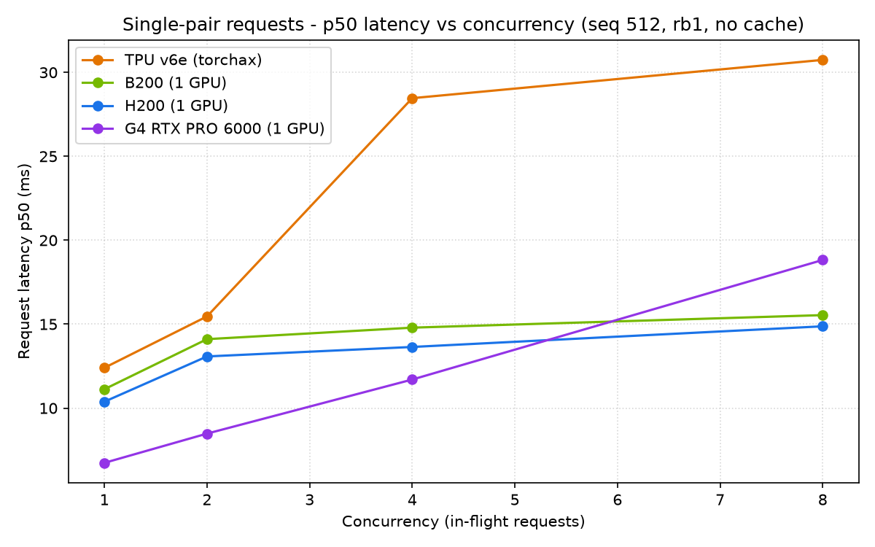
Single-pair p50 latency vs concurrency (seq 512).
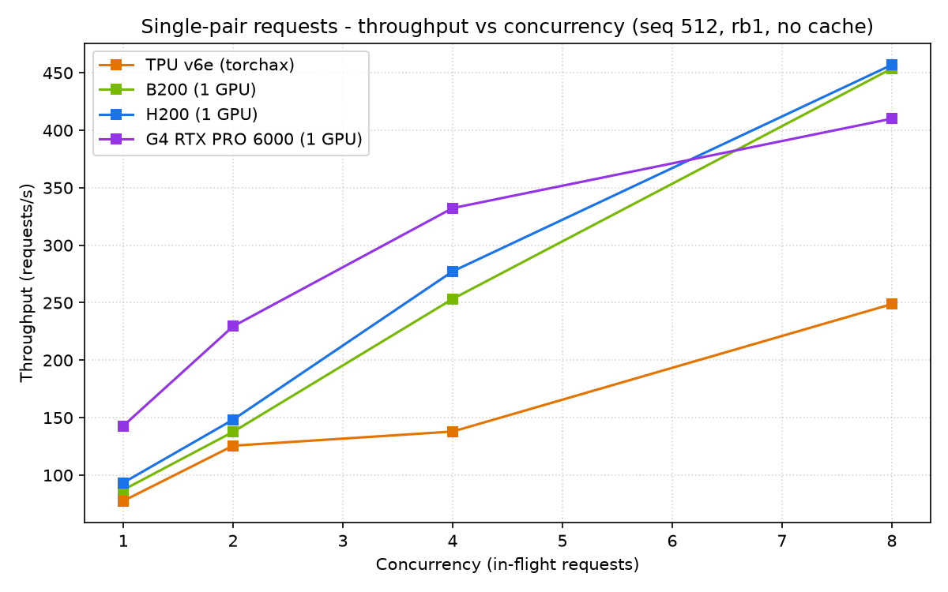
Single-pair throughput vs concurrency (seq 512).
Batch of 32 pairs per request (seq 512):
Conc | TPU v6e (torchax) | B200 (1 GPU) | H200 (1 GPU) | G4 RTX PRO 6000 (1 GPU)
1 | 187.8/189.55/191.416 | 5.075 | $0.08399 | 80.137/83.545/87.622 | 11.623 | $0.15471 | 92.257/96.226/100.366 | 10.147 | $0.09866 | 105.849/106.988/107.748 | 9.009 | $0.09144
2 | 251.522/252.949/254.629 | 7.654 | $0.11249 | 97.367/100.672/104.424 | 19.31 | $0.18797 | 99.261/102.138/119.89 | 18.981 | $0.10615 | 134.465/158.74/161.388 | 14.3 | $0.11616
4 | 509.381/512.851/514.375 | 7.686 | $0.22781 | 137.974/258.989/264.743 | 21.724 | $0.26637 | 182.008/188.307/223.734 | 21.298 | $0.19465 | 248.5/279.936/280.339 | 15.136 | $0.21468
8 | 1024.582/1028.547/1030.45 | 7.715 | $0.45822 | 309.212/462.843/474.611 | 22.783 | $0.59695 | 346.543/395.526/492.894 | 22.391 | $0.37061 | 533.215/534.158/534.487 | 15.091 | $0.46064
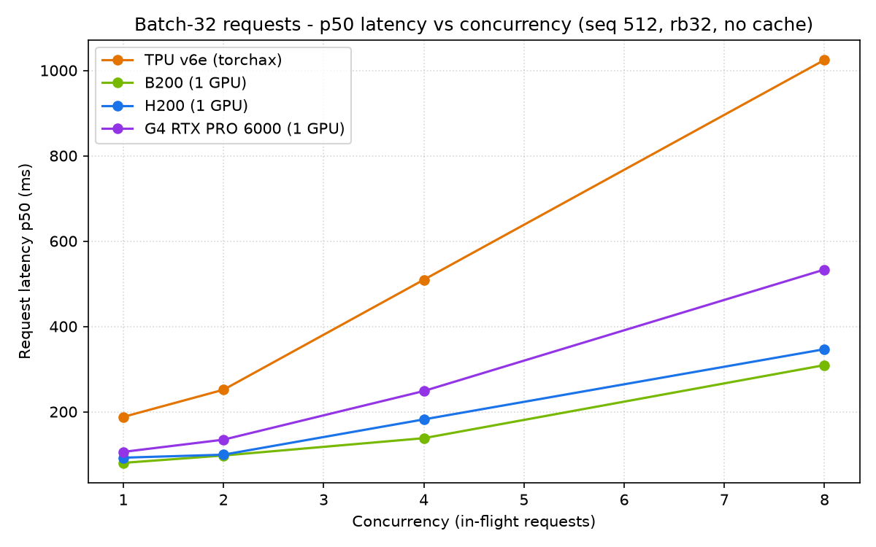
Batch-32 p50 latency vs concurrency (seq 512).
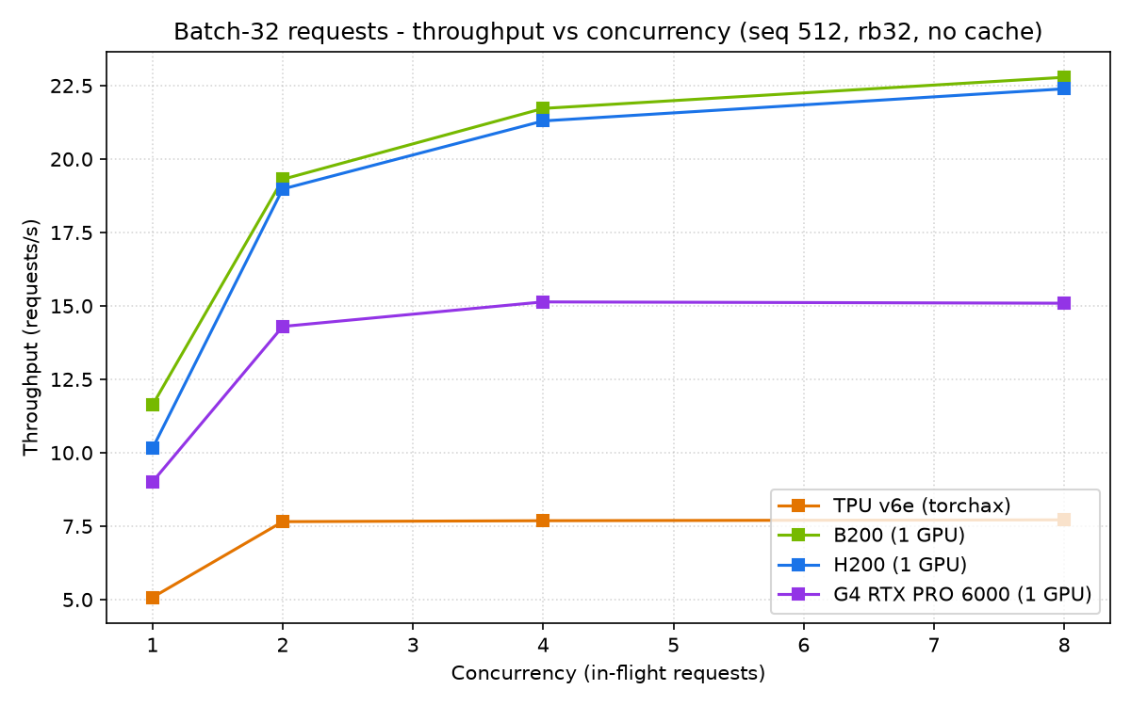
Batch-32 throughput vs concurrency (seq 512).

Sequence-length (long-context) sweep: 512 vs 1024 tokens
Holding the request shape at 32 pairs, doubling tokens per pair from 512 to 1024 roughly doubles per-request latency on every chip while preserving the price/perf ranking. Each cell: p50/p90/p99 (ms) | req/s | $/1k.
Conc | TPU v6e (torchax) | B200 (1 GPU) | H200 (1 GPU) | G4 RTX PRO 6000 (1 GPU)
1 | 355.952/357.217/412.871 | 2.625 | $0.15919 | 145.767/151.375/155.298 | 6.363 | $0.28141 | 175.478/178.714/180.494 | 5.361 | $0.18766 | 209.711/212.016/214.138 | 4.548 | $0.18117
2 | 480.343/482.032/483.08 | 3.991 | $0.21482 | 184.316/189.044/193.337 | 10.191 | $0.35583 | 183.429/187.333/212.304 | 10.205 | $0.19617 | 253.836/286.627/286.931 | 7.279 | $0.21929
4 | 977.128/983.107/1012.227 | 3.995 | $0.43699 | 268.762/505.915/532.652 | 11.128 | $0.51886 | 348.934/352.605/495.276 | 11.011 | $0.37317 | 550.31/551.072/551.442 | 7.253 | $0.47541
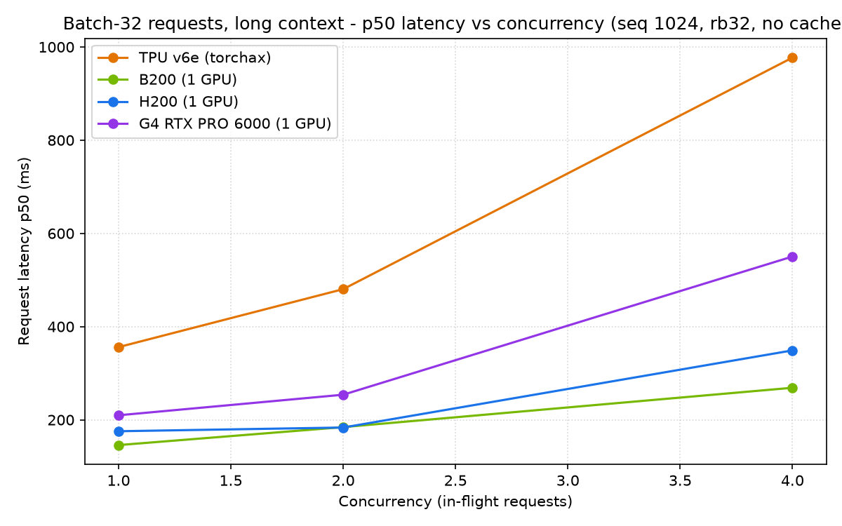
Batch-32 p50 latency vs concurrency, seq 1024.
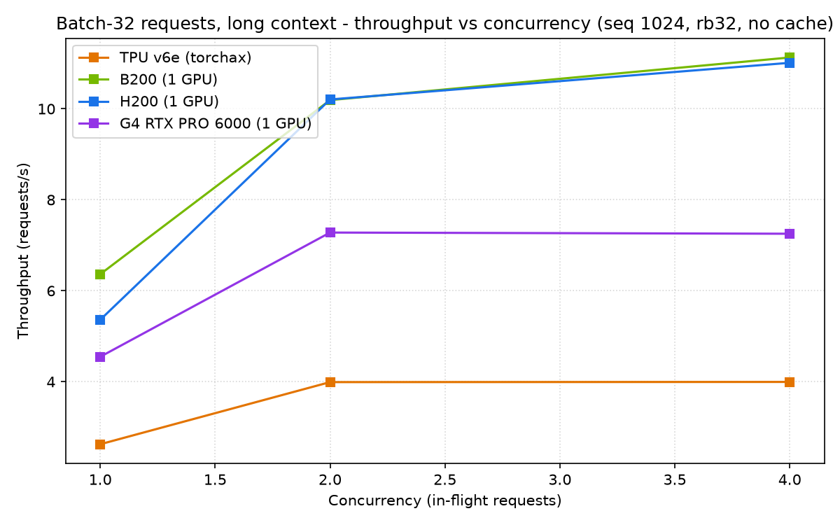
Batch-32 throughput vs concurrency, seq 1024.

Conclusions
• TPU v6e delivers the best price/performance for real-time reranking on both the throughput (USD/1M pairs) and latency (USD/1000 requests) views at every batch size tested.
• Among GPUs, G4 (RTX PRO 6000) is the best value and has the lowest single-request latency at small batches; B200 has the lowest absolute latency at larger batches; H200 sits between them.
• At equal latency, matching a GPU's p50 with a smaller TPU batch costs roughly 2x-6x less.
• Longer context (1024 vs 512) scales latency and cost proportionally without changing the ranking.

