

Republic of the Philippines
Sorsogon State University
College of Information and Communications Technology
COMPUTER SCIENCE
Bulan Campus
Zone 8, Bulan, Sorsogon
Tel. No.; 056 311-0103; Email Address: cict@sorsu.edu.ph

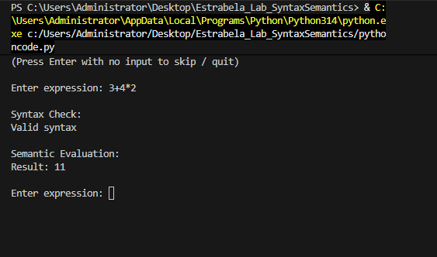
Test 1: 3 + 4 * 2

Test 2: ( 3 + 4 ) * 2
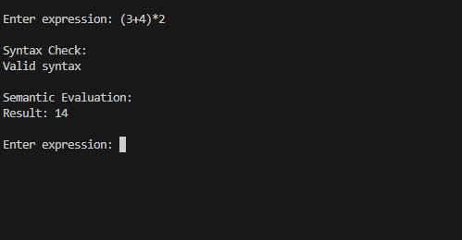

Test 3: 8 / 2 - 1
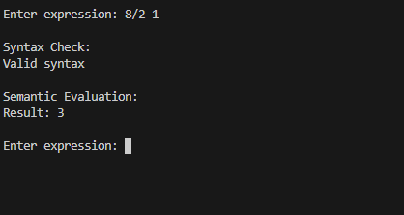

Test 4: 3 ++ 4
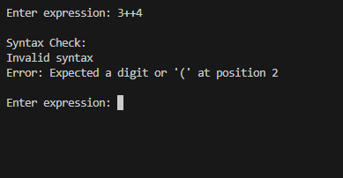

Test 5: ( 3 + 4
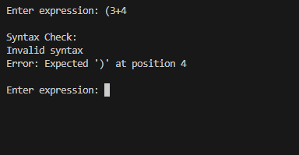

Test 6: 2 + 3 * 4
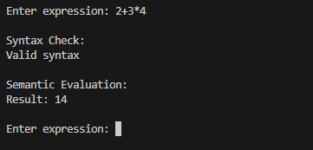

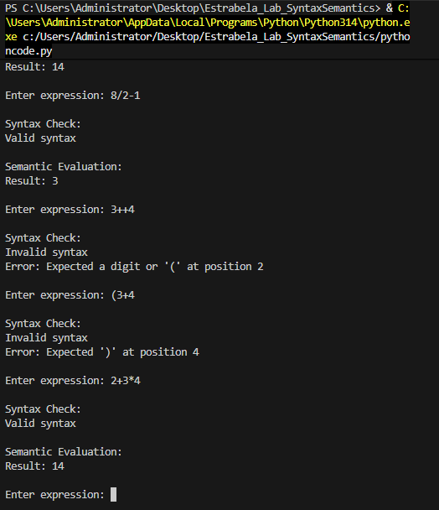
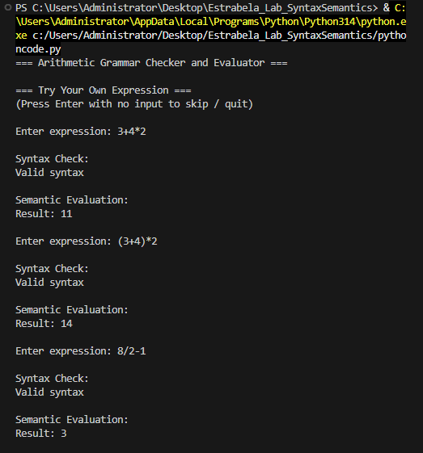
Whole picture Result

