Table S1. Size and repeat structure of the E. coli DH1 genome sequence using k-mers of different size

 | Total sequence (bp)
Copy number | k = 15 | k = 17 | k = 19 | k = 21 | k = 23 | k = 25 | k = 27 | k = 29
1x | 4,343,067 | 4,472,277 | 4,489,279 | 4,494,886 | 4,498,585 | 4,501,634 | 4,504,264 | 4,506,621
2x | 162,178 | 45,060 | 31,810 | 29,196 | 28,098 | 27,300 | 26,674 | 26,144
3x | 28,908 | 21,969 | 21,351 | 20,877 | 20,412 | 19,989 | 19,611 | 19,248
4x | 10,836 | 9,164 | 8,620 | 8,288 | 7,892 | 7,512 | 7,124 | 6,784
5x | 10,080 | 9,770 | 9,585 | 9,370 | 9,250 | 9,130 | 9,080 | 9,025
6x | 8,286 | 8,268 | 8,418 | 8,490 | 8,508 | 8,616 | 8,664 | 8,754
7x | 37,016 | 36,918 | 36,449 | 35,924 | 35,427 | 34,944 | 34,475 | 33,999
8x | 3,368 | 2,408 | 1,944 | 1,704 | 1,456 | 1,240 | 1,056 | 904
9x | 297 | 189 | 234 | 207 | 198 | 153 | 135 | 126
10x | 390 | 330 | 350 | 260 | 200 | 180 | 170 | 150
11x – 20x | 20,469 | 19,820 | 19,152 | 18,757 | 18,535 | 18,372 | 18,224 | 18,078
21x – 70x | 5,798 | 4,518 | 3,497 | 2,728 | 2,124 | 1,613 | 1,204 | 846
Totalª | 4,630,693 | 4,630,691 | 4,630,689 | 4,630,687 | 4,630,685 | 4,630,683 | 4,630,681 | 4,630,679

ª The size of the sequenced E. coli DH1 genome is 4,630,707 bp, k – 1 greater than the total k-mers.
Table S2. Genome sizes estimated from read sets of E. coli strains using k-mers of different size

 | Estimated genome size (bp)
E. coli strain | k = 15 | k = 17 | k = 19 | k = 21 | k = 23 | k = 25 | k = 27 | k = 29
A_03_34 | 4,778,825 | 4,776,822 | 4,776,195 | 4,775,705 | 4,775,453 | 4,774,872 | 4,774,274 | 4,773,837
B_04_28 | 4,927,099 | 4,932,857 | 4,934,298 | 4,935,111 | 4,933,859 | 4,935,175 | 4,934,608 | 4,936,041
C_04_22 | 5,168,076 | 5,175,804 | 5,177,972 | 5,180,594 | 5,182,109 | 5,183,615 | 5,184,004 | 5,185,904
D_04_27 | 5,216,262 | 5,218,504 | 5,219,054 | 5,219,387 | 5,219,365 | 5,219,058 | 5,216,893 | 5,216,055
E_01_37 | 5,504,417 | 5,503,399 | 5,502,931 | 5,502,511 | 5,502,004 | 5,501,319 | 5,500,696 | 5,500,121

Table S3. I-CeuI fragment lengths for E. coli strains

Fragment lengths (bp)  estimated by PFGE |  |  |  |  |  |  | Fragment lengths (bp) based on genome sequence
Strain A_03_34 | Strain B_04_28 | Strain C_04_22 | Strain D_04_27 | Strain E_01_37 | E. coli MG1655 |  | E. coli MG1655
40,036 | 41,747 | 40,720 | 41,062 | 37,299 | 40,378 |  | 41,398
115,992 | 94,779 | 130,161 | 120,097 | 117,873 | 93,239 |  | 93,812
139,086 | 136,862 | 120,782 | 179,801 | 138,060 | 133,099 |  | 131,117
525,392 | 540,151 | 530,411 | 538,598 | 547,142 | 528,111 |  | 520,769
680,359 | 645,404 | 860,359 | 711,042 | 708,712 | 663,270 |  | 657,364
683,855 | 720,752 | 733,957 | 831,831 | 812,800 | 702,109 |  | 697,595
2,684,174 | 2,866,877 | 2,939,489 | 3,000,390 | 2,905,916 | 2,827,057 |  | 2,497,592

Table S4. Estimates of microbial genome sizes based on k-mer analysis of short read datasets

NCBI SRAª  run number | Genome source | Genome size^{b} (kb) | Number of replicons | Genome size estimate (kb) | Coverage estimate | Unique estimate (kb)
SRR059788  SRR059789 | Niastella koreensis GR20-10, DSM 17620 | 9,033.7 | 1 | 8,392.0 | 53.4 | 8,287.2
SRR072318  SRR090709 | Burkholderia sp. CCGE1002 | 7,884.9 | 4 | 8,014.3 | 24.3 | 7,676.8
SRR031266  SRR031261  SRR031262  SRR031263  SRR031264  SRR031265  SRR031266 | Burkholderia sp. CCGE1002 | 7,884.9 | 4 | 7,627.3 | 104.6 | 7,410.5
SRR610299 | Cylindrospermum stagnale PCC 7417 | 7,610.6 | 4 | 7,617.2 | 510.7 | 7,064.6
SRR071425 | Mycobacterium smegmatis MC2 155 | 6,988.2 | 1 | 7,110.1 | 251.7 | 6,626.3
SRR610309 | Nostoc sp. PCC 7524 | 6,718.9 | 3 | 6,726.8 | 177.2 | 6,162.0
SRR090599 | Planctomyces brasiliensis IFAM 1448, DSM 5305 | 6,008.0 | 1 | 5,988.3 | 393.6 | 5,841.2
SRR059232  SRR059233  SRR059234  SRR059235  SRR059236 | Escherichia coli KO11FL | 5,029.3 | 2 | 5,203.4 | 36.8 | 4,710.7
SRR190843 | Owenweeksia hongkongensis DSM 17368 | 4,000.0 | 1 | 3,997.3 | 1,065 | 3,925.0
SRR006332 | Acinetobacter baylyi ADP1 | 3,598.6 | 1 | 3,546.2 | 52.6 | 3,480.8
SRR006330 | Acinetobacter baylyi ADP1 | 3,598.6 | 1 | 3,480.5 | 22.6 | 3,373.9
SRR396647  SRR396649  SRR396650  SRR396651  SRR396653 | Listeria monocytogenes J0161, FSL R2-499 | 3,000.4 | 1 | 3,353.8 | 33.8 | 2,911.6
SRR089543  SRR089544 | Rothia dentocariosa ATCC 17931 | 2,506.0 | 1 | 2,602.1 | 37.8 | 2,473.1
SRR060959  SRR060960 | Thermovirga lienii DSM 17291 | 1,999.6 | 2 | 2,052.7 | 108.1 | 1,875.8
SRR006331 | Mycoplasma agalactiae PG2 | 877.4 | 1 | 872.8 | 21.6 | 855.5
SRR387449 | phiX174 | 5.4 | 1 | 5.3 | 171,200.0 | 5.284.0
SRR769601 | Escherichia coli strain A_03_34^{c} | 4,908.0 |  | 4,759.9 | 54.6 | 4,642.5
SRR769603 | Escherichia coli strain B_04_28^{c} | 4,980.0 |  | 4,908.5 | 68.5 | 4,821.3
SRR769600 | Escherichia coli strain C_04_22^{c} | 5,039.0 |  | 5,145.4 | 80.3 | 4,585.4
SRR769602 | Escherichia coli strain D_04_27^{c} | 5,278.0 |  | 5,209.8 | 60.5 | 5,004.6
SRR769599 | Escherichia coli strain E_01_37^{c} | 5,196.0 |  | 5,445.7 | 84.5 | 4,801.5

ª NCBI SRA: National Center for Biotechnology Information Sequence Read Archive (http://www.ncbi.nlm.nih.gov/sra)
^{b} Genome size obtained by complete sequencing or by PFGE measurement.
^{c} Novel E. coli isolate, reported in this study.

Table S5. Effect of quality-score-based trimming on genome size estimates

 | Combined length of reads (bp) |  |  | Genome size estimate (bp)
E. coli strain | Raw reads | Trimmed readsª | Percentage  removed by  trimming | Raw reads | Trimmed readsª | Difference in genome size  estimates
A_03_34 | 362,127,992 | 344,702,582 | 4.81 | 4,775,814 | 4,766,569 | -0.19%
B_04_28 | 468,434,968 | 446,724,279 | 4.63 | 4,935,386 | 4,927,683 | -0.16%
C_04_22 | 580,398,016 | 554,098,452 | 4.53 | 5,180,545 | 5,176,786 | -0.07%
D_04_27 | 437,355,832 | 417,108,122 | 4.63 | 5,219,319 | 5,210,466 | -0.17%
E_01_37 | 645,818,056 | 614,475,488 | 4.85 | 5,502,494 | 5,492,264 | -0.19%

ª Sequence reads were trimmed with Dynamic Trim of the SolexaQA vers. 2.2 package. This procedure retains the longest contiguous region for which the probability of an incorrect base call remains below 10%. Estimates of incorrect base calls are based on the quality scores assigned to each read position during sequencing.
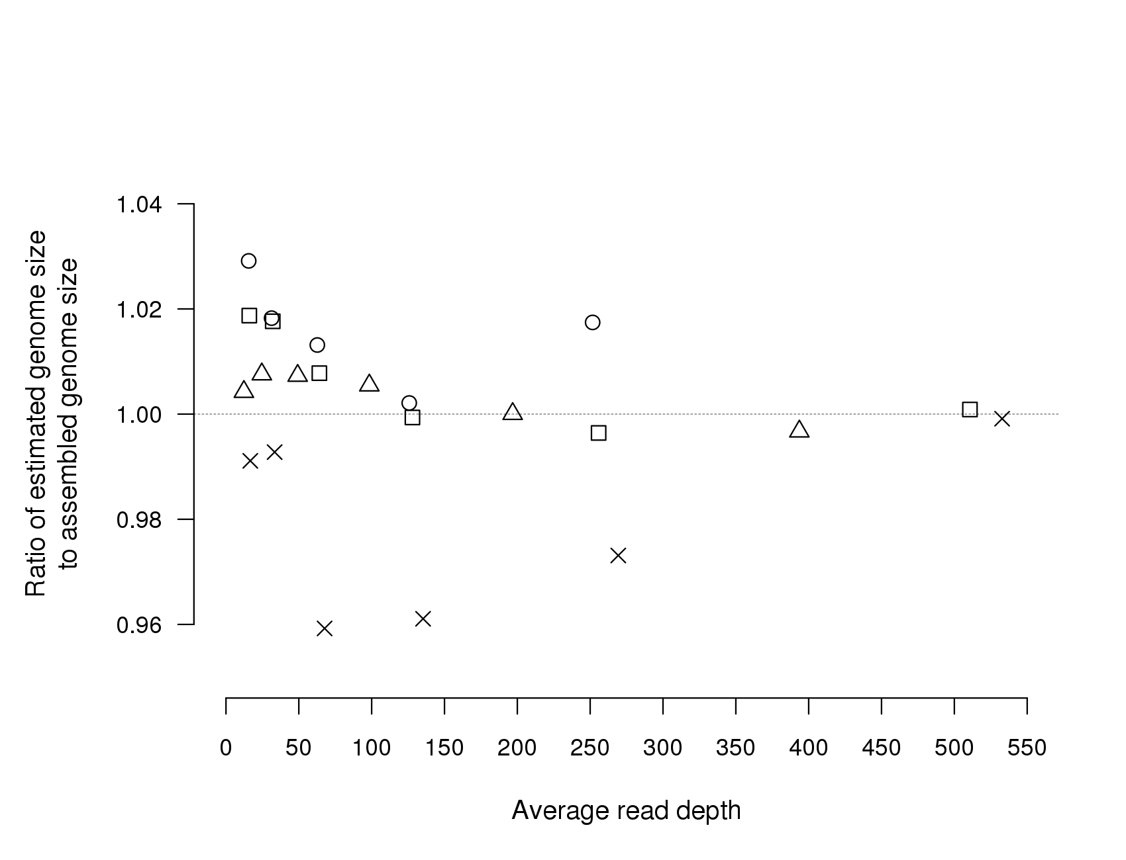
Figure S1. Ratio of assembled to estimated genome sizes at different read depths. Sample sets of different read depths were obtained by randomly selecting subsamples of short-read datasets at 0.5, 0.25, 0.125, 0.0625 and 0.03125 of their original sizes. Original dataset sizes were obtained from assembled sequences, and average read depths were estimated by 21-mer frequency analysis and correspond to the principle peak in a 21-mer spectrum. Symbols denote the organism from which the whole-genome shotgun sequence data were obtained: ○ Cylindrospermum stagnale PCC 7417 (SRA run number: SRR610299); △ Mycobacterium smegmatis MC2 155 (SRA run number: SRR071425); × Owenweeksia hongkongensis DSM 17368 [1] (SRA run number: SRR190843); □ Planctomyces brasiliensis IFAM 1448 DSM 5305 [2] (SRA run number: SRR090599).
References
1. Riedel T, Held B, Nolan M, Lucas S, Lapidus A, Tice H, Del Rio TG, Cheng JF, Han C, Tapia R, Goodwin LA, Pitluck S, Liolios K, Mavromatis K, Pagani I, Ivanova N, Mikhailova N, Pati A, Chen A, Palaniappan K, Rohde M, Tindall BJ, Detter JC, Göker M, Woyke T, Bristow J, Eisen JA, Markowitz V, Hugenholtz P, Klenk HP et al.: Genome sequence of the orange-pigmented seawater bacterium Owenweeksia hongkongensis type strain (UST20020801(T)). Stand Genomic Sci 2012, 7:120-130.
2. Wu DY, Hugenholtz P, Mavromatis K, Pukall R, Dalin E, Ivanova NN, Kunin V, Goodwin L, Wu M, Tindall BJ, Hooper SD, Pati A, Lykidis A, Spring S, Anderson IJ, D'haeseleer P, Zemla A, Singer M, Lapidus A, Nolan M, Copeland A, Han C, Chen F, Cheng JF, Lucas S, Kerfeld C, Lang E, Gronow S, Chain P, Bruce D et al.: A phylogeny-driven genomic encyclopaedia of Bacteria and Archaea. Nature, 2009, 462:1056-1060.

