/**

* Rock ChMS

* Developer

* Handbook

*/

DRAFT Version: 0.1.24

Last updated: 3/16/2012http://www.sparkdevelopmentnetwork.com/assets/images/spark-logo.png

# **Table of Contents**

Keeping Developers Happy 3

Coding Standards 6

Issue & Project Tracking 8

Required Reading 9

This Handbook 9

Developer Reference 9

The REST API 9

Highly Recommended 9

Recommended 9

Developer Communication 10

Blogs 10

# **Keeping Developers Happy**

Developers are fickle and that’s OK. They have good and bad habits, and have opinions on how things should be done. Unfortunately if left untamed, this can lead to a state of unhappiness for everyone. For example, attempting to perform diffs against code whose tab-spacing changes from version to version makes developers unhappy.

This handbook will contain the **rules and regulations** which are intended to keep everyone happy and it will also explain some of the environment setup needed to get started with developing.

# Setting Up Your Development Environment

## Getting Git

[SmartGit](http://www.syntevo.com/smartgit/index.html) is a Git client for Windows, Mac OS X and Linux. It provides a GUI to the Git command-line interface. We recommend SmartGit because it’s free for non-commercial use.

1. Download and install “**Git for Windows**” from here <http://code.google.com/p/msysgit/> with all the default settings.
2. [Download](http://www.syntevo.com/smartgit/download.html) and install SmartGit.
   1. Follow this to install Git <http://help.github.com/win-set-up-git/>
3. Run SmartGit to complete SmartGit setup using the defaults except where noted below:
   1. For the **Type of Usage** step you will probably want to select the third option, “Non-Commercial Use Only” as long as you’re only working on the non-commercial Rock-ChMS project.
   2. For the **Git & HG Executables step,** verify that the Git Executable path is filled in with the path to where you installed Git from step 1.
   3. For the **User Information** step, use your GitHub account name and email.
   4. For the **Hosting Providers** step, select GitHub as your main hosting provider.
   5. For the Master Passwords… step, we **do not** recommend choosing the “Don’t use a master password” option.
   6. In the Welcome to SmartGit window, if asked “What do you want to do?” just cancel/close that window and proceed to the next section.

## Getting RockChMS

1. Locate the project’s Git repository by visiting <https://github.com/SparkDevNetwork/Rock-ChMS>.
2. Find the project’s repository read-only URL address (it will be something like <https://github.com/SparkDevNetwork/Rock-ChMS.git>) if you’re a core developer you can use your read-write Url or if you’ve forked the Rock-ChMS repo, you can use the read-write Url to your forked repo.
3. In SmartGit, go to “Project” » “Clone” (or choose “clone existing repository”) and use the default settings except where noted here:
   1. In the **Repository Url** field, enter “[https:// github.com/SparkDevNetwork/Rock-ChMS.git](https://User@github.com/SparkDevNetwork/Rock-ChMS.git)”
   2. In the **Local Directory** step, locate or create a folder on your computer where you’ll store your Git Working Tree, e.g., C:\projects\Rock-ChMS.

## Getting Started

### Database

You’ll need to make a copy of our database to your local system. Download the latest schema and data from here: TBD

Make sure your SQL Server properties Security’s Server Authentication is set to “SQL Server and Windows Authentication mode”.

You’ll also need to enable TCP/IP and Named Pipes in your SQL Server Client Protocols (if you have not already done this before).

### Web Config

If it does not exist, create an empty web.connectionString.config file under your RockWeb project. Add with something like:



# **Coding Standards**

The following are the adopted coding standards:

* First and foremost, follow the established patterns you see in the existing code base. Don’t invent your own patterns.
* See <http://www.dotnetspider.com/tutorials/CodingStandards.doc>
* Follow the Naming Conventions and Standards outlined by items 1 through 11 in section 7.
* Follow the Indentation and Spacing outlined in section 8. Use Spacing Settings for Visual Studio. Under Options, Text Editor, C#, Spacing checkbox the following (you may need to check the “Show all settings” checkbox in the lower left corner if you don’t see these settings):

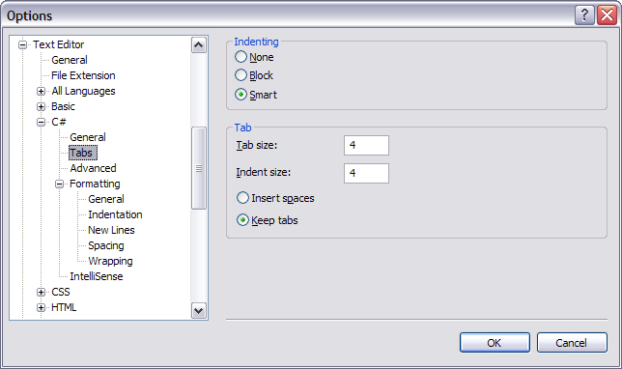

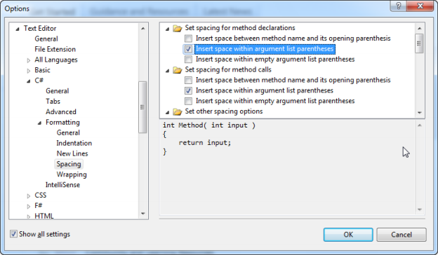

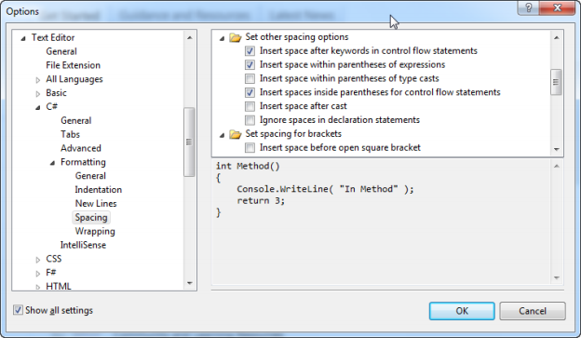

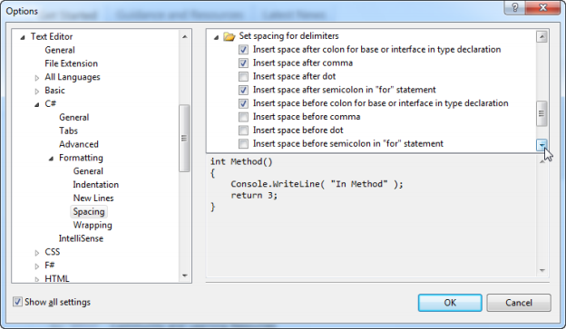

# **Issue & Project Tracking**

We use [GitHub for tracking issues](https://github.com/SparkDevNetwork/Rock-ChMS/issues) and are currently using [Basecamp for various other stuff](https://sparkdev.basecamphq.com/) including: to-dos, project management, and related tasks.





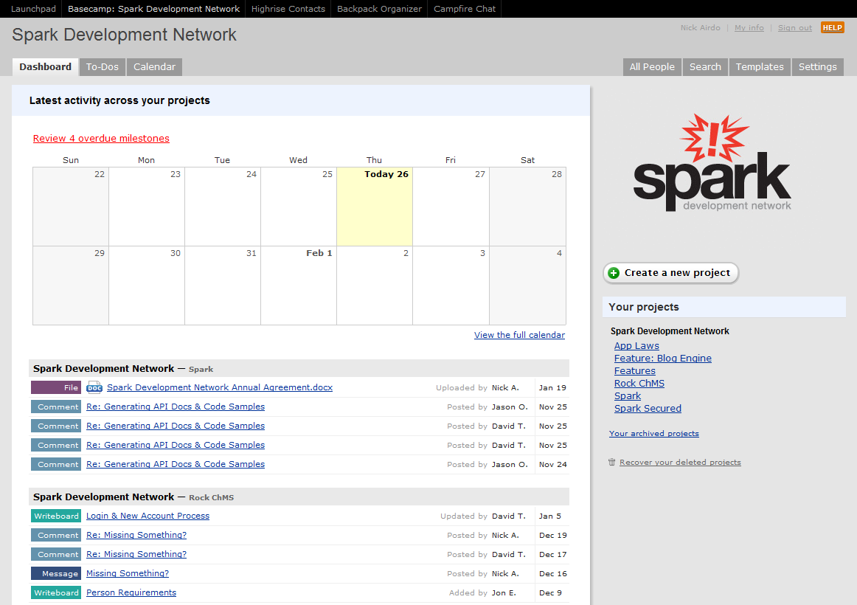

Projects

Your to-dos

Activity

# Required Reading

## This Handbook

Ok, you’re almost done so don’t get too flustered about it.

## Developer Reference

|  |  |
| --- | --- |
|  | Found in the **Documentation** folder, the Developer Reference is not only good for you, it is required reading. Seriously though – it is the best way to get ramped up developing proper in Rock ChMS. |

## The Framework API

This is found in your Documentation folder’s SandCastle\index.html

## The REST API

This is found on your Rock environment under ~/REST/help

## Highly Recommended

|  |  |
| --- | --- |
|  | [Getting Real](http://gettingreal.37signals.com/) by 37signals  *online copy is free* |
| [Producing Open Source Software: How to Run a Successful Free Software Project](http://www.amazon.com/dp/0596007590/?tag=codinghorror-20) | [Producing Open Source Software](http://www.amazon.com/Producing-Open-Source-Software-Successful/dp/0596007590) by Karl Fogel |
|  | [Don’t Make Me Think](http://www.amazon.com/Think-Common-Sense-Approach-Usability/dp/0789723107) by Steve Krug |

## Recommended

|  |  |
| --- | --- |
|  | [Agile Principles, Patterns, and Practices in C#](http://www.amazon.com/Principles-Patterns-Practices-Robert-Martin/dp/0131857258/ref=wl_it_dp?ie=UTF8&coliid=ILT32SV4UOLHS&colid=21HCWQ4W2TBGY) |

# **Developer Communication**

Here are the best ways to communicate with the team and the Rock ChMS developer community.

|  |  |
| --- | --- |
|  | IRC Channel #RockChMS irc://chat.freenode.net/#RockChMS |
|  | Twitter - Follow us:  [[@Rock](http://twitter.com/airdo)ChMS](http://twitter.com/rockChMS)  [@SparkDevNetwork](http://twitter.com/#!/SparkDevNetwork)  [@RefreshCache](http://twitter.com/refreshcache) |
| Spark Dev Network | TBD - Developer forums on our community site |
|  | TBD Wiki or other community documenting tool. |