Infrastructure Project Design Document



Authors: Yoan-Asen Popov, Mihai Glodici, Joep Vinken

Student Number: 4472152, 4538528, 4475003

Class & group: I02, group 8

Assignment: Project advanced phase infrastructure

Volume: V2.2

# Table of Contents

Table of Contents 2

Agreements – made with tutor 3

Requirements 4

What should the system be able to do? 4

Prioritize them 5

System setup 6

Describe the architecture of your system 6

Network configuration 7

Network drawing and description 7

Description of the diagram 7

GUI 8

Image and description 8

# Agreements – made with tutor

1. Present what we have done from week 2 to 5 in week 6.
2. Present what we have done from week 7 to 9 in week 10.
3. If there are any issues regarding the server or hardware, contact Bart van der Zanden or Andrius Kuprys.

# Requirements

## What should the system be able to do?

We have been tasked with developing an infrastructure for one of their clients by the company 'Make IT Work4U.' Our business client is a small business with part-time employees. Our client will use the infrastructure we develop to serve their own clients.

The customer is supposed to access the Windows virtual machines via Thin clients. One of the virtual machines hosts an active directory, DHCP server, and database server, while the other hosts a Windows client.

Each user should have access to his or her own home folder on the server.

Each file must be backed up to an external server to ensure that no data is lost in the event of a disaster.

Employees who travel abroad should have the ability to read and edit files while away from the office.

Remote desktop should be used to synchronize desktop files.

Make IT Work4U would like to monitor the operation of all systems.

As a result, we must establish a management application for their infrastructure and that of their clients.

Our client anticipates that we will eventually create an environment in which everyone can connect to the server and have their own workstation.

Management should establish a personal connection to active directory.

Our backup policy will be developed to safeguard all servers and their associated data in the event of a significant incident.

Additionally, a real-time dashboard with server and client statistics and key performance indicators (KPIs) will be used to manage and improve existing infrastructures and processes.

## Prioritize them

1. Infrastructure/Architecture diagram, define its communication.
2. Install Windows server with Hyper-V.

Add AD and DHCP to the host.

Configure AD Group Policies:

* Enable Folder Redirection for user’s “Desktop”

* Prevent changes to proxy settings on Internet Explorer

on every user’s machine.

Create multiple new users to test the system.

Create one custom Group (for sales users) and add few

employees to it.

1. Install one Windows desktop machine and connect it to AD.
2. Create backup policy to backup all servers and their data, using host and
3. agent-based backup strategies
4. Configure Firewall (gateway) to connect local private network to the Internet.
5. Set up VPN connection for remote employee
6. A management dashboard for all real-time statistics of server and
7. system’s KPI
8. A management dashboard to check all logs of system’s state
9. Security management analysis

Not mandatory:

1. A management dashboard for virtual clients

2. A database management CRUD application

3. An event and incident management system to alert in case of infrastructure component failure

4. In every client host use SCP to send monitoring activity log files (SQLite DBs) to the server

5. Self-signed certificates for web servers

# System setup

## Describe the architecture of your system

Our first task was to install Hyper-V. After successful enabling of the software for virtualization, we had to restart our server. And this is when the first problem came. The IP for the server changed and we could not connect to it via the Remote Desktop Connection application. After researching the problem, we learned that this is a random bug from Microsoft. The next step was creating a VM with the Hyper-V and installing Windows Server on it. We configured our first VM to be an AD/DC. Our only issue with it was navigating through its options, as this was new for us. Continuing on this VM we added the role of a DHCP on it. Also, we configured the DHCP pool of IP addresses to be 192.168.1.150-200 with a subnet mask of 255.255.255.0. Then we started to work on the security side and created a Firewall / Gateway for our system. We used the free software called pfSense. First, we had to create a VM in the Hyper-V with modest specs, as it would have become our new firewall. Very important thing we had to do was setting up two virtual network devices (virtual switches), so that it would be able to connect both to the LAN (local area network) and the WAN (wide area network) or so called the Internet. Installing the firewall was a bit overwhelming, but with little assistance from our teacher Bart van der Zanden we managed to pull it through. Our next task was creating users. We created three of them. Also, we added them to a group we created, called Sales. We created a third and fourth VMs. Through these VMs we are going to login with the created users and test the group policies. Our next endeavour was creating Organizational Unit for the Sales Department. Which we use it in creating Redirection Folder / Shared Folder policy for users in Sales.

# Network configuration

## Network drawing and description

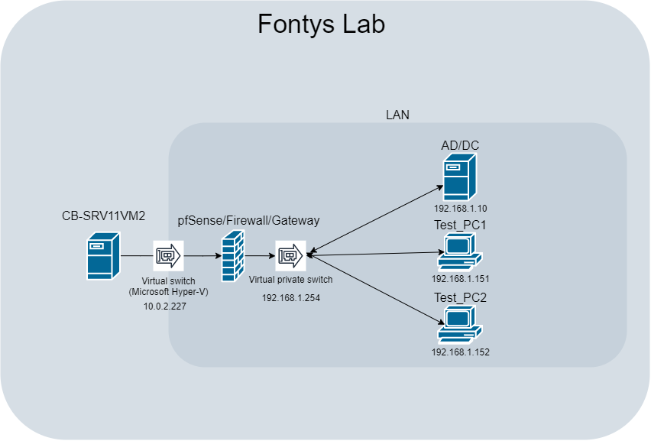

## Description of the diagram

In this network diagram, we start off with Fontys’ server (CB-SRV11VM2). We applied pfSense (10.0.2.227 external & 192.168.1.254 internal) to the server that formed the firewall and gateway. In order to get a connection between our environment and the internet, we used a virtual switch. From this virtual switch on, we go to our domain controller & active directory (192.168.1.10), virtual machine 1 (192.168.1.151) and virtual machine 2 (192.168.1.152).

# GUI

## Image and description

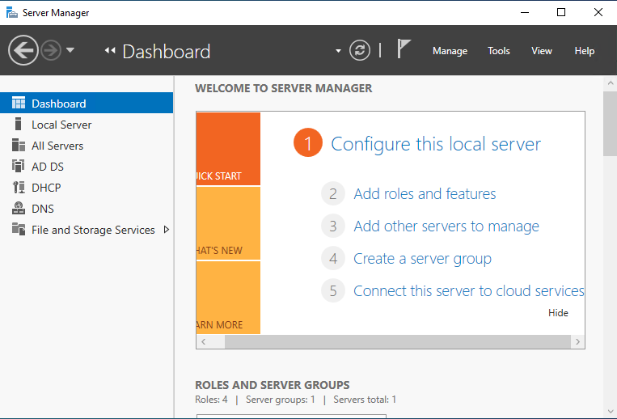

This is our server management GUI. From this application, you can access all kinds off resources, such as DHCP, DNS and shared folders. Clicking on 'manage' or 'tools' will give you a lot of options such as 'add roles and features' (DHCP, AD, DNS), active directory administrative centre.

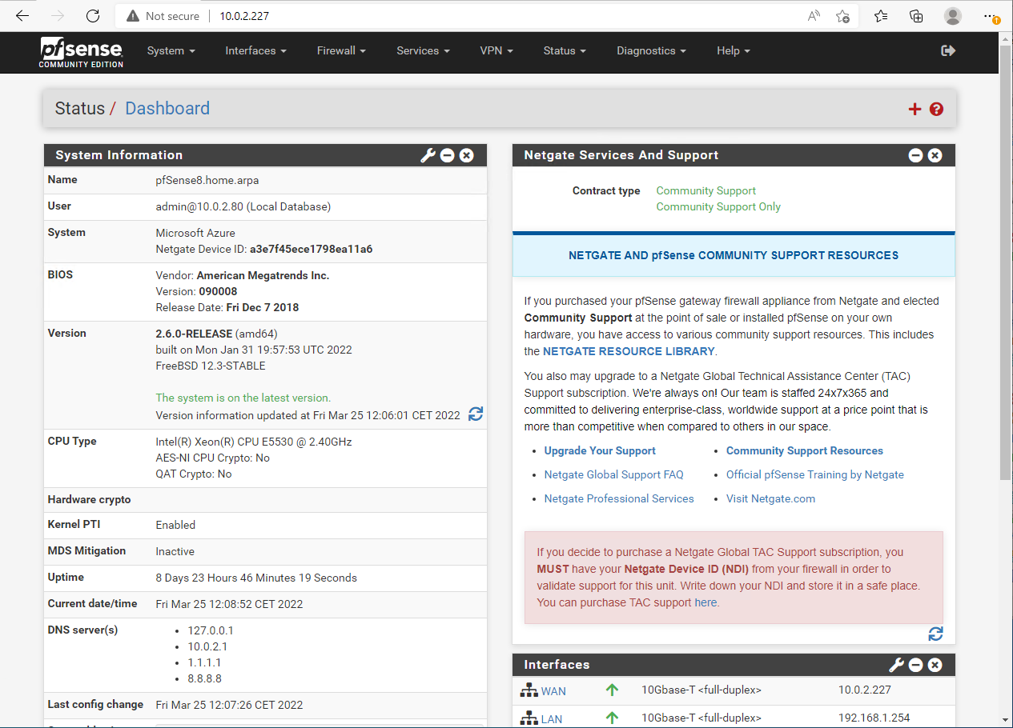

This is a print screen of the pfSense GUI which we used for gateway, firewall and a proxy server. You can add rules and block online sources.

zs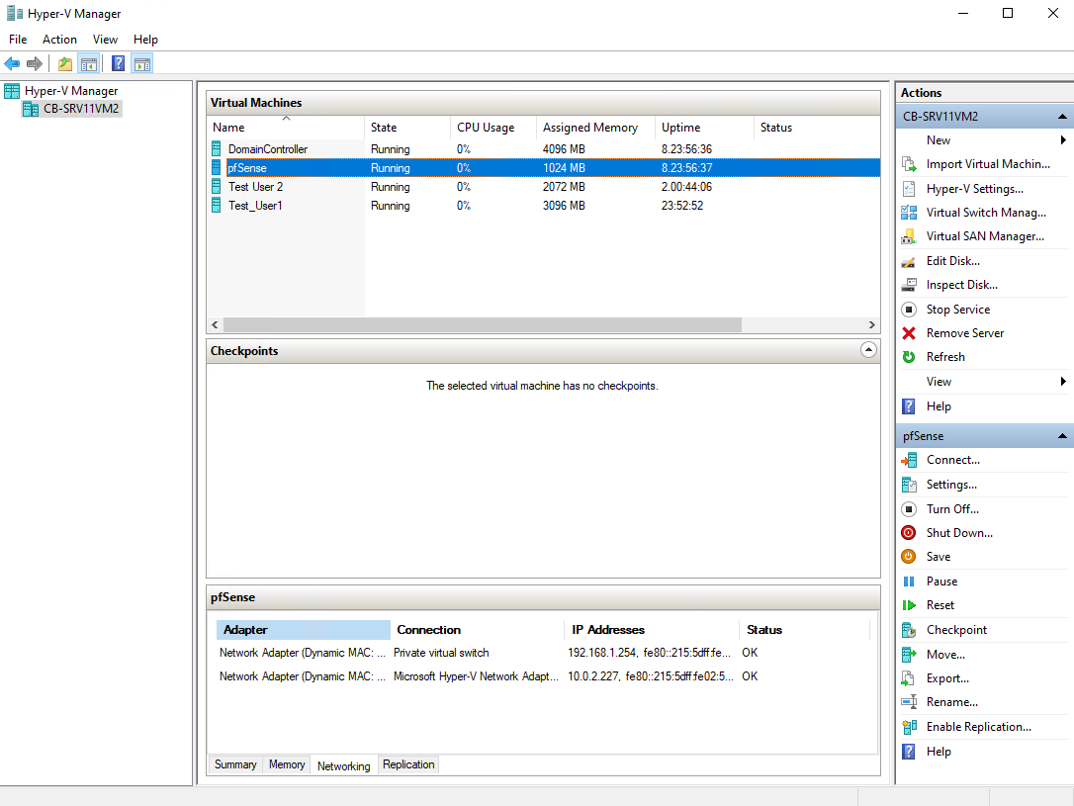Last but not least, our Hyper-V manager. Hyper-V is used for setting up the virtual machines, the DC/AD and our pfSense.