Process report case study 2

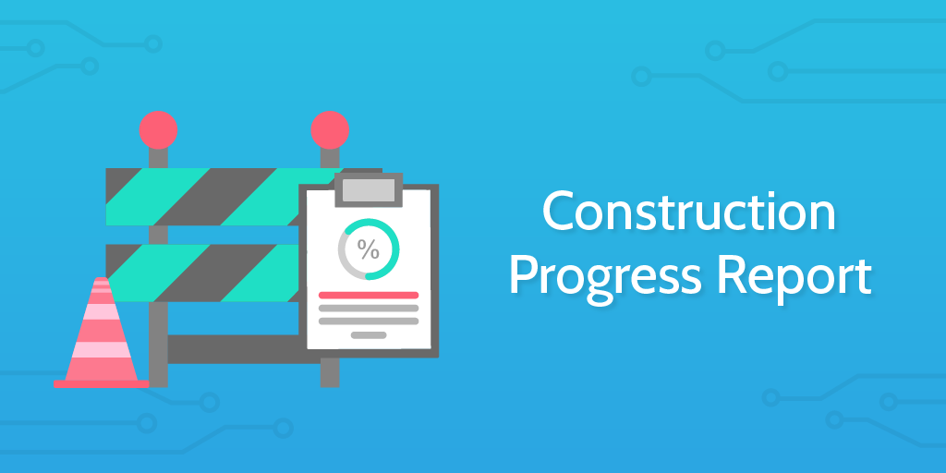

|  |
| --- |
| Authors: Yoan-Asen Popov, Mihai Glodici, Joep Vinken  Student Number: 4472152, 4538528, 4475003  Class & group: I02, group 8  Assignment: Case study 2 infrastructure |

# Table of contents

Table of contents 2

Global work division 3

Week 1 3

Minutes 3

Agenda 3

Work division 3

Week 2 3

Agenda 3

Work division 3

Week 3 4

Agenda 4

Work division 4

Week 4 4

Agenda 4

Work division 4

Week 5 4

Agenda 4

Work division 4

Week 6 5

Minutes 5

Agenda 5

Work division 5

Week 7 5

Agenda 5

Work division 5

Mark justification 6

Our own mark 6

Strong and weak points 6

Individual reflections 6

Mihai 6

Yoan 6

Joep 7

# Global work division

Overall, the work division could have been better. Some of us did more tasks than the other which resulted in more workload per member. This could have been prevented by dividing the work evenly both practical and documentational. Even though this could have been better, we agree on putting up a very nice case study whit a resulted we more or less had in mind. All the services we created worked fine and as we intended to.

# Week 1

Minutes

Topic

* Present the idea pitch
* Request feedback on first idea
* Ask for additional feature tips

Result

* Successful presentation pitch
* Mehrzad advised us not to use 'business plan' in this context because it wasn't a real plan
* Discussed the ideas and Mehrzad even told us this could be an idea for an actual company
* Advised us to start with the documentation as well so this won’t fall behind

## Agenda

1. Make the project plan
2. Idea pitch

## Work division

* Everyone contributed to the preparation of the presentation and project plan

# Week 2

## Agenda

1. Setup of IDS/IPS

## Work division

* Yoan: Setup of IDS/IPS
* Joep: not applicable due to circumstances
* Mihai: not applicable

# Week 3

Agenda

1. Start on chat application
2. Start on currency calculator

## Work division

* Yoan: Chat application
* Joep: Currency calculator
* Mihai: Not applicable

# Week 4

## Agenda

1. Make the Design Document
2. Setup Plex
3. Make first BASH script
4. Setup RADIUS for the chat application

## Work division

* Yoan: BASH, RADIUS
* Joep: Design Document
* Mihai: Plex

# Week 5

Agenda

1. Start on Flask application
2. Setup NagiosXI
3. Network Diagram
4. Setup SQL Server

## Work division

* Yoan: Flask, SQL Server, NagiosXI
* Joep: NagiosXI, Network Diagram
* Mihai: Not applicable

# Week 6

Minutes

Topic

* Present our progress

Result

* Advised us to make little improvements

## Agenda

1. Pen-testing of our system
2. Make second BASH script
3. Make the final presentation
4. URS

Work division

* Yoan: Pen-test, BASH, Presentation
* Joep: Pen-test, Presentation
* Mihai: URS

Week 7

Agenda

1. Pen-test report
2. Process report
3. Hand-in everything

Work division

* Yoan: Pen-test report, Process report
* Joep: Pen-test report, Process report
* Mihai: not applicable

Mark justification

## Our own mark

We think we did a quite good job, and the result is something we are pretty proud of. In comparison to the other groups, we think a **Sufficient** reflects on our final result, including documentation.

## Strong and weak points

The strong points of our process are the meetings we had with our mentor (Mehrzad). We also handed in all the documentation in time, which is always a good thing. The strong points for the system are as following. We have met the minimum constraints for 95%. We added multiple useful applications which should make the life of an employee easier and more efficient. The weak points of our process are not having a very good planning, time management and work division. It sometimes felt like we were in a group of only two members. One of the downsides of our system is not using a database server for signing in in the Flask web application. Another downside is not using High Availability or a Design for Failure service. We were only able to do the pfSense HA on a local lab.

# Individual reflections

## Mihai

## Yoan

One of my strong traits that affected the project is the knowledge about programming. Because I have more understanding, it was more efficient that I did most of the programming. Another strong point is my unquenchable thirst for knowledge. And that had led me to some rabbit holes about technical stuff. My biggest weak point is leadership. If I had more experience with that kind of projects, I think I would have helped my team a lot more in terms of time management and work division. This project gave me more opportunities to develop even more my soft skills and technical ones. I learned that in technical terms everything is possible with the correct amount of research. Also, that teamwork is really very important. I think the spent time and effort for this project was good, because in my opinion everyone learned something new from the others. However, I feel like that it can be improved one. Sometimes it felt like some people worked more than others and that bottlenecked the process of work. For my next project I will do better with time management, load of work and leadership.

## Joep

I think the communication in the group was pretty good from my side and we managed to work in both group and individual form. I also think my effort for this case study was on point and I made progress in both technical and soft skills.  
On the other hand, one of the negatives we suffered, was me not being able to work on the project for a week. I feel like this effected the whole case study and the teammates. This also resulted in having to catch up quite some bullet points towards the end.   
The biggest learning moment for me isn't really narrowed down to only one thing. I learned a lot of new stuff such as using NagiosXI, but also using live data in a TKinter application written in Python. I also learned something quite important from Yoan, which is how to look up stuff. Yoan is really good in finding answers on the internet and this wasn't always my strong suit. I think Yoan really helped me improving this skill, which will be really useful for the rest of my life.  
For my feeling, the effort I put in the project really reflected in the final result whit some nice features and good communication between the services we added to the server. I think that if time management would be better, the final result could have been even better and more professional.  
For the improvements, I think it is important to stay curious about learning new things and how to work with them. I also think that time management could be better in the future because it sometimes can be hard for me to combine a social life, school work and my side job all at ones. Making a better schedule could result in more free time and less stress when thinking about finishing everything in time and going to appointments and such.  
Overall, I am really pleased with the final result but I feel like the teamwork and work division could have been better. It sometimes felt like some did more for this project than others. Although I have this feeling, I am happy we finished everything like we wanted to and we didn't have to make big compromises.