Brand Audit for DOVE

Student’s Full Name: Mohammadali Ghaderi
Student’s Program: MSc in IT for Business Data Analytics
Module: Managing Global Brands
Academic Year / Semester: Spring 2026
Word Count : 2482
Seminar leader: Gábor Rekettye PhD
Due Date: Friday, 8 May 2026, 10:00 AM

Contents
Introduction 1
History of Dove and its Role within Unilever 1
Branding 2
3.1 Brand Elements 2
3.2 Products 4
3.3 Pricing 4
3.4 Distribution 4
3.5 Communication and Advertising 5
Brand Analysis 5
4.1 Brand Resonance Pyramid 5
4.2 Competitive Analysis 7
4.3 Brand Mantra 8
Strategy Recommendations 8
Summary 9
References 10

Introduction
This brand audit evaluates the status of Dove, an international personal care brand owned by Unilever. The purpose of the audit is to identify the main sources of Dove’s brand equity, assess its market position, and recommend how the brand can be strengthened and extended in the future. In Keller’s terms, a brand audit should examine both the visible marketplace expression of the brand and the consumer associations that shape customer-based brand equity (Keller, 2013).
This audit is based on secondary data and follows Keller’s brand audit logic: brand inventory, brand exploratory interpretation, competitive positioning, and recommendations. The analysis applies Keller’s CBBE/resonance model, Kapferer’s identity prism, and POP/POD comparison to evaluate Dove’s brand equity from both company and consumer perspectives.
Dove is a strong choice for this assignment because it combines two things that do not always appear together in one brand: clear product-based differentiation and strong emotional meaning. It began as a beauty bar with a moisturizing advantage, but over time it developed into a much broader brand associated with self-esteem, inclusive beauty, and authentic representation (Unilever, 2023; Unilever, 2024a). Dove is also one of Unilever’s most important brands, so its value lies not only in consumer markets but also in the company’s wider brand portfolio (Unilever, 2023).

History of Dove and its Role within Unilever
Dove was launched in the United States in 1957 with the introduction of the Dove Beauty Bar. According to Unilever, the product’s background goes back to 1952, when the company acquired a French patent for a mild cleansing bar enriched with moisturizers rather than formulated like ordinary soap. After further development in Unilever’s laboratories, the Dove Beauty Bar entered the market with the promise that, because it contained ¼ moisturizing cream, it would cleanse without drying the skin in the same way as ordinary soap (Unilever, 2023).
In its early years, Dove built its reputation through functional superiority. Unilever notes that by 1969, the brand was already using real women’s testimonials in its advertising, and by 1979, dermatologists were recommending the product. This gave Dove strong credibility and helped position it as a skin-friendly alternative in the cleansing category (Unilever, 2023).
The next important stage was expansion. Between 1991 and 1994, Dove entered 55 new countries, and from 1995 to 2000 it moved beyond the original beauty bar into deodorants, body washes, body lotions, facial cleansers, and haircare. Later, Dove Men+Care was launched in 2010, followed by Baby Dove in 2017. This showed that Dove was no longer just one successful product but a wider care brand that could stretch into related categories without losing its identity (Unilever, 2023).
The most important turning point came in 2004 with the Campaign for Real Beauty. This changed Dove from a primarily product-led brand into a purpose-led one. Instead of depending only on functional claims, Dove began to challenge narrow beauty ideals by featuring real women in its communications. Unilever argues that this shift helped build stronger affection and loyalty over time (Unilever, 2024a). In 2024, Dove updated this same position by promising never to use AI-generated or digitally distorted images of real women in its advertising, linking the brand’s values to a current cultural issue (Unilever, 2024a).
Within Unilever, Dove plays a major strategic role. Unilever described Dove in 2023 as one of the company’s three biggest brands, selling more than €5 billion worth of products annually, and later reported €6 billion turnover in 2023 (Unilever, 2023; Unilever, 2024a). This makes Dove more than a successful consumer brand. It is also a major growth driver and an important symbol of Unilever’s position in Beauty & Wellbeing and Personal Care.

Branding

3.1 Brand Elements
Brand elements matter because they identify the brand, make it memorable, and shape how consumers interpret it (Keller, 2013).
The name “Dove” is one of the brand’s strongest assets. It immediately suggests softness, gentleness, peace, and purity, which fit the brand’s long-standing promise of mild and caring personal care. The logo supports this meaning. Dove uses a blue wordmark together with a gold dove bird, creating visual associations with trust, softness, calmness, and understated premium quality.
The brand’s color palette of blue, white, and gold strengthens that impression further. Blue suggests trust and reliability, white suggests cleanliness and simplicity, and gold adds a light premium feel without making the brand seem exclusive. Although 1000logos is not a core strategic source, it is useful for tracing the visual development of the logo. It shows that Dove’s logo changed across the periods 1955–1969, 1969–2004, 2004–2012, and 2012–today, but always kept a strong sense of continuity in symbol, style, and overall mood (1000logos, 2025).
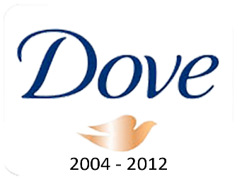
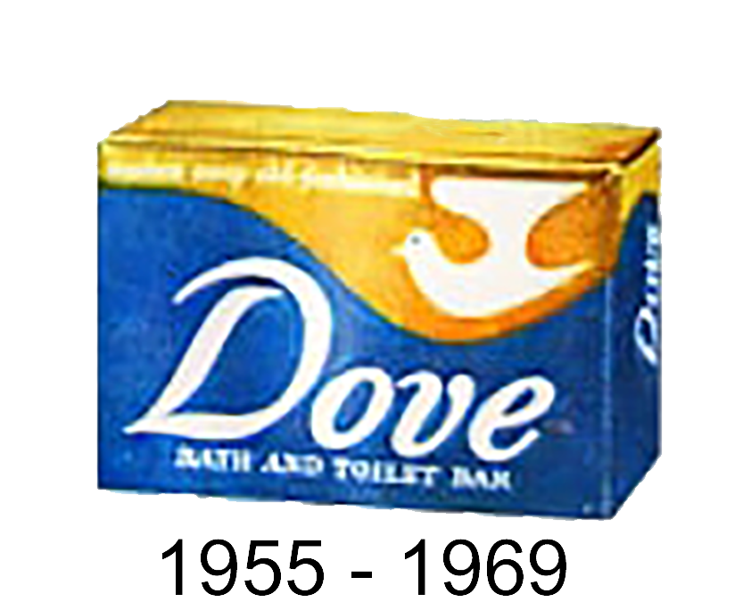
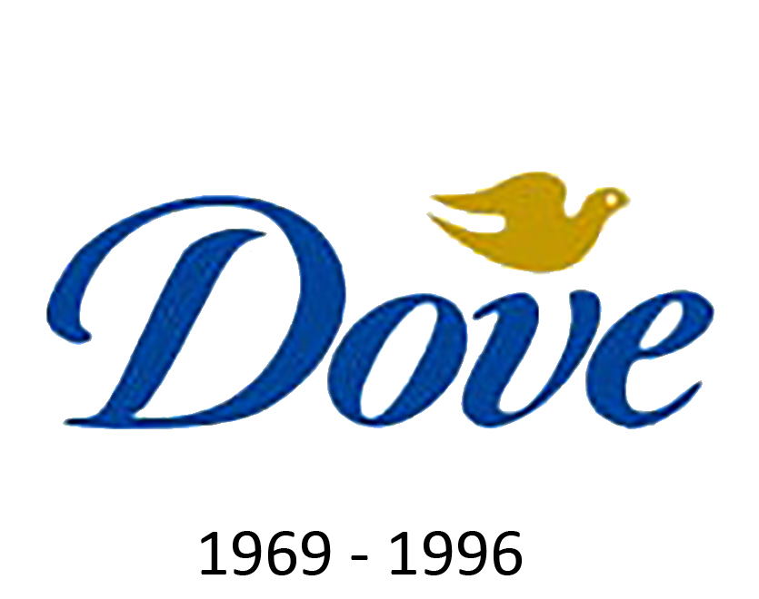
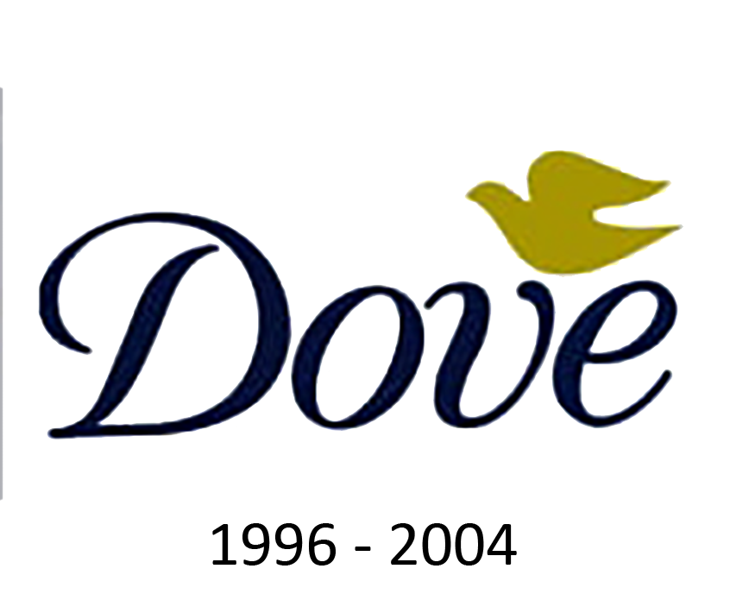
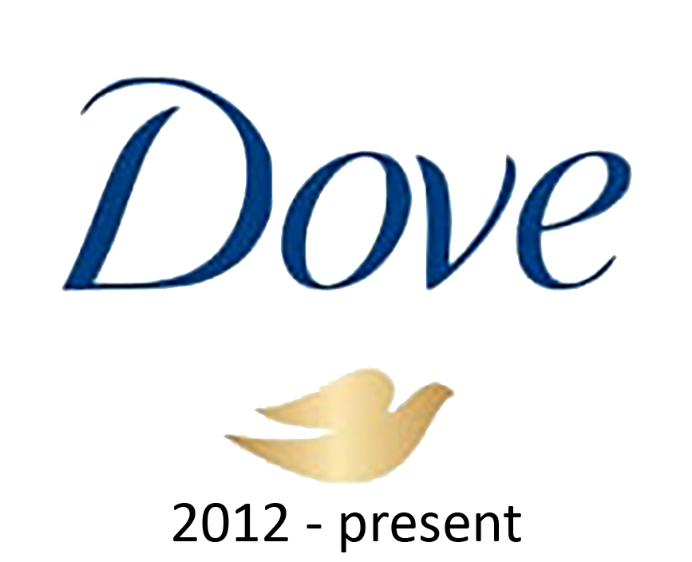
Figure 1. Evolution of the Dove logo, 1955–present.
This visual continuity is important because it protects recognition while allowing gradual modernization. The current logo still feels connected to the original identity, which helps preserve brand heritage (1000logos, 2025).
Dove’s packaging is also an important brand element. Across bars, body washes, lotions, and deodorants, it is usually clean, simple, and visually consistent. It avoids the dramatic glamour often seen in beauty categories and instead emphasizes softness, care, and reliability. In this sense, packaging does not just contain the product; it also reinforces Dove’s brand meaning at the point of purchase (Keller, 2013).
The brand’s strongest verbal element is its message that beauty should be “a source of confidence, not anxiety.” On Dove’s official vision page, the brand explains that it wants to help women and girls develop a positive relationship with the way they look. The same page reports that only 4% of women globally consider themselves beautiful and that six out of ten girls are so concerned about their appearance that they withdraw from parts of daily life (Dove, n.d.). This gives Dove a distinctive verbal identity built around emotional support and empowerment, not only around product performance.
Dove does not rely heavily on mascots or celebrity characters. Instead, it uses real women, diverse representation, and emotionally relatable storytelling. This supports the brand’s claims of authenticity and makes its identity feel more socially grounded than conventionally glamorous (Unilever, 2024a).
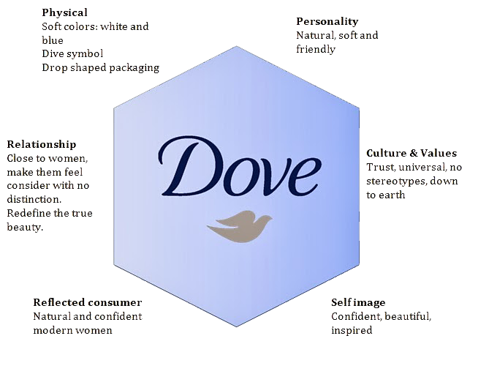
The prism shows that Dove’s identity is built around softness, trust, and inclusivity. Its physical and visual elements communicate care and simplicity, while its personality and values emphasize authenticity and support. The reflected consumer and self-image dimensions also reinforce Dove’s broader purpose of confidence-building rather than idealized beauty.
Figure 2. Dove Brand Identity Prism.

3.2 Products
Dove now covers multiple personal care categories. Unilever identifies the brand with body washes, lotions, haircare, deodorants, antiperspirants, and the original Beauty Bar, as well as Men+Care and Baby Dove ranges (Unilever, 2023; Unilever, n.d.). The important point is that this wider portfolio still fits one central promise: gentle, confidence-building care.

3.3 Pricing
Dove appears to occupy a mass-premium position. It is not a luxury beauty brand, but it is also not presented as a basic low-cost hygiene option. Its pricing logic seems to support the idea that consumers are paying for better care, trusted quality, and a more meaningful brand identity. This fits Keller’s view that price works together with product, communication, and distribution to shape customer-based brand equity (Keller, 2013).

3.4 Distribution
Dove’s distribution strategy is based on wide availability. Unilever reports that Dove is present in more than 80 countries, which helps keep the brand visible, easy to find, and relevant in everyday purchase situations (Unilever, 2023). For an FMCG brand, this kind of accessibility is crucial because it supports routine purchase and long-term familiarity.

3.5 Communication and Advertising
Dove’s communications are one of its strongest sources of equity. Since 2004, the brand has used the Campaign for Real Beauty to challenge narrow and unrealistic beauty standards. Unilever states that the campaign was inspired by research showing that only 2% of women in a ten-country study considered themselves beautiful, and Dove used this insight to reposition beauty as something broader and more positive (Unilever, 2023).
The Dove Self-Esteem Project is especially important because it turns this idea into ongoing action. Dove states that the project was founded in 2004, provides self-esteem education through schools, youth groups, and online resources, and aims to reach ¼ billion young people by 2030 (Dove, n.d.). Unilever’s current brand page reports that the project has already reached over 136 million young people across 153 countries (Unilever, n.d.). This makes the project one of the clearest examples of Dove linking brand purpose to a real long-term program.
This communication strategy gives Dove an advantage over competitors that focus more narrowly on anti-ageing, freshness, or technical performance. At the same time, Dove still links its communication to product care. Unilever continues to describe the brand as offering “superior care products” and “clinically superior products,” which helps prevent the brand from becoming all message and no product substance (Unilever, n.d.).
This positioning is clearly reflected in Dove’s Real Beauty campaigns, which feature diverse and unedited representations of women (see Appendix D).
However, Dove’s purpose-led positioning also creates risk. Because Real Beauty is built on authenticity, any perceived gap between social purpose and commercial selling could weaken trust. Academic work on Dove notes that the campaign can be read both as social change communication and as commercial cause branding, so its credibility depends on continued consistency between message, product, and action (Murray, 2013).

Brand Analysis

4.1 Brand Resonance Pyramid
Customer-based brand equity refers to the effect that brand knowledge has on how consumers respond to the brand’s marketing, and strong equity depends on strong, favorable, and unique associations (Keller, 2013).
Dove performs well across Keller’s Brand Resonance Pyramid. Brand salience is high because Dove is globally available, easy to recognize, and present in several daily-use categories. Brand performance is strongly linked to mildness, moisturization, and skin-friendly care, especially through the ¼ moisturizing cream heritage and dermatologist endorsements (Unilever, 2023; Unilever, n.d.). Brand imagery is particularly strong, built around authenticity, inclusivity, and the use of real women rather than idealized beauty stereotypes (Unilever, 2024a).
At the judgments level, Dove is likely to be seen as trustworthy, high-quality, and socially credible. At the feelings level, the brand most strongly evokes warmth, security, reassurance, and self-respect, which matches the emotional tone of its communication (Keller, 2013). At the top of the pyramid, resonance seems to be based mainly on habitual loyalty, emotional trust, and value alignment rather than fan culture. In other words, Dove’s relationship with consumers is steady and intimate rather than cult-like or exclusive.

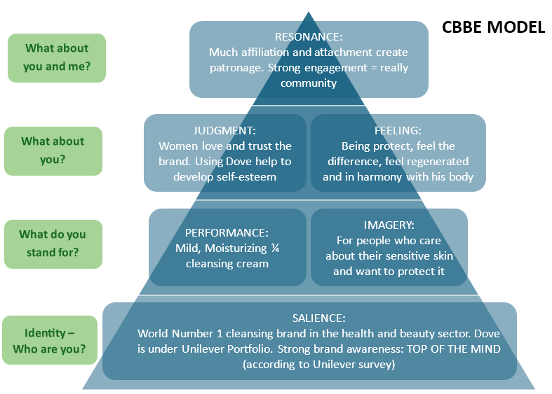
Figure 3. Dove Brand Resonance Pyramid (adapted from Keller, 2013).

4.2 Competitive Analysis
Table 1 presents a comparative overview of Dove’s key competitors, highlighting differences in price positioning, core promise, and both functional and emotional positioning.
Brand | Main positioning | POD | POP with Dove | Weakness vs Dove
Dove | Gentle, inclusive, confidence-building care | Real Beauty + mild care | Cleansing, moisturizing, daily care | Purpose must stay credible
Nivea | Trusted everyday skin care | Heritage, family care, skin expertise | moisturizing, accessibility | Less distinctive social purpose
Olay | Science-led anti-ageing skin care | Anti-ageing and facial skincare expertise | Skin care performance | Narrower age/beauty focus
L’Oréal | Aspirational beauty and self-worth | Glamour, innovation, “worth it” message | Beauty confidence | More premium/aspirational than inclusive
Neutrogena | Dermatological performance | Clinical/skin-health credibility | Skin care safety | Less emotional warmth
The Body Shop | Ethical/natural activism | Sustainability and activism | Values-based beauty | Less mass-market accessibility
Table 1. Comparative overview of Dove’s key competitors

This comparison shows that Dove’s strongest advantage is not one isolated product feature, but the combination of functional mildness, mass accessibility, and inclusive emotional meaning.
As shown in Table 1, Dove achieves differentiation primarily through its strong purpose-led positioning and emphasis on inclusive beauty, while maintaining key points of parity such as effective cleansing and moisturizing performance (Keller, 2013).
Effective positioning depends on identifying the right competitive frame of reference and balancing points of parity with points of difference (Keller, 2013).
Dove competes broadly in personal care, especially in cleansing, body care, deodorants, and some haircare categories. Its most relevant direct competitors are brands such as Nivea, Olay, and Palmolive, because they overlap most clearly in mainstream skin and body care. Indirect competitors include dermatological skincare brands and natural or organic care brands that attract consumers looking for specialist or “clean” positioning.
Dove’s main points of parity are effective cleansing, moisturization, product safety, pleasant usage experience, and wide accessibility. These are basic expectations in the category. Its points of difference are more powerful. First, Dove has a long-standing functional advantage based on mild cleansing and moisturizing care. Second, it has a clear imagery-based advantage through Real Beauty and inclusive representation. Third, it has a strong purpose-based advantage through the Dove Self-Esteem Project and related initiatives. Together, these make Dove distinctive in ways that many personal care competitors do not match.

4.3 Brand Mantra
A brand mantra should express the essence of the brand in a short and memorable way (Keller, 2013).
For Dove, a suitable brand mantra is:
Gentle, inclusive, confidence-building care.
This works because gentle reflects the brand’s care heritage, inclusive reflects Real Beauty and diversity, confidence-building reflects the Self-Esteem Project, and care keeps the brand anchored in actual product performance.

Strategy Recommendations
First, Dove should protect the link between purpose and product superiority. The audit shows that Dove’s equity depends on both mild, moisturizing care and Real Beauty associations. Therefore, product communication should continue to show clinical care benefits beside self-esteem messages. This would protect performance-based judgments and prevent Dove from becoming only a symbolic purpose brand (Keller, 2013; Unilever, n.d.).
Second, Dove should formalize its authenticity standards. Since Real Beauty depends on trust, Dove should make its anti-distortion and anti-AI commitments more visible across campaigns, packaging QR codes, and digital content. This would reduce skepticism and strengthen brand credibility, especially because purpose-led brands are vulnerable when consumers perceive inconsistency between claims and actions (Murray, 2013; Walter and Klein, 2024; Unilever, 2024a).
Third, Dove should extend only into categories that fit its core meaning, such as sensitive skincare, scalp care, and body serums. Extensions based mainly on glamour, exclusivity, or status beauty should be avoided because weak fit can dilute parent-brand meaning and damage brand equity (Keller, 2013).
Finally, Dove should keep global consistency but adapt local examples of beauty pressure. The brand mantra can remain stable, but campaign execution should reflect local cultural anxieties around appearance, age, skin, and digital beauty standards, because global brand equity requires balancing standardization with local adaptation (Keller, 2013).

Summary
Dove is a strong international brand whose equity has been built in stages: first through product performance, then through international growth, and finally through emotionally resonant, purpose-led branding. Its main strengths are a clear heritage, coherent brand elements, high salience, trusted care-based performance, and a distinctive social mission centered on confidence rather than anxiety. Unilever’s own statements also confirm that Dove is strategically important within the company, not just successful in the market (Unilever, 2023; Unilever, 2024a).
The brand’s main challenge is to keep balancing functional superiority, inclusive representation, and authentic purpose. If Dove continues to link strong product care with credible social relevance, it should remain well positioned to maintain and extend its brand equity over time.

References
Dove (n.d.) Our vision. Available at: https://www.dove.com/ca/en/stories/about-dove/our-vision.html (Accessed: 6 April 2026).
Keller, K.L. (2013) Strategic Brand Management: Building, Measuring, and Managing Brand Equity. 4th edn. Harlow: Pearson.
Unilever (2023) Behind the brand: Dove’s products, purpose and commitment to care. Available at:
https://www.unilever.com/news/news-search/2023/behind-the-brand-doves-products-purpose-and-commitment-to-care/ (Accessed: 6 April 2026).
Unilever (2024a) 20 years on: Dove and the future of Real Beauty. Available at:
https://www.unilever.com/news/news-search/2024/20-years-on-dove-and-the-future-of-real-beauty/ (Accessed: 6 April 2026).
Unilever (n.d.) Dove. Available at: https://www.unilever.com/brands/beauty-wellbeing/dove/ (Accessed: 6 April 2026).
1000logos (2025) Dove logo and symbol, meaning, history, PNG, brand. Available at:
https://1000logos.net/dove-logo/ (Accessed: 6 April 2026).
Murray, D.P. (2013) ‘Branding “Real” Social Change in Dove’s Campaign for Real Beauty’, Feminist Media Studies, 13(1), pp. 83–101.
Walter, N. and Klein, K. (2024) ‘Act as you preach! Authentic brand purpose versus “woke washing’s” impact on brand credibility’, Journal of Business Research, 179, Article 114685.

Excluding the cover page, table of contents, references and appendices.

