
Modeling Blood Glucose Dynamics Using Nonlinear Regression

Assignment Report

Submitted By:
Manish Gopal Karanjit
Softwarica Student ID: 250312
Faculty of Engineering, Environment and Computing
Coventry University,
Softwarica College of IT and E-commerce

Supervised By:
Lecturer Hikmat Saud
7089 CEM: Introduction to Statistical Methods for Data Science

Table of Contents
Introduction 1
Task 1 Preliminary Data Analysis 1
1.1 Time Series Plot 1
1.1.1 - Bg_mean 2
1.1.2 - Insulin_sum 2
1.1.3 - Carbs_sum 2
1.1.4 - Hr_mean 2
1.1.5 - Steps_sum 2
1.1.6 - Cals_sum 2
1.1.7 - Output signal 2
1.2 - Distribution Plot 3
1.2.1 - BG_Mean 3
1.2.2 - Insulin_sum 4
1.2.3 - Carbs_sum 4
1.2.4 - Hr_mean 5
1.2.5 - Steps_sum 5
1.2.6 - Cals_sum 6
1.3 - Correlation and Scatter plots 6
Task 2: Regression – Modelling the relationship between gene expression 8
Task 2.1: Estimate model parameters using Least Squares 8
Task 2.2: Residual sum of squared errors(RSS) 9
Task 2.3: Log-likelihood function 10
Task 2.4: AIC and BIC 10
2.4.1 - Akaike Information Criterion (AIC) 10
2.4.2: Bayesian Information Criterion (BIC) 11
Task 2.5 12
Task 2.6 14
Task 2.7 15
Task 3 – Approximate Bayesian Computation (ABC) 18
3.1 – Selection of parameters 18
3.2 Prior specification 18
3.3 Rejection ABC sampling 18
3.4 Joint and marginal posterior distributions 19
3.5 Result and interpretation 19
Conclusion 20
References 21
Appendix 22

Table of figures
Figure 1: Input signal’s time series plot 6
Figure 2: Output signal’s time series plot 8
Figure 3: bg_mean’s distribution plot 9
Figure 4: Insulin_sum’s distribution plot 9
Figure 5: Carbs_sum’s distribution plot 9
Figure 6: Hr_mean’s distribution plot (before and after imputation) 10
Figure 7: Steps_sum’s distribution plot 10
Figure 8: Cals_sum distribution plot 11
Figure 9: Scatterplot of input versus output 12
Figure 10: Correlation matrix of variables 12
Figure 11: Model parameters value from least square 14
Figure 12: RSS of each model 14
Figure 13: likelihood outcome of Models 15
Figure 14: AIC of each model 16
Figure 15: BIC of each model 17
Figure 16: Q-Q plots of model residuals 18
Figure 17; ACF plots of residuals for every Models 18
Figure 18: Cook’s distance plots for every Model 19
Figure 19: Best Model selection 20
Figure 20: Distribution of training o/p data 21
Figure 21: Distribution of Training Residuals 21
Figure 22: Test data versus predicted o/p for model 5 with 95% prediction interval 22
Figure 23: Zoomed comparison (first 300 samples) 22
Figure 24: parameter selection 23
Figure 25: Required values 23
Figure 26: Joint Posterior Distribution (rejection ABC) 24
Figure 27: Marginal Posterior Distribution of selected parameters 24

Introduction
Blood glucose matters to people with T1D since it reflects what balances when insulin gets delivered, when carbohydrate gets taken, when people get physical, and when processes metabolize. Predicting the value of blood glucose could help in maintaining the level of this variable in a physiological range, to avoid both hypoglycemia (low blood sugar) and hyperglycemia (high blood sugar). bg+1:00 was taken into account as per blood glucose & time, which was fed with the current glucose value, insulin delivery, carbohydrate intake, heart rate, steps, and calories burned. Therefore, statistical regression approaches were used to analyze the time series of the blood glucose values. A predictive regression model was selected based on the performance of the regression models.

Task 1 Preliminary Data Analysis

Time Series Plot
Plotting the necesasary data against time in this plot makes it easier to understand the event that created it. A time-series plot displays the observed data on the Y-axis whereas time on the X-axis.
Time series plots were put to use to investigate the temporal dynamics, variability, & non-stationary behavior of multivariate input data as well as blood glucose output. This first investigation validates the dynamic character of the system and encourages the application of nonlinear regression models for forecasting projected levels of blood sugar.
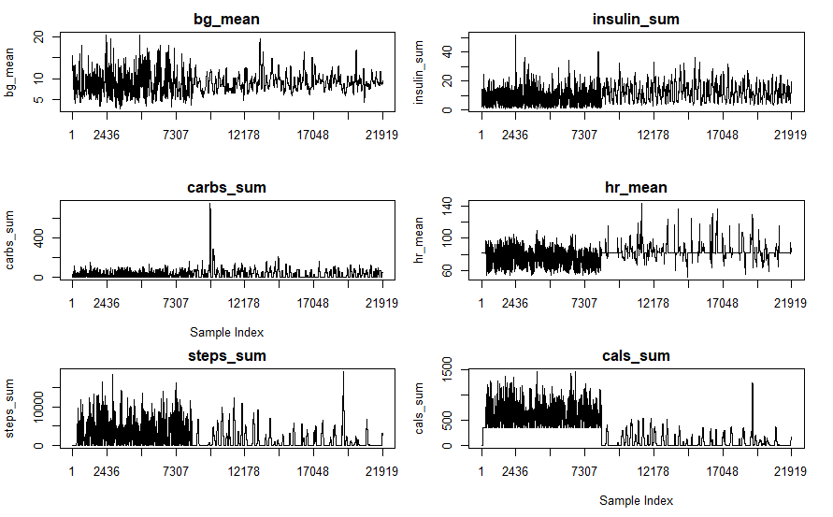
Figure 1: Input signal’s time series plot

1.1.1 - Bg_mean
The prior blood glucose pattern exhibits continuous changes over the period of time, with more changes in the early phases & smoother behavior afterwards. This shows that the signal is dynamic, including no constant mean, pointing to instability. The lack of extended flat patches suggests that glucose history fluctuates constantly and contains significant temporal information.

1.1.2 - Insulin_sum
The insulin signal consists of many tiny pulses and occasional bigger peaks. The readings tend to concentrate at low levels, exhibiting erratic spikes dispersed across time.

1.1.3 - Carbs_sum
The intake of carbohydrate signal is usually nil or tend to zero, with occasional high spikes. These spikes appear occasionally but determine signal’s spectrum.

1.1.4 - Hr_mean
Heart rate has a generally steady baseline, with modest rises and more variability during activities. Unlike insulin & carbohydrates, it fluctuates constantly & smoothly.

1.1.5 - Steps_sum
Signal of steps is made up of of dense clusters of strong activity followed by extended idle intervals. The amplitude of steps changes dramatically over time, with distinct variances between active and passive phases.

1.1.6 - Cals_sum
It’s time series exhibits activity-dependent fluctuation, with values approaching zero during idle periods and higher magnitudes throughout activity bursts, demonstrating a right-skewed, non-stationary distribution.

1.1.7 - Output signal
output variable bg+1:00’s time series fluctuates significantly during a 24-hour period, with bigger variations & more frequent spikes in the initial period (about 00:00 to 08:00). In this time, the signal shows large swings as well as abrupt peaks, depicting increased unpredictability. From almost mid axis, there are less variations & more consistent, with fewer sharp spikes. This demonstrates that the fluctuation in future blood glucose is time-dependent, with more instability in the early hours and more regulated behavior later in the day.
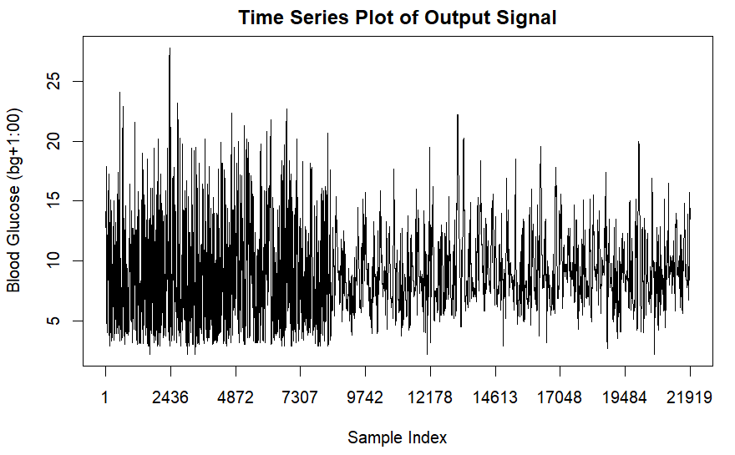
Figure 2: Output signal’s time series plot

1.2 - Distribution Plot
A distribution, arranged within smallest to greatest, explains the relationship between sample data and observed outcomes. Before performing any modeling or prediction, distribution graphs are employed to understand the behavior of a given variable. They display the majority of values, their dispersion, and the presence of anomalous or extreme observations. Here comparing of the input data like past glucose readings, insulin dose, carbohydrate intake, heart rate, taken steps, and calories burned are done.

1.2.1 - BG_Mean
Including small right skew, bg_mean’s distribution is unimodal & almost like bell-shaped. The density spike is placed between 9 & 10 mmol/L, suggesting that mean is almost close to this central value. A small amount of asymmetry is made by the right tail, which occasionally reflects kind of higher prior glucose levels.
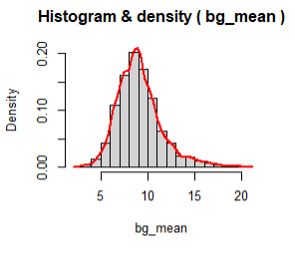
Figure 3: bg_mean’s distribution plot

1.2.2 - Insulin_sum
The distribution insulin_sum is mostly right-skewed, with the significant observations concentrated at low ranges & a lengthy tail at higher dosages. This implies that insulin is normally provided in tiny dosages, with occasional bigger doses raising the mean relative to the median.
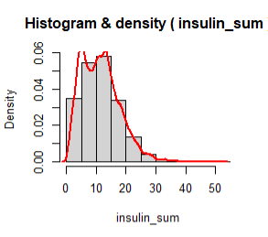
Figure 4: Insulin_sum’s distribution plot

1.2.3 - Carbs_sum
Here, it illustrates that the distribution is kind of very right-skewed & heavily biased toward 0, where most of them are near to zero & a extended upper tail that spreads to high values. This indicates occasional yet significant carbohydrate ingestion periods, resulting in a high tail distribution.
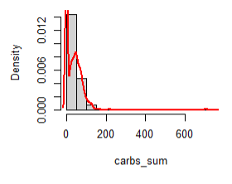
Figure 5: Carbs_sum’s distribution plot

1.2.4 - Hr_mean
For the Hr_mean, the missing data are replaced by the taking median of the existing data so that it can significantly impact on the reliability & accuracy while doing its analysis.
During no imputation, the peak is smooth as well as natural and the variability is preserved. The outlier’s sensitivity is relatively not affected and the distribution is mostly realistic.
After median imputation, the plot is narrow & sharply peaked with majorities are clustered around a core range(75-85bpm). Sharply peaked means variability is slightly reduced and the outlier’s sensitivity is low. The realism of distribution after imputation have mild distortion on plot. However minor right tail shows ocassional upsurged heart rate at the time of exercise.
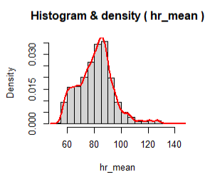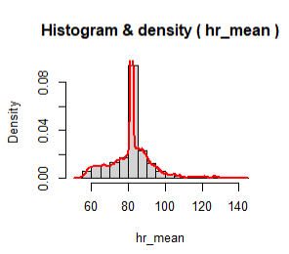
Figure 6: Hr_mean’s distribution plot (before and after imputation)

1.2.5 - Steps_sum
The plot is heavily right-skewed that includes the huge concentration of low values & lengthy tail pointing to high step counts. This indicates little activity on most of the time periods but when it happens, it occur with high amplitude.
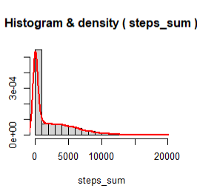
Figure 7: Steps_sum’s distribution plot

1.2.6 - Cals_sum
It’s sum also kind of behave similar to steps_sum where plot is right skewed with majority values at low levels and starts to fall towards higher values which tells that the calories burned is mostly influenced by intense activities.
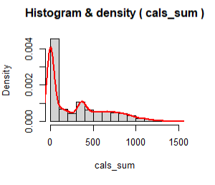
Figure 8: Cals_sum distribution plot

1.3 - Correlation and Scatter plots
Figure of scatterplot demonstrates the link between the input & output datasets. Here, the single dot denotes just a single piece of data whereas many dots reflect distinct patterns depending on their proximity. The red smooth line indicates the overall trend in data. A positive correlation occurs when the output increase in accordance with input, whereas a negative correlation occurs when output drops as input grows. And no or zero correlation represents that the change in input does not have any impact on output.
According to scatterplots, bg_mean has kind of strong positive link with the output, showing higher present glucose levels tend to result in higher future glucose readings. The carbs_sum & insulin_sum have weak, nonlinear correlations with outcomes. The other remaining output(hr_mean, steps_sum, cals_sum) have slight negative or near-zero trends, indicating that each has a limited direct impact on output.
The correlation matrix heatmap quantitatively supports these findings. Of all input variable, bg_mean tends to show high positive correlation with Y(bg+1:00). The correlation shown by insulin_sum and carbs_sum are weak & nonlinear. Also other variable like hr_mean, steps_sum and cals_sum shows weak negative correlation. So, on overall basis no any input variable has perfect correlation with output confirming nonlinear & multivariate relationship which supports the use of non-linear regression models to make accurate predictions.
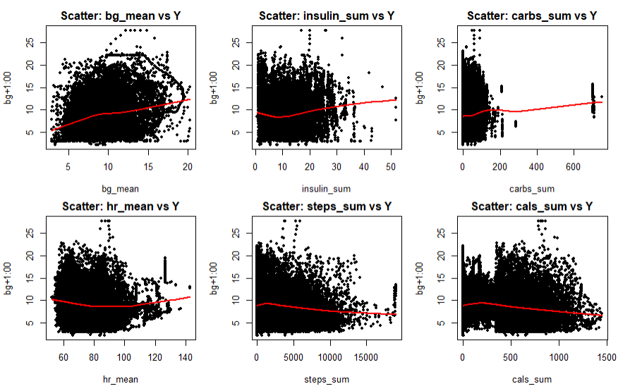
Figure 9: Scatterplot of input versus output
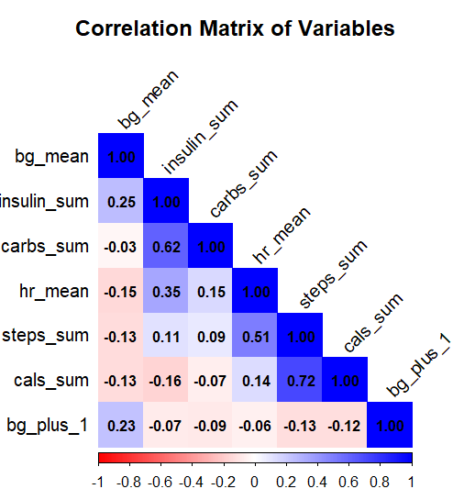
Figure 10: Correlation matrix of variables heatmap

Task 2: Regression – Modelling the relationship between gene expression

Task 2.1: Estimate model parameters using Least Squares
This task’s main function is to chose the unknown model parameters θ={θ₁​,θ₂​,…,θ_{p}​}^{T} . For each of the 5 possible models, the approach called Least squared (LS) is implemented. Here, the LS technique evaluates the model parameter by minimizing the squared residual’s sum, which are the variations between obtained output values & the model-predicted values.
Here, each potential model indicates the different non-linear polynomial relationship among the input variables X= [x₁, x₂,x₃,…..,x₆] & the output variable which is denoted by y=bg+1:00. This model can be represented in the form of matrix as:
y=X$θ$+€
where X is called as design matrix created corresponding to the structure of each candidate model which includes polynomial as well as interaction elements, here € denotes the error term and $θ$ represents the regression coefficient’s vector.
Also the parameter’s least squares estimator is given as:
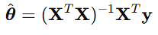
Where X is also design matrix created from input variables & y is output vector. In R, such computation is performed using the function called lm() that computes least squares solution. Also clean response is produced initially through output variables followed by a data frame comprising all input variables. The polynomial & interaction terms for each of 5 potential models are stated directly using I() operator. The function called lm() calculates the regression coefficient by minimizing sum of squared residuals over all accessible data points. The coef() methd is utilized to acquire estimated parameters vectors, whereas model.matrix() extracts the related design matrixes for every model. These parameter estimations provide the foundation for further assessment tasks such as AIC, BIC, RSS as well as residual analysis.
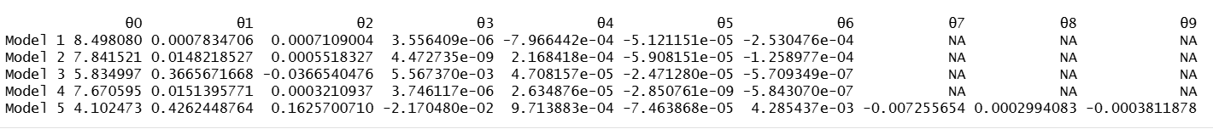
Figure 11: Model parameters value from least square
Parameter vectors are effectively computed for every 5 models via least squares. Each model creates a distinctive set of coefficient values for its relative polynomial & interaction terms, indicating that design matrixes are appropriately constructed & models are identifiable.

Task 2.2: Residual sum of squared errors(RSS)
The RSS is mostly used to evaluate the performance of each proposed regression model based on parameter estimates acquired from previous task. It is defined as the overall difference between observed output values & model-predicted values.
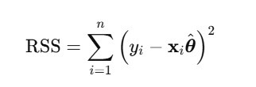
Here y_{i} represent output variable’s observed value for i^{th} data sample, x_{i} denotes the design matrix’s corresponding row & $\hat{θ}$ is estimated parameter vector acquired via least squares. In R, RSS is generally calculated using RSS= sum((Y-Y_hat)^2) where output signal is represented as Y and sum of every possible value is denoted by sum. The table below summarizes the computed RSS values for all 5 models.
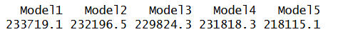
Figure 12: RSS of each model
The values from RSS differ amongst the 5 potential model, showing how well each model fits the data. RSS estimates overall prediction error, hence lower RSS values denotes a better model fit. At this point, model 5 has lowest RSS of selected models showing the smallest overall prediction error based on squared residuals. However, the model selection is not only dependent on RSS & will be further tested using log-likelihood, AIC, BIC & residual diagnostics in following tasks.

Task 2.3: Log-likelihood function
For additional evaluation of regression models, the log likelihood function is calculated for each model utilizing the estimated parameters from task2.1 and the residual errors from task2.2.
It measures whether model fits the observed data & is obtained using RSS’s residual error variance. A higher-log likelihood number signifies lower errors of prediction & an enhanced overall fit, allowing numerous models to be thoroughly evaluated & best optimal model to be selected.
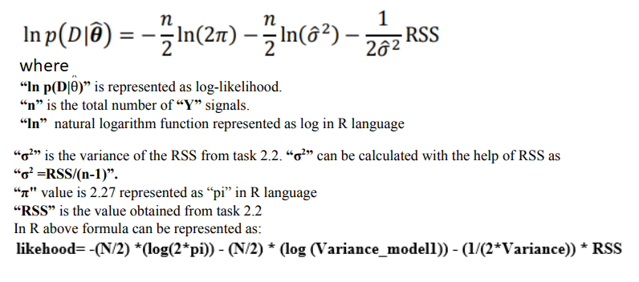
The outcomes of likelihood are given in the table below
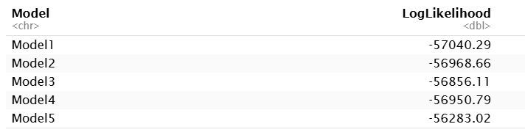
Figure 13: likelihood outcome of Models
The result from the table depicts that the model 5 gives the closest fit to the data, with the most favourable (least negative) log-likelihood of any candidate model.

Task 2.4: AIC and BIC

2.4.1 - Akaike Information Criterion (AIC)
This method is used to analyse various models & the one is chosen that fits the data without being overly complex. It applies the loglikelihood test, then assesses the closeness of predicted model to the observed data, with greater likelihood indicating better fit. Then, AIC value are increased when model utilizes more parameters, so that complex models are not preferred automatically. Thus, a lower AIC value indicates that model fits the data perfectly while remaining simple. Formula for AIC calculation is shown below.
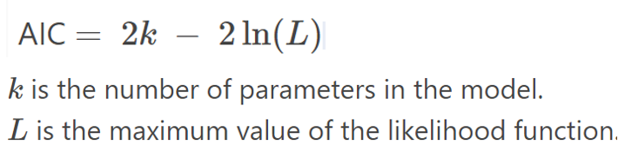
The result after the calculation of AIC is also given in the table below.
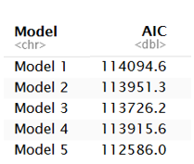
Figure 14: AIC of each model

2.4.2: Bayesian Information Criterion (BIC)
It’s also almost similar to AIC where this compares models & identifies which one fits best keeping the model vey basic. It also uses likelihood, to see how well the model’s prediction fit the actual data.On other hand, it increases its value more strongly when model uses large number of parameters when datasets are large. BIC prefers simpler models & only chooses a more complicated model if it significantly improve the fit. A lower BIC value is preferred so that model fits the data without unnecessary complexity. Formula for BIC calculation is shown below.
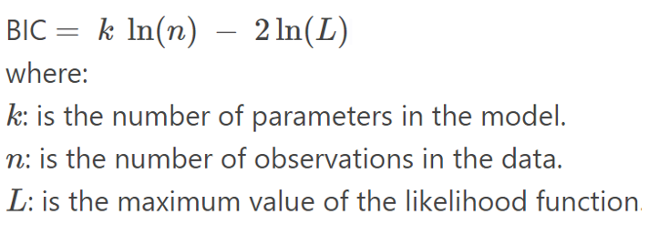
The outcome of BIC after calculation is shown below.
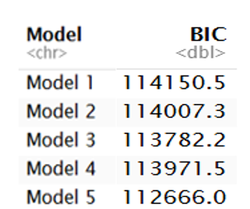
Figure 15: BIC of each model

Task 2.5
This task investigates the distribution of model prediction errors (residuals) so that it can confirm the assumption of additive Gaussian noise in o/p variable. For every candidate model, extraction of residuals are done & Q-Q plots evaluates them and finally compare the residual’s empirical quantiles to standard normal distribution’s theoretical quantiles. If the distribution of residuals are regular, then points on Q-Q plot should be quite near to 45º reference line.
The Q-Q graphs shows that all models have approximately linear alignment at central region, implying residual distributions are broadly symmetric. Yet, there are variances in tail behaviour. The Model 1, 3, 5 show deviations from reference line at upper quantiles that suggests heavier tails & shift from normality. Model 2 shows considerable deviation in both tails. Model 4 has closest overall alignment with reference line, with fewer deviation in between centre & tail areas indicating that its residuals are almost similar to Gaussian distribution.
In this task, only Q-Q plots is observed to determine residual normality. Hence, based on this single diagnostic, Model 4 seems to be closest to Gaussian.
Furthermore, the ACF plot indicates that for all models, the residuals show strong positive autocorrelation for lower lags, thus implying that the residuals retain some degree of temporal structure. In addition, the Cook’s distance plot indicates that the majority of the data points have little influence on the model fit, with only few data points having values greater than the threshold value, implying that no single data point tends to dictate the model fit.
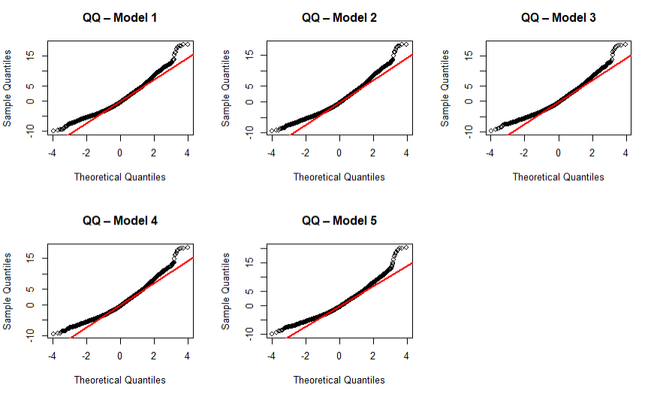
Figure 16: Q-Q plots of model residuals

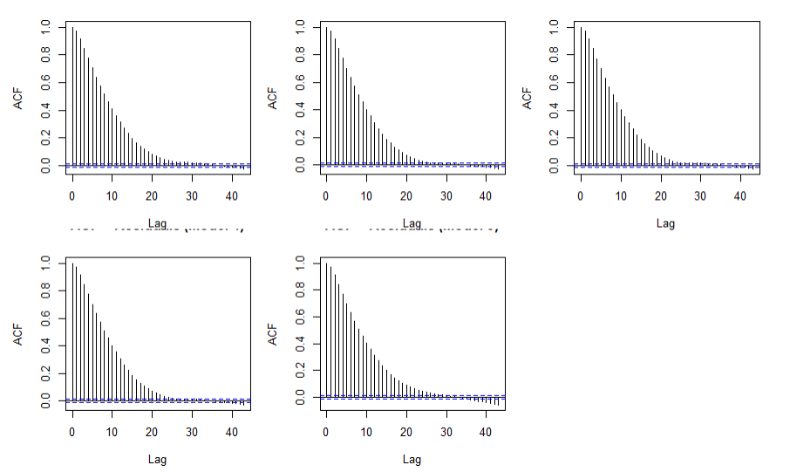
Figure 17; ACF plots of residuals for every Models
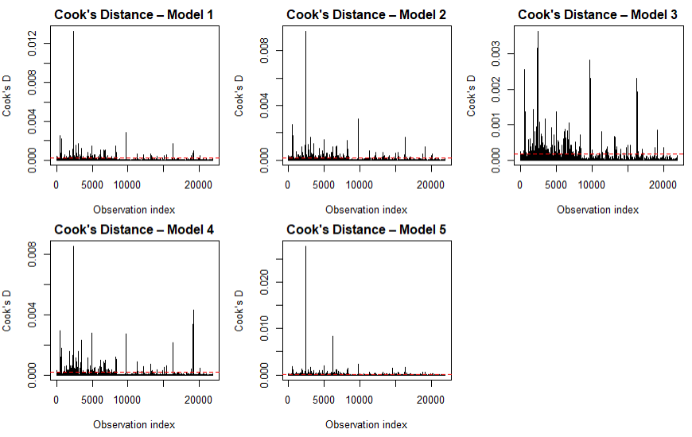
Figure 18: Cook’s distance plots for every Model

Task 2.6
In this section, entire evaluation from task 2.1 to task 2.5 are merged together to find the best regression model. Variety of statistical techniques such as RSS, log-likelihood, AIC, BIC and residual normality diagnostics for candidate models are done for this approach. Log-likelihood as well as RSS analyse each model’s goodness-of-fit where the AIC & BIC gives a trade-off among fitting the model and complexity of model. Having lower RSS, AIC & BIC represents better model performance while higher (less negative) log-likelihood values show a effective probabilistic fit.
Despite having higher parameters, Model 5 got the lowest RSS, highest log-likelihood, & minimum AIC as well as BIC between all candidate model. Hence, it implies that improvement in model fit adequately compensates for increased complexity. Even though 4th model shows somewhat superior residual normality from Q-Q plots, it nevertheless indicated reasonable residual behaviour & regularly beats other model in quantitative criteria for selection.
Hence model 5 is taken as final model since it shows best balance between model complexity, goodness-of-fit & statistical reliability.
Figure 19: Best Model selection

Task 2.7
For this current problem, the best model (model 5) is tested by splitting it into a training and a test set to determine how well it will perform on unseen examples. The split between training and test is set at 70% for training and 30% for test. The training set will be used for estimating parameters, while the test set will be used for solely judging how well a model predicts. The split was chosen to ensure that a sufficient amount of information is used for training, while still enabling a test to be done. A split of 60-40 would also work, providing less information for training, hence less reliable parameter estimation.
The training set of data is used to determine parameters of Model 5. Later, the trained model is used to make predictions of the test set of data. The training set of data is right-skewed as well as unimodal having close mean(red-line) and median(blue-line), and the training residuals are roughly around zero with mean(red-line) and median(blue-line) near zero, suggesting that there is Gaussian noise.
To better quantify the level of uncertainty in predictions, 95% prediction intervals are calculated for the predictions made upon the test data. The prediction curves display the predicted values along with the actual values from the test data, and bars denote the prediction intervals where most values from the test data lie, reflecting the correctness of predictions as well as capturing the uncertainty.
The performance of the chosen model in predicting the testing data is assessed using the Root Mean Squared Error (RMSE) and Mean Absolute Error (MAE) methods. With an MAE of 2.40, it is found to have an average error of 2.4 units between the predictions and actual results. With an RMSE of 3.10, where larger errors are given higher weights, RMSE is higher than MAE, implying the presence of some large errors but not outliers. Also, the fact that the values of RMSE and MAE are not vastly different shows that errors in predictions are normally distributed with fewer chances of large errors. All these values indicate the goodness of generalization by the model.
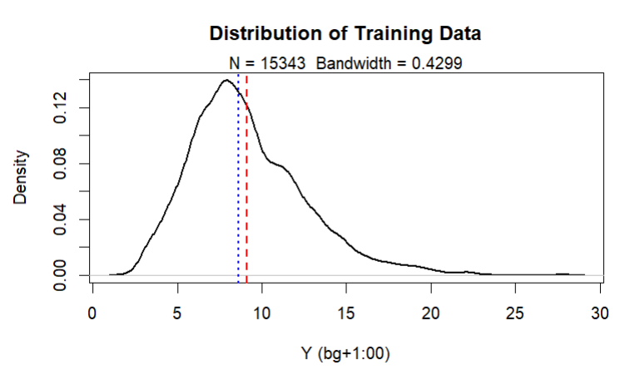
Figure 20: Distribution of training o/p data
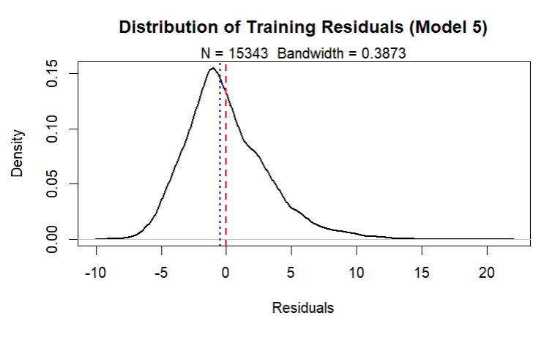
Figure 21: Distribution of Training Residuals
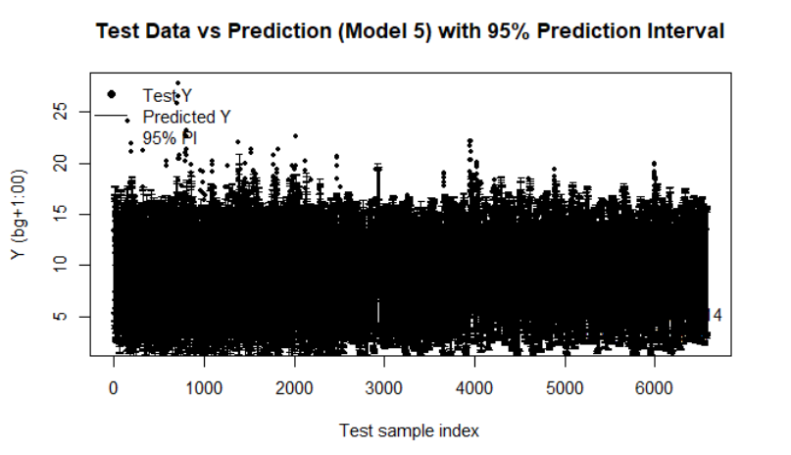
Figure 22: Test data versus predicted o/p for model 5 with 95% prediction interval
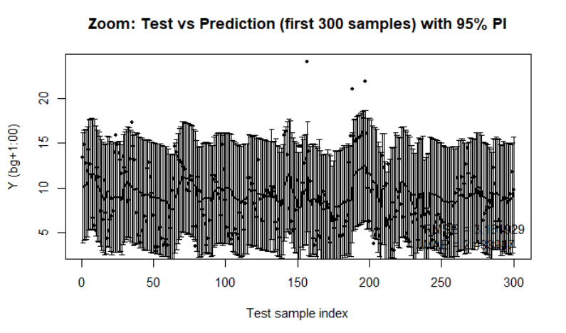
Figure 23: Zoomed comparison (first 300 samples)

Task 3 – Approximate Bayesian Computation (ABC)
For this task, the rejection method of Approximate Bayesian Computation (ABC) is used for finding the posterior distributions of the selected regression coefficients for the model that was best in task 2. Because of difficulty in evaluating the likelihood function analytically, the ABC approach approximates the posterior by sampling data from prior values for the parameters and selecting parameters that produces output close to the actual observed data.

3.1 – Selection of parameters
From the least-squares estimates derived in Task 2.1, the two parameters with the highest absolute values were selected for the Bayesian analysis, whereas all other parameters were set to the estimated values. Since they have greater influence on model output, so these parameters were chosen.
Figure 24: parameter selection

3.2 Prior specification
Uniform prior distributions were specified around the least squares estimates of these two parameters, showing weak previous weak assumption & local uncertainty around the point estimates.

3.3 Rejection ABC sampling
Random values were then obtained from the prior distribution, and model outputs were calculated for each set of these samples. The difference between the simulated outputs and the actual training outputs was calculated using the residual sum of squares method, which was denoted by RSS. The samples were then accepted, provided that the RSS was less than a chosen value of tolerance ε. This method provides an approximation of the posterior distribution of the parameters.
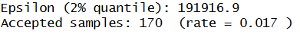
Figure 25: Required values

3.4 Joint and marginal posterior distributions
The joint posterior plot depicts how two parameters changes together and how uncertain they are. Whereas the marginal posterior plots indicate the uncertainty for each parameter distinctly. The posterior are more concentrated than the uniform priors, indicating that the data gives useful information for refining the parameter estimations.
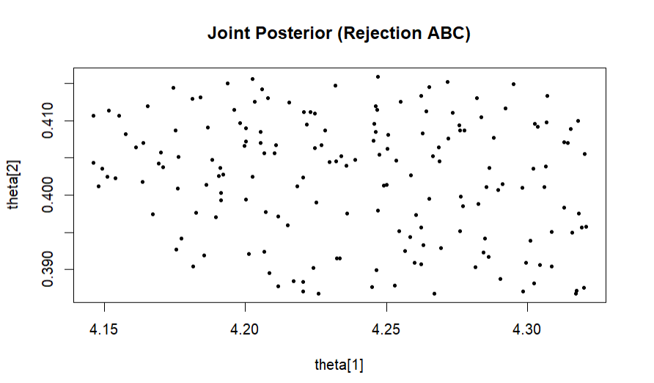
Figure 26: Joint Posterior Distribution (rejection ABC)
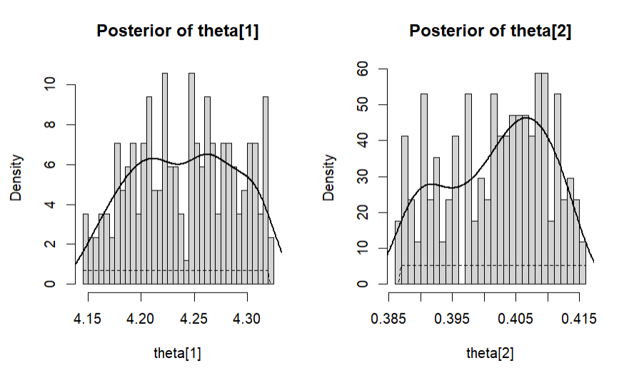
Figure 27: Marginal Posterior Distribution of selected parameters

3.5 Result and interpretation
The ABC rejection algorithm yielded an acceptance rate of about 1.7% & this is standard for rejection-based ABC algorithms with strict tolerance levels. This low acceptance rate suggest a strict matching requirement, which leads in a more relevant approximation of posterior distribution. In general, the ABC outcome show that data accurately identify the selected parameters, with posterior distributions centered near their least squares estimated & decreased dispersions. This gives a Bayesian interpretation of a parameter uncertainty to supplement the frequent regression analysis completed in Task 2.

Conclusion
Following the statistical analysis of every regression model, model 5 had been chosen as most appropriate choice for representing regression relationships between input & outputs. The result and visualization obtained are the most obvious outcomes from the R programming that predicted the best regression model. The source code and output for every process are included in appendix section.

References
A Gupta, A sharma, A Goel. (2017). Review of regression analysis models.
Antony, A.S. , Armaan, A. , Acharya, M.S. (2019). A comparison of regression models for prediction of graduate admissions.
B Caffo. (2015). Regression models for data science in R.
Grolemund, G, Wickham, H. (2017). R for data science (Vol. 2).
NJ horton, DT kaplan, BS Baumer. (2017). Modern data science with R.

Appendix
