
STW7071CEM
INFORMATION RETRIEVAL

Assignment Report

Submitted By:
Manish Gopal Karanjit
Softwarica Student ID: 250312
Coventry University,
Softwarica College of IT and E-commerce

Submitted To:
Lecturer Siddhartha Neupa

Table of Contents
1 Introduction 1
1.1 System overview and contributions 1
1.2 Polite Crawling and Scheduling 2
1.2.1 Crawler (Polite BFS crawler) 2
1.2.2 Schedule 4
1.3 Author Extraction 5
1.3.1 Find the authors 5
1.4 Pagination and Publication discovery 6
1.4.1 Pagination 6
1.4.2 Finding the publications (more publications + general publications) 6
1.5 Abstract and metadata extraction 8
2. Search Engine Implementation 9
2.1 Text Pre-processing 9
2.2 Indexing (Inverted Index and document Statistics) 10
2.3 Relevance Ranking (BM25-Retrieval) 11
2.4 Query Processing and Result Ranking 12
2.5 Partial Query Support 13
2.6 Comparison with existing academic search engines 13
3. Data classification 15
3.1 Data preparation 15
3.2 Train-Test Split 16
3.3 Model Selection and Pipelining 16
3.4 Model Evaluation and comparison 17
3.5 Confusion matrix 18
4. User Interface 20
4.1 Web-based search interface 20
4.2 Result & presentation/redirection 21
5. Conclusion 22
References 23
Appendix 24

1 Introduction
Information Retrieval (IR) systems are built to store, process, and retrieve relevant documents from a large set of documents efficiently based on user queries. Contemporary search engines use methods like text pre-processing, inverted indexing, and relevance ranking to produce precise results. This coursework aims to apply these fundamental IR concepts by developing a vertical search engine and a document classification system using Python programming.
The project will showcase the theoretical knowledge and implementation skills of IR pipelines like crawling, indexing, ranking, and supervised text classification.

1.1 System overview and contributions
The proposed system comprises two major parts. The first part is a vertical search engine that searches PurePortal pages, retrieves publication metadata, performs text pre-processing, builds an inverted index, and ranks search results using the BM25 ranking formula. In keeping with the requirements of the assignment, the crawler is programmed to be polite and can be scheduled to re-crawl the portal periodically to update the index with newly published research outputs. A web interface built using Django enables users to enter keyword-based search queries and display ranked results containing hyperlinks to the original publication pages. The second part is a document classification system that classifies text into Business, Entertainment, or Health categories using TF-IDF feature extraction and a Multinomial Naive Bayes classifier. Both parts of the system show the integration of information retrieval and machine learning concepts into a single web-based system, thus meeting the coursework objectives.
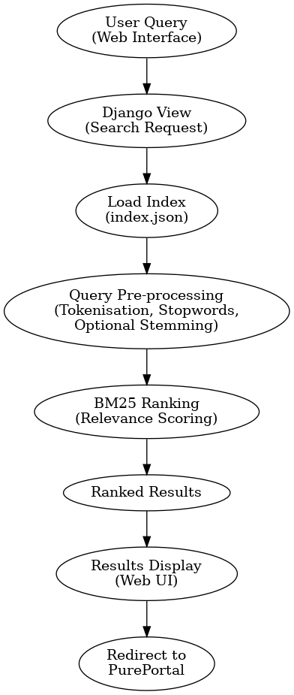
Figure 1: System overview

1.2 Polite Crawling and Scheduling

1.2.1 Crawler (Polite BFS crawler)
A crawler is a program that automatically visits web pages, downloads HTML, and discovers new links so the content can be indexed for search. Here, the polite crawler starts from the PurePortal ICS organization seed URL & traverses pages using BFS (queue-based crawling). Since it is polite so it reads robots.txt, checks can_fetch() function, sets a custom User-Agent and enforces a crawl delay before each request. During crawling, it detects list pages & extracts publication URLs, then visits each pages to collect metadata. The output is then stored to JSONL and the inverted index is rebuilt after each crawl so the search engine stays up to date.
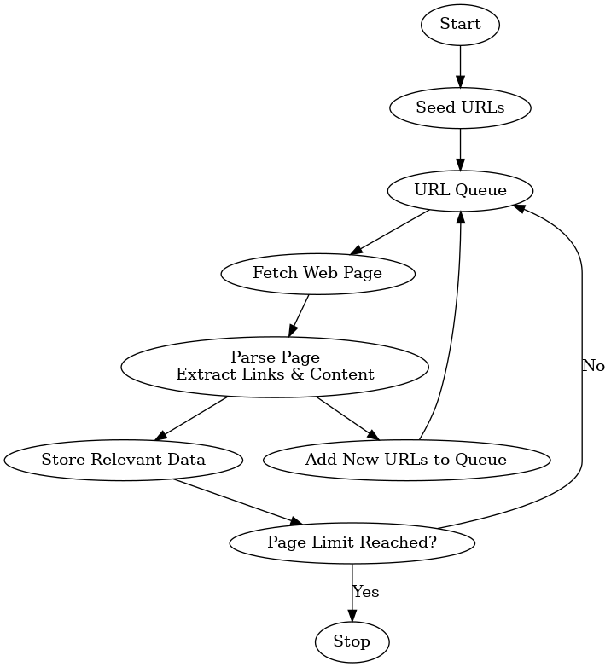
Figure 2: Basic Crawler function
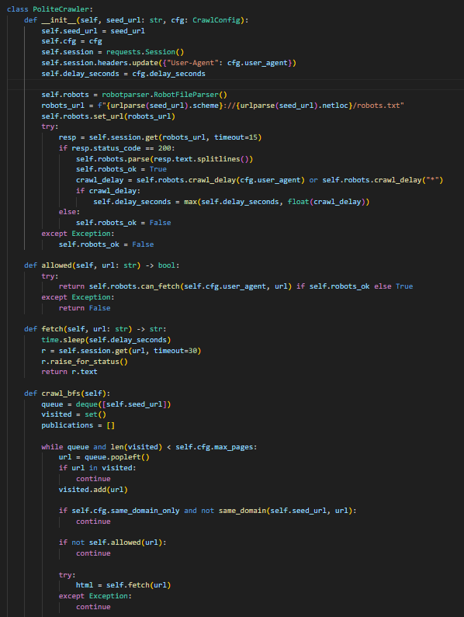
Figure 3: robots.txt handling and polite crawl

1.2.2 Schedule
A schedule in web crawling defines the timing, frequency, and order of web pages that a web crawler will visit or revisit in order to have up-to-date information and discover new content. The schedule is developed in a manner which takes into consideration the load on the server of the web page being crawled as well as how often new content appears on the page along with the politeness rules established by the sites being crawled.
Here, it includes a runnable script that calls the crawler with the correct seed URL & limits. To crawl weekly, this script is then run and each week it re-crawls, merge results, and rebuilds the index so new publications become searchable automatically.
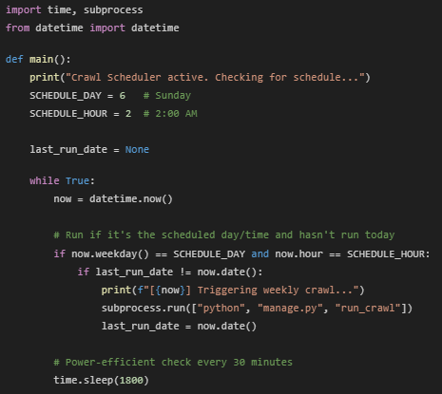
Figure 4: script to run weekly

1.3 Author Extraction

1.3.1 Find the authors
Initially, the authors are extracted from each publication page, not guessed from the query. Then parse_publication_page() function scans all <a> (anchor) tags whose href contains /en/persons/ and collect both the author name & profile URL. Duplicates are removed so that the repeated names/links don’t appear twice. If author links are missing, it falls back to <meta name=”citation_author”> when available. The final output stores authors and author_urls per publication, matching the requirement to keep profile links.
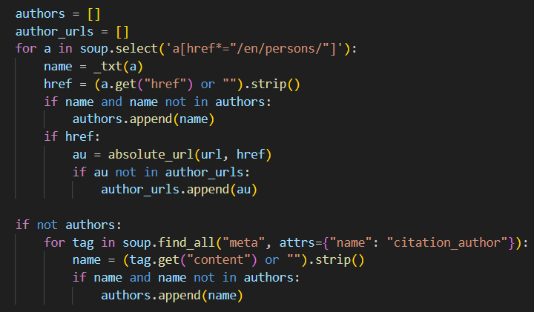
Figure 5: Finding Authors

1.4 Pagination and Publication discovery

1.4.1 Pagination
Instead of clicking next, the crawler extracts all hyperlinks from the current page using extract_links() function. Any internal URL containing organisation, persons, or publications is added to the BFS queue. This naturally includes pagination URLs when they exist in anchor tag. A visited set prevents loops and max_pages prevents infinite crawling.
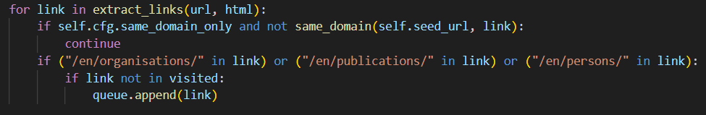
Figure 6: finding next pages

1.4.2 Finding the publications (more publications + general publications)
Any “list-like” pages is handled by parse_list_page_for_publication() function that searches for <a> anchor tag linking to publications. The crawler then enqueues every discovered publication URLs into BFS, so it can crawl all publications reachable from the department/people pages. This also works for both the cases: pages with a few visible outputs and pages that list many outputs, because both contain publication links. A publication page is detected using a regex (/en/publications/) and then parsed for structured fields (title/year/authors/abstracts).
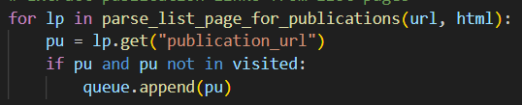
Figure 7: Queueing publication URLs
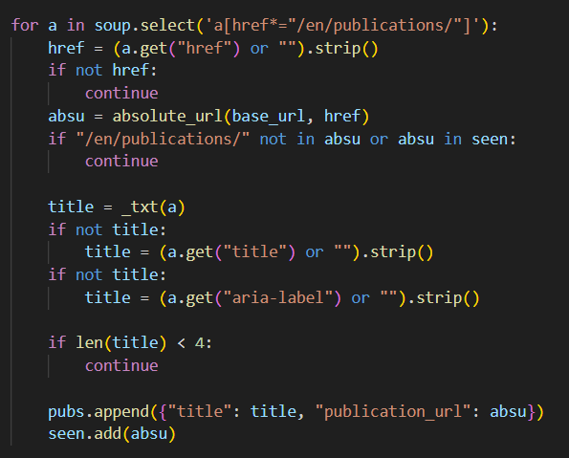
Figure 8: Extracting publication links on list pages

Figure 9: Crawler finding html component on the basis of headers, span etc

1.5 Abstract and metadata extraction
The abstract is extracted by locating a heading containing the word “Abstract” and reading the next <p>(paragraph tag) / <div> block. If that fails, it falls back to metadata like citation_abstract or description.
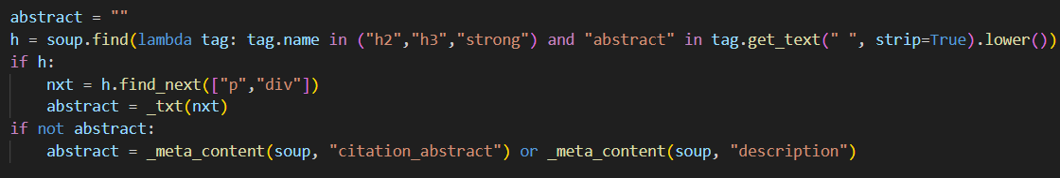
Figure 10: abstract extraction

Figure 11: Crawler finding abstract from publication

2. Search Engine Implementation
The search engine allows users to obtain research publications that are related to Coventry University based on keywords. The method used by the search engine employs normal methods of information retrieval, such as inverted indexing, text processing, & the automated creation of a relevance ranking list. The search engine component will provide an efficient method for returning the most relevant items, considering the variations in user input, such as distinction between upper case and lower case, punctuation, & character truncation.

2.1 Text Pre-processing
Before indexing and searching, pre-processed is done for both user & crawled publications into a uniform Representation (“Bag of Terms”). The pipeline for pre-processing contains lowering case, extraction of alphanumeric tokens only; removing short tokens (e.g., one or two letters) & commonly found stop words as well as some optional Lightweight Suffix-Based Stemming (Lightweight Suffix Based Stemming). This allows for better match closeness between words (for example, develop, developing, developed) allowing for better Match Retrieval on short queries versus using a more heavy weight pipeline method. Therefore, it is fast and does not have any dependencies and therefore better for a repeated amount of time/usage on the web based User Interface.
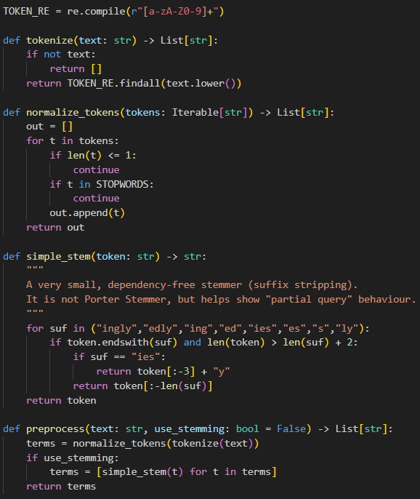
Figure 12: Keyword pre-processing (Roshdi, A. and Roohparvar, A, 2015) (Kausar, M.A., Dhaka, V.S. and Singh, S.K., 2013) (Udapure, T.V., Kale, R.D. and Dharmik, R.C., 2014) (Thelwall, M, 2001) (Kumar, M., Bhatia, R. and Rattan, D., 2017) (Xu, S., Li, Y. and Wang, Z., 2017) (Yacouby, R. and Axman, D., 2020) (Caelen, O., 2017)

2.2 Indexing (Inverted Index and document Statistics)
Each publication will become a "document" after crawling. The document will include fields for title, authors, year published, URL, and abstract. The URL of the publication will generate a stable unique ID for the document using the SHA-1 hash function. Each term will point to the documents in which that term appears. Additionally, the number of occurrences of each term was store in this classification system. The length of all the documents stored in inverted index system is important as it is required to normalize BM25 based on the number of tokens per document.
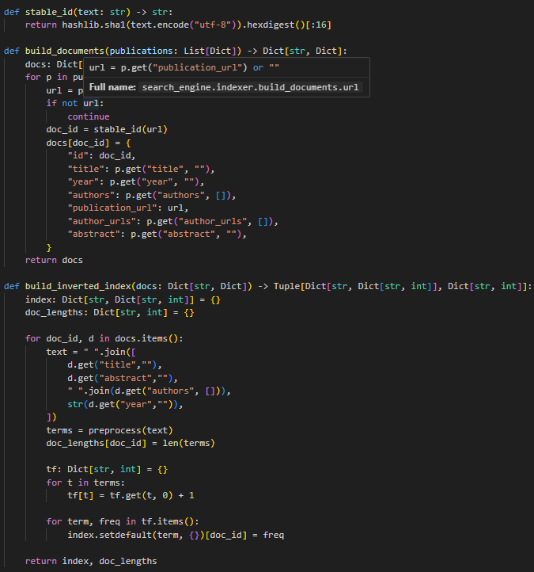
Figure 13: Implementation of Inverted Index

2.3 Relevance Ranking (BM25-Retrieval)
Unlike TF-IDF cosine similarity, BM25 is a probabilistic ranking function that is commonly used on real search engines when attempting to find similarity between documents. BM25 improves on the basic model of TF-IDF by implementing two enhancements: (a) term frequency saturation, meaning that it gives diminishing returns as the term frequency increases; and (b) normalization based on document length so that document length does not provide an advantage to long documents/abstracts. The IDF value is calculated during indexing and stored in the index.json file.
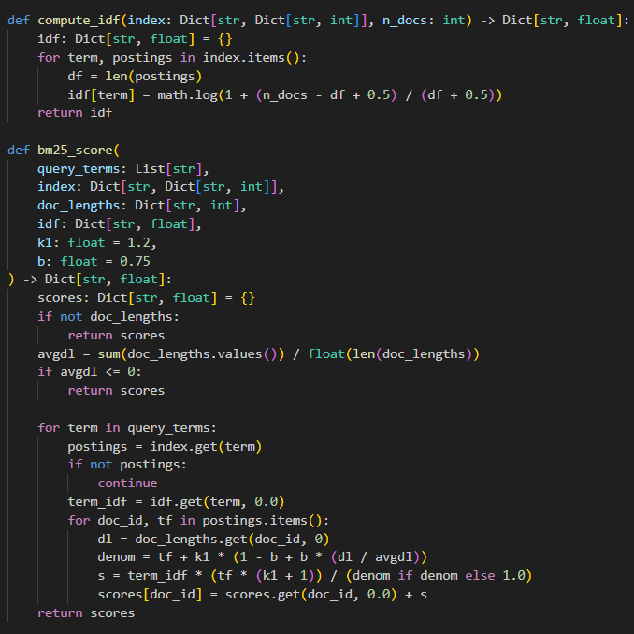
Figure 14: Relevance ranking using BM25

2.4 Query Processing and Result Ranking
When a user submits a query, it will be processed through the identical pre-process method that applied during indexing to guarantee matching on all aspects. The query text will be converted to lowercase, tokenized by way of a regular expression, remove all stop words, and optionally use stemming if it is enabled from their user interface. This guarantees that the query matches all terms stored in an inverted index with respect to those within an index.
Once the pre-processing stage of a system has been performed on a set of candidate documents and the search terms from a user's query have been used to retrieve those documents from the inverted index, a re-rank of the results is performed using the BM25 algorithm, which assesses the frequency of term occurrence in a given document, the inverse document frequency of the term relative to its use across all the documents in the database, and length normalization of the final score obtained. The BM25 score is calculated only against documents that exist in the postings lists, thus allowing for the efficient ranking of the top-scoring documents; the ranked documents are sorted and returned to the user interface in descending order by score, in addition to the relevant metadata (i.e., document title, authors, date of publication, and document abstract).
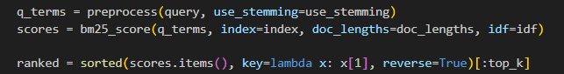
Figure 15: Query processing

2.5 Partial Query Support
Optional stemming is an additional option for obtaining partial queries. By using strict stemming, both indexed and entering query terms will be changed to base or simplified forms. As a result of this method, the system is capable of returning relevant documents even though users have entered incomplete (or approximate) keywords. Enhanced usability of the system's functions aligns with the behaviour of modern academic search engines.

2.6 Comparison with existing academic search engines
The developed search engine operates in a manner consistent with academic search engines, including Google Scholar, in how it utilizes keyword-based retrieval systems, relevance rankings, and presents results. Similarly, both search engines use text normalization, inverted indexes and relevance scores in generating rank-ordered result listings. Users of both search systems can enter free-text queries and receive ranked lists of publication containing titles, authors, and abstracts only.
The primary distinction between these two systems is their scale and scope of information. Google Scholar utilizes an immense database comprising many full-text articles and continually updates this database at a global scale using proprietary ranking algorithms. this system functions as a vertical search engine, restricted to a curated set of Coventry University PurePortal publications. As a consequence, this vertical search engine returns significantly narrower (i.e., domain-specific) results than Google Scholar. Finally, BM25 is employed as the ranking model for this vertical search engine versus citation-based or learning-to-rank models in the case of Google Scholar; therefore, it is transparent in nature & usable fosr academic demonstration purposes.
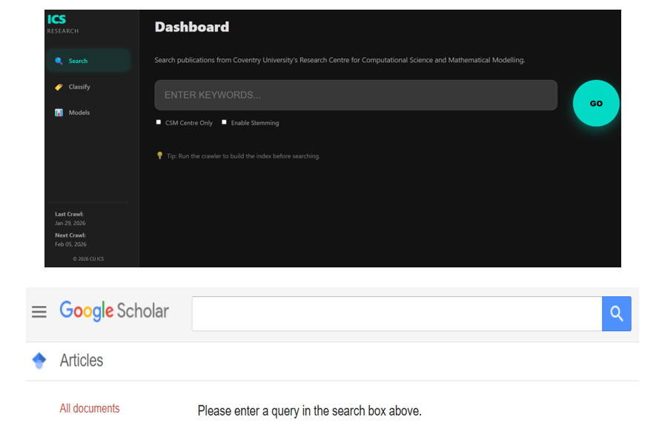
Figure 16: Interface comparison of proposed search engine & google scholar

3. Data classification
Now, the next task is to present a supervised text classification whose objective is to classify different categories of news articles into their respective categories mainly (Business, Entertainment, & Health) based on the content provided in small pieces, specifically, on premised specific articles from the BBC and accordingly. A scikit‑learn Pipeline is trained and saved as model.joblib, then reused for predictions
Using python’s scikit-learn library, a pipeline is utilized to create a scikit-learn classifier based on scikit-learn pipeline technique. This pipeline method allows to develop the classifier in different ways and apply them within one single file using different set of which can be called repeatedly without needing to retrain.
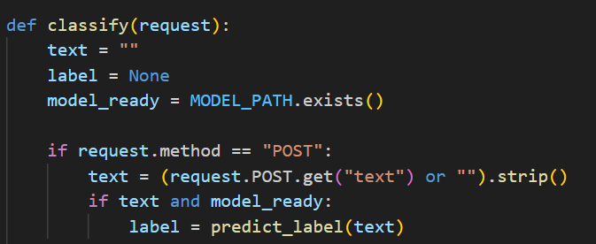
Figure 17: classification prediction

3.1 Data preparation
BBC RSS feeds automatically provide the source of the training data, with each RSS feed representing one of the available categories. The title and summary of each RSS entry are merged into one text sample for each RSS entry. Merging these two pieces together creates a single sample that is rich in context but lightweight in size.
To minimize the amount of noise in the training dataset, the samples that had very small numbers of characters have been removed. The files that were prepared for training are then structured in a file format called CSV (news_dataset.csv). Within this file, there are three columns: label, text, and source. The format of the files used for this dataset makes it easy to reuse during the training and evaluation process.
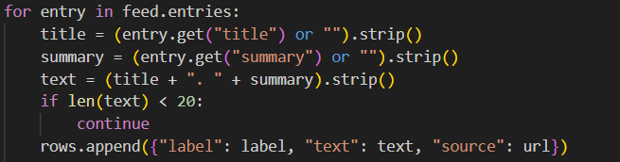
Figure 18: Data preparation sample

3.2 Train-Test Split
Once data has been prepared, it is divided into two sets; training and testing with a 75%/25% split between them. A fixed random state parameter ensures the results will be the same every time the data is run through the model.
The split will also be stratified in order to keep each category at the same level within the training and testing datasets. This helps to eliminate a potential bias towards the categories that have a greater number of samples.
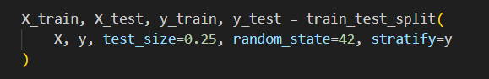
Figure 19: Data splitting

3.3 Model Selection and Pipelining
A machine learning pipeline that includes TF-IDF vectorisation and Multinomial Naive Bayes classification has been used to implement the classifier.
TF-IDF Vectorisation converts raw text into numerical features, giving heavier weights to words that carry information and lighter weights to words that do not. Stop words are eliminated; unigrams and bigrams are both used to encode the word selections meaningfully.
Multinomial Naive Bayes was chosen as the classifier because it is computationally efficient and produces favourable results when performing text classification tasks that involve sparse feature vectors.
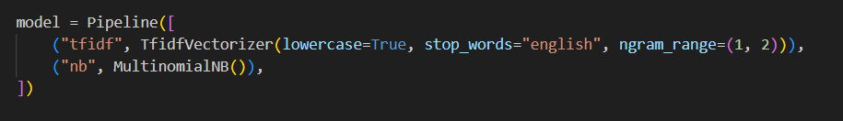
Figure 20: Model pipelining

3.4 Model Evaluation and comparison
Following training of the model, it was subsequently assessed against the test dataset to generate various evaluation metrics: accuracy, precision, recall, F1-score and support. Accuracy represents the total percentage of documents that were correctly classified by the model.
A classification report indicates how well the model performed across all of the individual categories (by providing separate performance measures — precision, recall, F1-score and support). It can be concluded that the model has a high level of accuracy on the whole, particularly within the Business and Health categories, suggesting that there may be some duplication in terms of vocabulary between categories which results in reduced recall rates within the Entertainment category.
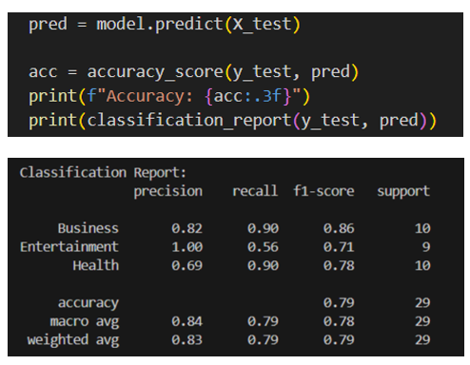
Figure 21: Model accuracy score
The classifier achieves a high overall performance, accurately classifying 23 of 29 documents (79% accuracy). The majority of errors occur between Entertainment and Health, suggesting a high degree of overlap or similarity in semantics between these two classes. The two most consistent classes in this study are Business and Health.
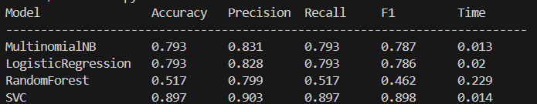
Figure 22: Model comparison result
The classifiers were selected based on analyses performed on all of the classifiers' performance metrics; these analyses included the same dataset and train-test splits. The classifiers were evaluated on several performance metrics: accuracy; precision; recall; F1 score; and run time.
The data presented in the table indicates that Multinomial Naive Bayes has the greatest overall performance, as evidenced by an accuracy of 79.3% and F1-score of 0.787, in addition to being by far the most cost effective in terms of computing resources and processing time. On the other hand, the more complicated models like SVM and Random Forest take up considerably more time, and do not provide as much accurate classification as the Multinomial Naive Bayes. As such, Multinomial Naive Bayes was chosen to represent the final model for this study.

3.5 Confusion matrix
By displaying the predicted categories in columns and the actual categories in rows, the confusion matrix gives detailed insight into the relationship between the classifier’s predictions and the actual labels. Each cell on the diagonal of the matrix corresponds to an accurate prediction.
Within the context of this study, the majority of misclassification of documents occurs for documents classified as Entertainment being misidentified as Health due to the substantial overlap in language found in the articles. The confusion matrix further indicates that the classifier exhibits overall stability with regard to accuracy by maintaining a consistent level of accuracy across all categories.
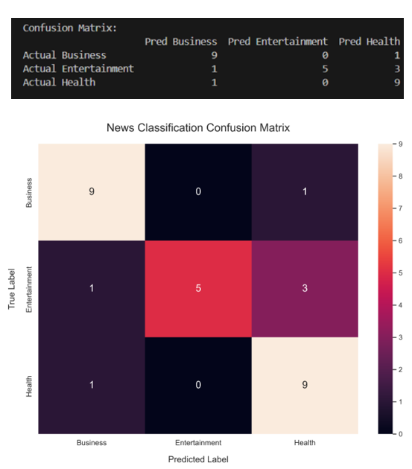
Figure 23: Confusion matrix model

4. User Interface
The search based implementation is implemented by means of a web application created in django, in which keywords input box, search results display including links to the pureportal publication pages, and stemming functionality can be turned on/off. In addition, the results of the searches that are submitted will be displayed in an order of their relevance (ranked), and will therefore include the title of the publication (including the year of publication), the name(s) of the author(s), the relevance score, and a brief abstract of the publication (if available). Ultimately each search result will be a hyperlink that takes you directly to the pureportal publication page. This allows all users to have access to the appropriate authority when they search for academic literature.
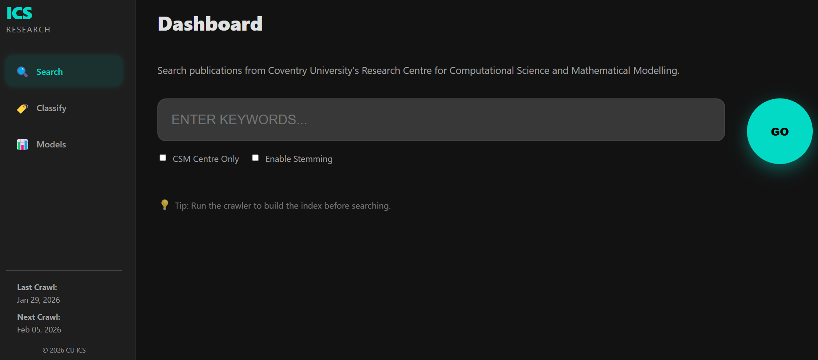
Figure 24: User Interface

4.1 Web-based search interface
The web-based search system has been implemented using the Django framework and HTML templates in order to provide an easy user interface for search. Users can enter search terms by entering a keyword into an input field on the page; this sends a request to the backend using the HTTP GET requests. Enabling stemming is provided as an optional checkbox that adds an additional field to the request to the backend when checked. Because there is a complete separation between presentation & retrieval, all information retrieval is done on the back end & all that is required by the interface is to accept user input and provide search results.

Figure 25: Search Interface Homepage with “Enable Stemming” checkbox

4.2 Result & presentation/redirection
BM25 relevance scoring produces a ranked list for search results along with title of publication; publication year; authors; relevance score; and abstract (when available). Search terms in the title and/or abstract will be highlighted to facilitate reading. The title of each search result will be a hyperlink that, when clicked, will take the user directly to the actual publication via the Coventry PurePortal site.
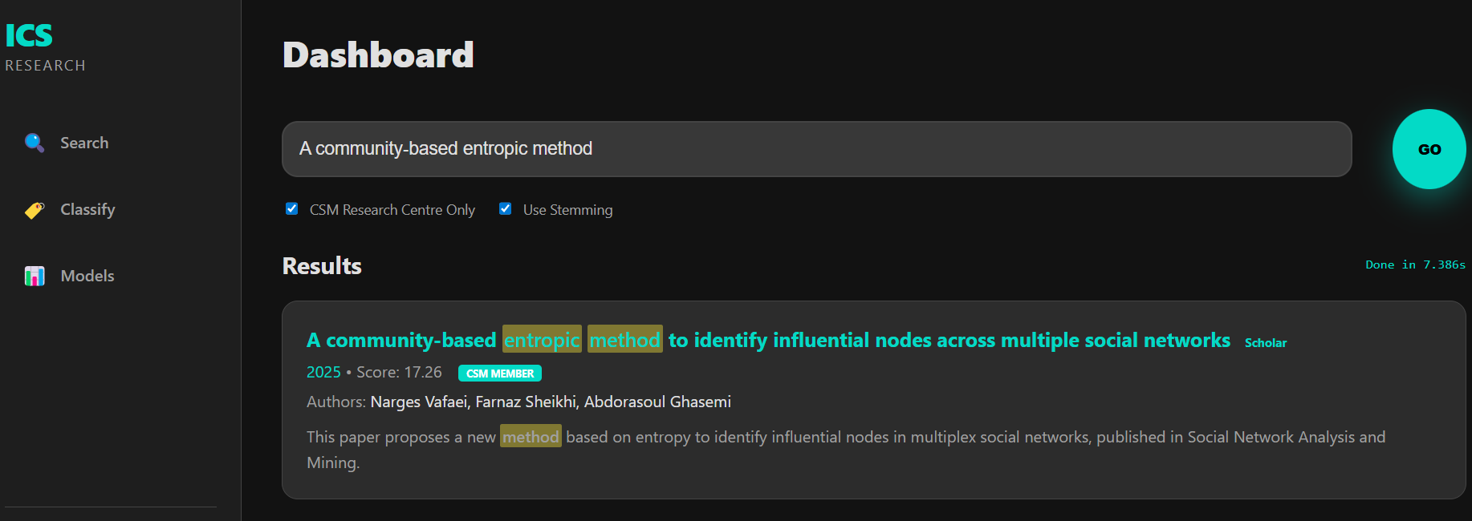
Figure 26: Overall search result
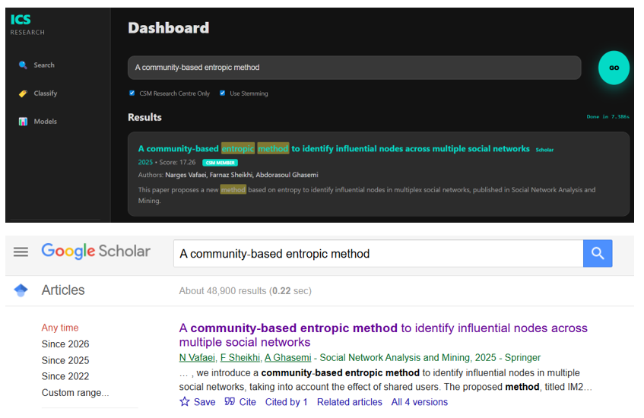
Figure 27: Overall comparison between proposed search engine & google scholar

5. Conclusion
A polite web crawler was designed to collect all published articles from the PurePortal, which were then pre-processed and indexed with an inverted search index. The articles were ranked according to relevance using the BM25 ranking algorithm, which allowed search results to be returned in ranked order based on keyword queries. An interface built on the Django web development framework enabled an end-user to perform searches, and additional functionality was included such as partial matching of user queries by allowing "stemming," or allowing complete terms to be broken down to their roots; and also enabled scheduled crawling to keep the search index current.
A supervised text classification system was constructed utilizing a dataset of RSS feeds collected by the BBC. The dataset consisted of articles within three categories: Business, Entertainment and Health. The articles were processed into vectors using TF-IDF and then classified with Multinomial Naive Bayes. Evaluation metrics including Accuracy, Precision, Recall, F1-Score and Confusion Matrix indicate that the classification system generally performed well. However, there were some cases of overlap between Entertainment and Health categories.

References
Caelen, O. (2017). A Bayesian interpretation of the confusion matrix. Annals of Mathematics and Artificial Intelligence.
Kausar, M.A., Dhaka, V.S. and Singh, S.K. (2013). Web crawler: a review. International Journal of Computer Applications.
Kumar, M., Bhatia, R. and Rattan, D. (2017). A survey of Web crawlers for information retrieval. Wiley Interdisciplinary Reviews: Data Mining and Knowledge Discovery.
Roshdi, A. and Roohparvar, A. (2015). Information retrieval techniques and applications. International Journal of Computer Networks and Communications Securit.
Thelwall, M. (2001). A web crawler design for data mining. Journal of information science.
Udapure, T.V., Kale, R.D. and Dharmik, R.C. (2014). Study of web crawler and its different types. . IOSR Journal of Computer Engineering.
Xu, S., Li, Y. and Wang, Z. (2017). Bayesian multinomial Naïve Bayes classifier to text classification. International Conference on Multimedia and Ubiquitous Engineering .
Yacouby, R. and Axman, D. (2020). Probabilistic extension of precision, recall, and f1 score for more thorough evaluation of classification models. Proceedings of the first workshop on evaluation and comparison of NLP systems.

Appendix
https://github.com/MGK998/Manish-GK-coventry.git

