##### 

##### Agrarian Crop & Fertilizers Proposal Utilizing Machine Learning Approach

##### A PROJECT REPORT

###### ***Submitted by***

**Melvingnanaliyes. S [REGISTER NO:211418104153]**

**Ragul Raj. A [REGISTER NO:211418104207]**

**Praveenkanth. C [REGISTER NO:211418104197]**

***in partial fulfillment for the award of the degree***

***of***

**BACHELOR OF ENGINEERING**

IN

# COMPUTER SCIENCE AND ENGINEERING



PANIMALAR ENGINEERING COLLEGE, CHENNAI-600123.

##### (An Autonomous Institution, Affiliated to Anna University, Chennai)

##### MAY 2022

**PANIMALAR ENGINEERING COLLEGE**

**(An Autonomous Institution, Affiliated to Anna University, Chennai)**

**BONAFIDE CERTIFICATE**

Certified that this project report “**Agrarian Crop & Fertilizers Proposal Utilizing Machine Learning Approach”** is the bonafide work of “**Melvingnanaliyes S [211418104153], Ragul Raj A [211418104207], Praveenkanth. C [211418104197]**  **”** who carried out the project work under my supervision

**SIGNATURE SIGNATURE**

**Dr.S.MURUGAVALLI,M.E.,Ph.D.,**  **Mr.K.GUNASEKARAN,M.E.,**

**HEAD OF THE DEPARTMENT SUPERVISOR**

**ASSISTANT PROFESSOR**

DEPARTMENT OF CSE, DEPARTMENT OF CSE,

PANIMALAR ENGINEERING COLLEGE, PANIMALAR ENGINEERING COLLEGE,

NASARATHPETTAI, NASARATHPETTAI,

POONAMALLEE, POONAMALLEE,

CHENNAI-600 123. CHENNAI-600 123.

Certified that the above mentioned students were examined in End Semester project viva-voice held on...........................

**INTERNAL EXAMINER EXTERNAL EXAMINER**

**DECLARATION BY THE STUDENT**

We Melvingnanaliyes. S [211418104153], Ragul Raj. A [211418104207], Praveenkanth. C [211418104197] hereby declare that this project report titled “Agrarian Crop & Fertilizers Proposal Utilizing Machine Learning Approach” , under the guidance of Mr.K.Gunasekaran, M.E., is the orginial work done by us and we have not plagiarized or submitted to any other degree in any university by us.

**ACKNOWLEDGEMENT**

We would like to express our deep gratitude to our respected Secretary and Correspondent **Dr.P.CHINNADURAI, M.A.,Ph.D.,** for his kind words and enthusiastic motivation, which inspired us a lot in completing this project.

We express our sincere thanks to our Directors **Tmt.C.VIJAYARAJESWARI**, **Dr.C.SAKTHI KUMAR,M.E.,Ph.D.,** and **Dr.SARANYASREE SAKTHI KUMAR,B.E.,M.B.A.,Ph.D.,** for providing us with the necessary facilities to undertake this project.

We also express our gratitude to our Principal **Dr.K.MANI,M.E.,Ph.D.,** who facilitated us in completing the project.

We thank the Head of the CSE Department,

**Dr. S.MURUGAVALLI,M.E.,Ph.D.,** for the support extended throughout the project.

We would like to thank my **Mr. GUNASEKARAN,M.E.,** and all the faculty members of the Department of CSE for their advice and encouragement for the successful completion of the project.

**Melvingnanaliyes S**

**Ragul Raj A**

**Praveenkanth C**

**Abstract**

In India, agriculture is the largest source of livelihood, A vast fraction of the population of India considers agriculture as its primary occupation. Excessive use of fertilizer or using not enough fertilizer Leads to Bad quality crop production Identifying the equivalent Crop & Fertilizers is a research issue. The main benefits of the proposed system are as follows: Balancing crop production, Yielding the right crop at the right time, Economic growth, and planning to reduce the crop meagreness.

In this project, a three level each is proposed by Analyze the Various related attributes like location, pH value from which alkalinity of the soil is determined . Along with it, percentage of nutrients like Nitrogen (N), Phosphorous (P), and

Potassium (K) Location is used along to Determine the weather and temperature using API, nutrient value of the soil in that region, amount of rainfall in the region, soil composition can be determined. The three levels include soil identification, crop suitability, and recommendation of Fertilizer ,. Experiments were conducted using real time agriculture dataset and the performance is evaluated in terms of accuracy, precision, recall, and F1 score. The experimental findings showed that the suggested approach provides more accurate and appropriate Crop & Fertilizzer recommendations.

**Table of Contents**

|  |  |  |
| --- | --- | --- |
| **Chapter No** | **Title** | **Page No** |
|  | Abstract | **ii** |
|  | **List of Tables** | **v** |
|  | **List of Figures** | **vi** |
|  | **List of Abbreviations** | **vii** |
| **1.** | **Introduction** | **1** |
|  | 1.1 Agriculture in India | 2 |
|  | 1.2 Machine Learning in Agriculture | 3 |
|  | 1.3 Challenges in Agriculture | 3 |
| **2.** | **Literature Survey** | **5** |
| **3.** | **Problem Definition and Background** | **8** |
|  | 3.1 Introduction | 9 |
|  | 3.2 Problem Statement | 9 |
|  | 3.3 Objective | 9 |
| **4.** | **System Analysis** | **10** |
|  | 4.1 Hardware specification | 11 |
|  | 4.2 Software specification | 11 |
| **5.** | **System Design**  5.1 Design of the System | **12**  **13** |
|  | 5.1.1 System Architecture | 14 |
|  | 5.1.2 UML Diagram | 15 |
|  | 5.3 Data Preprocessing | 18 |
|  | 5.4 Feature Elimination | 18 |
|  | 5.5 Soil Identification | 18 |
|  | 5.6 Crop Suitability | 19 |
|  | 5.7 Fertilizer Recommendation | 19 |
|  | 5.8 Measures used for Performance Evaluation | 19 |
| **6.** | **System Implementation** | **21** |
|  | 6.1 Data Pre-processing | 22 |
|  | 6.2 Recursive Feature Elimination | 23 |
|  | 6.3 Soil Identification | 24 |
|  | 6.3.1 Random Forest | 24 |
|  | 6.3.2 Decision Tree | 26 |
|  | 6.3.3 Naive Bayes | 26 |
|  | 6.3.4 Support Vector Machine | 26 |
|  | 6.4 Crop Suitability | 26 |
|  | 6.4.1 Random Forest | 27 |
|  | 6.4.2 Decision Tree | 27 |
|  | 6.4.3 Naive Bayes | 28 |
|  | 6.4.4 Support Vector Machine | 28 |
|  | 6.5 Fertilizer Recommendation | 29 |
|  | 6.5.1 Hierarchical Clustering | 30 |
|  | 6.5.2 k-Means Clustering | 30 |
| **7.** | **System Testing** | **31** |
|  | 7.1 Analysis using Classification Accuracy | 32 |
| **8.** | 7.2 Analysis using Clustering Accuracy  **Deployment**  8.1 Tool  8.2 Implementation  8.3 Our Web APP | 33  36  37  37  40 |
| **9.** | **Conclusion and Future work** | 41 |
| **10.**  **11.** | **Appendices**  **References** | **43**  **67** |

**List of Tables**

|  |  |  |
| --- | --- | --- |
| **S.No** | **Title** | **Page No** |
| 6.1 | Original vs Feature Extracted data | 23 |
| 7.1 | Overall metrics of Proposed Model | 35 |

**List of Figures**

|  |  |  |
| --- | --- | --- |
| **Figure No** | **Title** | **Page No** |
| 5.1  6.0 | Proposed Architecture  Corelation Graph | 14  24 |
| 6.1 | Confusion Matrix of Soil identification | 25 |
| 6.2 | Confusion Matrix of Crop Suitability | 28 |
| 6.3 | Clusters are plotted in 3D view | 30 |
| 7.1 | Accuracy of soil identification compared with different algorithms. | 32 |
| 7.2 | Accuracy of crop suitability compared with different algorithms. | 33 |
| 7.3 | Dendrogram clusters for organic manue and its composition | 33 |
| 7.4 | Hierarchical and K- means clustering cluster creation time | 34 |
| 7.5 | Accuracy of recommendation compared with K-means clustering algorithms | 34 |

**List of Abbreviations**

|  |  |
| --- | --- |
| SVM | Support Vector Machine |
| k-NN | k- Nearest Neighbor |
| RF | Random Forest |
| DT | Decision Tree |
| NB | Naive Bayes |
| NPK | Nitrogen, Potassium, and Phosphorus |
| FAO | Food and Agriculture Organization |
| RFE | Recursive Feature Elimination |

**CHAPTER 1**

**INTRODUCTION**

* 1. **Agriculture in India**

Agriculture is projected to continue growing to fulfill the demand for food as the human population hits 10 billion by 2050[1]. Agriculture nowadays is reliant on international trade. Agriculture is the only thing that can save us from extinction. Many crops are grown in India's agriculture, although rice and wheat are the most important dietary staples [2]. India is the world's second-largest producer of wheat and rice, which are two of the world's most important food essentials. Not only the largest producer of rice and wheat, but also the world's second largest producer of a variety of dry fruits, agricultural-based textile raw materials, roots and tuber crops, pulses, farmed fish, eggs, coconut, sugarcane, and a variety of vegetables. According to FAO world agriculture statistics from 2014, India is the world's leading producer of many fresh fruits and vegetables, including banana, mango, guava, papaya, lemon, and chickpea, okra, and milk, as well as major spices like chilli pepper and ginger, fibrous crops like jute, and staples like millets and castor oil seed. Over 80% of agricultural output items, including several cash crops like coffee and cotton, are produced in India, which ranks among the world's top five producers.

While after China India is the world’s second largest irrigated region, only one-third of the cropped area is under irrigation. Irrigation is the most significant agricultural input in a tropical monsoon country such as India, where rainfall is unpredictable, inconsistent, and irregular. India cannot achieve sustained agricultural progress unless and until more than half of the cropped area is brought in. Primitive people cultivate the desired crops in their field and harvest them to satisfy their needs. Chemical fertilizers are utilized to boost crop productivity. Crop rotation is yet another method for preventing soil erosion and diminishing soil productivity. The majority of farmers are unaware of the crop rotation process and rely completely on their intuition. This could cause a lot of problems. Agriculture has always relied heavily on decision-making processes. Crop yields have decreased as a result of poor agricultural decisions. Agriculture's success is determined by the selection of a suitable soil crop and the proper cycling of nutrients. As a result, a decision-making system is necessary to assist farmers in selecting the best crop and nutrients for their soil.

* 1. **Machine learning in agriculture**

Machine learning is a recent technique that helps farmers reduce farming losses by providing detailed advice and insights into their crops. Machine learning in agriculture enables more efficient and precise farming with lower human labor costs and higher productivity levels. Machine learning algorithms build the model by learning from historical data as their input and predicting new output values. Machine learning is present at every stage of the growing and harvesting process. It starts with a seed being planted in the ground — from soil preparation to seed breeding to water feed assessment — and concludes with machines picking up the crop and using computer vision to determine ripeness. The machine learning algorithms help in the identification of species, weeds, and pests, predicting suitable crops, pesticides, fertilizers, weedicides, providing the best cropping pattern, and so on. With the help of field information, a predictive model assists the farmers by providing knowledge about cropping patterns, planting time, crop yield, and organic manure. These machine learning models help to assist the farmers in achieving their goals.

* 1. **Challenges in Agriculture**

The challenges faced in agriculture such the management of soil, water, crop, fertilizer, pesticides, livestock, diseases, and weedicides. The addressed issue in agriculture is to increase crop productivity and profit by providing organic manure without diminishing the soil conditions. In brief, lacking the knowledge required to determine the correct proportion of chemical mixture for the crop, leads to an excess of one nutrient and a lack of one nutrient in the soil. Due to poor awareness about soil type, fertilizers, pesticides, soil condition becomes poor and crop yield production is decreased. Excess amounts of one nutrient also make the soil infertile. To achieve success in agriculture, we must analyze soil nutrients and forecast crop yields deemed appropriate for the soil. To assist the farmers in high yield, a predictive model is built to choose the correct crop and equivalent crop & manure.

# **10 Major Agricultural Problems**

* Small and fragmented land-holdings: ...
* Seeds: ...
* Manures, Fertilizers and Biocides: ...
* Irrigation: ...
* Lack of mechanisation: ...
* Soil erosion: ...
* Agricultural Marketing: ...
* Inadequate storage facilities

### Inadequate transport:

### Scarcity of capital:

**CHAPTER 2**

**LITERATURE SURVEY**

**LITERATURE SURVE**

With the help of field information, a predictive model assists the farmers by providing knowledge about cropping patterns, planting time, crop yield, and organic manure. A harvest is estimated in many Indian states based on field and influencing data that affect crop development in specific places and chooses the influencing factors using the dataset of 25 states in India [3]. The soil texture varies depending upon the region. The crop growth is affected by the feature of soil. The crop is predicted efficiently by classifying mapping soil instances to crop data to get better results [4]. Major issues in agriculture are soil nutrient prediction, crop yield prediction, and fertilizer recommendation, etc.

Machine learning methods are used to overcome these challenges. Sensors are used to measure the nutrients present in the soil moisture. The classification of soil is done with the help of data mining algorithms such as Naive Bayes, Decision Tree, Bagging and K- nearest neighbor [5]. The crop suitability for the soil is accurate by considering the soil nutrients. With the soil nutrients and crop data, the random forest algorithm is used to predict the crop [7]. The K-nearest neighbor algorithm is used to predict, forecast the crop and fertilizer recommendation [8]. Machine learning makes decisions based on what it has learned, while neural networks can do more than learn and make their own decisions intelligently. An adaptive neuro fuzzy inference system is proposed to study the impact of soil nutrients over fertilizer. Among all the soil nutrients, N and P are the best combinations to predict the fertilizer [9]. A neural network requires more data to make decisions and spends more time in computation.

A hybrid approach is developed by combining machine learning and artificial neural networks. A hybrid MLR-ANN model is created for efficient agricultural yield. For accurate paddy crop yield prediction, a Feed Forward Artificial Neural Network with Back Propagation training technique was adopted [10]. Although, there are many challenges in agriculture such as crop prediction, crop disease prediction, weed and nutrition management, fertilizer recommendation, and so on. The usage of chemical fertilizer also results in the decline of future crop yield. The existing system uses the soil parameters to predict the crop yield and suggest chemical fertilizers. The chemical fertilizers may help to attain high yield crop productivity but also makes the soil infertile as a downside.

A three level approach is proposed by Analyze the Various related attributes like location, pH value to determine the soil, the nutrients needed for the crop and nutrients present in the soil. The three levels include soil classification, crop prediction, and recommendation of Manure Recommendation. The dataset is collected from the website kaggle . The preprocessing is performed to reduce the complexity of data. It incorporates the dataset with random forest algorithm to classify the soil, support vector machine to predict crop suitability and hierarchical clustering to suggest the most relevant organic manure. The experimental findings illustrate that the suggested approach provides more accurate and appropriate Crop & Fertilizer recommendations.

**CHAPTER 3**

**PROBLEM DEFINITION AND BACKGROUND**

* 1. **Introduction**

Economy of India highly depends on agriculture. Still traditional ways of recommendations are used for agriculture. Currently, agriculture is done based on various approximations of fertilizers quantity and the type of crop to be grown or planted. Agriculture highly depends on the nature of soil and climate. Therefore, it becomes important to make advancement in this field. The paper proposes development of an ontology-based recommendation system for crop suitability and fertilizers recommendation. It bridges the gap between farmers and technology. The system predicts suitable crop for the field under consideration based on region in Maharashtra state of India and type of soil. It provides proper recommendation of fertilizers to the farmers. Fertilizer recommendation is done based on nitrogen, phosphorus, and potassium (NPK) contents of soil and using past years research data that is stored in ontology. Along with fertilizer recommendation system also provides suggestions about crop suitability in particular region. Recommendation system uses random forest algorithm and k-means clustering algorithm.

* 1. **Problem Statement**

The works done till now only concentrated on crop prediction using different soil properties and Data Mining Techniques. Fertilizer Recommendation is not taken into consideration. So, it is necessary to develop crop yield prediction and fertilizer recommendation system which predicts crop yield based on soil nutrients crop yield data and recommend fertilizer for selected crop based on different datasets like fertilizer data, location data and crop yield data.

* 1. **Objective**
* To classify the soil based on soil properties.
* To predict the crop suitability for the given soil.
* To recommend an Fertilizer to increase the crop yield.

**CHAPTER 4**

**REQUIREMENTS ANALYSIS AND SPECIFICATION**

* 1. **Hardware specification**

This project has the following minimum hardware requirement

* + - * Processor : Intel Core i3 Processor
      * RAM : 4 GB
      * Hard Drive : 100 GB
      * Disk Space : 1 GB
  1. **Software specification**

The software requirements of the project are:

* Operating System : Windows 10
* Tools : Google Colab

**CHAPTER 5**

**PROPOSED APPROACH**

**PROPOSED APPROACH**

A three level approach is proposed to identify equivalent Crop & Fertilizer By analyzing the composition of the nutrients needed for the crop and nutrients present in the soil. The three levels include soil identification, crop suitability, and recommendation of Fertilizer. The experimental findings illustrate that the suggested approach provides more accurate and appropriate organic manure recommendations.

* 1. **Design of the System**

A three level approach is proposed to identify equivalent organic manure by analyzing the composition of chemical fertilizer, the nutrients needed for the crop and nutrients present in the soil. The three levels include soil identification, crop suitability, and recommendation of organic manure. The dataset is collected from the website Kaggle. The preprocessing is performed to reduce the complexity of data. It incorporates the dataset with a random forest algorithm to classify the soil and crop suitability and hierarchical clustering to suggest the most relevant Fertilizer. The design of the proposed system is shown in the figure 5.1.

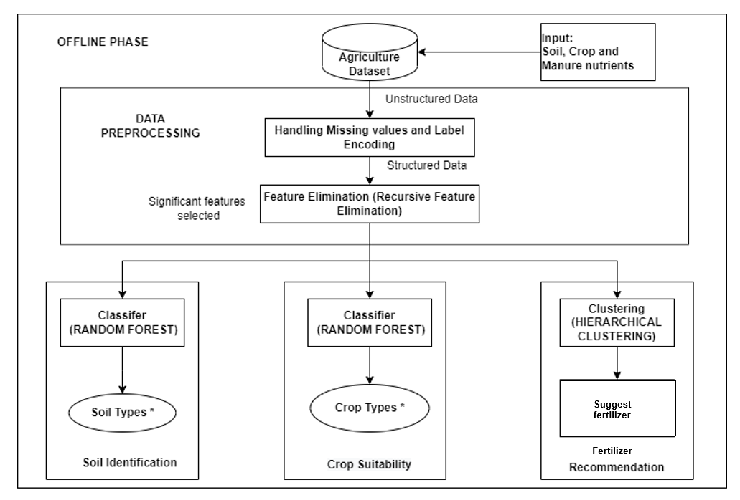

**Fertilizer**

**Recommendation**

**ONLINE PHASE**

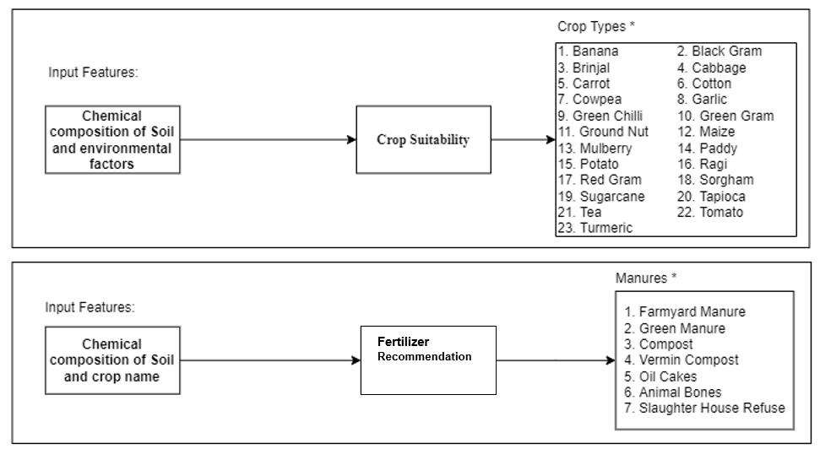

Figure 5.1.1 System Architecture

**Flowchart:**

**UML DIAGRAM**

**UseCase Diagram:**

**Sequence Diagram:**

* 1. **Data set Description**

The dataset is collected from the website Kaggle [1]The dataset contains 3 macronutrients (such as Nitrogen, Potassium, Phosphorus, etc.), 23 crops (such as Jute, Rice, maize, etc.) The features are listed in the table 6.1.

* No. of Instances - 2201
* No. of attributes - 9
  1. **Data Preprocessing**

Preprocessing of data is mainly to check the data quality. The quality can be reviewed in terms of Accuracy, Completeness, consistency, timeliness, believability, and interpretability. The collected dataset is raw in nature. Before performing the machine learning technique, the dataset needs to be in a structured format. The foremost step of data preprocessing is data cleaning. Correcting data errors and deleting bad records can be a time-consuming, time-consuming operation, which cannot be ignored.

* 1. **Feature elimination**

The feature selection method is used to identify the best set of attributes by eliminating irrelevant attributes. It will increase accuracy, decrease training time and overfitting. The feature selection is of three types namely filter, wrapper and embedded methods. Feature elimination is a feature selection method that fits a model and removes the weakest feature (or features) until the specified number of features is reached.

* 1. **Soil Identification**

The soil in the farm field is classified based on soil textures. Sandy, loamy sand, sandy loam, loam, silt loam, silt, sandy clay loam, clay loam, silty clay loam, sandy clay, silty clay, and clay are the major soil texture classification [13]. From the Kaggle dataset, the considered attributes such as PH , N(Nitrogen), P(Phosphorous), K(Potassium),

* 1. **Crop Suitability**

The crop yield is predicted by mapping nutrients needed for the crop and soil nutrient level. Crop yield prediction is performed on the soil macronutrient and crop nutrient dataset. The crops in the dataset are maize ,mothbeans, blackgram ,coconut ,mungbean ,cotton ,jute riceand so on. From the Kaggle dataset, the considered attributes such as the chemical composition of the soil (i.e. PH, EC(salinity), N(Nitrogen), P(Phosphorous), K(Potassium), environmental factors (i.e. Rainfall, Humidity, Temperature) and soil type. A random forest algorithm is used to predict crop suitability.

* 1. **Fertilizer Recommendation**

To increase the crop yield by analyzing the soil nutrients, predicting the crop, and suggesting the organic manure. The considered attributes are chemical composition of the soil (i.e. PH, EC(salinity), OC Organic Carbon), N(Nitrogen), P(Phosphorous), K(Potassium), S(Sulphur), Zn(Zinc), B(Boron), Fe(Iron), Mn(Manganese), Cu(Copper). and crop name.

* 1. **Measures used for Performance Evaluation**

The efficiency of the algorithms is evaluated based on the various criteria of the test, such as precision, recall and F1- score.

ACCURACY

It is the ratio of the number of correct predictions to the total number of predictions.

Accuracy =



PRECISION

It is defined as the ratio of true positives to total predicted positive (i.e. True Positive and False Positive).

Precision =



RECALL

It is defined as the ratio of true positives to total actual positive (i.e. True Positive and False Negative).

Recall =



F1 SCORE

It is an estimation of how accurate a proposed model is by using Precision and Recall.

F1 score = 2 x

**CHAPTER 6**

**SYSTEM IMPLEMENTATION**

**IMPLEMENTATION**

The proposed methodology is implemented in Python. The datasets are collected from the Kaggle website. It contains 2201 records comprising 23 variant crops and 3 Three macronutrients with 9 features. Experiments are conducted on a variety of train and test ratios and the performance of the proposed system is compared with benchmark algorithms in terms of accuracy, precision, recall and F1-measure.

* 1. **Data Preprocessing**

The collected dataset is raw in nature. Before performing the machine learning technique, the dataset needs to be in a structured format. The foremost step of data preprocessing is data cleaning. Correcting data errors and deleting bad records can be a time-consuming, time-consuming operation, which cannot be ignored. Missing values, noisy data, inconsistent data and outliers are eliminated during the cleaning process. Label encoding is performed to change categorical values into a numerical value.

**Handling Missing values**

The missing values are replaced by

* Standard values like “Not Available” or “NA”.
* Filling manually but not applicable for large data.
* Using mean value when the data is normally distributed wherein in the case of non-normal distribution median value of the attribute can be used.
* The most probable value is used using regression or decision tree algorithms.

The attributes ‘Latitude’ and ‘Longitude’ have null values. The null values are replaced by filling zeros.

**Label Encoding**

Label Encoding refers to converting the labels into a numeric form so as to convert them into the machine-readable form. Some of the attributes have categorical values. For example, districts have categorical values. It is converted into numeric form.

Chennai🡪 0

Trichy🡪 1

* 1. **Recursive Feature Elimination**

Recursive feature elimination(RFE) is a wrapper technique that selects the relevant features based on the Z - Score and Ranking method. At every step, it eliminates the weakest features from n features from the generated model by fitting the model multiple times. The weakest feature is determined by either the coef_ or feature_importances_ attribute of the fitted model. The selected features are shown in table 6.1.

Table 6.1. Original vs Feature Extracted data

|  |  |  |  |
| --- | --- | --- | --- |
| **S.No** | **Original Features** | **S.No** | **Extracted Feature** |
| 1. | Sample No | 1. | PH |
| 2 | PH | 4. | N(Nitrogen) |
| 3. | Crop | 5. | K(Potassium) |
| 4. | N(Nitrogen) | 6. | P(Phosphorus) |
| 5. | P(Phosphorus) | 7. | Rainfall |
| 6. | K(Potassium) | 8. | Humidity |
| 7. | Rainfall | 9. | Temperature |
| 8. | Humidity |  |  |
| 9. | Temperature |  |  |

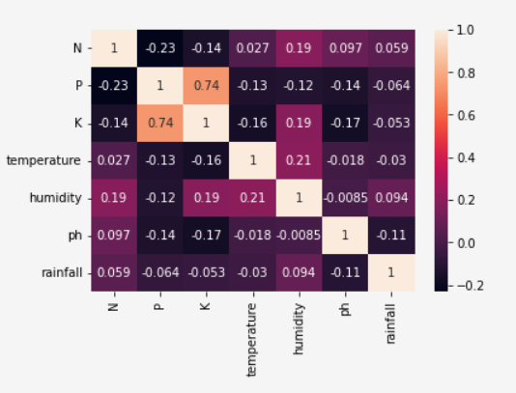

**6.0** Corelation Graph

* 1. **Soil Identification**

The soil in the farm field is classified based on soil textures. Sandy, loamy sand, sandy loam, loam, silt loam, silt, sandy clay loam, clay loam, silty clay loam, sandy clay, silty clay, and clay are the major soil texture classification [14]. From the agriculture dataset, the considered attributes such as PH, EC(salinity), N(Nitrogen), P(Phosphorous), K(Potassium), Based on these attributes, a random forest algorithm is used to classify the soil type.

**Random Forest:**

It is an ensemble learning algorithm that uses a bagging method. The bagging method creates a combination of decision trees and merges them to achieve more accurate and precise results. A random forest algorithm is used to solve classification and regression problems. The advantage of using random forest is that the dataset is automatically balanced, not biased classification and won’t affect the overall algorithm if a new record is added. It does not suffer from overfitting if more trees are affixed to the forest [16]. The working flow of random forest is:

1. Randomly k data points are picked from the dataset (i.e. k is a subset of the dataset) and the decision tree is built.
2. Specify the number of decision trees to construct (n).
3. Steps 1 and 2 are repeated until the dataset has been fully processed.
4. For the new data point, each decision tree will predict the result, the majority voting from the decision trees is considered as the final result.

Each record in the dataset is considered as a data point. Randomly k records are chosen from the soil dataset. The decision tree is built for the chosen records. The soil type is predicted by majority voting given by the decision trees. The soil types are classified with the help of decision trees in the random forest algorithm. The figure 6.1 shows the confusion matrix of soil identification by Random Forest algorithm.

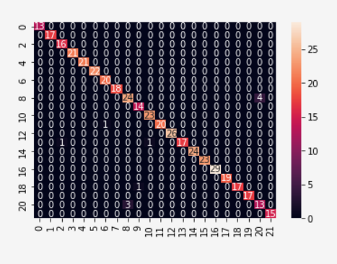

Figure 6.1 Confusion Matrix of Soil identification

**Decision tree**

A decision tree generates a set of rules for characterising data based on a collection of attributes and their groupings. The Decision Tree is simple to understand and interpret, requires little data processing and can handle numerical and categorical data. Decision trees can generate dynamic trees that are difficult to generalise and unreliable because tiny changes in the data might result in the production of a completely new tree [6].

**Naive Bayes**

A Naive Bayes classifier implies that the existence of one feature in a class is independent to the presence of any other feature.   It's mostly used for grouping and classification, and it is based on the conditional probability of happening.

**Support Vector Machine**

Support-vector machines are supervised learning models that examine data for classification and regression analysis in machine learning. SVMs may also do non-linear classification by implicitly mapping their inputs into high-dimensional feature spaces, which is known as the kernel trick. Essentially, it is used to draw boundaries between classes. The margins are drawn in such a way that the distance between the margin and the classes is as little as possible, resulting in the least amount of classification error.

* 1. **Crop Suitability**

The crop yield is predicted by mapping nutrients needed for the crop and soil nutrient level. Crop yield prediction is performed on the soil and crop nutrient dataset. The crops in the dataset are Banana, Black gram, Black gram, Brinjal, Cabbage, Carrot, Cotton, Cowpea, Garlic and so on. From the agriculture dataset, the considered attributes such as the chemical composition of the soil (i.e. PH, EC(salinity), OC Organic Carbon), N(Nitrogen), P(Phosphorous), K(Potassium), S(Sulphur), Zn(Zinc), B(Boron), Fe(Iron), Mn(Manganese), Cu(Copper)), environmental factors (i.e. Rainfall, Humidity, Temperature) and soil type. A random forest algorithm is used to predict crop suitability.

**Random Forest:**

It is an ensemble learning algorithm that uses a bagging method. The bagging method creates a combination of decision trees and merges them to achieve more accurate and precise results. A random forest algorithm is used to solve classification and regression problems. The advantage of using random forest is that the dataset is automatically balanced, not biased classification and won’t affect the overall algorithm if a new record is added. It does not suffer from overfitting if more trees are affixed to the forest [16]. The working flow of random forest is:

1. Randomly k data points are picked from the dataset (i.e. k is a subset of the dataset) and the decision tree is built.
2. Specify the number of decision trees to construct (n).
3. Steps 1 and 2 are repeated until the dataset has been fully processed.
4. For the new data point, each decision tree will predict the result, the majority voting from the decision trees is considered as the final result.

Each record in the dataset is considered as a data point. Randomly k records are chosen from the soil dataset. The decision tree is built for the chosen records. The soil type is predicted by majority voting given by the decision trees. The soil types are classified with the help of decision trees in the random forest algorithm. The figure 6.2 shows the confusion matrix of crop suitability by Random Forest.

**Decision tree**

A decision tree generates a set of rules for characterizing data based on a collection of attributes and their groupings. The Decision Tree is simple to understand and interpret, requires little data processing and can handle numerical and categorical data. Decision trees can generate dynamic trees that are difficult to generalize and unreliable because tiny changes in the data might result in the production of a completely new tree [6].

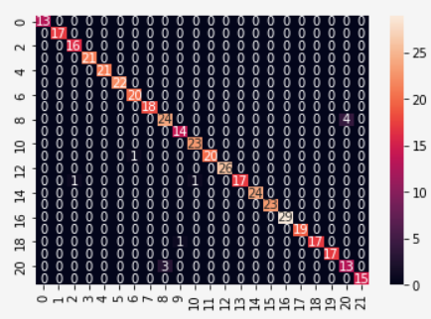

Figure 6.2. Confusion Matrix of Crop Suitability.

**Naive Bayes**

A Naive Bayes classifier implies that the existence of one feature in a class is independent to the presence of any other feature.   It's mostly used for grouping and classification, and it is based on the conditional probability of happening.

**Support Vector Machine**

Support-vector machines are supervised learning models that examine data for classification and regression analysis in machine learning. SVMs may also do non-linear classification by implicitly mapping their inputs into high-dimensional feature spaces, which is known as the kernel trick. Essentially, it is used to draw boundaries between classes. The margins are drawn in such a way that the distance between the margin and the classes is as little as possible, resulting in the least amount of classification error.

* 1. **Fertilizer Recommendation**

To increase the crop yield by analyzing the soil nutrients, predicting the crop, and suggesting the organic manure. The considered attributes are chemical composition of the soil (i.e. PH, N(Nitrogen), P(Phosphorous), K(Potassium). and crop name. The hierarchical clustering algorithm is used to recommend the organic manure and its composition.

**Hierarchical Clustering:**

Hierarchical cluster analysis constructs a hierarchy of clusters formed by grouping the datasets. The hierarchy of clusters looks like a tree shaped structure, named a dendrogram. The advantage of hierarchical clustering is that there is no need to have a predefined number of clusters. The working flow is:

1. Each data point is first defined as a separate cluster (i.e. N data points will have N clusters).
2. Combine two closed clusters to form a single cluster (i.e. N-1 clusters).
3. Step 2 should be repeated until only one cluster remains.
4. Create a dendrogram to divide the cluster once you've reached the final cluster.

The dendrogram will have the recommendation of organic manure and its proportion for a particular crop. The 3D view of clusters is shown in figure 6.3.

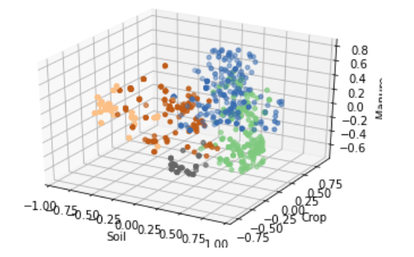

Figure 6.3. Clusters are plotted in 3D view

**K - means Clustering**

k-means clustering algorithm use k centroids to group similar data points. it assigns every data point to the nearest centroid. The centroid is updated by the average of the points assigned to it. The drawback of K-means clustering is an initialization of a predetermined number of clusters.

**CHAPTER 7**

**EXPERIMENTS AND RESULTS**

**EXPERIMENTS AND RESULTS**

The proposed methodology is implemented in Python. The datasets are collected from the soil health card website. It contains 2201 records comprising 23 variant crops and 3 Marco Nutrient with 9 features. Experiments are conducted on a variety of train and test ratios and the performance of the proposed system is compared with benchmark algorithms in terms of accuracy, precision, recall and F1-measure.

* 1. **Analysis using Classification Accuracy**

The accuracy of classification algorithms is shown in the graphical representation in Figure 7.1. In the overall proportion of the dataset, the random forest provides higher accuracy when compared with Naïve Bayes, Support Vector Machine and decision tree,Random Forest , Logistic Regression. So, Random forest is used for soil classification to attain higher accuracy

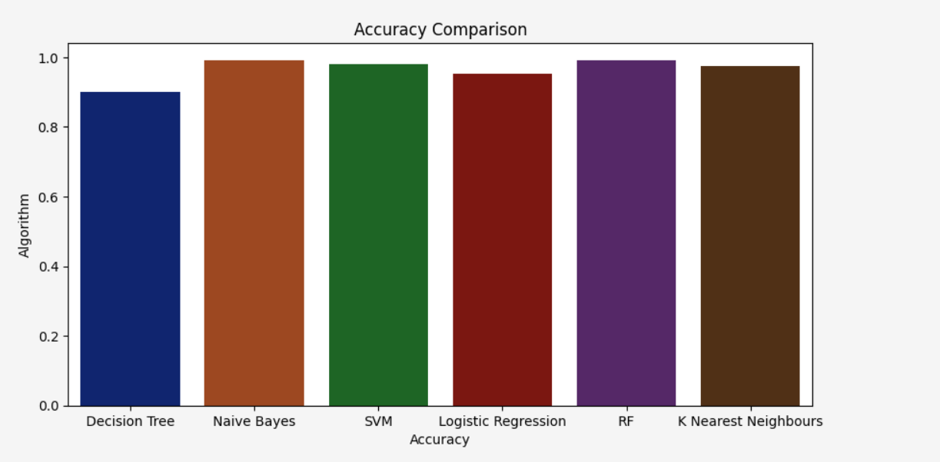

Figure 7.1. Accuracy of soil identification compared with different algorithms.

Figure 7.2. Accuracy of crop prediction compared with different algorithms

* 1. **Analysis using Clustering Accuracy**

Figure 7.3. Dendrogram clusters for Fertilizer and its composition

The organic manure and its proportion are visualized in the dendrogram clusters in Figure 7.3. The proportion of organic manure is at a lower level. The type of organic manure, type of crop and soil type and the attributes considered for recommendation are arranged in higher levels.

Figure 7.4 shows the cluster creation time taken by the clustering algorithms for the dataset when the number of clusters is increased. The inference from the graph is that when the number of clusters increases, the creation time also increases. Compared to K- means clustering, hierarchical clustering takes lesser time for cluster creation.

Figure 7.4. Hierarchical and K- means clustering cluster creation time.

Figure 7.5. Accuracy of recommendation compared with K-means clustering algorithms

The accuracy of the proposed algorithm and other algorithms are shown in the graphical representation in Figure 7.5. The hierarchical clustering algorithm performs better than K- means clustering algorithm

Table 7.1. Overall metrics of Proposed Model

|  |  |  |  |  |
| --- | --- | --- | --- | --- |
| **Metrics** | **Algorithms** | **Training - testing set Ratios** | | |
| 70 – 30 | 80 - 20 | 90 -10 |
| Precision | NB | 0.827 | 0.829 | 0.801 |
| **RF** | **0.947** | **0.979** | **0.990** |
| SVM | 0.905 | 0.910 | 0.891 |
| DT | 0.882 | 0.935 | 0.921 |
| K Nearest Neighbours | 0.975 | 0.97 | 0.98 |
| Recall | NB | 0.747 | 0.729 | 0.743 |
| K Nearest Neighbours | 0.97 | 0.97 | 0.97 |
| **RF** | **0.945** | **0.975** | **0.980** |
| SVM | 0.888 | 0.892 | 0.861 |
| DT | 0.875 | 0.911 | 0.891 |
| F1 score | NB | 0.761 | 0.747 | 0.754 |
| **RF** | **0.940** | **0.975** | **0.983** |
| SVM | 0.888 | 0.891 | 0.889 |
| K Nearest Neighbours | 0.97 | 0.97 | 0.98 |
| DT | 0.870 | 0.913 | 0.905 |

**CHAPTER -8**

**DEPLOYMENT**

**8.1 Tool**

* Github
* Heroku

**Github**

GitHub, Inc. is a provider of Internet hosting for software development and

version control using Git. It offers the distributed version control and source code

management (SCM) functionality of Git, plus its own features. It provides access

control and several collaboration features such as bug tracking, feature requests, task

management, continuous integration, and wikis for every project.

**Heruko**

Heroku is a cloud platform as a service (PaaS) supporting several

programming languages. One of the first cloud platforms, Heroku has been in

development since June 2007, when it supported only the Ruby programming

language, but now supports Java, Node.js, Scala, Clojure, Python, PHP, and Go.

For this reason, Heroku is said to be a polyglot platform as it has features for a

developer to build, run and scale applications in a similar manner across most

languages.

**8.2 Implementation**

Step 1 - Install the Heroku CLI on your Computer (You can find the procedure here for all OS https://devcenter.heroku.com/articles/heroku-cli)

Step 2 - Go to Heroku website (heroku.com), login and create a new App; choose a meaningful name for your App.

Step 3 - Now we need to add a python build path, head over to Settings>Add Build Path>Select the Python Option

Step 3 - Create a Python Flask web application which will act as Backend

Example of basic Flask Application

from flask import Flask

app = Flask(__name__)

@app.route("/")

def index():

return "Hello World!"

Before you can deploy an app to Heroku, you need to add Two Important Files which are the Procfile & requirements.txt file

Step 4 - Open your project in your favourite code Editor or Navigate to your project directory and create a file named Procfile (install Gunicorn package before moving on to next setup)

Setup 5-using any code editor like VSCode or TextEdit, open the Profile, and replace any text already prevalent with:

**web: gunicorn app:app**

Setup 6 -Open Your project folder On your Command Line Interface (CLI) inside your environment use the following command:

**heroku login**

**heroku git:remote -a App_name**

**git add .**

**git commit -m "Deployment commit"**

**git push heroku master**

Setup 7- After pushing the master branch to the heroku remote, you’ll see that the

output displays information about the building and deployment process:

remote: -----> Launching...

remote: Released v1

remote: https://example-app.herokuapp.com/ deployed to Heroku

remote:

remote: Verifying deploy... done.

To https://git.heroku.com/realpython-example-app.git

* [new branch] master -> master

you’ll find the URL for your application. In this case, it’s **https://example-app.herokuapp.com**/. You can also use the following Heroku CLI command to open your app’s URL:

$ heroku open

**8.3 Our Web app (url)**

https://croft1551.herokuapp.com/

|  |  |
| --- | --- |
| **Croft** | The activities of farmers and crofters are vital to the wellbeing of the Crofter |
| **1551** | Indian Farmers Helpline No. |
| **Herokuapp** | Deployment tool |

**CHAPTER 9**

**CONCLUSION AND FUTURE WORK**

**CONCLUSION AND FUTURE WORK**

The vital approach of this project is to predict the Crop & Fertilizer based on the soil nutrient content and the location To help crofter to choose the right crop for their land and to give the suitable amount of fertilizer to produce the maximum yield. It is tested for 23 crops (such as Paddy, wheat, maize, etc.) with 8 attributes such as pH, N, P, K, etc. and Crop & Fertilizer is recommended. The algorithms used in the three level approach are compared and evaluated with higher accuracy, precision and recall. Soil classification and crop prediction algorithms like Naive Bayes, Support Vector Machine, Decision Tree & Random Forest and organic manure recommendation algorithms like K means and hierarchical clustering are compared with one another. With better performance metrics, random forest and hierarchical clustering provide better results to the proposed model.

The proposed method is tested only for a small set of crops and Fertilizer. In future, the suggested method needs to be tested for more variety of Crops and Fertilizer . Feature of dataset is low, so more Feature like other macronutrients (C,Zn etc) need to be added on dataset to get the ideal accurate. An android application is designed to help the young farmers by just stuffing the field details into the interface and getting useful and accurate results in a fraction of time.

**CHAPTER 10**

**APPENDICES**

**Client Side Code:**

**Layout.html**

<!DOCTYPE html>

<html lang="en">

<head>

<title>{{ title }}</title>

<link rel="shortcut icon" href="{{ url_for('static', filename='images/favicon.ico') }}"/>

<!-- for-mobile-apps -->

<meta name="viewport" content="width=device-width, initial-scale=1">

<meta charset="utf-8">

<meta name="keywords" content="Agro Harvest Responsive web template, Bootstrap Web Templates, Flat Web Templates, Android Compatible web template,

Smartphone Compatible web template, free webdesigns for Nokia, Samsung, LG, SonyEricsson, Motorola web design" />

<style>

html {

font-size: 1rem;

}

@media (min-width: 576px) {

html {

font-size: 1.25rem;

}

}

@media (min-width: 768px) {

html {

font-size: 1.5rem;

}

}

@media (min-width: 992px) {

html {

font-size: 1.75rem;

}

}

@media (min-width: 1200px) {

html {

font-size: 2rem;

}

html {

font-size: 1rem;

}

h1 {

font-size: 1.2rem;

}

h2 {

font-size: 1.1rem;

}

@media (min-width: 768px) {

html {

font-size: 1.1rem;

}

h1 {

font-size: 1.3rem;

}

h2 {

font-size: 1.2rem;

}

}

@media (min-width: 991px) {

html {

font-size: 1.2rem;

}

h1 {

font-size: 1.5rem;

}

h2 {

font-size: 1.4rem;

}

}

@media (min-width: 1200px) {

html {

font-size: 1.2rem;

}

h1 {

font-size: 1.7rem;

}

h2 {

font-size: 1.6rem;

}

}

}

</style>

<script>

addEventListener("load", function () {

setTimeout(hideURLbar, 0);

}, false);

function hideURLbar() {

window.scrollTo(0, 1);

}

</script>

<script src="https://code.jquery.com/jquery-3.3.1.slim.min.js"

integrity="sha384-q8i/X+965DzO0rT7abK41JStQIAqVgRVzpbzo5smXKp4YfRvH+8abtTE1Pi6jizo"

crossorigin="anonymous"></script>

<script src="https://cdnjs.cloudflare.com/ajax/libs/popper.js/1.14.7/umd/popper.min.js"

integrity="sha384-UO2eT0CpHqdSJQ6hJty5KVphtPhzWj9WO1clHTMGa3JDZwrnQq4sF86dIHNDz0W1"

crossorigin="anonymous"></script>

<script src="https://stackpath.bootstrapcdn.com/bootstrap/4.3.1/js/bootstrap.min.js"

integrity="sha384-JjSmVgyd0p3pXB1rRibZUAYoIIy6OrQ6VrjIEaFf/nJGzIxFDsf4x0xIM+B07jRM"

crossorigin="anonymous"></script>

<script src="https://code.jquery.com/jquery-3.5.1.slim.min.js"

integrity="sha384-DfXdz2htPH0lsSSs5nCTpuj/zy4C+OGpamoFVy38MVBnE+IbbVYUew+OrCXaRkfj"

crossorigin="anonymous"></script>

<script src="https://cdn.jsdelivr.net/npm/popper.js@1.16.0/dist/umd/popper.min.js"

integrity="sha384-Q6E9RHvbIyZFJoft+2mJbHaEWldlvI9IOYy5n3zV9zzTtmI3UksdQRVvoxMfooAo"

crossorigin="anonymous"></script>

</body>

<!-- css files -->

<link rel="stylesheet" href="https://stackpath.bootstrapcdn.com/bootstrap/4.3.1/css/bootstrap.min.css"

integrity="sha384-ggOyR0iXCbMQv3Xipma34MD+dH/1fQ784/j6cY/iJTQUOhcWr7x9JvoRxT2MZw1T" crossorigin="anonymous">

<link href="{{ url_for('static', filename='css/bootstrap.css') }}" rel='stylesheet' type='text/css' />

<!-- bootstrap css -->

<link href="{{ url_for('static', filename='css/style.css') }}" rel='stylesheet' type='text/css' />

<!-- custom css -->

<link href="{{ url_for('static', filename='css/font-awesome.min.css') }}" rel="stylesheet"><!-- fontawesome css -->

<!-- //css files -->

<!-- <link rel="icon" type="image/png" href="{{ url_for('static', filename='images/favicon.png?') }}"> -->

<script type="text/JavaScript" src="{{ url_for('static', filename='scripts/cities.js') }}"></script>

<!-- google fonts -->

<link href="//fonts.googleapis.com/css?family=Thasadith:400,400i,700,700i&amp;subset=latin-ext,thai,vietnamese"

rel="stylesheet">

<!-- //google fonts -->

<style>

header {

background-color: rgba(30, 30, 30, 1);

margin-top: 0rem;

display: block;

}

</style>

</head>

<body>

<!-- Navigation -->

<nav class="navbar navbar-expand-lg navbar-dark bg-dark static-top" style="background-color: #1C00ff00;">

<div class="container">

<a class="navbar-brand" href="{{ url_for('home') }}">

<img src="{{ url_for('static', filename='images/logo.jpg') }}" style="width: 90px; height: 55px" alt="">

</a>

<button class="navbar-toggler" type="button" data-toggle="collapse" data-target="#navbarResponsive"

aria-controls="navbarResponsive" aria-expanded="false" aria-label="Toggle navigation">

<span class="navbar-toggler-icon"></span>

</button>

<div class="collapse navbar-collapse" id="navbarResponsive">

<ul class="navbar-nav ml-auto">

<li class="nav-item active">

<a class="nav-link" href="{{ url_for('home') }}">Home

<span class="sr-only">(current)</span>

</a>

</li>

<li class="nav-item">

<a class="nav-link" href="{{ url_for('crop_recommend') }}">Crop</a>

</li>

<li class="nav-item">

<a class="nav-link" href="{{ url_for('fertilizer_recommendation') }}">Fertilizer</a>

</li>

</ul>

</div>

</div>

</nav>

{% block body %} {% endblock %}

<!-- footer -->

<footer class="text-center py-5">

<div class="container py-md-3">

<!-- logo -->

<h2 class="logo2 text-center">

<a href="{{ url_for('home') }}">

Croft

</a>

</h2>

<!-- //logo -->

<!-- address -->

<div class="contact-left-footer mt-4">

<!-- <a href="community.html">Community</a> -->

</p>

</div>

<p class="homelogo">

<p>Made by

Melvingnanaliyes<br>

Ragul Raj<br>

Praveenkanth</p>

</div>

</footer>

<!-- //footer -->

<!-- move top icon -->

<a href="#home" class="move-top text-center"></a>

<!-- //move top icon -->

</body>

</html>

**Index.html**

{% extends 'layout.html' %}

{% block body %}

<!-- banner -->

<section class="banner_w3lspvt" id="home">

<div class="csslider infinity" id="slider1">

<div class="banner-top">

<div class="overlay">

<div class="container">

<div class="w3layouts-banner-info text-center">

<h3 class="text-wh">CROFT</h3>

<h4 class="text-wh mx-auto my-4"><b>Get informed decisions about your farming strategy.</b></h4>

<br>

<h4 class="text-wh mx-auto my-4"><strong> Here are some questions we'll answer</strong></h4>

<p class="text-li mx-auto mt-2">

1. What crop to plant here? <br>

2. What fertilizer to use? <br>

</div>

</div>

</div>

</div>

</div>

</section>

<!-- //banner -->

<!-- core values -->

<section class="core-value py-5">

<div class="container py-md-4">

<h3 class="heading mb-sm-5 mb-4 text-center"> About Us</h3>

<div class="row core-grids">

<div class="col-lg-6 core-left">

<img src="{{ url_for('static', filename='images/core.jpg') }}" class="img-fluid" alt="" />

</div>

<div class="col-lg-6 core-right">

<h3 class="mt-4">Improving Agriculture, Improving Lives, Cultivating Crops To Make Farmers Increase

Profit.</h3>

<p class="mt-3">We use state-of-the-art machine learning and deep learning technologies to help you

guide through

the entire farming process. Make informed decisions to understand the demographics of your area,

understand the

factors that affect your crop and keep them healthy for a super awesome successful yield.</p>

</div>

</div>

</div>

</section>

<!-- //core values -->

<!-- Products & Services -->

<section class="blog py-5">

<div class="container py-md-5">

<h3 class="heading mb-sm-5 mb-4 text-center"> Our Services</h3>

<div class="row blog-grids">

<div class="col-lg-4 col-md-6 blog-left mb-lg-0 mb-sm-5 pb-lg-0 pb-5">

<img src="{{ url_for('static', filename='images/s3.jpg') }}" class="img-fluid" alt="" />

<a href="{{ url_for('crop_recommend') }}">

<div class="blog-info">

<h4>Crop</h4>

<p class="mt-2"> Recommendation about the type of crops to be cultivated which is best suited

for the respective conditions</p>

</div>

</a>

</div>

<div class="col-lg-4 col-md-6 blog-right mt-lg-0 mt-5 pt-lg-0 pt-md-5">

<img src="{{ url_for('static', filename='images/s2.jpg') }}" class="img-fluid" alt="" />

<a href="{{ url_for('fertilizer_recommendation') }}">

<div class="blog-info">

<h4>Fertilizer</h4>

<p class="mt-2">Recommendation about the type of fertilizer best suited for the particular soil

and the recommended crop</p>

</div>

</a>

</div>

</div>

</div>

</section>

<!-- //Products & Services -->

<!-- Creating custom grid and hover effect

<section>

<div class="col-lg-3 col-md-4 col-sm-6 col-xs-12">

<div class="hovereffect">

<img class="img-responsive" src="images/s2.jpg" alt="">

<div class="overlay">

<h2>Hover effect 1</h2>

<a class="info" href="#">link here</a>

</div>

</div>

</div> -->

</html>

{% endblock %}

**Index Page**

**Server Side Code:**

from flask import Flask, render_template, request, Markup

import numpy as np

import pandas as pd

from utils.fertilizer import fertilizer_dic

import requests

import config

import pickle

import io

#import torch

#from torchvision import transforms

# ==============================================================================================

# -------------------------LOADING THE TRAINED MODELS -----------------------------------------------

# Loading crop recommendation model

crop_recommendation_model_path = 'Model/RandomForest.pkl'

crop_recommendation_model = pickle.load(

open(crop_recommendation_model_path, 'rb'))

# =========================================================================================

# Custom functions for calculations

def weather_fetch(city_name):

"""

Fetch and returns the temperature and humidity of a city

:params: city_name

:return: temperature, humidity

"""

api_key = config.weather_api_key

base_url = "http://api.openweathermap.org/data/2.5/weather?"

complete_url = base_url + "appid=" + api_key + "&q=" + city_name

response = requests.get(complete_url)

x = response.json()

if x["cod"] != "404":

y = x["main"]

temperature = round((y["temp"] - 273.15), 2)

humidity = y["humidity"]

return temperature, humidity

else:

return None

# ===============================================================================================

# ------------------------------------ FLASK APP -------------------------------------------------

app = Flask(__name__)

@ app.route('/')

def home():

title = 'Croft - Home'

return render_template('index.html', title=title)

# render crop recommendation form page

@ app.route('/crop-recommend')

def crop_recommend():

title = 'Croft - Crop Recommendation'

return render_template('crop.html', title=title)

# render fertilizer recommendation form page

@ app.route('/fertilizer')

def fertilizer_recommendation():

title = 'Croft - Fertilizer Suggestion'

return render_template('fertilizer.html', title=title)

# ===============================================================================================

# RENDER PREDICTION PAGES

# render crop recommendation result page

@ app.route('/crop-predict', methods=['POST'])

def crop_prediction():

title = 'Harvestify - Crop Recommendation'

if request.method == 'POST':

N = int(request.form['nitrogen'])

P = int(request.form['phosphorous'])

K = int(request.form['pottasium'])

ph = float(request.form['ph'])

rainfall = float(request.form['rainfall'])

# state = request.form.get("stt")

city = request.form.get("city")

if weather_fetch(city) != None:

temperature, humidity = weather_fetch(city)

data = np.array([[N, P, K, temperature, humidity, ph, rainfall]])

my_prediction = crop_recommendation_model.predict(data)

final_prediction = my_prediction[0]

return render_template('crop-result.html', prediction=final_prediction, title=title)

else:

return render_template('try_again.html', title=title)

# render fertilizer recommendation result page

@ app.route('/fertilizer-predict', methods=['POST'])

def fert_recommend():

title = 'Harvestify - Fertilizer Suggestion'

crop_name = str(request.form['cropname'])

N = int(request.form['nitrogen'])

P = int(request.form['phosphorous'])

K = int(request.form['pottasium'])

# ph = float(request.form['ph'])

df = pd.read_csv('data set/fertilizer.csv')

nr = df[df['Crop'] == crop_name]['N'].iloc[0]

pr = df[df['Crop'] == crop_name]['P'].iloc[0]

kr = df[df['Crop'] == crop_name]['K'].iloc[0]

n = nr - N

p = pr - P

k = kr - K

temp = {abs(n): "N", abs(p): "P", abs(k): "K"}

max_value = temp[max(temp.keys())]

if max_value == "N":

if n < 0:

key = 'NHigh'

else:

key = "Nlow"

elif max_value == "P":

if p < 0:

key = 'PHigh'

else:

key = "Plow"

else:

if k < 0:

key = 'KHigh'

else:

key = "Klow"

response = Markup(str(fertilizer_dic[key]))

return render_template('fertilizer-result.html', recommendation=response, title=title)

# ===============================================================================================

if __name__ == '__main__':

app.run(debug=False)

**CHAPTER 11**

**REFERENCES**

1. “Kaglee.com.”[Online].Available [https:/Kaglee.com/](https://Kaglee.com/)
2. <https://www.nationsencyclopedia.com/economies/Asia-and-the-Pacific/India-AGRICULTURE.html>
3. M. P. Kiran, and N. R. Deepak, "Crop Prediction Based on Influencing Parameters for Different States in India-The Data Mining Approach," In 2021 5th International Conference on Intelligent Computing and Control Systems (ICICCS), IEEE, Madurai, India, pp. 1785-1791, May 2021.
4. Awan, A. M., & Sap, M. N. M. (2006, April). An intelligent system based on kernel methods for cropyield prediction. In Pacific-AsiaConference on Knowledge Discovery and Data Mining (pp. 841-846).Springer,Berlin,HeidelbergK.
5. Bodake, R. Ghate, H. Doshi, P. Jadhav, & B. Tarle, “Soil based fertilizer recommendation system using Internet of Things,” MVP Journal of Engineering Sciences, India, vol 1, pp. 13-19, June 2018.
6. SantoshMahagaonkar, “Prediction Of Crop Yield And Fertilizer Recommendation Using Machine Learning Algorithms”. International Journal of Engineering Applied Sciences and Technology, ISSN No: 2455-2143, September 2019.
7. G. Suresh, A.S. Kumar, S. Lekashri, & R. Manikandan, “Efficient crop yield recommendation system using machine learning for digital farming,” International Journal of Modern Agriculture, Vol 10, pp. 906-914, 2021.
8. J. Pant, R.P. Pant, M.K. Singh, D.P. Singh, & H. Pant, “Analysis of agricultural crop yield prediction using statistical techniques of machine learning,” Materials Today: Proceedings, vol 46, pp 10922-10926, 2021.
9. K. Archana, and K. G. Saranya. "Crop yield prediction, forecasting and fertilizer recommendation using Data mining algorithm," International Journal of Computer Science Engineering, vol 9, pp. 76-79, Feburary 2020.
10. M. Rajeswari, A.S. Anushiya, K.S.A. Fathima, S.S. Priya, & N. Mathumithaa, “Fuzzy Decision Support System for Recommendation of Crop Cultivation based on Soil Type," In 2020 4th International Conference on Trends in Electronics and Informatics (ICOEI), IEEE,Tirunelveli, India, pp. 768-773, June 2020.
11. D. Elavarasan, & P.D. Vincent, “Crop yield prediction using deep reinforcement learning model for sustainable agrarian applications,” IEEE Access, vol 8, pp. 86886-86901, 2020.
12. B. Kuzman, B. Petković, N. Denić, D. Petković, B. Ćirković, J. Stojanović, & M. Milić, M. (2021). “Estimation of optimal fertilizers for optimal crop yield by adaptive neuro fuzzy logic,” Rhizosphere, vol 18, June 2021.
13. P.M. Gopal, & R. Bhargavi, “A novel approach for efficient crop yield prediction,” Computers and Electronics in Agriculture, vol 165, October 2019.
14. Chaudhary, S. Kolhe, & R. Kamal, “An improved random forest classifier for multi-class classification,” Information Processing in Agriculture, vol 3, pp. 215-222, December 2016.
15. Karna, & K. Gibert, “Automatic identification of the number of clusters in hierarchical clustering” Neural Computing and Applications, pp. 1-16, March 2021.
16. Chougule, V.K. Jha, & D. Mukhopadhyay, “Crop suitability and fertilizers recommendation using data mining techniques,” In Progress in Advanced Computing and Intelligent Engineering, Springer, Singapore, pp. 205-213, 2019.
17. S. Prakash, A. Sharma, & S.S. Sahu, “Soil moisture prediction using machine learning,” In 2018 Second International Conference on Inventive Communication and Computational Technologies (ICICCT), IEEE, Coimbatore, India, pp. 1-6, April 2018.
18. Viviliya B, Vaidhehi V, “7. The Design of Hybrid Crop Recommendation System using Machine Learning Algorithms”. Journal Name: International Journal of Innovative Technology and Exploring Engineering (IJITEE), ISSN No: 2278- 3075, 2 December 2019