|  |  |  |  |
| --- | --- | --- | --- |
| BN | Section | Student ID | اسم الطالب |
| **42** | **3** | **9210950** | **محمد جاد محمد احمد** |
| **17** | **3** | **9210808** | **فتحي مصطفي فتحي عبد الحميد** |

# System Design

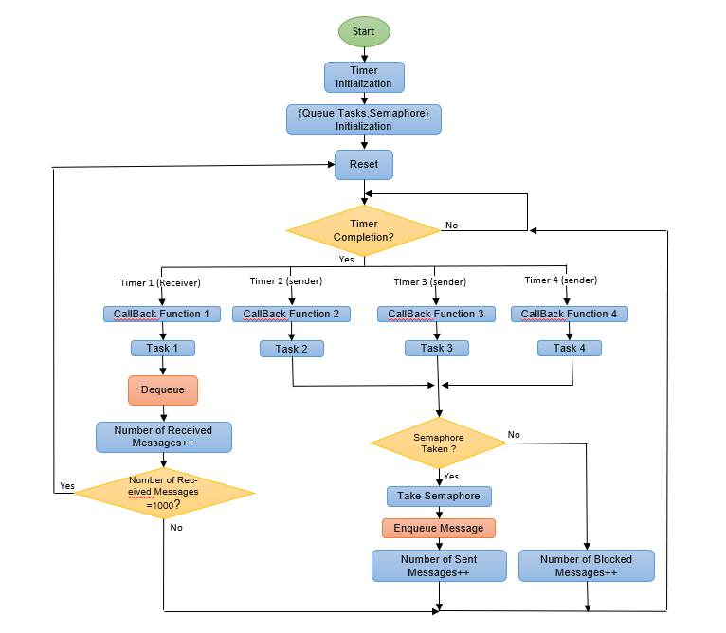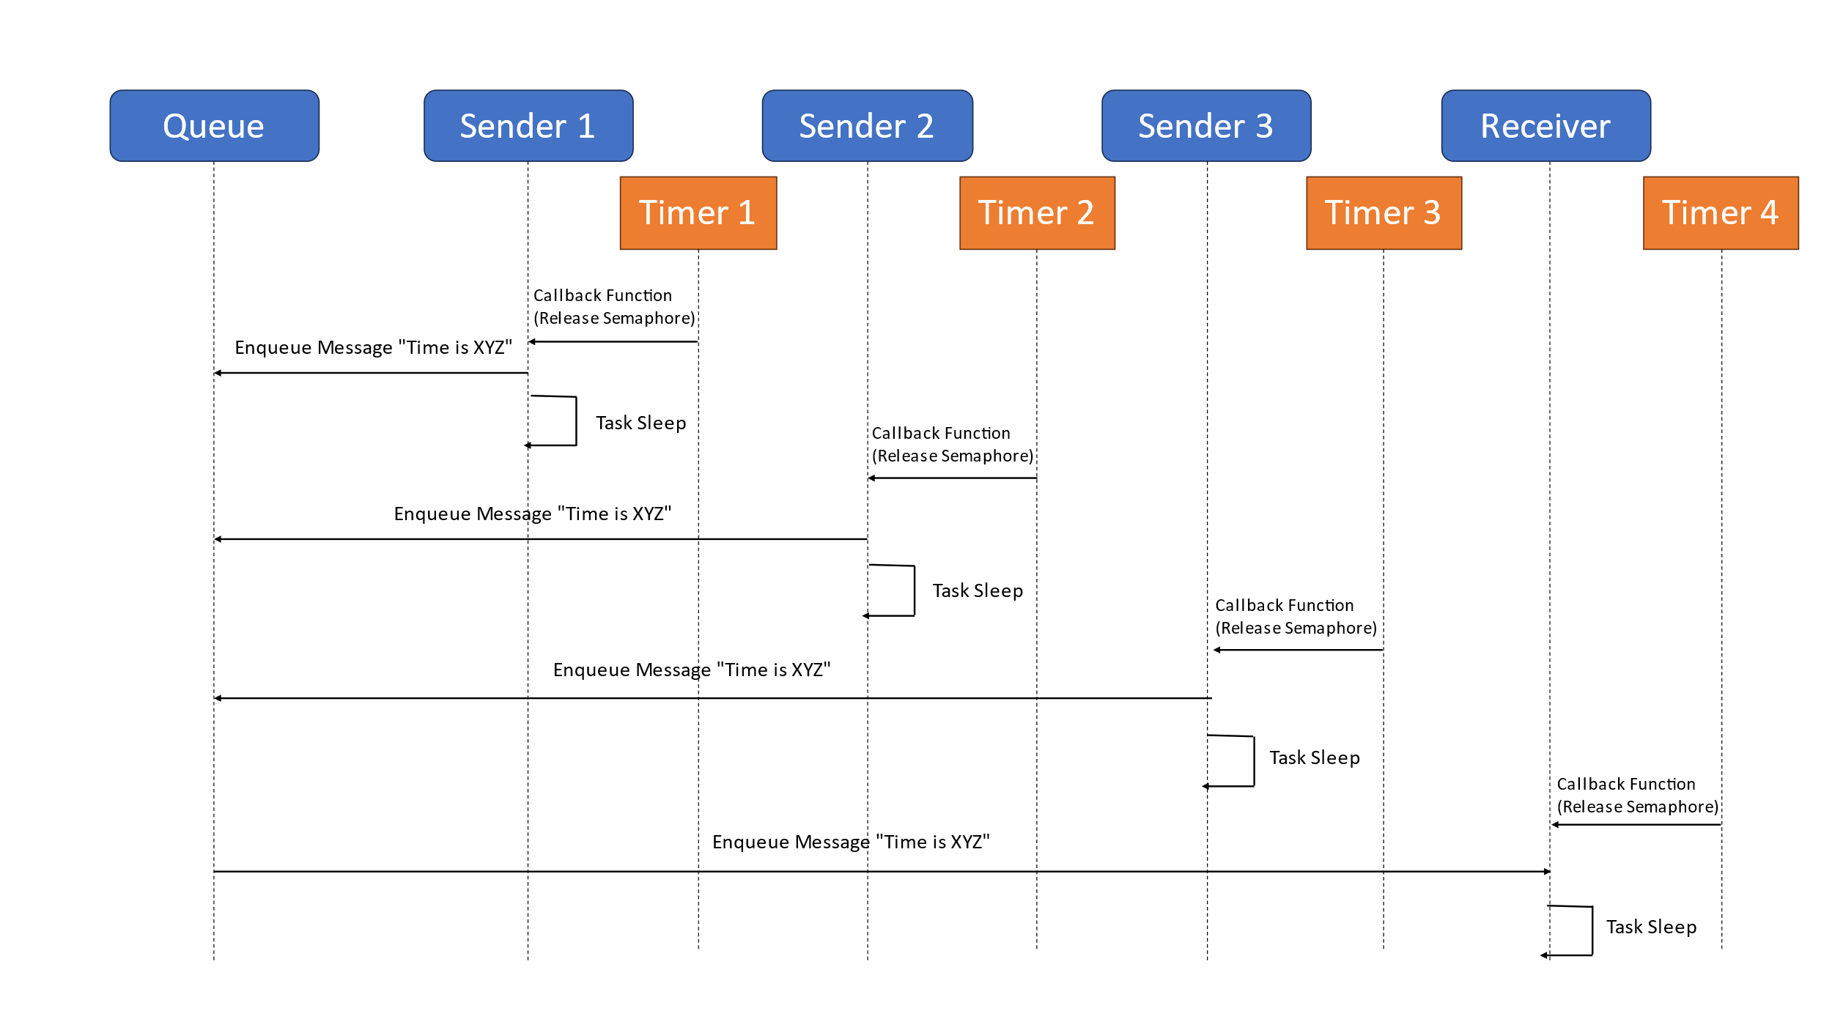

Figure 1:Message Sequence Figure 2:Flow Chart of the System

There is a priority to execute in the task, for example, task 1 has the highest priority because it is the receiver, and tasks 1 and 2 have the lowest priority because task 3 needs a strict deadline for execution, and if one of the tasks is in the execution state and another task is called, then we check Priority, and if the priority is greater, we cut off the first task and store its registers and execute the second task, and when it is finished, we return to the task with the lowest priority, and this priority cannot be changed unless the task with the highest priority needs a semaphore taken in the task of the lowest priority, then we continue Task is the lowest priority until it releases the semaphore.

# Results and Discussion

To represent the system data, we printed the process status statement from Success or Block, then we made a text processing using the MATLAB, the following table shows the output.

Comment:: We put our MATLAB code, variables and console outputs in [GitHub Repository](https://github.com/faatthy/rtos-project) .

Table 1: Overview of the Results and Statistics

|  |  |  |  |  |  |  |  |
| --- | --- | --- | --- | --- | --- | --- | --- |
| **Iteration** | **Queue** | **1** | **2** | **3** | **4** | **5** | **6** |
| **Average Of Sent Messages Time for Sender 1** | **3** | **98.3** | **139.976** | **179.973** | **221.144** | **261.717** | **302.926** |
| **10** | **98.666** | **139.473** | **181.751** | **219.331** | **259.567** | **301.832** |
| **Average Of Sent Messages Time for Sender 2** | **3** | **98.96** | **138.978** | **180.5** | **220.24** | **260.161** | **302** |
| **10** | **98.586** | **140.351** | **180.924** | **220.881** | **260.628** | **302.423** |
| **Average Of Sent Messages Time for Sender 3** | **3** | **98.85** | **140.12** | **182.659** | **222.463** | **257.918** | **300.929** |
| **10** | **98.858** | **139.37** | **181.072** | **224.84** | **260.916** | **302.724** |
| **The total number of Successfully sent Messages** | **3** | **1002** | **1002** | **1002** | **1001** | **1002** | **1002** |
| **10** | **1009** | **1009** | **1009** | **1009** | **1009** | **1001** |
| **the total number of Blocked Messages** | **3** | **2035** | **1145** | **655** | **353** | **152** | **13** |
| **10** | **2028** | **1139** | **648** | **346** | **145** | **0** |
| **Blocked Messages for Sender 1** | **3** | **640** | **357** | **219** | **113** | **52** | **4** |
| **10** | **686** | **385** | **207** | **112** | **50** | **0** |
| **Sent Messages Time for Sender 1** | **3** | **376** | **358** | **337** | **339** | **330** | **333** |
| **10** | **327** | **332** | **343** | **344** | **336** | **334** |
| **Blocked Messages for Sender 2** | **3** | **712** | **395** | **211** | **10** | **50** | **3** |
| **10** | **653** | **379** | **242** | **116** | **50** | **0** |
| **Sent Messages Time for Sender 2** | **3** | **298** | **324** | **343** | **324** | **335** | **335** |
| **10** | **360** | **334** | **311** | **337** | **334** | **333** |
| **Blocked Messages for Sender 3** | **3** | **683** | **323** | **225** | **110** | **50** | **6** |
| **10** | **689** | **375** | **199** | **118** | **45** | **0** |
| **Sent Messages Time for Sender 3** | **3** | **328** | **320** | **323** | **339** | **338** | **334** |
| **10** | **322** | **342** | **354** | **327** | **338** | **333** |

Average of Sent Messages Time for Sender Task is Almost equal the timer lower and upper bounds which mean that the function which generate the random values is uniformly distributive.

The total number of Successfully sent Messages equal the received messages plus the size of the queue if the rate of message sending is greater than the rate of receiving.

**Explaintion of the gap between the number of sent and received messages:**

The total number of sent Messages equal the Successfully sent Messages plus the Blocked Messages which mean that the gap between the number of sent and received messages in the running period is the message which still inside the queue after 1000 message received and the Blocked messages which could not sent Successfully because the queue is full.

The gap decreases as the sender timer period increases because it allows the sender task to send messages at a slower rate, reducing the likelihood of the queue becoming full. Eventually, when the receiver timer has a smaller period than the sender timer, the gap reaches zero. In this scenario, the receiver task is receiving messages at a faster rate than the sender task is sending them, ensuring that the queue doesn't become full and eliminating any gap between sent and received messages.

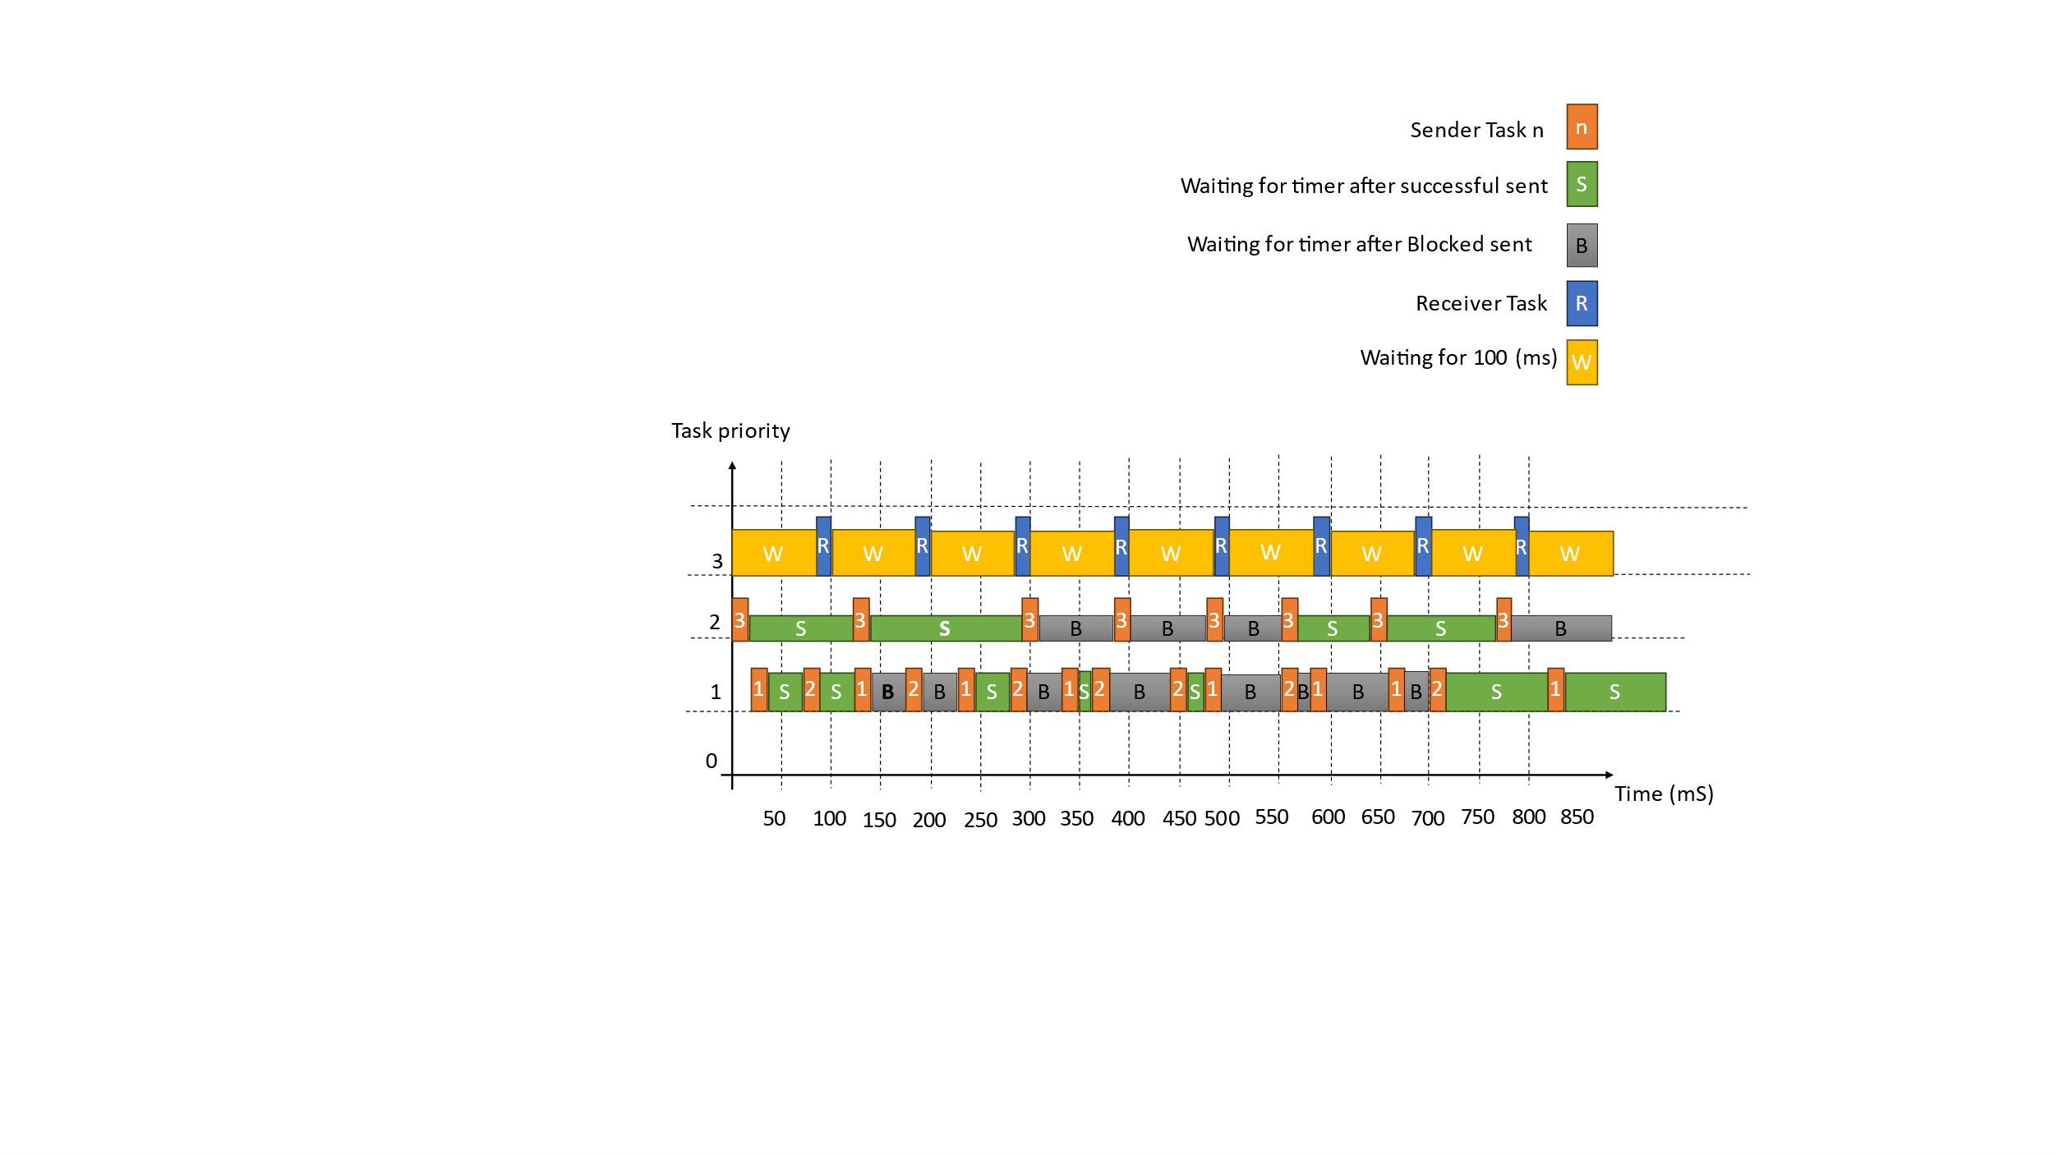

Figure 3: Tasks Flow with the priority (Queue size=3)

This Figure show the first 8 Iteration of our system with queue size = 3 , and from the figure We can conclude that when the queue is full, the first Task will execute after the Receiver Task will send the message successfully and the other Task’s messages will be blocked until the next Iteration.

رمز "تم التحقق منها بواسطة المنتدى"

|  |  |
| --- | --- |
| **Queue size = 3** | **Queue size = 10** |
|  |  |
|  |  |
|  |  |
|  |  |
|  |  |

Increasing the size of the queue can reduce the number of blocked messages and increase the number of successfully sent messages. With a larger queue, it takes more time for messages to accumulate and fill up the available space. This means that during this extended period, messages are not blocked because there are still empty spaces in the queue to accommodate them.

By allowing more room for messages in the queue, the system can handle a higher volume of messages without encountering blocking conditions. This results in a higher number of successfully sent messages, as fewer messages are prevented from being transmitted due to a full queue. Therefore, increasing the queue size can help mitigate the issue of blocked messages and improve overall message transmission efficiency.

Comment: Our GitHub repository link:

https://github.com/faatthy/rtos-project

## Code Snippets

/* Uniform Distribution (Function one)*/

int uniform_distribution(int Range_Low, int Range_High)

{ int Random_Value = (int)rand();

int Range = Range_High - Range_Low + 1; //+1 makes it [rangeLow, rangeHigh], inclusive.

int Scale = (Random_Value % Range) + Range_Low;

return Scale;}

/* Uniform Distribution (Function two)*/

int uniform_distribution(int Range_Low, int Range_High)

{ srand(time(NULL));

int Random_Value = rand();

int Range = Range_High - Range_Low ;

int DEV = RAND_MAX / Range;

Random_Value = Random_Value / DEV;

int Scale = Random_Value + Range_Low;

return Scale;}

**Uniform Distribution function**

To get Uniform Distribution Values we can use two algorithms, first function we used the modulus to get the random values, and the second one we used time seeding to make it more random and normalize it.

In our code we used the first function as the second one wasn’t totally Uniform Because of the time seeding.

**Reset Function**

void Reset_Function(){

if(i!=-1){

printf("\nTotal Number Of Sent Messages= %d \n",Number_of_Sent_Messages);

printf("Total Number Of Blocked Messages= %d \n\n",Number_of_Blocked_Messages);

printf("Total Number Of Received Messages= %d \n\n",Number_of_Received_Messages);

printf("\nSum Of Sent Messages Time for Sender1= %d \n",sum_sendr_time[0]);

printf("\nSum Of Sent Messages Time for Sender2= %d \n",sum_sendr_time[1]);

printf("\nSum Of Sent Messages Time for Sender3= %d \n",sum_sendr_time[2]);

}

if(i==5){

xTimerStop(xTimer1,0);

xTimerDelete(xTimer1, 0);

xTimerStop(xTimer2, 0);

xTimerDelete(xTimer2, 0);

xTimerStop(xTimer3, 0);

xTimerDelete(xTimer3, 0);

xTimerStop(xTimer4, 0);

xTimerDelete(xTimer4, 0);

puts("Game Over\n");

vTaskEndScheduler();

}

i++;

if(i==0)

{

Time_Sender=uniform_distribution(lower_bound[i],upper_bound[i]);

xTimerChangePeriod(xTimer1,Time_Sender,0);

xTimerChangePeriod(xTimer2,Time_Sender,0);

xTimerChangePeriod(xTimer3,Time_Sender,0);

}

// reset

Number_of_Sent_Messages=0;

Number_of_Blocked_Messages=0;

Number_of_Received_Messages=0;

xQueueReset(Queue);

}

**Sender Task**

void Sender_Task_1(void *p) //Sender 2 Task

{

TickType_t Current_Time; //Variable to store current time

char Data_Sent[20]; //Variable to store data that will be sent to Queue

while(1){

if(xSemaphoreTake(Sender_1, portMAX_DELAY)){

Current_Time = xTaskGetTickCount();

sprintf(Data_Sent, "Time is %d", Current_Time);

if(xQueueSend(Queue,Data_Sent,0)){

Number_of_Sent_Messages++;

puts("Sender 1");

}

else{

puts("Sender 1 Blocked");

Number_of_Blocked_Messages++;

} } } }

**Receiver Task**

static void SenderTimerCallback1( TimerHandle_t xTimer )

{

xSemaphoreGive(Sender_1); //release semaphore to act like a signal for Sender Task 1

Time_Sender=uniform_distribution(lower_bound[i],upper_bound[i]); //Change Time of Sender Callback function

sum_sendr_time[0]=sum_sendr_time[0]+Time_Sender;

xTimerChangePeriod(xTimer1,Time_Sender,0); //Function that changes Callback function time

}

void Receiver_Task(void *p) //Received Task

{

char Data_Received[20]; //variable to store data that will be received to Queue

while(1){

if(xSemaphoreTake(Receiver, portMAX_DELAY)){ //Semaphore waiting for signal from Timer Callback function

if(xQueueReceive(Queue,Data_Received,0)){ //Check if receiving messages was successful

Number_of_Received_Messages++; //Increment successful received messages

printf("Received %s \n",Data_Received);

} } } }

**Sender Timer Callback**

**Receiver Timer Callback**

static void ReciverTimerCallback( TimerHandle_t xTimer )

{

xSemaphoreGive(Receiver); //release semaphore to act like a signal for Receiver Task 1

if(Number_of_Received_Messages == 1000){

Reset_Function(); //Call reset function if messages reached 1000 message

}

}

int main(int argc, char* argv[])

{

vSemaphoreCreateBinary(Sender_1); //Sender 1 Binary Semaphore

vSemaphoreCreateBinary(Sender_2); //Sender 2 Binary Semaphore

vSemaphoreCreateBinary(Sender_3); //Sender 3 Binary Semaphore

vSemaphoreCreateBinary(Receiver); //Receiver Binary Semaphore

Queue=xQueueCreate(10,sizeof(char[20])); //Global Queue that store char variables

xTaskCreate(Sender_Task_1,(signed char*) "Sender_Task_1",1024,NULL,1,NULL); //Sender 1 Task Creation

xTaskCreate(Sender_Task_2,(signed char*) "Sender_Task_2",1024,NULL,1,NULL); //Sender 2 Task Creation

xTaskCreate(Sender_Task_3,(signed char*) "Sender_Task_3",1024,NULL,2,NULL); //Sender 3 Task Creation

xTaskCreate(Receiver_Task,(signed char*) "Receiver_Task",1024,NULL,3,NULL); //Receiver Task Creation

xTimer1 = xTimerCreate( "Timer1", ( pdMS_TO_TICKS(Time_Sender) ), pdTRUE, ( void * ) 0, SenderTimerCallback1); //Sender 1 Timer creation

xTimer2 = xTimerCreate( "Timer2", ( pdMS_TO_TICKS(Time_Sender) ), pdTRUE, ( void * ) 0, SenderTimerCallback2); //Sender 2 Timer creation

xTimer3 = xTimerCreate( "Timer3", ( pdMS_TO_TICKS(Time_Sender) ), pdTRUE, ( void * ) 0, SenderTimerCallback3); //Sender 3 Timer creation

xTimer4 = xTimerCreate( "Timer4", ( pdMS_TO_TICKS(Time_Reciever) ), pdTRUE, ( void * ) 0, ReciverTimerCallback); //Receiver Timer creation

Reset_Function();

if( ( xTimer1 != NULL ) && ( xTimer2 != NULL ) && ( xTimer3 != NULL )&&( xTimer4 != NULL ) )

{xTimer1Started = xTimerStart( xTimer1, 0 ); //Sender 1 time started at t=0

xTimer2Started = xTimerStart( xTimer2, 0 ); //Sender 2 time started at t=0

xTimer3Started = xTimerStart( xTimer3, 0 ); //Sender 2 time started at t=0

xTimer4Started = xTimerStart( xTimer4, 0 ); //Receiver time started at t=0

}

if( xTimer1Started == pdPASS && xTimer2Started == pdPASS && xTimer3Started == pdPASS&& xTimer4Started == pdPASS)

{

vTaskStartScheduler();

}

return 0;

}

**Main function**