Checkpoint

I wrote the first half of my project. I had 80 folders of images and many csv’s with two columns, the first column was the name of images and the second column was what I wanted the images to be renamed as. My code went through all the files and renamed them if it found the same name as the line in excel with what is in the second column. However, this code took absolutely forever because it had to search through all the files to find the jpg that’s the same name, then copy them to an external folder.

I first tried to rename about 100 images and it took about 20 minutes. I don’t think the issue was the copying the file.

I think I will have to rewrite this so addresses are saved to a dict instead of an array. The other option is using the binary search that we used in hwk 5.

I started looking into the fuzzy lookup library but the documentation is a little bit confusing. I have to create a dict of localities first, and this is involving a lot of data clean up. I will have to clean this data first before I can continue with the project.

This is starting to give me hope though, I can see the light at the end of the tunnel and hopefully I will never have to manually do either of these tasks ever again.

I am not expecting any difficulties with the metadata of the photos output to csv, other than taking some time.

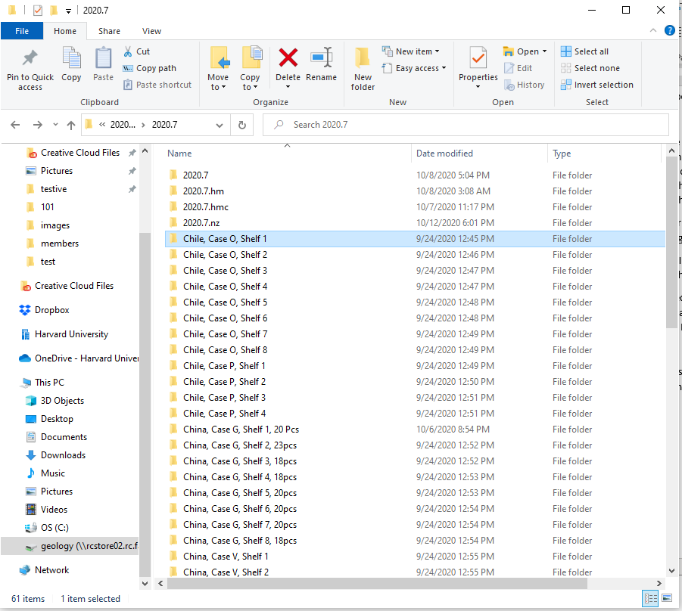

Have about 3000 images I’m trying to rename right now. Each folder has about 200 photos. It would have taken forever by hand.

Code snippets of renaming

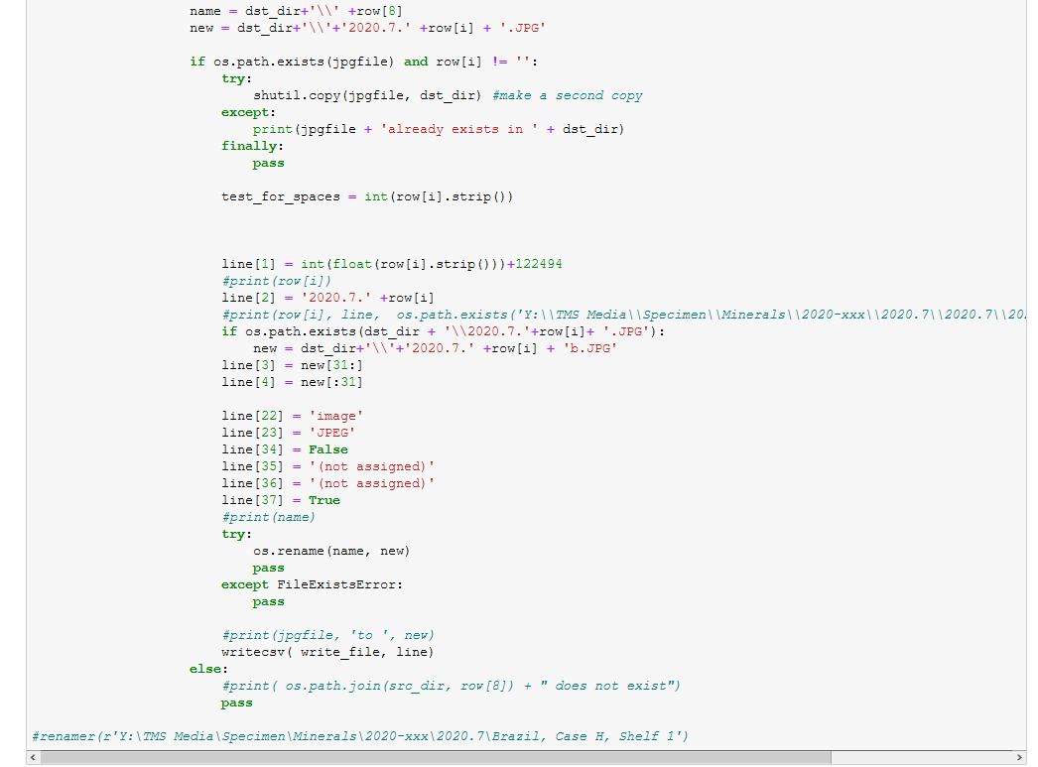

Code snippets of fuzzy lookup

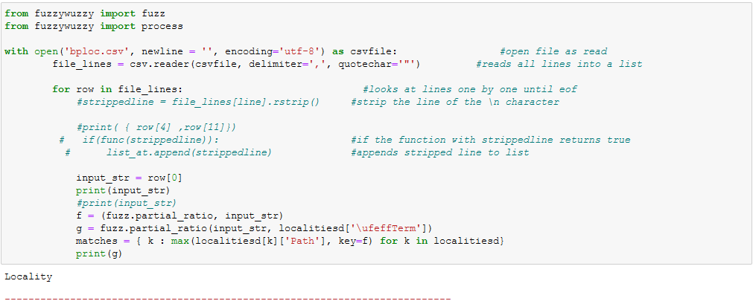

Locality csv I am having to clean up

