
Cairo University
Faculty of Computers and Information

CS251
Name | ID
Mohamed Ashour Mahmoud | 20170240
Mohamed Hamdy Mohamed | 20170227
Mohamed Ali Farouk | 20170249
Ahmed Gomma Farouk | 20170014
Software Engineering I
Project Name
Software Requirements Specifications
Team Names

Contents

Introduction 3
Software Purpose 3
Software Scope 3
Requirements 4
Functional Requirements 4
Non Functional Requirements 5
Definitions, acronyms, and abbreviations 4
System Models 5
Use Case Model 7
Use Case Tables 8
Traceability Matrix………………………………………………………………14
Ownership Report 15

Document Purpose and Audience
The introduction of the Software Requirements Specification (SRS) provides an overview of the entire SRS with purpose, scope, function Requirements ,NonfunctionRequirements and overview of the SRS. The aim of this document analyze and give an in-depth insight of the complete API by defining the problem statement in detail
The audience to read this document client , project manager , system analysis and system designer

1. Introduction
1.1 Purpose of the system
This document purpose is to make a preview for our new API system which will be a social network, showing the goal of the project, functions that the program will be able to do , the design and how will the program will look like , who will be our audience .
Note: some of our functions may be modified while developing the system.
1.2 Scope of the system
Our project will be an API for a social network .this API will be a simple social network which can be developed later to service a small community like a school.
Our system will be as follow Users which is the main element in this system and it can make a group , page ,post ,like ,massage ,hashtag or adding another user and has many attributes like name ,age ,email ….etc. users can be normal or premier . Groups are one of what user can make and it can be private or public and managed by many users. Users create fan pages which managed by one or many users and it’s attribute is the number of likes. Users make like to the posts they
admire. User make hashtag# to organize a specific content of posts. Users send massages to other users in their friend list. Users send friend add request to other users to add them in their friend list.
Concept | Defintion
User | Anyone can be a user by sing up write his name and password if the name was exist before program ask him to enter again
Group | Group is a set of users collected together can share their needs in, group can be secret no one see posts accept them and could be not secret (public && private group ) group contain 2 types of users  admin user and ordinary user
Post | user can write what he want , post picture and share photos and  share it with his friends and they show it and can comment on it and do like
Message | Message is a private text from user to another no one can see it except them
Hashtag | Is and ordinary post but contain ‘#’ and must contain ‘_’ that make it shared with any one write this hashtag also can share a specific subject using it
API | a set of functions and procedures allowing the creation of applications that access the features or data of an operating system, application, or other service.

Requirements

Functional Requirements | Comment
2.1.1 User | - Anyone can be a user by sing up write his name and password, gender , valid code ,or sign in by enter name and password
2.1.2 Group
2.1.3 Post
2.1.4 Message
2.1.5 Hashtag

Non functional Requirements | Classifications
2.2.1 Performance | - In the loading phase of the page and got the error needed to see a message written error loading  - The reback of the page must be at the same time of loading page
2.2.2 Reliability | - Can apply security by make a Security Team and they make permanently test social network ,and show my network on the Site detection gaps.
2.2.3 Usability | - Make a Suitable GUI for any one can use this social network , and put a user support in the social network
- Supportability | - Print the message if the user write invalid information to sign in – in the social network  - User can sign up if the first time to visit the social network and if he enter the information and this is already exist print message he already sign in before and can go to the log In page
2.2.5 Implementation | - In the case of the implementation the site is divided into two parts are part front end and part back end .. 1- Front End include the user interface and developer team will use some programming language such as ( Html and css and JavaScript and some other languages )  2- Back end include the database and developer team will use some programming language such as  ( PHP and MYSQL and some other languages )
- User Interface | The user interface of API should be understandable to interface, The user interface is based on a main window, which include two sections one for login and one for signup ,login section include two inputs area Email and Password and have a Login button and other section have area to write user mail and password and username and date of birth and gender and sign up button .  after the statement the network user interface page include section in left side of page this section include the list of user friends and in right side section include list of groups and search section and the center of page include the social news and posts .
- Legal | Cheap Api , The development of API must be done with a budget <= 1000 $. As the software should reach as many users as possible and it should be financed over advertisement, it cannot be expensive
2.2.8 Packaging | Must be use the servers to In order to record every operation performed by the user and save it in this servers .
Use case model
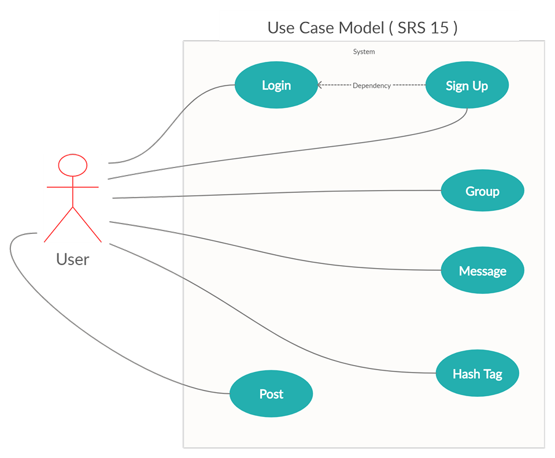
Use case tables
Use case ID | 1
Use case name | Log in
actor | User
precondition
  User sign up, sign in
Post-conditions | User already exist so sign in or new so register to create new user
Flow of events |  | System interaction
  User Action
Flow of events |  | Check on name and password if correct sign in else ask user to resign in or register
  Sign in
Flow of events |  | Check on name and pass and create account
  Register at it by enter his data name ,pass ,other ordered information
Includes | None
exception | Invalid information |  | Print error message
Notes and Issues | None

Use case ID | 2
Use case name | Create group
actor | User
precondition | User login and create group
Post-conditions | Group be Available for users
Flow of events |  | System interaction
  User Action
Flow of events | User create group | Ask user for name, secret or public and description and some other info
Flow of events | User enter all data ordered by system | System check all data and create group
Includes | None
exception | None |  | None
Notes and Issues | This case owner for case 1 who create it

Use case ID | 3
Use case name | Write post
actor | User
precondition | User log in then write post
Post-conditions | The Post arise and be available to anyone who has the authority to see it
Flow of events |  | System interaction
  User Action
Flow of events | User write post and share it
  System make it available to anyone who has the authority to see it
Flow of events |  | If any one make like or comment appear on the post
Includes | None
exception | Unwritten(empty)post |  | Invalid process to write post
Notes and Issues | None

Use case ID | 4
Use case name | Write message
actor | User
precondition | User log in then write message and send it to other user
Post-conditions | Gets the message to the other user
Flow of events |  | System interaction
  User Action
Flow of events | User write message and select other user to send this message to it
Flow of events |  | Send message and let the other user see it
Includes | None
exception | None |  | None
Notes and Issues | No one can see message Except them

Use case ID | 5
Use case name | Write Hashtag
actor | User
precondition | User write post and write mark of hash tag ‘#’
Post-conditions | Post add to the hash tag written
Flow of events |  | System interaction
  User Action
Flow of events | User write post and write hash tag | Check if the hash tag exist if yes add post to it
Flow of events |  | If no create hash tag then add post to it
Includes | None
exception | Writing Hashtag without “_” |  | Undefined Hashtag

Class diagram

Traceability Matrix

 | Use case id | Class name
  (NetWork / Functional Recuirement number)
1 | #1 | User
2 | #2 | Group
3 | #3 | Post
4 | #4 | Message
5 | #5 | Hashtag

Ownership Report

Item | Owners
Introduction , System Purpose ,Scope | Mohamed ali farouk ali  Mohamed ashour Mahmoud
Functional recuirements , Use case tables | Mohamed ali farouk ali  Mohamed ashour Mahmoud  Ahmed gomaa farouk
Non functional Recuirments | Ahmed gomaa farouk  Mohamed hamdy mohamed
Use case model , Class diagram , traceability matrix | Mohamed hamdy Mohamed  Mohamed ashour mahmoud

