INVENTORY CONTROL SYSTEM
Project Report
System Analysis and Design Assignment

Prepared by: MG_Pathum
Technology: Java SE · MySQL 8.0 · Apache Maven
Date: June 2026

1. Introduction
The rapid advancement of technology has transformed the way businesses manage their daily operations. In a competitive retail and trading environment, the ability to track inventory accurately, process sales efficiently, and generate timely reports is no longer a luxury but a fundamental operational requirement. Manual inventory tracking methods are prone to human error, difficult to scale, and offer no real-time visibility into stock levels or sales performance.
This report documents the analysis, design, and implementation of an Inventory Control System developed as a desktop application for small-to-medium-sized retail businesses. The system provides a centralised platform for managing products, processing point-of-sale transactions, monitoring stock levels, and producing financial and inventory reports. The application was developed using Java with a Swing-based graphical user interface and a MySQL relational database backend.
The system addresses four primary operational areas: secure user authentication, product and category management, real-time billing at the point of sale, and report generation. The architecture follows a layered design pattern, separating the presentation layer (GUI forms), business logic layer (controller classes), and data access layer (DAO interfaces and implementations).
Technologies Used
- • Programming Language: Java SE (compiled with JDK 25)
- • GUI Framework: Java Swing with AbsoluteLayout
- • Database: MySQL 8.0 (InnoDB engine, utf8mb4 charset)
- • Build Tool: Apache Maven
- • Password Security: jBCrypt 0.4 (bcrypt, cost factor 12)
- • Barcode Generation: Google ZXing 3.5.3 (CODE-128)
- • PDF Report Generation: Apache PDFBox 3.0.3
- • Excel Export: Apache POI 5.2.5
- • Logging: Apache Log4j 2.23.1
2. Requirements Analysis
2.1 Problem Statement
Small retail businesses that rely on manual stock registers or basic spreadsheets face recurring challenges: inaccurate stock records, inability to detect low-stock situations proactively, slow transaction processing at the counter, and the absence of structured financial reporting. The proposed system resolves these issues by digitising and centralising all inventory and sales-related operations.
2.2 Functional Requirements
User Authentication and Access Control
- • The system must allow users to log in using a username and password.
- • Passwords must be stored securely using bcrypt one-way hashing (cost factor 12).
- • The system must support multiple user roles: Admin, Manager, and Cashier.
- • Inactive accounts must be prevented from logging in with an appropriate error message.
Product Management
- • Allow authorised users to add, view, update, and soft-deactivate product records.
- • Associate each product with a category and optionally a supplier.
- • Support automatic CODE-128 barcode generation per product via Google ZXing.
- • Auto-generate product codes in sequential PROD-XXXX format.
- • Identify and display low-stock products based on a configurable reorder level.
Point-of-Sale Billing
- • Allow cashiers to add products to an invoice by code or name.
- • Automatically calculate subtotals, tax, discounts, and total amount due.
- • Calculate change and persist the invoice atomically upon payment.
- • Decrement inventory stock automatically upon each completed sale.
- • Assign unique sequential invoice numbers (format: INV-YYYY-NNNNN).
Reporting
- • Generate sales reports for a specified date range.
- • Generate inventory stock status reports.
- • Export reports as professional PDF documents using Apache PDFBox.
2.3 Non-Functional Requirements
- • Security: Passwords hashed with bcrypt; SQL injection prevented via parameterised queries.
- • Usability: Intuitive Swing GUI; all critical actions reachable within two clicks.
- • Reliability: Database transactions ensure atomicity during sales and stock updates.
- • Maintainability: Layered MVC architecture with clearly defined DAO interfaces.
- • Portability: Packaged as a fat JAR; deployable on any JDK 25-compatible machine.
3. Database Design
3.1 Overview
The database, named inventory_db, was designed and implemented on MySQL 8.0 using the InnoDB storage engine, selected for its support of foreign key constraints and ACID-compliant transactions. The character set was configured as utf8mb4 with utf8mb4_unicode_ci collation for full Unicode support. The schema consists of eight primary tables and two supporting database views.
3.2 Table Descriptions
- • roles — Stores the three system roles: Admin, Manager, and Cashier.
- • users — Stores user accounts with bcrypt password hash, role assignment, is_active flag, and last_login timestamp.
- • categories — Stores product categories with a self-referencing parent_id for hierarchical classification.
- • suppliers — Stores supplier company details; soft-deletable via is_active flag.
- • products — Central table: product_code (PROD-XXXX, unique), pricing, tax_rate, reorder_level, barcode, is_active.
- • inventory_stock — Tracks real-time quantity_on_hand and quantity_reserved per product per warehouse location.
- • sales_invoices — Invoice headers with payment_method ENUM (CASH/CARD/E-WALLET/CREDIT) and status ENUM (PAID/VOID/REFUNDED).
- • invoice_items — Line items per invoice; unit_price snapshotted at time of sale for historical accuracy.
- • purchase_orders — Procurement orders with status ENUM (PENDING/PARTIAL/RECEIVED/CANCELLED).
- • purchase_order_items — Line items per PO; line_total is a MySQL stored computed column (qty * unit_cost).
3.3 Database Views
- • vw_sales_summary — Joins sales_invoices with users to expose cashier full_name alongside each transaction.
- • vw_stock_status — Joins products, inventory_stock, and categories; computes available_qty and assigns LOW STOCK / OK label.
3.4 Database Schema Screenshot
The following screenshot shows the physical database tables as viewed in MySQL Workbench:
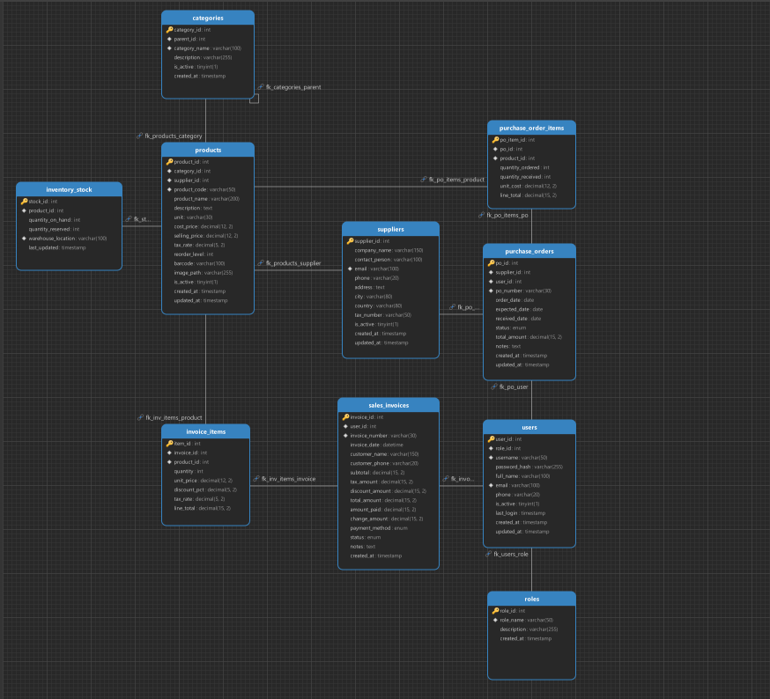
Figure: Database Tables
4. System Implementation
The application follows the Model-View-Controller (MVC) architectural pattern. The model layer contains POJO entities (Product, User, SalesInvoice, etc.). The view layer consists of Java Swing forms. The controller layer (LoginController, ProductController, SalesController) validates inputs and coordinates with the DAO layer. A centralised DAOFactory provides all controllers with their DAO dependencies.
4.1 Login Module
The Login module serves as the entry point and security gate of the application. When the user submits credentials, the view delegates all authentication logic to LoginController.authenticate(), keeping the GUI entirely free of business logic.
The authentication sequence performs the following steps:
- • Input Validation — Blank username or password immediately throws an AuthException.
- • User Lookup — UserDAO.findByUsername() executes a parameterised query. If no match is found, a generic 'Invalid username or password' error is returned to prevent username enumeration.
- • Account Status Check — If is_active is false, a distinct 'Account deactivated' message is shown.
- • Password Verification — PasswordUtil.verify() uses jBCrypt to compare the plain-text input against the stored bcrypt hash (cost factor 12).
- • Last Login Update — On success, users.last_login is updated asynchronously. A fully populated User object is returned to the view for role-based navigation.
The screenshot below shows the Login Screen of the application:
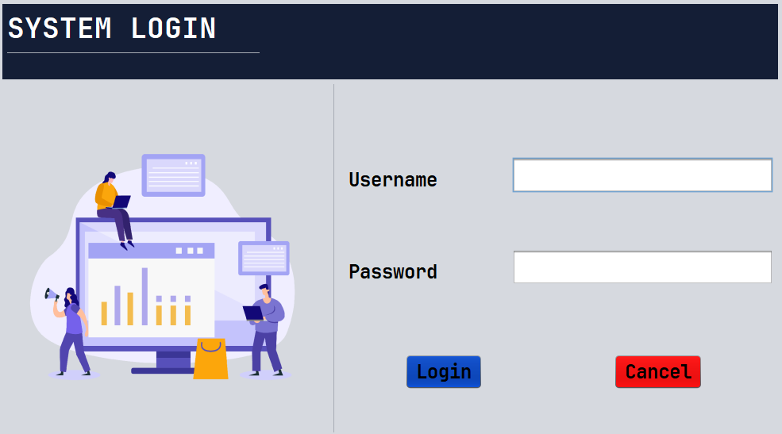
Figure: Login Screen
4.2 Dashboard
The Dashboard is the main navigation hub, loaded immediately after a successful login. It presents the authenticated user with a high-level overview of the system's current state and provides navigation to all major modules: Product Management, POS Counter, Supplier Management, Purchase Orders, and Reports.
The Dashboard displays key summary metrics drawn from the database at load time, including the total number of active products, the count of low-stock products (queried via ProductDAO.findLowStock()), and total sales figures. The layout is role-aware: administrative functions are only presented to users with the appropriate role.
The screenshot below shows the system Dashboard:
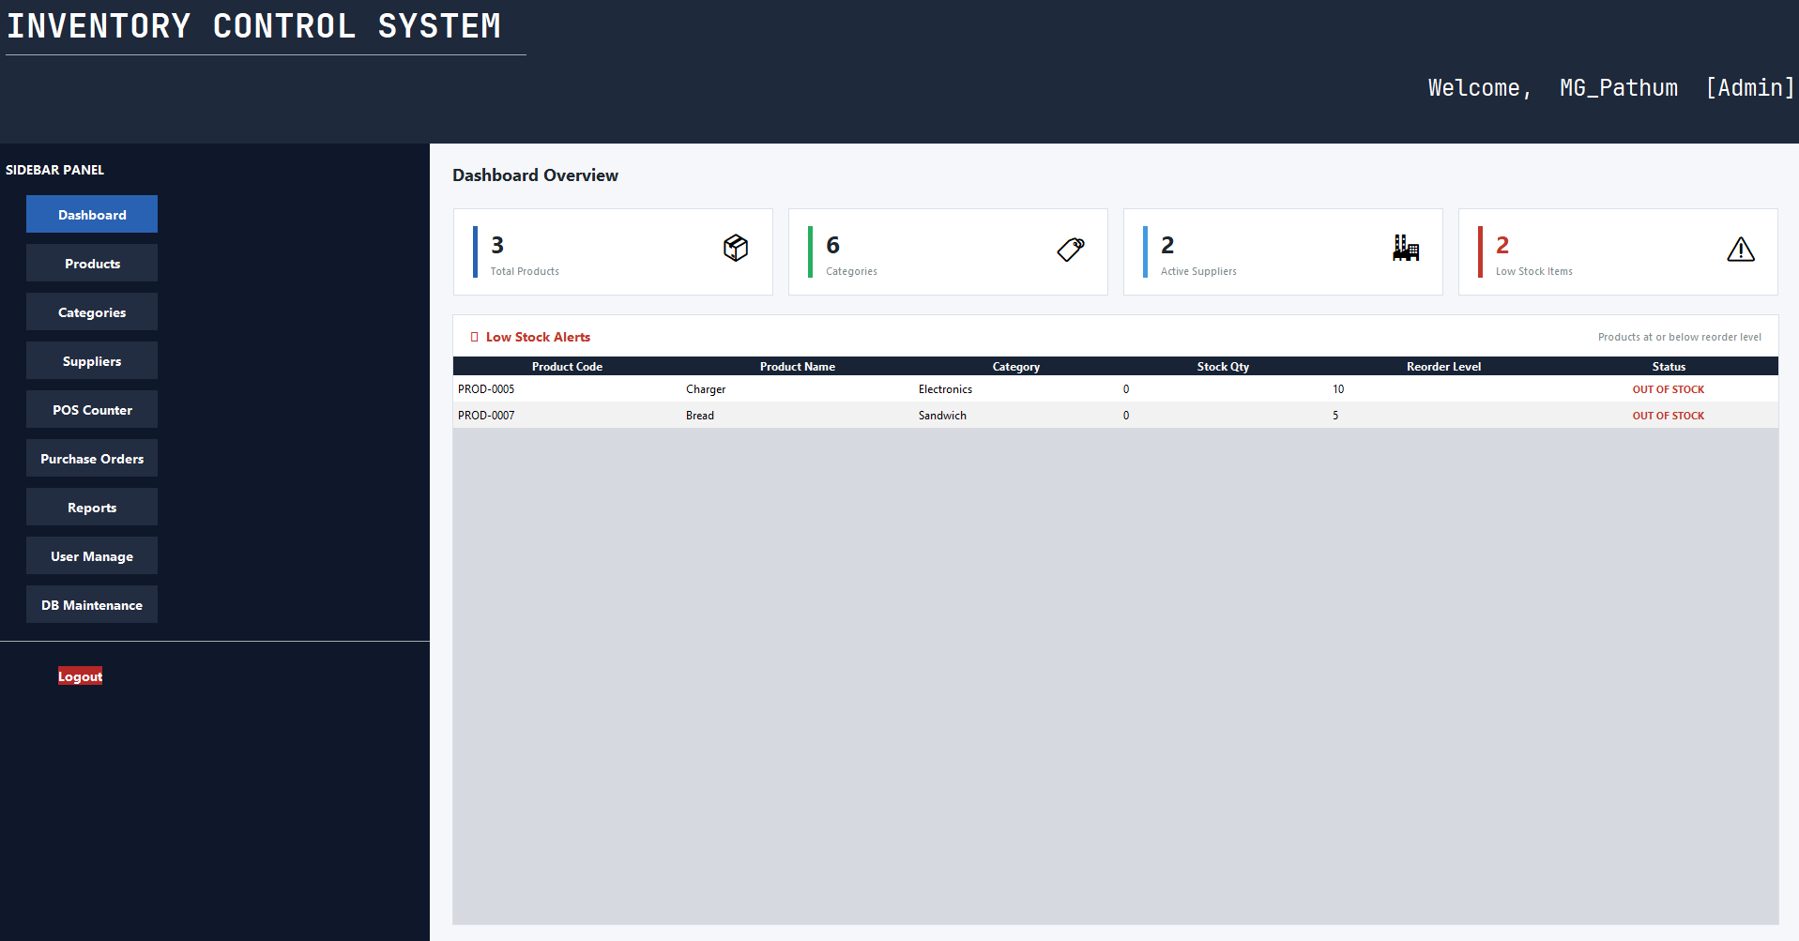
Figure: Dashboard
4.3 Product Management (CRUD Operations)
The Product Management module provides a complete interface for creating, reading, updating, and deactivating product records. All business logic resides in ProductController.
Adding a New Product:
- • ProductController.generateNextProductCode() auto-generates the next PROD-XXXX code via a lightweight indexed query, eliminating manual duplication risk.
- • A private validateProduct() method enforces non-blank code/name and non-negative prices before any database write.
- • If no barcode is provided, the barcode field defaults to the product code.
- • BarcodeUtil.applyBarcodeToLabel() uses Google ZXing to render a CODE-128 barcode image directly onto a JLabel for instant visual feedback.
Updating and Deactivating Products:
- • updateProduct() applies the same validation rules before calling ProductDAO.update().
- • Soft-delete via deactivateProduct() sets is_active = 0, preserving referential integrity with invoice_items.
- • The product list supports keyword search (LIKE query on name and code), filter by category, and filter for low-stock items only.
The screenshot below shows the Product Management / CRUD Operations screen:
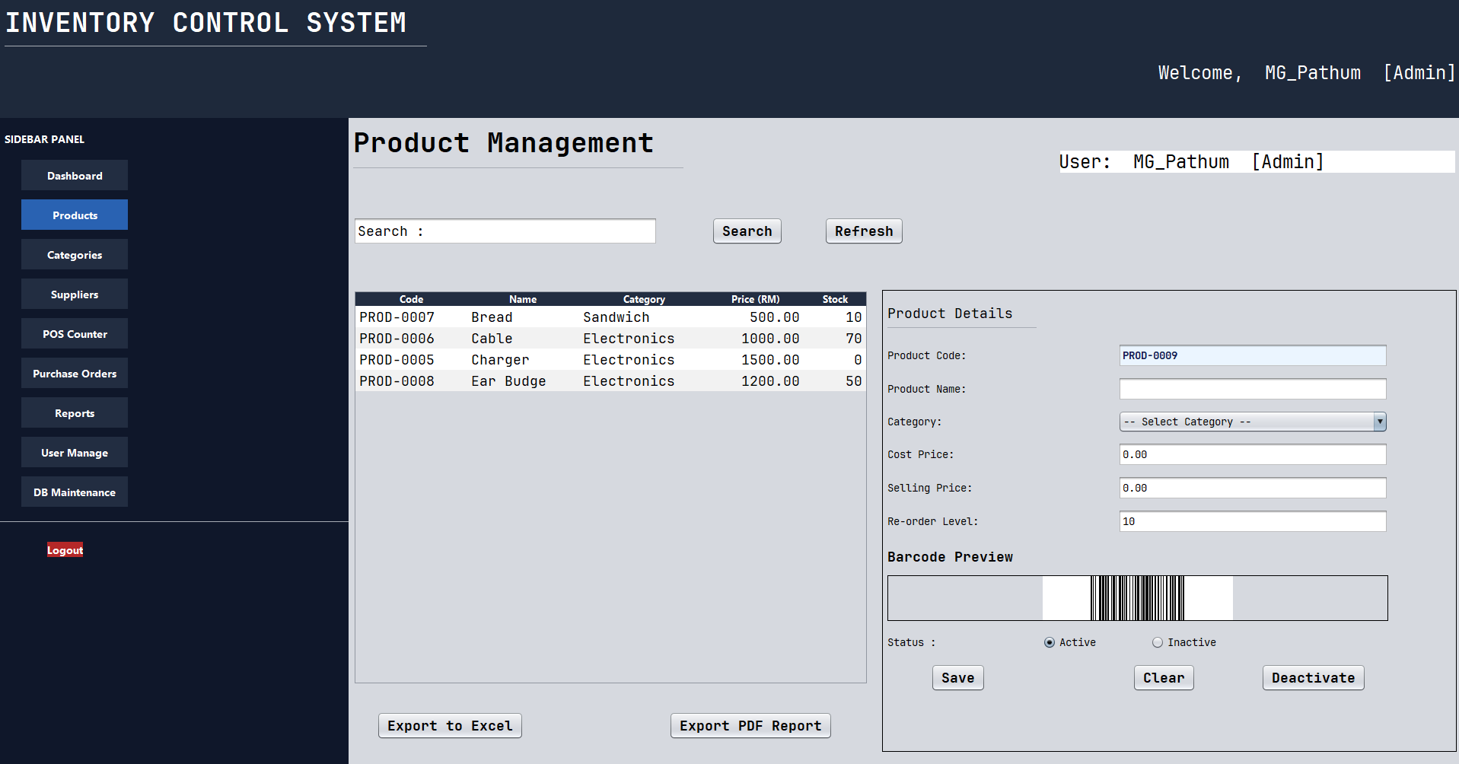
Figure: CRUD Operations
4.4 POS Counter
The POS Counter module provides a fast, reliable billing interface for cashier operations. Business logic is encapsulated in SalesController.
Invoice Initialisation:
- • SalesController.newInvoice() creates a SalesInvoice pre-populated with a sequential invoice number (INV-YYYY-NNNNN), current timestamp, default customer 'Walk-in Customer', and payment method CASH.
Adding Line Items:
- • SalesController.addLineItem() rejects quantity <= 0 and performs a real-time stock check (throws IllegalArgumentException with product name and available qty if insufficient stock).
- • Each InvoiceItem captures unit_price at the time of sale for historical accuracy.
- • recalculateTotals() uses BigDecimal arithmetic with RoundingMode.HALF_UP for precise financial calculations after every change.
Finalising the Invoice:
- • finaliseInvoice() validates at least one item exists and amount paid >= total due, then calculates change.
- • SalesInvoiceDAO.insertWithItems() persists the header, all line items, and decrements inventory_stock in a single atomic database transaction. A rollback is triggered on any failure.
- • Invoice voiding is supported via voidInvoice(), marking status as VOID.
The screenshot below shows the POS Counter screen:
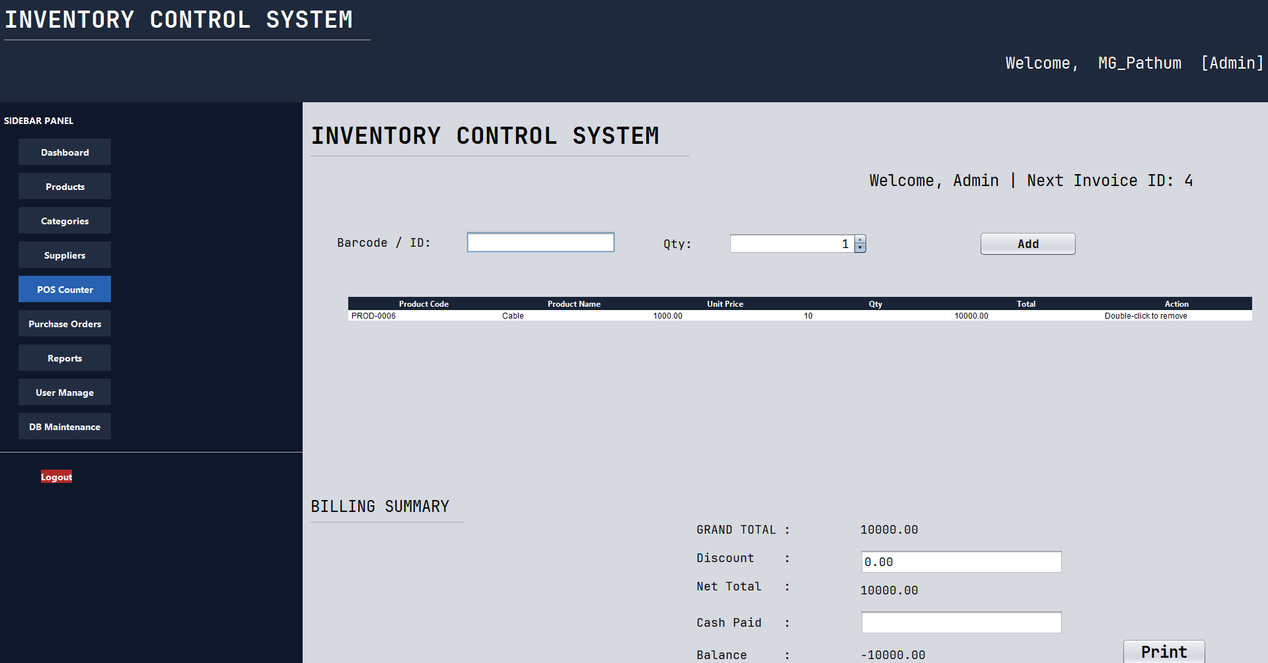
Figure: POS Counter
4.5 Reports Module
The Reports module allows management to generate and export professional formatted documents. Apache PDFBox 3.0.3 was chosen as the PDF generation engine for its pure-Java implementation, precise programmatic control over page layout, lightweight footprint, and Apache 2.0 open-source license — making it ideal for a desktop application context.
Sales Report:
- • User specifies a date range; data is sourced from vw_sales_summary (joins sales_invoices with users).
- • Output includes: invoice number, date, customer name, cashier name, subtotal, tax, discount, total, and payment method.
- • A summary row presents aggregate totals for the selected period.
Stock Status / Inventory Report:
- • Data sourced from vw_stock_status; computes available quantity and flags products as OK or LOW STOCK.
- • Both report types are generated as PDF files, saved to a user-specified path, and can be opened directly from within the application.
The screenshot below shows the Reports module:
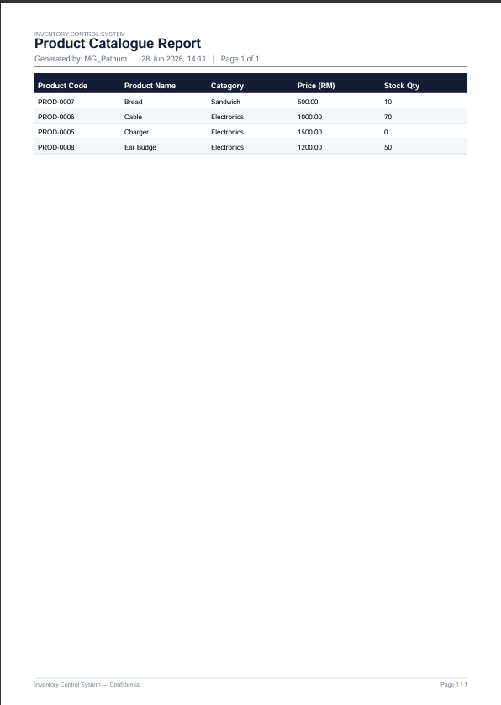
Figure: Reports
5. Conclusion
This project successfully demonstrates the design and implementation of a functional, multi-module Inventory Control System for a retail business environment. The system addresses all core operational requirements identified during the requirements analysis phase: secure role-based authentication, comprehensive product and stock management, real-time point-of-sale transaction processing, and professional report generation.
The layered MVC architecture with clearly defined DAO interfaces ensures each module is independently maintainable and extensible. The use of parameterised SQL queries and bcrypt password hashing reflects a security-conscious development approach. The atomic database transaction for invoice finalisation — simultaneously persisting the invoice header, line items, and stock decrements — ensures data integrity under concurrent usage scenarios.
The adoption of industry-standard libraries, including Apache PDFBox for report generation, Google ZXing for barcode rendering, and jBCrypt for password security, demonstrates an awareness of the Java ecosystem and the value of leveraging well-maintained, purpose-built tools.
Future enhancements could include: network-based multi-terminal deployment, barcode scanner device integration for faster POS input, a more granular role-permission system, and graphical dashboard charts visualising sales trends over time. Overall, this Inventory Control System achieves its stated objectives and provides a solid foundation for a production-ready retail management platform.

