**Tic_Tac_Toe game in Python**

This is my **Python** version code for a player board game featuring a human player, **MG**, and a computer player, **AI**. The game uses a 5x5 grid, with each cell initially empty. Here is the design and the explanation of the code.

**Class Board:**

Responsibilities

Picture 1: Storing game state.

* **Storing game state:** it maintains the state of the game board using the list of 25 elements representing a 5x5 grid.

Picture 2: Displaying the board.

* **Displaying the board:** the display method prints the current state of the board in a grid format.

Picture 3: Checking for the winner.

* **Checking for winner:** the winner method checks if any player has achieved a winning combination.

Picture 4: Handling the moves.

* **Handling moves:** the add method updates the board with the player’s move if the chosen position is available.

**Class Game:**

Responsibilities

Picture 5: The game control flow.

* **Game flow control:** this class orchestrates the overall flow of the game.

Picture 6: Resetting the game.

* **Game reset:** the **reset_game** method resets the game to its initial state.

Picture 7: The turn management.

* **Turn management:** It manages players' turns using a list (turn). **In the while loop,** the **play** method coordinates a single play cycle like a display board and take turn.

**Note:** if player MG did not enter the valid number, it will show the invalid move and let the player AI play tell you to enter the correct number(1 to 25).

**Main function:**

Responsibilities:

Picture 8: Game initialisation.

* **Game initialisation:** it initialises the game by creating **board** and **game** objectives.

Picture 9: The game looping.

* **Game loop**: controls the main game loop, determining when the game ends and if it should restart, and the Winning condition check will check if either player has won after each turn. When we have no winner, it’s a Tie!

Picture 10: The restarting logic.

* **Restart logic**: offers the player a choice to restart the game. Otherwise, end the game.

**Python UML Diagram**

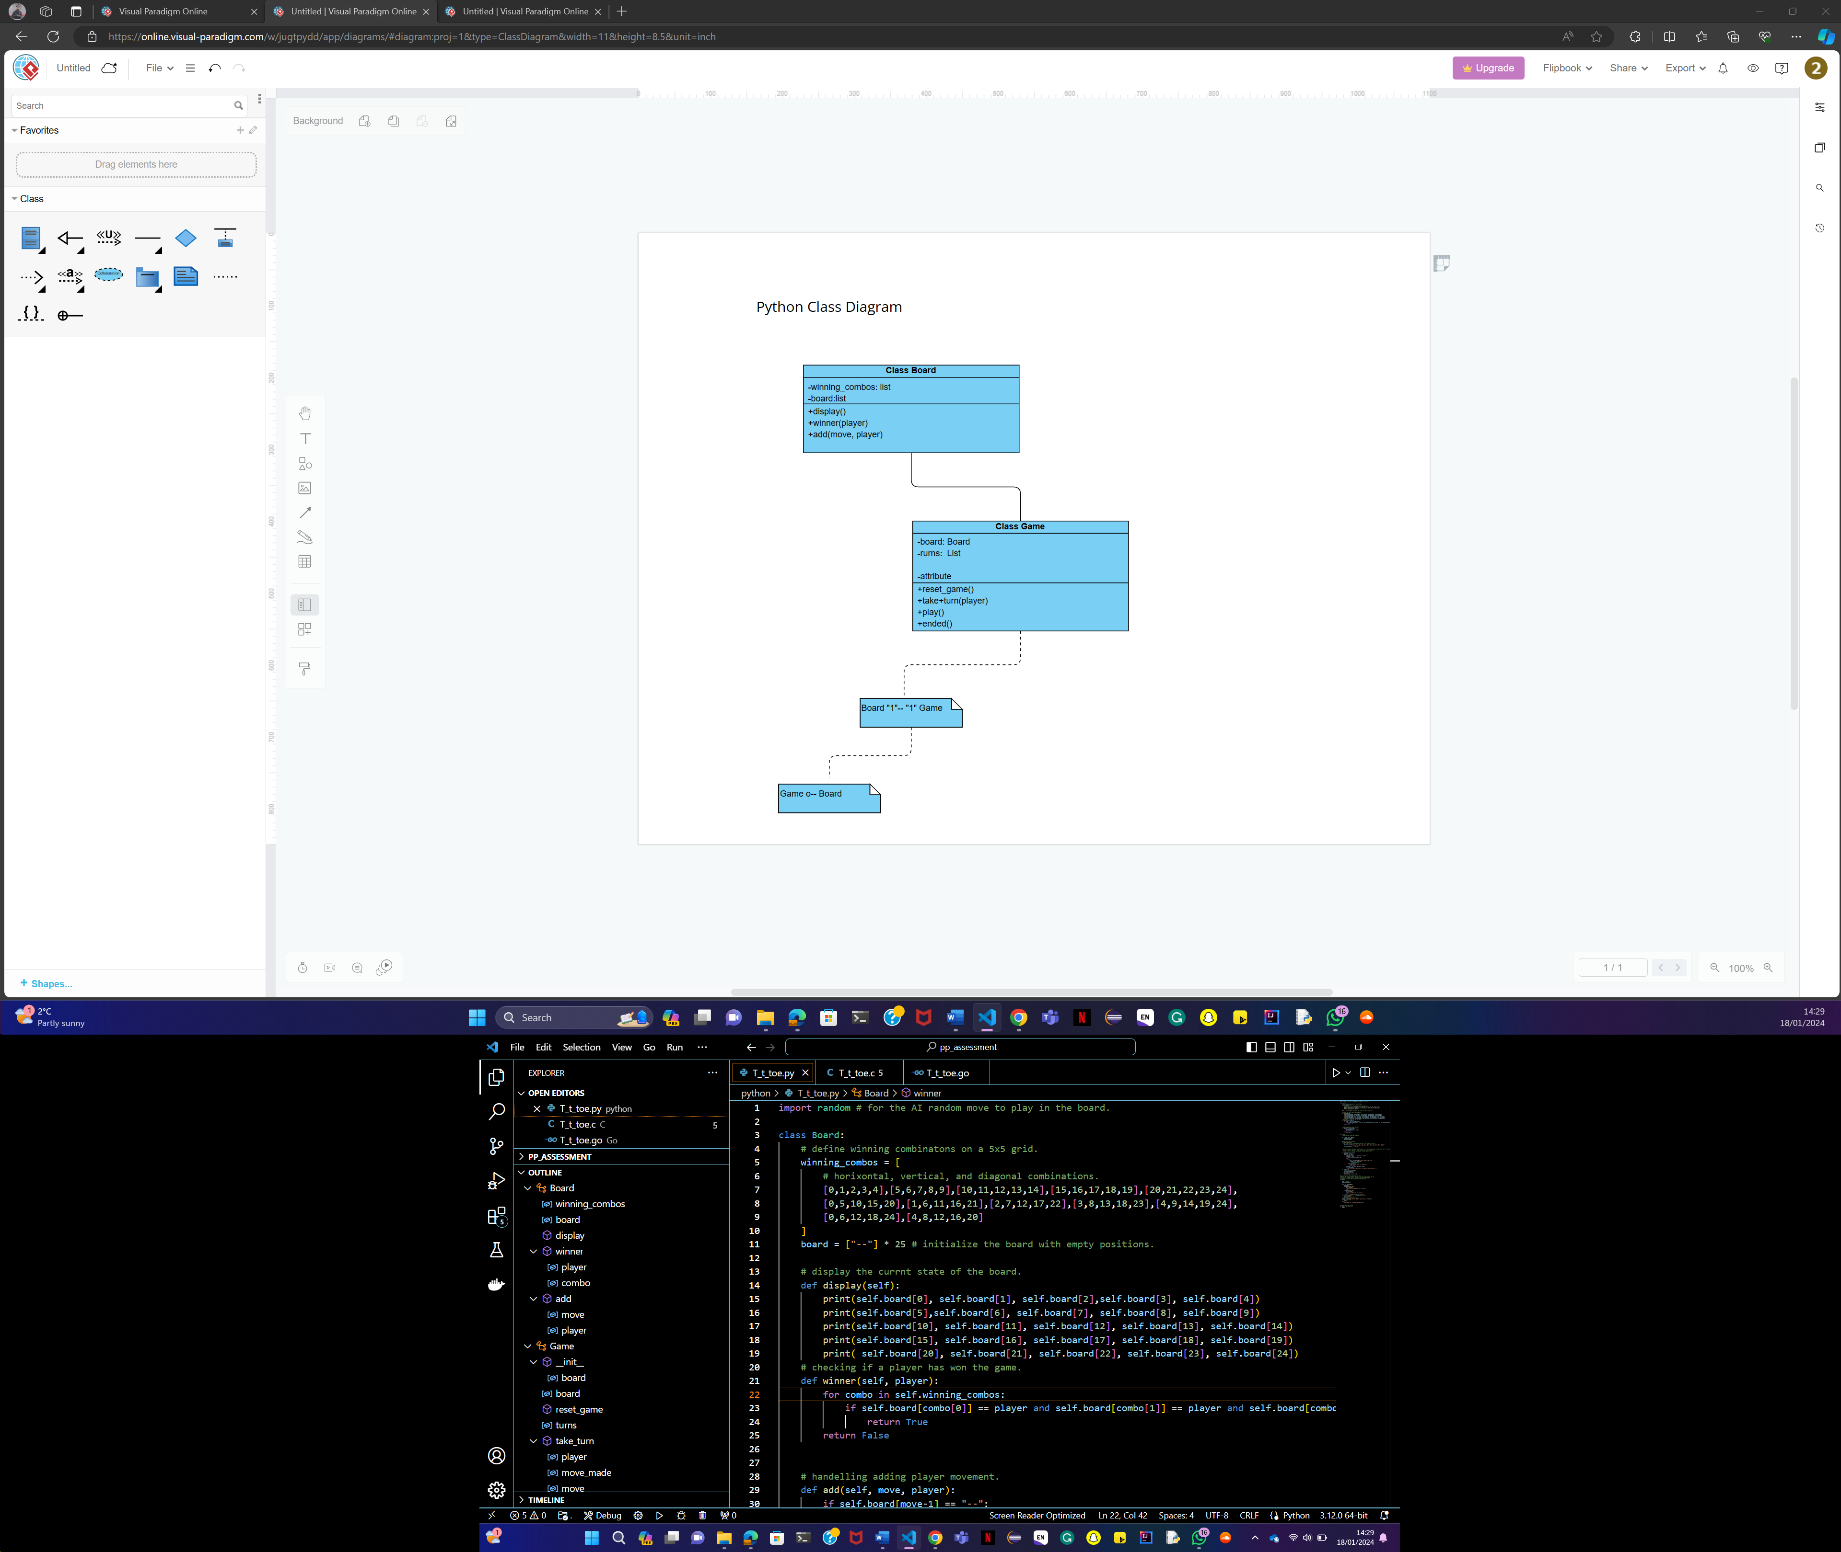

Picture 11: the drawing of the class diagram.