 Blinkit

Product Dissection for Blinkit.

Overview:

Blinkit formerly known as Grofer’s was founded in December,2013 by 2 IIT Graduates Suresh Kumar & Albin Dhindsa and is currently based in Gurugram, India. It is basically an Indian based instant grocery delivery services which provides an extensive range of fresh vegetables, fruits, dairy products, snacks, etc within minutes i.e. 10 - 15minutes. In June,2022 it was acquired by Zomato. In this all the work is done in the Mobile App named Blinkit-India’s last-minute App which basically follows the concept of Hyperlocal model & helps in ensuring rapid delivery by partnering itself with local stores & warehouses. Through this app, customers can select the items and order it any time accordingly. Across India, it is available in more than 28 cities.

Product Dissection and Real-world Problems solved by the Blinkit

In an era marked by the increase in online shopping, Blinkit emerged itself as one of most distinguished name in Indian online grocery delivery landscape. Its goal is to modernize the shopping experience by enabling the ultra-fast deliveries and also there more focus is to be more reliable, have more speed to gain customer satisfaction in such quick space of e-commerce.

Founded in year 2013, Blinkit was formerly known as Grofers but rebranded themselves as Blinkit in Dec, 2021 to introduce the 10 min delivery model to transform online shopping experience of groceries by ensuring the ultra-fast deliveries of essentials. It achieves this through micro fulfilment centres strategically placed within 2-3 kms of customers, enabling AI-driven order allocation for speed optimization & real-time inventory management. The sys. ensures quick dispatch, minimal delivery time & seamless order processing. Other several key reasons for rebranding was Shift to Quick Commerce, Brand Perception, Investor Strategy & Competitive Pressure.

After rebranding, the new name “Blink it” aligns with the vision of delivering groceries in an instant in other words we can say “in the blink of eye” so according to that they created a brand-new Tagline “Let’s Blinkit” or “#letsblinkit”.

In year June 2022, Zomato acquired Blinkit for $568 million in all-stock deal. Zomato acquired Blinkit due to four main reasons: Expansion into quick commerce, synergy with existing operations, competitive landscape & Increased Customer Engagement.

Blinkit works on hyper local market model which provides on demand logistic system whose main goal is to eliminate need for consumers to travel to local shops to purchase goods instead of online ordering. It doesn’t have any grocery store or warehouse it partners with local stores in city. After that company sends it boys to collect the order which needs to delivered to customers from various stores and deliver it to their desired location.

In conclusion, Blink has effectively addressed real-world problems by creating a platform that simplifies the life of consumers.

Case Study: Real-world problems and Blinkit Solutions.

Problem 1: Convenience & Time-saving
Real-World Challenge: Traditional grocery shopping is often a very lengthy & inconvenient process because of travel-time, navigating store to search for a specific product, waiting time & carrying of heavy bags if there is no source of vehicles.

Blinkit Solution: Blinkit helps to eliminates the need for long supermarket visits by offering doorstep delivery in mins. & it also helps busy professionals, elderly individuals access groceries effortlessly

Problem 2: Emergency & Last- Minute Needs
Real-World Challenge: People often find themselves in situations where they urgently require an essential item but do not have time or means for store visit such as Household & Daily use items, Cooking & Food Preparation, Medical Emergencies, or some Unpredictable situations

Blinkit Solution: Blinkit helps in quick accessing of essentials such as medicine’s, cooking products, etc when needed urgently.

Problem 3: Unpredictable Grocery Demand
Real-World Challenge: Traditional grocery requires estimation & planning of food consumption but in some cases people exp. Unpredictable needs of grocery such as over-buying wastage, change in patterns of consumption, unexpectedly running out on essentials or inconsistent shopping behaviour.

Blinkit Solution: Blinkit helps to reduce burden of bulk shopping, allowing users to order smaller quantities as needed & solve the problem of running out items unexpectedly.

Problem 4: Hyperlocal Economic Boost
Real-World Challenge: In traditional grocery supply chains are dominated by large supermarket chains, leaving small vendors, local suppliers & businesses with fewer opportunities. Some of challenges are Inefficient local supply chain, limited employment opportunities & small-scale retailer struggles.

Blinkit Solution: Blinkit helps local vendor & small business by supporting them by integrating both of the factors in a supply chain. Also helps in providing employment opportunities for delivery partners.

Problem 5: Efficient Urban Planning
Real-World Challenge: In today’s world, Urbanization has led to increased pollution, congestion & inefficient infrastructure which also includes grocery shopping as it causes increase in traffic for grocery runs & environment impact of personal shopping.

Blinkit Solution: Blinkit uses optimized delivery routes to reduce traffic impact & helps in addressing congestion & pollution issues by minimizing personal vehicle trips to stores.

Top Features of Blinkit:
- Seamless App & Website Experience
Blinkit uses Intuitive UI/UX, Multiple Payment Options and Order Tracking & Notifications for seamless app & w/b experience.

- Instant Delivery
The core USP of Blinkit is its super-fast delivery, leveraging a n/w of MFC’s. Also, kit ensures that products are stocked in nearby warehouses to facilitate quick dispatch.

- Wide Product Range
Fresh produce, Medicines & Health Essentials, Grocery & Staples, Electronics & Quick Needs & Personal care & Household Essentials.

- Integration with Zomato & other Partners
Since Zomato acquired Blinkit, the platform has started offering restaurant style meal kits, gourmet ingredients & cross promotions with Zomato’s food delivery services.

- Hyperlocal Inventory Management
Operates on dark store model, where warehouses are strategically located within a few kms. Of customers to optimize delivery speed. For ensuring real-time updates, preventing stock-outs & improving product availability they work using AI-driven inventory Tracking.

- Smart Order Processing & AI Powered Logistics
Blinkit uses data Analytics & AI for demand prediction & optimize stock levels in diff. regions. Also, it uses Dynamic order allocation technique for ensuring that the deliveries are assigned to the nearest rider available.

- Subscriptions & Loyalty Program
It also offers frequent shopper’s benefits (Free Deliveries, Cashback & early access to discounts)

Schema Design:

The schema for Blinkit involves multiple entities that represent different aspects of the platform. These entities include Users, Products, Orders, Order_Items , Delivery Partners, Suppliers, and Inventory. Each entity has specific attributes that describe its properties and relationships with other entities.

User Entity:
Contains details of customers who are using Blinkit platform.
- User_id: Unique Identifier for each user.
- name: Tells Full name of the user.
- email: Email id for Account login
- phone: Contact number
- address: Default delivery Address
- created_at: Account creation date and time

Product Entity:
Contains details of products which are present.
- Product_id: Unique Identifier for each product.
- name: Tells Full name of the product.
- category: Which kind of product and its type?
- price: Product price per unit
- stock_quantity: Total no. of stocks available as per each product quantity
- supplier_id(Foreign Key referencing Suppliers Entity):: Linked to Table “Suppliers”
- expiry_date: Tells about the perishable item’s expiration date.

Orders Entity:
Contains details of all orders placed by user.
- Order_id: Unique Identifier for each order.
- User_id(Foreign Key referencing User Entity):: Tells about customer who placed order.
- Total_Amount: Tells about the Total order value.
- status: Tells about the order progress status.
- order_date: Tells about the date & time of order placement.
- delivery_address: Tells about the address where the order needs to be delivered.
- delivery_partner_id: Assigns delivery agent.

Order_Items Entity:
Tracks products in each order.
- Order_item_id: Unique Identifier for each order-product entry.
- Order_id(Foreign Key referencing Order Entity):: order associated with this product.
- Product_id(Foreign Key referencing Product Entity):: product included in order.
- quantity: No. of units of this product in the order.
- price: Price at time of purchase.

DeliveryPartners Entity:
Stores delivery personnel details.
- Partner_id: Unique Identifier for partner.
- name: Tells Full name of the delivery person’s name.
- phone: Contact number
- vehicle_type: Delivery mode
- location: Current operational area

Suppliers Entity:
Stores product supplier details
- Supplier_id: Unique Identifier for Supplier id.
- name: Tells Full name of the supplier company name.
- contact: Supplier Contact number
- location: Location of office/warehouse

Inventory Entity:
Heps in managing product availability across different locations.
- inventory_id: Unique Identifier for each inventory.
- Product_id(Foreign Key referencing Product Entity):: Tells about the reference of product.
- Warehouse_location: Tells about the address of warehouse.
- Stock_quantity: Tells the total count of available stocks
- last_updated: Last stock update time

Relationships:
- Users Orders(1:M)
One user can place multiple orders.

- Orders Order_Items(1:M)
One order contains multiple order items.

- Order_Items Products(M:1)
Each order item corresponds to one product.

- Products Suppliers(M:1)
Each product is supplied by one supplier.

- Products Inventory(M:1)
A product is stored in multiple inventory locations.

- Orders DeliveryPartners(M:1)
Each order is assigned to one delivery partner.

ER Diagram

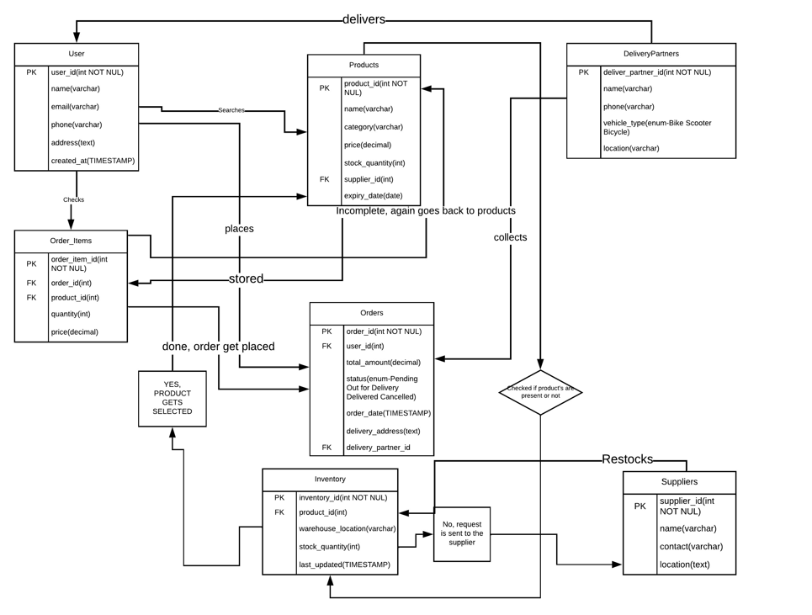

Conclusion

In conclusion, Blink it transformation from Grofer’s to a leading quick-commerce platform underscores the agility & innovation in e-commerce industry.

Video Link:
https://drive.google.com/file/d/1QOlHvDOb-ZZZvtxLrr-UNe9D4Flim5um/view?usp=drive_link

