Associative memory: A network approach with pictorial stimuli

Massimiliano Garzoni di Adorgnano (m.garzonidiadorgnano@uvt.nl)

Department of Cognitive Science and Artificial Intelligence, Warandelaan 2, 5037 AB

Tilburg, The Netherlands

U662083 – Group 2

Abstract

The current study sets to determine the emergence and appearance of associative memory illusions by employing pictorial stimuli instead of the primarily used language stimuli. An experiment was designed and then implemented online in order to reach a wide number of subjects. Nevertheless, a very limited number of participants successfully completed the task. Overall, the results showed no significant difference between the fake-within edges and the fake-between edges of the graphs that formed the stimuli.

**Keywords:** associative memory illusions; Fuzzy-Trace Theory; perceptual relatedness; false recall and false recognition.

# Introduction

Memory is debatably the most interesting cognitive phenomenon as it resembles the uniqueness of who we are. In the brain, memory is constituted by networks of connections. These connections and their combined strengths are the pivotal features of our ability to seamlessly make sense of the world. However, is at times inevitable that this cognitive process fails to elicit information present in one or more of its three stages: encoding, storage and retrieval. Especially concerning the latter one, memory can be easily influenced when retrieving information that was illusory at the encoding stage.

Associative memory illusion (AMI) is a phenomenon that has been greatly studied, with a specific emphasis on experiments that employed language stimuli (e.g. word lists or phrases). One of the first cognitive paradigms – still widely acknowledged and applied - was the The Deese, Roediger and McDermott (DRM) task and it was developed for the purpose of construing effective experiments to explore deficits of associative memory. In this simple but efficient task, the participants are to learn a list of words related to a general theme, or “gist”. After a set consolidation period, they are presented with a word that is semantically associated with the words learned at encoding, then asked whether it appeared or not in the original list. As a result, subjects tend to mistakenly recall the word and claim that it was present in the training phase, when, in fact, it was not (Roediger & McDermott, 1995).

Another recognized set of principles aimed at understanding the cognitive nature of AMI is the Fuzzy Trace Theory (FTT). Successful studies based on the FTT illustrated that spontaneous associations fall under the spectrum of higher cognitive functions and thus result from endogenous (internal) processes. Another aspect that this theory speculates on is the dual processing engine of memories, composed of verbatim and gist representations (Reyna & Brainerd, 1995). As motivation for the present study, we took a closer look at the latter one, namely gist representation. This is the primary mental representation involved in reasoning and associative memory recall and it’s based on the notion of “gauzy” semantic representations that are attached to the general theme of the stimuli involved. In this sense, gist-based representations are top-down processes, as they rely predominantly on cognition rather than on sensory inputs. Accordingly, gist-based resembles the fact that higher cognition is substantially intuitive (Corbin, Reyna, Weldon, & Brainerd, 2015). This is believed to depend on implicit associations which also seem to happen at a higher level of cognitive processing and play a key role in the production of illusive memories. Closely related to this is the idea, firstly reported by Underwood (1965), of implicit associative responses. In simple words, a person tends to tacitly associate concepts in memory just based on their semantic or perceptual relatedness (Underwood, 1965).

Subsequently, a widely encountered phenomenon resulting from experiments employing the DRM paradigm is the concept of false recall and false recognition (Robinson & Roediger, 1997). Similar to the concepts on which the FTT is based on, false recognition is tied to the associations between the items that subjects learn and the ones presented in the testing phase. To illustrate this, experiments by Robinson and Roediger (1997) show inverse proportionality between recall accuracy and the number of items in the training phase: the higher the latter, the lower the former.

The above-mentioned theories form the indispensable conceptual basis for the study of associative memories. However, experiments designed for empirically testing these cognitive illusions have mainly dealt with language stimuli (e.g. word lists or phrases). To date there does not seem to be valid research employing different stimuli, such as pictorial stimuli. For this reason, the intent of the present study is to provide novel evidence in line with the theoretical framework presented. To this end, we devised a task aimed at assessing whether the known associative memory illusions would persist in subjects using pictorial stimuli instead of verbal stimuli. We thus pose the question: will participants, in the testing phase, mistakenly recall pairs of figures indeed not present in the training phase? More specifically, will they form illusive memories for figures coming from the same cluster (fake-within) or from across clusters (fake-between)? Following the theories reported above, we expect to find a significant difference between the recall of pairs coming from within one of the graphs rather than from between the two graphs.

# Methods

## Terminology

Before delineating the design and procedure of the present study, it’s necessary to elucidate some key terms used to formulate the task. To this end, we used terminology proper of networks.

We first created one main graph consisting of two subgraphs (clusters). The subgraphs comprised 5 nodes and 5 edges, resulting in 10 nodes and 10 edges in total. The figures represented the nodes of the networks (see Materials section for details) and the similarity between them represented edges, both for between and within the two subgraphs. More specifically, we included edges that truly existed in the graph – referred to as ‘real’ edges – and connections that did not in fact exist in the graph – referred to as ‘fake’ edges. Moreover, the ‘real’ edges were only present ‘within’ one of the two clusters and there were no ‘real’ edges present in between the two subgraphs.

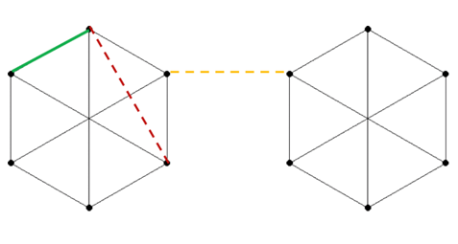

Figure 1: This figure shows the design of the subgraphs, with nodes and edges. In green is the real edge, in red the fake-within edge and in yellow the fake-between edge.

## Participants

The participants consisted of friends and family members. Thus, convenience and snowball sampling were used to gather participants. Because the experiment was to be complied online, a link was created so that participants could easily access it and redirect it within their social networks. A total of 22 (*N =* 22; 11 male and 11 female) participants, with a mean age of 24 years old, successfully completed the experiment and provided data for the research. It is worth to mention that the experiment was accessed online, but not completed, 206 times. As reported below in the discussions, this seems to be one of the reasons for the outcome of the study.

## Materials

### Data. Images representing the “Heptapod” language from the movie “Arrival” were chosen as the visual stimuli for the task (logograms). These were retrieved from an online source (https://github.com/WolframResearch/Arrival-Movie-Live-Coding). The original dataset contained 37 figures. Out of these, 10 were selected as they represented the most different ones. No specific criteria were adopted for assessing the diversity, but a simple visual assessment, which does not seem to be a threat to the validity of the present study in any apparent way. The figures, originally in .jpeg format, were then converted to .png format to ensure their quality. Lastly, the entities were resized to 200x200 pixels, in order to be easier to implement in the Python script (Fig.1).



Figure 2: This shows the pair of logograms representing the Heptapod language used as stimuli.

**Software**.Both the training and the test graphs were generated by a python script implemented with the PsychoPy toolkit (https://www.psychopy.org/). This platform was chosen for two reasons. First, it was an open source platform and therefore increased the researchers’ flexibility in creating the experiment. Second, a recently introduced feature enabled to run the designed experiments online, which was a prerequisite for attaining a valuable number of participants.

## Design and procedures

### Participants were asked to memorize pairs of figures, and subsequently asked whether a pair appeared in the training set. The variables manipulated were the three types of logogram pairs: real edges (50%), fake-within edges (25%), fake-between edges (25%).

Right after showing the instructions about the task, the participants had the opportunity to practice with a trial test phase. The initial part of the task – the training - consisted of 30 epochs. For each epoch, 6 pairs of nodes (12 figures in total) resembling true relations (‘real’ edges) were shown to the participants for 4s each. Then, a set of 4 binary choice (yes/no) questions were asked at the end of each epoch, resulting in 40 questions in total for the training phase. This was done for two main reasons: (1) to provide immediate feedback to the subjects and (2) to engage them in an otherwise passive task. The binary choice allowed the participants to make a judgement for whether the shown pair of pictures were related or not. Specifically, 20 questions concerned the ‘real’ edges, while the other set of 20 questions were divided to 10 queries about the ‘fake’ within-cluster edges and to 10 queries about the ‘fake’ between-clusters edges. Finally, again to provide feedback for the answers, a green screen appeared as result of a correct answer. Accordingly, a red screen appeared in the case of a wrong answer.

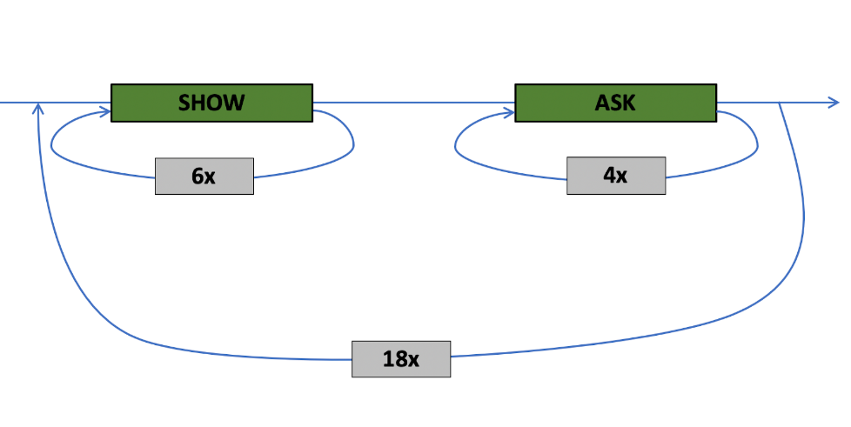

Figure 3: This figure represents the design of the recurring epochs.

After filling in the demographic data, the participants were informed that they would be presented with pairs of images from the Heptapod language of the movie Arrival. Moreover, subjects were told that the aim of the research was to measure humans’ ability to learn an “alien” language. Clearly, this was not the real end, but it served as a distractor and a way to entertain the participants. Right after the end of the training phase, the testing phase started. This part consisted again of binary choice questions for each of the 50 possible pairs of nodes, which is the resulting number after merging all the ‘real’ and ‘fake’ edges. This were presented as result of a random selection. Overall, the experiment measured: (1) demographic data (age, gender), (2) choices whether a pair appeared in the training set (yes / no) and (3) response time.

# Results

First, descriptive statistics were obtained to have an overview of the overall performance of the participants. The results yielded a mean of *M = 71.60* (*SD = 0.15*) of correct responses (real nodes, column ‘Yes’), a mean of *M = 54.10* (*SD = 0.23*) for fake-within nodes (‘No-Within’ column) and a mean of *M = 51.82* (*SD = 0.23*) for fake-between nodes (‘No-Between’ column). In order to assess the statistical significance between the fake-within and fake-between results a Fisher’s Exact Test was conducted on the resulting data. The reason for using this statistical test was related to our sample size, which was greatly restricted in nature. Contrary to our expectations, the test proved to be statistically insignificant, with a p-value *p = 0.138* (*DF = 21*). This does not support our original hypothesis which claimed that the ratio of false positives would be higher for the within-cluster category.

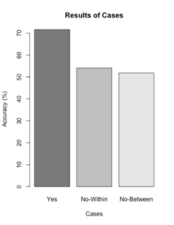

# Discussion

The present paper was aimed at testing whether associative memory illusions arise in participants by employing pictorial stimuli as opposed to language.

Although a large body of research examined the appearance, presence and function of induced memory illusions, these studies have always dealt with stimuli related to language (for a review, see Roediger et al., 1998). In the present paper, we aimed at employing the theoretical frameworks of the DRM paradigm and the Fuzzy Trace Theory by manipulating pairs of logograms (figures resembling the Heptapod language of the movie Arrival). By doing this we wanted to provide evidence for a pictorial account to associative memory illusions.

The results showed that the difference in recall accuracy between the fake-within and the fake-between responses was not statistically significant. Hence, the data obtained from the subjects does not support the initial hypothesis.

Much of the previous research concerned with the nature and function of this implicit cognitive process reported overall significant difference in recall accuracy and false recognition (Dewhurst, Bould, Knott, & Thorley, 2009). Accordingly, these results were obtained in carefully designed experiments that primarily included training on lists of words and their semantic relatedness. Gist-based representations drive and facilitate the occurrence of associative memory illusions, resulting in a participant recalling a word that did not appear in the training list. For this reason, in the present paper we focused on eliminating the inherent semantics present in language by having pairs of figures and their connections as the stimuli.

The novel approach applied in this research proved to be ineffective under the designed experimental condition and with the limited sample size. Therefore, we discuss two main possible reasons that could account for this.

In the first place, the implementation of the code allowed to run the experiment online, but its lack of mobile accessibility led to a minimal sample size. The experiment could run only on laptops or desktop computers and hence subjects with smartphones had no possibility to efficiently participate. The consequence of this was that only very few people – 22 subjects - successfully completed the experiment. As mentioned in the methods section, 206 people were able to access the platform on which the experiment ran, but data for these subjects did not get recorded as they did not reach the end.

In the second place, the length and annoyance of the task seemed to have motivated people to carefully conduct the experiment. Thus, the design of the experiment should have been framed and arranged in a more effective way. For example, the number of nodes and possible edges could be reduced to a lower one, to eliminate length of the task as a possible confounding variable.

Additionally, we chose the figures of the Heptapod’s language as they are clearly hard to differentiate and to specifically remember. The design of this study was aimed at complexify the learning process as much as possible in order to not influence the appearance of illusive memories. Participants seemed to have scored well in the recall of the ‘real’ edges. More specifically, around 70% of participants recalled the pairs of figures that were in fact present in the training phase (‘real’ edges). However, there was not a valid difference between the recall accuracy of the fake-within edges and the fake-between edges.

# Conclusions

Still, we firmly believe that testing the emergence of AMI with pictorial //stimuli// could reinforce the FTT and shed light on this implicit, subconscious, cognitive process. If this is the case, it would suggest an advance for the creation of models of cognition and their possible computational applications in technologies.

Future studies should reproduce the current experiment by creating subgroups (clusters) that have at least one visual feature in common, rather than randomize fully the relations between the figures. By doing this, the emergence of false recalls in relation to the fake-between and fake-between edges could result in a significant difference.

Finally, a replica of the experiment should be run in a more controlled setting. This is thought to (at least partially) rule out confounds such as participants accessing the study from unsupported devices or following the task in unclear manners. As a result, a larger number of participants could be achieved and an overall more stable behavior, which would presumably lead to more in depth and significant results.

# References

Brainerd, C., & Reyna, V. (2002). Fuzzy-Trace Theory and False Memory. *Current Directions in Psychological Science, 11*(5), 164-169. doi:10.1111/1467-8721.00192

Corbin, J. C., Reyna, V. F., Weldon, R. B., & Brainerd, C. J. (2015). How reasoning, judgment, and decision making are colored by gist-based intuition: A fuzzy-trace theory approach. *Journal of Applied Research in Memory and Cognition, 4*(4), 344-355. doi:10.1016/j.jarmac.2015.09.001

Deese, J. (1959). On the prediction of occurrence of particular verbal intrusions in immediate recall. *Journal of Experimental Psychology, 58*(1), 17-22. doi:10.1037/h0046671

Dewhurst, S. A., Bould, E., Knott, L. M., & Thorley, C. (2009). The roles of encoding and retrieval processes in associative and categorical memory illusions. *Journal of Memory and Language, 60*(1), 154-164. doi:10.1016/j.jml.2008.09.002

Roediger, H. L. (1996). Memory Illusions. *Journal of Memory and Language, 35*(2), 76-100. doi:10.1006/jmla.1996.0005

Roediger, H.L., & McDermott, K.B. (1995). Creating false memories: Remembering words not presented in lists. *Journal of Experimental Psychology: Learning, Memory, and Cognition, 21*, 803– 814.

Park, L., Shobe, K. K., & Kihlstrom, J. F. (2005). Associative and Categorical Relations in the Associative Memory Illusion. *Psychological Science, 16*(10), 792-797. doi:10.1111/j.1467-9280.2005.01616.x

Reyna, V., & Brainerd, C. (1995). Fuzzy-trace theory: An interim synthesis. *Learning and Individual Differences, 7*(1), 1-75. doi:10.1016/1041-6080(95)90031-4

Robinson, K. J., & Roediger, H. L. (1997). Associative Processes in False Recall and False Recognition. *Psychological Science, 8*(3), 231-237. doi:10.1111/j.1467-9280.1997.tb00417.x

Toglia, M. P. (1999). Recall Accuracy and Illusory Memories: When More is Less. *Memory, 7*(2), 233-256. doi:10.1080/741944069

Underwood, B. J. (1965). False recognition produced by implicit verbal responses. *Journal of Experimental Psychology, 70*(1), 122-129. doi:10.1037/h0022014