DigiBill
Smart Billing and Inventory Management System

PROJECT REPORT

Table of Contents

Sr. No |  | Subject | Page  Number
1 |  | Project Profile & Company Profile | 5-6
2 |  | Introduction to tools | 7-8
3 |  | System Study | 9-12
 | 1. | Existing System | 10
 | 2. | Proposed System | 10
 | 3. | Scope of the Proposed System | 11
 | 4. | Aim and Objective of the Proposed  System | 11
 | 5. | Feasibility Study | 12
 |  | Operational Feasibility | 12
 |  | Technical Feasibility | 12
 |  | Economic Feasibility | 12
4 |  | System Analysis | 13-24
 |  | Requirements Specification (along with  System Modules) | 14-17
 |  | Activity Diagram | 18-22
 |  | Use Case Diagram | 23
 |  | Class Diagram | 24
5 |  | System Design | 25-40
 |  | Data Dictionary | 26-28
 |  | Screen Layouts | 29-40
6 |  | Future Enhancement | 41-42
7 |  | Bibliography/References | 43-44
8 |  | System Testing | 45—47
 |  | Testing Strategies | 46

 |  | Test Cases | 47
9 |  | Reporting Report (to be collected from  respective internal guide)

PROJECT PROFILE

- Project Profile
- Project Name: DigiBill
- Type of Application: Android Application
- Project Description: DigiBill is a mobile-based invoicing and inventory management system designed for shopkeepers. It enables users to generate invoices, scan barcodes, manage inventory, and share invoices digitally via SMS and QR codes. The system replaces traditional manual billing with a fast, efficient, and paperless solution.
- Team Size: 3
- Frontend Technologies
  - KOTLIN
  - XML

- Backend Technologies
  - Firebase Firestore (Database)
  - Firebase Authentication (Login system)

- Tools Used
- Android Studio
- Firebase Console
- GitHub

INTRODUCTION TO TOOLS


Introduction to Tools & Technology

Frontend Technologies

Kotlin:
Modern, concise, and safe programming language officially recommended for Android development. It improves code readability and reduces errors.

XML:
Used for designing layouts like login screen, invoice UI, dashboard, etc.

Material Design:
Provides a clean and user-friendly interface.

Backend

Firebase Firestore:
Cloud-based NoSQL database for storing invoices, products, and customer data.

Firebase Authentication:
Secure login system using email/password or phone authentication.

Firebase Storage:
Stores invoice images and files securely.

Libraries & APIs
  - Google ML Kit: Barcode & QR code scanning
  - Firebase SDK

SYSTEM STUDY


System Study

Existing System
The current billing system used by small shopkeepers is mostly manual and paper-based. In this system, invoices are written by hand or created using basic calculators without any automation. This approach leads to several problems such as:
- Time-consuming billing process
- High chances of human errors in calculations
- No proper record management
- Difficulty in tracking inventory and stock levels
- Lack of data backup and security
- No easy way to share invoices with customers
Additionally, maintaining physical records becomes difficult over time and increases the risk of data loss or damage.

Proposed System
The DigiBill system is designed to overcome the limitations of the existing manual system by providing a digital and automated solution.
DigiBill is an Android-based application developed using Kotlin that allows shopkeepers to generate invoices quickly and efficiently.
The system provides the following features:
- Digital invoice generation with automatic calculations (GST, total amount)
- Barcode scanning using Google ML Kit for fast product entry
- Real-time inventory management
- Invoice sharing via SMS and QR code
- Secure cloud storage using Firebase
- User-friendly interface for easy operation

This system ensures faster billing, improved accuracy, and better management of business data.

Scope of the Proposed System
The DigiBill system is designed to support small and medium-sized businesses by providing the following functionalities:
- Easy invoice creation and management
- Barcode-based product entry system
- Real-time stock and inventory tracking
- Secure cloud-based data storage
- SMS and QR code-based invoice sharing
- Ofline invoice creation with later synchronization
- Basic sales reporting and analytics
The system is limited to Android devices and does not currently support web or iOS platforms

Aim and Objective of the Proposed System
The main aim of DigiBill is to simplify and digitize the billing process for shopkeepers.

Objectives:
- Efficiency: Reduce billing time and improve transaction speed
- Accuracy: Minimize calculation errors using automation
- Paperless System: Promote eco-friendly digital invoicing
- Data Management: Store and manage invoices securely in the cloud
- Customer Satisfaction: Provide quick and professional billing experience

- Feasibility Study

Operational Feasibility
The DigiBill system is highly user-friendly and designed for shopkeepers with minimal technical knowledge.
- Simple and intuitive interface
- Reduces manual work
- Easy to learn and operate
- Improves overall business workflow

Technical Feasibility
The system is developed using modern and reliable technologies:
- Kotlin for Android development
- Firebase for backend services
- Google ML Kit for barcode scanning
It works efficiently on Android devices with basic hardware requirements.

Economic Feasibility
The DigiBill system is cost-effective:
- Uses free Firebase services (within limits)
- No need for expensive hardware or software
- Reduces paper and operational costs
- Suitable for small business owners

SYSTEM ANALYSIS


- Requirement Specification (along with System Module)

New Invoice Module
Functional Requirements:
    - Create a new invoice
    - Add products manually or via scanning
    - Automatically calculate total amount, tax (GST), and final bill
    - Save invoice data to Firebase
    - Generate invoice preview

Non-Functional Requirements:
    - Fast invoice creation
    - Accurate calculations
    - Smooth user interface

Manage Invoice Module
Functional Requirements:
- View all saved invoices
- Search invoices by date or customer
- Edit or delete invoices
- View invoice details

Non-Functional Requirements:
- Fast data retrieval
- Efficient list handling (RecyclerView)

- Secure invoice storage

Recent Invoice Module
Functional Requirements:
- Display recently created invoices
- Quick access to latest transactions
- View invoice summary

Non-Functional Requirements:
- Real-time updates
- Minimal loading time

Scan Product Module
Functional Requirements:
- Scan barcode using camera (Google ML Kit)
- Fetch product details automatically
- Add scanned product directly to invoice

Non-Functional Requirements:
- Fast and accurate scanning
- Works in different lighting conditions
- Low latency response

Search Product Module
Functional Requirements:
- Search products by name
- Display matching product list

- Add selected product to invoice

Non-Functional Requirements:
- Fast search results
- Efficient filtering
- User-friendly UI

Manage Product Module
Functional Requirements:
- Add new products
- Update product details
- Delete products
- Maintain stock quantity

Non-Functional Requirements:
- Real-time database update
- Accurate stock management
- Smooth UI interaction

Reports Module
Functional Requirements:
- Generate sales reports (daily/monthly)
- Show total sales and transactions
- Identify best-selling products

Non-Functional Requirements:
  - Fast report generation

  - Accurate data analysis
  - Clear and readable UI

Taxation Module
Functional Requirements:
    - Automatically calculate GST
    - Apply tax rates on products
    - Display tax breakdown in invoice

Non-Functional Requirements:
    - High accuracy in tax calculation
    - Compliance with GST rules
    - Fast processing

Activity Diagram

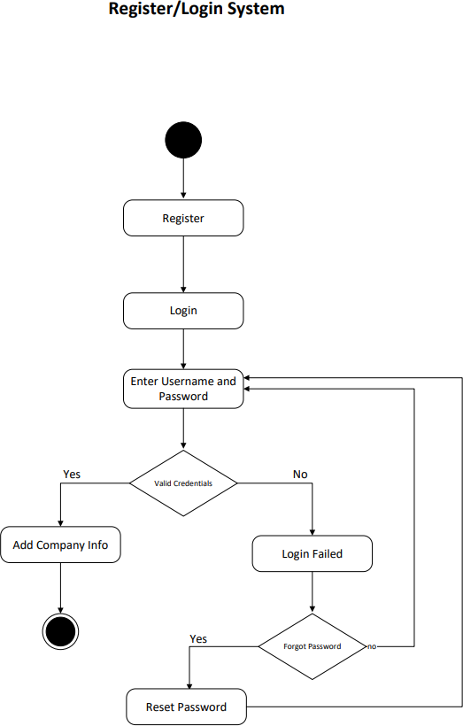

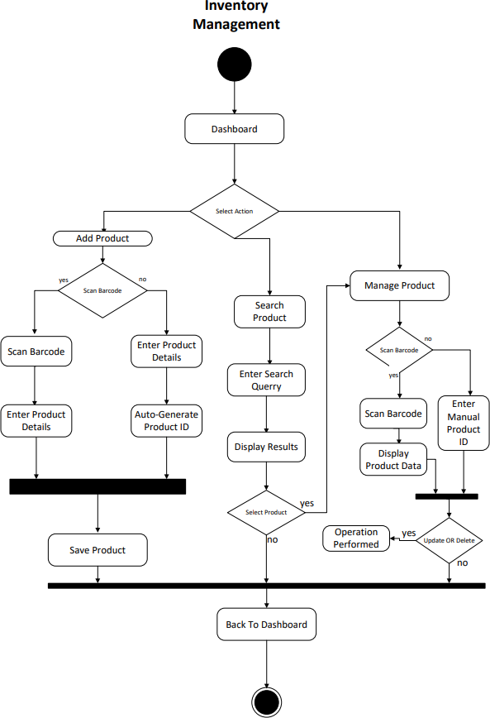

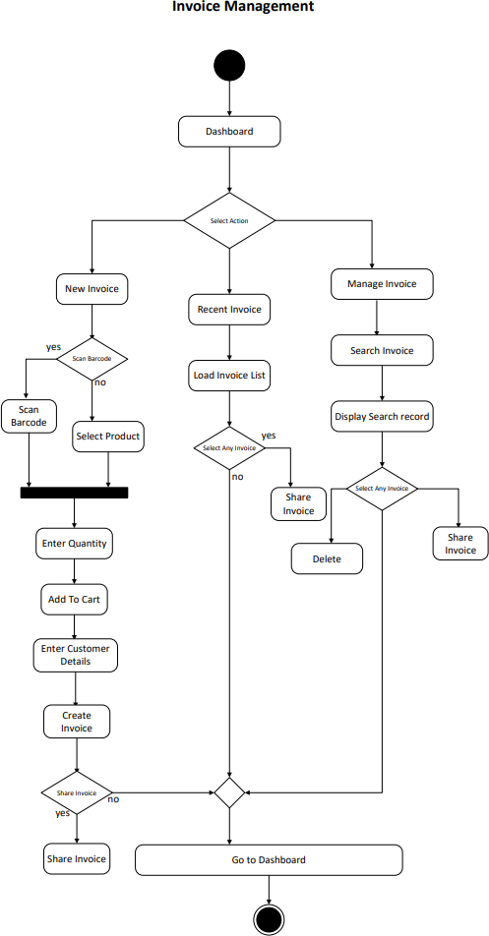

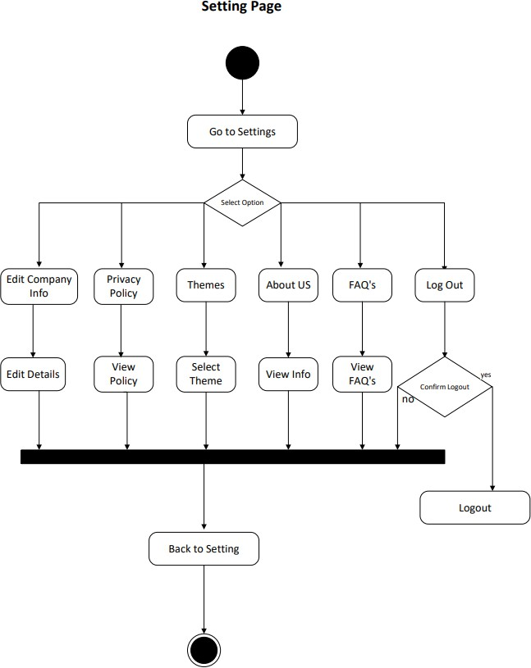

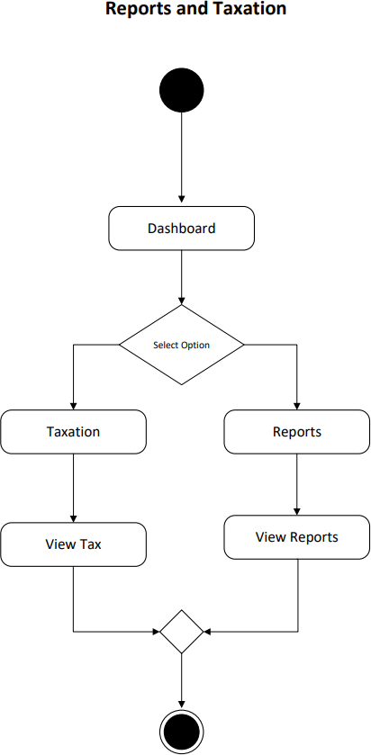

Use Case Diagram

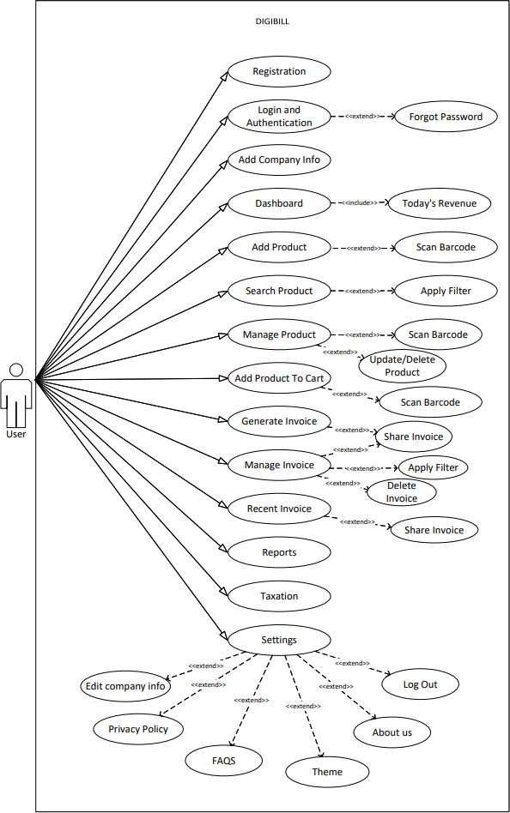

Class Diagram

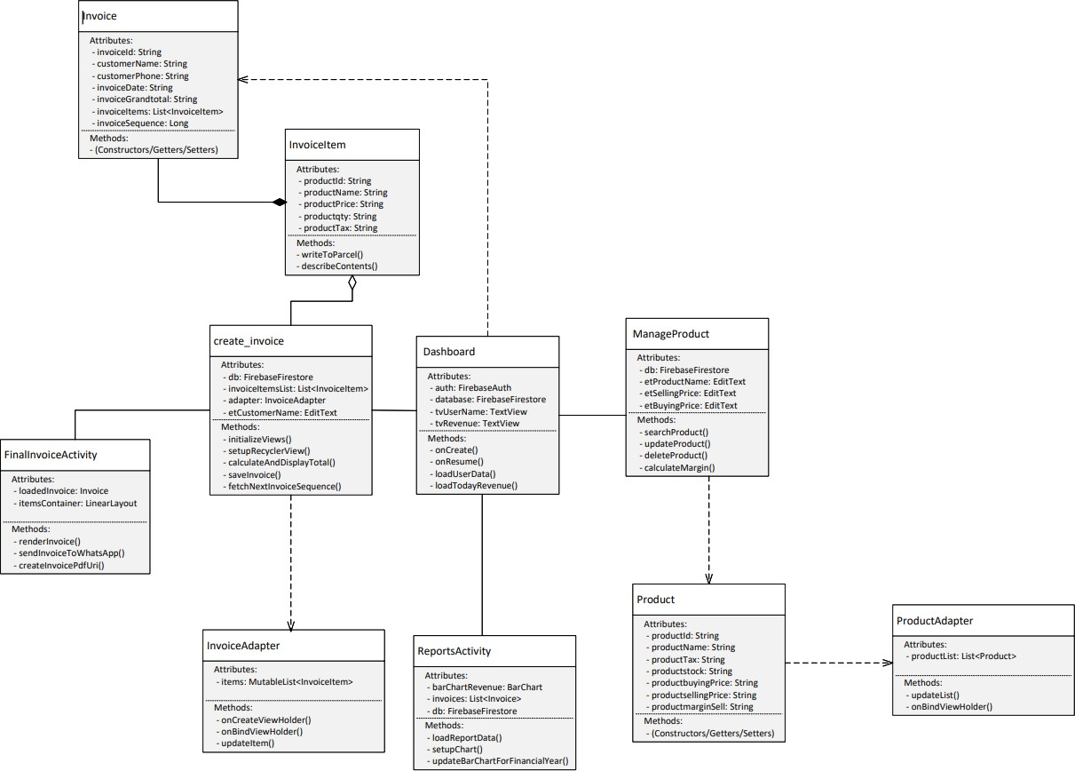

SYSTEM DESIGN

Data Dictionary
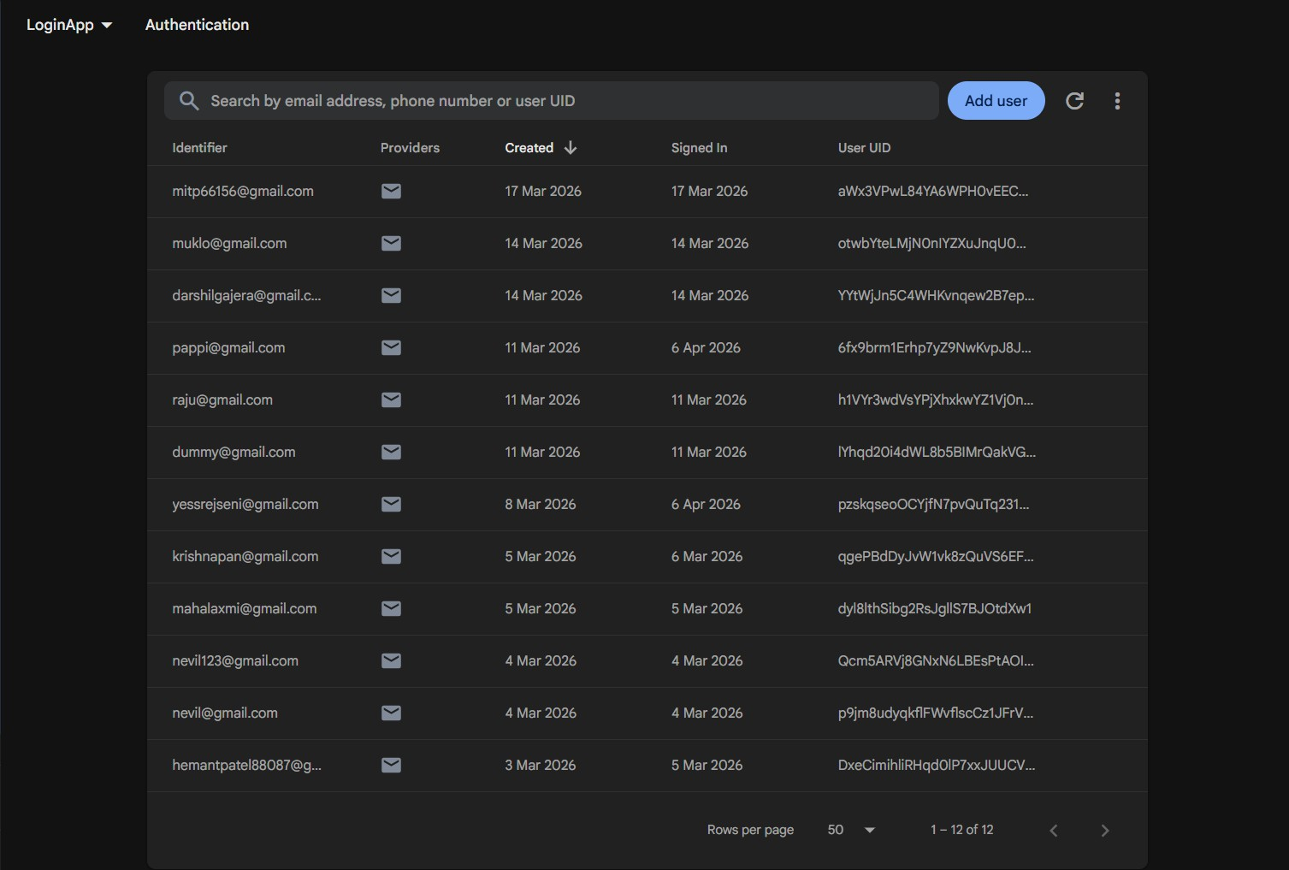
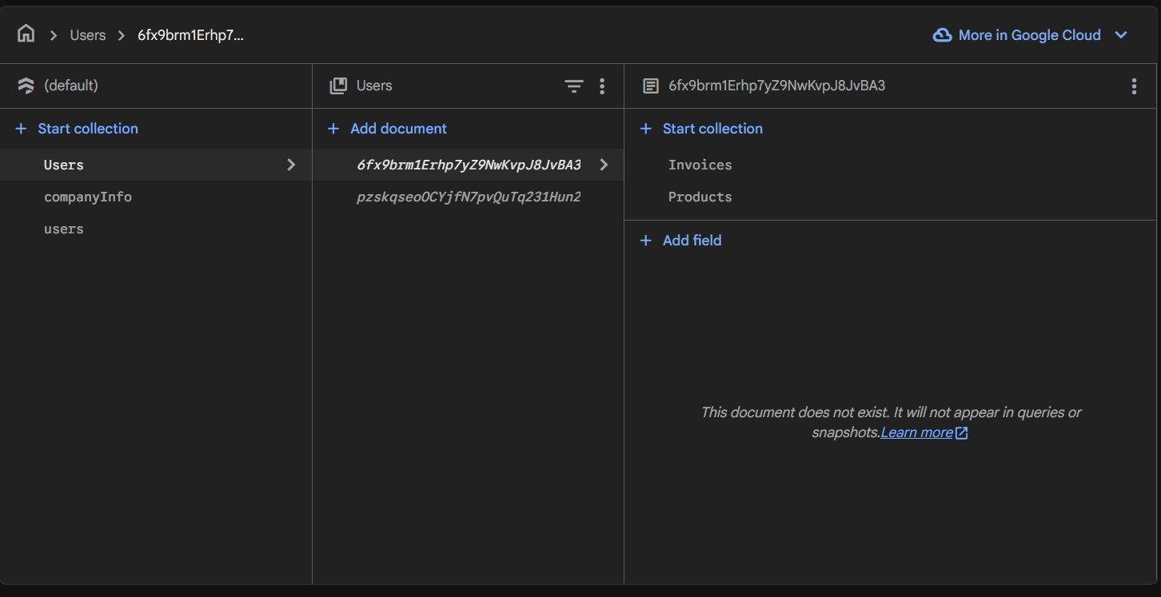

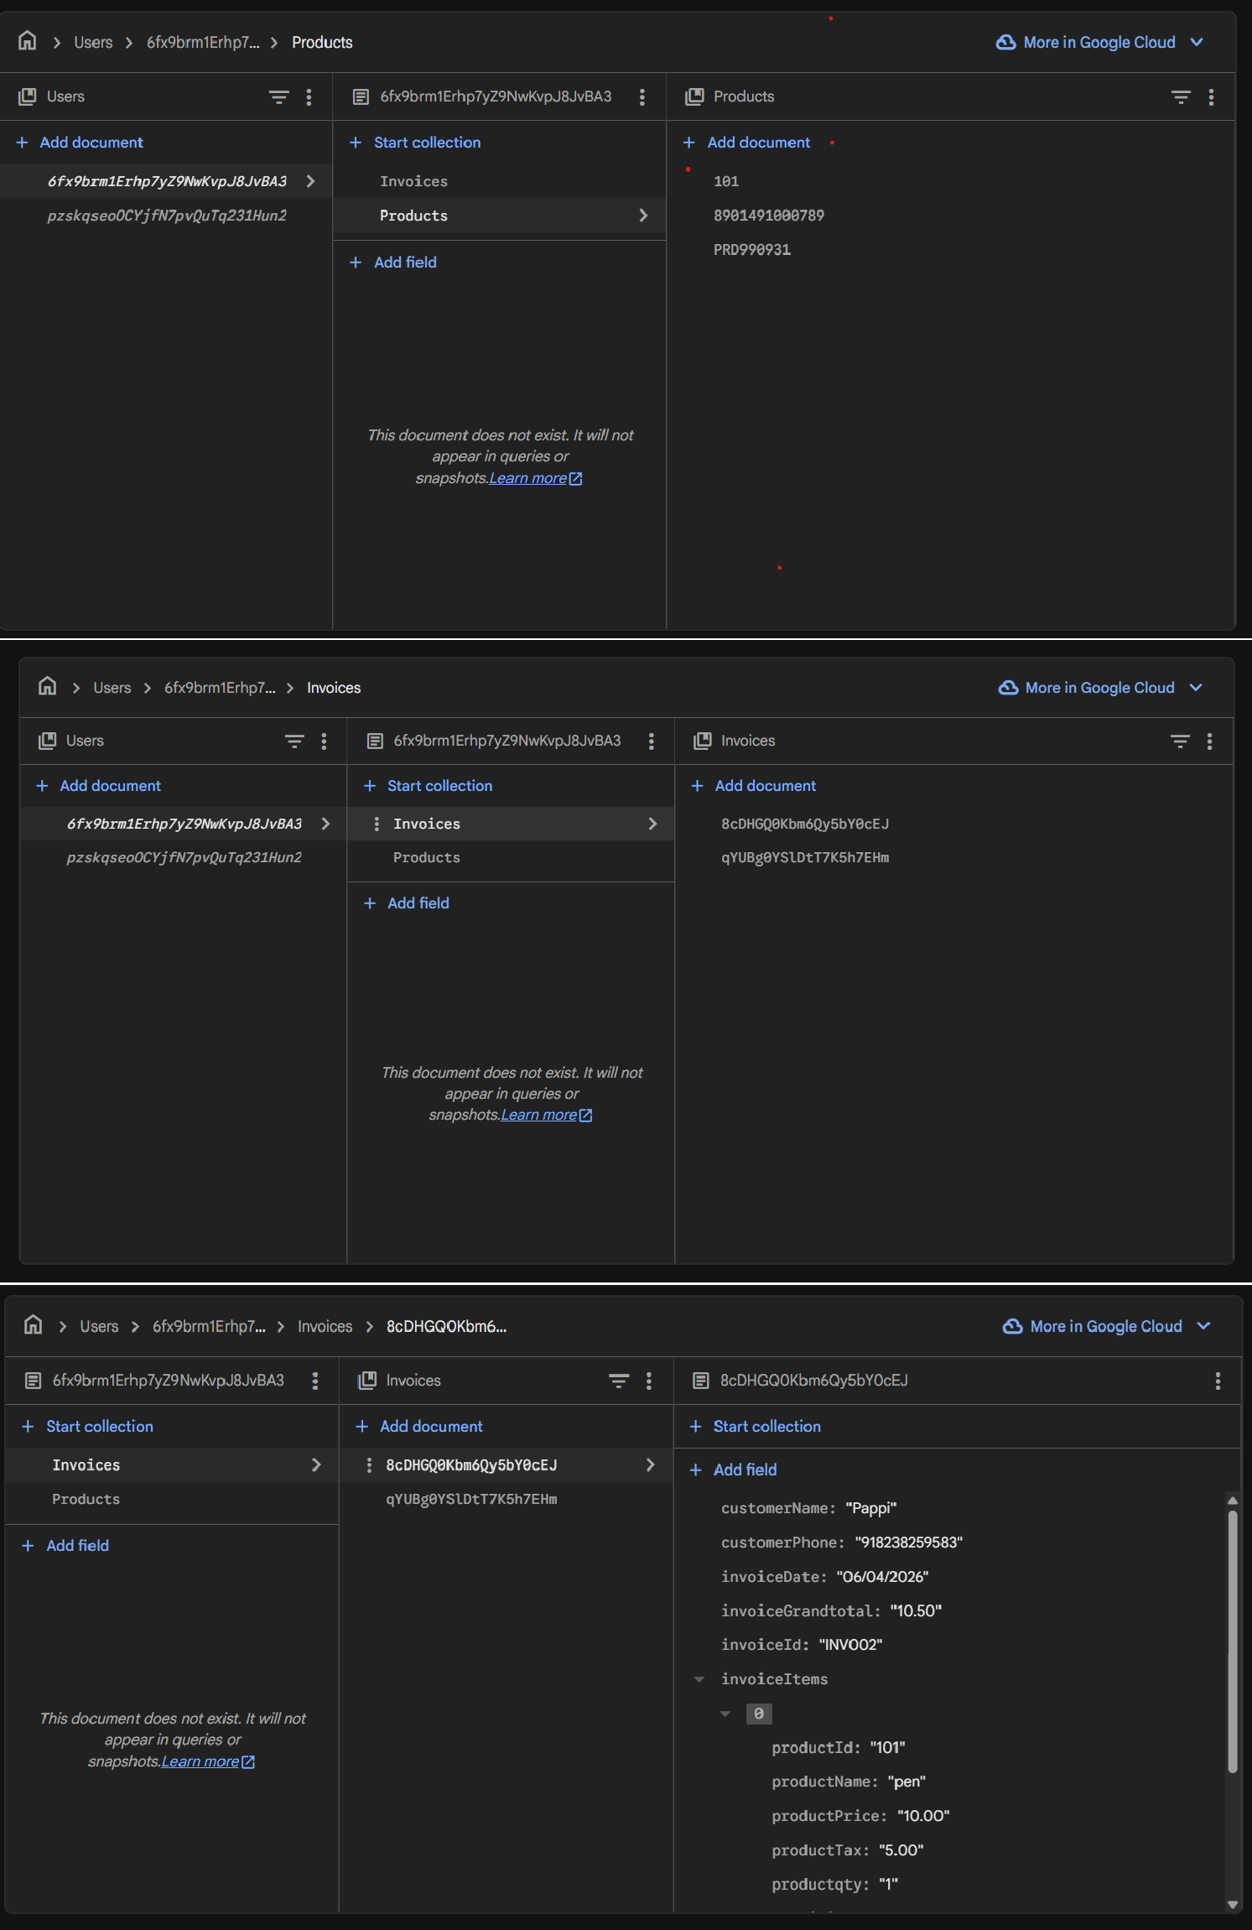

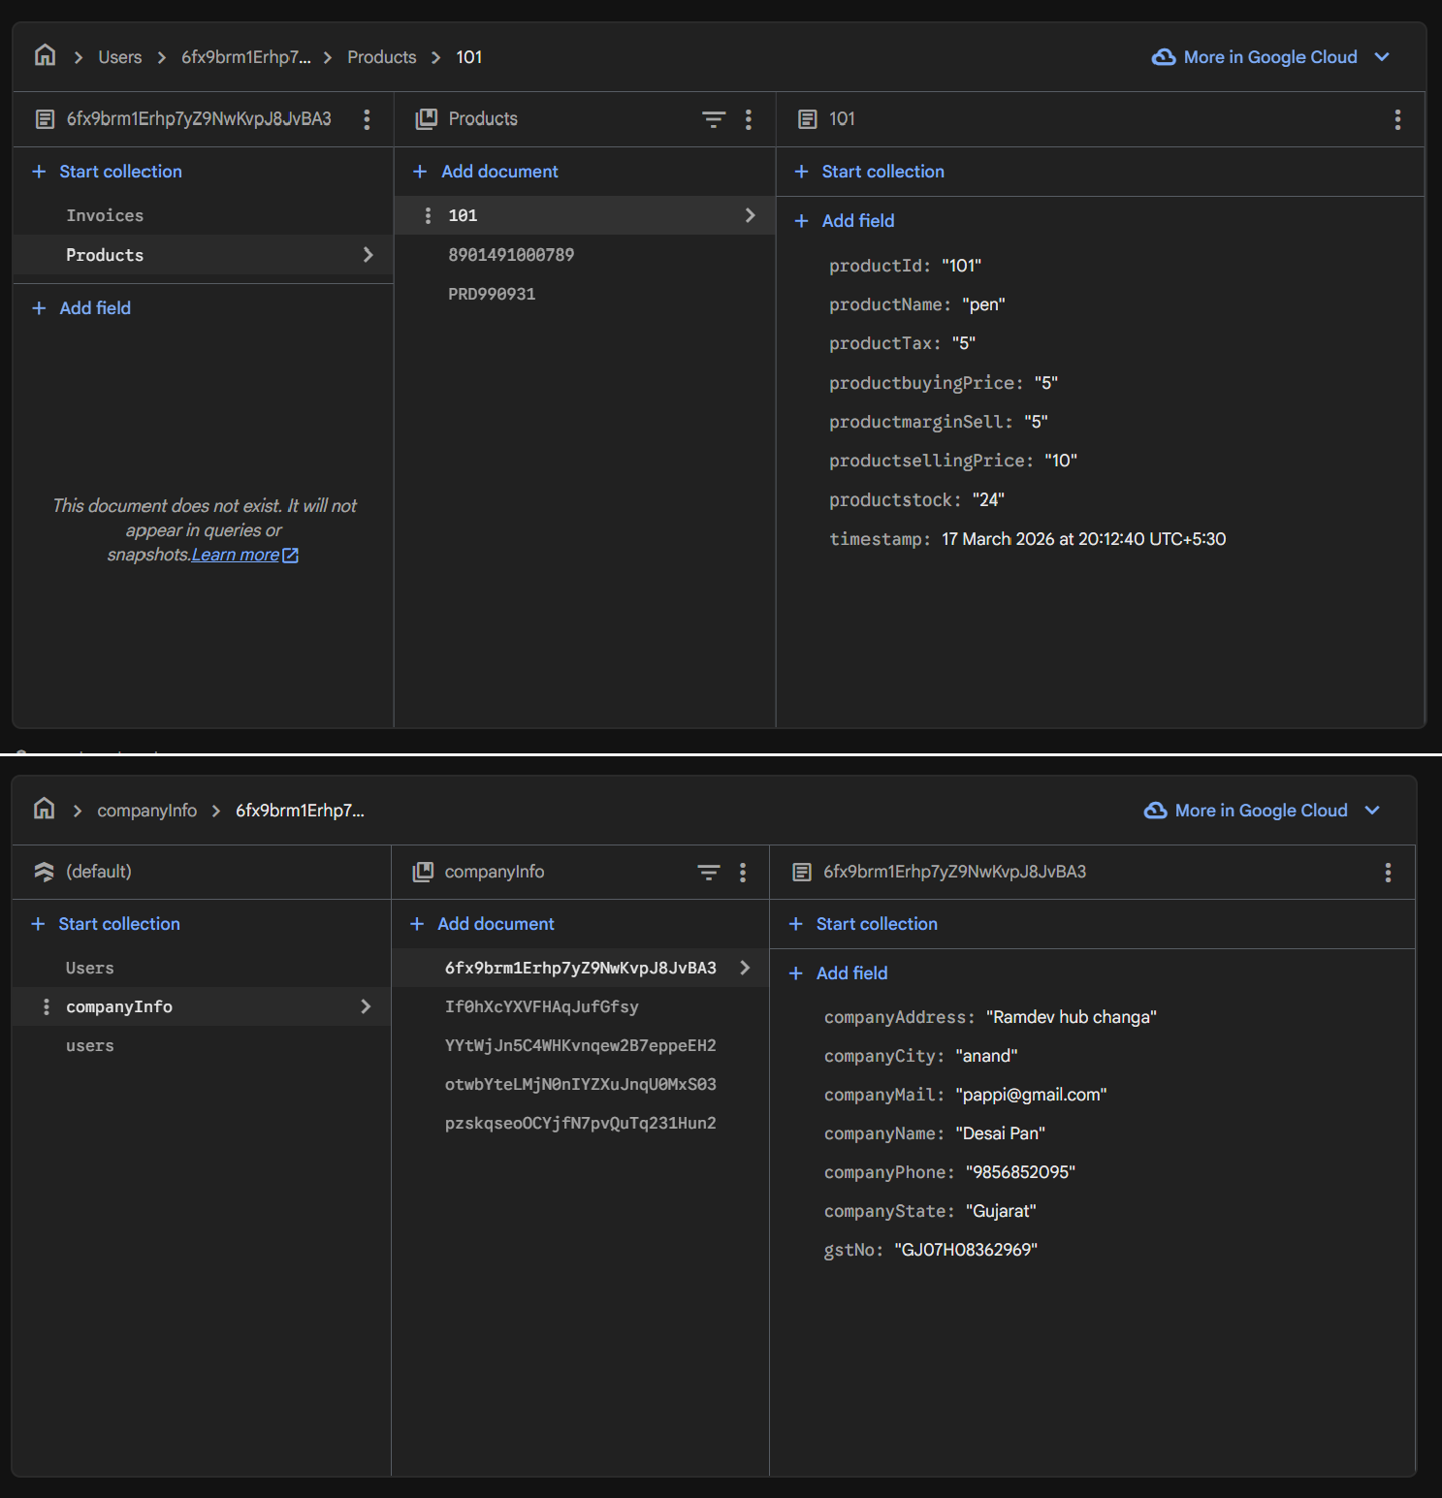

Screen Layout

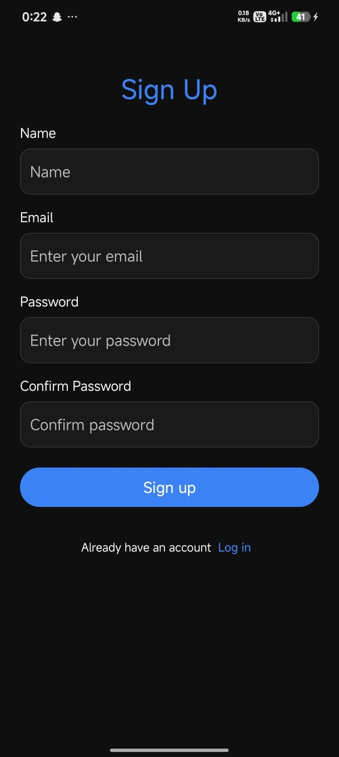  Register Page | 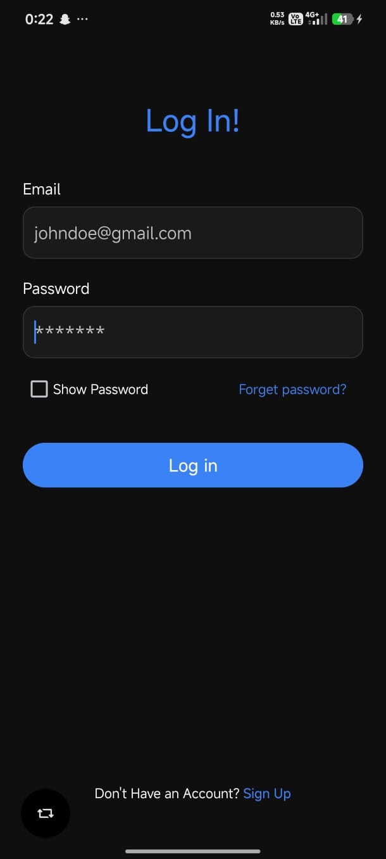  Log In Page

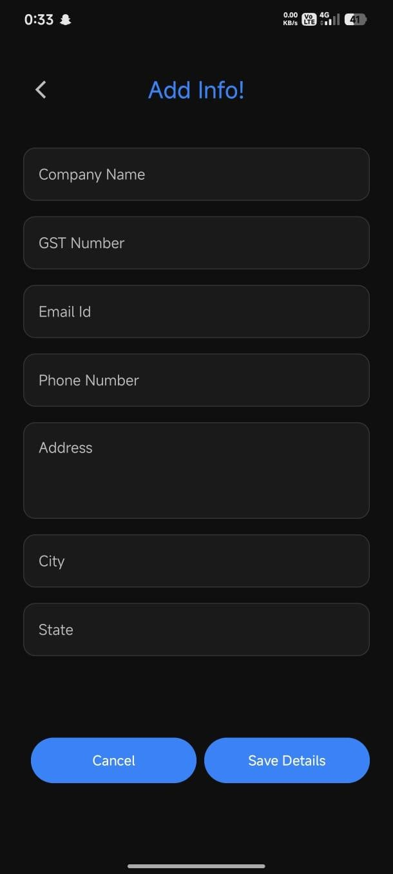  Add Info Page | 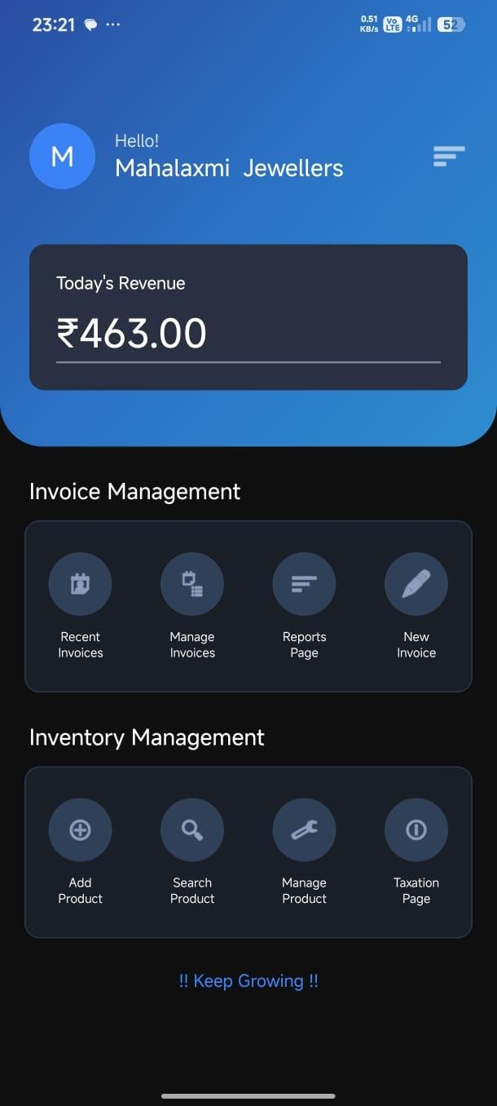  Dashboard

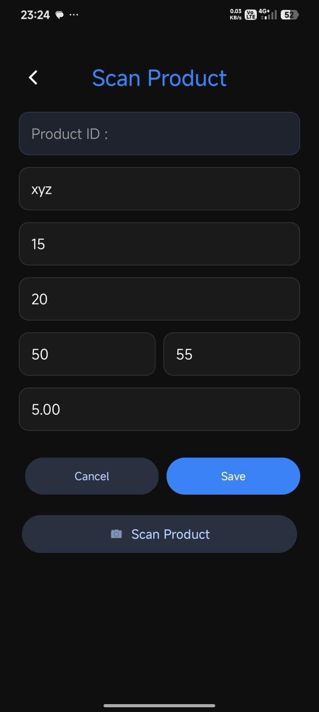  Add Product | 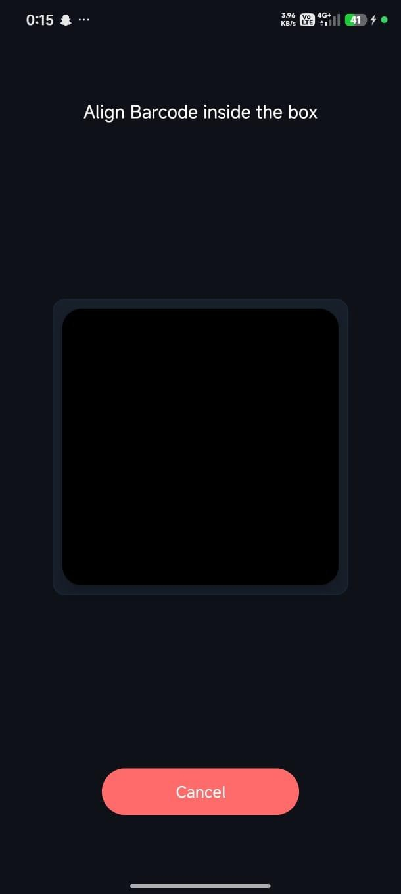  Scan Barcode

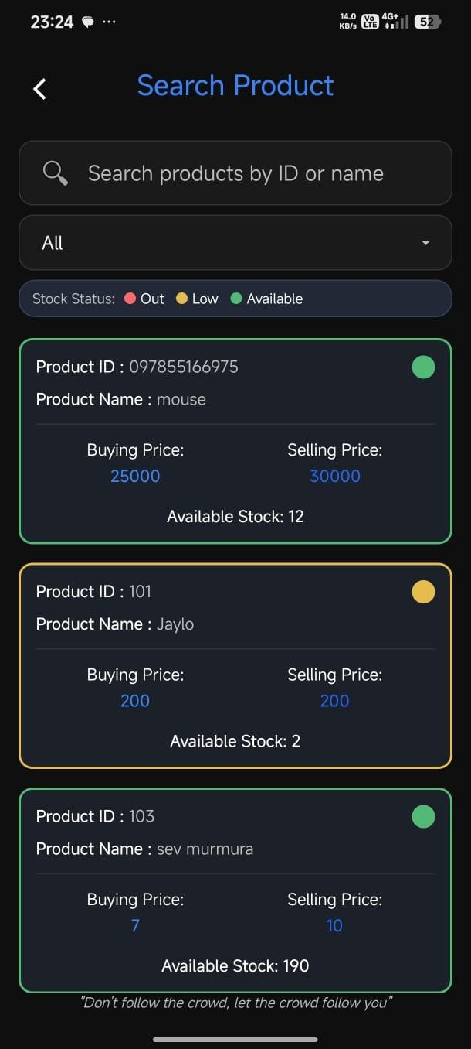  Search Product | 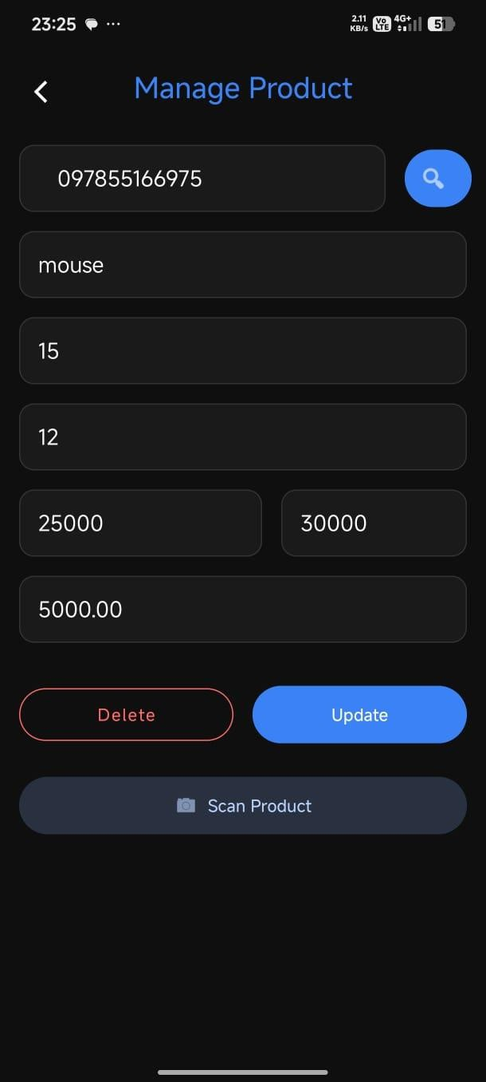  Manage Product

Scan Barcode | 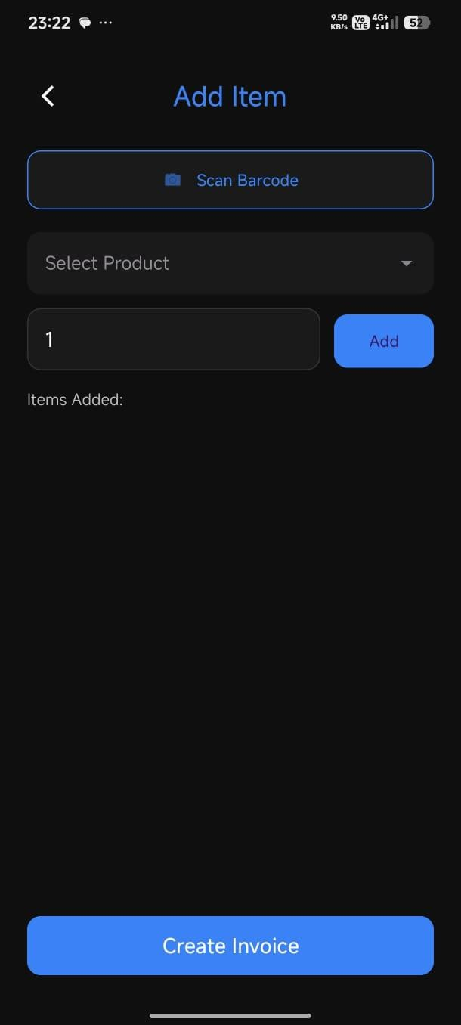  Add Item Invoice

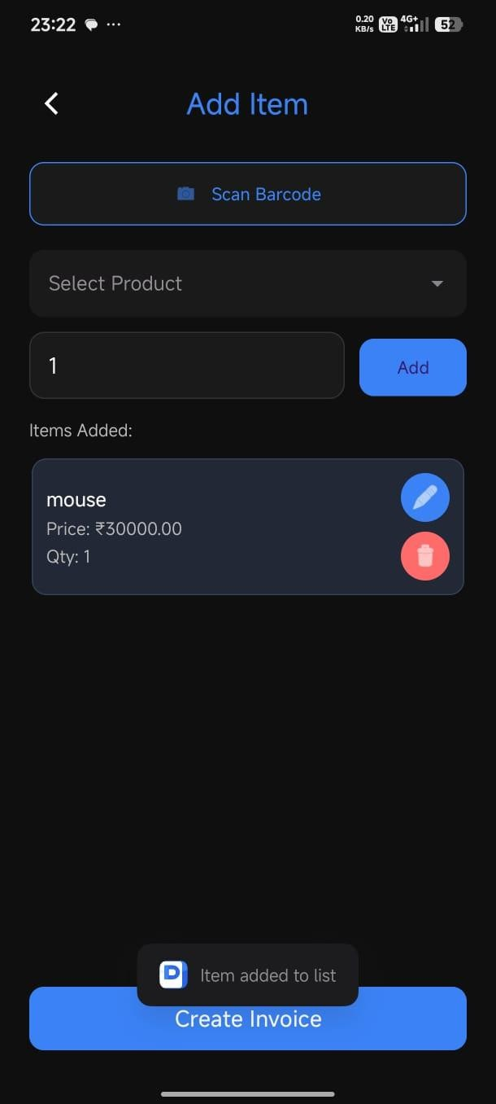  Add Item List | Scan Barcode

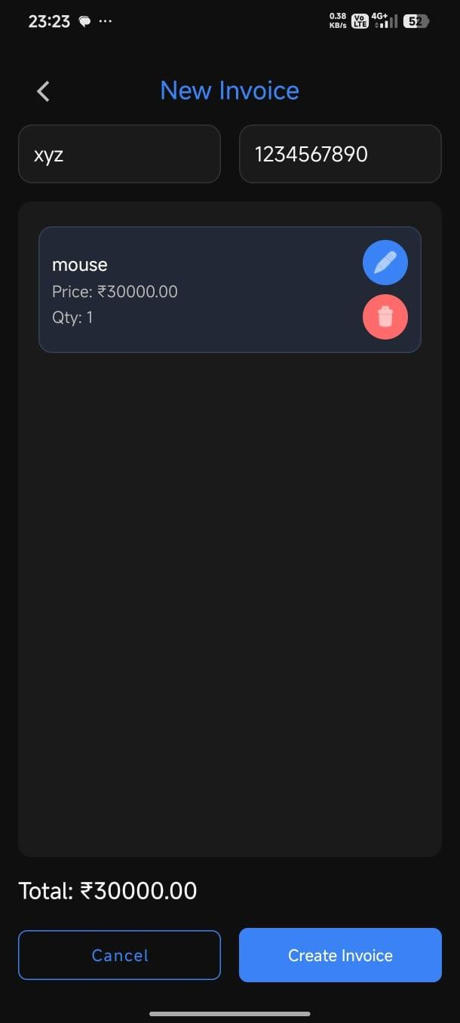  Final Invoice | 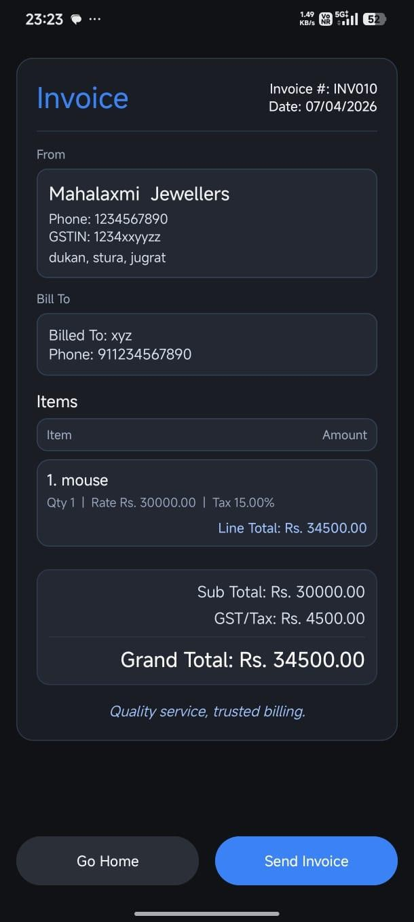  Generated Invoice

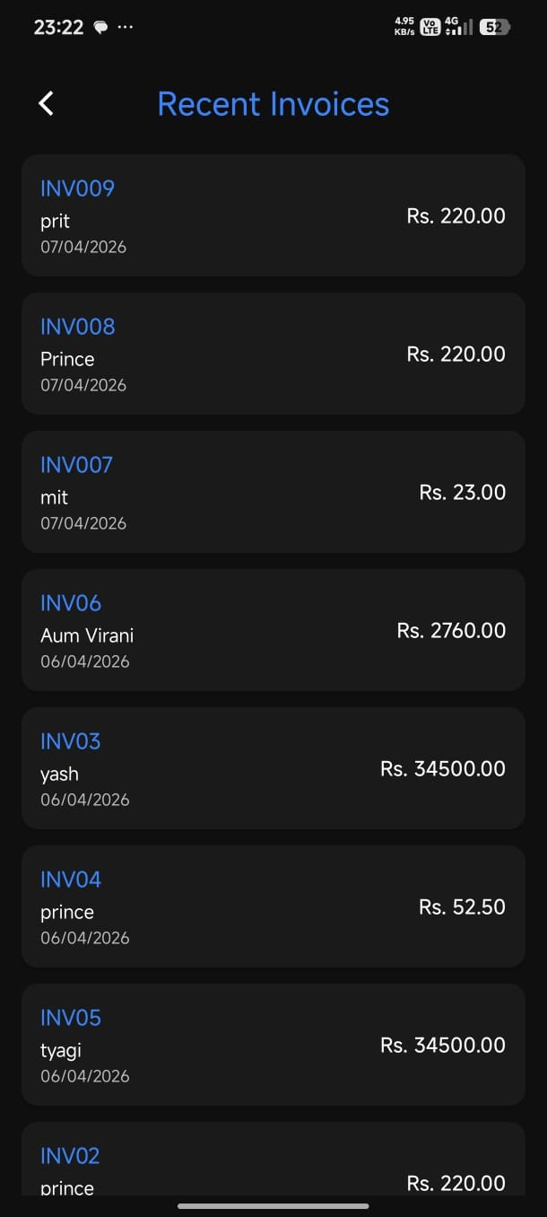  Recent Invoice | 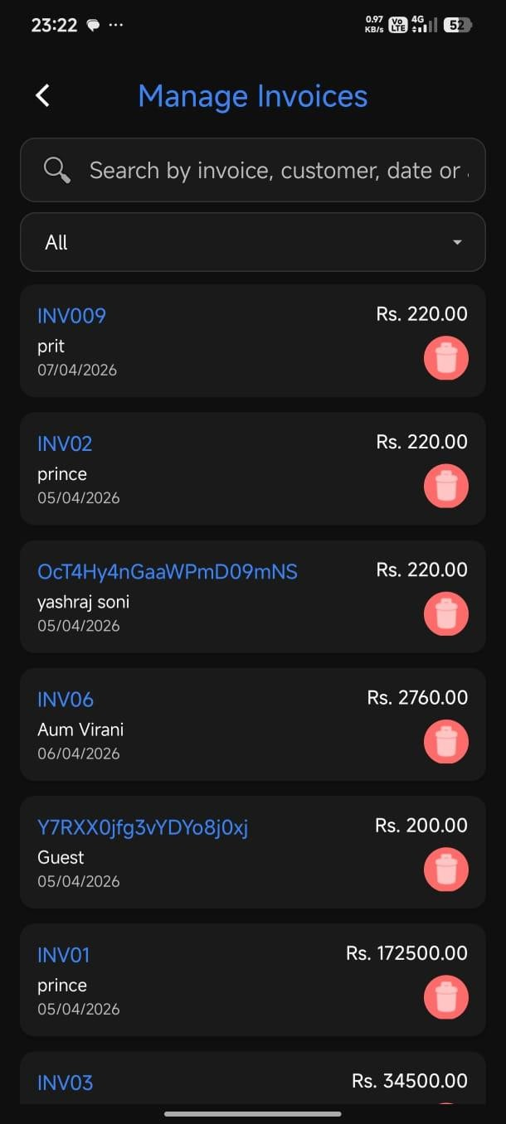  Manage Invoice

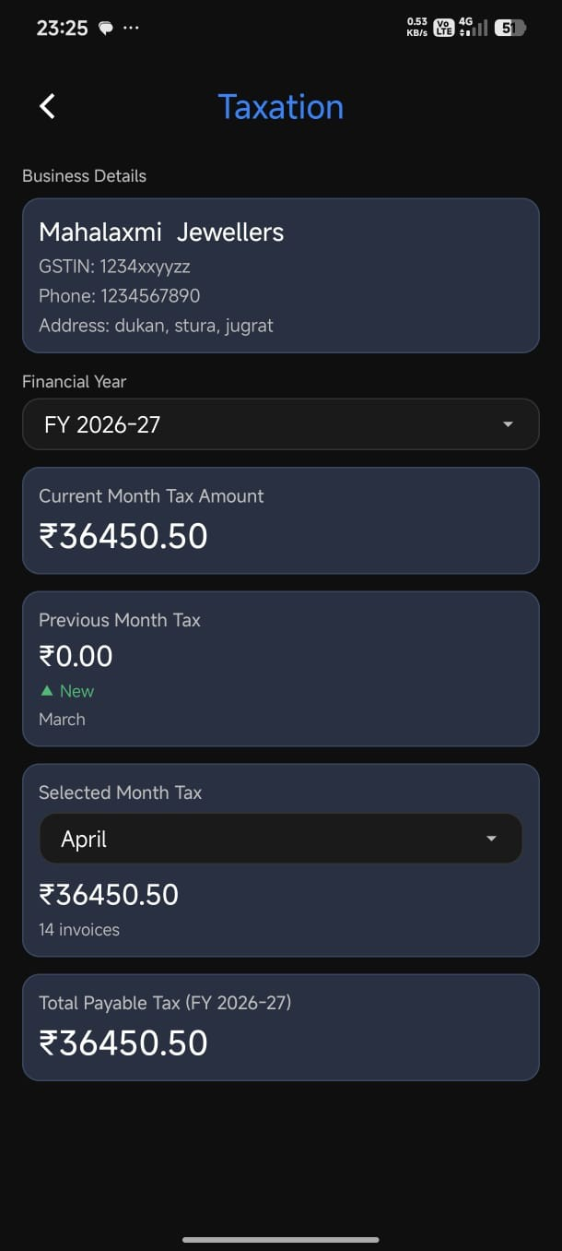  Taxation | 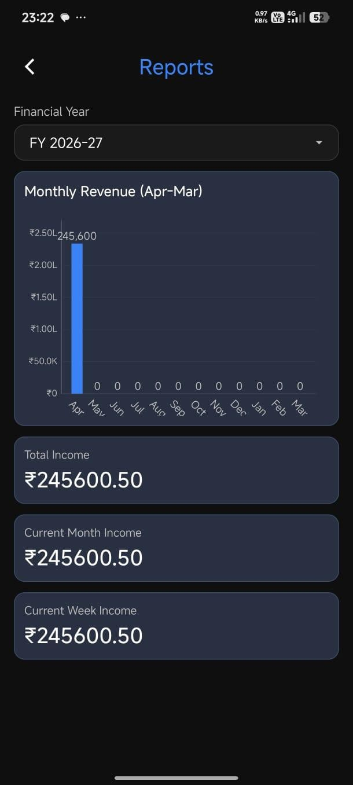  Reports

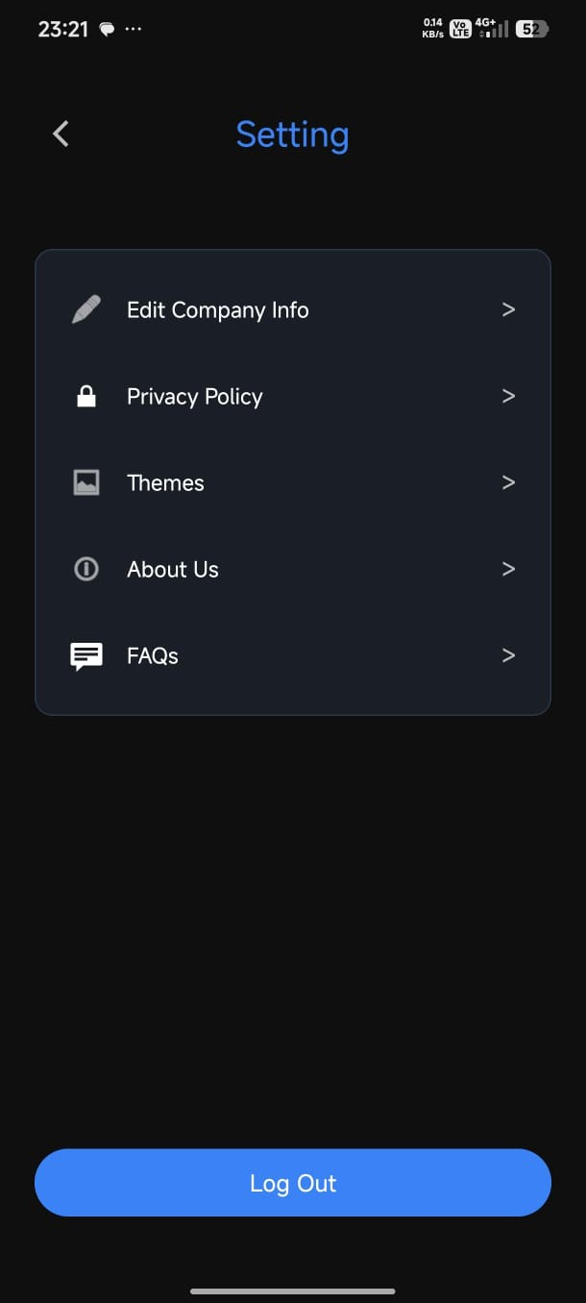  Setting Page | 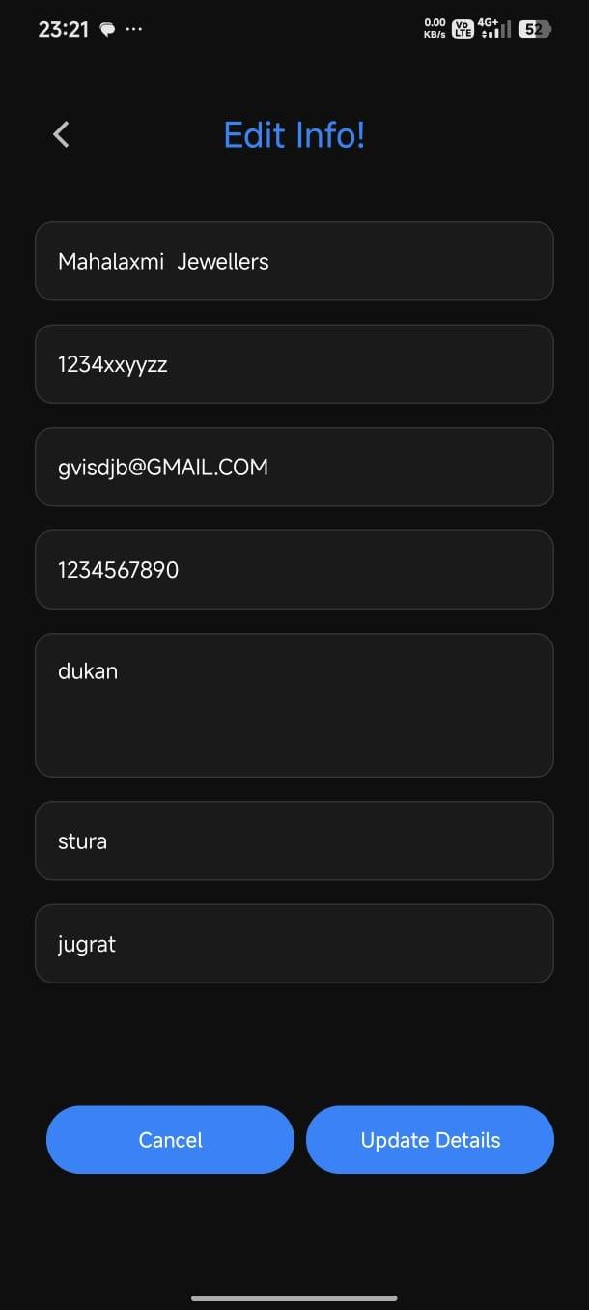  Edit Info

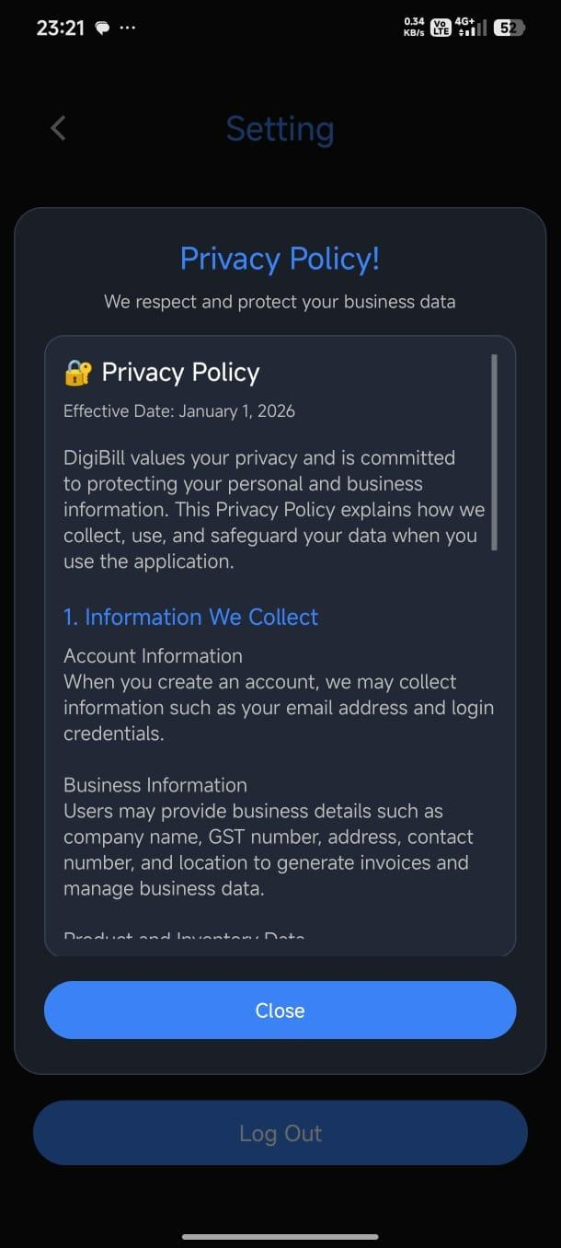  Privacy Policy Page | 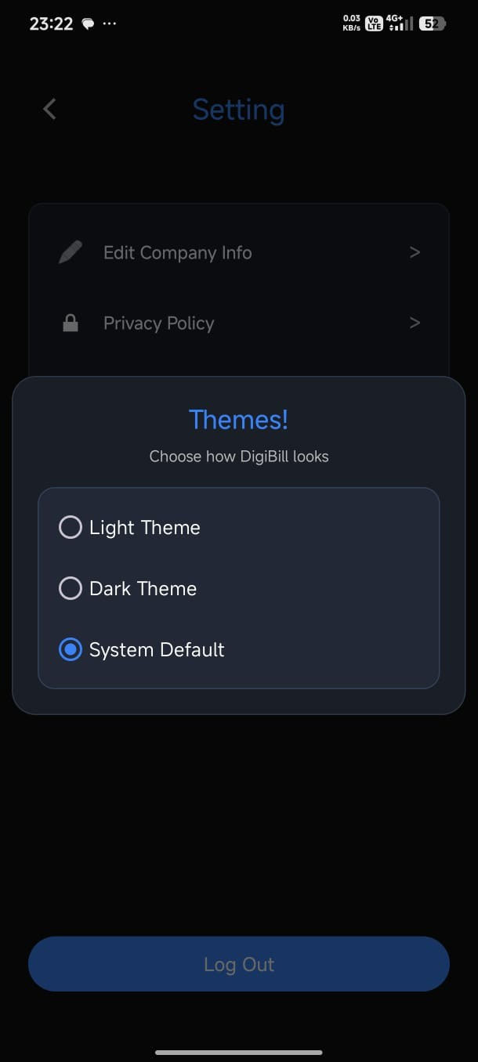  Themes Page

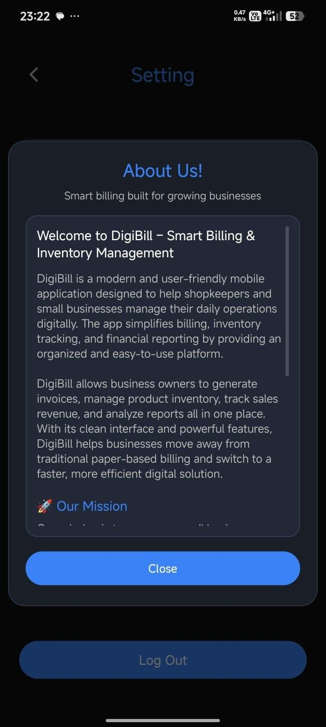  About Us | 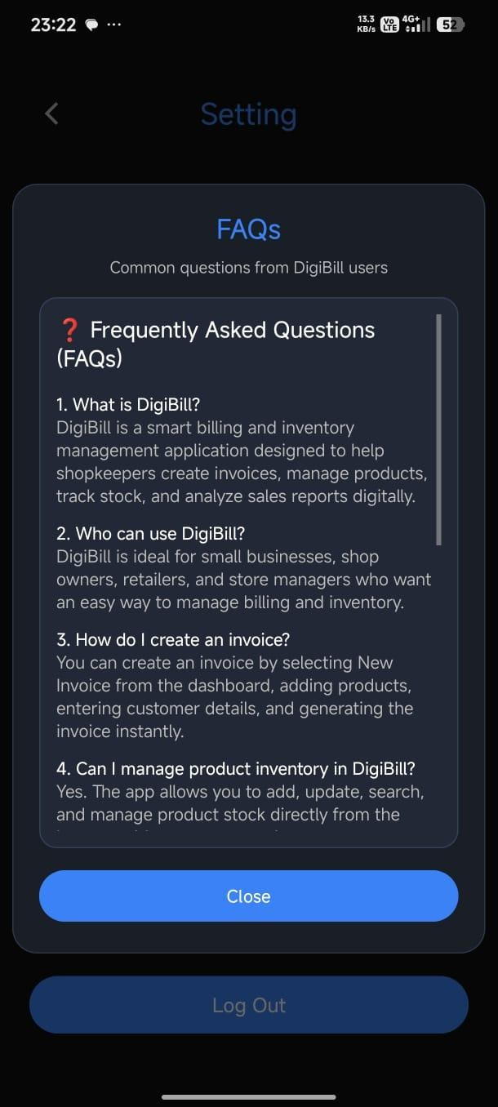  FAQ’s

FUTURE
ENHANCEMENTS

- Future Enhancements

  - Advanced Analytics Dashboard:
    - Add graphical reports such as charts and graphs to visualize sales trends, profit analysis, and product performance.
  - Multi-Language Support:
    - Enable the application to support multiple languages so that shopkeepers from different regions can use it easily.
  - Cloud Backup & Sync:
    - Implement automatic cloud backup and synchronization to prevent data loss and allow access from multiple devices.
  - Payment Integration:
    - Integrate online payment methods such as UPI, credit/debit cards, and wallets for seamless transactions.
  - Real-Time Notifications:
    - Provide push notifications or SMS alerts for invoice generation, low stock alerts, and important updates.
  - Customer Management System:
    - Maintain detailed customer records and provide personalized offers or billing history tracking.
  - Offline Mode Enhancement:
    - Improve offline functionality so that invoices can be created without internet and synced later.
  - AI-Based Sales Prediction:
    - Use AI/ML to predict future sales trends and suggest stock management strategies.

BIBLIOGRAPHY/ REFERENCES

- Bibliography/ References
- Kotlin Documentation: Kotlin Programming Language. Retrieved from https://kotlinlang.org/docs/home.html
- Android Developers Documentation: Android App Development Guide. Retrieved from https://developer.android.com/
- Firebase Documentation: Firebase Platform and Services. Retrieved from https://firebase.google.com/docs
- Firebase Firestore Documentation: Cloud Firestore Database. Retrieved from https://firebase.google.com/docs/firestore
- Firebase Authentication Documentation: User Authentication Services. Retrieved from https://firebase.google.com/docs/auth
- Google ML Kit Documentation: Barcode Scanning API. Retrieved from https://developers.google.com/ml-kit
- Material Design Documentation: UI/UX Design Guidelines. Retrieved from https://material.io/design

SYSTEM TESTING

- Testing Strategy
- Unit Testing:
Testing individual components in isolation, including invoice calculation logic (GST and total amount), product management functions (add, update, delete), barcode scanning functionality, and Firebase operations to ensure each module works correctly.
- Integration Testing:
Verifying that interconnected components work together properly, focusing on complete workflows such as creating a new invoice, adding products (via scan/search), saving invoice data to Firebase, and updating reports and taxation modules.
- Functional Testing:
Ensuring all system features meet requirements, testing invoice creation, product scanning and searching, inventory management, report generation, recent invoice display, and taxation calculations.
- Security Testing:
Validating secure authentication using Firebase, ensuring proper data protection, input validation, and preventing unauthorized access to invoices, products, and user data.
- User Acceptance Testing:
Confirming the system meets actual user needs through real-world scenarios, such as shopkeepers generating invoices, managing products, viewing reports, and handling daily billing operations.
- Performance Testing:
Assessing application responsiveness under various conditions, including handling large product datasets, fast invoice generation, barcode scanning speed, and efficient Firebase data retrieval.

- System Testing

