Rooted in Community, Empowering the Future | MGenius Academy Shines at the Wellesley Chinese American Network Picnic
Under bright, sunny skies, the Wellesley Chinese American Network (WECAN) neighborhood family food and social picnic was a great success. As the Premier Platinum Title Sponsor of the food competition, MGenius Academy (MGA) gave the event its full support, demonstrating a deep commitment to local community building and family engagement.
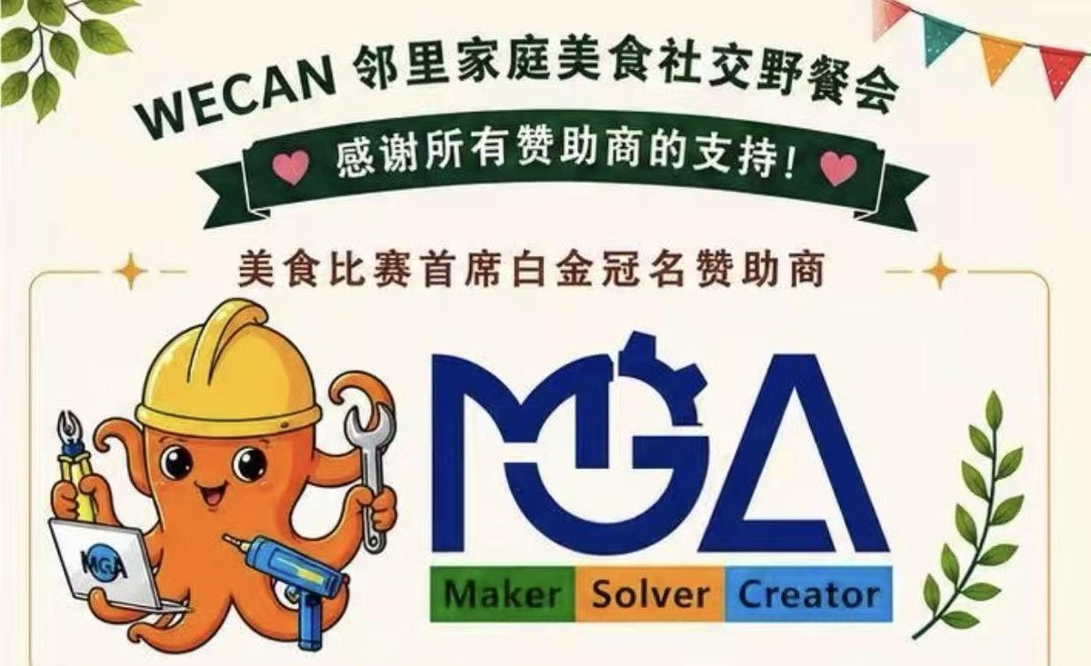
The atmosphere on site was lively and warm. MGA set up a dedicated booth to showcase the unique appeal of maker technology and STEAM education to parents and children. In addition to offering a wealth of program materials and lovely small gifts, team representatives engaged warmly with community families, answered questions, and presented awards to the winners of the food competition on site — sharing a fulfilling and delightful weekend with everyone.
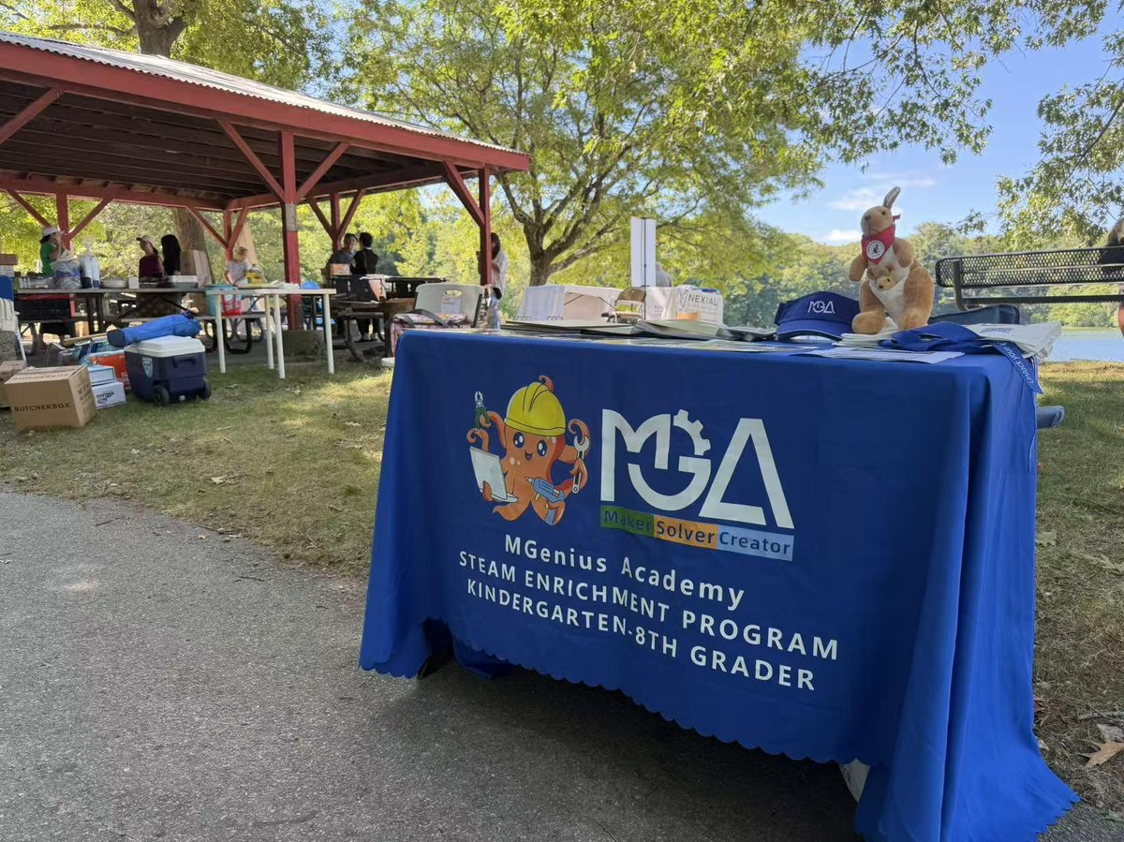 | 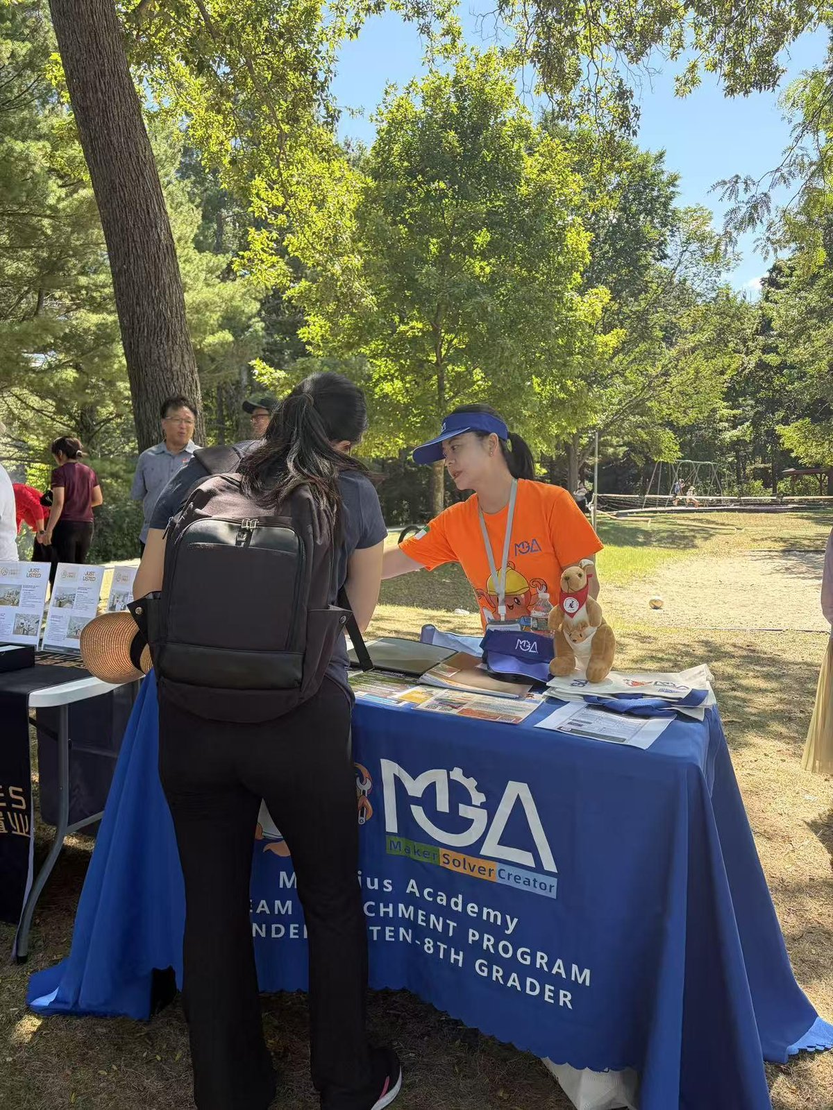

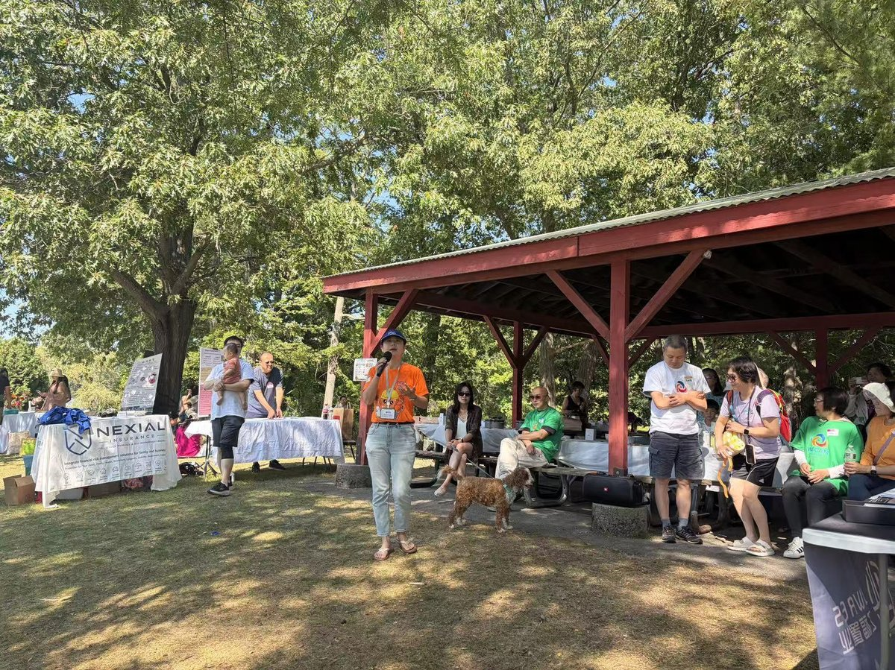 | 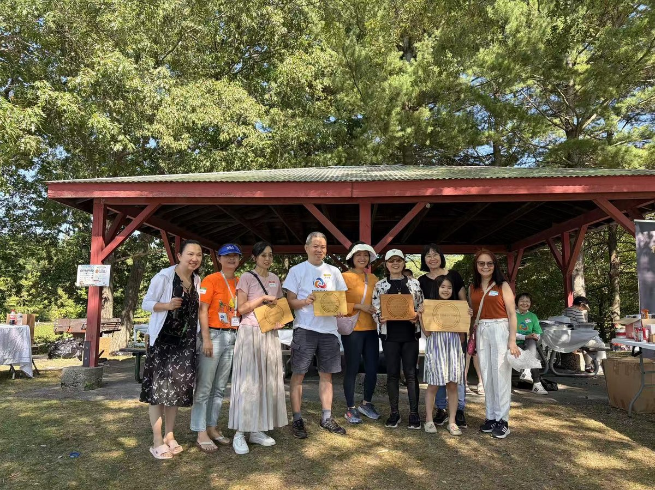

Meanwhile, MGA also joined forces with Shadow Joy Lab to present a shadow puppet performance and cultural experience at the Wellesley Free Library, blending the interplay of light and shadow. The event seamlessly fused modern technology with the aesthetics of traditional folk art, and was warmly received by readers and families in attendance.
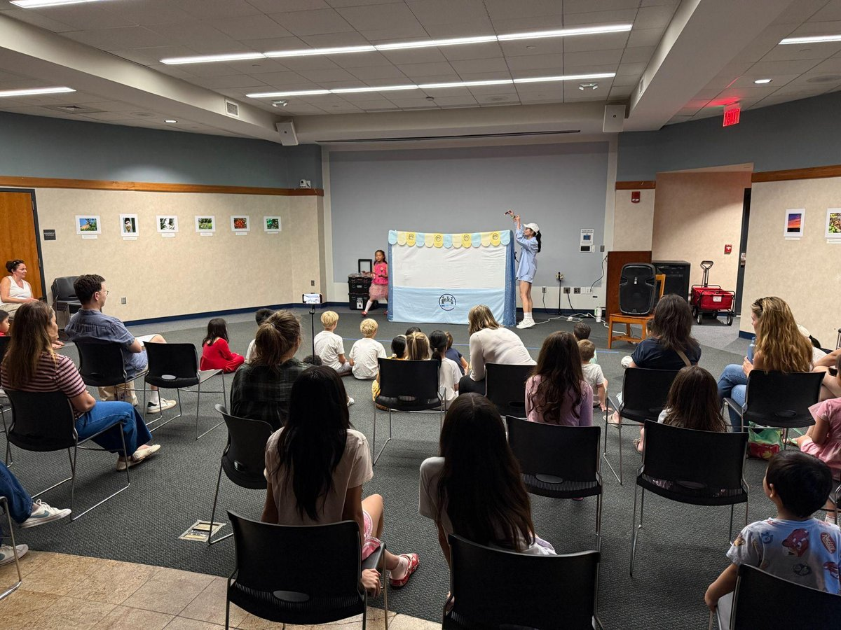
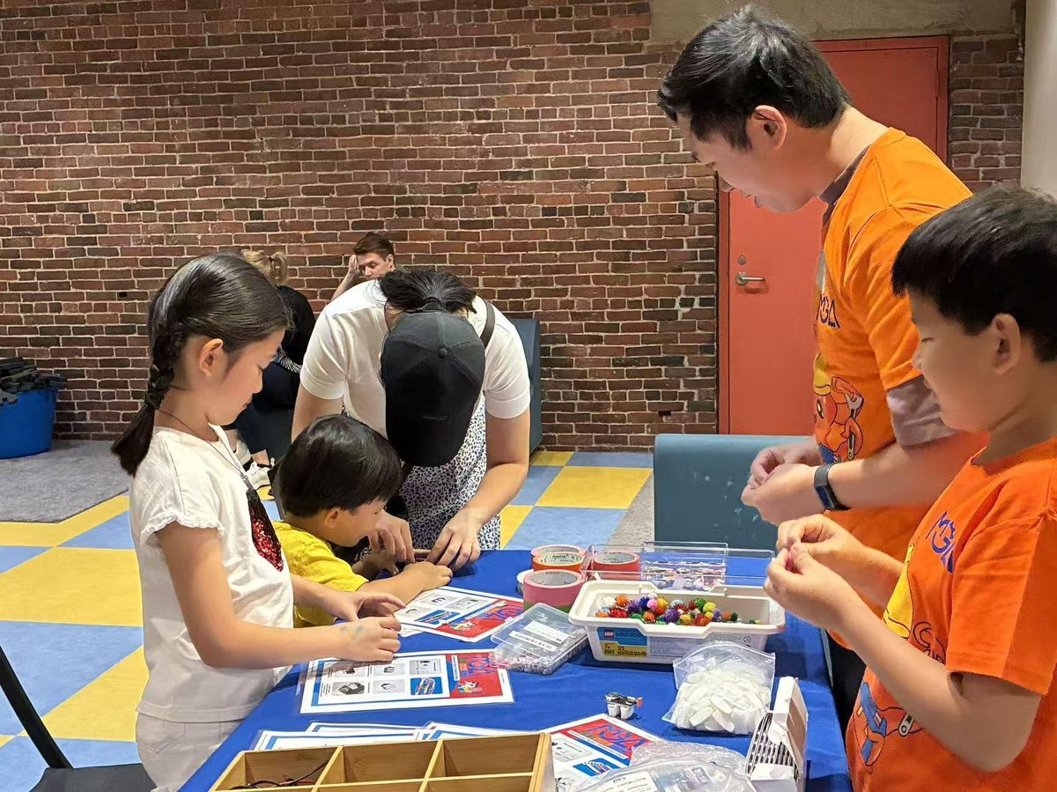 | 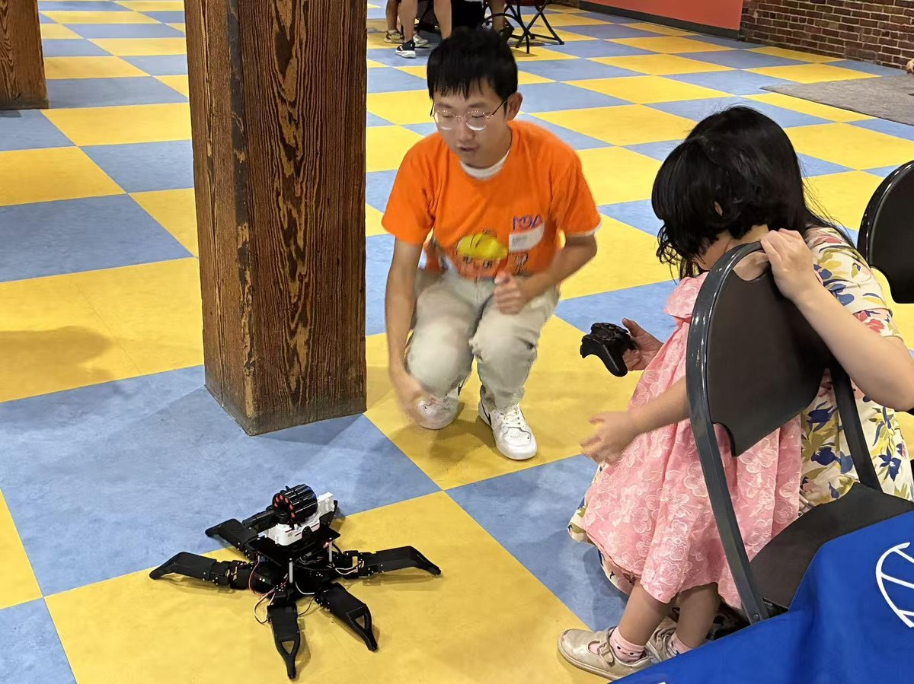

Building on its standout appearance in early August at the CreatedBy Festival, the flagship maker event hosted by the Boston Children's Museum, MGA is moving forward one solid step at a time, promoting traditional culture and the maker spirit on a broad public stage through education that is as fun as it is enriching.
As a locally rooted, future-oriented educational institution, MGA has always upheld its “Maker, Solver, Creator” philosophy, placing social responsibility and community service at the core of its mission. In the weeks ahead, MGA's community outreach will continue to expand:
- September 20: Invited to participate in Newtonville Village Day, bringing quality STEAM education resources and hands-on experiences to more families in the Newton community.
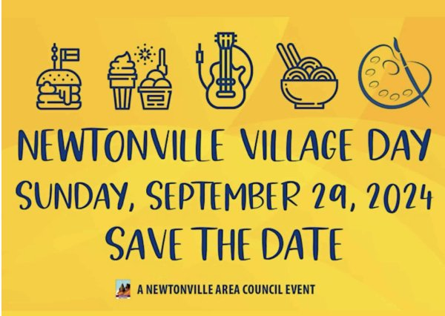
- October 4: Invited to exhibit at the Cambridge Science Carnival hosted by MIT. At this top-tier science event — known for its extremely rigorous, high-bar selection of exhibitors and projects — MGA will showcase students' innovative work and the spirit of science and technology education, engaging in deep dialogue with the world's leading scientific community!
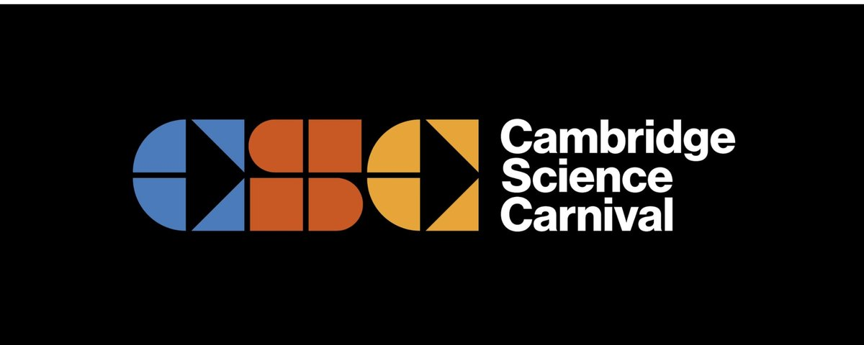
MGA will continue to actively take part in charitable and community-building activities, empowering the next generation through concrete action and working hand in hand with the community to create a brighter future!

