Unsupervised-Learning

K-Means Clustering
K-Means is an unsupervised machine learning algorithm used for clustering similar data points into K groups. It works by minimizing the variance within each cluster.

2. How K-Means Works
- Choose the number of clusters (K).
- Initialize K centroids randomly within the dataset.
- Assign each data point to the nearest centroid using Euclidean distance:
D = ( x 2 − x 1 ) 2 + ( y 2 − y 1 ) 2
where xᵢ and yᵢ are the coordinates of two points.
- Recalculate the centroids as the mean of all points assigned to that cluster.
- Repeat steps 3 and 4 until centroids stop changing or a maximum number of iterations is reached.
Mathematical formula
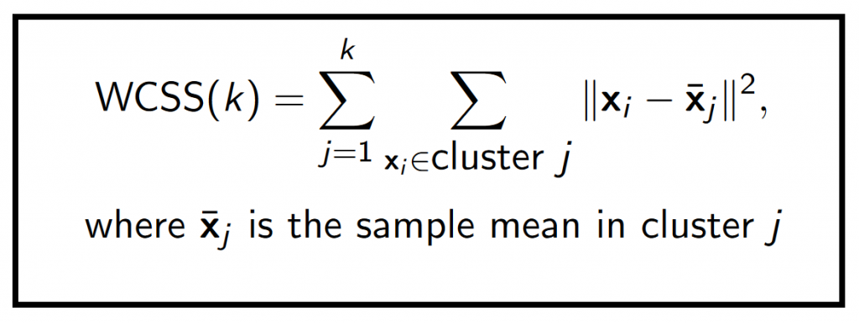
The goal is to minimize the Within-Cluster Sum of Squares (WCSS)

4. Selecting the Optimal K
Choosing the right K is crucial for meaningful clustering. Common techniques include:
- Elbow Method: Plot WCSS vs. K and choose the point where WCSS starts decreasing slowly.
- Silhouette Score: Measures how well-separated clusters are, with higher values indicating better clustering.

K-Medoids Clustering:
K-Medoids is an unsupervised clustering algorithm that works similarly to K-Means but is more robust to outliers and noise. Instead of using centroids (mean points) like K-Means, it selects actual data points (medoids) as cluster centers.
How K-Medoids Works (Ajenda is to reduce the cost(Total distance))
- Initialize K Medoids randomly from the dataset.
- Assign each point to the nearest medoid based on Manhattan distance or another distance metric.
|x1 - x2| + |y1 - y2|
- Swap and update medoids:
  - Select a non-medoid point and swap it with the current medoid if it reduces the total distance (sum of dissimilarities).
- Repeat the assignment and update steps until no further improvement occurs.
Difference btw K-means & K-Medoids
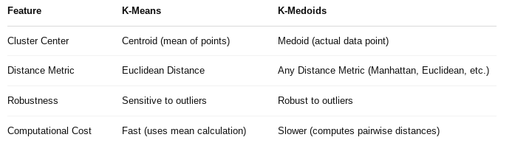
Choosing Optimal K in K-Medoids
Similar to K-Means, the Elbow Method can be used by plotting the sum of dissimilarities vs. K.
Analysis of Clustering Results
The medoids (red points) represent real observations in the dataset, making the model less affected by extreme values.
Compared to K-Means, the clusters may be more stable and better suited for non-convex data distributions.

Hierarchical Clustering
Hierarchical clustering is a clustering technique that builds a tree-like structure of clusters (dendrogram). It is useful when the number of clusters is unknown or when the data has a natural hierarchy.
Types of Hierarchical Clustering

Agglomerative (Bottom-Up Approach)
Starts with each data point as its own cluster.
Merges the closest clusters iteratively until one cluster remains.
Uses linkage methods (single, complete, average, ward).
Divisive (Top-Down Approach)
Starts with one cluster containing all data points.
Splits clusters iteratively until each point is its own cluster.
Less common than agglomerative.

Steps in Agglomerative Clustering
Compute the distance matrix (Euclidean, Manhattan, etc.).
Create clusters based on linkage criteria:
Single Linkage → Closest point between clusters.
Complete Linkage → Farthest point between clusters.
Average Linkage → Mean distance between clusters.
Ward’s Method → Minimizes variance within clusters.
Merge clusters iteratively.
Cut the dendrogram at an optimal point to form clusters.

How to Choose the Number of Clusters
Dendrogram Cut-Off
Cut at a significant jump in distance.
The number of vertical lines cut gives the number of clusters.
Silhouette Score
Higher silhouette score = better clustering.
Elbow Method (for hierarchical clustering)
Plot the distances in the dendrogram.
Look for a point where the distance increases sharply.

DBSCAN Clustering
DBSCAN (Density-Based Spatial Clustering of Applications with Noise) is a clustering algorithm that groups dense regions of data points and labels scattered points as outliers.

Key Concepts
Core Points: Have enough nearby points (min_samples within eps).
Border Points: Close to a core point but don’t have enough neighbors.
Noise Points: Not part of any cluster.

How DBSCAN Works?
Pick a random point.
Check if it has at least min_samples points within eps.
Yes? → It’s a core point → Expand the cluster.
No? → Mark it as noise (may change later).
Repeat until all points are processed.

Advantages
No need to specify clusters (k).
Can detect irregularly shaped clusters.
Identifies outliers automatically.

Limitations
Struggles with varying densities.
Choosing eps and min_samples can be tricky.
Doesn’t work well in high dimensions.

When to Use DBSCAN?
You don’t know the number of clusters.
Clusters have irregular shapes.
You want to detect outliers.

Principal Component Analysis (PCA)
Principal Component Analysis (PCA) is a dimensionality reduction technique used in machine learning to transform high-dimensional data into a lower-dimensional space while preserving as much variance as possible.

Key Concepts of PCA:
- Standardization – Ensuring all features are on the same scale.
- Covariance Matrix Computation – Finding relationships between features.
- Eigenvalues and Eigenvectors – Identifying the principal components.
- Selecting Principal Components – Choosing the top components based on explained variance.
- Projecting Data – Transforming the original dataset into the new lower-dimensional space.
Reinforcement Learning (RL)
Reinforcement Learning (RL) is a type of machine learning where an agent learns to make decisions by interacting with an environment to maximize rewards.
Unlike supervised learning, where the model learns from labeled data, RL learns from trial and error by receiving rewards or penalties based on its actions.

Key Components of RL
Component | Description
Agent | The decision-maker (e.g., a robot, self-driving car, or chess AI).
Environment | The world in which the agent operates (e.g., a chessboard, a traffic system).
State (S) | The current situation of the agent in the environment.
Action (A) | Choices the agent can make at each state.
Reward (R) | The feedback (positive or negative) received after taking an action.
Policy (π) | The strategy that the agent follows to choose actions.
Value Function | Estimates the long-term reward for being in a state.
Q-Learning
Q-Learning is a model-free, value-based reinforcement learning algorithm used for finding the optimal action-selection policy using a Q-table.
How Q-Learning Works
Q-Learning helps an agent learn the best actions to take in a given state by iteratively updating a table called the Q-table.
Key Equation (Q-Update Rule)
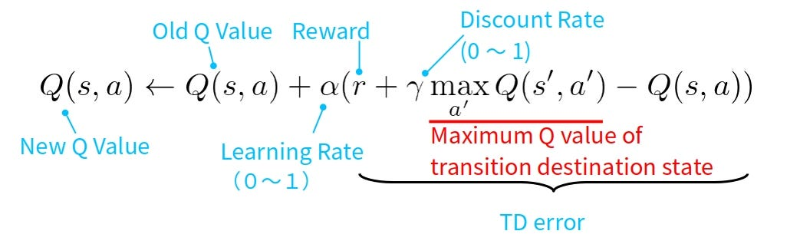
Steps in Q-Learning

Initialize Q-table with all zeros (states × actions).
Choose an action using an exploration strategy (e.g., ε-greedy).
Take the action and observe the reward and new state.
Update Q-table using the Q-learning equation.
Repeat until convergence or a stopping condition is met.

Exploration vs Exploitation
Exploration: Trying new actions to discover better rewards.
Exploitation: Using known actions that yield the best rewards.
ε-Greedy Strategy:
- With probability ε, explore random actions.
- With probability 1-ε, exploit the best-known action.
Example Use Case – Grid World
Imagine an agent in a 4×4 grid trying to reach a goal (bottom-right) while avoiding obstacles.
- States: Grid positions (e.g., (0,0), (1,2))
- Actions: Move up, down, left, right
- Rewards:
  - +10 for reaching the goal
  - -1 for hitting obstacles
  - 0 for other moves
By applying Q-Learning, the agent learns the optimal path to the goal while avoiding penalties.
Examples of Reinforcement Learners:
- Game Playing (e.g., Pac-Man, Chess): agent learns moves to win the game through rewards and penalties.
- Self-Driving Cars: learns to drive safely by receiving rewards for staying on the road and penalties for accidents.
- Stock Trading Bots: learns to buy/sell stocks to maximize profit based on market trends.
- Robot Navigation: learns the shortest path in a maze by trial and error.
- Ad Recommendation Systems: learns which ads users are more likely to click on to maximize engagement.

supervised-Learning
Supervised learning is all about learning from labeled data.
You give the algorithm:
- Input features (X)
- Target labels (y)
The model learns the mapping from inputs to outputs and uses that to predict unseen data.

Two Types:
Regression,Classification

Ridge, Lasso, and Elastic Net
Technique | What It Does | Use Case
Ridge | Adds L2 penalty (squares of coefficients) to reduce model complexity. It shrinks coefficients but doesn't make them zero. | When all features matter, we want to avoid overfitting.
Lasso | Adds L1 penalty (absolute values of coefficients). It can shrink some coefficients to zero – useful for feature selection. | When you want a simpler model with fewer variables.
Elastic Net | Combines L1 + L2 penalties. It balances Ridge and Lasso. | When data has many features, some of which are correlated.

Important Parameters:
- alpha: Overall strength of regularization.
- l1_ratio: How much to mix L1 and L2 regularization:
  - l1_ratio = 1: behaves like Lasso
  - l1_ratio = 0: behaves like Ridge
  - l1_ratio = 0.5: mix of both (balanced)
Support Vector Machine (SVM)
is a supervised machine learning algorithm that can be used for classification or regression tasks. It works by finding the optimal hyperplane that best separates the data into classes.

🔸 Core Concepts:
Term | Meaning
Hyperplane | A decision boundary that separates different classes. In 2D, it’s a line. In 3D, a plane.
Support Vectors | Data points closest to the hyperplane. These are the most critical elements of the training set.
Margin | The distance between the hyperplane and the support vectors. SVM maximizes this margin.
Kernel Trick | Transforms non-linearly separable data into higher dimensions to make it separable.
Soft Margin | Allows some misclassifications in exchange for a better overall decision boundary.
C (Regularization Parameter) | Controls trade-off between achieving a low error on the training data and minimizing model complexity.
Gamma (for RBF Kernel) | Defines how far the influence of a single training example reaches. High gamma means closer reach, low gamma means far.

🔸 Types of Kernels
Kernel | Use-case
Linear | When data is linearly separable
Polynomial | When relationships are polynomial in nature
RBF (Gaussian) | Works well when there's no clear linear boundary
Sigmoid | Used in neural networks (less common in SVM)

K-Nearest Neighbors
is a supervised learning algorithm used for both classification and regression.
- It does not learn any model during training.
- It memorizes the data and predicts the output for a new sample by checking the K nearest data points (based on distance, usually Euclidean).
- The prediction is made by majority vote (classification) or average (regression).
Logistic Regression
is a supervised learning algorithm used to predict categorical outcomes — especially binary outcomes (like 0/1, True/False, Spam/Ham, etc.).
It predicts the probability of a class label using the sigmoid function.
