DCD Design System: UI Kit Review

This review of the assembled components created for use in the DCD Design System is done from the perspective of an external designer/developer who would want to implement all or some of the components from the UI Kit. A great deal of high-quality work has gone into the components and documentation of the Design System. It is a comprehensive UI Kit that the DCD and its contributors can be proud of. Thanks to the talent and energy of multiple contributors, a professional-grade Design System is coming to fruition. Because there are multiple contributors due to budget & staffing related challenges over a protracted period, some unexpected dissonance permeates the technical structure of the vector files, the visual harmony, and overall visual consistency of the Design System UI Kit. By making suggestions that could clear up dissonance, this review aims to help the team achieve their goal of supplying a credible, world-class Design System that is comparable to the ones upheld as industry standard.

The UI Kit file: “design_system_ui_kit.ai” was opened in Adobe Illustrator and reviewed for:

* **Technical file structure**   
  Grouping, management and identification of layers and layer groups as well as using artboards as a means of organization can significantly assist external designers and developers. A well-organized source file can improve user satisfaction and encourage continued adoption while preventing re-interpretation errors. Also, rendering techniques of custom font libraries and embedding custom visuals ensures the devices are accessible to external designers using the *.ai file, reducing compatibility errors, and ensuring DS integrity is maintained from the start.
* **Visual harmony and consistency**  
  Visual composition, balance, padding, spacing, proximity to other visual devices, horizontal & vertical alignment, justification (left, centred, right etc.) line weight, outline use & stroke alignment, corner radii, typography, leading & kerning to be reviewed for consistency with (<https://gctools-outilsgc.gitbook.io/-gcdigital-design-system>) & suggestions made
* **Compliance with Mood Board**Are the colours derived from the Mood board being put to use in alignment with the expected perception, and intended function as recommended in the report.   
  (<https://github.com/gctools-outilsgc/design-system/blob/master/Mood%20Boards/mood%20board_clean%20and%20colourful.png>)

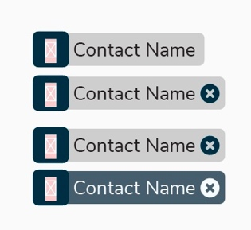**Technical File Structure Suggestions**

* **Font Awesome errors**  
  Font Awesome v04 & v05 is in use by the design team. External designers opening the file on their local system get a broken linked image error message as well as a blank box where the icon should be.
  + Recommend converting the Font Awesome icons to vector outline before adding to design_system_ui_kit.ai as final art
* **Linked Raster Image errors**External designers opening the file on their local system get a broken linked image error message and a blank box instead of the image.
  + Recommend selecting “embed” function when placing a raster image (GC Tool icons/thumbnail images/other raster images) into any *.ai file.
  + 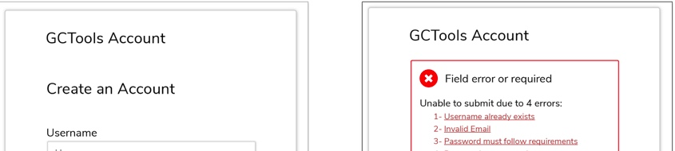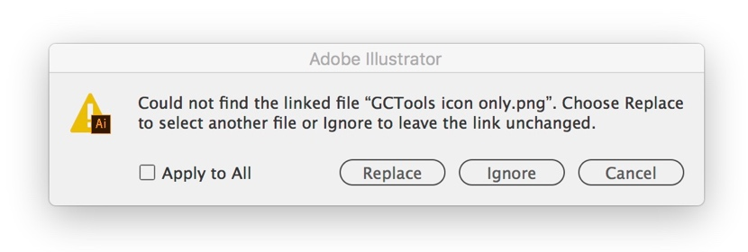Recommend using a vector version of any GC Tools icon (or future branding) in any *.ai file instead of a placed raster image
* **Artboards, layer group names and layer naming and locking**  
  Since there are numerous visual elements being documented as components derived from numerous individual *.ai files in the overall design_system_ui_kit.ai, it can be difficult for external designers to be confident they are selecting all the correct vector layers and sublayers of a specific visual element that are in use per component.   
    
  Also, ensuring that Layer groups that comprise a UI component consist of only the visual elements designed for that component set can reduce the occurrences where the wrong vector layer is grabbed/selected and copied. This helps external designers grab only what they need with one click instead of accidentally selecting the wrong elements nested in a constrained selection.
  + Recommend a breaking out each titled component into its own artboard
  + For a specific component artboard, visual elements are nested in named layer groups, so that for example a button square, the number within and its associated label and possible stroked background frame is grouped together and named.
  + Once a collection of labelled groups are collected, they are further nested in an overall layer that describes their use.
  + Ensure that the grey background that is used to emphasize the UI components in the foreground is locked and placed on the lowest layer possible. Depending on the individual designer’s Illustrator preferences it gets grabbed 1st, instead of the component, or 3 layers of a component are grabbed, and then the background, since it was nested amongst the UI visual elements.
* **Button build structure**The vector structure of the buttons viewed in the UI Kit appear to be built in layers where the text is then placed ‘by eye’, left justified in its own layer. As a design draft, this technique is acceptable. However, this technique can create inconsistencies, leaving button shape size and text placement open to interpretation or error when being transferred into a new composition.
  + Recommend converting buttons to shaped text boxes. A step-by-step tutorial can be provided.
  + -OR- Recommend converting button text to outlines and locking the two layers together as a group in final art

**Visual Harmony & Consistency Suggestions**

* **Button height, length & width irregularities and padding around button text**  
  Some buttons feature less padding than others, and inconsistent use of padding, height and width. The specified height is minimum 10mm, with 15px padding around the button, but there is no mention of a maximum height and padding between text within a button and its perimeter. (<https://gctools-outilsgc.gitbook.io/-gcdigital-design-system/buttons>). For the UI Kit file, it would be preferable if all buttons were the same height and an established range of widths (3 variations), so external users are absolutely certain that the assets they are composing an experience with are fundamentally consistent.
  + re-establishing consistent padding between button text and button perimeter for all buttons. Build a default button and re-use (see tutorial)
  + Recommend using either px or mm for dimension specifications throughout the UI Kit. Currently a combination of mm & px dimensions are used creating some leeway for misinterpretation
  + Recommend converting button to text shape where button text is centred, This allows the button perimeter to scale consistently & proportionately in accordance with changes to the text content. A step-by-step tutorial can be provided. The technique can also prevent ‘eyeballing’ of text within a shape.
  + Recommend

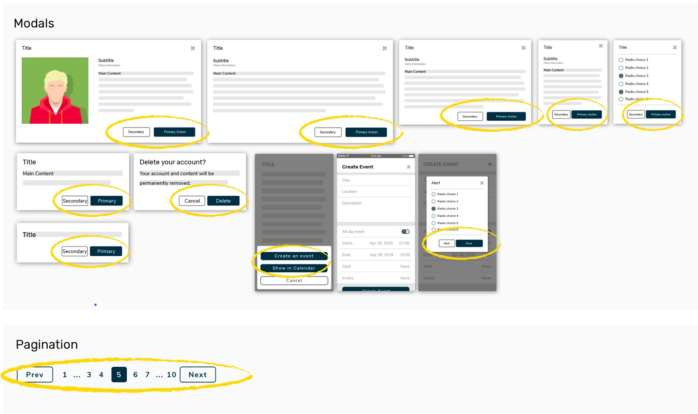**Screen shot showing a variety of button dimensions, button text tracking (spacing) and padding:**

**Screen shot showing at of button at 10mm, and highlighted button is 14.11mm or 40px.**

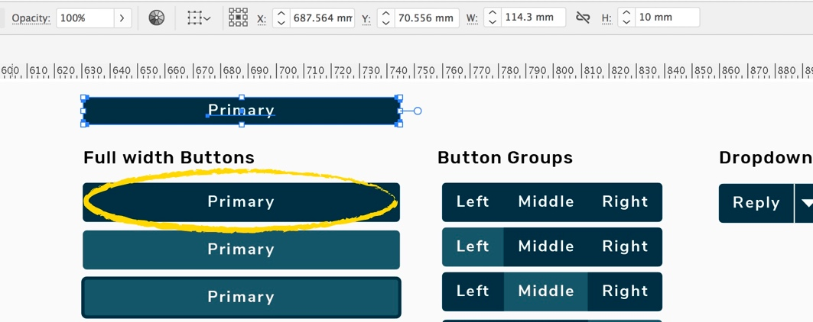

* **Button text tracking (spacing)**  
  The button text appears to have slightly exaggerated spacing between letters eventhough it is set to its default. This may be done for accessibility purposes, however because of the typeface chosen, the text becomes slightly harder to read at-a-glance making ‘Secondary’ appear more like ‘S e c o n d a r y’.
  + Recommend tighter tracking
* **Nunito button text tracking vs. Rubik text list tracking**Nunito button text tracking appears to have exaggerated spacing between letters, eventhough it is set to its default. The tracking used for Rubik text lists and text fields appears to be set to normal as well, however Rubik’s tracking appears to be natural, whereas Nunito looks exaggerated.
  + Recommend Slightly reduced tracking on Nunito button text instances

**Visual Harmony & Consistency Suggestions**