**EXPERIMENT-2**

**AIM : TO Write SQL queries to MANIPULATE TABLES for various databases using DML commands(i.e. INSERT, SELECT, UPDATE, DELETE,).**

**Creating table :**

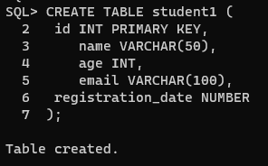

**INSERT COMMAND:**

**It is used to add values to a table.**

**SYNTAX:**

**INSERT INTO tablename**

**VALUES (value1,value2,...,valuen);**

**INSERT INTO tablename (column1, column2,...,column)**

**VALUES (value1, value2,...,valuen);**

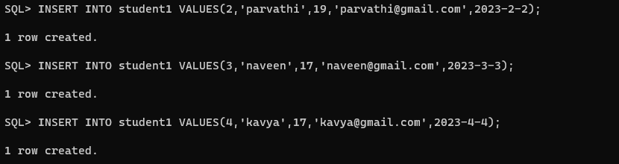

**SELECT COMMAND:**

**The SELECT command used to list the contents of a table.**

**SYNTAX:**

**Select * from table_name;**

**Select col_name from table_name;**

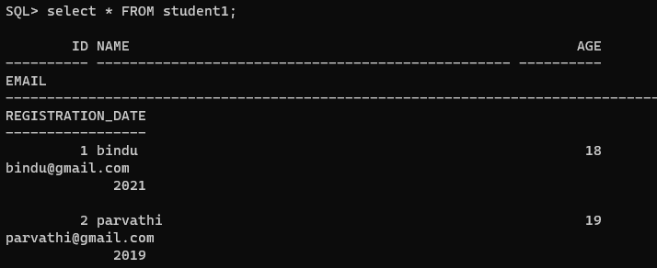

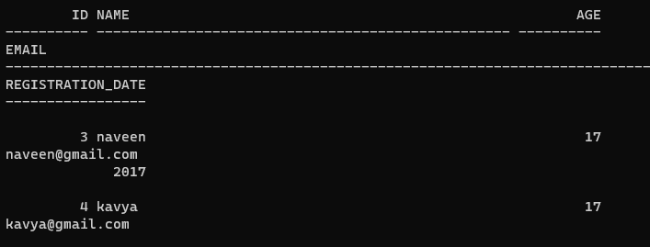

**UPDATE COMMAND:**

**The update command used to modify the contents of specified table.**

**SYNTAX:**

**UPDATE tablename**

**SET column_name = value[,**

**Column_name = value ]**

**[ WHERE condition_lsit ];**

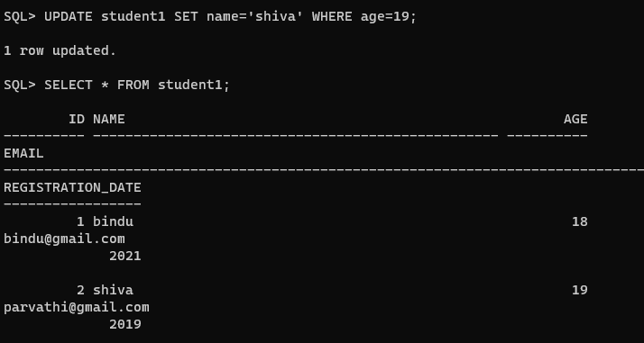

**DELETE COMMAND:**

**To delete all rows or specified rows in a table.**

**SYNTAX:**

**DELETE FROM tablename [ WHERE condition_list];**

