**Cover Page**

**COMPSCI 345 / SOFTENG 350 Human-Computer Interaction**

**Assignment Three: Realizing a Design**

**Student Name:** Max Griffith

**Student ID: 932743455**

**Student UPI: mgri334**

____________________________________________________________________

Note: To ensure a fair playing field for all students in the class the University of Auckland will not tolerate cheating or assisting others to cheat, and views cheating in coursework as a serious academic offence.

Student Declaration:

* I declare that this work is my own work and reflects my own learning.
* I declare that where work from other sources (including sources on the world-wide web) has been used, it has been properly acknowledged and referenced.
* I understand that my assessed work may be reviewed against electronic source material using computerised detection mechanisms.

Place this page in the front as the first page of your document that you are submitting to Canvas

Baroque Buddy Walkthrough

For this assignment, I chose to prototype the Baroque architecture education tool, Baroque Buddy, specialising in case study activities (problem-based learning activity #1 from Assignment 2). The task starts with the student reading the case brief, followed by answering teacher-submitted questions on the Baroque architecture case study. Lastly, after the task deadline arrives and the teacher enables it, students can review answers given by their peers through comment feedback. Users are also able to send and receive messages to fellow students and teachers.

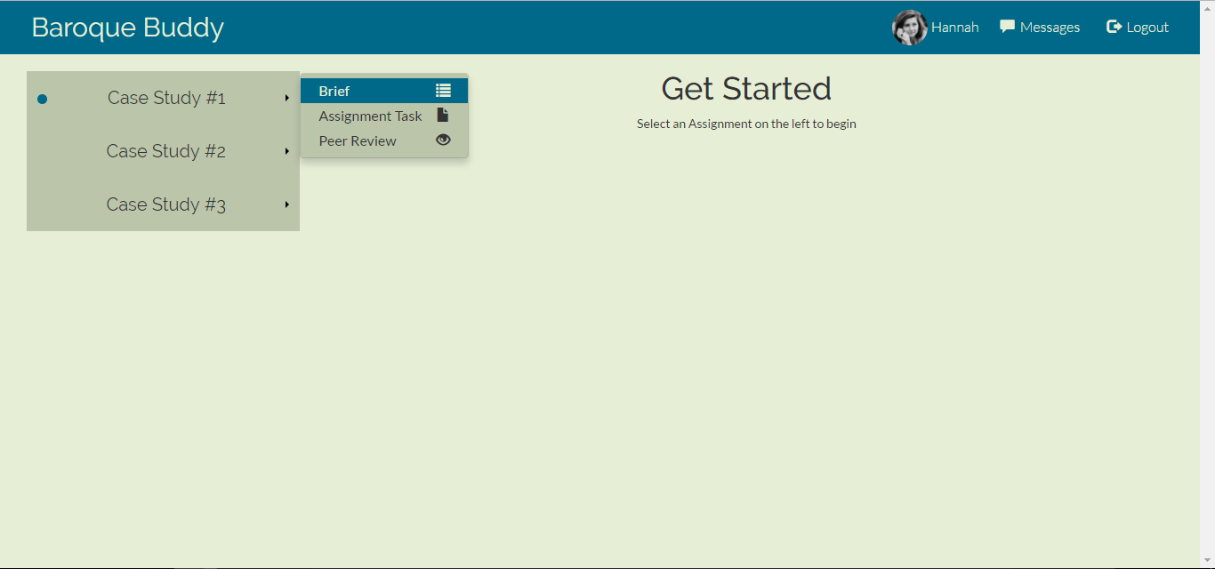After logging in (not implemented), the user starts at the welcome screen where they are able to access all available assignments via the left-side banner. A small blue circle indicates the teacher has enabled a new task to complete (e.g. Peer review enabled). Once an assignment is selected (see below with Case Study #1) the user can navigate to one of the three pages associated with that Case Study. The user can also navigate to the message page or log out at any time via the navbar in the top right of the page.

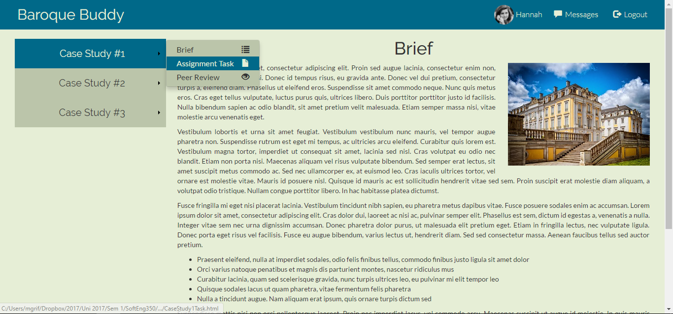Once at the Brief page, the user can read up on assignment details and perform research on their assignment topic via the external links provided (not pictured). It is expected of the teacher to write up the brief for their students and publish it to the site. Take note that the Case Study #1 button on the left-side banner is now highlighted, reinforcing which assignment is currently in use.

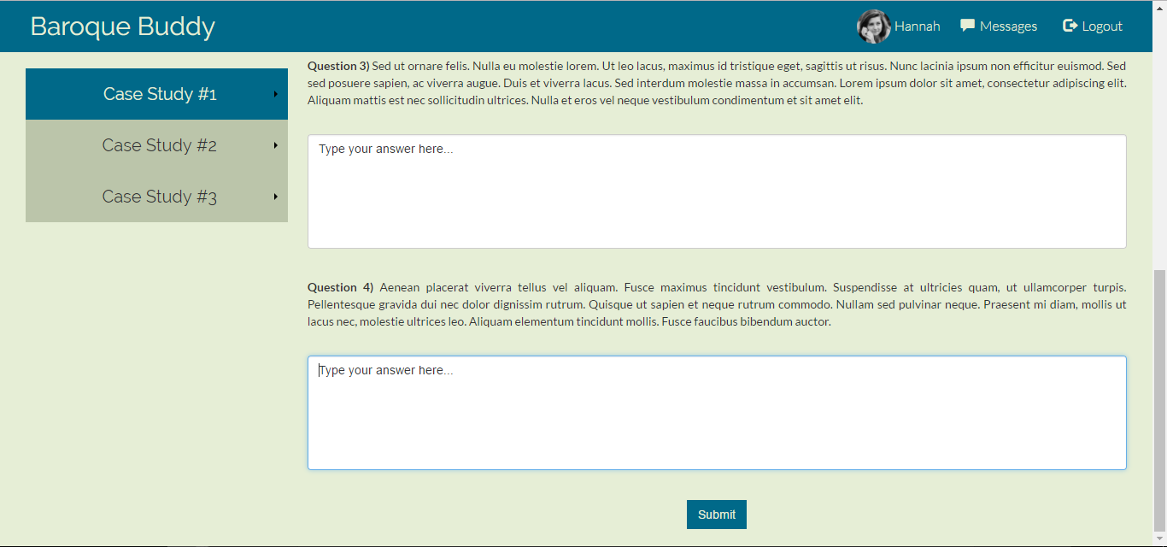At the Assignment Task page, students are given a set of 4 questions to answer based on the case study and their ideas on Baroque architecture. Once they are satisfied with their answers they can click the submit button at the bottom of the page (pictured) to send them to be marked and peer reviewed. A confirmation modal will appear to confirm the submission once the answers have been submitted.

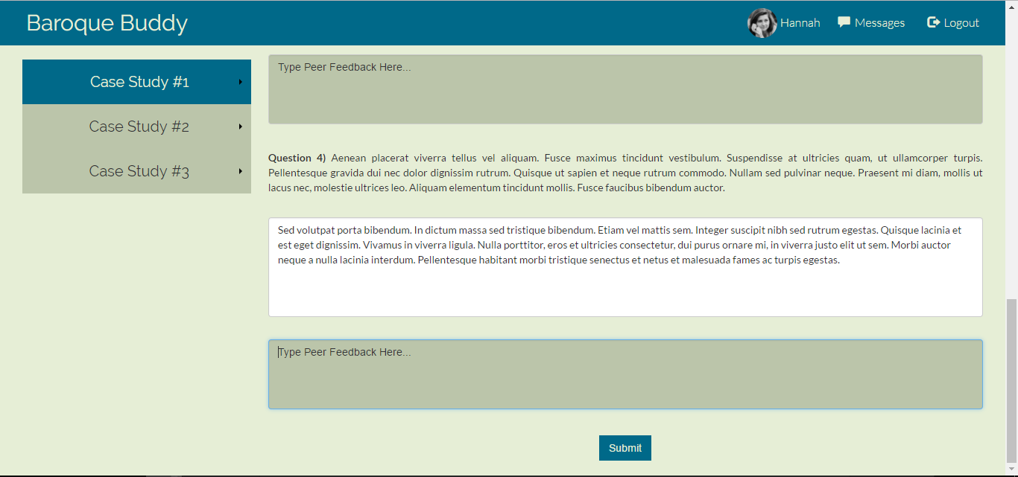At the Peer Review page, student will receive a set of answers from a randomly selected peer, along with the original questions for recollection. From here, the reviewing student can read the submitted answers and write their feedback responses in the comment boxes below each answer. Once every answer has an adequate response, the user can submit their feedback in a similar fashion to the assignment task. After clicking the submit button at the bottom, a confirmation modal will appear like before.

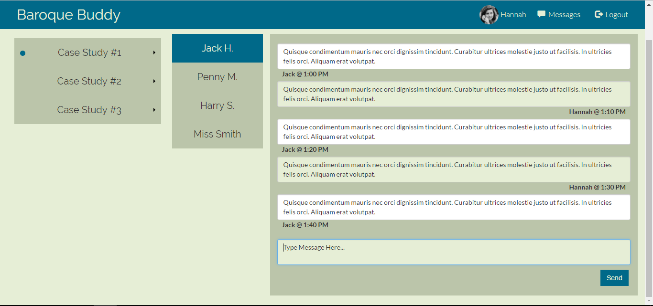At the messages page, the user can select conversations with fellow Baroque Buddy users. Received messages are displayed, with the time they were sent and who sent them. To help distinguish between messages, received messages are white and sent messages are grey. To send a message, the user must type in the bottom-most box and click the send button.

Out of Scope

Expected features that aren’t implemented

-Notification circle on the navbar message icon for any recently received messages

-Cookies to save assignment progress when navigating between pages or when a session ends

-An account settings page accessed via the user profile in the navbar, to change authentication details, settings, etc.

-Logout confirmation. Currently it restarts the tool to the welcome page

-Rich text editors to format comments with different font styles and embedded images

-Same as above with messaging service

UI-implemented with incomplete functionality

Though there are buttons for Case Studies #2 and #3, I did not implement any assignment pages as they would have an identical design to Case Study #1. This is the same for 3 of the 4 users on the Messages page since one implementation demonstrates the entire page’s concept.

In addition, the notification circle isn’t currently removed when the user initially accesses the assignment since it is just a demonstration of how users can identify new assignment content.

Colour Scheme

RGB: (0, 105, 137) Navigation bar background, Brief image border and button highlight

RGB: (230, 238, 214) Main page background, sent message box background and font colour when against a blue background

RGB: (187, 197, 170) Button background (when not highlighted), peer review comment box background and message panel background

RGB: (255, 255, 255) Assignment task/Peer review answer box background and received message box background

RGB: (51, 51, 51) Font colour when not against a blue background

These colours offer a clean-looking palette that is welcoming (blue) while remaining formal for the academic purposes it is aimed towards (grey colours). The colours are also representative of the Baroque architecture topic, where buildings were often coloured grey, black and white. The chosen black colour for the font is easy viewing on screens and contrasts well with the grey for distinctive, readable text. When the background is blue and the font is grey, matching with the page background, the text appears see-through behind into the background which highlights it further to separate it from other elements on the page (E.g. The selected assignment in blue on the left-side banner).

Border Scheme

I decided to minimise the borders in my prototype, hence all elements are without borders. Borders weren’t necessary to segregate separate sections on the page as my design relies on colour and blank space to do so. This results in a cleaner looking interface that isn’t cluttered with lines that can cut off elements from the rest of the page.

I decided to have squared corners on all the elements to have a distinct, clear-cut shape. This offers a sharp look to suit the formal design associated with the prototype.

I chose to not have borders to remove distraction for the user and allow them to focus on each element as they navigate the page.

Fonts Scheme

|  |  |  |
| --- | --- | --- |
| Font | Example Type | Role |
| Lato | Baroque Buddy | Headings |
| Raleway | Lorem ipsum | Body |

Lato as a headings font helps reinforce the clean, formal design within the Baroque Buddy page. It is distinct and a rounded font which is used in contrast to the sharp-cornered elements on the page. The assignment buttons are a good example as their size and shape help narrow the user’s attention to the centre where the Lato text is positioned. Altogether the design subconsciously guides the user to reading and clicking these buttons.

Raleway as a body font is easily readable so the user needs minimal effort to browse through the bodies of text. With good spacing between words, letters and text-lines the paragraphs in the prototype are highly presentable which is especially useful for the larger text bodies on the Brief page.

Resources Used

Role: Right submenu and right caret design for selection of assignment pages

<https://stackoverflow.com/questions/16409266/change-bootstrap-drop-down-to-drop-horizontal-right>

Role: Image - Example of Baroque Architecture used in Brief

Source:<https://pixabay.com/en/castle-noble-architecture-wealth-2040712/>

Role: Modal pop-up for submission buttons

Source: <https://www.w3schools.com/bootstrap/bootstrap_modal.asp>

Role: Image – Hannah’s profile picture used in navigation bar

Source: <https://pixabay.com/en/girl-portrait-black-and-white-624223/>

Role: Help for HTML and Bootstrap tutorials

Source: <https://www.w3schools.com/html/default.asp>

Role: Colour palette generator

Source: <https://coolors.co/e6eed6-2e86ab-006989-a72608-333333>

Role: Lato and Raleway Fonts

Source: <https://fonts.google.com/>