**Database**

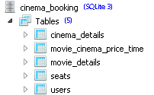

* **cinema_details**

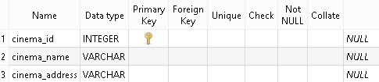

* **movie_cinema_price_time**

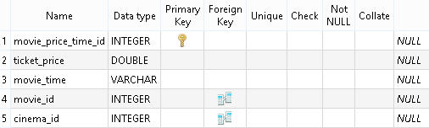

* **movie_details**

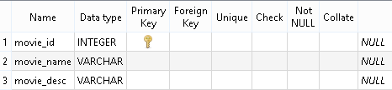

* **Seats**

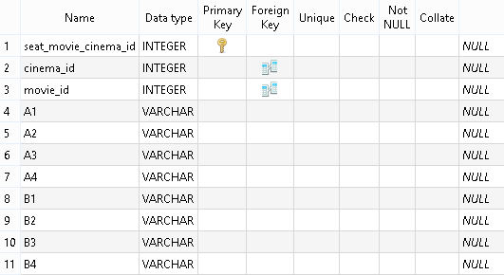

* **users**

