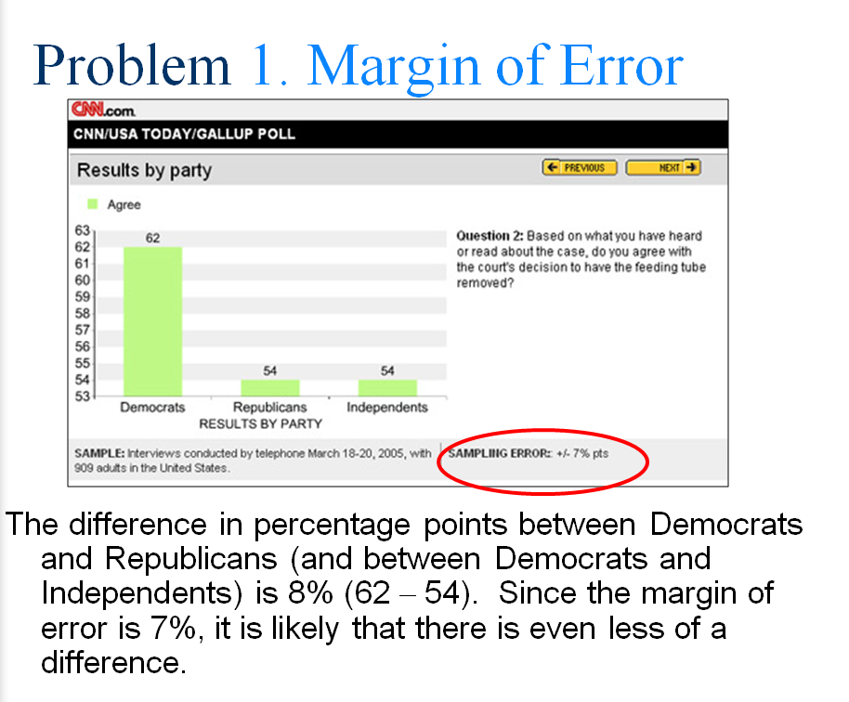

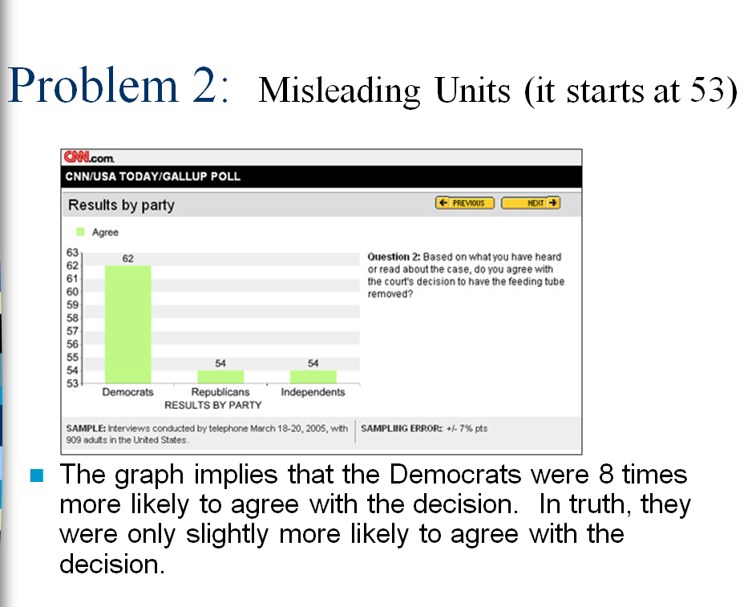

1. The misleading parts are (1) error of margin (2) scale used in y-axis.  
  
2.  Distorting Data - The scale doesn't start at zero.  It makes scale very small to emphasize the differences among parties.   It also hides the fact that the sampling error is huge.  
  
3. 54% means more than half of the republicans and independents also agree with the decision.  But small scale was used to emphasize that democrats are 8 times more likely to agree with the decision than republicans and independents.   Indeed, with sampling error 7%,  there is not much differences among parties.   The chart was designed to influence viewers' opinions about certain parties, hence, strengthen its own propaganda.