Cairo University  
Faculty of Computers and Artificial Intelligence



**CS251**

**Software Engineering I**

Project Name

Software Design Specifications

Version X.X

Team Names and Emails

Month & Year

Contents

Instructions [To be removed] **Error! Bookmark not defined.**

Team **Error! Bookmark not defined.**

Document Purpose and Audience **Error! Bookmark not defined.**

System Models 3

I. Class Diagram(s) 4

II. Class Descriptions 5

III. Sequence diagrams 5

Class - Sequence Usage Table 10

IV. State Diagram 10

Tools **Error! Bookmark not defined.**

Ownership Report **Error! Bookmark not defined.**

# Team

|  |  |  |  |
| --- | --- | --- | --- |
| **ID** | **Name** | **Email** | **Mobile** |
| 20170227 | Mohamed Hamdy Mohamed | m.hamdy5474@gmail.com |  |
| 20170045 | Islam Saleh Ahmad | eslamsaleh5668@gmail.com |  |
|  |  |  |  |

# Document Purpose and Audience

* **Any document anywhere should tell us 2 things:**
  + **what this document is : football playgrounds**
  + **who is excepted to read it: administrator and software’s engineers that intersected to learn how develop software engineering documents**
* **Write in simple notes: booking system for football playgrounds**
* **List the target audience to read this document (e.g. administrator? software’s engineers?)**

# System Models

## I. Class Diagram(s)

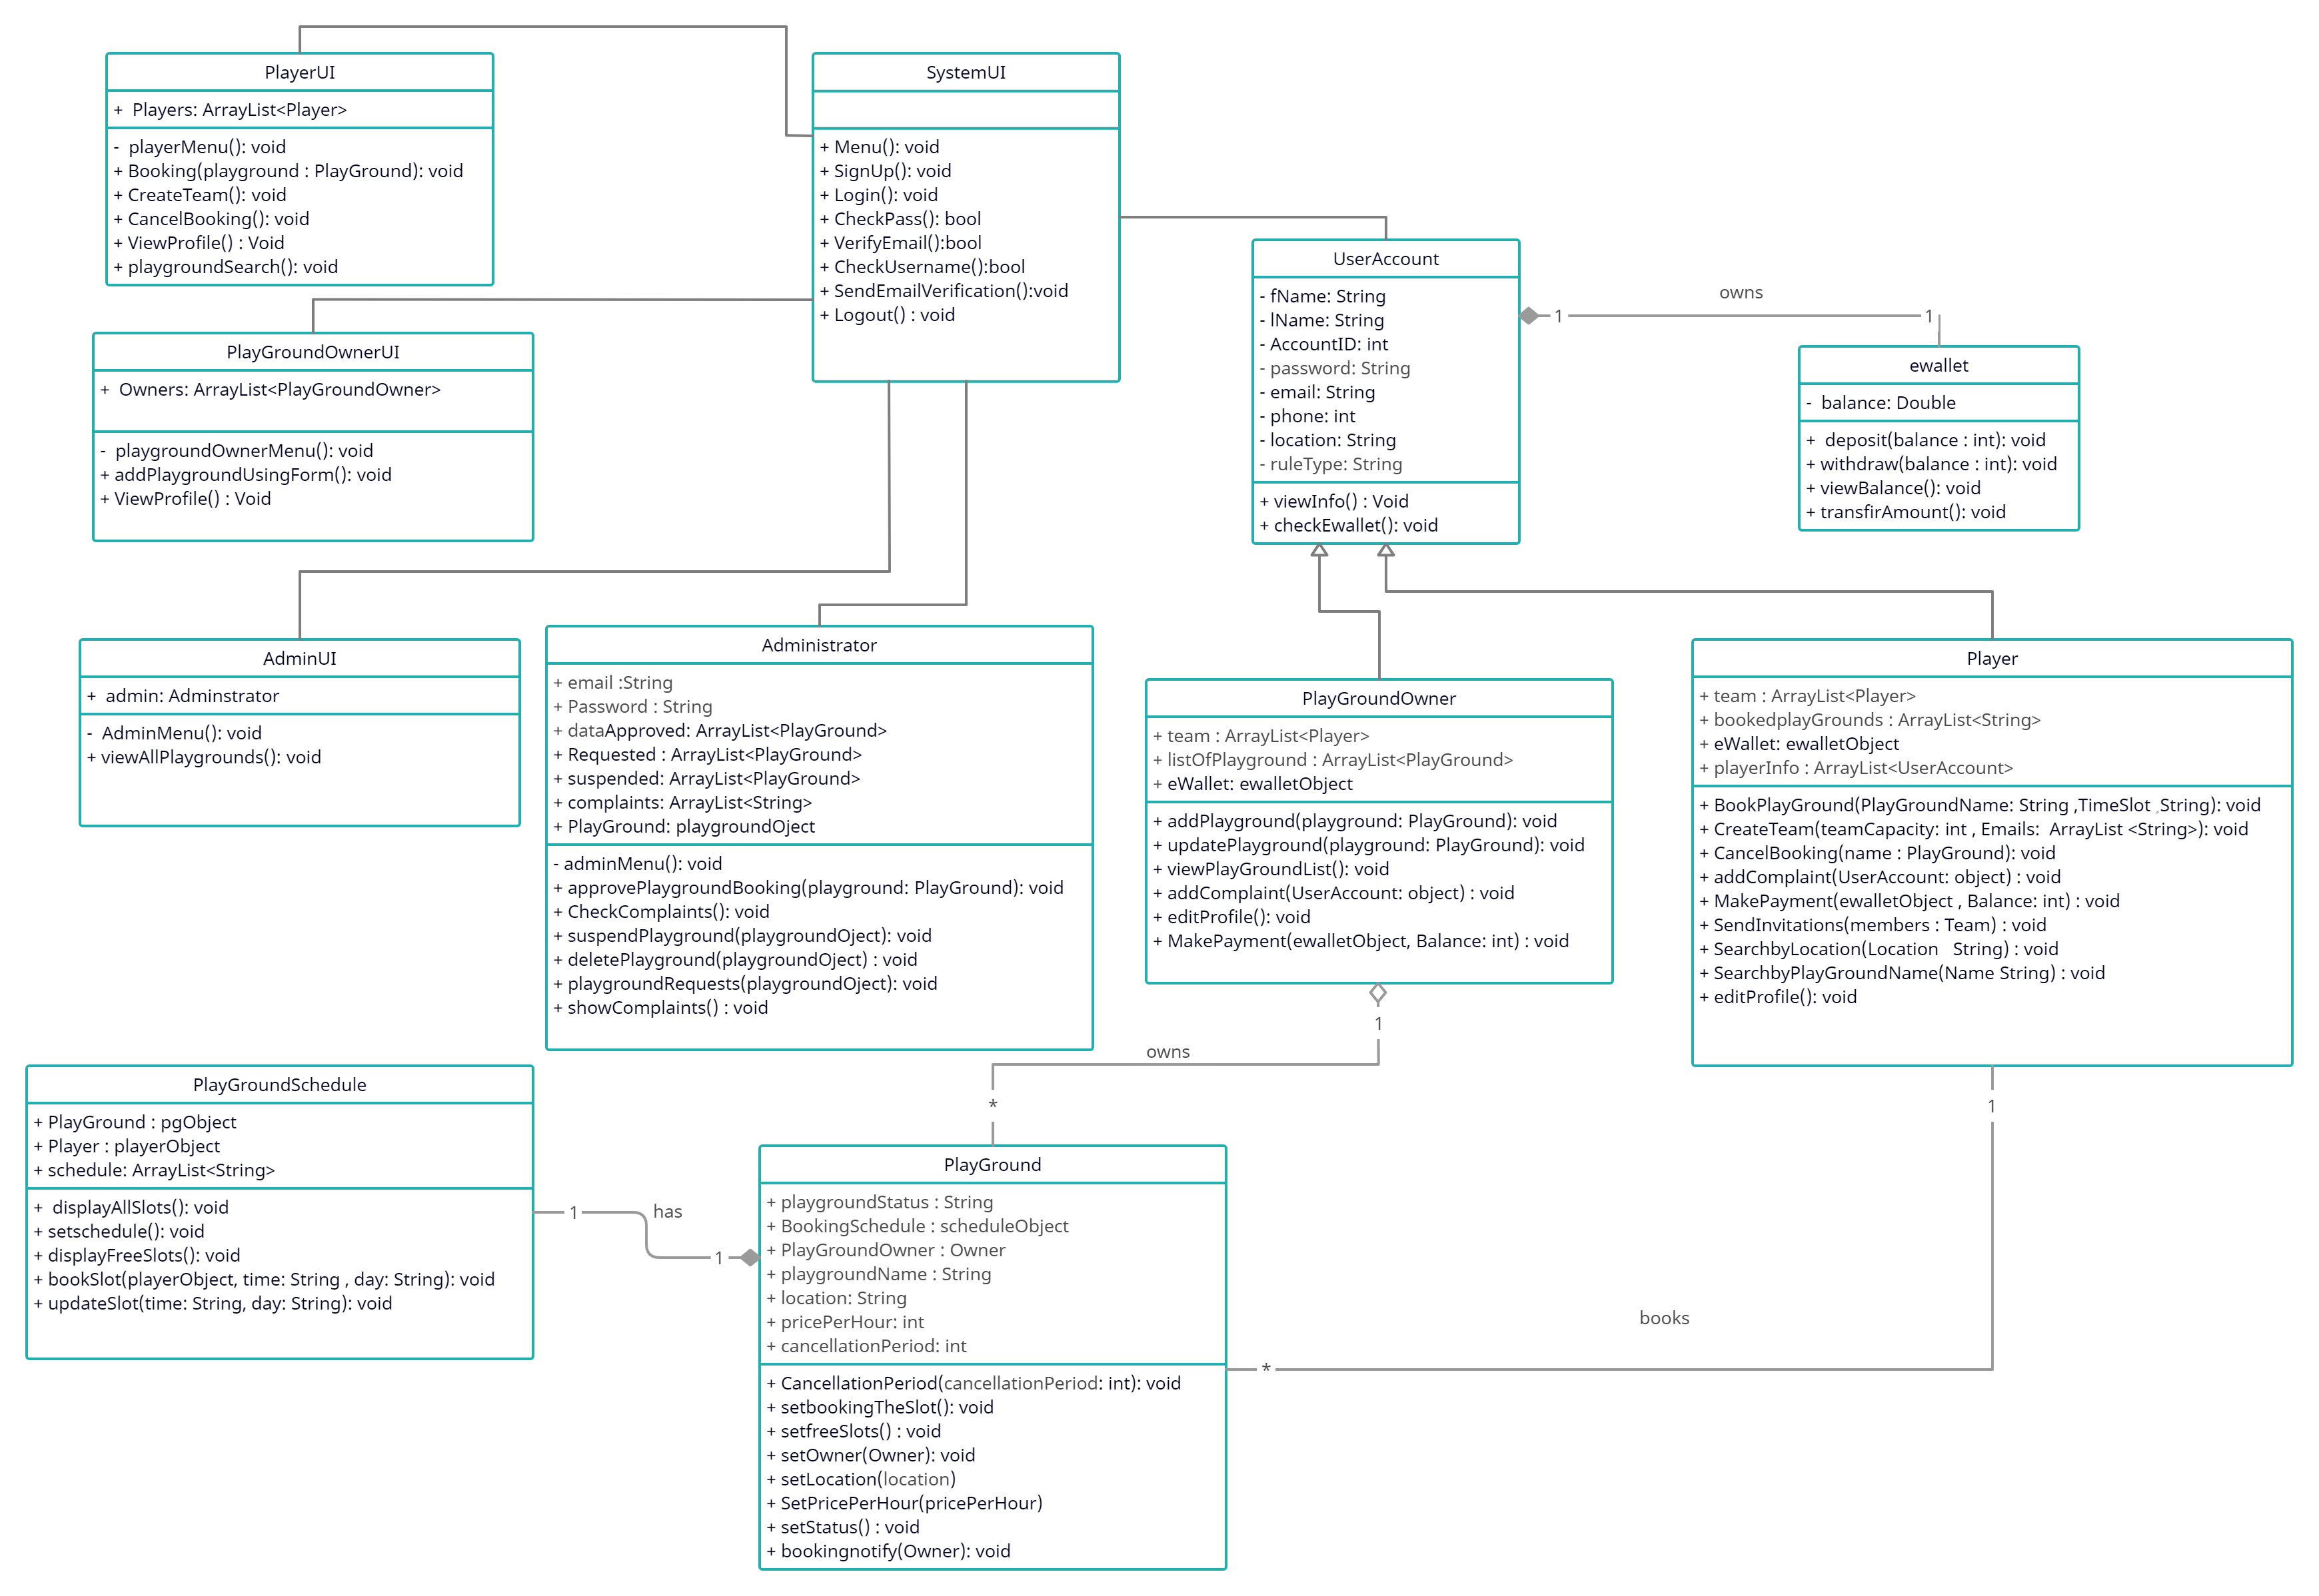

## II. Class Descriptions

| **Class ID** | **Class Name** | **Description & Responsibility** |
| --- | --- | --- |
| 1 | UserAccount | An abstract class (generalization) that holds the common properties between a Player and a Playground Owner |
| 2 | Player | A class that inherits UserAccount, It allows player to book playgrounds and do player functionalities. |
| 3 | PlaygroundOwner | A class that inherits UserAccount, It allows an owner to add (own) playgrounds and control them and do more functionalities. |
| 4 | Playground | A class that hold the attributes and operations that are done on a Playground, and it is owner by a PlaygroundOwner |
| 5 | PlayGroundSchedule | Every class should has PlayGroundSchedule class, It save all playground booking time in every day and it will display all time slots and use for another functionalities like setschedule and displayFreeSlots and it allow to owner to update playground slotsif he want. |
| 6 | eWallet | A class that has the responsibility of controlling financial operations in the system, and can be connected to an outside method like Fawry, and any User must have one eWallet. |
| 7 | Administrator | A class that can do special operations concerning playgrounds such as delete or suspend a playground and view all complaints and do another functionalities. |
| 8 | SystemUI | A boundary class for enabling users to sign up and login to the system, |
| 9 | PlayerUI | A boundary class for enabling players to interact with the system, book playgrounds, etc. |
| 10 | PlaygroundOwnerUI | A boundary class for enabling owners to interact with the system, add playgrounds, review their current bookings, etc. |
| 11 | AdminUI | A boundary class for enabling admins to control playgrounds, like activating, suspending or deleting a playground |

## III. Sequence diagrams

## 1- Registration:

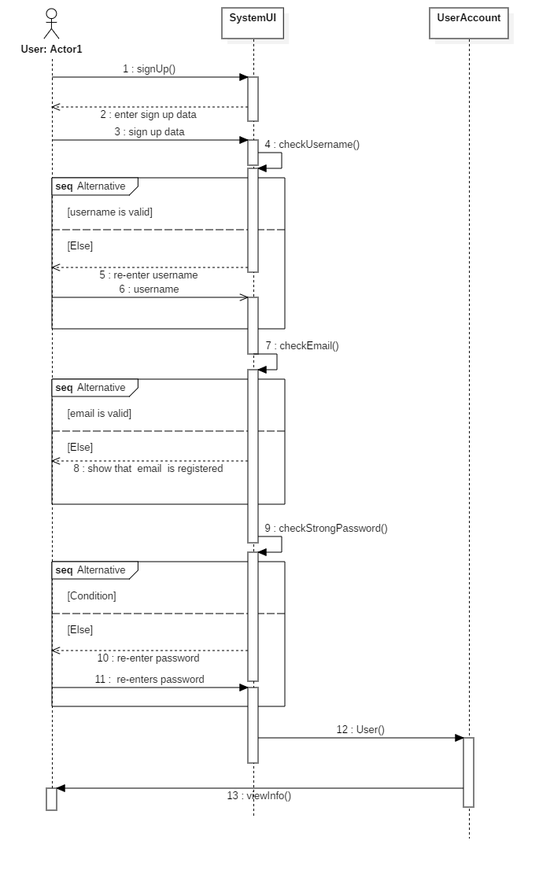

## 2- CreateTeam:

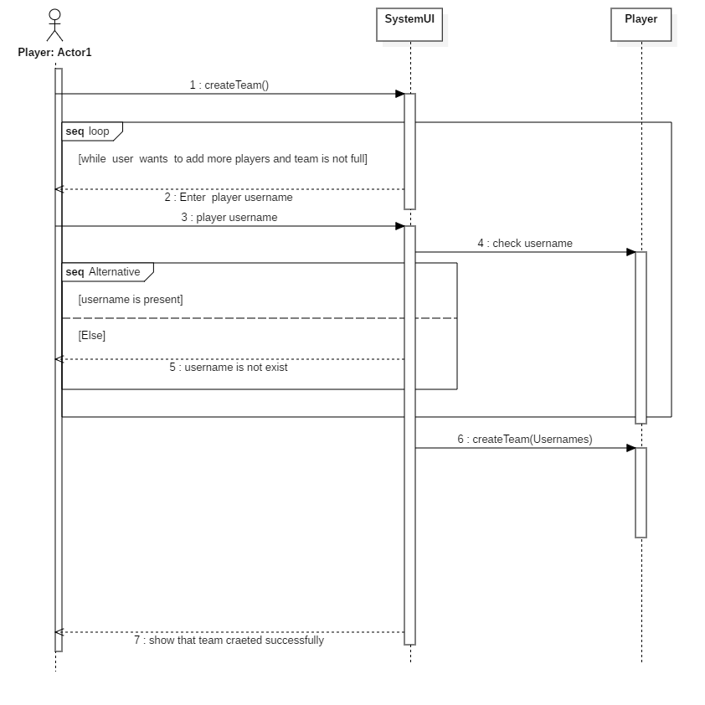

## 3- Booking PlayGround:

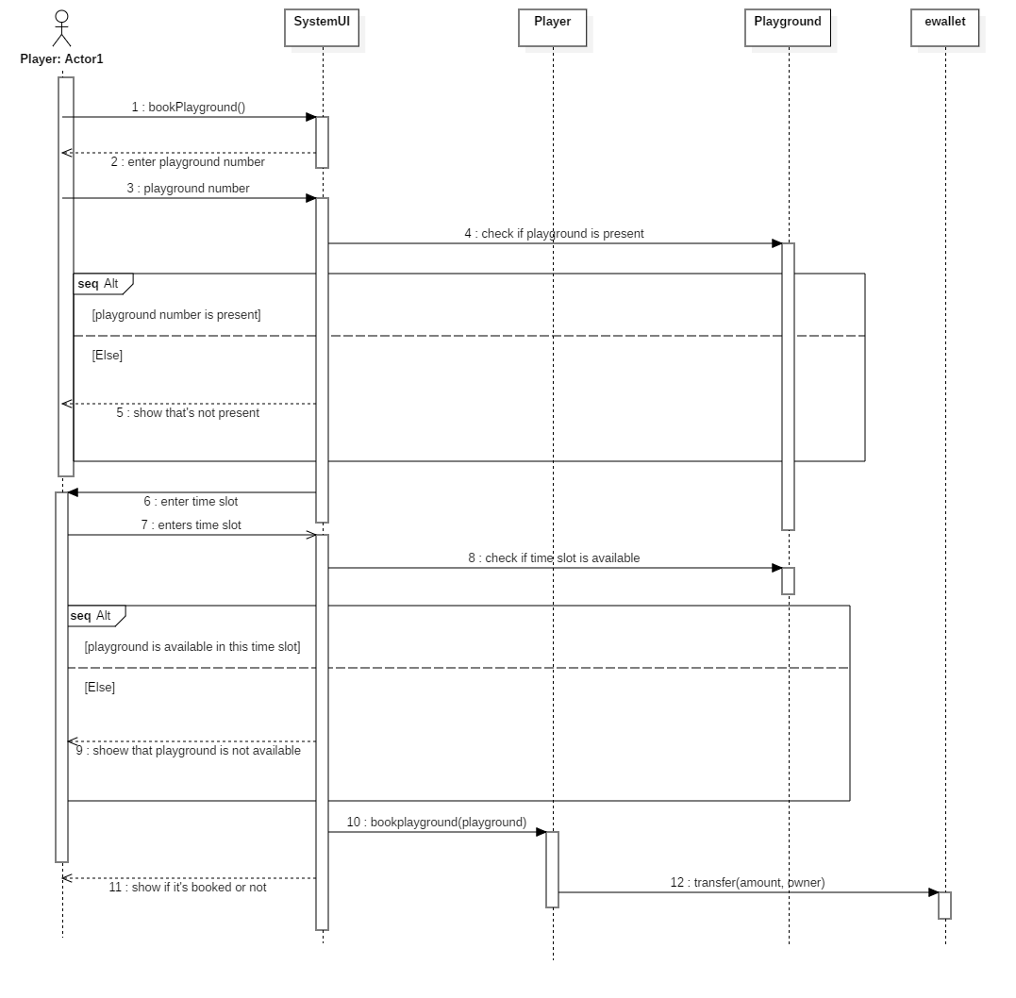

## 4- Add PlayGround:

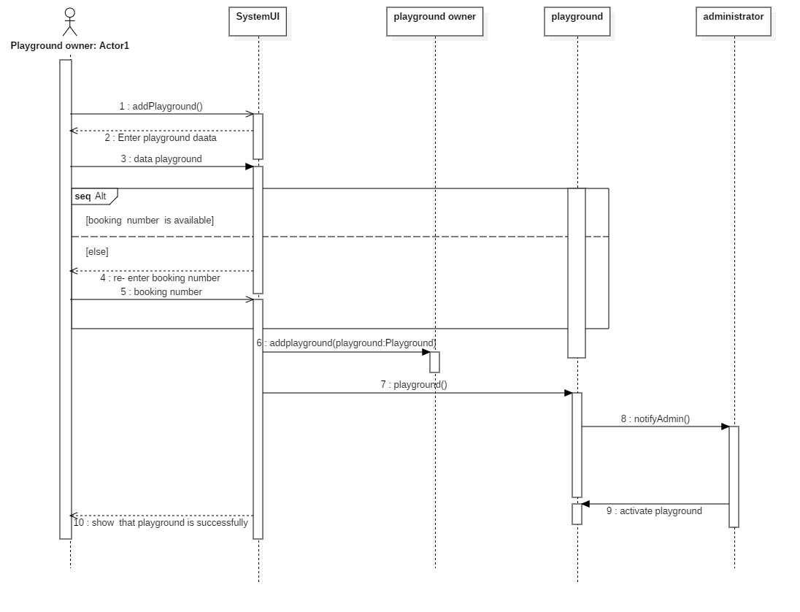

### 

### Class - Sequence Usage Table

| **Sequence Diagram** | **Classes Used** | **All Methods Used** |
| --- | --- | --- |
| Register a new user | Class SystemUI  Class UserAccount | signUp()  checkUsername()  checkEmail()  checkStrongPassword()  User()  viewInfo() |
| Add a Playground | Class SystemUI  Class PlaygroundOwner  Class Playground  Class Administrator | addPlayground()  Playground()  addPlayground(playground)  playground()  notifyAdmin() |
| Book a Playground | Class SystemUI  Class Player  Class Playground  Class eWallet | bookPlayground()  bookPlayground(playground, timeslot)  transfer(amount, owner) |
| Create a Team | Class SystemUI  Class Player | createTeam()  createTeam(usernames) |

## IV. State Diagram

* **For the Playground object:**

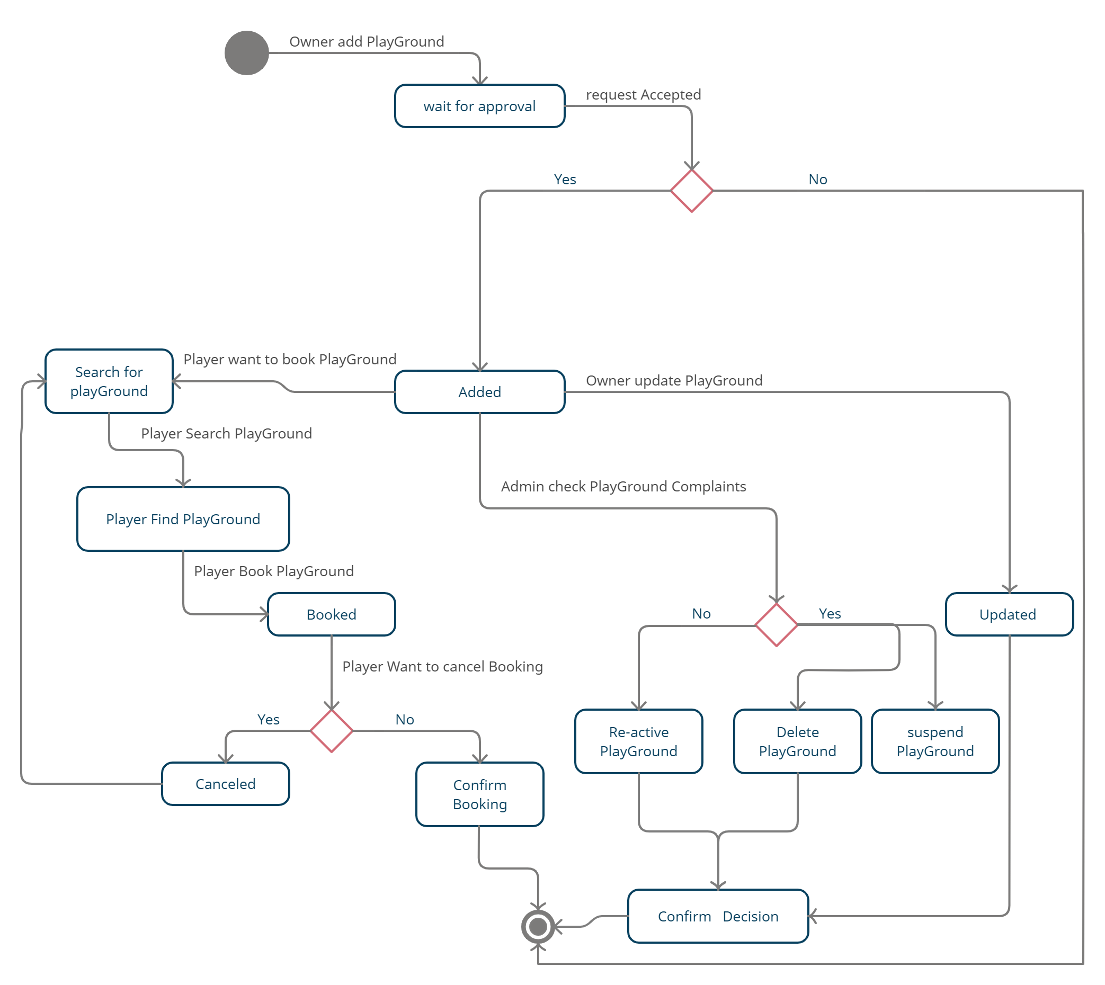

# Tools

* **creately website**
* **StarUML**

# Ownership Report

|  |  |
| --- | --- |
| **Student** | **Items he created** |
| **Mohamed Hamdy Mohamed** | **Class Diagram With team members , sequence diagram 1 and 2 ,** **Class Descriptions , State Chart With team members , implementation and java doc With team members** |
| **Islam Saleh Ahmad** | **Class Diagram With team members , sequence diagram 3 and 4,** **Sequence Usage Table , State Chart With team members , implementation and java doc With team members** |