**Blocking assignment delay models**

**LHS Blocking Assignment**

G1: LHS Blocking Assignment

G2 & G3: Multiple LHS Blocking Assignments

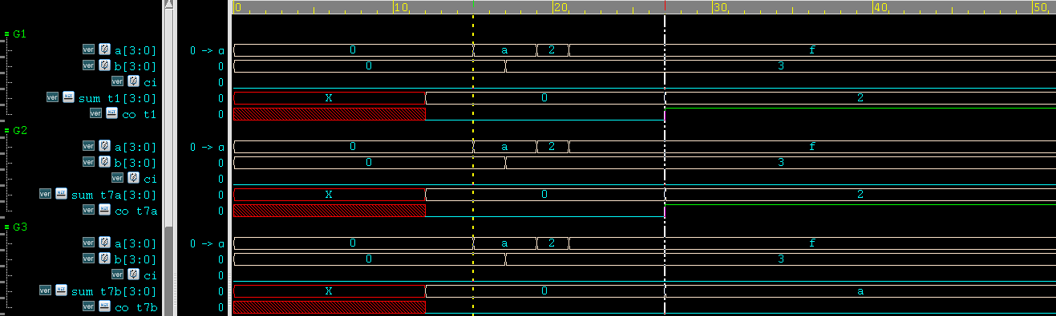

**RHS Blocking Assignment**

G4: RHS Blocking Assignment

G5 & G6: Multiple RHS Blocking Assignments

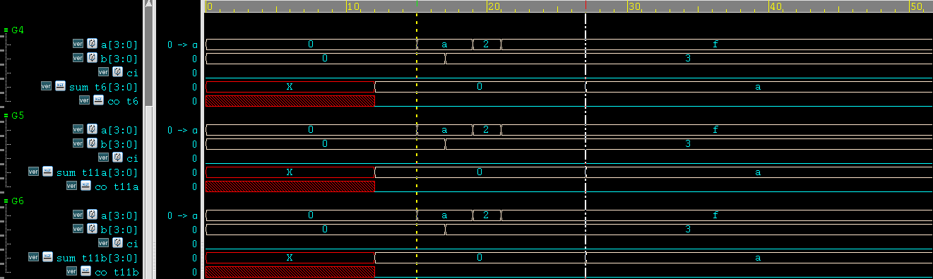

**Nonblocking assignment delay models**

G7: LHS Nonblocking Assignment

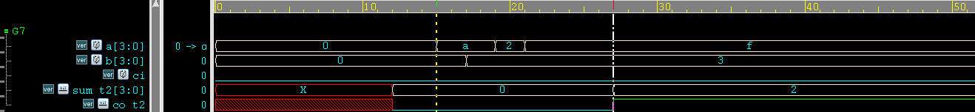

G8: RHS Nonblocking Assignment

transport delays

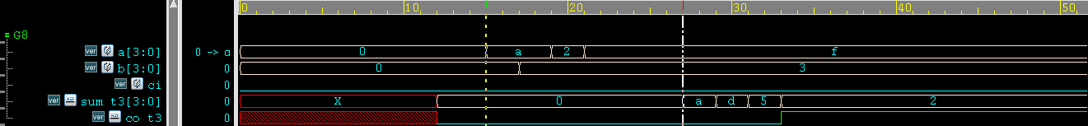

G9 & G10: Multiple RHS Nonblocking Assignments

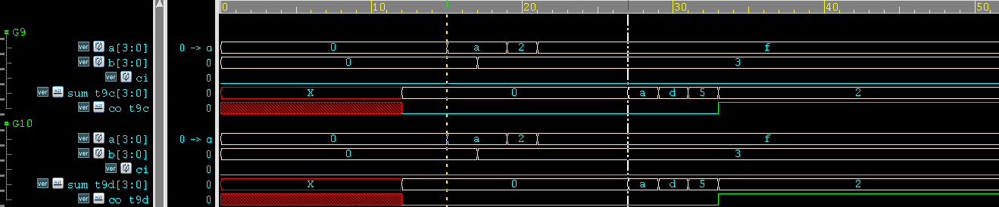

**Continuous assignment delay models**

G11: Continuous Assignment

inertial delays

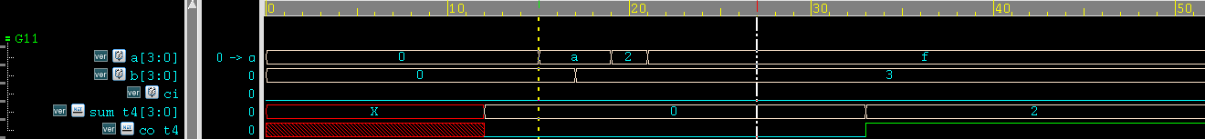

**Multiple continuous assignments**

G12 & G13: Multiple Continuous Assignments

inertial delays

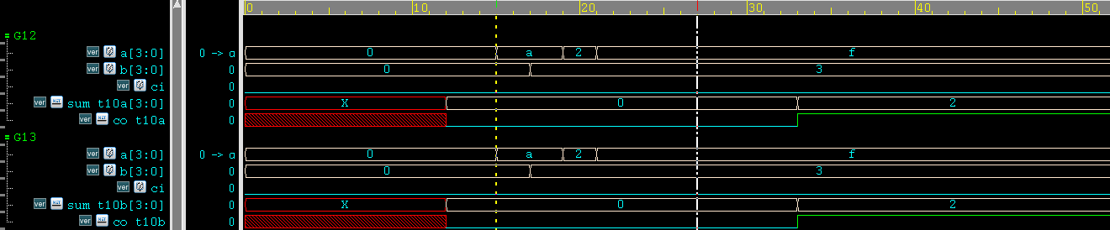

**Mixed no-delay always blocks and continuous assignments**

G14: No-Delay Always Block & Continuous Assignment

inertial delays

