Helpflow - ITIL Desk
Contents
Introduction 2
Design Patterns 2
Full Stack Overview 3
Frontend 3
Backend 3
Database 3
System architecture 3
Directory structure 3
Presentation Layer (Frontend) 3
Application Layer (Frontend services + Backend API logic) 4
Data Layer (Database + Access) 4
Diagrams 5
DB-Diagram 5
Sequence-diagrams 5
Component-diagram 5

Introduction
This project was created to learn about ITIL and GUI programming. I have tried to create an intuitive design. That is easy to understand and navigate. The project was created as a school project during my second school term.
I have created a connection between the back- and front-end system with API calls that use CRUD and SELECT statements from the database.

Design Patterns
The project is not built around one single design pattern but rather utilizing a few different.
- Component-based architecture
Each page is a standalone component (like tickets, sidebar, footer etc.). This allows for reusability of each component and a more organized directory structure.
- Service layer pattern
API calls are wrapped in services.
- Reactive state pattern
I am using Angular signals and computed values for derived UI state. This is similar to MVVM. Examples of this can be seen in the tickets.ts and sla-management.ts.
- Router-driven lazy loading
Pages are loaded by routes in app.routes.ts instead of all at once.
- Singleton
I am using a singleton state service pattern for the role switcher.
Overall, this design would be an Angular component-service architecture with reactive state handling.

Full Stack Overview

Frontend
- Angular 21
- TypeScript 5.9
- Angular Material + CDK
- Component-scoped CSS (Angular styles)
- Vitest (via ng test)

Backend
- Express
- MySQL 8+

Database
- MySQL 8+ (Using helpflowdb schema)

System architecture
This project follows a layered, feature-oriented full-stack architecture built around Angular on the frontend, Express.js on the backend, and MySQL as the persistence layer.

Directory structure
- {Helpflow-backend} Node/Express API layer for tickets, articles and SLA endpoints
  - {db} Database connection setup
  - {routes} REST route handlers
  - {node_modules} Backend dependencies
- {Helpflow-frontend} Angular application (UI, routing, pages, components, services)
  - {src/app} Root and Core app code folder
    - {layout/main-layout} Main sidebar, content + footer wrapper
    - {pages} Route-level feature pages - containing all page views
    - {services} API/data and app-wide services
    - {shared} Reusable shared components like sidebar
    - {public} Static assets, SQL files and docs
    - {.angular} Angular CLI cache/build metadata
    - {node_modules} Frontend dependencies

Presentation Layer (Frontend)
The presentation layer is implemented as a Single Page Application (SPA) using Angular standalone components. This layer is responsible for rendering UI pages and reusable layout components, handling user interactions and delegating data access to service classes rather than calling API’s directly from the templates.

Application Layer (Frontend services + Backend API logic)
This layer contains business behavior and orchestration logic.
On the frontend it uses service classes to encapsulate HTTP communication with backend endpoints. It uses UI components to consume service and transform the data for display.
It also controls the role-based UI behavior through a shared role-state service.

Data Layer (Database + Access)

Diagrams

DB-Diagram
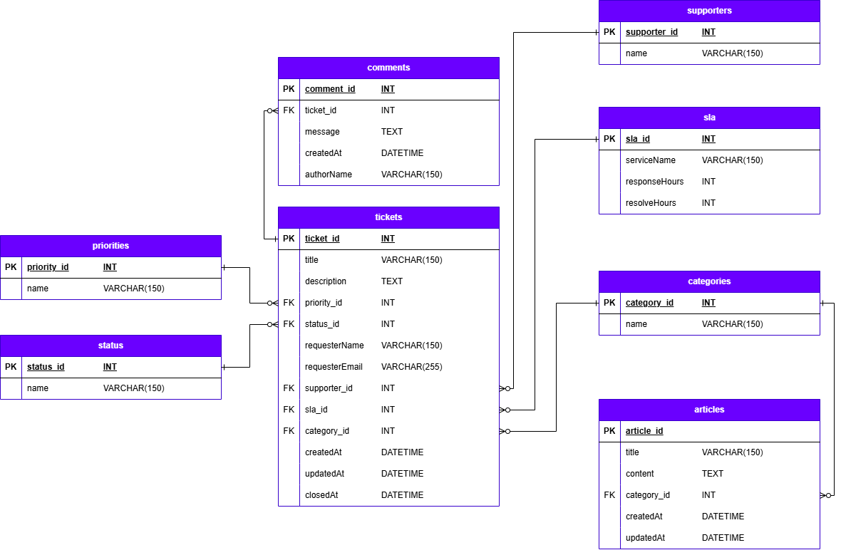

Sequence-diagrams

Component-diagram

