**ASSIGNMENT 3**

**Exercise1:**

* Database: MyDB3.
* Using file appsettings.json to store ConnectionString.
* Using entity framework.
* Using ASP.NET Core MVC (not using MVC template)

When load web page:

* GridView shows all information of the products in the table Products
* DropdownList **Product Code** will load all of the productcode and show.

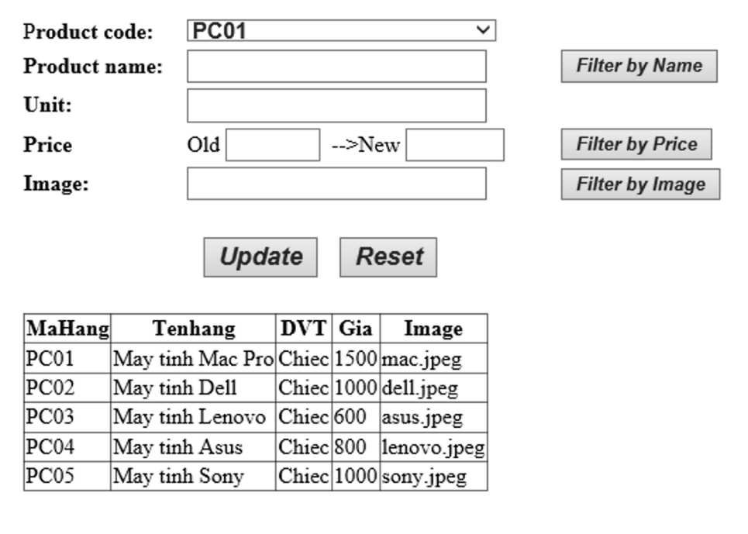

1. When selecting a product in the DropDownList, all its information will be displayed in the corresponding TextBoxes and filtered to the GridView.
2. When changing the TextBoxes and clicking Update, the information related to that product code will be updated in the Database and displayed right now on the GridView.
3. When entering all or part of the product name in the corresponding TextBox and pressing the Filter by Name button, the products with the name containing the value in the text will be displayed on the GridView.
4. When entering all or part of the product image in the corresponding TextBox and clicking the Filter by Image button, the products with the image containing the value in the text will be displayed on the GridView.
5. When entering the old price and the new price of the product in the respective TextBox and pressing the Filter by Price button, the products with values within the limits entered in the 2 text will be displayed on the GridView.

**Exercise2:**

* Database: MyDB3.
* Using file appsettings.json to store ConnectionString.
* Using ADO.NET.
* Using ASP.NET Core MVC (not using MVC template)
* **Do the same as Exercise1 but apply to the Customers table**