GAF-CNN - Final Result Report
Electrochemical image classification (Gramian Angular Field + CNN)
Generated (UTC): 2026-10-13 15:04:16 UTC

1. Model and input
Item | Value
Model file | CNN_5classes__epo_4000_pat_1000_batch_16_tl.keras
Parameters | 20,641
Keras version | 3.3.3 (saved 2024-10-10@16:49:11)
Input size | 224 x 224 x 3 (GAF image, 100x100 RGB on disk)
Number of classes | 5
Classes | Benzochinone, Catecolo, Ferro-Ferri, Idrochinone, Idrochinone-Benzochinone
Pre-processing | pixel rescale 1/255, no augmentation at test time, batch 1, shuffle disabled

2. Dataset used
Kind | Layout | Split | Class | Images
CNN input image | concentrations_based | Test | Benzochinone | 3
CNN input image | concentrations_based | Test | Catecolo | 3
CNN input image | concentrations_based | Test | Ferro-Ferri | 3
CNN input image | concentrations_based | Test | Idrochinone | 3
CNN input image | concentrations_based | Test | Idrochinone-Benzochinone | 3
CNN input image | concentrations_based | Train | Benzochinone | 9
CNN input image | concentrations_based | Train | Catecolo | 9
CNN input image | concentrations_based | Train | Ferro-Ferri | 9
CNN input image | concentrations_based | Train | Idrochinone | 9
CNN input image | concentrations_based | Train | Idrochinone-Benzochinone | 9
CNN input image | concentrations_based | Val | Benzochinone | 3
CNN input image | concentrations_based | Val | Catecolo | 3
CNN input image | concentrations_based | Val | Ferro-Ferri | 3
CNN input image | concentrations_based | Val | Idrochinone | 3
CNN input image | concentrations_based | Val | Idrochinone-Benzochinone | 3
CNN input image | shuffled | Test | Benzochinone | 9
CNN input image | shuffled | Test | Catecolo | 4
CNN input image | shuffled | Test | Ferro-Ferri | 5
CNN input image | shuffled | Test | Idrochinone | 4
CNN input image | shuffled | Test | Idrochinone-Benzochinone | 3
CNN input image | shuffled | Train | Benzochinone | 13
CNN input image | shuffled | Train | Catecolo | 14
CNN input image | shuffled | Train | Ferro-Ferri | 14
CNN input image | shuffled | Train | Idrochinone | 15
CNN input image | shuffled | Train | Idrochinone-Benzochinone | 13
CNN input image | shuffled | Val | Benzochinone | 3
CNN input image | shuffled | Val | Catecolo | 6
CNN input image | shuffled | Val | Ferro-Ferri | 5
CNN input image | shuffled | Val | Idrochinone | 1
CNN input image | shuffled | Val | Idrochinone-Benzochinone | 5
raw GAF output | voltammetry/GAFData | - | Benzochinone | 15
raw GAF output | voltammetry/GAFData | - | Catecolo | 15
raw GAF output | voltammetry/GAFData | - | Ferro-Ferri | 15
raw GAF output | voltammetry/GAFData | - | Idrochinone | 15
raw GAF output | voltammetry/GAFData | - | Idrochinone-Benzochinone | 15
Total images in data/: 264

3. Overall results
Test split | Images | Correct | Wrong | Accuracy %
shuffled | 25 | 24 | 1 | 96.00
concentrations_based | 15 | 15 | 0 | 100.00
Combined: 39 / 40 images classified correctly.

4. Accuracy per class (%)
Class | shuffled | concentrations_based
Benzochinone | 88.89 | 100.00
Catecolo | 100.00 | 100.00
Ferro-Ferri | 100.00 | 100.00
Idrochinone | 100.00 | 100.00
Idrochinone-Benzochinone | 100.00 | 100.00

4.1 Prediction confidence
Test split | Avg confidence (correct) | Avg confidence (wrong)
shuffled | 0.9048 | 0.5987
concentrations_based | 0.9511 | 0.0000

5. Confusion matrices
Rows = true class, columns = predicted class (alphabetical order).

shuffled split
 | Benzochinone | Catecolo | Ferro-Ferri | Idrochinone | Idrochinone-
Benzochinone | 8 | 0 | 0 | 1 | 0
Catecolo | 0 | 4 | 0 | 0 | 0
Ferro-Ferri | 0 | 0 | 5 | 0 | 0
Idrochinone | 0 | 0 | 0 | 4 | 0
Idrochinone-Benzochinone | 0 | 0 | 0 | 0 | 3
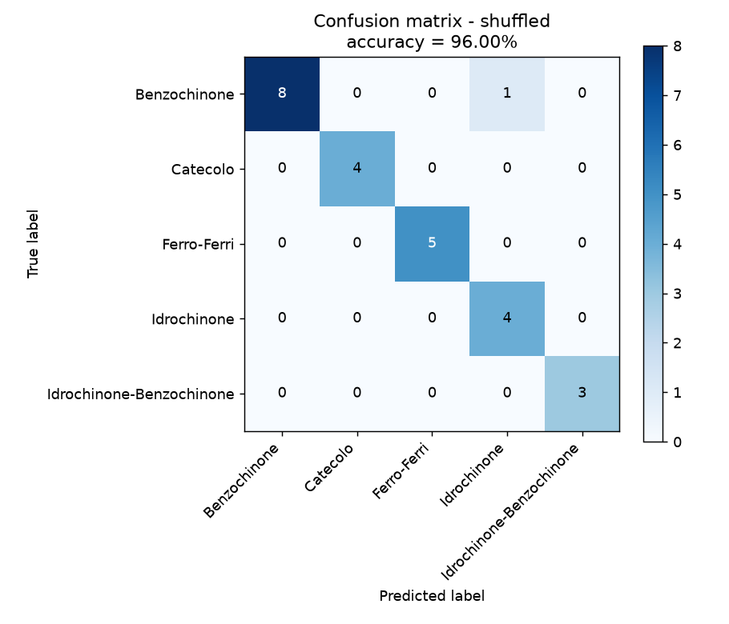

concentrations_based split
 | Benzochinone | Catecolo | Ferro-Ferri | Idrochinone | Idrochinone-
Benzochinone | 3 | 0 | 0 | 0 | 0
Catecolo | 0 | 3 | 0 | 0 | 0
Ferro-Ferri | 0 | 0 | 3 | 0 | 0
Idrochinone | 0 | 0 | 0 | 3 | 0
Idrochinone-Benzochinone | 0 | 0 | 0 | 0 | 3
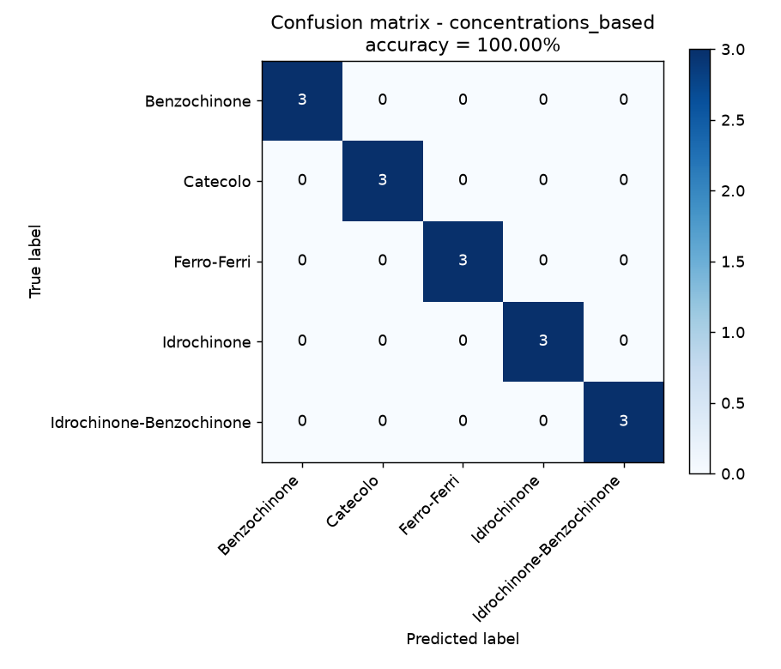

6. Classification reports

shuffled split
precision recall f1-score support
Benzochinone 1.0000 0.8889 0.9412 9
Catecolo 1.0000 1.0000 1.0000 4
Ferro-Ferri 1.0000 1.0000 1.0000 5
Idrochinone 0.8000 1.0000 0.8889 4
Idrochinone-Benzochinone 1.0000 1.0000 1.0000 3
accuracy 0.9600 25
macro avg 0.9600 0.9778 0.9660 25
weighted avg 0.9680 0.9600 0.9610 25

concentrations_based split
precision recall f1-score support
Benzochinone 1.0000 1.0000 1.0000 3
Catecolo 1.0000 1.0000 1.0000 3
Ferro-Ferri 1.0000 1.0000 1.0000 3
Idrochinone 1.0000 1.0000 1.0000 3
Idrochinone-Benzochinone 1.0000 1.0000 1.0000 3
accuracy 1.0000 15
macro avg 1.0000 1.0000 1.0000 15
weighted avg 1.0000 1.0000 1.0000 15

7. Per image predictions

shuffled split (25 images)
# | File | True class | Predicted class | Confidence | Result
0 | 0.01mMSPE-Benzochinone_2.png | Benzochinone | Benzochinone | 0.6977 | OK
1 | 0.01mMSPE-Benzochinone_3.png | Benzochinone | Benzochinone | 0.9017 | OK
2 | 0.1mMSPE-Benzochinone_2.png | Benzochinone | Benzochinone | 0.9227 | OK
3 | 0.5mMSPE-Benzochinone_2.png | Benzochinone | Benzochinone | 0.7916 | OK
4 | 1mMSPE-Benzochinone_1.png | Benzochinone | Benzochinone | 0.7166 | OK
5 | 1mMSPE-Benzochinone_3.png | Benzochinone | Benzochinone | 0.9627 | OK
6 | 2mMSPE-Benzochinone_1.png | Benzochinone | Idrochinone | 0.5987 | WRONG
7 | 2mMSPE-Benzochinone_2.png | Benzochinone | Benzochinone | 0.9547 | OK
8 | 2mMSPE-Benzochinone_3.png | Benzochinone | Benzochinone | 0.9576 | OK
9 | 0.01mMSPE-Catecolo_1.png | Catecolo | Catecolo | 0.8779 | OK
10 | 0.1mMSPE-Catecolo_1.png | Catecolo | Catecolo | 0.9199 | OK
11 | 0.1mMSPE-Catecolo_3.png | Catecolo | Catecolo | 0.6279 | OK
12 | 0.5mMSPE-Catecolo_1.png | Catecolo | Catecolo | 0.9924 | OK
13 | 0.01mMSPE-Ferro-Ferri_1.png | Ferro-Ferri | Ferro-Ferri | 0.5847 | OK
14 | 0.5mMSPE-Ferro-Ferri_1.png | Ferro-Ferri | Ferro-Ferri | 0.9929 | OK
15 | 0.5mMSPE-Ferro-Ferri_3.png | Ferro-Ferri | Ferro-Ferri | 0.9778 | OK
16 | 2mMSPE-Ferro-Ferri_1.png | Ferro-Ferri | Ferro-Ferri | 0.9996 | OK
17 | 2mMSPE-Ferro-Ferri_3.png | Ferro-Ferri | Ferro-Ferri | 0.9704 | OK
18 | 0.1mMSPE-Idrochinone_2.png | Idrochinone | Idrochinone | 0.9760 | OK
19 | 0.5mMSPE-Idrochinone_2.png | Idrochinone | Idrochinone | 0.9986 | OK
20 | 0.5mMSPE-Idrochinone_3.png | Idrochinone | Idrochinone | 0.9987 | OK
21 | 2mMSPE-Idrochinone_3.png | Idrochinone | Idrochinone | 0.9691 | OK
22 | HB13SPE-Idrochinone-Benzochinone_1.png | Idrochinone-Benzochinone | Idrochinone-Benzochinone | 0.9877 | OK
23 | HB21SPE-Idrochinone-Benzochinone_3.png | Idrochinone-Benzochinone | Idrochinone-Benzochinone | 0.9904 | OK
24 | HB31SPE-Idrochinone-Benzochinone_1.png | Idrochinone-Benzochinone | Idrochinone-Benzochinone | 0.9468 | OK

concentrations_based split (15 images)
# | File | True class | Predicted class | Confidence | Result
0 | 1mMSPE-Benzochinone_1.png | Benzochinone | Benzochinone | 0.7166 | OK
1 | 1mMSPE-Benzochinone_2.png | Benzochinone | Benzochinone | 0.9149 | OK
2 | 1mMSPE-Benzochinone_3.png | Benzochinone | Benzochinone | 0.9627 | OK
3 | 1mMSPE-Catecolo_1.png | Catecolo | Catecolo | 0.9929 | OK
4 | 1mMSPE-Catecolo_2.png | Catecolo | Catecolo | 0.9914 | OK
5 | 1mMSPE-Catecolo_3.png | Catecolo | Catecolo | 0.9665 | OK
6 | 1mMSPE-Ferro-Ferri_1.png | Ferro-Ferri | Ferro-Ferri | 0.9959 | OK
7 | 1mMSPE-Ferro-Ferri_2.png | Ferro-Ferri | Ferro-Ferri | 0.9947 | OK
8 | 1mMSPE-Ferro-Ferri_3.png | Ferro-Ferri | Ferro-Ferri | 0.9940 | OK
9 | 1mMSPE-Idrochinone_1.png | Idrochinone | Idrochinone | 0.9981 | OK
10 | 1mMSPE-Idrochinone_2.png | Idrochinone | Idrochinone | 0.9927 | OK
11 | 1mMSPE-Idrochinone_3.png | Idrochinone | Idrochinone | 0.9960 | OK
12 | HB21SPE-Idrochinone-Benzochinone_1.png | Idrochinone-Benzochinone | Idrochinone-Benzochinone | 0.8397 | OK
13 | HB21SPE-Idrochinone-Benzochinone_2.png | Idrochinone-Benzochinone | Idrochinone-Benzochinone | 0.9206 | OK
14 | HB21SPE-Idrochinone-Benzochinone_3.png | Idrochinone-Benzochinone | Idrochinone-Benzochinone | 0.9904 | OK

8. Misclassified images
- shuffled: 2mMSPE-Benzochinone_1.png - true Benzochinone, predicted Idrochinone (confidence 0.5987)

9. Conclusion
The trained CNN classified 39 of 40 test images correctly. Best split: concentrations_based with 100.00% accuracy; shuffled: 96.00%.
The perfect score of the concentrations_based split (which contains every concentration level, from 0.01 mM to 2 mM) shows that the GAF representation preserves the information needed to recognise the substance independently of its concentration. The single error (shuffled split) is a Benzochinone image at the highest concentration (2 mM) predicted as Idrochinone with 0.60 confidence; the two molecules have very similar quinone / hydroquinone redox responses.

10. Appendix - full probability matrix
Probability assigned by the CNN to each of the 5 classes, for every test image.

shuffled split
# | File | True | Benzochinone | Catecolo | Ferro-Ferri | Idrochinone | Idrochinone-Benzochinone
0 | 0.01mMSPE-Benzochinone_2.png | Benzochinone | 0.6977 | 0.0514 | 0.0070 | 0.2191 | 0.0247
1 | 0.01mMSPE-Benzochinone_3.png | Benzochinone | 0.9017 | 0.0249 | 0.0048 | 0.0514 | 0.0173
2 | 0.1mMSPE-Benzochinone_2.png | Benzochinone | 0.9227 | 0.0284 | 0.0092 | 0.0312 | 0.0084
3 | 0.5mMSPE-Benzochinone_2.png | Benzochinone | 0.7916 | 0.0577 | 0.0084 | 0.1355 | 0.0068
4 | 1mMSPE-Benzochinone_1.png | Benzochinone | 0.7166 | 0.0166 | 0.0310 | 0.2285 | 0.0073
5 | 1mMSPE-Benzochinone_3.png | Benzochinone | 0.9627 | 0.0113 | 0.0046 | 0.0118 | 0.0096
6 | 2mMSPE-Benzochinone_1.png | Benzochinone | 0.2783 | 0.0781 | 0.0103 | 0.5987 | 0.0345
7 | 2mMSPE-Benzochinone_2.png | Benzochinone | 0.9547 | 0.0142 | 0.0044 | 0.0075 | 0.0192
8 | 2mMSPE-Benzochinone_3.png | Benzochinone | 0.9576 | 0.0144 | 0.0039 | 0.0072 | 0.0170
9 | 0.01mMSPE-Catecolo_1.png | Catecolo | 0.0596 | 0.8779 | 0.0191 | 0.0366 | 0.0069
10 | 0.1mMSPE-Catecolo_1.png | Catecolo | 0.0126 | 0.9199 | 0.0407 | 0.0245 | 0.0024
11 | 0.1mMSPE-Catecolo_3.png | Catecolo | 0.2350 | 0.6279 | 0.0091 | 0.1191 | 0.0089
12 | 0.5mMSPE-Catecolo_1.png | Catecolo | 0.0021 | 0.9924 | 0.0009 | 0.0008 | 0.0037
13 | 0.01mMSPE-Ferro-Ferri_1.png | Ferro-Ferri | 0.1203 | 0.0292 | 0.5847 | 0.2610 | 0.0047
14 | 0.5mMSPE-Ferro-Ferri_1.png | Ferro-Ferri | 0.0009 | 0.0008 | 0.9929 | 0.0051 | 0.0001
15 | 0.5mMSPE-Ferro-Ferri_3.png | Ferro-Ferri | 0.0034 | 0.0015 | 0.9778 | 0.0170 | 0.0003
16 | 2mMSPE-Ferro-Ferri_1.png | Ferro-Ferri | 0.0000 | 0.0000 | 0.9996 | 0.0003 | 0.0000
17 | 2mMSPE-Ferro-Ferri_3.png | Ferro-Ferri | 0.0081 | 0.0017 | 0.9704 | 0.0187 | 0.0011
18 | 0.1mMSPE-Idrochinone_2.png | Idrochinone | 0.0102 | 0.0064 | 0.0016 | 0.9760 | 0.0059
19 | 0.5mMSPE-Idrochinone_2.png | Idrochinone | 0.0002 | 0.0005 | 0.0003 | 0.9986 | 0.0003
20 | 0.5mMSPE-Idrochinone_3.png | Idrochinone | 0.0002 | 0.0004 | 0.0004 | 0.9987 | 0.0002
21 | 2mMSPE-Idrochinone_3.png | Idrochinone | 0.0081 | 0.0106 | 0.0013 | 0.9691 | 0.0109
22 | HB13SPE-Idrochinone-Benzochinone_1.png | Idrochinone-Benzochinone | 0.0066 | 0.0037 | 0.0004 | 0.0015 | 0.9877
23 | HB21SPE-Idrochinone-Benzochinone_3.png | Idrochinone-Benzochinone | 0.0022 | 0.0037 | 0.0014 | 0.0023 | 0.9904
24 | HB31SPE-Idrochinone-Benzochinone_1.png | Idrochinone-Benzochinone | 0.0099 | 0.0203 | 0.0089 | 0.0142 | 0.9468

concentrations_based split
# | File | True | Benzochinone | Catecolo | Ferro-Ferri | Idrochinone | Idrochinone-Benzochinone
0 | 1mMSPE-Benzochinone_1.png | Benzochinone | 0.7166 | 0.0166 | 0.0310 | 0.2285 | 0.0073
1 | 1mMSPE-Benzochinone_2.png | Benzochinone | 0.9149 | 0.0564 | 0.0082 | 0.0101 | 0.0104
2 | 1mMSPE-Benzochinone_3.png | Benzochinone | 0.9627 | 0.0113 | 0.0046 | 0.0118 | 0.0096
3 | 1mMSPE-Catecolo_1.png | Catecolo | 0.0014 | 0.9929 | 0.0023 | 0.0010 | 0.0025
4 | 1mMSPE-Catecolo_2.png | Catecolo | 0.0020 | 0.9914 | 0.0023 | 0.0013 | 0.0030
5 | 1mMSPE-Catecolo_3.png | Catecolo | 0.0180 | 0.9665 | 0.0060 | 0.0034 | 0.0061
6 | 1mMSPE-Ferro-Ferri_1.png | Ferro-Ferri | 0.0002 | 0.0003 | 0.9959 | 0.0035 | 0.0001
7 | 1mMSPE-Ferro-Ferri_2.png | Ferro-Ferri | 0.0003 | 0.0005 | 0.9947 | 0.0044 | 0.0001
8 | 1mMSPE-Ferro-Ferri_3.png | Ferro-Ferri | 0.0005 | 0.0006 | 0.9940 | 0.0047 | 0.0001
9 | 1mMSPE-Idrochinone_1.png | Idrochinone | 0.0003 | 0.0006 | 0.0003 | 0.9981 | 0.0007
10 | 1mMSPE-Idrochinone_2.png | Idrochinone | 0.0022 | 0.0020 | 0.0006 | 0.9927 | 0.0025
11 | 1mMSPE-Idrochinone_3.png | Idrochinone | 0.0013 | 0.0006 | 0.0014 | 0.9960 | 0.0007
12 | HB21SPE-Idrochinone-Benzochinone_1.png | Idrochinone-Benzochinone | 0.0266 | 0.0227 | 0.0837 | 0.0273 | 0.8397
13 | HB21SPE-Idrochinone-Benzochinone_2.png | Idrochinone-Benzochinone | 0.0206 | 0.0183 | 0.0144 | 0.0260 | 0.9206
14 | HB21SPE-Idrochinone-Benzochinone_3.png | Idrochinone-Benzochinone | 0.0022 | 0.0037 | 0.0014 | 0.0023 | 0.9904

11. Generated files
- results/CNN_COMPLETE_OUTPUT.txt
- results/CNN_FULL_REPORT.html
- results/CNN_Final_Report.docx
- results/CNN_Final_Report.pdf
- results/CNN_Final_Report.txt
- results/CNN_Results_Package.zip
- results/README.md
- results/all_generated_images_manifest.csv
- results/all_splits_summary.json
- results/concentrations_based_classification_report.txt
- results/concentrations_based_confusion_matrix.csv
- results/concentrations_based_confusion_matrix.png
- results/concentrations_based_full_output.txt
- results/concentrations_based_predictions.csv
- results/concentrations_based_summary.json
- results/shuffled_classification_report.txt
- results/shuffled_confusion_matrix.csv
- results/shuffled_confusion_matrix.png
- results/shuffled_full_output.txt
- results/shuffled_predictions.csv
- results/shuffled_summary.json

