**Super perform assignment**

**MD MEHEDI HASAN RABBE**

**ID: 2018200000030**

**COURSE: 4041.1**

**COURSE NAME: ARTIFICIAL INTELLIGENCE**

# **Image Classification Using Multi Layer Perceptron**

1. **Importing all the required model and directory to all the in that particular folder.**

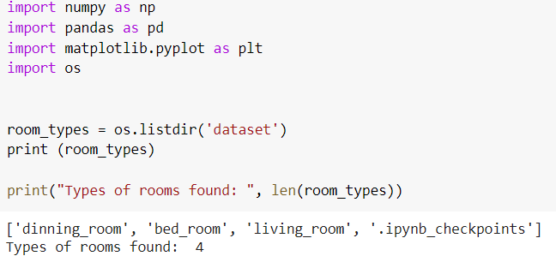

1. **Storing all the images to their corresponding label using loop**

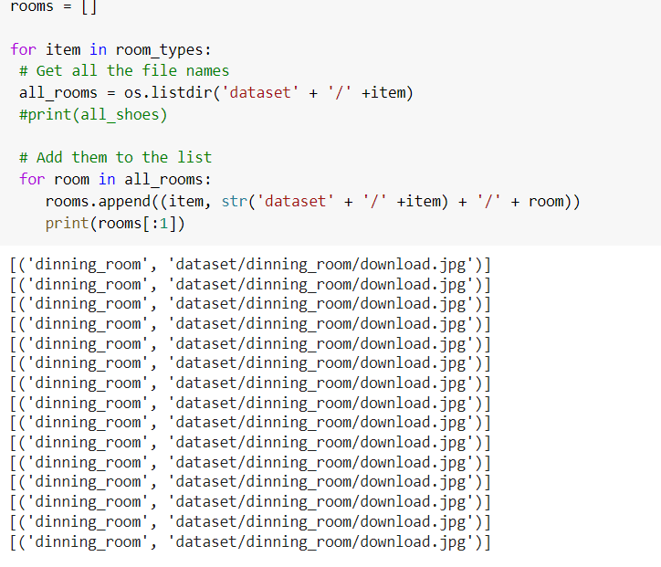

1. **Now building a data frame**

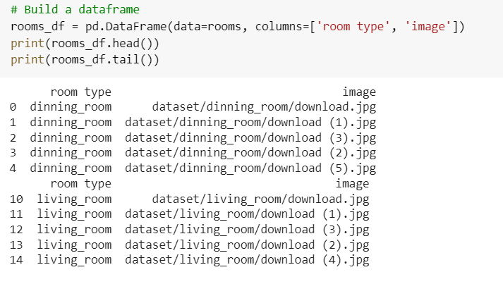

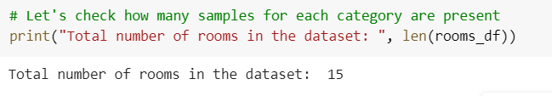

1. **How many image is in every room**

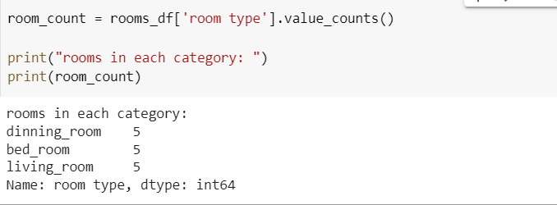

1. **Resizing all the images of every room in a single size**

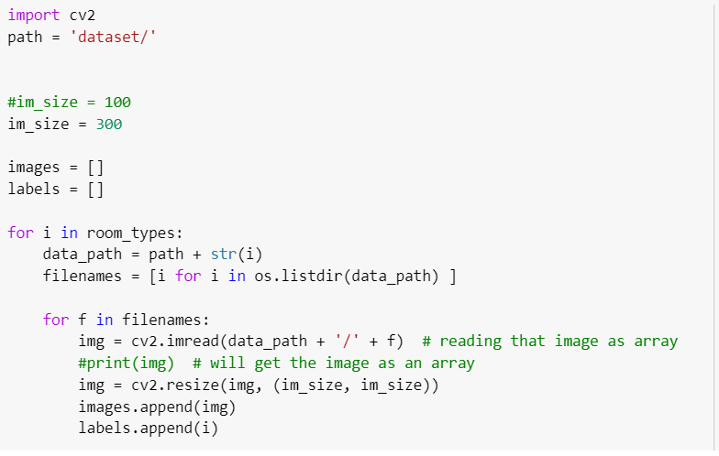

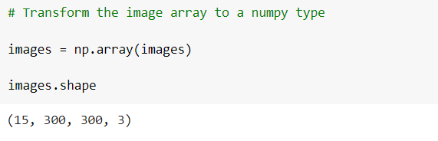

1. **Pixel of tensity lies between 0-255**



1. **Again checking the shape**

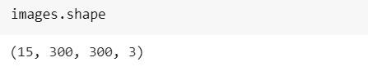

1. **Working on other column on label**

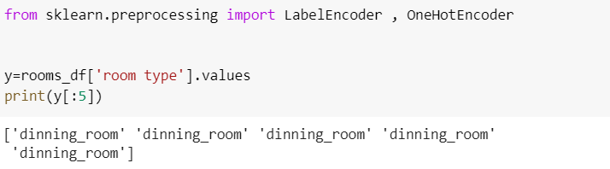

1. **Label encoding on it**

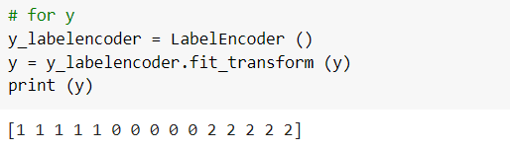

1. **Now train and testing data**

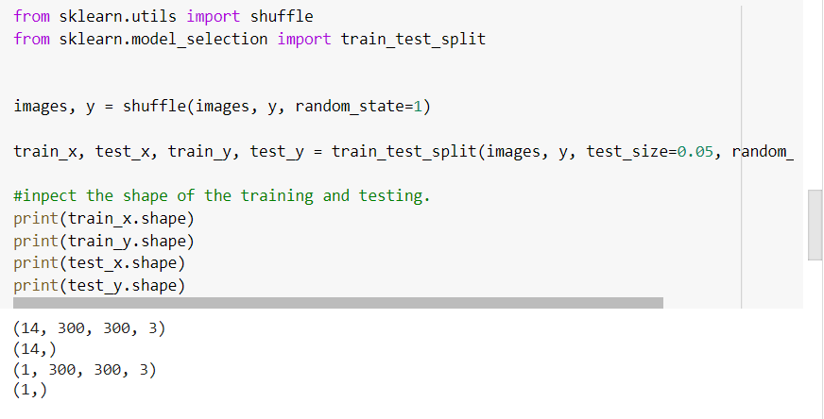

# **Now our data is ready for Image Classification**

1. **Flatten the convert the image into 1D**

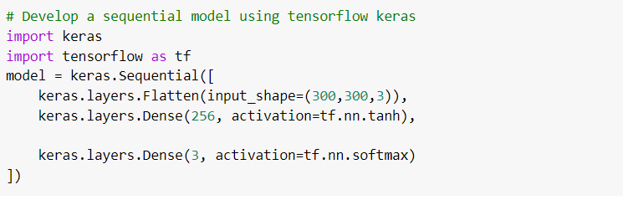

1. **Checking the model summary**

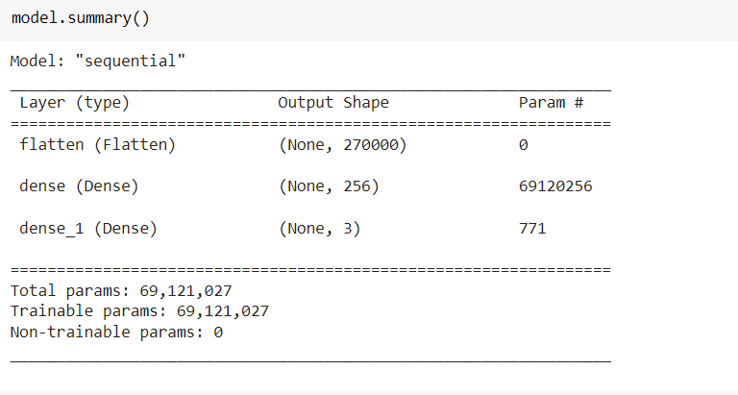

1. **Compiling the model**

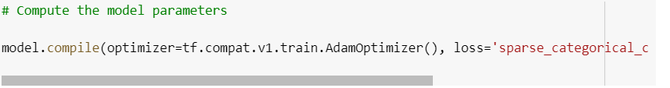

1. **Fitting the model with training data**

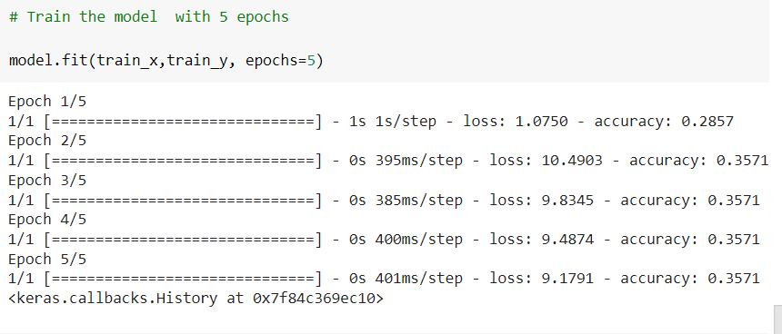

1. **Now we are predicting data(accuracy is less because of less data)**

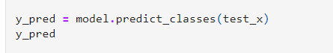

1. **Take input user to predict which image is in which classification**

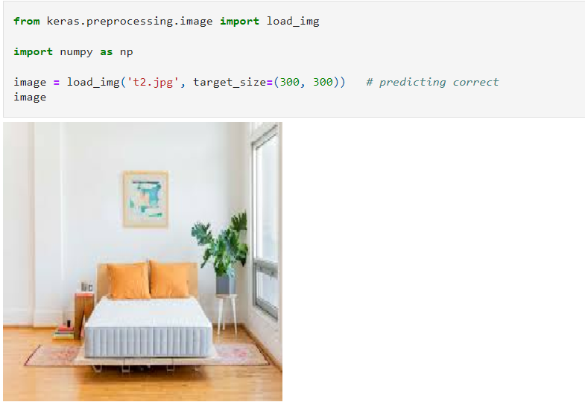

1. **Computer dont understand image so we have to convert the image into a array**

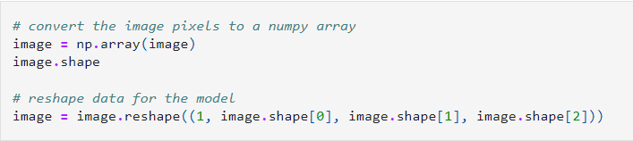

1. **Finally prediction for the input of the belongs to which class**

**Here the hire probability is the 2nd class. So the inputed image will be in 2nd class.**

