FORENSIC ACOUSTIC FOR SYNTHETIC SPEECH DETECTION



by

Rana Muhammad Areeb Muhammad Hasnain

Supervisor
Mr. Faran Mehmood

Department of Computing
Institute of Space Technology, Islamabad July 2026

FORENSIC ACOUSTIC FOR SYNTHETIC SPEECH DETECTION

A thesis submitted to the
Institute of Space Technology
in partial fulfillment of the requirements for the degree of Bachelor of Science in
Computer Science

by
Rana Muhammad Areeb - 220201004 Muhammad Hasnain - 220201022

Supervisor
Mr. Faran Mehmood

Department of Computing
Institute of Space Technology, Islamabad
July 2026

Institute of Space Technology Department of Computing


FORENSIC ACOUSTIC FOR SYNTHETIC SPEECH DETECTION

by
Rana Muhammad Areeb - 220201004 Muhammad Hasnain - 220201022

APPROVAL BY BOARD OF EXAMINERS

Supervisor:
Mr. Faran Mehmood

AUTHORS DECLARATION

We take full responsibility of the research work conducted during the Bachelor’s Thesis titled:
"Forensic Acoustic for Synthetic Speech detection"

We solemnly declare that the research and development work presented in the Bachelor’s Thesis is done solely by us with no significant help from any other person; however, small help wherever taken is duly acknowledged. We have also written the complete thesis by ourself. Moreover, We have not presented this thesis or any part of the thesis previously to any other degree awarding institution within Pakistan or abroad. We understand that the management of IST has a zero-tolerance policy towards plagiarism. Therefore, We as an author of the above-mentioned thesis solemnly declare that no portion of my thesis has been plagiarized and any material used in the thesis from other sources is properly referenced. Moreover, the thesis does not contain any literal citing (verbatim) of more than 70 words (total) even by giving a reference unless we have obtained the written permission of the publisher to do so. Furthermore, the work presented in the thesis is my own original work and I have positively cited the related work of the other researchers by clearly differentiating my work from their relevant work.
We further understand that if we found guilty of any form of plagiarism in my thesis work even after my graduation, the Institute reserves the right to revoke my Bachelor’s degree. Moreover, the Institute will also have the right to publish my name on its website that keeps a record of the students who plagiarized in their theses work.

Rana Muhammad Areeb Muhammad Hasnain

We hereby acknowledge that the submitted thesis is final version and should be scrutinized for plagiarism as per IST policy.

Mr. Faran Mehmood
Dated:

Verified by Plagiarism Cell Officer

Dated:

CERTIFICATE

This is to certify that the research work described in this thesis is the original work of the authors and has been carried out under my direct supervision. I have reviewed all the data/results/materials reported in the manuscript and certify their correctness/authenticity. I certify that the material included in this thesis is not plagiarized and has not been used in part or full in a manuscript already submitted or in the process of submission in partial/complete fulfillment of the award of any other degree from any institution. I also certify that the thesis has been prepared under my supervision according to the prescribed format and I endorse its evaluation for the award of Bachelor of Science in Materials Science & Engineering through the official procedures of the institute.

Mr. Faran Mehmood

Copyright © 2026
This document is jointly copyrighted by the author and the Institute of Space Technology (IST). Both author and IST can use, publish or reproduce this document in any form. Under the copyright law no part of this document can be reproduced by anyone, except copyright holders, without the permission of author.

DEDICATION

This thesis is dedicated to the initial guidance provided by NCCIA, which helped shape the starting direction of this research work, and to my supervisor, Sir Faran Mehmood, whose supervision, feedback, and continuous guidance supported the project from its early idea to its final form

ACKNOWLEDGEMENT

We would like to express our sincere gratitude to our supervisor, Sir Faran Mehmood, for his guidance, support, and continuous feedback throughout the development of this project. His supervision helped us improve the direction of FASSD from a simple deepfake audio detection model into a more careful forensic audio decision-support prototype. His feedback also helped us understand the importance of presenting the system honestly, especially in terms of its experimental nature, limitations, and manual-review requirements.
We are also thankful to the Computing Department at the Institute of Space Technology for providing the academic environment and technical foundation needed to complete this Final Year Project. We especially acknowledge the support and research environment connected with the IST Cyber and Information Security Lab, which helped us approach the project from a cybersecurity and forensic technology perspective. The project required continuous learning in audio processing, machine learning, evaluation, deployment, and report design, and the department’s support played an important role in completing this work.
We would also like to acknowledge the collaboration between our group members, Rana M. Areeb and M. Hasnain. This project involved several stages, including dataset preparation, model training, evaluation, system redesign, backend development, interface integration, testing, and documentation. The final form of FASSD was only possible because of consistent teamwork, discussion, and shared responsibility during different phases of the project. We are also grateful to everyone who provided academic or technical feedback during the project in a neutral advisory capacity.

ABSTRACT

FASSD, or Forensic Acoustics for Synthetic Speech Detection, is a BSCS Final Year Project developed to study the detection and forensic interpretation of AI-generated and manipulated speech. The project addresses the problem that synthetic speech and voice manipulation can affect identity verification, digital trust, and audio-based evidence review. A single real/fake score is not enough for such cases because an audio recording may contain replay effects, mixer/channel processing, compression, or only a small inserted synthetic segment. For this reason, the project gradually moved from a basic deepfake audio detector toward a multi-axis forensic audio decision-support prototype.
The initial approved implementation followed a machine learning anti-spoofing pipeline using ASVspoof data, LFCC and log-mel features, augmentation, and CNN/LCNN-style models. During the project, stronger models such as ResNet and HybridResNetEnvironmental were also evaluated. The LCNN augmented baseline reached 15.71% EER, the ResNet model reached 2.61% augmented EER, and the HybridResNetEnvironmental model reached 16.21% test EER. Later testing showed that benchmark performance alone was not enough for the forensic goal, so the final system was redesigned around separate evidence axes for voice origin, replay/rerecording, mixer/channel processing, and partial-fabrication candidate regions. The release also includes fusion logic and evidence-band reporting instead of a conclusive authenticity verdict.
The final implementation includes the FASSD machine learning pipeline in the FYP repository and a deployed web application at deepfakedetection.dev, using a Next.js frontend, Phase 9 FastAPI backend on DigitalOcean, and Firebase-based user features. Final release testing reported origin balanced accuracy of 0.825 on the testing_audios matrix, while also documenting remaining replay, mixer/channel, and compressed-audio limitations. Therefore, FASSD is best described as an experimental forensic decision-support prototype that highlights evidence for manual review, not as a court-ready proof system.

TABLE OF CONTENTS

AUTHORS DECLARATION iii
CERTIFICATE v
DEDICATION vii
ACKNOWLEDGEMENT viii
ABSTRACT x
TABLE OF CONTENTS xii
LIST OF TABLES xix
LIST OF FIGURES xx
LIST OF ABBREVIATIONS xxi
1. INTRODUCTION 1
1.1. Motivation 1
1.2. Background 2
1.3. Problem Statement 4
1.4. Approved Scope and Extended Development Boundary 5
1.5. Project Objectives 8
1.5.1. Official Approved Objectives 8
1.5.2. Extended Implementation Objectives 10
1.6. Scope of the Study 11
1.7. Development Model 13
1.8. Environment and Sustainability 15
1.9. Relevance to Sustainable Development Goals 16
1.10. Thesis Outline 16
2. LITERATURE SURVEY 18
2.1. Historical Background 18
2.2. Synthetic Speech and Audio Deepfakes 20
2.3. Audio Anti-Spoofing 22
2.4. ASVspoof Dataset and Evaluation Tracks 23
2.5. Audio Features for Deepfake Detection 26
2.6. Deep Learning Models for Audio Detection 28
2.7. Data Augmentation and Real-World Robustness 31
2.8. Advanced Anti-Spoofing and SSL-Based Methods 33
2.9. Forensic Audio Cues and Manipulation Evidence 35
2.10. Partial Fabrication and Segment-Level Analysis 37
2.11. Research Gaps 38
2.12. Summary of Literature Survey 41
3. METHODOLOGY 43
3.1. Overview of Methodology 43
3.2. Research Design 45
3.3. Official Approved Methodology 46
3.4. Extended Methodology 47
3.5. Dataset Preparation 49
3.6. Audio Preprocessing 52
3.7. Data Augmentation 53
3.8. Feature Extraction 54
3.8.1. LFCC Features 56
3.8.2. Log-Mel Spectrogram Features 57
3.8.3. Environmental and Acoustic Features 58
3.8.4. SSL Embeddings 59
3.9. Baseline CNN/LCNN Model 60
3.10. ResNet-Based Model 61
3.11. Environmental Feature Classifier 62
3.12. HybridResNetEnvironmental Model 63
3.13. AASIST Experiment 65
3.14. Final Multi-Axis Forensic Architecture 65
3.14.1. Origin Evidence Axis 68
3.14.2. Replay/Rerecording Evidence Axis 68
3.14.3. Mixer/Channel Evidence Axis 69
3.14.4. Partial Fabrication Evidence Axis 70
3.14.5. Fusion and Manual Review Logic 71
3.15. Report Generation 71
3.16. System Interface and Deployment Design 72
3.17. API Design 75
3.18. Storage and Output Structure 77
3.19. Hardware and Software Environment 78
3.20. Ethical and Safety Considerations 79
3.21. Methodology Limitations 81
4. RESULTS AND DISCUSSION 83
4.1. Evaluation Overview 83
4.2. Baseline CNN/LCNN Results 84
4.3. LFCC and Log-Mel Feature Comparison 85
4.4. ResNet Results 86
4.5. Environmental Classifier Results 87
4.6. HybridResNetEnvironmental Results 88
4.7. Controlled Forensic Evaluation Results 90
4.8. AASIST and Historical Model Comparison 92
4.9. Final Multi-Axis Evidence Results 94
4.10. Release/Demo Validation Results 96
4.11. Release Audit Results 97
4.12. Interface and Report Output 101
4.13. Discussion Against Literature 104
4.14. Official Objective-Wise Discussion 106
4.15. Extended Contribution Discussion 108
4.16. Failure Cases and Limitations 110
4.17. Summary of Results 113
5. CONCLUSION AND FUTURE WORK 115
5.1. Conclusion 115
5.2. Objective-Wise Conclusion 116
5.3. Main Contributions 119
5.4. Limitations 121
5.5. Future Work 122
5.6. Final Statement 124
REFERENCES 126
APPENDICES 129

LIST OF TABLES

Table ‎1.1: Project scope 7
Table ‎1.2: Project Approved Objectives 9
Table ‎1.3: Project Extended Objectives 11
Table ‎2.1: ASVspoof Tracks and Relevance to FASSD 25
Table ‎2.2: Research Gaps and FASSD Response 40
Table ‎3.1: Dataset Summary 50
Table ‎3.2: Feature Sets Used in FASSD 55
Table ‎3.3: FASSD API Endpoints 76
Table ‎3.4: Hardware and Software Environment 78
Table ‎4.1: Baseline CNN/LCNN Metrics 84
Table ‎4.2: LFCC and Log-Mel Augmented EER ComparisonTable 85
Table ‎4.3: HybridResNetEnvironmental Evaluation Results 88
Table ‎4.4: Controlled Forensic Evaluation Summary 91
Table ‎4.5: Active and Reference Model Comparison 93
Table ‎4.6: Final Evidence-Axis Results 95
Table ‎4.7: Consolidated Key Results Summary 98
Table ‎4.8: Official Objectives vs Achieved Work 107
Table ‎4.9: Limitations and Failure Cases 111
Table ‎5.1: Objective-Wise Conclusion 117

LIST OF FIGURES

Figure ‎1.1: FASSD Iterative-Incremental Development Flow 14
Figure ‎3.1: FASSD Workflow 44
Figure ‎3.2: Final Multi-Axis FASSD Architecture 67
Figure ‎3.3: System Deployment Architecture 74
Figure ‎4.1: HybridResNetEnvironmental Confusion Matrix 89
Figure ‎4.2: HybridResNetEnvironmental Confusion Matrix 89
Figure ‎4.3: Live Web Landing and Multi-Axis Architecture 101
Figure ‎4.4: Dashboard Upload Interface 102
Figure ‎4.5: Multi-Axis Result and Report Output 103

LIST OF ABBREVIATIONS

FASSD  AI  ASVspoof  LA  DF  PA  LFCC  MFCC  LCNN  CNN  ResNet  AASIST  SSL  EER  AUC  VAD  API  UI  JSON  PDF  SNR  RT60  SDG | Forensic Acoustics for Synthetic Speech Detection  Artificial Intelligence  Automatic Speaker Verification Spoofing and Countermeasures  Logical Access  Deepfake  Physical Access  Linear Frequency Cepstral Coefficients  Mel-Frequency Cepstral Coefficients  Light Convolutional Neural Network  Convolutional Neural Network  Residual Neural Network  Audio Anti-Spoofing Using Integrated Spectro-Temporal Graph Attention Networks  Self-Supervised Learning  Equal Error Rate  Area Under the Curve  Voice Activity Detection  Application Programming Interface  User Interface  JavaScript Object Notation  Portable Document Format  Signal-to-Noise Ratio  Reverberation Time for 60 dB Decay  Sustainable Development Goal

INTRODUCTION

Motivation
The motivation behind FASSD comes from the growing risk of AI-generated speech being used in situations where people normally trust a voice as evidence of identity. Modern synthetic speech and voice conversion systems can create realistic audio, and this creates security concerns such as impersonation, fraud, misinformation, and misuse of voice-based communication [1]. In many cases, the problem is not only whether a voice sounds natural, but whether the recording can be trusted in its full context. A short audio clip may be shared online, used in a phone call, or presented as proof of a statement. If such audio is generated or manipulated, it can damage trust before a proper technical review is performed.
This project was also motivated by a limitation we observed during the development of FASSD: a simple binary “fake” or “real” detector is not enough for forensic-style audio review. Audio deepfake research has started moving beyond only binary classification by also considering tasks such as locating manipulated regions and identifying generation sources [2]. This direction is important because suspicious audio may contain different types of evidence. For example, a human voice may be replayed through a speaker, an AI voice may be rerecorded through a phone, a recording may pass through mixer/channel processing, or only one part of a longer file may be replaced. Treating all these cases as the same fake/real decision can hide important details that a reviewer needs to understand.
FASSD was therefore framed as a cybersecurity and digital trust software project rather than only a model-training exercise. The aim was to build a system that can support human review by presenting structured acoustic evidence in a careful way. This motivation guided the project from the initial ASVspoof-based detection pipeline toward the final multi-axis forensic design. In the final direction, the system separates evidence related to voice origin, replay/rerecording, mixer or channel processing, and partial-fabrication candidate regions. The purpose is not to replace a forensic expert or produce a legal conclusion, but to help a reviewer identify which parts of an audio file need closer attention. This makes the project more aligned with practical forensic triage, where the explanation behind a suspicious result is often as important as the result itself.

Background
Synthetic speech refers to audio that is generated or modified using computational methods instead of being directly spoken in a natural recording. Common forms include text-to-speech, where written text is converted into speech, and voice conversion, where one speaker’s voice characteristics are transformed to sound like another speaker [1]. With the improvement of deep learning models, these techniques have become more realistic and are now often discussed under the broader term of audio deepfakes. In the context of this project, the concern is not only that synthetic speech can sound natural, but that it can be used in places where people normally trust audio as a record of identity, intention, or communication.
Audio deepfake detection is usually studied as an anti-spoofing problem, where a system tries to separate bona fide human speech from spoofed or manipulated speech [2]. A bona fide recording generally refers to genuine speech, while spoofed audio may include synthetic speech, voice conversion, replayed speech, or other forms of manipulated audio. Replay attacks are especially important because they involve playing an audio sample through a device and recording it again, which adds speaker, room, microphone, and channel effects. Partial edits create another difficulty because only a small region of a longer recording may be altered, while the remaining parts may still be natural. These cases show why the detection problem becomes more complex when it is viewed from a forensic angle.
Machine learning has become a standard approach for audio anti-spoofing because it can learn patterns from spectral features, acoustic features, or learned speech representations [3]. Early systems often focus on extracting features such as cepstral or spectrogram-based representations and then training a classifier to separate genuine and spoofed samples. FASSD also started from this direction through ASVspoof-based feature extraction and CNN/LCNN-style classification. However, the project later moved beyond a single fake/real decision because real audio review may require separate evidence about origin, replay, channel processing, and possible segment-level fabrication. This background is kept at a high level here, while the detailed discussion of datasets, models, features, and previous research is presented in the literature survey chapter.

Problem Statement
The main problem addressed in this thesis is the detection and interpretation of AI-generated or manipulated speech in a way that is useful for forensic-style review. The original approved scope of FASSD focused on classifying audio as bona fide or spoofed/AI-generated by using spectral and forensic acoustic cues. This included the use of features such as LFCC and log-mel representations, machine learning models for audio anti-spoofing, and evaluation through metrics such as EER and AUC. At this stage, the problem was framed mainly as a software-based deepfake audio detection task, where the system had to process external audio and decide whether the recording showed signs of synthetic or spoofed speech.
During implementation, the problem became broader than a normal binary classifier. Audio deepfake detection research itself shows that systems often face difficulty when they are tested on unseen attacks, different recording conditions, and real-world audio processing [1]. The same issue appeared in FASSD when strong benchmark-style results did not fully explain real-world cases such as broadcast audio, replayed recordings, mixer/channel processing, and partial fabrication. A recording may sound suspicious because it is AI-generated, but it may also look suspicious because it was replayed through a speaker, compressed by a platform, recorded through a phone, or mixed through a channel chain. These cases cannot be represented properly by one fake/real score.
For this reason, the final problem addressed by FASSD is not only to detect whether speech may be AI-generated, but to provide structured evidence that can help a reviewer understand the type of suspicious behavior present in an audio recording. The thesis therefore combines the approved scope with documented extensions that were added after testing and evaluation. The final FASSD problem focus is to design and evaluate an experimental forensic audio decision-support system that analyzes uploaded speech through separate evidence axes for voice origin, replay/rerecording, mixer or channel processing, and partial-fabrication candidate regions, while keeping the final interpretation under manual review.

Approved Scope and Extended Development Boundary
The approved scope of FASSD was first defined as a software-based deepfake audio detection project. In that scope, the main task was to classify audio as bona fide or spoofed/AI-generated by using machine learning and forensic acoustic features. The initial methodology focused on ASVspoof data, especially the DF and LA tracks, and used feature extraction methods such as LFCC and log-mel spectrogram representations. The planned model direction included CNN/LCNN-style classification, data augmentation, and evaluation through standard metrics such as EER, AUC, accuracy, and confusion matrices. This approved scope gave the project a clear starting point: build a working audio anti-spoofing pipeline and test whether machine learning could detect synthetic or manipulated speech from external audio samples.
During implementation, the approved scope was completed as the foundation of the project, but the results also showed that the original binary formulation was not enough for the forensic direction of FASSD. The early pipeline was able to train and evaluate deepfake audio models, and later experiments such as ResNet and HybridResNetEnvironmental improved the technical depth of the system. However, testing showed that a single fake/real score could not explain all important cases. Real recordings may contain replay effects, channel or mixer processing, compression, or only a small inserted synthetic region. These cases are not the same as direct AI-generated speech, so treating them as one class would reduce the usefulness of the system for forensic-style review.
For this reason, the project was extended beyond the original proposal while keeping the approved scope as its base. The extended work introduced a multi-axis forensic architecture in which different evidence streams were handled separately. Instead of depending only on one binary classifier, the final system included separate evidence axes for voice origin, replay/rerecording, mixer or channel processing, and partial-fabrication candidate regions. These axes were then combined through fusion logic and presented using evidence-band reporting, so the system could support manual review without claiming a conclusive legal verdict. The extension also added structured reports, API outputs, and a deployed web platform at deepfakedetection.dev, while the machine learning pipeline and Phase 9 inference backend remained part of the FYP repository.
It is important to clarify that the extended development did not replace the official IST-approved scope. The original scope provided the first technical foundation, including dataset processing, feature extraction, model training, augmentation, evaluation, and software-based inference. The extended work was added after the project revealed practical limitations in binary detection. Therefore, the thesis presents FASSD as an approved deepfake audio detection project that developed into an experimental forensic audio decision-support prototype through documented testing, evaluation, and redesign.
Table ‎1.1: Project scope
Area | Official Approved Scope | Extended Development Boundary
Main goal | Detect bona fide vs spoof/AI audio | Support forensic review using multiple evidence axes
Dataset focus | ASVspoof DF and LA tracks | ASVspoof plus replay, real-world, controlled forensic, and testing-audio evaluations
Feature extraction | LFCC and log-mel features | Additional environmental, acoustic, and SSL-based evidence features
Model direction | CNN/LCNN-style classifier | ResNet, HybridResNetEnvironmental, AASIST experiments, and final multi-axis models
Evaluation | EER, AUC, accuracy, confusion matrices | Controlled forensic testing, release audit matrix, evidence-axis evaluation
Output | Software tool for external audio testing | Web platform, FastAPI backend, evidence cards, reports, and manual-review wording
Claim boundary | Audio deepfake detection system | Experimental decision-support prototype, not court-ready proof

Project Objectives
The objectives of FASSD were divided into two parts: the officially approved objectives from the initial project proposal and the extended implementation objectives that were added after practical testing and evaluation. The approved objectives gave the project its main foundation as a software-based deepfake audio detection system. These objectives focused on audio classification, forensic acoustic cues, data augmentation, evaluation, and a working software tool. During development, the project remained connected to this approved scope, but the experiments also showed that a single binary detector was not enough for the final forensic direction of the work. This led to additional objectives related to multi-axis evidence, manual-review support, report generation, and deployment through a web-based interface.

Official Approved Objectives
The official approved objectives focused on building a machine learning system for detecting AI-generated or spoofed speech. The first objective was to classify audio as bona fide or spoofed/AI-generated, which was achieved through the early CNN/LCNN-based detection pipeline. The second objective was to use forensic acoustic cues in the detection process, which was achieved and later extended through environmental and acoustic feature analysis. The third objective was to detect cases where AI voices are embedded in real recordings. This was addressed through the partial-fabrication evidence axis, but it remained a manual-review feature rather than a conclusive detector. The fourth objective was to detect replayed AI speech, which was achieved as a replay/rerecording evidence axis. The fifth objective was to evaluate the system using augmented and real-world-style audio conditions, which was completed through augmentation, controlled testing, and release audit evaluation. The final objective was to build a complete software system, which was achieved through the deployed web platform and the supporting machine learning backend.
Table ‎1.2: Project Approved Objectives
Official Objective | Completion Status
Classify bona fide vs spoof/AI audio | Achieved through CNN/LCNN and later model experiments
Use forensic acoustic cues | Achieved and extended through environmental/acoustic evidence
Detect AI voice embedded in real recordings | Partially achieved as manual-review partial-fabrication evidence
Detect AI replayed through a device | Achieved as replay/rerecording evidence, not legal proof
Evaluate with augmentation and real-world-style testing | Achieved and extended through controlled and release-audit evaluation
Build a complete software system | Achieved through the web platform and ML backend

Extended Implementation Objectives
The extended objectives were added after the project revealed limitations in the original binary detection approach. The main extended objective was to design a multi-axis forensic audio system that could analyze different types of evidence separately instead of forcing every result into a single fake/real decision. This included voice-origin evidence, replay/rerecording evidence, mixer/channel evidence, and partial-fabrication candidate regions. Another objective was to add fusion and abstention logic so that uncertain or mixed cases could be reported carefully instead of being overclaimed. The project also aimed to generate structured JSON and report-style outputs using evidence bands, making the results easier to understand without presenting them as legal conclusions. The final extended objective was to integrate the Phase 9 inference API with a deployed web-based frontend at deepfakedetection.dev. This web platform became the main user-facing software representation of the system, while the website hosting repository remained separate from the FYP machine learning repository.
Table ‎1.3: Project Extended Objectives
Extended Objective | Completion Status
Build multi-axis evidence analysis | Achieved through origin, replay, mixer/channel, and partial axes
Add fusion and abstention logic | Achieved through final decision-support rules and cautious wording
Produce structured reports and evidence bands | Achieved through JSON/report outputs and Low/Medium/High evidence indicators
Deploy a web-based frontend | Achieved through deepfakedetection.dev integrated with Phase 9 API
Keep web and ML repositories separated | Achieved; frontend hosting repo is separate from the FYP ML repo

Scope of the Study
The scope of this study covers the design, training, evaluation, and software implementation of FASSD as an experimental deepfake audio detection and forensic decision-support system. The work includes dataset preparation using ASVspoof data, augmented samples, RealWorld-style audio, and unified dataset statistics. It also includes the feature extraction stages used throughout the project, such as LFCC, log-mel spectrograms, environmental/acoustic features, and SSL-based representations. These components were used to build and compare different model directions, starting from CNN/LCNN-based detection and later extending to ResNet, HybridResNetEnvironmental, AASIST experiments, and the final multi-axis evidence models.
The study also includes the evaluation process used to understand the strengths and weaknesses of the system. This includes standard anti-spoofing metrics such as EER and AUC, controlled forensic testing, and the final release audit matrix. The final system scope is not limited to model training only. It also includes the evidence system, fusion logic, report layer, and the deployed web software interface. The web platform allows users to upload audio, view four evidence cards, inspect waveform-based highlights, and access authentication/history features. In this thesis, the web platform is treated as the primary user-facing software representation of FASSD, while the FYP repository contains the machine learning pipeline and Phase 9 inference backend source.
The study does not cover court or legal certification of audio evidence. FASSD is not presented as a court-ready forensic tool, and its outputs should not be treated as final proof that an audio file is fake or authentic. The work also does not claim universal detection of all deepfake voices, all manipulation methods, or all real-world recording conditions. Similarly, the system is not designed as a speaker identification or automatic speaker verification product. Its scope is limited to providing structured evidence indicators for voice origin, replay/rerecording, mixer or channel processing, and possible partial-fabrication regions, with manual review remaining necessary for final interpretation.

Development Model
FASSD followed a hybrid iterative-incremental development model because the project could not be completed correctly through one fixed design from the beginning. The initial approved direction was to build a deepfake audio detection system using ASVspoof data, feature extraction, and CNN/LCNN-style classification. This gave the project a clear first increment: prepare the dataset, extract LFCC and log-mel features, train baseline models, and evaluate them using standard metrics. After each major experiment, the results were reviewed before moving to the next stage. When a model performed well on one dataset but failed under more realistic audio conditions, the next phase was adjusted instead of continuing with the same assumption. This made the development process more practical for a research-based FYP, because each phase produced either a usable component, a rejected approach, or a lesson for the next design decision.
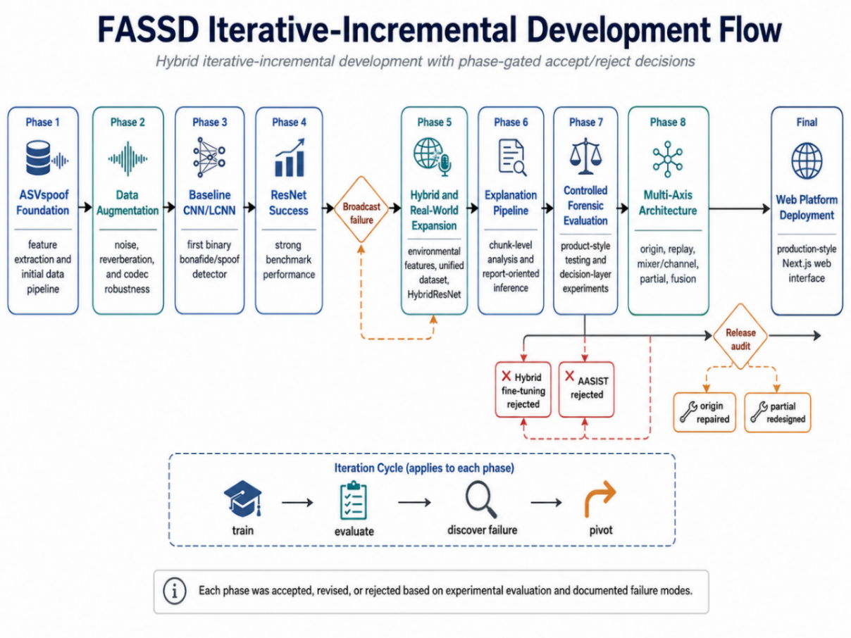
Figure ‎1.1: FASSD Iterative-Incremental Development Flow
The project also used prototyping throughout its development. The system first moved from a binary CNN/LCNN baseline to a stronger ResNet model, then to a HybridResNetEnvironmental model that combined spectral and environmental evidence. Later, controlled forensic testing showed that even stronger binary or anti-spoofing models were not enough for the final project goal. This led to the multi-axis architecture, where origin, replay, mixer/channel, and partial-fabrication evidence were handled separately. The final stages included release-audit fixes, evidence-band reporting, FastAPI backend packaging, and integration with the deployed web platform. In this way, the development model can be understood as a repeated cycle of training, evaluation, failure analysis, redesign, and integration. A phase-flow figure can be added here to show the movement from binary CNN detection to ResNet, HybridResNet, multi-axis evidence, release audit, and web deployment.

Environment and Sustainability
FASSD was developed as a software-only Final Year Project, so it did not require any custom hardware manufacturing or physical product assembly. Most of the work was carried out through dataset preparation, feature extraction, model training, backend development, and web-based deployment. From an environmental point of view, this kept the project’s physical footprint limited to existing computing resources such as student laptops, cloud servers, and available GPU hardware. The main resource cost was computational, especially during model training and repeated evaluation.
The project also required responsible use of computing resources because deep learning experiments can consume significant processing power. For this reason, the development followed an iterative approach where models were tested, accepted, rejected, or refined based on documented results instead of running unnecessary experiments without purpose. The final web deployment used cloud services such as Vercel for the frontend and DigitalOcean droplet for the Phase 9 API backend, which avoided the need to maintain a separate on-premises server for demonstration. Since FASSD remains an experimental decision-support prototype, its deployment choices were kept practical for an academic project while still allowing the system to be tested through a real web interface.

Relevance to Sustainable Development Goals
FASSD has a limited but relevant connection with the Sustainable Development Goals because it is a software-based project focused on digital trust and responsible innovation. The project relates to SDG 9, which focuses on industry, innovation, and infrastructure [3]. FASSD supports this goal at an academic level by developing a web-based audio analysis system that combines machine learning, API-based inference, and a user-facing interface. It does not create physical infrastructure, but it contributes to digital innovation by showing how deep-fake audio detection research can be converted into a working software prototype.
The project also has a connection with SDG 16, which focuses on peace, justice, and strong institutions [4]. Audio manipulation can affect trust in communication, public statements, and evidence review, so tools that support careful analysis may help reduce the risk of misinformation and false claims. However, FASSD should not be overclaimed as a legal or institutional solution. Its contribution is limited to experimental decision support: it provides structured evidence indicators and manual-review guidance, but it does not make court-ready or conclusive authenticity decisions.

Thesis Outline
This thesis is organized into five main chapters, followed by supporting appendices. Chapter 1 introduces motivation, background, problem statement, project objectives, scope, development model, sustainability relevance, and overall direction of FASSD. Chapter 2 presents the literature survey related to synthetic speech, audio deepfakes, anti-spoofing datasets, feature extraction methods, deep learning models, and forensic audio evidence. Chapter 3 explains the methodology and system design, including dataset preparation, preprocessing, feature extraction, model experiments, the final multi-axis forensic architecture, report generation, API design, and the deployed web platform. Chapter 4 presents the results and discussion, covering baseline model performance, ResNet and HybridResNet results, controlled forensic testing, release-audit findings, final evidence-axis results, and the user-facing report output. Chapter 5 concludes the work by summarizing the achieved objectives, main contributions, limitations, and possible future improvements. The appendices provide additional supporting material such as proposal details, dataset and manifest information, feature extraction settings, model configurations, API documentation, interface screenshots, extra result tables, safety wording, and repository structure.

LITERATURE SURVEY

Historical Background
Speech synthesis has developed from earlier rule-based and statistical methods into modern neural systems that can generate speech with much more natural rhythm, tone, and speaker similarity. In general, synthetic speech may be produced through text-to-speech systems, where written text is converted into spoken audio, or through voice conversion systems, where the characteristics of one speaker are modified to resemble another speaker [1]. These techniques are useful in many positive applications, such as assistive technology, media production, and human-computer interaction. At the same time, the same progress has created new risks because generated speech can now be used to imitate a person’s voice more convincingly than older speech synthesis methods.
The problem became more serious as neural text-to-speech and voice conversion models improved in quality. Earlier synthetic voices were often easier to notice because they sounded robotic or unnatural, but recent deep learning systems can produce speech that is more fluent and speaker-like. In audio deepfake research, common manipulated audio types include text-to-speech, voice conversion, emotion manipulation, scene manipulation, and partially fake speech [3]. This wider range of manipulation types means that deepfake audio detection cannot be limited to one narrow case. A recording may be fully generated, converted from another speaker, replayed through a device, or edited only in selected regions.
Audio spoofing countermeasures were developed to protect systems and users against such manipulated speech. In anti-spoofing research, audio is commonly divided into bona fide speech and spoofed speech, where spoofed speech may include synthetic, converted, replayed, or deepfake audio. ASVspoof became one of the important benchmark efforts in this area because it provided structured tasks and datasets for evaluating spoofing countermeasures, including logical access, physical access, and deepfake-related tracks [2]. This type of benchmark-based research helped the field compare different feature extraction methods and machine learning models, such as cepstral features, spectrogram-based features, CNN-style models, and later deep learning architectures.
FASSD was developed within this historical direction, but the project also moved beyond a simple benchmark-style detector. The early stages followed the usual anti-spoofing path by using ASVspoof data, LFCC and log-mel features, and CNN/LCNN-based classification. Later testing showed that forensic audio review needs more than a single fake/real score. Replay, channel processing, mixer effects, and partial edits can all create suspicious evidence, but they do not all mean the same thing. This background explains why FASSD finally shifted toward a multi-axis forensic decision-support design, where origin, replay, mixer/channel, and partial-fabrication evidence are treated separately and reported with cautious manual-review wording.

Synthetic Speech and Audio Deepfakes
Synthetic speech is audio that is generated or modified through computational models instead of being recorded directly from a natural speaker. The two main forms related to this thesis are text-to-speech and voice conversion. In text-to-speech, a system takes written text as input and produces spoken audio. In voice conversion, speech from one speaker is transformed so that it sounds closer to another speaker while keeping much of the original speech content. Modern audio deepfake systems may use these techniques to create speech that sounds natural, speaker-like, and difficult to identify by listening alone [1]. This improvement is useful in many legitimate areas, but it also creates security risks when the generated voice is used without consent or in a misleading context.
Audio deepfakes are different from simple audio editing because they can imitate voice identity, speaking style, and acoustic patterns more realistically. A cloned voice can be used to make it appear as if a real person said something they never said. This can affect personal communication, public statements, online media, and identity-based trust. From a detection point of view, the problem becomes difficult because synthetic speech is not always obviously robotic or unnatural. Some generated samples may contain very small artifacts, while others may sound smooth but still carry hidden spectral or temporal patterns that a machine learning model can learn. This is one reason why audio deepfake detection is commonly studied using anti-spoofing methods and benchmark datasets [3].
The detection problem becomes even more complex when the audio is processed after generation. A synthetic voice may be replayed through a speaker and recorded again through a phone or microphone. It may also be compressed by social media platforms, passed through a mixer, or affected by background noise and room reverberation. These changes can hide some synthetic traces while also adding new acoustic artifacts. In some cases, a recording may not be fully fake; only a short segment may be replaced or inserted. Such partial edits are harder to detect with a single file-level score because the manipulated region can be averaged out by the rest of the recording. These conditions show why real-world deepfake audio detection is not only a classification problem, but also a forensic interpretation problem.
FASSD was designed with these difficulties in mind. The early part of the project followed the standard anti-spoofing direction by using spectral features and machine learning models to separate bona fide and spoofed audio. However, the later stages of the project showed that synthetic speech detection alone could not explain every suspicious case. Replay, channel effects, mixer processing, and partial fabrication may all make an audio file suspicious, but they do not carry the same meaning. For this reason, FASSD was extended into a multi-axis evidence system that separately considers voice origin, replay/rerecording, mixer or channel processing, and partial-fabrication candidate regions. This approach keeps the system useful for human review while avoiding the unsafe claim that every suspicious signal proves deepfake generation.

Audio Anti-Spoofing
Audio anti-spoofing is the task of separating natural human speech from speech that has been artificially generated, converted, replayed, or otherwise produced to imitate a valid speech signal. In this area, natural speech is commonly called bona fide speech, while manipulated or attack speech is called spoofed speech [2]. A countermeasure system, often written as CM, is used to detect whether an input audio sample is likely to be bona fide or spoofed before it is accepted by a larger speech system or reviewed by a human analyst. In automatic speaker verification, this is important because a spoofed sample may try to fool the system into accepting an attacker as a target speaker. In the context of FASSD, the same general idea was used as the starting point, but the final project later expanded from simple anti-spoofing classification into forensic evidence analysis.
A typical anti-spoofing pipeline begins by loading and preprocessing the audio, then extracting acoustic features that represent important speech patterns. Earlier and widely used approaches include cepstral and spectral features such as LFCC, MFCC, and log-mel spectrograms, while more recent systems may use deep neural networks or self-supervised speech representations to learn features directly or semi-directly from audio [1], [3]. After feature extraction, a classifier or neural model produces a score for the input recording. This score is compared with a decision threshold. If the score falls on one side of the threshold, the recording may be treated as bona fide; if it falls on the other side, it may be treated as spoofed. The exact meaning of the score depends on the model design, so the threshold must be chosen carefully using validation or test data rather than assumed manually.
One common evaluation measure in audio anti-spoofing is the Equal Error Rate, or EER. EER is the point at which the false acceptance rate and false rejection rate are equal. A lower EER usually indicates a stronger countermeasure because it means the model is making fewer errors at the operating point where both error types are balanced. However, EER alone does not fully describe real-world reliability. A model may achieve a good EER on a benchmark dataset but still fail when the audio is compressed, replayed, recorded in a different environment, or partially edited. This issue was visible during the development of FASSD, where strong binary models were useful for learning spoofing patterns but were not enough for the final forensic purpose. Therefore, FASSD used anti-spoofing concepts such as bona fide/spoof labels, scores, thresholds, and EER as a foundation, while the final system reported separate evidence axes instead of giving only one fake/real decision.

ASVspoof Dataset and Evaluation Tracks
ASVspoof is one of the main benchmark resources used in audio anti-spoofing research. It provides organized evaluation tracks for studying different forms of spoofed and manipulated speech. The Logical Access track, usually written as LA, focuses on speech synthesis and voice conversion attacks, where the audio is generated or converted digitally before being presented to the system. The Physical Access track, written as PA, focuses on replay attacks, where a bona fide or spoofed recording may be played through a loudspeaker and captured again through a microphone. The Deepfake track, written as DF, was introduced to support evaluation on more diverse deepfake-style audio conditions [2]. Earlier ASVspoof 2019 work mainly formalized LA and PA as separate scenarios for synthetic/converted and replayed speech, while ASVspoof 2021 expanded the challenge setting to include LA, PA, and DF tasks [6], [2].
FASSD used these tracks because the project goal gradually moved beyond a single fake/real classifier. If only LA or DF data had been used, the system would mainly learn digital synthesis or conversion patterns. If only PA data had been used, the system would mainly learn replay and recording-channel artifacts. In real audio review, these conditions can overlap. A suspicious file may contain direct AI-generated speech, replayed speech, compressed speech, channel-processed speech, or a mixture of these effects. For this reason, the FASSD dataset preparation stage included ASVspoof LA, DF, and PA data, then extended the training and testing view through augmentation and RealWorld-style audio. In the unified project statistics, ASVspoof LA, DF, PA, and RealWorld sources were combined to create a broader experimental base for model training and forensic evidence analysis.
Table ‎2.1: ASVspoof Tracks and Relevance to FASSD
ASVspoof Track | Main Focus | Example Attack Type | Relevance to FASSD
Logical Access (LA) | Digitally generated or converted speech | Text-to-speech and voice conversion | Supported early bona fide/spoof learning and voice-origin related experiments
Deepfake (DF) | Deepfake-style generated speech under broader conditions | AI-generated speech and deepfake audio | Helped the project study direct AI-origin detection and deepfake audio evidence
Physical Access (PA) | Replay and rerecording conditions | Audio played through a speaker and recorded again | Supported replay/rerecording evidence modeling in the final multi-axis system

The use of all three tracks also helped FASSD avoid treating every suspicious case as the same type of attack. During development, models trained only for binary spoof detection produced useful results, but they could not fully explain whether the suspicious evidence came from synthetic origin, replay/rerecording, mixer or channel processing, or possible partial fabrication. This was one reason the final system moved toward separate evidence axes. ASVspoof remained important as a foundation because it provided structured anti-spoofing data and evaluation practice, but FASSD used it as part of a larger experimental pipeline rather than as the only definition of the problem.

Audio Features for Deepfake Detection
Audio features are the measurable representations extracted from a speech signal before it is given to a machine learning model. In deepfake audio detection, the model does not usually learn from the raw waveform alone in basic systems; instead, the audio is converted into feature forms that make speech patterns, frequency behavior, and artifacts easier to analyze. Earlier anti-spoofing systems commonly used cepstral and spectral features, while recent systems also use deep learning and self-supervised representations [1], [3]. The choice of features is important because different features highlight different parts of the signal. Some features may capture fine spectral artifacts left by synthesis, while others may better represent general speech structure or environmental effects.
LFCC, or Linear Frequency Cepstral Coefficients, is a commonly used feature in anti-spoofing work because it represents the speech signal on a linear frequency scale. This can be useful for detecting synthetic speech artifacts that may appear in different parts of the spectrum. In FASSD, LFCC was used in the early approved scope because it is strongly connected with traditional spoofing countermeasure research and ASVspoof-style experimentation. The project used LFCC as one of the baseline feature directions for CNN/LCNN-based detection. This helped establish the first working comparison between bona fide and spoofed audio before the project moved toward deeper and more forensic evidence-based stages.
MFCC and log-mel features are also important in speech analysis. MFCCs are based on the mel scale, which is designed to approximate human hearing sensitivity, while log-mel spectrograms represent the energy distribution of audio across mel-frequency bands over time. In deep learning systems, log-mel features are often useful because they preserve a time-frequency structure that CNN-style models can process like an image. FASSD compared LFCC and log-mel because both were relevant to the approved project direction, but they represent audio differently. LFCC provided a more traditional anti-spoofing feature path, while log-mel gave the project a stronger spectrogram-based input for CNN and ResNet-style experiments. This comparison allowed the project to test whether a more image-like spectral representation could improve detection under the selected training and augmentation settings.
Apart from cepstral and spectrogram features, FASSD also explored environmental and acoustic cues. These cues were added after early experiments showed that a model could perform well on benchmark-like data but still behave poorly on more realistic broadcast-style audio. Environmental features in the project included indicators related to noise, reverberation, spectral shape, background behavior, and overly clean audio conditions. These features were not intended to replace deep learning features completely. Instead, they were used to examine whether recording conditions, replay effects, and channel artifacts could provide useful supporting evidence. This step was important because real audio may be affected by microphones, rooms, speakers, compression, and editing tools, not only by the synthetic speech model itself.
The feature development in FASSD therefore moved from a simple feature-comparison stage to a broader forensic evidence view. LFCC and log-mel were useful for the earlier bona fide/spoof experiments, while environmental and acoustic cues helped the project think beyond direct synthetic speech detection. Later, SSL-based representations were also used in the final system for voice-origin related evidence, while acoustic feature sets were used for replay and mixer/channel evidence. This progression matched the main lesson of the project: no single feature type was enough to explain every suspicious audio condition. The final system kept multiple evidence sources separate so that the report layer could describe what type of evidence was present instead of reducing the whole file to one unsupported fake/real claim.

Deep Learning Models for Audio Detection
Deep learning models are widely used in audio deepfake detection because they can learn patterns from spectral or learned audio representations instead of relying only on manually selected rules. In a typical detection setting, an audio file is converted into features such as LFCC, log-mel spectrograms, or learned embeddings, and the model learns to separate bona fide speech from spoofed or synthetic speech. Research in audio deepfake detection has used several model families, including convolutional neural networks, residual networks, graph-based models, attention-based models, and self-supervised learning methods [1], [3]. For FASSD, deep learning was used first as a binary anti-spoofing approach, and later as part of a broader forensic evidence system.
The first model direction in FASSD was based on CNN and LCNN-style classifiers. CNNs are suitable for audio detection when the signal is represented as a spectrogram or cepstral feature map, because convolutional layers can learn local time-frequency patterns. LCNN-style models follow a similar idea but are usually designed to be lighter and more efficient, which made them a practical baseline for a student FYP environment. In the early phases of FASSD, these models were trained with LFCC and log-mel features to test whether the system could classify bona fide and spoofed samples. These experiments were important because they gave the project its first measurable anti-spoofing results and helped compare feature choices under clean and augmented conditions.
After the baseline experiments, FASSD moved to ResNet-style architecture. Residual networks were originally introduced to make deeper neural networks easier to train by using shortcut connections between layers [7]. In FASSD, the ResNet direction was useful because deeper convolutional processing could capture more complex speech patterns than the earlier lightweight baseline. The ResNet experiments showed strong benchmark-style performance in the project, especially on controlled data. However, later real-world style testing showed that strong performance on one evaluation setting did not automatically mean reliable forensic behavior under broadcast, replay, or processed audio. This became one of the main reasons the project did not stop at a single ResNet-based binary detector.

The next step was a hybrid fusion idea, where spectral features were combined with environmental and acoustic cues. This produced the HybridResNetEnvironmental direction, which joined a ResNet-based spectrogram branch with an environmental feature branch. The purpose was to test whether the model could learn both synthetic speech patterns and recording-condition evidence, such as noise, reverberation, background behavior, and channel effects. This hybrid model was an important experiment because it showed that environmental cues could provide useful evidence, but it also showed that a single fused model could still confuse different causes of suspicious audio. A file may be suspicious because of AI origin, replay, mixer/channel processing, or partial editing, and these conditions should not always be treated as one class.
For this reason, the final FASSD architecture did not depend only on CNN, ResNet, or HybridResNet as one final decision engine. These models were part of the development path, but the final system moved toward multi-axis evidence. Separate models and feature sets were used for voice origin, replay/rerecording, mixer or channel processing, and partial-fabrication candidate regions. This design kept the useful learning from the earlier deep learning experiments while reducing the risk of presenting one overconfident fake/real result. In the final report layer, model outputs are treated as evidence indicators and are explained with cautious wording so that manual review remains part of the interpretation.

Data Augmentation and Real-World Robustness
Data augmentation is used in audio detection to expose a model to more varied recording conditions during training. In deepfake audio detection, a model trained only on clean benchmark audio may learn patterns that do not remain stable when the same type of speech is affected by noise, reverberation, compression, gain changes, or device effects. For this reason, augmentation is commonly used to simulate some of the changes that can happen outside a controlled dataset. In FASSD, augmentation was added after the early baseline stage so that the models could be tested against less ideal conditions instead of only clean speech samples. The project used augmentation methods such as background noise, room impulse response reverberation, codec-style processing, gain changes, and clipping. MUSAN was used as a source for music, speech, and noise material, while RIR-style augmentation was used to simulate reverberant room conditions [8], [9].
The augmentation stage in FASSD produced 611,829 additional augmented samples. This was important because the project was not only trying to detect synthetic speech in clean conditions but also needed to understand how models behave when audio quality changes. Noise augmentation helped test whether background sounds could disturb the model. RIR-based reverberation helped represent room and microphone effects. Codec-style processing was useful because real audio is often compressed by platforms, messaging applications, or recording tools. Gain and clipping changes were added because volume and signal distortion can also affect feature extraction. These augmentations were not treated as a complete replacement for real-world data, but they helped make the training process more varied than using clean samples alone.
A major lesson from FASSD was that augmentation improves coverage, but it does not automatically guarantee real-world robustness. The project’s later experiments showed that a model may still perform well on benchmark-style or augmented data and then fail on broadcast-style or highly processed audio. This happened because augmentation can only simulate selected conditions; it cannot fully reproduce every microphone, speaker, room, platform codec, language condition, or editing pattern that may appear in real usage. Audio deepfake detection research also reports that generalization across datasets, attacks, and recording conditions remains a difficult problem [1], [3]. Therefore, FASSD did not treat augmented training results as final proof of reliability.
This limitation influenced the final direction of the system. Instead of relying only on augmentation to make one binary classifier robust, FASSD moved toward controlled forensic testing and separate evidence axes. Augmentation remained useful in the development process, but the final system also considered replay/rerecording evidence, mixer or channel processing, voice-origin evidence, and possible partial-fabrication regions. This made the project more cautious in its interpretation. The system reports evidence indicators and manual-review recommendations rather than claiming that augmentation alone made the detector reliable for all real-world audios.

Advanced Anti-Spoofing and SSL-Based Methods
Advanced anti-spoofing methods were developed because simple feature-based classifiers are often not enough to handle the wide range of attacks found in synthetic and manipulated speech. One important model in this area is AASIST, which stands for Audio Anti-Spoofing using Integrated Spectro-Temporal Graph Attention Networks. AASIST was designed to learn spoofing artifacts from both spectral and temporal information and to model relationships between them using graph attention [10]. This made it different from simpler CNN-style systems that mainly learn local feature patterns. In general, models like AASIST show how audio anti-spoofing research has moved toward architectures that can study more complex relationships inside the speech signal.
FASSD tested AASIST during the project because it was relevant to modern anti-spoofing research and could provide a stronger comparison against the project’s own CNN, ResNet, and HybridResNet experiments. However, AASIST was not selected as an active final model in FASSD. The project documentation showed that although AASIST was useful as a shadow comparison, it produced unacceptable behavior for the final forensic direction of the system, especially with human-origin audio. This was an important phase-gated decision. Instead of keeping a model only because it was advanced in literature, FASSD accepted or rejected models based on how they behaved in the project’s controlled testing and release-audit conditions.
Another important direction in recent speech processing is the use of self-supervised and large-scale pretrained speech representations. Models such as wav2vec 2.0 and WavLM learn useful speech representations from large amounts of audio and can be adapted for downstream tasks [11], [12]. Whisper is also a large-scale speech model, trained for robust speech recognition using weak supervision, and its internal representations are often considered useful for speech-related processing tasks [13]. These models are different from hand-crafted features such as LFCC or log-mel because they can encode richer information from the waveform, including speech content, speaker-related patterns, acoustic context, and other latent characteristics.
In FASSD, the final voice-origin axis used SSL-based embeddings in a WavLM-style direction, while other evidence axes used acoustic feature sets more suited to replay, mixer/channel, and partial-fabrication evidence. This was a cautious design choice. The project did not claim that SSL embeddings alone solved deepfake detection, and it did not replace the full forensic pipeline with one pretrained model. Instead, SSL features were used where they were most useful: supporting the origin-related evidence axis. The final architecture therefore combined lessons from advanced anti-spoofing and SSL-based research while still preserving the project’s manual-review wording and separate evidence interpretation.

Forensic Audio Cues and Manipulation Evidence
Forensic audio analysis does not only look for whether a voice was generated by AI. It also considers whether the recording contains signs of replay, rerecording, channel processing, editing, or other manipulation evidence. Replaying evidence is especially important because a real human voice can become suspicious after being played through a loudspeaker and recorded again through another microphone. This type of signal may contain additional room reverberation, speaker response, microphone coloration, background noise, or loss of high-frequency detail. ASVspoof physical access research treats replay as a separate spoofing condition because it involves the acoustic path between playback and recording devices, not only the digital generation of speech [2], [6].
Channel and device effects are also important forensic cues. A recording may pass through mobile phones, microphones, communication platforms, editing tools, mixers, or compression systems before it is analyzed. Each stage can change the spectral shape, noise floor, dynamic range, and overall signal quality. In forensic audio authentication, the examiner is concerned with whether the recording is consistent with the way it is claimed to have been produced, and whether there are signs of alteration, copying, or generation loss [14]. These cues may help identify suspicious processing, but they do not automatically prove AI generation. For example, a clean human recording compressed by a social media platform may look different from its original version, while a synthetic voice replayed in a noisy room may hide some of its synthetic traces.
This separation is important for FASSD because early binary detection experiments showed that different suspicious conditions can be confused if they are forced into one fake/real label. A replayed human voice, a direct AI voice, an AI voice passed through a mixer, and a partially edited recording may all produce abnormal evidence, but the meaning of that evidence is not the same. Replay or mixer evidence mainly points toward recording-path or channel manipulation. Voice-origin evidence points toward whether the speech appears closer to human-origin or AI-origin patterns. Partial-fabrication evidence points toward possible localized regions that may require manual inspection. Treating these cues separately reduces the risk of saying that every suspicious audio file is AI-generated.
The final FASSD design follows this distinction by separating synthesis-related evidence from forensic manipulation evidence. The system includes separate axes for voice origin, replay/rerecording, mixer or channel processing, and possible partial-fabrication candidate regions. This does not make the system a certified forensic authority, but it makes the output more careful and explainable than a single confidence score. The report layer therefore describes replay and channel findings as forensic indicators, not as proof of deepfake generation. This cautious wording is necessary because manipulation evidence can support human review, but it should not be treated as a conclusive authenticity decision without additional expert examination and case context.

Partial Fabrication and Segment-Level Analysis
Partial fabrication refers to a case where only a selected part of an audio recording is synthetic, inserted, replaced, or otherwise manipulated, while the remaining part may still be natural speech. This is different from a fully generated deepfake, because the suspicious region may occupy only a small percentage of the full file. A file-level detector can miss this type of manipulation because it produces one overall score for the whole recording. If most of the recording is natural and only a short region is manipulated, the evidence from the manipulated part may be weakened when it is averaged with the rest of the signal. Recent work on segmental speech features also highlights the need to examine smaller audio regions when the goal is forensic deepfake detection rather than only whole-file classification [15].
Segment-level analysis addresses this problem by dividing the audio into shorter windows and analyzing each part separately. Instead of asking only whether the complete file is suspicious, the system can ask whether any region contains stronger evidence than the surrounding audio. This is useful for partial fabrication because the manipulated region may create local differences in spectral structure, acoustic consistency, voice-origin evidence, or processing behavior. Segment analysis can also support visual review because candidate timestamps can be shown to the user or examiner. However, segment-level results must be handled carefully. A suspicious segment may indicate an area that deserves attention, but it does not automatically prove that the segment is AI-generated or maliciously edited.
In FASSD, partial fabrication was treated as an experimental manual-review axis rather than a conclusive detection module. The project built segment-level tests, file gates, localization experiments, and oracle-style evaluations to understand whether the system could identify candidate regions in partially fabricated files. These experiments showed that segment analysis was useful, especially for pointing toward possible areas of interest, but the results were not strong enough to claim reliable partial-fabrication detection in all cases. For this reason, the final FASSD report layer presents partial evidence as candidate evidence only. The system may highlight suspicious regions for review, but it does not claim that every highlighted segment is fake, and it does not claim that the absence of partial evidence proves the recording is authentic.

Research Gaps
Research in audio deepfake detection has made strong progress through benchmark datasets, standard evaluation tracks, and improved deep learning models. However, one gap is that many systems are still designed mainly around a binary decision: bona fide or spoofed. This is useful for anti-spoofing research, but it does not fully match the needs of a forensic-style software product. In a real review setting, a user may need to know whether the suspicious evidence is related to AI voice origin, replay/rerecording, channel processing, or a possible local edit. Recent work also shows that generalization remains a major problem when models learn speaker- or dataset-specific patterns instead of stable forgery artifacts [16]. This supports the need for systems that do more than output a single confidence score.
A second gap is the difference between benchmark performance and real-world platform behavior. Metrics such as EER and AUC are useful for comparing models on controlled test sets, but they do not guarantee that the same model will work reliably on broadcast audio, compressed social-media clips, phone recordings, or replayed files. This issue was also observed during FASSD development, where strong binary models gave useful benchmark results but did not provide enough reliability under more practical audio conditions. For this reason, the project treated benchmark evaluation as necessary but not sufficient. Controlled forensic testing and release-audit checks were added to examine how the system behaved on replay, mixer/channel, partial-fabrication, and real-world-style cases.
Another important gap is the lack of user-facing forensic explanation in many detection workflows. A model score may be useful for researchers, but it is difficult for a normal user or reviewer to interpret without context. FASSD responded to this gap by shifting the final design toward a report-based evidence system. The final system separates origin, replay/rerecording, mixer or channel processing, and partial-fabrication candidate evidence. It also uses evidence bands, cautious wording, waveform/timeline support, and manual-review recommendations. This does not make FASSD a certified forensic tool, but it makes the output more suitable for structured review than a single fake/real label.
Table ‎2.2: Research Gaps and FASSD Response
Research Gap | FASSD Response
Single fake/real score hides different causes of suspicious audio | Four evidence axes with fusion logic and cautious interpretation
ASVspoof-only domain may not represent all real-world audio conditions | Unified dataset direction, RealWorld-style audio, augmentation, and controlled forensic testing
Benchmark EER does not guarantee success on broadcast, replayed, or platform-compressed audio | Phase-wise failure analysis, controlled role testing, and release-audit matrix
No clear user-facing forensic report in many research pipelines | Evidence-band reports, waveform/timeline support, and deployed web interface
Partial edits can be missed by file-level scores | Experimental segment-level partial-fabrication candidate axis

These gaps directly shaped the final direction of FASSD. The project did not reject benchmark-based anti-spoofing; instead, it used it as the foundation and then extended the work toward forensic decision support. The final system still depends on machine learning evidence, but it avoids claiming universal detection or legal proof. Its main contribution is the combination of model experimentation, real-world failure analysis, multi-axis evidence, and a usable web interface that presents results in a more careful and review-oriented form.

Summary of Literature Survey
The literature survey shows that FASSD is connected to both traditional audio anti-spoofing research and newer audio deepfake detection work. Existing studies and benchmark efforts support the official project direction of using ASVspoof-style data, bona fide/spoof labels, feature extraction, and deep learning models for speech spoofing detection [1], [2]. Features such as LFCC, MFCC, and log-mel spectrograms provide a foundation for CNN and LCNN-based experimentation, while later research also supports the use of stronger architectures and self-supervised speech representations [3]. This background justifies the approved scope of the project, where the initial goal was to prepare datasets, extract features, train anti-spoofing models, and evaluate them using standard metrics such as EER and AUC.
At the same time, the reviewed literature and the project’s own experiments show that benchmark performance alone is not enough for a forensic-style software system. Real audio may contain replay effects, channel processing, compression, background noise, or partial manipulation, and these conditions can make a single fake/real score difficult to interpret. This gap motivated FASSD to move beyond the original LCNN-based detection scope toward a multi-axis decision-support system. The extended system separates voice-origin evidence, replay/rerecording evidence, mixer or channel evidence, and partial-fabrication candidate regions, then presents them through a web-based interface and report layer. The next chapter explains how this methodology was implemented, including dataset preparation, preprocessing, model development, evidence-axis design, backend integration, and the deployed user-facing software.

METHODOLOGY

Overview of Methodology
The methodology of FASSD follows an end-to-end experimental pipeline that starts with dataset preparation and ends with a user-facing forensic audio report. The first stage involved preparing audio data from ASVspoof tracks, augmented samples, Real-world-style sources, and controlled project recordings. After dataset preparation, the audio was processed into different feature forms depending on the experiment. LFCC and log-mel features were used in the early anti-spoofing models, environmental/acoustic cues were added to study recording conditions, and SSL-based representations were later used for the voice-origin evidence axis. This allowed the project to move from a simple bona fide/spoof classification setup toward a broader forensic evidence workflow.
The model development process was phase-based. Earlier experiments trained CNN/LCNN, ResNet, and HybridResNetEnvironmental models to compare feature types and model behavior. These experiments helped identify both useful patterns and practical limitations, especially when benchmark-style performance did not fully match real-world or controlled forensic testing. The final methodology therefore separated the inference process into four evidence axes: voice origin, replay/rerecording, mixer or channel processing, and partial-fabrication candidate regions. Each axis produced its own evidence indicator, and the fusion layer combined these indicators into a cautious interpretation instead of 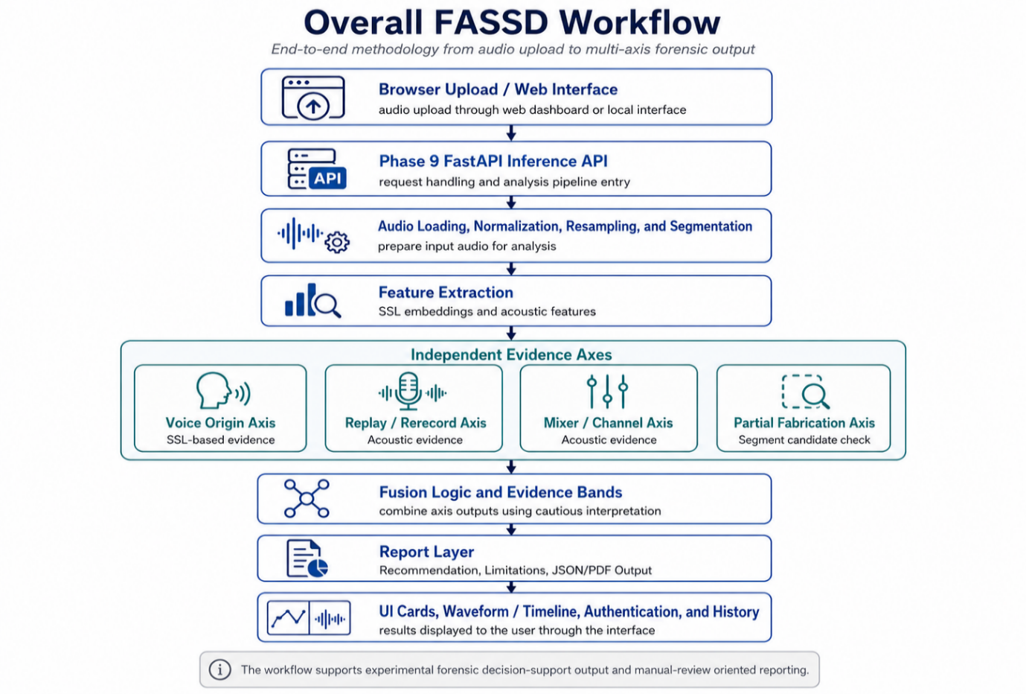forcing all evidence into one fake/real decision.
Figure ‎3.1: FASSD Workflow
The final software methodology connects the machine learning backend with the deployed web interface. A user uploads an audio file through the browser, the API analyzes the file using the four evidence axes, and the interface displays the results through evidence cards, waveform/timeline support, and report outputs. Authentication and history features are included in the web platform to support repeated use during demonstration and review. The methodology keeps the system practical as software deliverable while preserving the project’s main limitation: FASSD provides experimental decision support and manual-review guidance, not court-ready authenticity judgment.

Research Design
The research design of FASSD was experimental because the project depended on training, testing, comparing, and revising machine learning models. The work did not begin with a fixed final architecture that remained unchanged until the end. Instead, each phase tested a specific assumption about deepfake audio detection. For example, the early assumption was that spectral features with CNN/LCNN models could separate bona fide and spoofed speech. Later assumptions tested whether ResNet-style models, environmental features, hybrid fusion, AASIST comparison, and finally separate evidence axes could improve the system’s practical value. This made the project suitable for an experimental ML design, where progress was measured through results, failure cases, and documented model behavior.
The project also followed a hypothesis-test-pivot pattern. In each phase, a method was selected, trained or implemented, evaluated, and then either accepted, modified, or rejected. When a model produced strong benchmark results but failed under real-world or controlled forensic conditions, the next phase was changed instead of hiding the weakness. This was visible in the shift from binary fake/real detection toward multi-axis evidence. The ResNet and HybridResNetEnvironmental stages were useful experiments, but they were not treated as final forensic solutions because later tests showed that replay, channel processing, and AI-origin evidence should not be merged into one simple decision.
This design helped keep the final system realistic. The accept/reject decisions across phases were documented through validation reports, controlled testing outputs, release-audit checks, and final packaging results. By the end of development, the research design had produced not only trained models, but also a structured inference pipeline, evidence fusion rules, report wording, and a deployed web interface. Therefore, the methodology of FASSD can be described as an iterative experimental design with phase-gated decisions, where the final system was shaped by both successful results and documented failures.

Official Approved Methodology
The officially approved methodology of FASSD was based on an audio anti-spoofing workflow using ASVspoof 2021 data, mainly the Deepfake and Logical Access tracks. These tracks were selected because they provided structured bona fide and spoofed speech samples for studying synthetic and converted speech detection [2]. In the approved scope, the audio files were first prepared and standardized for feature extraction. Two main feature types were used at this stage: 20-dimensional LFCC features and 64-dimensional log-mel representations. LFCC was included because of its common use in spoofing countermeasure research, while log-mel features were included because they provide a time-frequency representation suitable for convolutional deep learning models. This setup allowed the project to compare traditional cepstral-style features with spectrogram-style inputs under the same general detection task.
The approved classifier direction was LCNN-based deepfake audio detection. The purpose of this stage was to train a model that could separate bona fide speech from spoofed or AI-generated speech and then evaluate its performance using measurable classification metrics. To improve robustness, the methodology also included data augmentation. MUSAN noise was used to add background noise conditions, RIR-based processing was used to simulate reverberation, and codec-style processing was used to represent compression effects that may appear in practical audio files [8], [9]. These augmentation methods were not treated as a complete solution to real-world generalization, but they were part of the approved training strategy for making the model less dependent on clean audio conditions.
The approved evaluation plan included Equal Error Rate, ROC-AUC, accuracy, and confusion matrices. EER was useful for measuring the balance between false acceptance and false rejection, while ROC-AUC helped show the model’s separation ability across different thresholds. Accuracy and confusion matrices were used to understand correct and incorrect predictions in a simpler form. The final approved deliverable also included a software tool where an external audio file could be uploaded and analyzed by the trained model. This approved methodology formed the foundation of FASSD before the later project phases extended the work into multi-axis forensic evidence, report generation, and web-based deployment.

Extended Methodology
The extended methodology of FASSD was added after the approved LCNN-based plan showed that a basic binary anti-spoofing workflow was not enough for the final project direction. These extensions did not replace the approved methodology; they developed from it. The project first moved from CNN/LCNN baselines toward a ResNet-style model to test whether deeper convolutional architecture could learn stronger audio patterns from spectrogram-based inputs [7]. This stage gave useful benchmark-style results and helped show the value of deeper feature learning. However, later testing also showed that strong results on controlled data did not automatically mean that the system could handle broadcast-style, replayed, compressed, or channel-processed audio reliably.
To study these weaknesses, the methodology was extended with environmental and acoustic feature analysis. The project added cues related to noise, reverberation, spectral behavior, background conditions, and overly clean audio patterns. These features were then combined with a ResNet branch in the HybridResNetEnvironmental direction. The purpose was to check whether synthetic speech evidence and recording-conditioning evidence could be learned together. This hybrid model was useful as an experiment because it showed that environmental features can support analysis, but it also showed a limitation: a single fused binary or multiclass model can still confuse different causes of suspicious audio. A replayed human voice, a direct AI voice, and a mixer-processed file may all appear abnormal, but their forensic meaning is not the same.
The project also tested AASIST as a modern anti-spoofing comparison model because it is designed to capture spectro-temporal spoofing evidence using graph attention [10]. In FASSD, AASIST was treated as a trial and shadow comparison, not as a final active model. The decision to reject it from the active release was based on project testing, where its behavior did not match the cautious forensic requirements of the final system. This followed the phase-gated method used throughout the project: train or test a model, evaluate it under the project’s own conditions, then accept, modify, or reject it based on documented evidence.
The final extended methodology was shaped through Phase 7 controlled forensic testing, Phase 8 multi-axis evidence design, Phase 9 release freezing, and the final release audit. Instead of giving one fake/real result, the final system separated voice-origin evidence, replay/rerecording evidence, mixer or channel evidence, and partial-fabrication candidate evidence. Fusion rules and evidence bands were added so that the report could describe what type of evidence was present without making a conclusive legal claim. The methodology was then connected to the production web deployment, where the browser interface sends uploaded audio to the Phase 9 API and displays the four evidence cards, waveform/timeline support, report output, authentication, and history features. This made the final FASSD deliverable both a machine learning pipeline and a usable forensic decision-support software prototype.

Dataset Preparation
Dataset preparation in FASSD was handled through a manifest-based workflow so that every audio sample could be tracked with its source, label, attack type, domain, speaker information, and split assignment. The official dataset foundation came from ASVspoof data, especially the Logical Access, Deepfake, and Physical Access tracks, which provided structured bona fide and spoofed speech conditions for anti-spoofing experimentation [2]. During project development, the dataset preparation was extended beyond the original proposal because the system needed to study not only synthetic speech, but also replay, channel effects, and more realistic audio conditions. For this reason, ASVspoof LA, DF, PA, and RealWorld-style audio were merged into a unified dataset view.
The label schema was designed to support both basic anti-spoofing and later forensic interpretation. At the highest level, each file was labelled as bona fide or spoofed. Additional fields were used to describe attack categories such as replay, conversion, and synthesis. Domain labels were also important because the dataset was not evenly distributed across all recording conditions. The unified statistics show that the dataset was heavily studio-dominated, which is useful for controlled learning but also explains why later project phases needed RealWorld-style testing, augmentation, and forensic role-based evaluation. Speaker information was also preserved, and speaker-independent splitting was used to reduce overlap between training and testing speakers.
Table ‎3.1: Dataset Summary
Dataset / Statistic | Count / Value
Total unified samples | 1,893,919
ASVspoof PA samples | 943,110
ASVspoof DF samples | 611,829
ASVspoof LA samples | 181,566
RealWorld-style samples | 157,414
Spoof samples | 1,573,308
Bona fide samples | 320,611
Replay attack samples | 816,480
Conversion attack samples | 589,212
Synthesis attack samples | 167,616
Studio-domain samples | 1,819,660
Read-speech-domain samples | 28,539
Broadcast-domain samples | 17,994
Podcast-domain samples | 17,512
Social-domain samples | 5,712
Synthetic-domain samples | 4,502
Speakers | 73,421
Mean duration | 6.25 seconds
Test speakers overlap | 0

The unified merge was important because FASSD was not kept limited to one dataset condition. The PA portion supported replay/rerecording learning, the LA and DF portions supported synthetic and converted speech detection, and the Real-world-style portion helped the project examine behavior outside clean benchmark conditions. However, the dataset summary also shows a clear limitation: most samples came from studio-like domains, while broadcast, podcast, social, and synthetic-domain recordings were much smaller in comparison. This imbalance was considered during later evaluation, where the project did not rely only on aggregate dataset performance. Instead, controlled forensic testing and release-audit checks were used to understand how the system behaved under replay, mixer/channel, partial-fabrication, and web-deployment conditions.

Audio Preprocessing
Audio preprocessing in FASSD was used to make uploaded and dataset audio files consistent before feature extraction and model inference. The first step was audio loading, where the system reads the input file and prepares it for analysis. Since audio files can come in different formats, sampling rates, channel layouts, and durations, the production API standardizes the signal before passing it to the evidence models. In the deployed pipeline, audio is handled as mono speech and resampled to 16 kHz for consistent downstream processing. This helps reduce variation caused only by file format or recording settings, so that the models receive audio in the expected form.

Normalization was applied to keep the waveform amplitude within a stable range. This does not mean that the audio is made “clean” or that manipulation traces are removed. It only means that the signal level is adjusted so that feature extraction is less affected by large volume differences between files. After resampling and normalization, the system extracts the required feature sets depending on the evidence axis. For example, SSL-based processing is used for the voice-origin axis, while acoustic features are used for replay and mixer/channel evidence. Keeping this preprocessing stage consistent was necessary because small changes in sampling rate, channel format, or amplitude handling can affect the features and final model scores.
Segmentation was used where the system needed local evidence instead of only a whole-file result. This was especially important for the partial-fabrication axis, because a manipulated region may appear only in a short part of the recording. By dividing the audio into smaller segments, the system can examine whether any region behaves differently from the rest of the file. These segment-level outputs are not treated as final proof of fabrication. In FASSD, they are used as candidate evidence for manual review, with the report layer presenting them cautiously through waveform or timeline support when available.

Data Augmentation
Data augmentation in FASSD was used to increase the variety of training audio and to reduce dependence on clean dataset conditions. The project applied several augmentation types, including MUSAN-based background noise, room impulse response reverberation, codec-style processing, gain changes, and clipping. MUSAN was useful for adding noise, music, and speech-like background conditions, while RIR-based processing helped simulate reverberation caused by rooms and recording spaces [8], [9]. Codec-style augmentation was included because real audio is often compressed by platforms or recording tools and gain or clipping changes were added to represent common signal-level variations. Through this augmentation stage, FASSD generated 611,829 additional samples for training and robustness experiments.
The purpose of augmentation was not to artificially inflate the dataset without reason. It was used to test whether models could remain stable when audio conditions changed. In the early phases, augmentation supported CNN/LCNN and later model experiments by exposing the system to more than clean ASVspoof-style recordings. This was important because a deepfake detector may perform well on clean audio but become less reliable when the same speech is noisy, reverberant, compressed, or distorted. Augmentation therefore helped the project study robustness in a controlled way before moving toward RealWorld-style and forensic role-based testing.
In the final release-audit work, augmentation was also used more carefully for the voice-origin retraining stage. The release audit treated augmentation as a train-only strategy, meaning augmented samples were used to improve training coverage without mixing those same transformed samples into the final testing logic in a way that would make the evaluation misleading. This was especially important for the origin evidence axis, where the project needed better behavior on processed AI-origin cases while still avoiding false AI claims on human-origin audio. The final lesson from FASSD was that augmentation is useful, but it is not enough by itself. It improved exposure to expected distortions, but the project still required controlled forensic testing, release-audit checks, and separate evidence axes to handle replay, channel processing, and partial fabrication more cautiously.

Feature Extraction
Feature extraction in FASSD changed across the project phases as the system moved from a basic anti-spoofing classifier to a multi-axis forensic evidence system. In the approved scope, the main purpose of feature extraction was to convert speech audio into measurable inputs for bona fide/spoof classification. LFCC and log-mel features were used at this stage because they are common in speech and spoofing detection pipelines and can represent useful spectral patterns for CNN/LCNN-style models [1], [3]. This stage helped the project build a measurable baseline before moving toward deeper and more complex models.
As development continued, the feature strategy became broader. Log-mel spectrograms were used in the ResNet and HybridResNetEnvironmental experiments because they provided a two-dimensional time-frequency representation suitable for convolutional learning. Environmental and acoustic features were later added after the project found that benchmark-style synthetic speech detection did not fully explain replay, broadcast, channel, or mixer-related conditions. In the active release direction, SSL embeddings were used for the voice-origin model, while acoustic features supported replay and mixer/channel evidence. The final feature extraction design therefore did not depend on one feature type only; it used different feature sets for different evidence axes.
Table ‎3.2: Feature Sets Used in FASSD
Project Phase / Use | Feature Set | Main Model or Axis | Purpose in FASSD
Official baseline phase | LFCC, 20 coefficients | CNN/LCNN baseline | Initial bona fide/spoof detection
Feature comparison phase | Log-mel, 64 bins | CNN/LCNN comparison | Compare spectrogram-style input against LFCC
ResNet phase | Log-mel spectrograms | ResNet CNN | Stronger convolutional feature learning
Hybrid phase | Log-mel + 12-D environmental vector | HybridResNet_  Environmental | Combine synthetic speech and recording-condition cues
Final origin axis | SSL embeddings, WavLM-style | origin_file_model | Voice-origin evidence
Final replay axis | Acoustic feature set | replay_file_model | Replay/rerecording evidence
Final mixer/channel axis | Acoustic feature set | mixer_file_model | Mixer or channel processing evidence
Partial fabrication axis | Segment-level feature set | Partial fabrication segment model | Candidate region analysis for manual review

LFCC Features
LFCC features were used in the early approved methodology of FASSD as a baseline representation for spoofing detection. The project used 20 LFCC coefficients as input features for the initial CNN/LCNN-style model experiments. LFCC was selected because it gives a compact cepstral representation of the speech signal and is commonly used in anti-spoofing research. In the FASSD pipeline, LFCC features helped convert raw audio into a fixed feature form that could be used for supervised bona fide/spoof classification.
The LFCC baseline produced a clean EER of 9.68% and an augmented EER of 15.71%. These results showed that the approved feature-and-model pipeline was working, but they also showed that the baseline was not strong enough to retain the final system direction. The increase in EER under augmentation suggested that robustness was still a challenge. For this reason, LFCC was kept as an important baseline in the thesis, while later phases explored log-mel features, ResNet-style models, environmental features, and multi-axis evidence.

Log-Mel Spectrogram Features
Log-mel spectrogram features were used as an alternative to LFCC because they preserve the time-frequency structure of audio in a form that is suitable for CNN and ResNet-style learning. In FASSD, 64 log-mel bins were used during the feature comparison stage. Unlike compact cepstral coefficients, log-mel features give the model a spectrogram-like view of how energy changes over time and frequency. This made them useful for experiments where convolutional models needed to learn local patterns from speech audio.
The log-mel feature direction performed slightly better than LFCC in the augmented comparison, with an augmented EER of 15.25% compared with 15.71% for LFCC. Although this difference was not enough by itself to solve the detection problem, it helped justify continuing the log-mel path in later experiments. Log-mel features were then used in the ResNet and HybridResNetEnvironmental stages, where deeper models could learn more complex patterns from the spectrogram representation. In the final thesis, this feature path is important because it connects the approved LCNN-style scope with the later ResNet and hybrid model development.

Environmental and Acoustic Features
Environmental and acoustic features were added after the project observed that synthetic speech detection alone could not fully explain real-world audio behavior. A recording may become suspicious because of replay, room reverberation, microphone effects, compression, or mixer/channel processing, even when the voice itself is not AI-generated. To study this, FASSD introduced a 12-dimensional environmental feature vector during the HybridResNetEnvironmental phase. These features represented conditions such as noise behavior, reverberation-related cues, spectral shape, background characteristics, and overly clean audio patterns.
This feature direction later influenced the active release models for replay and mixer/channel evidence. In the final system, acoustic features were not used to claim that a voice was AI-generated. Instead, they were used to support separate forensic evidence axes. The replay model used acoustic evidence to detect possible replay or rerecording behavior, while the mixer/channel model used acoustic evidence to identify possible channel or processing effects. This separation was important because replay or mixer evidence may indicate manipulation or recording-path change, but it is not the same as AI-origin evidence.

SSL Embeddings
SSL embeddings were used in the final FASSD release for the voice-origin evidence axis. Self-supervised speech models such as WavLM are trained to learn speech representations from large-scale audio and can be useful for downstream speech tasks [11]. In FASSD, a WavLM-style SSL feature direction was used for the active origin_file_model. This model was responsible for estimating whether the voice-origin evidence appeared closer to human-origin or AI-origin patterns. It was not used as a universal deepfake detector, and its output was interpreted through the report layer as one evidence axis only.
In the deployed API, the SSL model dependency was handled during backend startup, where the required Hugging Face model resources were downloaded or prepared for inference. This made the production backend different from the earlier local experiments because the web-facing system needed reliable model loading before accepting uploaded audio. The SSL origin axis was combined with acoustic replay, mixer/channel, and partial-fabrication evidence in the final fusion layer. This design allowed FASSD to use stronger speech representations while keeping the forensic interpretation cautious and multi-axis.

Baseline CNN/LCNN Model
The baseline CNN/LCNN model was developed to satisfy the official approved scope of FASSD and to establish the first complete training and evaluation pipeline. This stage used extracted audio features as model input and focused on the basic anti-spoofing task of separating bona fide speech from spoofed or AI-generated speech. The model was intentionally lightweight, with approximately 5,000 trainable parameters, so that it could be trained and evaluated within the available student hardware environment. Although it was not expected to be the final forensic model, it was important because it confirmed that the dataset preparation, feature extraction, training loop, validation process, and metric calculation were functioning correctly.
In this baseline stage, LFCC features were used as one of the main inputs for the CNN/LCNN-style classifier. The LFCC clean condition produced an EER of 9.68%, while the augmented condition produced an EER of 15.71%. These results showed that the baseline model was able to learn useful spoofing-related patterns from the prepared data, but it also showed that performance became weaker when augmentation was introduced. This was an early indication that robustness would be a major issue for the project. The baseline therefore served two purposes: it met the approved methodology requirement and provided a reference point for later models.
The CNN/LCNN stage was not treated as a final solution for FASSD. Instead, it became the foundation for later experiments with log-mel features, ResNet-style models, hybrid environmental fusion, AASIST comparison, and the final multi-axis evidence system. By starting with a small baseline model, the project could measure whether each later extension improved the system or reveal new limitations. This helped keep the development process evidence-based rather than changing the architecture without a clear reason.

ResNet-Based Model
The ResNet-based model was developed after the baseline CNN/LCNN experiments to test whether a deeper spectral convolutional model could learn stronger spoofing patterns from the prepared audio features. ResNet-style models use residual connections to support deeper network training, which made this direction suitable for moving beyond the lightweight baseline [7]. In FASSD, the ResNet model performed very strongly in the ASVspoof-style evaluation path. It achieved a clean EER of 0.57% and an augmented EER of 2.61%, which showed a clear improvement over the earlier CNN/LCNN baseline. These results confirmed that deeper spectral learning could capture useful patterns in controlled benchmark-style conditions.
However, the ResNet model was not selected as the final active model because its later behavior did not satisfy the forensic requirements of FASSD. When the project tested real-world broadcast-style audio, the model produced serious false-positive behavior and predicted all tested Trump broadcast examples as fake, including the real samples. This became an important project lesson: a model can perform very well on ASVspoof-style evaluation while still failing when the audio comes from a different recording environment, media source, or processing condition. For a forensic decision-support tool, this type of failure is too risky because it may create an overconfident fake claim on genuine audio.
For this reason, the ResNet model was kept as a reference experiment rather than an active release component. Its status in the release direction was treated as reject_for_now, not because the model was weak in benchmark testing, but because benchmark success was not enough for the final product goal. The ResNet stage helped prove that high benchmark performance alone could not define FASSD’s final methodology. This finding directly supported the later shift toward multi-axis evidence, release-audit checks, cautious report wording, and manual-review recommendations.

Environmental Feature Classifier
The environmental feature classifier was added after the ResNet stage showed that strong benchmark performance was not enough to handle real-world-style audio. The purpose of this experiment was to study whether recording-conditioning cues could help explain why some real broadcast samples were being misclassified. Instead of looking only for synthetic speech artifacts, this stage examined acoustic conditions such as noise level, reverberation behavior, spectral shape, background characteristics, and overly clean audio patterns. These features were useful because a suspicious recording may be affected by the microphone, room, platform compression, or replay path, even when the voice itself is not AI-generated.
Two directions were tested in this stage. The first was an anomaly-based approach, where the system attempted to separate unusual audio conditions without relying fully on supervised class labels. This approach performed poorly, with accuracy around 24.5%, so it was not suitable for the project’s final direction. The second direction used supervised classification with environmental features and achieved 81.69% accuracy on ASVspoof-style data. This showed that environmental cues did contain useful information, but the project also found that real and fake broadcast-style scores could still overlap. For this reason, the environmental classifier was treated as an important learning stage rather than a standalone detector.
The main contribution of this phase was not a final production model, but a change in project understanding. It showed that recording-conditioning evidence can support forensic analysis, yet it should not be mixed carelessly with AI-origin evidence. This lesson later influenced the HybridResNetEnvironmental experiment and the final multi-axis design, where replay and mixer/channel evidence were separated from voice-origin detection. In the final FASSD system, acoustic evidence is therefore used cautiously as supporting evidence for specific manipulation axes, not as direct proof that an audio file is AI-generated.

HybridResNetEnvironmental Model
The HybridResNetEnvironmental model was developed to test whether spectral deep learning and environmental audio cues could be combined in a single model. Its architecture used log-mel spectrogram input for the ResNet-based branch and a 12-dimensional environmental feature vector for the acoustic-condition branch. The ResNet branch focused on time-frequency speech patterns, while the environmental branch represented cues such as noise behavior, reverberation, background characteristics, spectral shape, and overly clean audio conditions. These two branches were fused so that the model could learn from both synthetic-speech patterns and recording-condition evidence. In testing, the model achieved an EER of 16.21% and an AUC of 0.9167. On the Real-world-style test portion, it achieved an EER of 16.14%, which showed that the hybrid approach had useful separation ability across the evaluated data. The multiclass accuracy was 64.36%, which indicated that separating different attacks or condition types was still more difficult than binary scoring.
Although the HybridResNetEnvironmental model was an important improvement in the project’s learning process, it was not selected as an active final release model. The main limitation was its high bona fide false-positive behavior, where some real human audio was still treated as suspicious. This was a serious issue for FASSD because the final system needed cautious forensic wording rather than overconfident fake claims. The model also showed that combining all evidence into one fused classifier could still confuse different causes of suspicious audio. A replayed human recording, a direct AI voice, and a mixer-processed file may all appear abnormal, but they should not be interpreted in the same way. For this reason, the HybridResNetEnvironmental model was kept as a reference-only model in the final release. Its results helped motivate the later multi-axis design, where voice origin, replay/rerecording, mixer or channel processing, and partial-fabrication candidate evidence are handled separately.

AASIST Experiment
The AASIST experiment was carried out in Phase 7E to compare FASSD’s own model path with a stronger modern anti-spoofing architecture. AASIST was relevant because it is designed for audio anti-spoofing using integrated spectro-temporal graph attention, which allows the model to learn relationships across both spectral and temporal information [10]. In FASSD, it was not introduced as a guaranteed replacement for the existing models. It was tested as a controlled comparison to see whether an advanced anti-spoofing model could behave more reliably on the project’s forensic role-based audio cases.
The Phase 7E results showed that AASIST was not suitable as a standalone judge for the final system. It produced false alarms on 22 out of 23 clean-human samples, meaning that most clean human audio was treated as suspicious. This behavior was unacceptable for FASSD because the project required cautious forensic decision support, not a model that overflags genuine human recordings. For this reason, AASIST was rejected as an active release model and kept only as an inactive reference under release/models/reference/aasist/. This decision also supported the wider project lesson that advanced benchmark models still need project-specific validation before being used in a user-facing forensic tool.

Final Multi-Axis Forensic Architecture
The final FASSD architecture was designed after the earlier model experiments showed that a single binary fake/real detector was not enough for forensic-style audio review. The project began with CNN/LCNN baselines, then tested ResNet, HybridResNetEnvironmental, and AASIST-based directions. These models helped improve understanding of spoofing and synthetic speech patterns, but they also showed practical weaknesses when audio contained replay, broadcast processing, mixer/channel effects, or clean human speech that was incorrectly flagged. The final architecture was therefore frozen as a multi-axis forensic evidence system rather than a single verdict model.
In the final design, FASSD analyzes an uploaded audio file through four active evidence axes: voice origin, replay/rerecording, mixer or channel processing, and partial-fabrication candidate evidence. Each axis is responsible for a different type of evidence. The origin axis estimates whether the voice-origin pattern appears closer to human or AI speech. The replay axis checks for possible rerecording or playback-path evidence. The mixer/channel axis checks for processing effects that may come from channel or editing conditions. The partial-fabrication axis examines segment-level candidate regions for manual review. This separation is important because replay or channel evidence is not the same as AI generation, and partial evidence does not automatically prove that a file is fake.
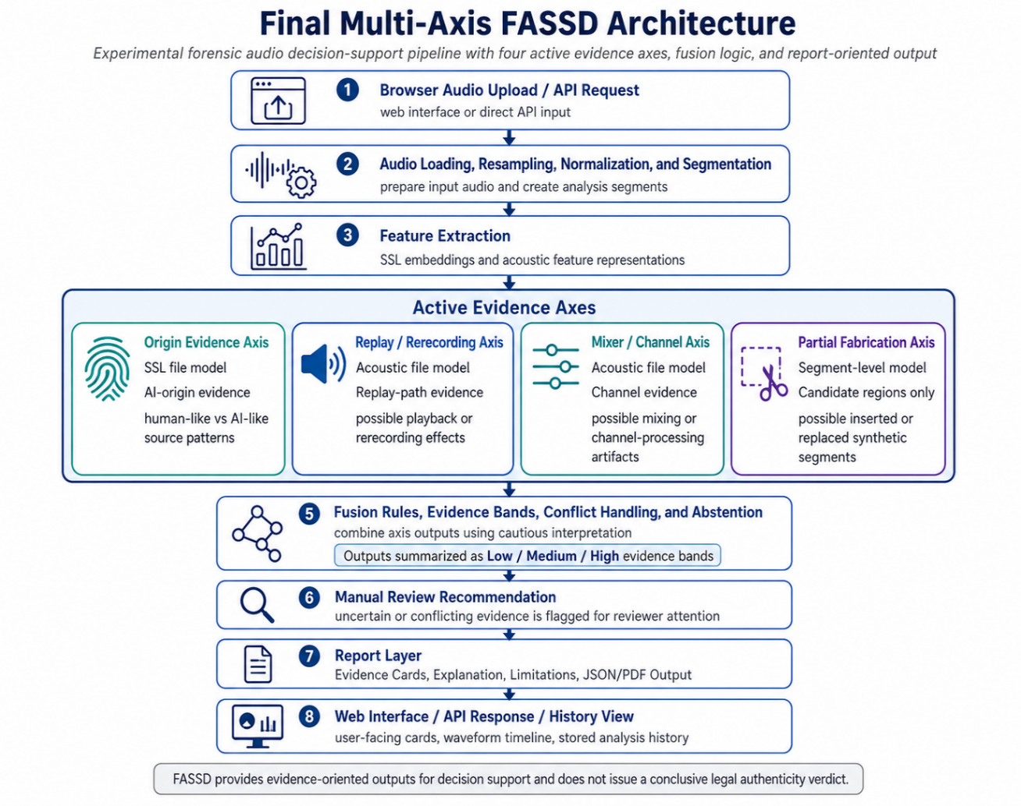
Figure ‎3.2: Final Multi-Axis FASSD Architecture
The fusion and report layers are central to the final architecture. Instead of showing only raw model scores, FASSD converts evidence into cautious interpretation bands and user-facing report sections. The system may report that a certain axis shows low, medium, or high evidence, but it avoids presenting the result as a final legal or forensic conclusion. This design supports the project’s main safety boundary: FASSD is an experimental forensic decision-support prototype. Its purpose is to organize and explain evidence for review, not to certify whether an audio file is authentic or fake.

Origin Evidence Axis
The origin evidence axis uses an SSL-based file model to estimate whether the voice-origin evidence appears closer to human-origin or AI-origin speech. SSL speech models such as WavLM are designed to learn useful speech representations from large-scale audio, which makes them suitable for downstream speech analysis tasks [11]. In FASSD, this direction was used for the active origin_file_model, with a release threshold of 0.92. During the release audit, the origin model was retrained with processed-AI positives so that the system could better handle AI audio affected by processing conditions.
The origin axis achieved leakage-safe balanced accuracy of 0.95 during the audit process. On the final release-audit matrix, it achieved 0.8333 accuracy and 0.825 balanced accuracy. The known failure cases were also documented instead of hidden. T1.2 and T4.1 were human-to-AI false positives, while T4.5 was a WhatsApp-compressed AI sample that was missed as human. These results show that the axis provides useful voice-origin evidence, but it is not a complete authenticity decision. For this reason, the origin result is combined with other evidence axes and explained through the report layer using cautious wording.

Replay/Rerecording Evidence Axis
The replay/rerecording evidence axis uses an acoustic file model with a threshold of 0.65. Its purpose is to detect evidence that the audio may have passed through a replay or recording path, such as speaker playback, microphone capture, room effects, or other acoustic changes. This axis is important because replay can appear in both human and AI audio. A human recording can be replayed and rerecorded, and an AI-generated voice can also be replayed through a device. Therefore, replay evidence must not be interpreted as direct proof that the voice is AI-generated.
On the final release-audit matrix, the replay axis achieved 0.80 accuracy and 0.7738 balanced accuracy. The documented failures included T2.2 and T3.2–T3.4, showing that the replay model still had remaining weaknesses under some test conditions. In the final FASSD architecture, this axis is therefore used as supporting forensic evidence only. It helps describe whether the recording path appears suspicious, but the report layer keeps the meaning separate from voice-origin evidence.

Mixer/Channel Evidence Axis
The mixer/channel evidence axis uses an acoustic model with a threshold of 0.75. This axis was included because audio may be affected by channel processing, mixing, platform conversion, or other signal-path changes that are not the same as speech synthesis. A real human recording may pass through a mixer or communication channel and show processing artifacts, while an AI-generated recording may also be processed in the same way. For this reason, the mixer/channel axis is semantically separate from the origin axis.
The final release-audit matrix showed a major limitation for this axis: recall was 0.0, meaning no true positives were detected on the 25-case matrix. This result was kept in the project documentation because it is important for honest evaluation. The mixer/channel model remained part of the evidence design, but its weakness means that its output should be interpreted with extra caution. In the final report, mixer or channel evidence is not treated as AI evidence and is not used to make a conclusive fake/real claim.

Partial Fabrication Evidence Axis
The partial fabrication evidence axis uses a segment-level model to identify candidate regions that may require manual inspection. The active audit direction used the combined_no_f9 model with a threshold of 0.95. During the audit, F9 within-file features were removed because they could create unsafe dependence on within-file patterns that may not generalize properly. This made the partial axis more cautious, even if it reduced the temptation to overfit to local file structure.
The final gated 25-file matrix showed 1.0 accuracy for the partial axis, and the Phase 5 oracle-style result showed 10/10 performance. However, FASSD does not present this as universal or court-ready partial fabrication detection. The partial module is kept as experimental manual-review candidate evidence only. Its role is to highlight possible regions of interest, not to prove that a segment is fake. This distinction is important because partial edits are difficult, and a highlighted segment still needs human review and case context.

Fusion and Manual Review Logic
The fusion layer combines the outputs from the four evidence axes into a cautious interpretation. Instead of simply averaging model scores or forcing one fake/real result, the Phase 8F fusion rules handle evidence strength, conflicts between axes, and cases where the system should abstain from a strong conclusion. This is necessary because different axes may disagree. For example, origin evidence may be low while replay evidence is high, or partial evidence may be present without strong AI-origin evidence.
In the release API contract, FASSD keeps manual_review_required: true and does not produce a conclusive authenticity decision. The fusion output supports evidence bands, recommendation text, and report wording, but it does not replace human judgment. This design matches the project’s final forensic boundary: the system provides structured indicators for review, while the final interpretation remains cautious, manual-review based, and non-court-certified.

Report Generation
Report generation in FASSD was designed to make model output understandable without turning it into an unsafe final verdict. After the Phase 9 API analyzes an uploaded audio file, it produces a structured JSON analysis payload that includes fields such as phase9c_report and evidence_axis_cards. These fields organize the results from the four evidence axes into a form that the frontend can display as separate cards. Instead of showing only raw model scores, the system maps evidence into Low, Medium, or High bands using the release calibration configuration. This makes the result easier to interpret while still keeping the wording cautious.
The report layer also includes partial segment information when candidate regions are available. These timestamps can be used by the interface to support waveform or timeline highlights, so the user can see where the system found possible localized evidence. However, these highlights are not presented as proof of fabrication. They are treated as candidate regions for manual review. The API response also includes safety and limitation blocks, which explain that FASSD is an experimental forensic decision-support prototype and does not provide a conclusive authenticity decision. The backend can generate optional PDF or Markdown-style reports, while the deployed web interface focuses mainly on on-screen evidence cards, waveform support, recommendation text, and disclaimer wording. This design keeps the report useful for review while avoiding the overclaim that the system can legally certify an audio file as real or fake.

System Interface and Deployment Design
The system interface and deployment design of FASSD were planned around the public web application at https://www.deepfakedetection.dev/, which became the main software representation of the project for demonstration, evaluation, and defense. The web application was developed in a separate website hosting repository, documented under the path D:\FASSD\, while the main FYP repository remained focused on the machine learning pipeline, experiments, release backend, models, reports, and validation files. This separation was important because the final product was not only a local model or a notebook experiment. The user-facing system needed a clean interface where a person could upload an audio file, receive structured forensic evidence, and review the result without directly interacting with backend scripts. The Gradio and local release interfaces were useful during development and testing, but the online web platform is treated as the primary deployed software interface in this thesis.
The front end was implemented using Next.js 16 and hosted on Vercel. It includes the landing page, dashboard upload flow, result display, profile area, and history view. The backend inference service was deployed separately as a Phase 9 FastAPI application on a DigitalOcean droplet, served over HTTPS through Caddy at https://api.deepfakedetection.dev/. This design allowed the frontend and backend to scale and update independently. A key deployment decision was the upload architecture. Since Vercel serverless routes have a payload limit of about 4.5 MB, large audio files could not reliably pass through a frontend proxy. To solve this, the browser uploads audio directly to the DigitalOcean API for analysis, while the frontend receives the JSON result and displays it to the user. The FYP repository’s release/ folder contains the Phase 9 inference backend source used to build this production API.
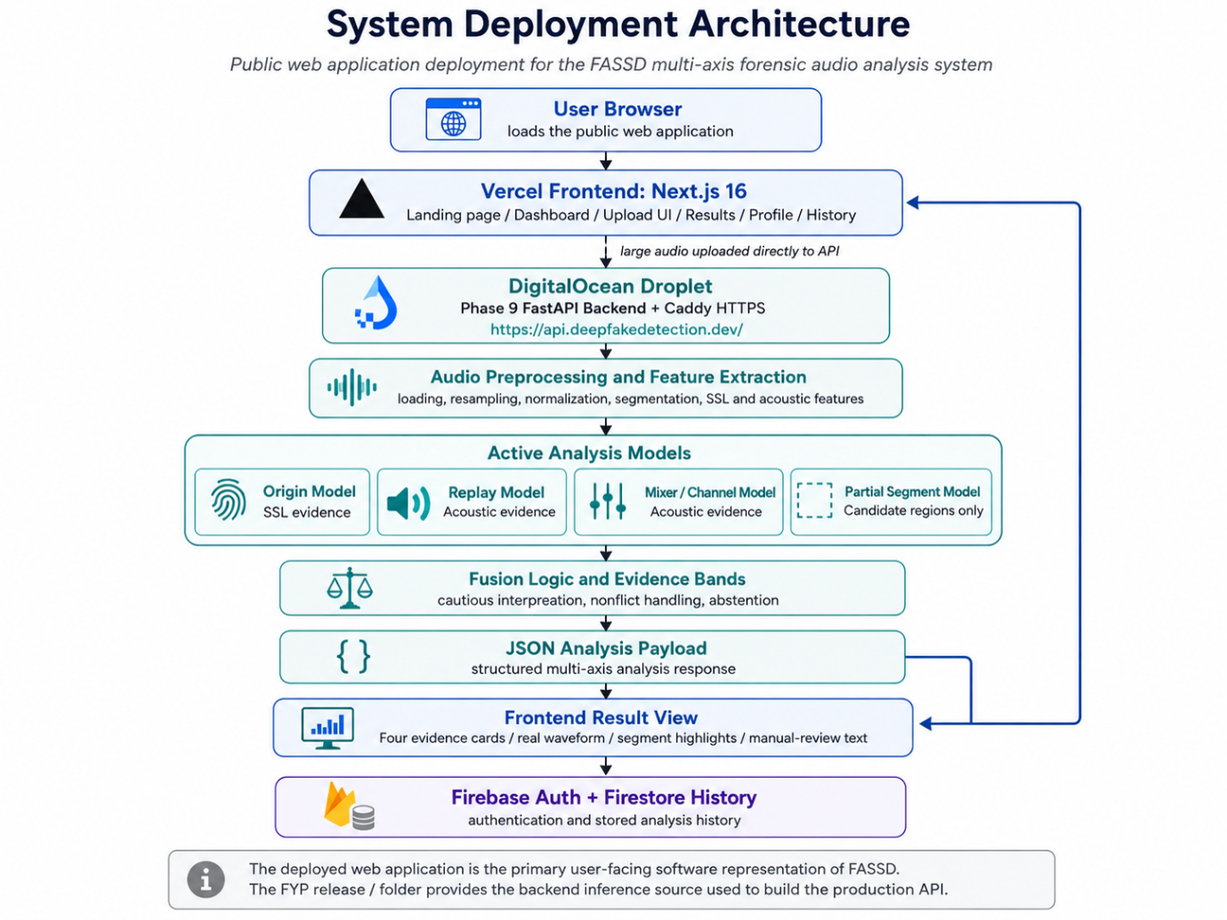
Figure ‎3.3: System Deployment Architecture
The user experience was designed to make the system understandable without presenting it as a final legal detector. After analysis, the interface shows four evidence check cards corresponding to voice origin, replay/rerecording, mixer or channel processing, and partial-fabrication candidate evidence. The result page also includes a real waveform view and segment highlights when the backend returns candidate partial regions. Instead of using aggressive verdict wording, the interface uses cautious review-oriented headlines such as “Sounds human-made” or “Worth a closer look,” depending on the evidence returned by the system. Firebase Authentication was used for user login, while Firestore was used to store simplified analysis history so that users could view previous checks from the dashboard.
The deployment design also keeps the system’s limitations visible. The backend returns safety and limitation fields as part of the analysis response, and the frontend presents disclaimer wording so that users understand that FASSD is an experimental forensic decision-support prototype. The report is based on evidence bands and axis-specific interpretation, not a single court-ready conclusion. Earlier integration material based on the legacy HybridResNet direction was not treated as the final authority for the deployed thesis system, because the final online platform uses the Phase 9 multi-axis backend. This makes the deployed design consistent with the final project methodology: a browser-based audio integrity tool connected to a dedicated inference API, with structured evidence output and manual-review framing.

API Design
The FASSD API was designed as the connection between the public web interface and the Phase 9 multi-axis inference backend. In production, the API is served through https://api.deepfakedetection.dev/, while the frontend sends analysis requests from the browser. The API contract follows the same structure as the Phase 9 FastAPI backend used in the release package. It exposes health and model-information endpoints for readiness checking, and analysis endpoints for multipart audio upload. This design allows the web interface to confirm that the backend is live, models are loaded, and the system is ready before or during user analysis. It also keeps the machine learning inference logic separate from the frontend, which is important because the frontend is responsible for user interaction while the backend is responsible for preprocessing, feature extraction, model inference, fusion, and JSON response generation.
Table ‎3.3: FASSD API Endpoints
Method | Path | Purpose
GET | /health | Checks liveness, model loading status, ready_for_analyze, and backend health
GET | /model-info | Returns model inventory, active model metadata, and partial module status
POST | /analyze | Accepts multipart audio upload and returns the multi-axis JSON analysis payload
POST | /analyze-audio | Alternate analysis endpoint for multipart audio upload using the same Phase 9 analysis contract

The analysis endpoint accepts audio through multipart upload and returns a structured JSON response for the web interface. The backend also supports query flags such as return_top_segments, generate_report, and generate_visual, which control whether segment details, report files, or visual outputs are generated. The response includes evidence-axis information, recommendation text, safety wording, and report-related fields used by the frontend result page. Two important safety fields are manual_review_required: true and conclusive_authenticity_decision: false. These fields make the API contract consistent with the final thesis boundary of FASSD: the system provides forensic evidence indicators and manual-review guidance, but it does not certify whether an audio file is authentic or fake.

Storage and Output Structure
The storage design of FASSD separates temporary analysis data from saved user history. In the deployed web platform, uploaded audio is processed for analysis and is not kept as persistent audio storage after the request is completed. This keeps the web workflow focused on in-memory or request-time processing rather than building an audio file archive. The main saved user-facing record is stored in Firestore under the analysis history structure, such as the audioAnalyses collection. This history is simplified for dashboard use and does not store the full Phase 9 JSON response. It is mainly used to show previous checks, basic result information, timestamps, and summary fields needed by the interface.
The backend can still produce structured outputs for testing and reproducibility. When report saving is enabled, the Phase 9 backend can generate a case_id and save JSON or related report outputs under sample output folders such as sample_outputs. These backend artifacts are separate from the public web history and are mainly useful for development, audit, and demonstration checks. The project also maintains a clear separation between repositories: the FYP repository contains the machine learning pipeline, models, release backend, reports, and source artifacts, while the website repository contains the deployed frontend and web-specific integration code. This separation is important for reproducibility because the thesis can distinguish between the research/inference artifacts and the user-facing web implementation.

Hardware and Software Environment
The development and deployment environment of FASSD was divided into separate layers for machine learning training, backend inference, web interface, and hosting. The machine learning work was carried out in a Python-based environment using PyTorch, librosa, and the project’s fassd conda environment. Training and experimentation were performed on the available local development machine, where the documented hardware included Windows 11, an Intel Core i5-13420H processor, 16 GB RAM, and an NVIDIA RTX 3050 Laptop GPU with 6 GB VRAM. This setup was enough for the project’s CNN, ResNet, feature extraction, and controlled experimentation stages, while larger deployment responsibilities were moved to cloud services.
Table ‎3.4: Hardware and Software Environment
Layer | Technology / Environment
Local development system | Windows 11 laptop environment
Processor | Intel Core i5-13420H
Memory | 16 GB RAM
GPU for training | NVIDIA RTX 3050 Laptop GPU, 6 GB VRAM
ML training | Python, PyTorch, librosa, conda environment fassd
Feature/model utilities | joblib models, audio feature extraction scripts, saved model artifacts
Inference API | FastAPI, Docker, WavLM-style SSL model loading, Phase 9 release backend
Web frontend | Next.js 16, React 19, Tailwind 4, shadcn/ui
Hosting | Vercel for frontend, DigitalOcean 4 GB Droplet for API, Firebase for authentication and history
HTTPS / routing | Caddy reverse proxy for API HTTPS
Data/history layer | Firebase Authentication and Firestore history records

The final deployment used a cloud-based separation between the frontend and inference backend. The front end was hosted on Vercel and handled the user interface, dashboard upload, result display, profile, and history pages. The Phase 9 FastAPI backend was deployed on a DigitalOcean 4 GB droplet and exposed through HTTPS using Caddy. Firebase was used for authentication and simplified Firestore history. This environment supported the final web-based demonstration while keeping the FYP machine learning artifacts and website repository separate for clearer reproducibility.

Ethical and Safety Considerations
Ethical and safety considerations were important in FASSD because an audio detection system can affect how people interpret a person’s voice or statement. A wrong result may create a false accusation, especially if a genuine human recording is incorrectly presented as AI-generated or manipulated. For this reason, FASSD was designed to avoid court-style or absolute verdict wording. The system reports evidence indicators and manual-review recommendations, but it does not claim that an audio file is legally fake or authentic. The final API and interface keep manual_review_required: true and conclusive_authenticity_decision: false so that users understand the result is not a replacement for expert review.
Privacy was also considered in the deployed web workflow. Uploaded audio is processed for analysis and is not retained as persistent web storage after the request is completed. The web platform may keep simplified history fields in Firestore for dashboard use, but it does not store the full Phase 9 JSON result or maintain an audio archive as part of the user history. This design reduces unnecessary storage of sensitive voice recordings. The interface also includes experimental prototype disclaimer wording in the footer and result flow, so users are reminded that FASSD is a decision-support prototype rather than an official forensic authority.
Another safety concern is over-trusting automation. Since deepfake detection models can fail under compression, replay, channel effects, unusual speakers, or partial editing, the system should be treated as a support tool rather than a final judge. FASSD addresses this by separating evidence axes, using cautious report wording, and showing limitations alongside the result. These choices do not remove all risk, but they make the system more responsible for academic demonstration and controlled reviews.

Methodology Limitations
The methodology of FASSD had several limitations that affected how the final system was interpreted. The unified dataset was large, with 1,893,919 total samples, but it was still heavily dominated by studio-style audio. This helped with controlled training and evaluation, but it did not fully represent every real-world recording condition, such as social media compression, phone recordings, broadcast sources, noisy rooms, and platform-specific processing. The active shipped models also used smaller axis-specific training and validation sets compared with the full unified dataset, because the final architecture separated the problem into origin, replay/rerecording, mixer/channel, and partial-fabrication evidence axes. This made the final system more explainable, but it also meant that each axis had its own data limitations and failure patterns.
The release audit also showed specific weaknesses that must be considered when reading the results. Platform compression was one issue, especially in the documented WhatsApp-compressed AI case where the origin axis missed AI evidence and treated it as human. The mixer/channel axis was another limitation because it showed weak positive detection on the final release matrix, with no true positives detected in that specific 25-case test. The partial-fabrication module was kept as candidate evidence only, not as a conclusive detector, because segment-level fabrication is difficult and requires human review. On the software side, the deployed web history stores simplified analysis fields for usability and dashboard display, but it does not preserve the full multi-axis Phase 9 JSON in Firestore. Reproducibility also requires attention because the FYP machine learning artifacts and the deployed website are maintained in separate repositories. For a complete technical review, both the FYP ML/release path and the website deployment path need to be documented together.

RESULTS AND DISCUSSION

Evaluation Overview
The evaluation of FASSD was carried out using both standard machine learning metrics and project-specific forensic validation stages. In the benchmark-style experiments, Equal Error Rate (EER), ROC-AUC, accuracy, precision, recall, balanced accuracy, and confusion matrices were used to understand model behavior. EER measures the point where false acceptance and false rejection are balanced, so a lower EER indicates better separation at that operating point. ROC-AUC measures how well a model separates classes across different thresholds. Accuracy gives the overall percentage of correct predictions, while balanced accuracy is useful when the classes are not equally represented because it considers performance across both positive and negative classes. Precision shows how many flagged cases were correct, recall shows how many actual target cases were detected, and confusion matrices show the detailed pattern of correct predictions, false positives, and false negatives.
The evaluation was divided into three main tiers. The first tier was benchmark evaluation, which used ASVspoof and unified dataset test splits to measure how the early CNN/LCNN, ResNet, and HybridResNetEnvironmental models performed under structured dataset conditions. The second tier was controlled forensic evaluation, mainly developed during Phase 7, where audio was tested in roles such as clean human, direct AI, replayed audio, mixer/channel audio, and partial fabrication. This stage was important because it showed that a strong benchmark result did not always produce reliable forensic behavior. The third tier was releasing validation, where the final multi-axis system was checked through the testing_audios matrix and release-audit reports. This final tier tested the active evidence axes for origin, replay/rerecording, mixer/channel, and partial-fabrication evidence. Together, these tiers allowed FASSD to report not only model performance, but also the limitations and failure cases that shaped the final cautious report wording.

Baseline CNN/LCNN Results
The baseline CNN/LCNN results confirmed that the official FASSD training and evaluation pipeline was functioning correctly. This stage used LFCC features with the lightweight CNN/LCNN-style model and focused on the standard bona fide/spoof classification task. The model was not intended to be the final forensic architecture, but it provided the first measurable result for the approved project scope. The clean LFCC condition achieved an EER of 9.68%, which showed that the model could learn useful spoofing-related patterns from the prepared data. When augmentation was added, the EER increased to 15.71%, showing that the task became more difficult under noisier and more varied conditions.

Table ‎4.1: Baseline CNN/LCNN Metrics
Model Stage | Feature Set | Condition | EER
Baseline CNN/LCNN | LFCC | Clean | 9.68%
Baseline CNN/LCNN | LFCC | Augmented | 15.71%

These results were important because they established a working reference point for later project phases. The baseline proved that dataset preparation, feature extraction, model training, and EER-based evaluation were connected properly. At the same time, the drop in robustness under augmentation showed that the project needed stronger models and broader evaluation. This led to later experiments with log-mel features, ResNet-based learning, environmental features, and eventually the final multi-axis evidence architecture.

LFCC and Log-Mel Feature Comparison
The LFCC and log-mel comparison was carried out to decide which feature direction should be continued for later model development. LFCC was part of the official anti-spoofing scope and provided a compact cepstral representation for the baseline CNN/LCNN model. Log-mel features, on the other hand, preserved a clearer time-frequency structure that was more suitable for deeper convolutional models such as ResNet and the later hybrid architecture. Under augmented conditions, LFCC achieved an EER of 15.71%, while log-mel achieved a slightly better EER of 15.25%.

Table ‎4.2: LFCC and Log-Mel Augmented EER ComparisonTable
Feature Set | Feature Size / Form | Augmented EER | Project Decision
LFCC | 20 coefficients | 15.71% | Kept as approved baseline feature
Log-mel spectrogram | 64 mel bins | 15.25% | Continued for ResNet and HybridResNetEnvironmental stages

The improvement from LFCC to log-mel was small, so it was not treated as a complete solution to robustness. However, the result was enough to justify using log-mel features in the next model stages because they aligned better with image-like convolutional processing. This comparison also showed that feature choice affected performance, but model architecture, augmentation, and evaluation conditions were still equally important. For this reason, FASSD kept LFCC as a baseline reference and continued the log-mel path for deeper spectral learning.

ResNet Results
The ResNet stage produced the strongest benchmark-style EER results in the earlier model development path. Compared with the lightweight CNN/LCNN baseline, the deeper spectral model learned more effective patterns from the prepared audio features and achieved a clean EER of 0.57% and an augmented EER of 2.61%. These results showed that the ResNet direction was technically successful on the ASVspoof-style evaluation setup and gave the project a much stronger anti-spoofing model than the initial baseline. At this point, the model appeared to be a strong candidate for the final detector because its benchmark numbers were significantly better than the earlier feature and baseline experiments.
However, later testing showed that the best EER result did not make the ResNet model the best final system choice. When the project tested real-world broadcast-style samples, the model incorrectly flagged all tested Trump broadcast examples as fake, including the real ones. This failure was important because it showed that benchmark separation and forensic reliability are not the same thing. A model can perform very well on structured test splits but still fail when the recording source, channel, compression, or speech context changes. For FASSD, this became one of the main reasons for moving away from a single binary detector and toward a multi-axis forensic evidence system. The ResNet results were therefore treated as a successful research phase, but not as the final release architecture.

Environmental Classifier Results
The environmental classifier was evaluated to check whether recording-condition features could support deepfake audio detection after the ResNet stage showed weakness on real-world-style broadcast samples. The anomaly-based version performed poorly, with accuracy around 24.5%. This result showed that unsupervised or anomaly-style separation was not reliable enough for the project’s needs. It could not clearly separate useful forensic evidence from normal variation in recording conditions, so it was not continued as a final model direction.
The supervised environmental classifier performed better, reaching 81.69% accuracy on ASVspoof-style data. This confirmed that environmental and acoustic cues contained useful information, especially for understanding noise, reverberation, background behavior, and signal-condition differences. However, this result was still not enough for a standalone forensic detector. The project found that real and fake broadcast-style scores could overlap, meaning the classifier could support interpretation but could not safely decide authenticity by itself. For this reason, environmental evidence was later used as part of the HybridResNetEnvironmental experiment and then influenced the final multi-axis design, where recording-condition evidence was kept separate from AI-origin evidence.

HybridResNetEnvironmental Results

The HybridResNetEnvironmental model was evaluated to understand whether combining spectral deep learning with environmental acoustic cues could improve the system’s behavior beyond the earlier ResNet-only direction. The model used log-mel spectrogram input through a ResNet-style branch and combined it with a 12-dimensional environmental feature vector. On the main test evaluation, the model achieved an EER of 16.21%, ROC-AUC of 0.9167, and binary accuracy of 89.78%. These results showed that the model had useful separation ability at the binary level and could learn from both speech-spectrum patterns and recording-condition features. The ROC curve and confusion matrix generated in the evaluation reports can be used here as supporting figures to show the model’s score separation and error distribution.
Table ‎4.3: HybridResNetEnvironmental Evaluation Results
Metric | Result
Test EER | 16.21%
ROC-AUC | 0.9167
Binary accuracy | 89.78%
Bona fide false-positive rate at threshold 0.5 | 41.28%
Multiclass accuracy | 64.36%

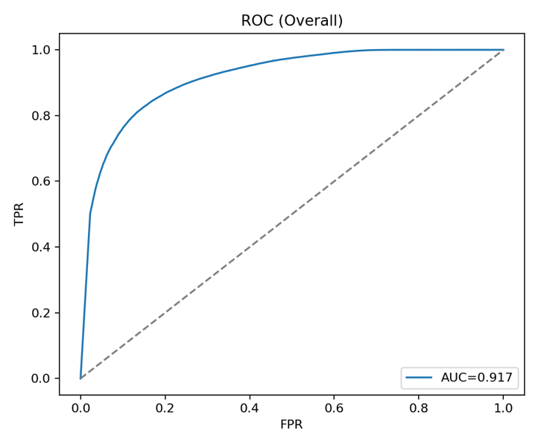
Figure ‎4.1: HybridResNetEnvironmental Confusion Matrix
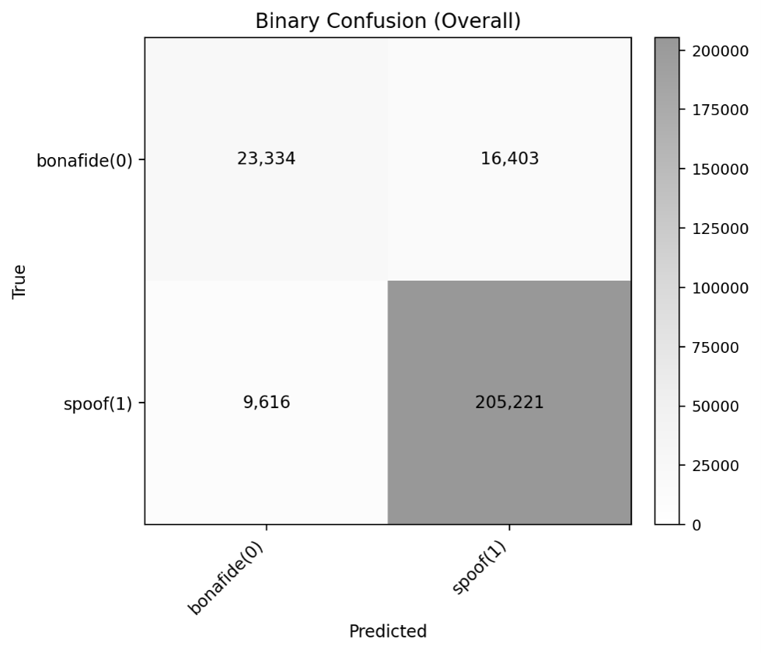
Figure ‎4.2: HybridResNetEnvironmental Confusion Matrix

Although the binary accuracy and AUC were strong enough to show that the hybrid approach was useful, the detailed error behavior showed that it was not safe as the final FASSD decision model. The most serious issue was the high bona fide false-positive rate of 41.28% at threshold 0.5, which means many real human samples were still being treated as suspicious. The multiclass accuracy was also limited at 64.36%, showing that the model struggled to clearly separate different attack or condition types. For a forensic decision-support system, these weaknesses were important because replay, channel effects, synthesis, and genuine recordings should not be collapsed into one overconfident result. The HybridResNetEnvironmental model was therefore kept as a reference experiment in the final release, while the project moved toward separate evidence axes and cautious report wording.

Controlled Forensic Evaluation Results
The controlled forensic evaluation was carried out during Phase 7 to test whether the system could handle audio roles that were closer to forensic use cases than normal benchmark splits. Instead of evaluating only bona fide and spoofed labels, the Phase 7 tests separated the audio into conditions such as clean human, direct AI, human replay, AI replay, human mixer/channel, AI mixer/channel, and partial fabrication. This evaluation was important because it showed that a model could be highly sensitive to manipulated or processed audio while still producing too many false alarms on clean human speech. In other words, the system was able to detect many suspicious conditions, but its specificity for genuine human audio was not strong enough for a final standalone judge.
Table ‎4.4: Controlled Forensic Evaluation Summary
Evaluation Stage | Clean Human Behavior | Direct AI Behavior | Replay / Mixer Behavior | Partial Fabrication Behavior | Main Finding
Phase 7C1 Hybrid baseline | 4/23 accepted, 17/23 false alarms | 0/23 file-level detected, but 19/23 segment-suspicious | Human replay 23/23, AI replay 23/23, human mixer 23/23, AI mixer 23/23 | 43/46 detected | High manipulation sensitivity, but weak clean-human specificity
Phase 7C4-v2 prototype | 1/23 accepted, 7/23 false alarms, 15/23 borderline | 19/23 detected or segment-suspicious | Replay and mixer cases remained 23/23 | 44/46 detected | Better direct-AI sensitivity, but clean-human uncertainty remained high

The Phase 7C1 results showed that replay, mixer/channel, and partial-fabrication conditions were strongly detected, but clean human recordings were often treated as suspicious. Only 4 out of 23 clean human samples were accepted, while 17 out of 23 were false alarms. This was a serious limitation because a forensic audio system should not overflag genuine human recordings. At the same time, the model showed strong sensitivity to manipulated conditions, with replay and mixer categories reaching 23 out of 23 detections and partial fabrication reaching 43 out of 46 detections. This suggested that the system was learning useful manipulation evidence, but the interpretation was too broad when used as one combined decision.
The Phase 7C4-v2 prototype improved some parts of the behavior, especially for direct AI cases, where 19 out of 23 samples were detected or marked as segment-suspicious. Partial fabrication also improved slightly to 44 out of 46 detections, and replay/mixer categories remained highly sensitive. However, clean human behavior still remained a problem because only 1 out of 23 clean human samples was accepted, 7 were false alarms, and 15 were borderline. These results became a key reason for the final FASSD redesign. The project moved away from treating one model as a final judge and instead separated the output into voice-origin, replay/rerecording, mixer/channel, and partial-fabrication evidence axes with manual-review wording.

AASIST and Historical Model Comparison
The historical model comparison was used to separate models that were useful during research from models that were safe enough to remain active in the final release. FASSD tested several model directions, including CNN/LCNN baselines, ResNet, HybridResNetEnvironmental, AASIST, and the final multi-axis models. The main lesson from this comparison was that a model should not be selected only because it is stronger in a benchmark or more advanced architecturally. For the final forensic decision-support system, model behavior on clean human audio, replayed audio, processed audio, and partial-fabrication cases was more important than a single headline metric.
Table ‎4.5: Active and Reference Model Comparison
Model / Model Group | Final Status | Key Issue or Role
Origin SSL model | Active | Best available voice-origin evidence axis in the final release
Replay model | Active | Experimental replay/rerecording evidence axis; not AI-origin proof
Mixer/channel model | Active | Experimental channel-processing evidence axis; weak positive detection in release matrix
Partial fabrication model | Active with limitation | Experimental manual-review candidate axis only
HybridResNetEnvironmental | Reference only | Useful binary/hybrid experiment, but collapsed different evidence types into one output
AASIST | Reference only | Produced 22/23 clean-human false alarms in Phase 7E
ResNet | Reference only | Strong benchmark EER but failed on real-world broadcast-style testing

The HybridResNetEnvironmental model was rejected as an active final model because it mixed synthetic-origin, replay, channel, and environmental evidence into one fused prediction. Although its binary results were useful, the high bona fide false-positive behavior made it unsafe for final forensic wording. AASIST was also rejected as a standalone judge because it produced false alarms on 22 out of 23 clean-human samples. This showed that even a modern anti-spoofing model could behave poorly under FASSD’s controlled forensic conditions. The final release therefore kept these models as references and used the multi-axis architecture instead, where each evidence type is interpreted separately and manual review remains required.

Final Multi-Axis Evidence Results
The final release-audit evaluation measured the active evidence axes separately instead of reporting one overall fake/real score. This matched the final FASSD architecture, where voice origin, replay/rerecording, mixer or channel processing, and partial-fabrication evidence are treated as different forensic indicators. The results below come from the final testing_audios matrix and should be read as axis-level validation results, not as a single system-wide authenticity score. This distinction is important because each axis answers a different question. For example, replay evidence checks the recording path, while origin evidence checks whether the voice pattern appears closer to human or AI speech.
Table ‎4.6: Final Evidence-Axis Results
Evidence Axis | n | Accuracy | Balanced Accuracy | Recall | Source
Origin | 18 | 0.8333 | 0.8250 | 0.9000 | phase7_final_  testing_audios_  matrix.md
Replay/rerecording | 25 | 0.8000 | 0.7738 | 0.7143 | phase7_final_  testing_audios_  matrix.md
Mixer/channel | 25 | 0.8800 | 0.4783 | 0.0000 | phase7_final_  testing_audios_  matrix.md
Partial fabrication | 25 | 1.0000 | 1.0000 | 1.0000 | phase7_final_  testing_audios_  matrix.md

The origin axis gave the strongest practical result among the main active axes, with 0.8333 accuracy, 0.8250 balanced accuracy, and 0.9000 recall on the 18-case origin subset. This shows that the SSL-based origin model was useful for identifying AI-origin evidence in the release matrix, but it was not perfect. The documented failures included human-to-AI false positives and a WhatsApp-compressed AI sample that was missed as human. The replay/rerecording axis also produced usable but imperfect results, with 0.8000 accuracy and 0.7738 balanced accuracy across 25 cases. Its recall of 0.7143 showed that some replay cases were still missed, so replay evidence remained a supporting indicator rather than a final conclusion.
The mixer/channel axis had high accuracy at 0.8800, but its balanced accuracy was only 0.4783 and its recall was 0.0000. This means the axis failed to detect positive mixer/channel cases in the release matrix, even though the overall accuracy appeared high because of the class distribution. This is an important limitation and should not be hidden. The partial fabrication axis showed 1.0000 accuracy, balanced accuracy, and recall on the gated 25-file matrix, but its interpretation remains limited because the module is treated as experimental manual-review candidate evidence only. Overall, these results support the final FASSD design choice: the system should present separate evidence cards and manual-review recommendations instead of one overconfident authenticity verdict.

Release/Demo Validation Results
The final release and demo validation confirmed that the FASSD backend was ready to operate as the inference engine for the deployed system. Phase 9G was marked as PASS after the release package, model registry, active model loading, health checks, analysis pipeline, report fields, and API contract were validated. This phase did not introduce a new model; instead, it confirmed that the selected Phase 9 multi-axis backend could run as a packaged system and return structured outputs for uploaded audio. The validated backend included the origin, replay/rerecording, mixer/channel, and partial-fabrication evidence paths, along with fusion logic, safety fields, and report-ready JSON responses. In this sense, Phase 9G mainly validated ML backend readiness for demonstration and handoff.
The user-facing validation was completed through the live web platform workflow. The frontend at https://www.deepfakedetection.dev/ connects to the production FastAPI backend at https://api.deepfakedetection.dev/, allowing users to upload audio, receive multi-axis evidence cards, view waveform or segment highlights where available, and see manual-review wording. The deployment checklist also covered practical issues such as HTTPS access, CORS, direct browser-to-API upload for large files, Firebase authentication, Firestore history, and removal of outdated HybridResNet-style wording from the user interface. These checks showed that the system was usable as an online FYP demonstration platform, not only as a local backend package.
It is important to interpret the release result correctly. Phase 9G PASS does not mean that FASSD is legally approved, court-certified, or reliable for every real-world recording. It only means that the final demo package and production-style web/API pipeline were technically ready for the project’s intended academic demonstration. The system still keeps manual_review_required: true and avoids conclusive authenticity decisions. Therefore, the release validation supports the system’s readiness as an experimental forensic decision-support prototype, while the final interpretation of any audio result remains cautious and human-reviewed.

Release Audit Results
The release audit was the final validation stage used to check whether the active FASSD evidence axes were ready for the demo and production-style web/API flow. Unlike earlier benchmark testing, this audit focused on the final testing_audios matrix and examined the behavior of the active origin, replay/rerecording, mixer/channel, and partial-fabrication axes. The purpose was not only to report successful cases, but also to identify the remaining failure patterns before freezing the release. This was important because the final system was designed as a forensic decision-support prototype, where known weaknesses must be documented instead of hidden behind a single overall accuracy value.
Table ‎4.7: Consolidated Key Results Summary
Evidence Axis | Key Result | Main Failure Cases | Failure Type | Interpretation
Origin | Accuracy 0.8333, BA 0.8250, recall 0.9000 | T1.2, T4.1 | Human audio flagged as AI | Shows remaining false-positive risk for human-origin audio
Origin | Same axis | T4.5 | WhatsApp-compressed AI missed as human | Shows platform compression can hide AI-origin evidence
Replay/rerecording | Accuracy 0.8000, BA 0.7738, recall 0.7143 | T3.2, T3.3 | Replay cases missed | Shows replay axis still misses some positive cases
Replay/rerecording | Same axis | T2.2, T3.4, T4.1 | Replay false positives | Shows some non-replay cases can appear replay-like
Mixer/channel | Accuracy 0.8800, BA 0.4783, recall 0.0000 | T2.2, T3.4 | Mixer/channel positives missed | Shows weak positive detection on the release matrix
Mixer/channel | Same axis | T2.4 | Mixer/channel false positive | Shows possible overflagging on at least one non-target case
Partial fabrication | Accuracy 1.0000, BA 1.0000, recall 1.0000 | No gated failure in matrix | None in 25-file gated matrix | Still interpreted as candidate evidence only

The origin axis was the strongest active evidence axis in the release matrix, but it still had important limitations. T1.2 and T4.1 showed human-to-AI false positives, which is serious because a forensic tool must avoid creating unsupported accusations against genuine human speech. T4.5 showed the opposite problem: a WhatsApp-compressed AI sample was missed as human. This failure confirmed that platform compression can weaken or hide origin-related evidence. Therefore, the origin axis was useful, but it could not be treated as a complete authenticity decision by itself.
The replay and mixer/channel axes also showed why FASSD needed cautious report wording. The replay axis achieved usable balanced accuracy, but it still missed some replay cases and produced false positives on others. The mixer/channel axis had high raw accuracy, but its balanced accuracy and recall showed a much weaker picture because it failed to detect positive mixer/channel cases in the release matrix. This is an important example of why accuracy alone can be misleading when the target cases are limited. The partial-fabrication axis achieved perfect gated matrix results, but the project still kept it as experimental manual-review candidate evidence because earlier partial-localization testing showed that segment-level fabrication detection remains difficult outside controlled conditions.
Overall, the release audit supported the decision to freeze FASSD as a multi-axis evidence system rather than a single verdict engine. The audit confirmed that the backend could produce structured outputs for the final demo, but it also showed that each evidence axis had its own reliability limits. These findings shaped the final report design: evidence bands, safety wording, manual-review requirement, and no conclusive authenticity decision. The release audit therefore acted as both a validation step and a safeguard against overclaiming the system’s forensic reliability.

Interface and Report Output
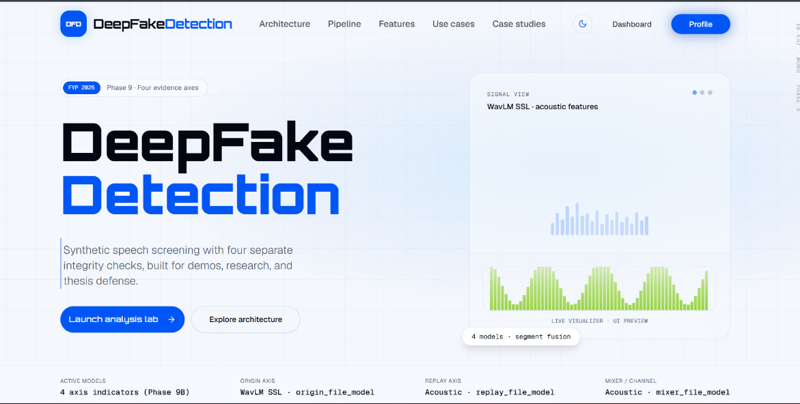
The final FASSD interface was implemented as a live web application connected to the Phase 9 backend, not as the earlier Gradio demo. The interface presents the system as a voice integrity lab and follows the final multi-axis design used in the release pipeline. Instead of showing only a single fake/real result, the web application explains that uploaded audio is checked through separate evidence areas, including voice source, replay signs, channel effects, and edited-segment indicators.
Figure ‎4.3: Live Web Landing and Multi-Axis Architecture
This is important because the final interface had to match the actual forensic decision-support architecture. The outdated HybridResNet REAL/FAKE style interface is therefore not used as final evidence in the thesis.
The dashboard upload screen provides the main user workflow. A user uploads an audio file from the browser, and the page explains the analysis pipeline in simple terms: decoding, segmentation, feature extraction, four models, and fusion/report generation. The upload area also includes supported formats and safety wording such as screening estimate and not legal proof. This helps the user understand that the system is designed for forensic evidence review, not for automatic legal judgment. The design is also useful for non-ML users because the interface hides unnecessary backend complexity while still showing what type of analysis is being performed.
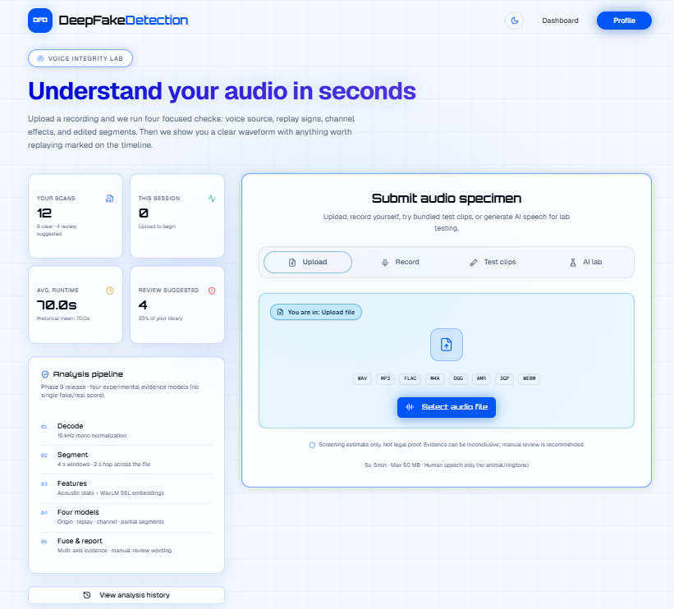
Figure ‎4.4: Dashboard Upload Interface

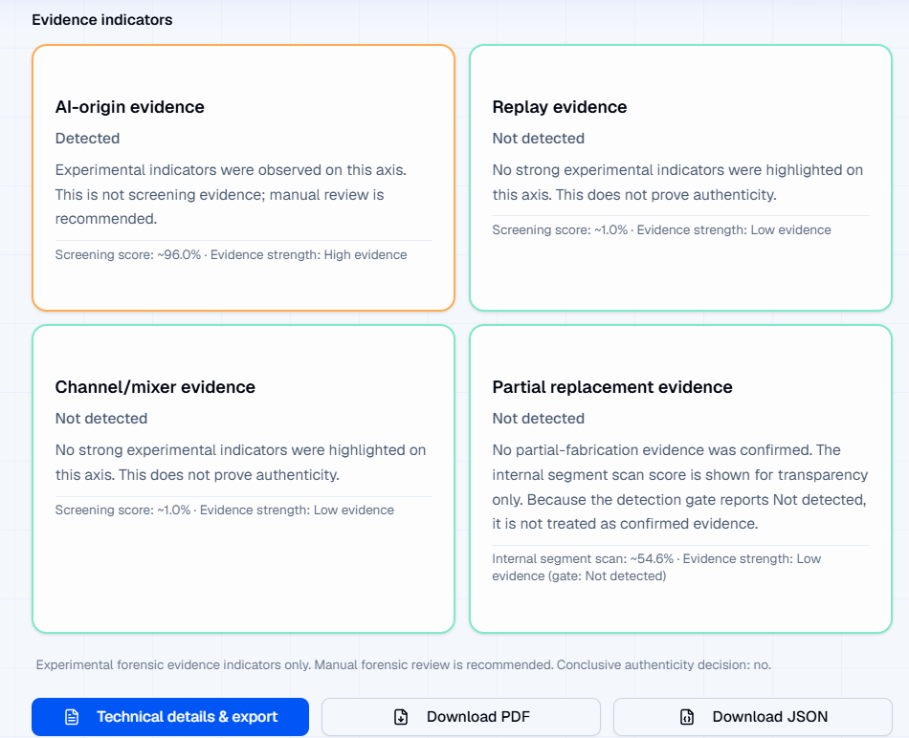After analysis, the user receives a plain-language result view with four evidence cards: AI-origin evidence, replay evidence, channel/mixer evidence, and partial replacement evidence. Each card states whether evidence was detected, gives a short explanation, and shows the evidence strength. When the partial module identifies suspicious regions, the interface can guide the user to moments to replay through timestamps or highlighted segments. The report output also includes case information, duration, status, manual-review fields, and evidence-axis summaries. This makes the result more readable than raw JSON while still preserving the cautious forensic wording required by the project.
Figure ‎4.5: Multi-Axis Result and Report Output
The interface and report layer do not present the output as a legal certificate. The result text states that the indicators are experimental forensic evidence and that manual forensic review is recommended. This safety wording is necessary because the release audit documented remaining weaknesses, including mixer/channel detection limitations, replay errors, platform-compression effects, and partial-localization uncertainty. Additional interface screenshots, including the profile/history page, mobile views, and generated PDF report examples, are provided in Appendix F.

Discussion Against Literature
The results of FASSD are consistent with the main direction reported in recent audio deepfake literature. Current surveys describe audio deepfake detection as a growing problem where synthetic speech, voice conversion, replay, and post-processing can affect trust in recorded speech [1], [3]. The ASVspoof line of research also shows that audio spoofing is not limited to one simple attack type and that evaluation becomes harder when systems move closer to real-world or “in the wild” conditions [2]. FASSD followed this same direction during development. The early phases started with standard anti-spoofing experiments, but later testing showed that good benchmark performance was not enough when the system was exposed to broadcast-style audio, replayed samples, mixer/channel processing, and partial fabrication cases.
At the same time, FASSD differs from many normal detector-style approaches because the final system refused to present a single overconfident fake/real score as the main output. This decision came directly from the project results. The ResNet model achieved very strong EER values, but it failed on broadcast-style testing. The HybridResNetEnvironmental model produced useful AUC and accuracy values, but its false-positive behavior on bona fide audio made it unsuitable as a final forensic judge. AASIST was also kept as reference only because it produced a high number of clean-human false alarms in the controlled evaluation. These results support the same concern raised in the literature: high performance on a known benchmark does not always prove reliable generalization to new speakers, channels, compression settings, or manipulation conditions [1], [3].
The final multi-axis design of FASSD can be understood as a practical response to this gap. Instead of collapsing every signal into one decision, the system separates voice-origin evidence, replay/rerecording evidence, mixer/channel evidence, and partial-fabrication candidate evidence. This design is also related to recent generalization-focused discussions, where the main challenge is not only detecting known attacks but building systems that remain meaningful when identity, recording condition, and manipulation style change [16]. FASSD does not claim to fully solve this problem. However, it addresses it more cautiously by showing different evidence axes separately, reporting limitations, and requiring manual review instead of treating model output as legal proof.

This discussion shows that the main contribution of FASSD is not only the best numerical result from one model. The project’s stronger contribution is the shift from a binary deepfake detector toward an experimental forensic audio decision-support prototype. The results confirm that some axes are useful, especially the origin and replay axes, while others such as mixer/channel and partial-fabrication localization need further work. Therefore, the final system aligns with the literature on the importance of audio deepfake detection, but it also takes a more cautious position by avoiding unsupported forensic certainty.

Official Objective-Wise Discussion
The official objectives of FASSD were evaluated against the work completed during the project phases. The first objective, bona fide versus spoof or AI classification, was achieved through the CNN/LCNN baseline pipeline and later improved through deeper model experiments. The second objective, forensic acoustic cue analysis, was achieved and extended through environmental features, replay evidence, mixer/channel evidence, and the final multi-axis report structure. The third objective, detection of AI voice embedded inside real recordings, was only partially achieved because the partial-fabrication module can identify candidate regions under controlled conditions, but it is still treated as experimental and manual-review evidence. This is consistent with the final project position that segment-level fabrication should not be presented as legal proof.
Table ‎4.8: Official Objectives vs Achieved Work
Official Objective | Achieved Work / Evidence | Final Status
Bona fide vs spoof/AI classification | CNN/LCNN baseline, LFCC/log-mel comparison, ResNet and later model experiments | Achieved
Forensic acoustic cue analysis | Environmental features, replay/rerecording axis, mixer/channel axis, evidence cards | Achieved and extended
AI voice embedded in real recordings | Partial-fabrication segment model and candidate-region reporting | Partially achieved; manual-review only
Replay of AI through device re-recording | Replay/rerecording evidence axis in the final multi-axis backend | Achieved as evidence axis
Robust augmented and real-world evaluation | Augmentation, unified dataset work, controlled Phase 7 evaluation, release audit matrix | Achieved and extended
Complete software system | Phase 9 backend package, FastAPI inference API, deployed web platform, report-ready outputs | Achieved

Overall, the official objectives were met in a realistic academic and experimental scope, but not all objectives reached the same level of reliability. The strongest completed parts were the classification pipeline, software system, and final evidence-based backend. The replay and origin axes also showed practical value in the release matrix, although they still had documented failure cases. The weaker areas were mixer/channel positive detection and partial-fabrication localization, which is why the final system uses cautious wording and keeps manual review as a required part of interpretation.
This objective-wise review also shows why the final FASSD output is different from the original simple detector idea. The proposal objectives were not discarded; instead, they were expanded into a safer forensic decision-support design after the project found that single-model decisions could create false alarms or hide important evidence differences. The final system therefore satisfies the official scope while clearly separating achieved, extended, and limited parts of the work.

Extended Contribution Discussion
The main extended contribution of FASSD is the move from a simple binary deepfake detector to a multi-axis forensic evidence architecture. During development, the project showed that a single fake/real score was not enough for the type of audio cases being tested. Strong benchmark models could still fail on broadcast-style audio, while models sensitive to replay or channel changes could also create false alarms on clean human recordings. To address this, the final system separated the analysis into evidence axes for voice origin, replay/rerecording, mixer or channel processing, and partial-fabrication candidate regions. This design allowed the system to describe what type of suspicious evidence was present instead of treating every abnormal signal as proof of AI generation. This became the main research extension beyond the originally approved detector scope.
Another important contribution was the use of evidence-band reporting and cautious forensic wording. The final report layer did not only return model scores; it translated those outputs into readable evidence cards, axis interpretations, recommendation text, and limitations. The system used evidence bands such as low, medium, and high indicators where appropriate, while still keeping the final interpretation under manual review. This was important because FASSD was designed as an experimental forensic decision-support prototype, not a court-certified authenticity tool. The deployed web platform extended this idea further by making the forensic evidence understandable for non-ML users. Through the web interface, a user could upload audio and view the main evidence axes, waveform or timeline support where available, and report-ready outputs without reading raw model logs or backend JSON files.
The project’s extended contribution also includes the documented rejection of models and approaches that did not meet the final forensic requirement. AASIST, HybridResNetEnvironmental, and the unified manipulation v3 direction were not hidden after they failed certain project conditions. Instead, they were kept as reference experiments and used to explain why the final architecture changed. AASIST showed high clean-human false alarms, HybridResNetEnvironmental collapsed different forensic signals into one binary output, and the unified manipulation direction did not provide reliable enough evidence for final release use. These rejected paths strengthened the final design because they showed that the system choices were based on observed limitations, not only on selecting the most advanced model. Therefore, the extended contribution of FASSD is both technical and methodological: it provides a working multi-axis audio evidence system and documents why safer forensic interpretation was preferred over a single overconfident model result.

Failure Cases and Limitations
The final FASSD release audit identified several important failure cases that affected how the system should be interpreted. The origin axis produced useful results overall, but it still had both false-positive and false-negative behavior. In the release matrix, T1.2 and T4.1 were human-origin samples that were incorrectly flagged as AI-origin evidence, while T4.5 was a WhatsApp-compressed AI sample that was missed as human. This showed that the origin model was useful, but it was still affected by recording and compression conditions. The replay axis also remained imperfect. It missed some replay cases, including T3.2 and T3.3, and produced replay false positives on cases such as T2.2, T3.4, and T4.1. These errors confirm that replay-like acoustic patterns can appear in recordings that are not actually replay cases.
Table ‎4.9: Limitations and Failure Cases
Area | Failure / Limitation | Observed Evidence | Interpretation
Origin axis | Human audio flagged as AI | T1.2, T4.1 | False-positive risk remains for human-origin audio
Origin axis | Compressed AI missed as human | T4.5 | WhatsApp/platform compression can hide AI-origin evidence
Replay axis | Replay cases missed | T3.2, T3.3 | Replay evidence is useful but not fully reliable
Replay axis | Replay false positives | T2.2, T3.4, T4.1 | Some non-replay signals can appear replay-like
Mixer/channel axis | Positive mixer cases missed | T2.2, T3.4 | Release matrix recall was 0.0000
Mixer/channel axis | Mixer/channel false positive | T2.4 | Channel evidence can also overflag
Partial fabrication | Candidate evidence only | Final matrix passed, but wider localization remained limited | Segment-level output should support manual review, not final proof
Web history | Simplified stored history | Firestore stores reduced fields, not full Phase 9 JSON | Past user history is less detailed than the full analysis report

The mixer/channel axis was one of the clearest limitations in the final evaluation. Although its raw accuracy was 0.8800, the balanced accuracy was only 0.4783 and the recall was 0.0000. This means that the axis did not successfully detect positive mixer/channel cases in the final matrix, even though the overall accuracy looked acceptable. This is a useful example of why FASSD reports axis-level evidence instead of hiding weaknesses behind one combined score. The result shows that mixer/channel evidence should be treated cautiously in the final report and should not be used as a strong standalone conclusion.
The partial-fabrication module also has an important limitation. In the final gated testing matrix, the partial axis achieved 1.0000 accuracy, balanced accuracy, and recall, but this does not mean the project solved partial fabrication in all cases. Earlier partial-localization testing showed that identifying exact fabricated regions remained difficult outside controlled conditions. For this reason, the final release kept the partial module as candidate evidence only. Its role is to highlight suspicious regions for manual review, not to prove that a specific segment was fabricated with forensic certainty.
There was also a deployment-side limitation in the live platform. The immediate analysis output can show the Phase 9 evidence structure, but the stored Firestore history keeps simplified fields for user history compatibility instead of saving the full Phase 9 JSON report. This does not change the live analysis result, but it limits the detail available when a user later reviews past history from the web interface. Overall, these limitations support the final safety position of FASSD: the system can assist forensic audio review, but it should not be treated as a conclusive or legal authenticity decision.

Summary of Results
The results of FASSD show that the official project scope was completed and then extended into a wider forensic decision-support system. The baseline CNN/LCNN pipeline using LFCC features achieved a clean EER of 9.68% and an augmented EER of 15.71%, which confirmed that the approved anti-spoofing training and evaluation pipeline was working. Later, the ResNet and HybridResNetEnvironmental models showed stronger benchmark-style behavior, but their limitations on forensic-style cases made them unsuitable as final standalone decision models.
The main findings from the result chapter can be summarized as follows:
- The official LCNN/CNN-based scope was met with documented feature extraction, training, and EER-based evaluation.
- The ResNet model achieved strong benchmark EER values, but real-world broadcast testing showed that the best EER phase was not automatically the best final system choice.
- The HybridResNetEnvironmental model achieved useful AUC and accuracy, but its bona fide false-positive behavior made it unsafe as a final forensic judge.
- The final multi-axis release improved the project direction by separating origin, replay/rerecording, mixer/channel, and partial-fabrication evidence.
- The origin and partial axes gave the strongest release-matrix results, while replay remained useful but imperfect.
- The mixer/channel axis remained weak for positive detection, with 0.0000 recall in the final release matrix.
- The live web platform delivered the final system as an experimental forensic decision-support interface with evidence cards, report-ready outputs, and manual-review wording.
- Remaining gaps include mixer/channel positive detection, platform compression effects such as WhatsApp-compressed audio, partial-fabrication generalization, and the need for human review before any final interpretation.

CONCLUSION AND FUTURE WORK

Conclusion
FASSD achieved its approved software and machine learning scope by developing a complete audio deepfake detection pipeline and evaluating it through multiple stages. The project began with the official anti-spoofing direction, where LFCC and log-mel features were extracted, baseline CNN/LCNN models were trained, and EER-based evaluation was used to measure detection performance. This confirmed that the basic dataset preparation, feature extraction, training, and testing workflow was working correctly. Later phases extended the work through ResNet, environmental-feature analysis, HybridResNet Environmental, AASIST comparison, and controlled forensic evaluation. These stages helped the project move beyond a simple model comparison and showed that strong benchmark results alone were not enough for practical forensic-style audio analysis.
The final version of FASSD became an experimental multi-axis forensic audio decision-support prototype. Instead of giving only one fake/real score, the system analyzes uploaded speech through separate evidence axes for voice origin, replay or rerecording, mixer/channel processing, and partial-fabrication candidate regions. This design was selected because earlier models showed different types of failure, such as clean-human false alarms, broadcast-style errors, and weak separation between AI generation and recording-condition effects. The final backend also includes fusion logic, evidence-band reporting, cautious wording, manual-review recommendations, and report-ready outputs. These parts make the system more suitable as an analysis assistant than as a single automatic authenticity judge.
The project was also completed as a working software system through the deployed web application at deepfakedetection.dev, supported by a production-style FastAPI backend. This allowed the final model pipeline to be used through a browser interface where users can upload audio and view readable forensic evidence instead of raw model outputs. However, the system is not court-ready and should not be treated as legal proof of authenticity or fabrication. The release audit showed useful results, especially for the origin and partial evidence axes, but it also documented remaining weaknesses such as mixer/channel positive detection, replay errors, platform compression effects, and the experimental nature of partial-fabrication localization. Therefore, FASSD successfully meets the academic project goals as a functional and evaluated forensic audio prototype, while clearly preserving the need for human review and further research before any real forensic deployment.

Objective-Wise Conclusion
The objective-wise conclusion shows that FASSD completed the approved FYP scope and also produced meaningful extensions beyond the original detector idea. The official scope was satisfied through the development of an audio preprocessing pipeline, feature extraction, CNN/LCNN baseline training, and EER-based evaluation for bona fide versus spoofed audio. As the project progressed, the work was extended into a broader forensic audio prototype because single-model results were not reliable enough for the type of cases being tested. This extension was not added only for extra complexity; it was based on observed failures in ResNet, HybridResNetEnvironmental, AASIST, and controlled forensic evaluations. The final system therefore concludes with both completed official objectives and clearly bounded extended objectives.
Table ‎5.1: Objective-Wise Conclusion
Objective Type | Objective | Final Status | Conclusion
Official | Develop an audio deepfake detection pipeline | Achieved | Audio loading, preprocessing, feature extraction, training, and evaluation were completed.
Official | Train and evaluate CNN/LCNN-style baseline models | Achieved | The LFCC baseline achieved documented EER results and proved the approved ML pipeline.
Official | Compare acoustic feature representations | Achieved | LFCC and log-mel features were compared, and log-mel was continued for deeper models.
Official | Evaluate improved deep learning models | Achieved | ResNet and HybridResNetEnvironmental were evaluated but not selected as final decision engines.
Official | Build a usable software system | Achieved | The system was packaged through Phase 9G and deployed through the web application.
Extended | Separate forensic evidence into multiple axes | Achieved | Origin, replay/rerecording, mixer/channel, and partial-fabrication evidence were separated.
Extended | Provide report-ready forensic interpretation | Achieved | Evidence bands, safety wording, recommendations, and manual-review fields were added.
Extended | Detect partial fabrication candidates | Partially achieved | Candidate-region evidence was produced, but the module remains experimental and manual-review only.
Extended | Make the system usable for non-ML users | Achieved | The deployed web platform presents readable evidence cards and report-oriented output.

Overall, the official objectives were successfully completed, while the extended objectives were achieved with different reliability levels. The strongest final outcomes were the working ML pipeline, deployed web platform, origin evidence axis, report layer, and cautious multi-axis architecture. The weaker outcomes were mixer/channel positive detection, replay edge cases, platform-compressed audio, and the generalization of partial-fabrication localization. For this reason, the conclusion is not that FASSD is a complete forensic authority, but that it is a functional and evaluated experimental decision-support system. It meets the academic goals of the project while honestly preserving the need for manual review and further improvement before any serious forensic use.

Main Contributions
The first contribution of FASSD is the development of a complete dataset, feature extraction, and training pipeline for audio deepfake detection. The project started with ASVspoof-style anti-spoofing data and later moved toward a larger unified evaluation direction that included multiple spoofing and recording conditions [2], [6]. Within this pipeline, LFCC and log-mel features were extracted, baseline CNN/LCNN models were trained, and later experiments tested deeper and hybrid model designs. This gave the project a structured experimental path instead of relying on one model result only.
The main contributions of the project can be summarized as follows:
- Dataset and feature pipeline: FASSD implemented audio loading, preprocessing, segmentation, LFCC extraction, log-mel extraction, augmentation, and evaluation steps. This pipeline supported both the approved baseline scope and later forensic-style experiments.
- Model experiment trail: The project evaluated several model directions, including CNN/LCNN, ResNet, HybridResNetEnvironmental, AASIST, and final axis-specific models. A useful contribution was that failed or unsuitable models were documented instead of ignored. AASIST, HybridResNetEnvironmental, and unified manipulation v3 were kept as reference directions because their behavior did not match the final forensic requirements.
- Multi-axis forensic evidence design: The final system separates voice-origin evidence, replay/rerecording evidence, mixer/channel evidence, and partial-fabrication candidate regions. This design avoids forcing all audio conditions into one fake/real output and better matches the type of uncertainty found during testing.
- Evidence-band report layer: FASSD adds a report layer that converts model outputs into readable evidence cards, interpretation text, recommendations, limitations, and manual-review wording. This makes the system more suitable as a decision-support prototype rather than an overconfident automatic judge.
- Production web software interface: The project was completed with a deployed web application integrated with the Phase 9 FastAPI backend. The frontend is maintained separately from the ML backend and allows users to upload audio, view multi-axis evidence, and access report-ready outputs through a browser-based interface.
Overall, the main contribution of FASSD is not only one trained classifier, but a complete experimental forensic audio system. It combines machine learning evaluation, documented model rejection, cautious evidence interpretation, and a usable web platform. The final system remains limited and not court-ready, but it provides a clear foundation for future work in forensic audio decision-support.

Limitations
FASSD has several limitations that must be stated clearly to keep the project interpretation realistic. The system was developed and evaluated as a BSCS final year project and an experimental forensic decision-support prototype, not as a court-ready authentication tool. Although the final multi-axis design improved the way evidence is presented, the individual axes still have weaknesses. The release audit showed that the origin axis could produce false positives on human audio and could miss AI-origin evidence when platform compression was involved, such as in the WhatsApp-compressed case. The replay axis also remained imperfect because some replay cases were missed and some non-replay samples were marked as replay-like. These results show that the system can support analysis, but it cannot replace expert review.
Another major limitation is the mixer/channel evidence axis. Its raw accuracy appeared acceptable in the final matrix, but its recall for positive mixer/channel cases was 0.0000, which means it did not detect the actual positive mixer examples in that release test. This makes mixer/channel evidence weak as a positive indicator and limits how strongly it can be used in the final report. The partial-fabrication module also needs careful interpretation. It performed well in the final gated matrix, but earlier localization experiments showed that identifying exact fabricated regions is still difficult outside controlled settings. For this reason, the final system treats partial output as candidate-region evidence for manual review only.
The deployed web platform also has practical limitations. The live analysis view can present the Phase 9 evidence structure, but the stored history keeps simplified fields for user-history compatibility rather than saving the complete Phase 9 JSON output. This means that past results shown through history may not contain the full detail available in the immediate report. Overall, these limitations do not reduce the value of FASSD as an academic prototype; instead, they make the thesis stronger by showing that the final system was evaluated honestly. The project demonstrates a working and deployed forensic audio evidence workflow, but its results must remain cautious, evidence-based, and reviewed by a human before any serious interpretation is made.

Future Work
Future work for FASSD should first focus on broader external validation beyond the current testing_audios matrix and controlled project datasets. The final system showed useful behavior in the release audit, but the testing set is still limited compared with the range of real audio that may appear in practical cases. Future evaluation should include more speakers, languages, microphones, room conditions, social-media sources, compression formats, and unseen AI voice generators. This would help measure whether the origin, replay, mixer/channel, and partial-fabrication axes remain stable outside the project’s prepared evaluation conditions. The goal should not only be to improve accuracy, but also to understand which evidence axes remain reliable under different recording environments.
The replay and mixer/channel axes need specific improvement because their release-matrix behavior was weaker than the origin and partial axes. Replay evidence was useful but still missed some replay cases, while the mixer/channel axis had 0.0000 recall for positive mixer/channel examples in the final matrix. Future work should improve these axes using more diverse replay devices, speaker playback setups, recording distances, room reverberation levels, mixers, editing tools, and channel-processing conditions. Another important direction is robustness against platform-compressed audio. The WhatsApp-compressed AI case showed that compression can reduce or hide useful origin evidence, so future models should be tested and trained with common compression pipelines used by messaging apps and social platforms.
Partial-fabrication detection also needs further research before it can be treated as strong forensic evidence. The current system can report candidate regions, but earlier experiments showed that exact localization can still fail outside controlled conditions. Future work should improve segment-level labeling, increase the number of partial-fabrication examples, reduce clean-human partial spikes, and evaluate timestamp accuracy more strictly. The dataset should also be expanded with more natural partial edits, different AI insertion lengths, overlapping speech, noisy backgrounds, and multilingual speech. This would make the partial module more useful for investigation while keeping manual review as part of the final interpretation.
On the software side, the deployed web platform is already integrated with the Phase 9 backend, so future work should focus on enhancement rather than completion. The history system should be improved to store the full Phase 9 JSON output instead of simplified fields, so users can later review the same level of evidence shown in the immediate report. The Next.js frontend should also be tightened through better TypeScript and ESLint quality checks, cleaner build handling, and more complete error states for large uploads or failed analysis. Since the backend is hosted on DigitalOcean and the student credit is expected to expire in July 2026, future planning should also include cost management, server monitoring, and a sustainable hosting plan. Finally, expert forensic validation should be carried out with audio-forensic or law-enforcement professionals before the system is considered for any serious investigative workflow.

Final Statement
FASSD provides a BSCS-level foundation for deepfake audio detection research and experimental forensic audio decision-support. The project started from the approved machine learning scope and developed into a complete system that combines dataset preparation, feature extraction, model evaluation, multi-axis evidence analysis, report wording, and a public web demonstration. Its final value is not that it gives a guaranteed judgment on every audio file, but that it shows how suspicious audio can be examined through separate evidence axes such as voice origin, replay, channel processing, and partial-fabrication candidates. The deployed platform makes this evidence easier to read for non-ML users, while keeping the interpretation cautious. Manual review remains essential, and FASSD should be treated as an academic prototype and research foundation rather than a court-ready forensic authority.

REFERENCES

[1] B. Zhang, H. Cui, V. Nguyen, and M. Whitty, “Audio Deepfake Detection: What Has Been Achieved and What Lies Ahead,” Sensors, vol. 25, no. 7, Art. no. 1989, 2025, doi: 10.3390/s25071989.
[2] X. Liu et al., “ASVspoof 2021: Towards Spoofed and Deepfake Speech Detection in the Wild,” arXiv preprint arXiv:2210.02437, 2022.
[3] J. Yi, C. Wang, J. Tao, X. Zhang, C. Y. Zhang, and Y. Zhao, “Audio Deepfake Detection: A Survey,” arXiv preprint arXiv:2308.14970, 2023.
[4] United Nations, “Goal 9: Industry, Innovation and Infrastructure,” United Nations Sustainable Development Goals. [Online]. Available: https://www.un.org/sustainabledevelopment/infrastructure-industrialization/. Accessed: Jun. 20, 2026.
[5] United Nations, “Goal 16: Peace, Justice and Strong Institutions,” United Nations Sustainable Development Goals. [Online]. Available: https://www.un.org/sustainabledevelopment/peace-justice/. Accessed: Jun. 20, 2026.
[6] X. Wang et al., “ASVspoof 2019: A large-scale public database of synthesized, converted and replayed speech,” arXiv preprint arXiv:1911.01601, 2019.
[7] K. He, X. Zhang, S. Ren, and J. Sun, “Deep Residual Learning for Image Recognition,” in Proc. IEEE Conf. Computer Vision and Pattern Recognition (CVPR), Las Vegas, NV, USA, 2016, pp. 770–778, doi: 10.1109/CVPR.2016.90.
[8] D. Snyder, G. Chen, and D. Povey, “MUSAN: A Music, Speech, and Noise Corpus,” arXiv preprint arXiv:1510.08484, 2015.
[9] T. Ko, V. Peddinti, D. Povey, M. L. Seltzer, and S. Khudanpur, “A Study on Data Augmentation of Reverberant Speech for Robust Speech Recognition,” in Proc. IEEE Int. Conf. Acoustics, Speech and Signal Processing (ICASSP), New Orleans, LA, USA, 2017, pp. 5220–5224, doi: 10.1109/ICASSP.2017.7953152.
[10] J.-W. Jung et al., “AASIST: Audio Anti-Spoofing using Integrated Spectro-Temporal Graph Attention Networks,” in Proc. IEEE Int. Conf. Acoustics, Speech and Signal Processing (ICASSP), Singapore, 2022, pp. 6367–6371, doi: 10.1109/ICASSP43922.2022.9747766.
[11] S. Chen et al., “WavLM: Large-Scale Self-Supervised Pre-Training for Full Stack Speech Processing,” IEEE Journal of Selected Topics in Signal Processing, vol. 16, no. 6, pp. 1505–1518, 2022, doi: 10.1109/JSTSP.2022.3188113.
[12] A. Baevski, H. Zhou, A. Mohamed, and M. Auli, “wav2vec 2.0: A Framework for Self-Supervised Learning of Speech Representations,” in Advances in Neural Information Processing Systems, vol. 33, 2020, pp. 12449–12460.
[13] A. Radford, J. W. Kim, T. Xu, G. Brockman, C. McLeavey, and I. Sutskever, “Robust Speech Recognition via Large-Scale Weak Supervision,” in Proc. 40th Int. Conf. Machine Learning (ICML), 2023, pp. 28492–28518.
[14] Scientific Working Group on Digital Evidence, “SWGDE Best Practices for Digital Audio Authentication,” Version 1.3, 2018. [Online]. Available: https://www.swgde.org/documents/published-complete-listing/15-a-001-swgde-best-practices-for-digital-audio-authentication/. Accessed: Jun. 20, 2026.
[15] T. Yang et al., “Forensic Deepfake Audio Detection Using Segmental Speech Features,” arXiv preprint arXiv:2505.13847, 2025.
[16] Y. Ahmadiadli, X.-P. Zhang, and N. Khan, “Beyond Identity: A Generalizable Approach for Deepfake Audio Detection,” arXiv preprint arXiv:2505.06766, 2025

APPENDICES

Appendix A: Official Project Proposal Details

This appendix records the officially approved project details extracted from the IST project proposal form, (IST-Dean-F-18)_S_Project Proposal Form-1.pdf. The purpose of including this appendix is to show the original approved scope of FASSD before the project was extended into the final multi-axis forensic evidence system. In the proposal stage, the project was planned as a software-based machine learning system for detecting AI-generated or manipulated speech. The approved technical direction focused on ASVspoof-based training, spectral feature extraction, LCNN-based binary classification, data augmentation, and evaluation using standard detection metrics. Later phases of the project expanded this scope through ResNet, HybridResNetEnvironmental, AASIST comparison, replay/mixer/partial-fabrication axes, and a deployed web platform. However, these later additions are treated as extensions. The table below preserves the official proposal details so that the thesis clearly separates the approved baseline scope from the extended forensic decision-support work.
Table A.1: Extracted Official Project Proposal Details
Proposal Field | Extracted Details
Project Title | Forensic Acoustics for Synthetic Speech Detection
Short Name | FASSD
Project Type / Deliverable | Software-based deepfake speech detection system
Main Aim | To develop a robust machine learning system for detecting AI-generated or manipulated speech using acoustic and environmental cues.
Official Objectives | 1. Classify speech as bonafide/human or spoof/AI-generated. 2. Use forensic audio cues such as noise patterns, reverberation, and channel artifacts. 3. Identify deepfake voice embedded into real audio recordings. 4. Detect replayed synthetic speech where AI-generated audio is played through a device and re-recorded. 5. Build a robust evaluation pipeline using augmented and real-world testing scenarios. 6. Deliver a complete software-based system for deepfake speech detection.
Approved Dataset Direction | ASVspoof 2021 DeepFake and Logical Access tracks
Approved Augmentation Method | MUSAN noise, RIR reverberation, and codec distortion-based augmentation
Approved Feature Extraction Method | LFCC features and Log-Mel spectrograms
Approved Classifier Direction | LCNN-based binary classification
Approved Robustness Focus | Noise, replay simulation, compression, and external audio testing
Approved Evaluation Metrics | EER, ROC-AUC, accuracy, and confusion matrices
Final Approved Deliverable | A functional software tool for evaluating speech authenticity and detecting deepfake audio

Appendix B: Dataset and Manifest Details

This appendix provides the supporting dataset and manifest details used during the FASSD development process. The main thesis chapters summarize the dataset preparation at a higher level, while this appendix preserves the detailed unified dataset statistics, manifest-field meanings, and RealWorld source description. The unified dataset was created to move the project beyond a narrow ASVspoof-only setup and to include replay, synthetic, conversion, and real-world-style audio sources. However, the statistics also show an important limitation: the unified dataset was still strongly dominated by studio-style data, even after adding RealWorld material. For this reason, the dataset was useful for large-scale model development, but it did not fully remove the need for controlled forensic testing and release-audit evaluation. The manifest structure was used to track file paths, labels, source groups, attack types, domains, speaker information, and split information so that later training and evaluation phases could remain traceable.
Table B.1: Unified Dataset Group Counts
Dataset / Group | Samples
ASVspoof PA | 943,110
ASVspoof DF | 611,829
ASVspoof LA | 181,566
RealWorld | 157,414
Total | 1,893,919

Table B.2: Unified Dataset Group Counts
Label | Samples | Approximate Share
Bona fide | 320,611 | 16.9%
Spoof | 1,573,308 | 83.1%
Total | 1,893,919 | 100%

Table B.3: Attack-Type Distribution
Attack Type | Samples
Replay | 816,480
Conversion | 589,212
Bona fide | 320,611
Synthesis | 167,616

Table B.4: Domain Distribution
Domain | Samples
Studio | 1,819,660
Read speech | 28,539
Broadcast | 17,994
Podcast | 17,512
Social | 5,712
Synthetic | 4,502

Table B.5: Additional Unified Dataset Statistics
Statistic | Value
Total samples | 1,893,919
Total speakers | 73,421
Mean duration | 6.25 seconds
Median duration | 4.65 seconds
Duration range | 1.41 to 10.0 seconds
Speaker-independent split used | Yes
Speaker overlap in final test evaluation | 0

Table B.6: Manifest Column Definitions
Manifest Column | Meaning
file_path / path | Location of the audio file used for training, validation, testing, or inference.
dataset / source_dataset | Source group such as ASVspoof LA, ASVspoof DF, ASVspoof PA, or RealWorld.
split | Dataset partition, such as train, validation, test, or release-audit set.
label | Main class label, usually bona fide/human or spoof/AI/manipulated depending on phase.
attack_type | Attack or evidence type, such as synthesis, conversion, replay, bona fide, mixer/channel, or partial fabrication.
domain | Recording or content domain, such as studio, broadcast, podcast, social, read speech, or synthetic.
speaker_id | Speaker identifier used to support speaker-independent splitting and overlap checks.
duration_sec | Duration of the audio sample in seconds.
sample_rate | Sampling rate of the audio file after loading or preprocessing.
augmentation / processing | Indicates whether the sample was clean, noise-augmented, reverberated, compressed, clipped, gained, replayed, or otherwise processed.
case_id / sample_id | Internal identifier used to trace a sample, controlled test case, or release-audit file.

Table B.7: Manifest Column Definitions
RealWorld Source Type | Description / Role in FASSD
Broadcast audio | Used to expose the system to public-speech and media-style recording conditions.
Podcast audio | Added longer-form spoken content with different microphones, platforms, and compression behavior.
Social audio | Represented informal platform-processed audio closer to real user uploads.
Read speech | Added cleaner human speech outside the main ASVspoof setup.
Synthetic/generated audio | Added generated speech material for origin and robustness experiments.
Processed local material | Used to study recording-condition effects, compression, and manipulation-style behavior.

Appendix C: Feature Extraction Details

This appendix records the main feature extraction settings used across the FASSD development pipeline. The project did not depend on one feature type only. Instead, different feature sets were used at different stages: LFCC features for the official CNN/LCNN baseline, log-mel spectrograms for deeper spectral models, environmental/acoustic features for forensic cue analysis, and SSL embeddings for the final origin evidence axis. This separation is important because the final system was not a single feature-to-score classifier. The release version used feature sets according to the evidence axis being tested, such as SSL features for voice-origin evidence and acoustic features for replay and mixer/channel evidence. The tables below summarize the parameters and feature groups that should be retained as appendix material for reproducibility.
Table C.1: Spectral Feature Extraction Parameters
Feature Type | Parameter / Setting | Value Used in FASSD | Main Use
LFCC | Number of coefficients | 20 | Baseline CNN/LCNN anti-spoofing pipeline
Log-mel spectrogram | Number of mel bins | 64 | ResNet and HybridResNetEnvironmental models
LFCC / Log-mel | Input audio handling | Loaded, normalized, and resampled before feature extraction | Standard preprocessing before model input
LFCC / Log-mel | Evaluation use | EER, ROC-AUC, accuracy, confusion matrix | Official and extended model evaluation

Table C.2: Environmental / Acoustic Feature Set
No. | Environmental /  Acoustic Feature Name | Purpose in FASSD
1 | RT60 / reverberation-related evidence | Captures room or reverberation behavior
2 | SNR | Estimates signal-to-noise condition
3 | Spectral tilt | Represents frequency-balance changes
4 | Spectral flatness | Measures noise-like or tone-like spectrum behavior
5 | Spectral rolloff | Captures high-frequency energy distribution
6 | Background noise analysis | Represents background consistency
7 | Too-clean indicator | Flags unusually clean or low-noise audio behavior
8 | Energy / loudness behavior | Captures overall signal strength pattern
9 | Dynamic range behavior | Represents variation between quieter and louder parts
10 | Silence / low-activity behavior | Captures pauses or inactive regions
11 | Channel or recording-condition cue | Supports replay/mixer/channel evidence
12 | Segment-level acoustic consistency cue | Supports partial-fabrication candidate analysis

Table C.3: SSL and Active Release Feature Details
Component | Value / Identifier | Use in Final System
SSL feature type | WavLM-style frozen speech embeddings | Voice-origin evidence axis
Active origin model ID | origin_file_model__ssl__  experimental.joblib | Active Phase 9 origin evidence model
Origin evidence axis | origin_file_model | Human vs AI-origin evidence indicator
Replay feature type | Acoustic feature set | Replay/rerecording evidence axis
Mixer feature type | Acoustic feature set | Mixer/channel evidence axis
Partial feature type | combined_no_f9 segment feature set | Partial-fabrication candidate evidence
Partial feature note | F9 within-file percentile features removed | Reduced broad false activation in partial module

Appendix D: Model and Configuration Details

This appendix records the final model and configuration details used in the FASSD Phase 9 release. The purpose of this appendix is to preserve the active model registry, calibration thresholds, and inactive reference model status in one place so that the final thesis does not treat every trained model as part of the deployed decision pipeline. During development, several models were trained or tested, including CNN/LCNN, ResNet, HybridResNetEnvironmental, AASIST, and axis-specific models. However, the final release activated only the multi-axis evidence models for origin, replay/rerecording, mixer/channel, and partial-fabrication candidate analysis. The remaining models were kept as historical or reference artifacts because their behavior was not suitable for final forensic decision-support wording. The calibration configuration was also included because the final report uses evidence bands and thresholds rather than presenting raw model scores as legal certainty. All models listed in this appendix must be interpreted as experimental components for academic review and manual forensic assistance, not as court-ready proof systems.

D.1 MODEL_REGISTRY.md Content to Preserve

The full contents of release/MODEL_REGISTRY.md should be copied verbatim into the final formatted appendix from the project repository. The following table preserves the thesis-relevant registry content used for the final write-up.
Table D.1: Active Release Model Registry Summary
Model / Axis | Artifact | Feature Type | Threshold | Status | Allowed Use | Forbidden Use
Origin evidence | release/models/origin/origin_file_model__ssl__experimental.joblib | SSL | 0.92 | Active experimental | Human vs AI-origin evidence indicator | Final fake/real verdict, legal proof, replacing forensic analyst
Replay/rerecording evidence | release/models/replay/replay_file_model__acoustic__experimental.joblib | Acoustic | 0.65 | Active experimental | Replay or recording evidence indicator | Claiming replay means AI-generated
Mixer/channel evidence | release/models/mixer/mixer_file_model__acoustic__experimental.joblib | Acoustic | 0.75 | Active experimental | Mixer/channel processing evidence indicator | Claiming channel evidence means AI-generated
Partial-fabrication evidence | release/models/partial_segment/partial_segment_model__combined__experimental.joblib | combined_no_f9 | 0.95 | Active experimental/manual-review only | Candidate segment evidence for review | Claiming a segment is proven fabricated

Table D.2: Reference and Rejected Models
Model | Final Status | Reason for Reference-Only Status
Baseline CNN/LCNN | Historical official-scope baseline | Used to prove the approved training and evaluation pipeline, not final release model
ResNet | Reference only / reject_for_now | Strong benchmark EER, but failed broadcast-style forensic testing
HybridResNetEnvironmental | Reference only / reject_for_now | Collapsed different forensic meanings into one binary output and showed high bona fide false-positive behavior
AASIST | Reference/shadow only / reject_for_now | Produced 22/23 clean-human false alarms in controlled evaluation
Unified manipulation v3 | Stopped / reference only | Did not provide reliable enough manipulation evidence for final release use

D.2 evidence_calibration. json

Table D.3: Evidence Calibration Configuration
Evidence Axis | Low Maximum | Medium Maximum | Decision Threshold | Interpretation
Origin | 0.0444 | 0.0986 | 0.92 | Used for voice-origin evidence banding
Replay/rerecording | 0.5338 | 0.9891 | 0.65 | Used for replay/rerecording evidence banding
Mixer/channel | 0.2201 | 0.9663 | 0.75 | Used for mixer/channel evidence banding
Partial segment | 0.2638 | 0.8139 | 0.95 | Used for partial-fabrication candidate segment banding

Table D.4: Final Active vs Reference Model View
Category | Models Included | Used in Final API Decision-Support Output
Active evidence models | Origin SSL, replay acoustic, mixer acoustic, partial segment model | Yes
Active supporting logic | Fusion rules, evidence calibration, report wording, manual-review flags | Yes
Reference models | CNN/LCNN, ResNet, HybridResNetEnvironmental, AASIST | No
Rejected/stopped directions | Unified manipulation v3 and other non-final experimental paths | No

Appendix E: API Documentation

This appendix records the API contract used by the final FASSD Phase 9 backend and the deployed web platform. The production API is hosted at https://api.deepfakedetection.dev/ and follows the same contract as the Phase 9 FastAPI release used in the local demo package. The API is designed to return multi-axis forensic evidence rather than a single fake/real score. Its response includes voice-origin evidence, replay/rerecording evidence, mixer/channel evidence, partial-fabrication candidate information, safety wording, and manual-review fields. This contract is important because the public web application depends on it for upload analysis and result display. Large audio uploads are sent directly from the browser to the DigitalOcean API instead of passing through the Vercel serverless proxy, which avoids the upload-size limitation encountered during deployment. The API output should always be interpreted as experimental forensic decision-support evidence, not as a conclusive legal decision.

E.1 Full Phase 9F API Contract

Table E.1: Phase 9F API Endpoints
Method | Endpoint | Input | Output | Purpose
GET | / | None | Application metadata and safety flags | API discovery
GET | /health | None | Backend status, model loading status, ready_for_analyze, manual_review_required | Liveness and readiness check
GET | /model-info | None | Active model inventory, model registry details, partial module metadata | Debugging and handoff documentation
POST | /analyze-audio | Multipart audio_file, optional case_id; query flags such as return_top_segments, save_report, generate_report, and generate_visual | Phase 9 multi-axis JSON response | Primary audio analysis endpoint
POST | /analyze | Multipart audio upload; same behavior as /analyze-audio | Phase 9 multi-axis JSON response | Production/web compatibility endpoint

E.2 Sample Phase 9 JSON Output Structure

Table E.2: API Contract Rules
Contract Item | Required Behavior
Output style | Multi-axis evidence JSON, not a single fake/real score
Safety field | manual_review_required: true
Final decision field | conclusive_authenticity_decision: false
Unsupported wording | The API should not expose final legal proof wording
Main response areas | Request metadata, voice origin, forensic indicators, recommendation, evidence cards, partial details, safety/limitations, generated report paths
Large upload handling | Browser uploads directly to the production API instead of Vercel proxy
Production base URL | https://api.deepfakedetection.dev/

{
"request_id": "sample-request-id",
"case_id": "sample-case-id",
"file_name": "sample_audio.wav",
"duration_sec": 0.0,
"status": "completed",
"manual_review_required": true,
"conclusive_authenticity_decision": false,
"voice_origin": {
"axis": "origin",
"label": "human_or_ai_origin_evidence",
"score": 0.0,
"evidence_band": "low_medium_or_high",
"interpretation": "Voice-origin evidence interpretation"
},
"forensic_indicator_summary": {
"replay_or_rerecording": {
"score": 0.0,
"evidence_band": "low_medium_or_high",
"interpretation": "Replay or rerecording evidence interpretation"
},
"mixer_or_channel": {
"score": 0.0,
"evidence_band": "low_medium_or_high",
"interpretation": "Mixer or channel evidence interpretation"
}
},
"recommendation": {
"headline": "Manual review recommended",
"summary": "Result should be interpreted as decision-support evidence only."
},
"evidence_axis_cards": [
{
"axis": "voice_origin",
"title": "Voice Origin Evidence",
"status": "available",
"evidence_band": "low_medium_or_high"
},
{
"axis": "recording_chain",
"title": "Replay/Rerecording Evidence",
"status": "available",
"evidence_band": "low_medium_or_high"
},
{
"axis": "channel_processing",
"title": "Mixer/Channel Evidence",
"status": "available",
"evidence_band": "low_medium_or_high"
},
{
"axis": "partial_fabrication",
"title": "Partial-Fabrication Candidate Evidence",
"status": "experimental_manual_review_only",
"evidence_band": "low_medium_or_high"
}
],
"partial_fabrication": {
"module_status": "experimental_manual_review_only",
"top_segments": [
{
"start_sec": 0.0,
"end_sec": 0.0,
"score": 0.0,
"evidence_band": "low_medium_or_high"
}
]
},
"safety_and_limitations": [
"This system provides experimental forensic decision-support evidence.",
"Manual review is required.",
"The output is not a conclusive authenticity decision."
],
"generated_reports": {
"json_path": "release/sample_outputs/sample_output.json",
"pdf_path": "release/sample_outputs/sample_report.pdf",
"visual_path": "release/sample_outputs/sample_visual.png"
}
}

Appendix F: UI and Report Screenshots

This appendix contains additional screenshots from the live FASSD web application. These screenshots should be taken from the deployed web platform, not from the earlier Gradio demo, because the final user-facing system was delivered through the public Next.js interface connected to the Phase 9 FastAPI backend. The appendix should include the landing page, analysis lab, profile/history view, result cards, report output, and mobile responsiveness where relevant. The purpose of this appendix is to document how the final system presents multi-axis forensic evidence to users in a readable form. The live interface shows the Phase 9 evidence-axis design, including origin, replay/rerecording, mixer/channel, and partial-segment indicators, with manual-review and non-legal-proof wording preserved in the user interface.

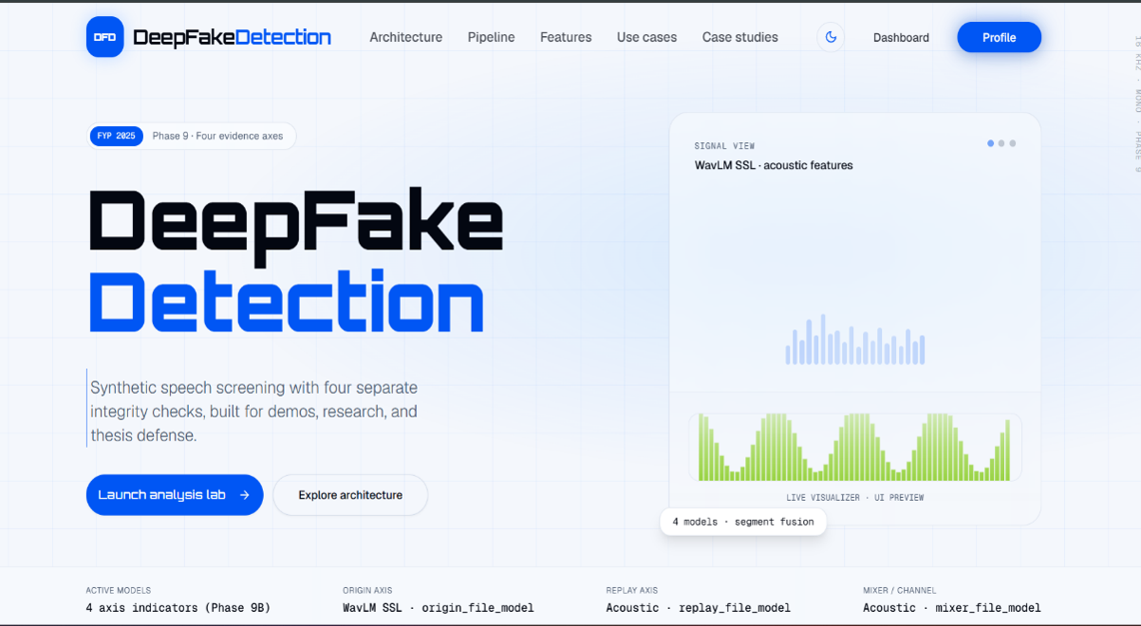
Figure F.1: FASSD Landing Page Hero Section


Figure F.2: Architecture / System Overview Section

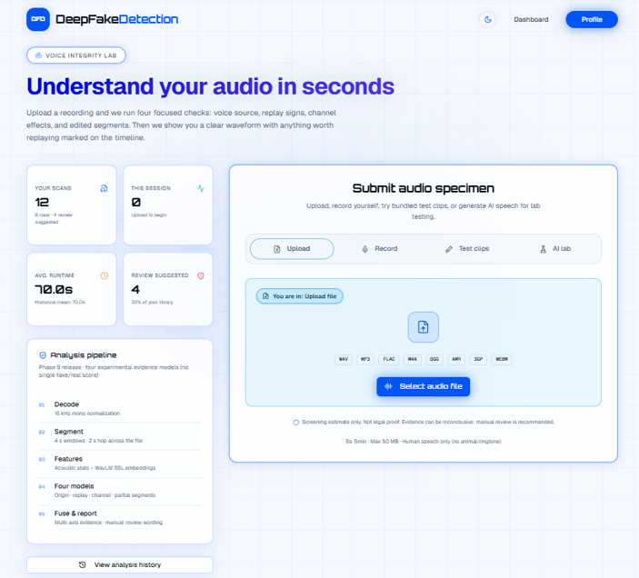
Figure F.3: Upload and Analysis Lab Interface

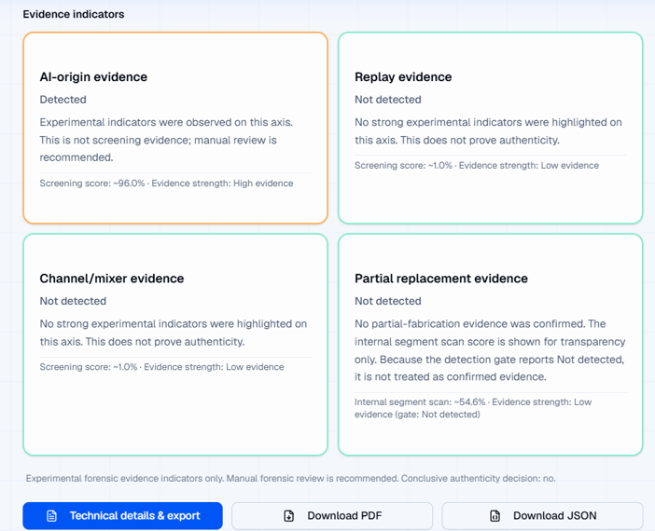
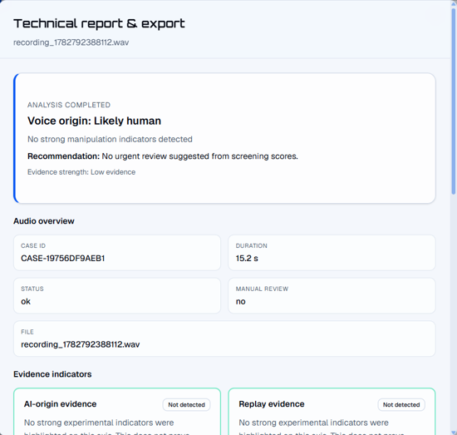
Figure F.4: Multi-Axis Evidence Result View
Figure F.5: Report and Manual-Review Wording

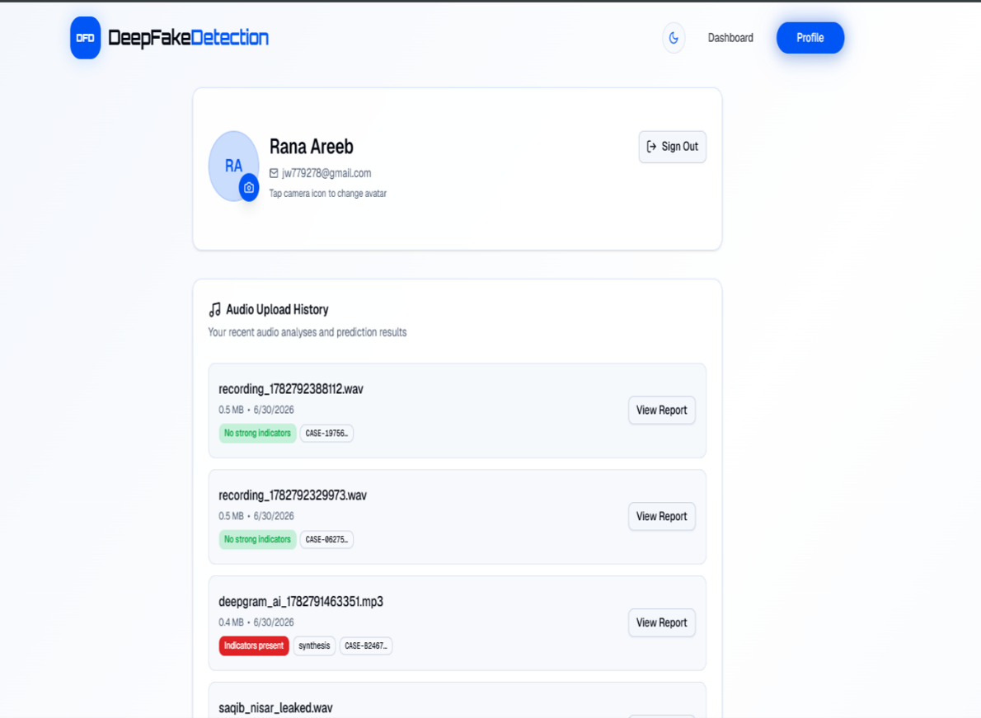

Figure F.6: Profile and History Page
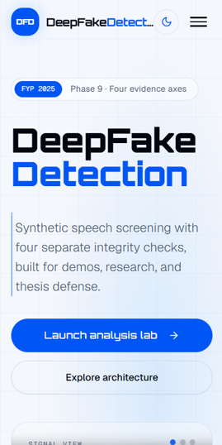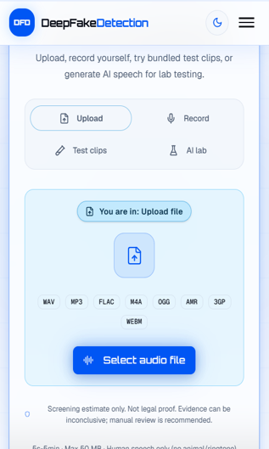
Figure F.7: Mobile Responsive View

Appendix G: Additional Results

This appendix contains additional result artifacts that support the evaluation chapter but are too detailed to include in the main thesis body. These materials include confusion matrices from the baseline, ResNet, HybridResNetEnvironmental, and final evidence-axis evaluations; full Phase 7 controlled forensic tables; and Phase 9G release packaging evidence. The purpose of this appendix is to preserve traceability between the reported thesis results and the actual project validation outputs. These results should be used as supporting evidence only, because the final FASSD system remains an experimental forensic decision-support prototype and not a conclusive authenticity authority.
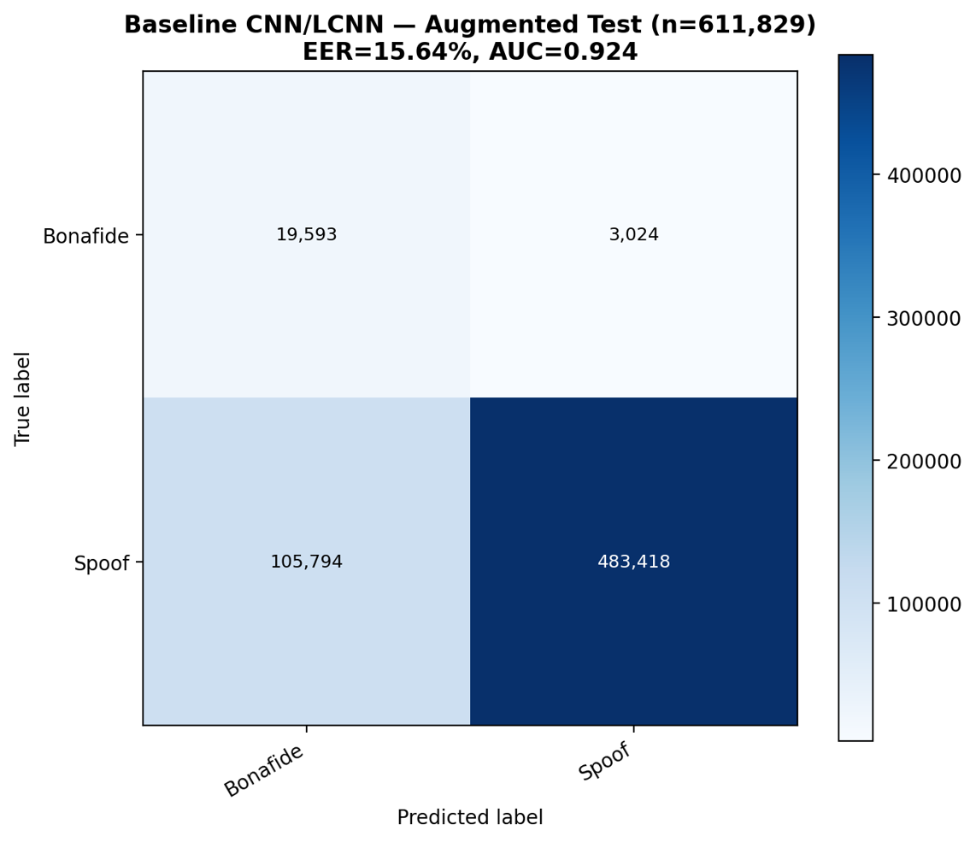
Figure G.1: Baseline CNN/LCNN Confusion Matrix

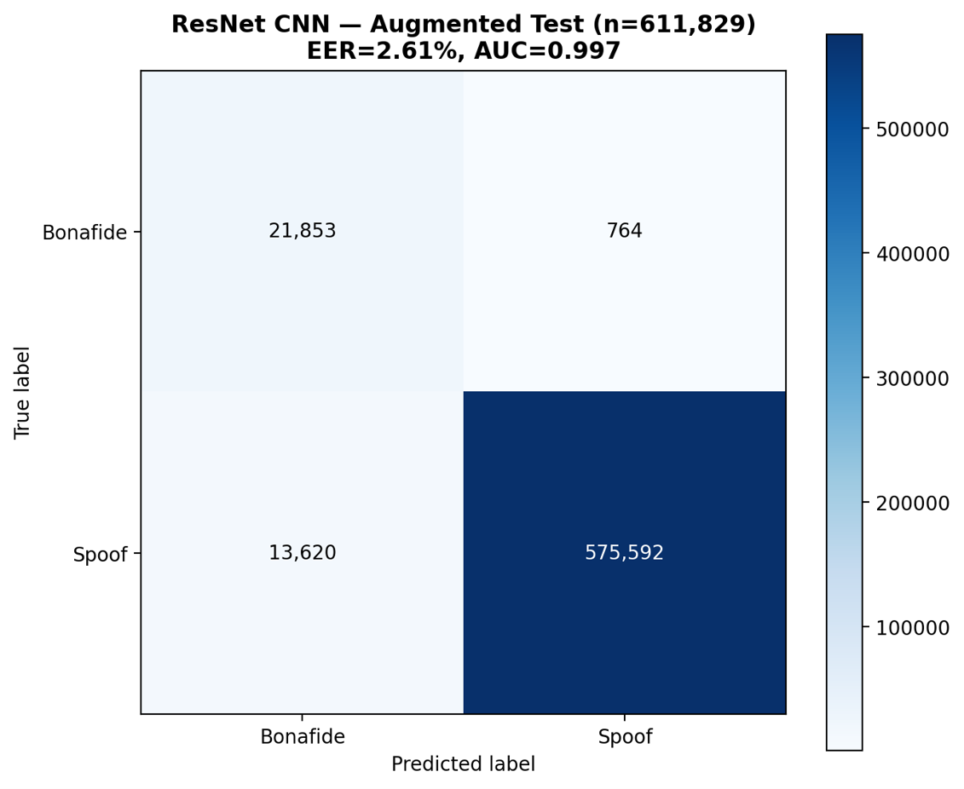
Figure G.2: ResNet Evaluation Confusion Matrix
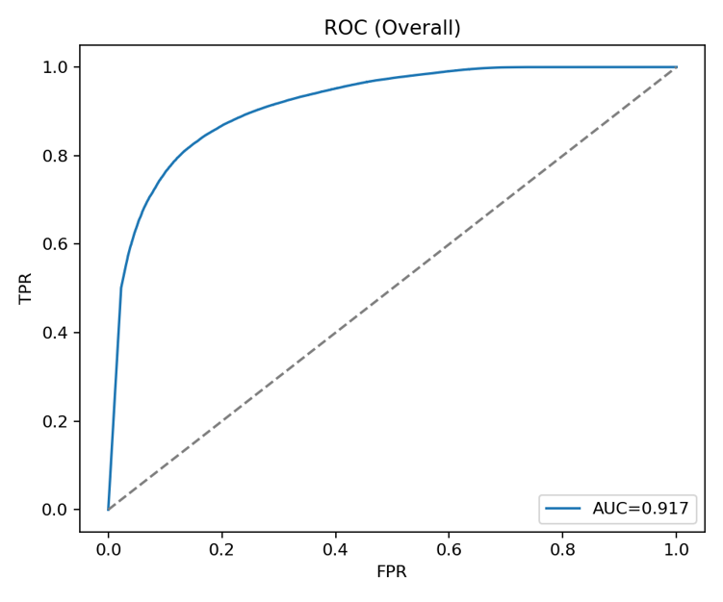
Figure G.3: HybridResNetEnvironmental ROC Curve

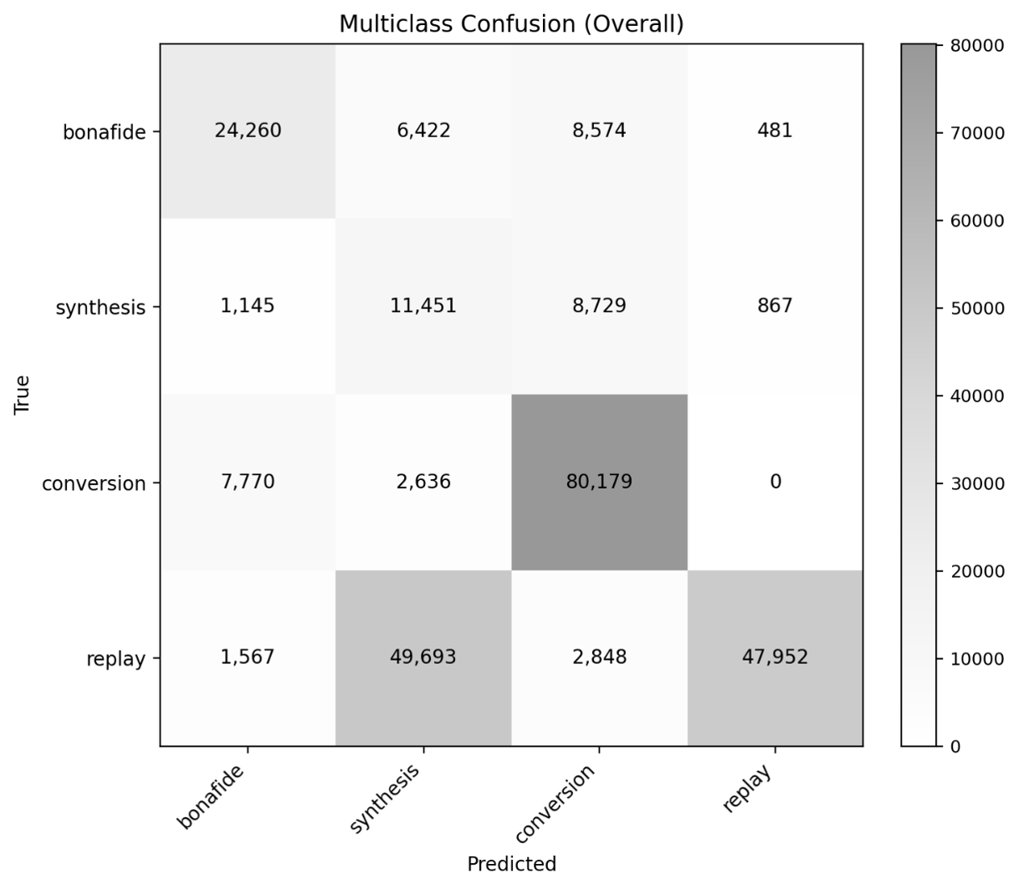
Figure G.4: HybridResNetEnvironmental Confusion Matrix
Table G.1: Phase 7 Full Controlled Evaluation Tables
Phase 7 Category | Result Summary | Appendix Source
Clean human | Acceptance, false alarm, and borderline behavior | PHASE7_EXPERIMENT_  RESULTS_SUMMARY.md
Direct AI | File-level and segment-suspicious detection behavior | PHASE7_EXPERIMENT_  RESULTS_SUMMARY.md
Human replay | Replay sensitivity under controlled conditions | PHASE7_EXPERIMENT_  RESULTS_SUMMARY.md
AI replay | Replay sensitivity for AI-origin audio | PHASE7_EXPERIMENT_  RESULTS_SUMMARY.md
Human mixer/channel | Mixer/channel sensitivity under controlled conditions | PHASE7_EXPERIMENT_  RESULTS_SUMMARY.md
AI mixer/channel | Mixer/channel sensitivity for AI-origin audio | PHASE7_EXPERIMENT_  RESULTS_SUMMARY.md
Partial fabrication | Candidate detection and segment-level behavior | PHASE7_EXPERIMENT_  RESULTS_SUMMARY.md

Table G.2: Phase 9G Release Manifest Summary
Release Item | Value
Release phase | Phase 9G
Release status | PASS
Handoff status | GO for local demo/handoff
Package name | phase9g_deepfake_audio  _detector_demo_handoff.zip
Package path | release_packages/phase9g_  deepfake_audio_detector  _demo_handoff.zip
Total files | 71
Package size | 37,248,295 bytes
Main purpose | Final backend package for demo, API handoff, and release validation

Table G.3: Checksum Summary
Artifact | Checksum Type | Checksum Value
Phase 9G release package | SHA-256 | Paste exact value from Phase 9G manifest/checksum file
Model registry file | SHA-256 | Paste exact value from release manifest if available
Evidence calibration file | SHA-256 | Paste exact value from release manifest if available
API contract file | SHA-256 | Paste exact value from release manifest if available

Appendix H: Ethical and Safety Wording

This appendix records the wording rules used in FASSD to avoid overstating the system’s forensic value. Because the project deals with deepfake audio and possible accusations of synthetic or manipulated speech, the output language must remain cautious. The final system is not designed to prove whether a recording is real or fake. It reports evidence indicators that may support further review by a human analyst. This wording policy was applied in the thesis, API response design, report layer, and web interface. The same rules also apply to the partial-fabrication module, which highlights candidate regions only and does not prove that a segment was fabricated. These wording controls are part of the project’s ethical design because incorrect or overconfident claims could mislead users, damage reputations, or create unsupported forensic conclusions.

Table H.1: Safe Wording Bank
Safe Wording | Recommended Use
Experimental forensic audio decision-support prototype | Describing the final FASSD system
Evidence indicator / evidence axis | Describing model outputs
Manual review recommended | Used when evidence is uncertain, mixed, or elevated
Voice-origin evidence | Used for human-like or AI-like origin patterns
Replay/rerecording evidence | Used for possible playback or recording-chain effects
Mixer/channel evidence | Used for possible channel processing or mixing artifacts
Partial-fabrication candidate region | Used for segment-level suspicious regions
Evidence strength: Low / Medium / High | Used instead of legal certainty or raw confidence
Not a conclusive authenticity decision | Required safety statement
Results are experimental and not population representative | Used when discussing controlled or limited test sets

Table H.2: Forbidden Claims Bank
Forbidden Claim | Why It Must Be Avoided
The system proves the audio is fake/authentic | The system is not a legal proof engine
Court-ready / admissible legal evidence / certified forensic tool | FASSD has not been forensically certified
Detects all deepfakes | The release audit documents known failures
100% reliable in all real-world conditions | Contradicted by platform compression and matrix failures
Replay detection confirms AI-generated speech | Replay evidence does not equal AI origin
Mixer/channel detection confirms deepfake | Channel artifacts can also appear in human recordings
No partial-fabrication evidence means authentic | Absence of flagged segments does not prove authenticity
HybridResNet or AASIST is the production decision model | Both are reference-only models in the final system
EER 2.61% means the final product is solved | Strong benchmark EER did not remove forensic limitations
Gradio is the final public interface | The final user-facing system is the live Next.js web platform

Table H.3: Partial-Fabrication Report Contract Rules
Contract Rule | Safe Interpretation
Partial module status | experimental_manual_review_only
Output meaning | Candidate segment evidence for reviewer attention
Allowed wording | “Possible partial-fabrication candidate region”
Forbidden wording | “This segment is proven fabricated”
Negative result wording | “No candidate regions were flagged by the experimental module”
Negative result limitation | Does not prove the recording is authentic
Required action | Human/manual review remains necessary
Final decision status | No conclusive authenticity decision should be produced

Appendix I: Ethical and Safety Wording

This appendix records the final two-repository structure used in FASSD. The project was not kept as one simple folder because the machine learning work and the deployed web application had different roles. The main FYP repository at E:\FYP contained the research, training, datasets, reports, and Phase 9 backend release package. The separate website hosting repository at D:\FASSD contained the Next.js frontend, Firebase integration, production API client, deployment notes, and a vendored copy of the Phase 9 backend for Docker-based hosting. This separation made the project easier to manage because model training and release validation could remain in the ML repository, while the public web interface could be deployed and maintained through its own hosting workflow. The frontend and deployment structure is documented in FRONTEND_AND_DEPLOYMENT_STORY.md, Section 5.
Table I.1: FASSD Two-Repository Layout
Repository / Location | Main Folder | Purpose
E:\FYP — FYP ML repository | Code/ | Training scripts, feature extraction code, phase-wise experiments, validation scripts, and model development.
E:\FYP — FYP ML repository | release/ | Phase 9 inference backend source, active model loading, API logic, report generation, calibration, and final release files.
E:\FYP — FYP ML repository | reports/ | Evaluation reports, release audit outputs, validation summaries, figures, and phase documentation.
E:\FYP — FYP ML repository | data/ | Dataset manifests, statistics, feature references, and prepared audio/data structures.
E:\FYP — FYP ML repository | submissions/ | University submission material, proposal-related files, and thesis/project artifacts.
D:\FASSD — website hosting repository | app/ | Next.js routes and pages for the public web application, analysis lab, landing sections, and profile/history views.
D:\FASSD — website hosting repository | components/ | UI components such as detection results, upload zone, evidence cards, and waveform-related display components.
D:\FASSD — website hosting repository | lib/ | Inference client, response mapper, Firebase configuration, Firestore helpers, and frontend utility logic.
D:\FASSD — website hosting repository | new backend/release/ | Vendored Phase 9 API backend used for Docker deployment and production inference hosting.
D:\FASSD — website hosting repository | deploy/ | DigitalOcean deployment runbook, server notes, Caddy/API setup guidance, and production hosting instructions.

E:\FYP
├── Code\
│ ├── phase-wise training and validation scripts
│ └── feature extraction / model development code
├── release\
│ ├── Phase 9 inference backend
│ ├── active model registry and calibration
│ └── report/API generation files
├── reports\
│ ├── evaluation figures
│ ├── release audit outputs
│ └── validation summaries
├── data\
│ ├── manifests
│ ├── dataset statistics
│ └── feature/data references
└── submissions\
└── proposal, thesis, and university submission files

D:\FASSD
├── app\
│ └── Next.js pages and routes
├── components\
│ ├── detection-results
│ ├── upload-zone
│ └── waveform / evidence UI components
├── lib\
│ ├── inference-client
│ ├── response-mapper
│ └── firebase
├── new backend\
│ └── release\ Phase 9 API vendored for Docker deploy
└── deploy\
└── DigitalOcean runbook and hosting notes

