

INSTITUTE OF SPACE TECHNOLOGY

Forensic Acoustic for Synthetic Speech Detection

FYP Team
Rana Muhammad Areeb …………220201004
Muhammad Hasnain…………220201022

Supervised by
Mr. Faran Mehmood

Department of Computing
January, 2026

Anti-Plagiarism Declaration
This is to declare that the above publication produced under the:
Title: Forensic Acoustics For Synthetic Speech Detection
is the sole contribution of the author(s) and no part hereof has been reproduced on as it is basis (cut and paste) which can be considered as Plagiarism. All referenced parts have been used to argue the idea and have been cited properly. I/We will be responsible and liable for any consequence if violation of this declaration is determined.

Date: 17/1/2026
Student 1
Name: Rana Muhammad Areeb

Signature:

Student 2
Name: Muhammad Hasnain
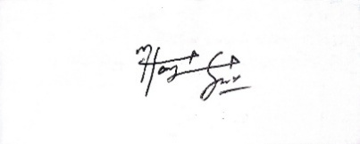
Signature:

Abstract

Recent developments in artificial intelligence have made it possible to generate speech that sounds very close to natural human voice, which creates challenges for digital forensics and security systems. This project focuses on identifying synthetic and manipulated speech using acoustic analysis techniques. The system is developed and tested using the ASVspoof 2021 dataset, which contains both genuine speech and various spoofing attacks such as speech synthesis, voice conversion, and replay. Log-Mel spectrogram features are extracted from audio samples and used as input to a deep learning classifier to capture spectral patterns related to synthetic speech. Alongside this, a set of environmental acoustic features has been defined for later integration to improve performance under real recording conditions. The proposed work aims to support reliable verification of speech authenticity in forensic applications.

Table of Contents

Anti-Plagiarism Declaration ii
Abstract iii
List of Tables v
List of Figures vi
List of Appendices vii
List of Abbreviations & Symbols viii
Chapter 1: Introduction 1
1.1 Project Vision 1
1.2 Problem Domain Overview 1
1.3 Problem Statement 1
1.4 Problem Elaboration 1
Goals and Objectives 2
1.6 Project Scope 2
Chapter 2: Literature Review / Related Work 4
Conclusion: 5
Chapter 3: Proposed Approach and Methodology 6
3.1 Dataset 6
3.2 Preprocessing 6
3.3 Feature Extraction 6
3.3.1 Spectrogram Features (Implemented) 6
3.3.2 Environmental Features (Planned) 6
Hybrid Model Fusion Framework (FASSD) 7
Conclusion: 7
Chapter 4: Executed Work 8
4.1 Dataset Collection and Finalization 8
4.2 Audio Preprocessing Pipeline 8
4.3 Feature Extraction (Completed Work) 9
4.3.1 Log-Mel Spectrogram Feature Extraction 9
4.3.2 Feature Storage and Organization 9
4.4 Environmental Feature Design (Preparation Completed) 9
4.5 Model Selection and Design (Conceptualized) 10
4.6 Summary of Completed Deliverables (Up to 7th Semester) 10
4.7 Remaining Work 10
4.8 Gantt Chart 11
References 12
Appendix 13

List of Tables

Table 1: List of Abbreviation & Symbols viii
Table 2: Literature Review 4
Table 3: Executed Work 8

List of Figures

Figure 1: FASSD System Architecture 3
Figure 2: FASSD Fusion Framework 7
Figure 3: FASSD Phases Gantt Chart 11

List of Appendices

Appendix A: Dataset Details 13
A.1 ASVspoof 2021 Dataset 13
A.2 LibriSpeech Dataset (OpenSLR) 13
A.3 VCTK Corpus 14
Appendix B: Audio Preprocessing Configuration 14
Appendix C: Feature Extraction Parameters 14
C.1 Spectrogram Feature Parameters (Implemented) 14
C.2 Environmental Acoustic Features (Planned) 14
Appendix D: HDF5 Data Storage Structure 15
Appendix E: Tools and Software Environment 15
Appendix F: Ethical Considerations 15
Appendix G: Hybrid Model Architecture and Fusion Framework. 15
G.1 Mermaid Code: Overall Hybrid FASSD System Architecture 16
G.2 Mermaid Code: Hybrid Fusion Strategy 16
Appendix H: Project Timeline Visualization (Python Code) 17
H.1 Python Code for Gantt Chart Generation 17

List of Abbreviations & Symbols

Table 1: List of Abbreviation & Symbols
Abbreviation | Description
AI | Artificial Intelligence
CNN | Convolutional Neural Network
MLP | Multi-Layer Perceptron
EER | Equal Error Rate
AUC | Area Under Curve
TTS | Text-to-Speech
LFCC | Linear Frequency Cepstral Coefficients
ASV | Automatic Speaker Verification

Chapter 1: Introduction

The rapid growth of artificial intelligence has significantly transformed the field of speech processing. Modern text-to-speech and voice conversion systems are now capable of producing synthetic speech that closely resembles natural human voices. While these technologies have enabled beneficial applications such as virtual assistants and accessibility tools, they have also introduced serious concerns related to misuse. Synthetic speech can be exploited for impersonation, misinformation, fraud, and manipulation of digital audio evidence. As a result, verifying the authenticity of speech recordings has become an important challenge in digital forensics and security.
Traditional audio verification methods were designed for controlled environments and are often unable to detect advanced AI-generated speech. Many existing systems rely on speaker-specific traits or simple spectral features, which may fail when the spoofing method or speaker is unseen. This limitation highlights the need for more robust and generalized approaches that focus on intrinsic acoustic artifacts introduced during speech generation. The aim of this project is to address this challenge by developing a forensic acoustic framework for synthetic speech detection.
This chapter introduces the vision of the project, outlines the problem domain, defines the problem statement, and describes the objectives and scope of the work. It also provides an overview of how the remaining chapters are organized.

1.1 Project Vision
The vision of this project is to design a reliable and forensic-oriented system capable of distinguishing genuine human speech and AI-generated synthetic speech. The system is intended to operate independently of specific speakers and spoofing techniques, making it suitable for real-world forensic scenarios. Emphasis is placed on building a framework that can be extended with additional acoustic and environmental features to improve robustness over time.

1.2 Problem Domain Overview
The problem domain of this project lies in synthetic speech detection, which is closely related to automatic speaker verification and digital audio forensics. The system analyzes recorded speech signals and determines whether they are bona fide or spoofed. Spoofed speech may originate from text-to-speech systems, voice conversion models, or replay attacks. The detection process focuses on identifying acoustic inconsistencies and artifacts that are introduced during artificial speech generation but are less prominent in natural human speech.

1.3 Problem Statement
With the increasing realism of AI-generated speech, it has become difficult to distinguish synthetic audio from genuine recordings using conventional techniques. Many existing detection systems perform well only under controlled conditions and fail to generalize to unseen attack types or recording environments. The problem addressed in this project is the development of a robust detection framework that can reliably identify synthetic speech across diverse conditions and attack scenarios.

1.4 Problem Elaboration
Several factors make synthetic speech detection challenging. Speech signals vary significantly across speakers, accents, and recording devices. Synthetic speech systems are continuously improving, reducing the effectiveness of handcrafted detection rules. Environmental conditions such as noise and reverberation further complicate the detection process. Addressing these challenges requires the extraction of meaningful acoustic features and the use of data-driven learning models capable of capturing subtle spectral patterns.

Goals and Objectives
The primary goals and objectives of this project are:
- To analyze and detect AI-generated and spoofed speech
- To utilize benchmark datasets such as ASVspoof 2021 for evaluation
- Extracting discriminative acoustic features for classification
- To design a modular framework that supports future feature fusion
- To improve robustness against unseen spoofing attacks

1.6 Project Scope
The scope of this project is limited to offline analysis of speech recordings using deep learning techniques. The focus is on feature extraction and classification for synthetic speech detection. Real-time implementation, multilingual speech analysis, and hardware-based solutions are not considered within the current scope of this work.

Overall Hybrid FASSD System Architecture

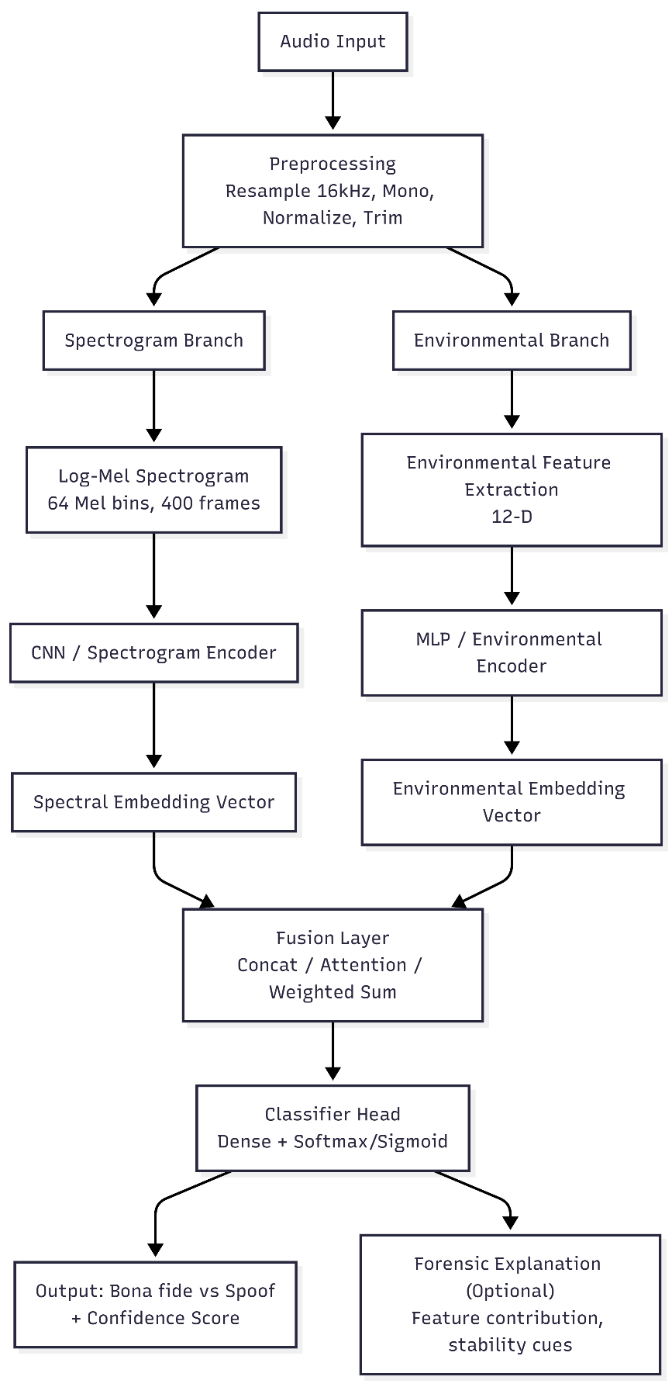
Figure 1: FASSD System Architecture

Chapter 2: Literature Review / Related Work

Early approaches to synthetic speech detection relied on handcrafted features such as MFCCs and CQCCs combined with statistical classifiers. Recent research has shifted towards deep learning methods using CNNs and raw waveform or spectrogram inputs. The ASVspoof challenges have played a central role in benchmarking spoofing countermeasures, highlighting the effectiveness of spectrogram-based models.
However, many studies focus on controlled datasets and lack robustness in real-world environments. Recent works suggest that incorporating environmental acoustic cues can improve detection performance. This project builds on these findings by first establishing a strong spectrogram-based baseline and then extending towards environmental feature integration.

Table 2: Literature Review
Study | Work Summary | Limitations & Comments
ASVspoof Challenges (2015–2021) | Released large benchmark datasets for detecting spoofed audio (Logical Access – TTS/VC, Physical Access – replay). Provided baseline systems with cepstral features (MFCC, LFCC, CQCC) and simple classifiers (GMM, SVM, LCNN). | Established global standards, but detection models often overfit to known attacks and perform poorly on unseen vocoders and real-world noise.
Li et al. (2025) – SONAR Framework | Built a benchmark framework using 9 diverse TTS platforms, including foundation-model-based detectors. Compared 11 detection models (RawNet2, AASIST, Whisper, HuBERT, Wav2Vec2, etc.) across languages and vocoders. | Showed foundation models (Whisper, Wav2Vec2) generalize better, but even they fail on in-the-wild manipulations; system is resource-intensive.
Ahmadiadli et al. (2025) | Proposed identity-independent deepfake detection by introducing Artifact Detection Modules (ADM). Focused on removing “identity leakage” where models confuse speaker traits with forgery artifacts. Used dynamic artifact generation (frequency swaps, noise injection). | Strong cross-dataset performance gains, but pipeline is complex, relies on large labeled datasets, and training is computationally costly.
Yang et al. (2025) – Forensic Features | Investigated segmental speech features (formants, vowel articulation, phonetic cues) commonly used in forensic voice comparison. Demonstrated that such interpretable features outperform global features in detecting fakes. | Improves transparency for legal/forensic settings but tested only on limited datasets. May miss subtle artifacts captured by deep models.
Tahaoglu et al. (2025) – ResNeXt Model | Combined spectral features (MFCC, LFCC, CQCC) with an improved ResNeXt architecture. Applied feature fusion and multi-layer perceptron for classification. Tested on ASVspoof 2019 & 2021. | Achieved very low error rates (EER < 2% on ASVspoof 2019), but generalization remains weak on real-world replay and unseen synthesis methods.
Kulangareth et al. (2024) – Biological Cues | Proposed detecting deepfakes using speech pause patterns (respiration, swallowing, cognitive pauses). Built ML models (AdaBoost, SVM, RF) on pause statistics to capture missing “biological markers” in cloned speech. | Achieved ~80% accuracy, but performance is lower than deep learning. Works better as a complementary forensic cue rather than standalone.
Kawa et al. (2023) – Whisper Features | Used Whisper ASR encoder features as input to CNN-based detectors (LCNN, SpecRNet, MesoNet). Showed Whisper embeddings improve robustness on Deepfakes In-The-Wild dataset compared to traditional MFCC/LFCC. | Outperformed baseline detectors, but computationally heavy. Still shows performance drop in highly noisy, real-world conditions.

Conclusion:
The literature reviewed in this chapter demonstrates that synthetic speech detection has evolved significantly in response to rapid advances in text-to-speech and voice conversion technologies. Early approaches largely depended on handcrafted acoustic features such as MFCCs, CQCCs, and LFCCs combined with conventional classifiers, which showed acceptable performance in controlled environments but struggled to generalize to unseen attack types and recording conditions. More recent studies have shifted toward deep learning–based methods, particularly convolutional neural networks operating on spectrogram representations, as these models can automatically learn discriminative patterns associated with synthetic speech artifacts. Benchmark efforts such as the ASVspoof challenges have provided standardized datasets and evaluation protocols, revealing that while current systems achieve high accuracy on known attacks, their robustness in real-world scenarios remains limited. A recurring observation across the literature is the heavy reliance on spectral features, with relatively little emphasis placed on environmental and channel-related characteristics, despite evidence that such cues can enhance detection performance, especially against replay and deepfake attacks. Overall, the reviewed studies indicate that although substantial progress has been made, challenges related to generalization, robustness, and forensic reliability persist, which directly motivates the proposed approach of establishing a strong spectrogram-based baseline and extending it through the integration of environmental acoustic features.

Chapter 3: Proposed Approach and Methodology

The proposed approach follows a forensic acoustic pipeline consisting of preprocessing, feature extraction, and classification. The methodology is designed to be modular, allowing future extension with additional forensic features.

3.1 Dataset
The ASVspoof 2021 dataset is used, which includes bona fide speech and multiple spoofing attack types such as text-to-speech, voice conversion, and replay attacks.

3.2 Preprocessing
All audio files are converted to mono WAV format with a sampling rate of 16 kHz. Silence trimming and normalization are applied to ensure consistency across samples.

3.3 Feature Extraction

3.3.1 Spectrogram Features (Implemented)
Log-Mel spectrograms are extracted and stored in HDF5 (h5) format. The configuration is:
- Mel bins: 64
- Frames: 400 (~4 seconds)
- Sampling rate: 16 kHz
- Window size: 25 ms
- Hop size: 10 ms
- Feature shape: [64 × 400]

These features are used as input to a CNN-based classifier.

3.3.2 Environmental Features (Planned)
A set of 12 environmental acoustic features has been defined, including RT60, DRR, SNR, background noise level, and spectral statistics. The feature storage structure (h5) has been prepared, and extraction will be performed in the next phase for hybrid model fusion.

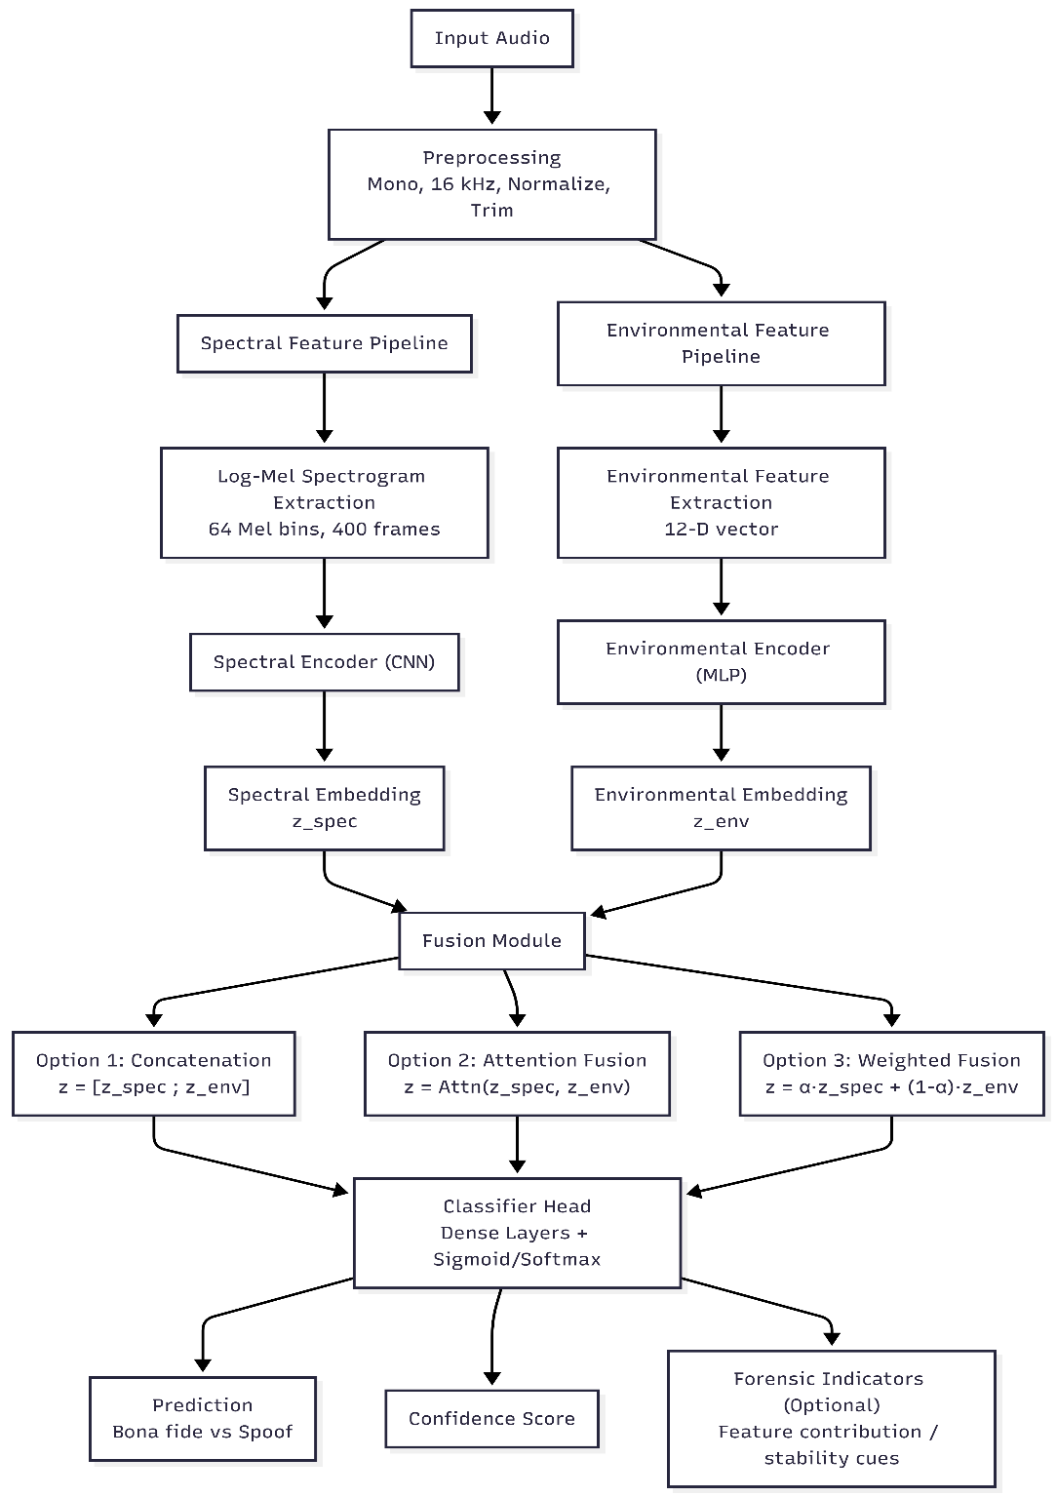
Hybrid Model Fusion Framework (FASSD)
Figure 2: FASSD Fusion Framework

Conclusion:
The hybrid approach effectively leverages complementary information sources, addressing limitations of single-feature systems.

Chapter 4: Executed Work

Sr. No. | Project Milestone | Deliverable | Expected Completion | Completed (%)
1 | Dataset selection & analysis | Dataset report | Month 1 | 100%
2 | Preprocessing pipeline | Cleaned audio | Month 2 | 100%
3 | Spectrogram feature extraction | .h5 files | Month 3 | 100%
4 | Baseline model training | CNN model | Month 4 | 00%
5 | Evaluation & analysis | Results | Month 5 | 00%
Table 3: Executed Work

4.1 Dataset Collection and Finalization

The first milestone executed involved the identification and finalization of appropriate datasets for real and spoofed speech detection. Multiple publicly available data sets were initially explored, including VoxCeleb2 and Mozilla Common Voice. However, these datasets could not be fully utilized due to large storage requirements, access restrictions, and technical limitations.

After evaluation, the following datasets were finalized:
- ASVspoof 2021 Dataset: Selected as the primary benchmark dataset for spoofed speech detection. It contains bona fide and spoofed speech samples generated using text-to-speech, voice conversion, and replay attack techniques.
- LibriSpeech (train-clean-100): Selected to provide clean and high-quality real human speech samples.
- VCTK Corpus: Selected to introduce speaker and accent diversity in the real speech category.

Deliverables achieved:
- Finalized dataset list with justification
- Successful local availability of selected datasets

4.2 Audio Preprocessing Pipeline

A complete audio preprocessing pipeline was implemented to ensure uniformity across all selected datasets. This step was essential to remove data set-specific inconsistencies and prepare the audio data for feature extraction.

The preprocessing pipeline included:
- Conversion of all audio files to mono channel
- Resampling to a uniform sampling rate of 16 kHz
- Amplitude normalization
- Trimming of leading and trailing silence

The pipeline was implemented using Python-based audio processing libraries to ensure reproducibility and scalability.

Deliverables achieved:
- Fully preprocessed and standardized WAV audio files
- Consistent audio format across all datasets

4.3 Feature Extraction (Completed Work)

Feature extraction represents the primary technical work completed up to this stage of the project. According to the project plan, spectrogram-based feature extraction was committed for completion by the end of the 7th semester, and this task has been fully accomplished.

4.3.1 Log-Mel Spectrogram Feature Extraction
Log-Mel spectrogram features were extracted from all preprocessed audio samples to capture time–frequency characteristics relevant to synthetic speech detection. These features are effective in highlighting spectral artifacts introduced by speech synthesis and voice conversion systems.

The extraction configuration is summarized as follows:
- Sampling rate: 16,000 Hz
- Window length: 25 ms
- Hop length: 10 ms
- Number of Mel frequency bins: 64
- Number of frames: 400 (approximately 4 seconds of audio)
- Feature dimension per sample: 64 × 400

The Short-Time Fourier Transform (STFT) was applied to the audio signals, followed by Mel filter bank projection and logarithmic compression.

4.3.2 Feature Storage and Organization
All extracted Log-Mel spectrogram features were stored in HDF5 (.h5) format to enable efficient access during training. This storage strategy minimizes disk input/output overhead and supports batch-wise loading in deep learning frameworks.

Each .h5 file contains:
- Log-Mel spectrogram features
- Corresponding binary labels (bona fide or spoof)
- Metadata indicating dataset source

Deliverables achieved:
- Complete spectrogram feature dataset
- Verified feature dimensions and consistency
- .h5 files ready for direct model input

4.4 Environmental Feature Design (Preparation Completed)

Although environmental acoustic features have not yet been extracted, their design and definition were part of the 7th semester commitments and have been completed. A total of 12 environmental acoustic features were finalized, covering reverberation characteristics, noise behavior, spectral statistics, and signal stability. These features are intended to capture recording environment inconsistencies that are difficult for synthetic speech systems to reproduce. The storage structure for environmental features has already been defined using the .h5 format, enabling side-by-side integration with spectrogram features in subsequent phases.
Deliverables achieved:
- Finalized list of environmental features
- Defined .h5 storage schema
- Clear integration plan for future fusion

4.5 Model Selection and Design (Conceptualized)

Model selection was conceptually finalized during this phase. A convolutional neural network (CNN)–based architecture was selected due to its effectiveness in processing two-dimensional spectrogram representations.

The selected architecture is designed to:
- Accept Log-Mel spectrogram inputs
- Learn discriminative spectral patterns
- Support future fusion with environmental features

Model implementation and training have not yet been performed, as per the approved project timeline.

4.6 Summary of Completed Deliverables (Up to 7th Semester)

By the end of the 7th semester, the following tasks had been fully completed:
- Dataset selection and justification
- Audio preprocessing pipeline implementation
- Log-Mel spectrogram feature extraction
- HDF5-based feature storage
- Environmental feature design and planning
- Conceptual model selection
No classification results, performance metrics, or evaluation outcomes are reported at this stage, ensuring transparency and alignment with the project timeline.

4.7 Remaining Work

The remaining work includes environmental feature extraction, deep learning model training, performance evaluation using ASVspoof 2021, feature fusion, and final documentation. These tasks are scheduled from January 2026 to April 2026 and will be addressed in subsequent phases.

4.8 Gantt Chart
A detailed Gantt chart covering all project phases will be attached.
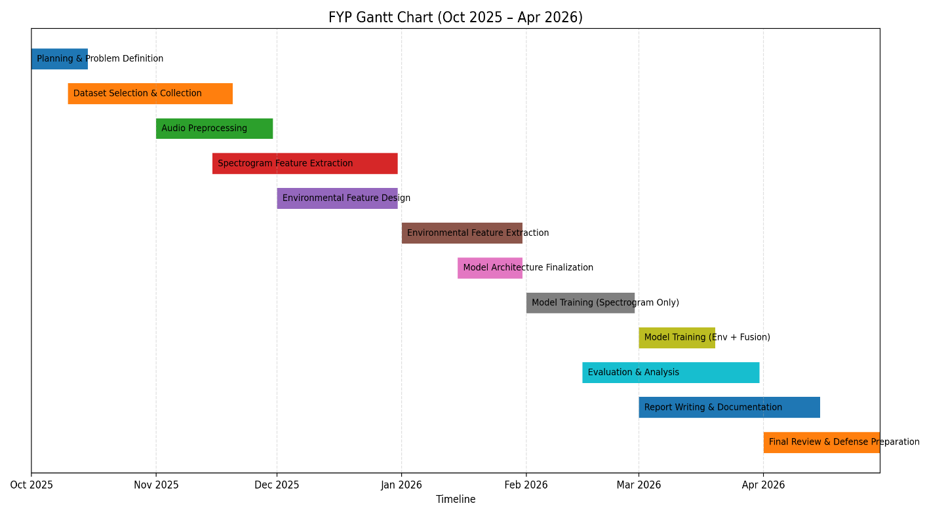
Figure 3: FASSD Phases Gantt Chart

References
H. Delgado et al., “ASVspoof 2021: Automatic Speaker Verification Spoofing and Countermeasures Challenge Evaluation Plan,” 2021. [Online]. Available: https://www.asvspoof.org/asvspoof2021/asvspoof2021_evaluation_plan.pdf
P. Korshunov and S. Marcel, “DeepFakes: A New Threat to Face Recognition? Assessment and Detection,” Dec. 2018. [Online]. Available: https://arxiv.org/abs/1812.08685
H. Kuttruff, Room Acoustics. Boca Raton, FL, USA: CRC Press, 2009. [Online]. Available: https://www.taylorfrancis.com/books/mono/10.1201/9781482266450/room-acoustics-heinrich-kuttruff
Paszke et al., “PyTorch: An Imperative Style, High-Performance Deep Learning Library,” in Advances in Neural Information Processing Systems (NeurIPS), 2019. [Online]. Available: https://papers.nips.cc/paper/9015-pytorch-an-imperative-style-high-performance-deep-learning-library
ASVspoof, “ASVspoof Official Website.” [Online]. Available: https://www.asvspoof.org/

Appendix

This appendix provides supplementary technical information that supports the work presented in the main body of the report. The material included here enhances reproducibility, transparency, and technical clarity; however, it is not essential for the continuity of the main discussion. The appendix documents dataset characteristics, preprocessing configurations, feature extraction parameters, data storage structures, software tools, and ethical considerations relevant to the proposed forensic acoustic synthetic speech detection framework.

Appendix A: Dataset Details

A.1 ASVspoof 2021 Dataset

The ASVspoof 2021 dataset is used as the primary benchmark for spoofed speech detection in this project. It is a widely adopted dataset in the speech forensics community and is specifically designed to evaluate the robustness of automatic speaker verification (ASV) countermeasures against synthetic and manipulated speech. The dataset contains both bona fide (genuine) and spoofed speech samples generated using a variety of state-of-the-art attack techniques.
Key characteristics:
- Audio format: WAV
- Sampling rate: 16 kHz
- Classification categories: Bona fide and spoofed
- Attack types: Logical Access (LA) and Deepfake (DF)
- Spoofing methods: Text-to-speech synthesis, voice conversion, and replay attacks
This data set serves as the foundation for training and evaluating the spectrogram-based spoof detection model implemented in this work.

A.2 LibriSpeech Dataset (OpenSLR)

LibriSpeech is a large-scale corpus of read English speech derived from publicly available audiobooks. In this project, LibriSpeech is used to supplement real human speech data, enabling improved generalization and robustness of the detection framework when exposed to clean, non-spoofed speech.
Subset used:
- train-clean-100
Characteristics:
- Approximate number of files: 28,500
- Audio quality: Clean, studio-like recordings
- Sampling rate: 16 kHz
- Format: WAV
The inclusion of LibriSpeech helps balance bona fide speech samples and strengthens the system’s ability to distinguish real speech from synthetic artifacts.

A.3 VCTK Corpus

The VCTK corpus provides speech recordings from speakers with a wide range of accents and speaking styles. This dataset contributes speaker and accent diversity, which is essential for building a spoof detection system that generalizes across different speakers and recording conditions.
Characteristics:
- Number of speakers: 110
- Audio format: WAV
- Original sampling rate: 48 kHz (downsampled to 16 kHz for consistency)
- Accent diversity: High
VCTK is used to enhance variability in the real speech class and to simulate more realistic forensic scenarios.

Appendix B: Audio Preprocessing Configuration

All audio samples from different datasets are standardized prior to feature extraction using a unified preprocessing pipeline. This ensures consistency across datasets and minimizes variability unrelated to spoofing artifacts.
The preprocessing steps include:
- Conversion to mono channel
- Resampling to 16 kHz
- Amplitude normalization
- Silence trimming
These steps reduce dataset bias, improve feature consistency, and ensure compatibility with the spectrogram extraction configuration.

Appendix C: Feature Extraction Parameters

C.1 Spectrogram Feature Parameters (Implemented)
Log-Mel spectrogram features are extracted as the primary input representation for the deep learning classifier implemented in this project. These features capture time–frequency characteristics that are effective for identifying artifacts introduced by synthetic speech generation.
Extraction parameters:
- Sampling rate: 16,000 Hz
- Window size: 25 ms
- Hop size: 10 ms
- Number of Mel bins: 64
- Number of frames: 400
- Feature dimension: 64 × 400
- Storage format: HDF5 (.h5)
These spectrogram features have been fully implemented and stored in HDF5 format to support efficient training and experimentation.

C.2 Environmental Acoustic Features (Planned)
In addition to spectral features, a comprehensive set of environmental acoustic features has been designed for future integration. These features aim to capture recording-environment characteristics that are difficult for synthetic speech systems to replicate consistently.
The planned environmental feature set includes:
- Reverberation Time (RT60)
- Direct-to-Reverberant Ratio (DRR)
- Signal-to-Noise Ratio (SNR)
- Background Noise Level
- Silence Ratio
- Spectral Tilt
- Spectral Flatness
- Spectral Rolloff
- Cleanliness Score
- High-Frequency Content
- Background Consistency
- Environmental Stability
The HDF5 storage structure for these features has already been prepared. Feature extraction and integration will be performed in later project phases.

Appendix D: HDF5 Data Storage Structure
To enable efficient data handling and scalable training, all extracted features and labels are stored using the HDF5 (.h5) format. The logical structure of the storage is organized as follows:
- /features/spectrograms → Log-Mel spectrogram feature arrays
- /labels → Binary labels (bona fide / spoof)
- /metadata → Dataset source identifiers and sample information
This structured storage approach allows fast batch loading, reduced memory overhead, and seamless integration with deep learning frameworks.

Appendix E: Tools and Software Environment
The following tools and software libraries are used throughout the project:
- Python 3.9
- NumPy
- Librosa
- PyTorch
- FFmpeg
- HDF5 (h5py)
All tools used are open-source and freely available, ensuring reproducibility and accessibility for future research.

Appendix F: Ethical Considerations
This project is conducted strictly for academic and research purposes. All datasets used are publicly available and licensed for research use. No personally identifiable or private data is collected or processed. The proposed system is designed to support forensic verification, enhance trust in digital speech evidence, and mitigate the misuse of synthetic speech technologies rather than facilitate it.

Appendix G: Hybrid Model Architecture and Fusion Framework.
This appendix provides the structural representation of the proposed Hybrid Forensic Acoustic Synthetic Speech Detection (FASSD) framework. The code is included for documentation and reproducibility purposes and is not required for understanding the main workflow described in Chapter 1.

G.1 Mermaid Code: Overall Hybrid FASSD System Architecture
flowchart TD
A[Audio Input] --> B[Preprocessing<br/>Mono, 16 kHz, Normalize, Trim]

B --> C1[Spectrogram Branch]
B --> C2[Environmental Branch]

%% Spectrogram Branch
C1 --> D1[Log-Mel Spectrogram<br/>64 Mel bins, 400 frames]
D1 --> E1[CNN / Spectrogram Encoder]
E1 --> F1[Spectral Embedding Vector]

%% Environmental Branch
C2 --> D2[Environmental Feature Extraction<br/>12-D]
D2 --> E2[MLP / Environmental Encoder]
E2 --> F2[Environmental Embedding Vector]

%% Fusion
F1 --> G[Fusion Layer<br/>Concat / Attention / Weighted Sum]
F2 --> G

G --> H[Classifier Head<br/>Dense + Softmax / Sigmoid]
H --> I["Output: Bona fide vs Spoof<br/>+ Confidence Score"]

H --> J["Forensic Explanation (Optional)<br/>Feature contribution, stability cues"]
This diagram illustrates the parallel extraction of spectrogram-based and environmental acoustic features, followed by feature fusion and classification for spoof detection.

G.2 Mermaid Code: Hybrid Fusion Strategy
flowchart LR
S[Spectral Embedding] --> F{Fusion Strategy}
E[Environmental Embedding] --> F

F --> C1[Concatenation Fusion]
F --> C2[Attention-Based Fusion]
F --> C3[Weighted Fusion]

C1 --> O[Final Prediction]
C2 --> O
C3 --> O
This flowchart documents the alternative fusion mechanisms considered in the proposed framework.

Appendix H: Project Timeline Visualization (Python Code)

This appendix provides the Python script used to generate the Gantt chart illustrating the project timeline from October 2025 to April 2026. The chart reflects phased model training, with evaluation beginning in mid-February 2026.

H.1 Python Code for Gantt Chart Generation

import matplotlib.pyplot as plt
import matplotlib.dates as mdates
from datetime import datetime

tasks = [
("Planning & Problem Definition", "2025-10-01", "2025-10-15"),
("Dataset Selection & Collection", "2025-10-10", "2025-11-20"),
("Audio Preprocessing", "2025-11-01", "2025-11-30"),
("Spectrogram Feature Extraction", "2025-11-15", "2025-12-31"),
("Environmental Feature Design", "2025-12-01", "2025-12-31"),
("Environmental Feature Extraction", "2026-01-01", "2026-01-31"),
("Model Architecture Finalization", "2026-01-15", "2026-01-31"),
("Model Training (Spectrogram Only)", "2026-02-01", "2026-02-28"),
("Model Training (Env + Fusion)", "2026-03-01", "2026-03-20"),
("Evaluation & Analysis", "2026-02-15", "2026-03-31"),
("Report Writing & Documentation", "2026-03-01", "2026-04-15"),
("Final Review & Defense Preparation", "2026-04-01", "2026-04-30"),
]

tasks_dt = [(t, datetime.strptime(s, "%Y-%m-%d"),
datetime.strptime(e, "%Y-%m-%d")) for t, s, e in tasks]

fig, ax = plt.subplots(figsize=(14, 7))
y_positions = list(range(len(tasks_dt)))[::-1]

for y, (task, start, end) in zip(y_positions, tasks_dt):
ax.barh(y, (end - start).days, left=start, height=0.6)

ax.set_yticks([])
ax.set_xlim(datetime(2025, 10, 1), datetime(2026, 4, 30))
ax.xaxis.set_major_locator(mdates.MonthLocator())
ax.xaxis.set_major_formatter(mdates.DateFormatter("%b %Y"))
ax.set_title("FYP Gantt Chart (Oct 2025 – Apr 2026)")
ax.set_xlabel("Timeline")
ax.grid(axis="x", linestyle="--", alpha=0.4)

plt.tight_layout()
plt.show()
This script was used to generate the Gantt chart included in Chapter 4.2 of the report.

