

INSTITUTE OF SPACE TECHNOLOGY

Forensic Acoustics for Synthetic Speech Detection

FYP Team
Rana M. Areeb…………220201004
M. Hasnain…………220201022

Supervised by
Sir. Faran Mehmood

Department of Computing

Anti-Plagiarism Declaration
This is to declare that the above publication produced under the:
Title: ______Forensic Acoustics for Synthetic Speech Detection_________________
is the sole contribution of the author(s) and no part hereof has been reproduced on as it is basis (cut and paste) which can be considered as Plagiarism. All referenced parts have been used to argue the idea and have been cited properly. I/We will be responsible and liable for any consequence if violation of this declaration is determined.

Date: 10/12/2025
Student 1
Name: ___Rana M. Areeb______

Signature: _______________________

Student 2
Name: _M. Hasnain________________

Signature: _______________________

Abstract
An Abstract is a short summary of the work being reported. Three to five sentences describing the essence of the work. An abstract is a short, 50-125 words summary of a work. An Abstract should state: the purpose, findings, and conclusion of your work without commenting on or evaluating the work itself. It should be only one paragraph. Put the abstract on a separate page that follows the title page.

Table of Contents
Table of Contents i
List of Tables ii
List of Figures iii
List of Abbreviation & Symbols iv
Chapter 1: Introduction 1
1.1 Project Vision 1
1.2 Problem Domain Overview 1
1.3 Problem Statement 1
1.4 Problem Elaboration 1
1.5 Goals and Objectives 1
1.6 Project Scope 1
Chapter 2: Literature Review / Related Work 2
Literature Review Summary Table 2
Chapter 3: Proposed Approach and Methodology 3
Chapter 4: Executed Work 4
4.1 Remaining Work: 4
4.2 Gantt chart 4
References 5
Appendix 6
Appendix A: Guidelines 6
Formatting Guidelines 7
Chapter 1: Heading 1 7
1.1 Heading 2 7
1.1.1 Heading 3 7
Tables and Figures 8
Equations 9
Header/Footer 9
Other Formatting Guidelines 9
References 9

List of Tables
Table 1: History of Computing Devices 3
Table 2: This is Sample table caption 3
Table 3: This is Sample table caption 3

List of Figures
Figure 1: Sustainable Development Goals 3
Figure 2: List of Styles 3
Figure 3: IEEE Reference style 3

List of Abbreviation & Symbols

GPS  SD cards  PCB  App  USB  Hz  GND | Global Positioning Sensor  Secure Digital Memory Card  Printed Circuit Board  Application  Universal Serial Bus  Hertz  Ground

Introduction
This chapter is mandatory. The introduction should contain a brief overview of the problem being addressed and the background information needed for the reader to understand the work being done and the reasoning behind it.
The last paragraph of introduction chapter should contain an outline of the entire report. Summarize each chapter in one line to make the last paragraph.

Project Vision

Problem Domain Overview
Describe in full detail what your system does. This section can be further divided into sub-sections, but basically a paragraph description of the system is required.

Problem Statement

Problem Elaboration
Describe the problem in detail and the various sub-problems you would work on.

Goals and Objectives
Write goals and objectives here.

Project Scope
Specify scope of your project here

Literature Review / Related Work
For each related work provide a paragraph of introduction and in the end a paragraph of conclusions. Give a page break after the chapter ends. This chapter is mandatory.
NOTE: For development projects describe related or similar work done by other teams and details of their methods/algorithms. For a research project a detailed literature survey is expected.

Literature Review Summary Table
The columns in the table depend upon your problem and should be specific to your project.
Table 1: History of Computing Devices
The summary of various computing devices invented in the past from 1833-1901 is presented here.
No. | Name, reference | Inventor | Year | Input | Output | Description
1. | Analytical Engine, [1] | Charles Babbage | 1833 | Punch cards | Printer, curve plotter, bell | First general purpose computer that had an arithmetical logic unit and could compute using conditional branching and loops. Also incorporated integrated memory.

Write the one paragraph for the conclusion of the literature review.

Proposed Approach and Methodology
The proposed approach could be a Framework, Heuristic, Algorithm, Protocol, or a Mathematical-model.
For each chapter provide a paragraph of introduction and in the end a paragraph of conclusions. Not the programming code but the algorithmic and procedural details especially related to the hidden/ backend algorithms that are not covered in the design.

Executed Work

Concisely list down the principle milestones and associated deliverables that must be achieved
in order to accomplish the project objectives. Add more rows if required.

S.No. | List of project milestones | Deliverable(s) | Expected months to complete | Percent Completed
1.
2.
3.
4.
5.

Use the above sequence to describe in details the works along with the obtained results and deliverables that have been completed until now and how. Note that very general information about topics is NOT required so try to include everything that you have committed to be done by 7th semester whether its design, dataset collection, model selection, algorithms, equations, figures, results and tables etc.

Remaining Work:
Describe in details the plans to execute remaining works. The sequence, as already described above in the table should be followed as possible.

Gantt chart
A detailed and neat Gantt chart should be attached. It may be landscape but it should not have any page number, header and footer. Gantt chart should be listing all the major and minor activities, indicating executed and remaining tasks, along with the time spans. Make sure that the Gantt chart is reflecting all the project milestones

References
This chapter is mandatory. List all important sources of information which have been consulted for this project.

Appendix

Appendix A: Guidelines
This section should include all supporting information from the project that was not included in the body of the report. You should include surveys, complex statistical calculations, certain detailed tables and other such information in an appendix. The information presented in this section is important to support the work presented in the body of the report but would make it more difficult to read and understand if presented within the body of the report.
Cite the appendix items in the report narrative (write "see Appendix A") and organize appendices (e.g., Appendix A, Appendix B,
Any tables, figures, forms, or other materials that are not totally central to the analysis but that need to be included are placed in the Appendix.

Formatting Guidelines
This document also serves as style guide for final year project reports. In order to give a similar high-quality appearance to all final year software project reports this template uses a collection of predefined Microsoft Word formatting styles. These styles should be used without modification or replacement. Font in the document is “Time New Roman”. This template provides following styles:
- Title – the main title style
- Title2 – the subtitle style
- Body Text – style for paragraphs
- Caption – the style for a figure or table caption
- Table Description – the style for description of table, it must be added after caption.
- Figure Description - the style for description of figure, it must be added after caption.
- Code – the style for program source code
int x = 10; // Writing important code
- Table Header Row – Style for the header row of table
- Table Grid – the style for the data rows in the tables
- Reference – The style for references
- Bullets – The style for the bullet lists
- Numbered List– Style for numbered lists
All Heading styles with different level numbers are listed below.

Heading 1

Heading 2

Heading 3

Heading 4

Heading 5

Heading 6

Heading 7

Heading 8

Heading 9

Tables and Figures
Tables and figures should be centered horizontally. The caption button should be used to insert caption for both the figures and tables. All figures and tables must be numbered properly. Always refer to tables and figures according to their numbers. A table or figure can be cited as follows: ‘see Table1’ or ‘as shown in Table1’. The caption of table should be centered above the table and figure caption should be centered below the figure. Place the tables/figures close to their reference. Use “Table Header Row” and ‘Table Grid’ style for table’s header and data rows respectively. It is compulsory to provide brief description of table/figure after its caption. Styles for table and figure descriptions are “Table Description” and “Figure Description” respectively.
Press Ctrl + Shift + S to see list of styles mentioned above. Figure 1 shows the Apply Style window displaying the list of styles. Select any text then press Ctrl + Shift + S, the Apply Style window will show you the current style applied on that text and if required, you can change the style by selecting any other style from the “Style Name” dropdown.
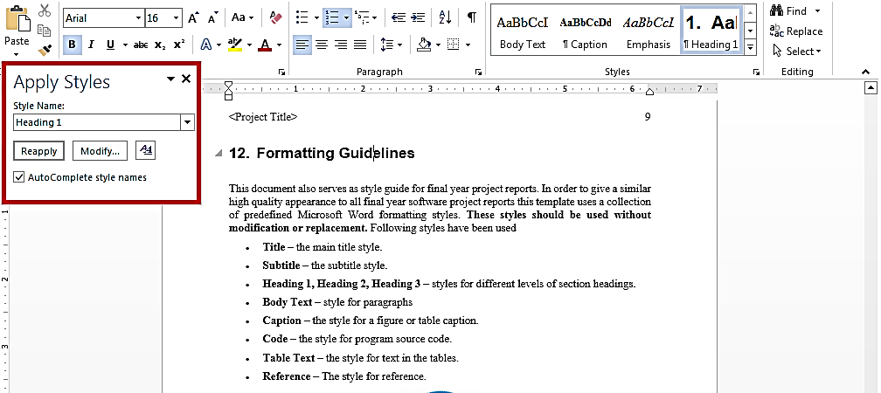
This is brief description of above figure.
Figure 2: List of Styles
Table 2: This is Sample table caption
This is brief description of following Table.
Header row | Header row | Header row | Header row
Row1 col1 | Row1 col2 | Row1 col3 | Row1 col4
Row2 col1 | Row2 col2 | Row2 col3 | Row2 col4
Table 3: This is Sample table caption
This is brief description of following Table.
Header row | Header row | Header row | Header row
Row1 col1 | Row1 col2 | Row1 col3 | Row1 col4
Row2 col1 | Row2 col2 | Row2 col3 | Row2 col4

Equations
Use equation editor to write equations in this report. Use last button of the custom tool bar to invoke equation editor. Similar to tables and figures, equations should also be aligned centered horizontally. Number all equations and insert them in parenthesis. Below is a sample equation and its reference number. An equation can be referenced like this: ‘it is clear from (1)’.
(1)

Header/Footer
Notice the headers in this document, before Introduction (i.e., the main content of this document) page numbers are in roman numerals. The page numbers of the actual content start with Arabic numerals i.e. 1, 2, 3 and so on. All of the odd numbered pages contain title of your project while the even numbered pages contain the section heading (i.e., chapter’s name) in the headers.

Other Formatting Guidelines
- Keep 2-4 GUIs in one page. Consume as much space as possible. Do not leave most of page blank unnecessarily.
- Do not break tables (or use cases) in multiple pages unless the table is too large to fit in one page.
- Re-arrange the content i.e., text, images and tables properly to meet above two guidelines.

References
Always refer to the source of information by inserting the reference number in square brackets like this [5]. The reference numbers can either be added at the end of the sentence or within the sentence without changing the punctuation of sentence. A reference can also be cited as follows: ‘as Ruskey [2] mentioned’. List each source only once on your reference page.
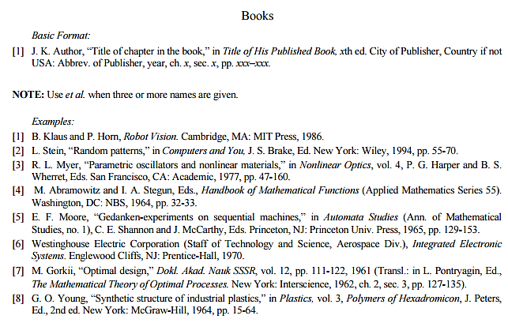
Figure 3: IEEE Reference style
This figure represents the styling information for adding references in IEEE format

Following is a list of sample reference for various type of sources in IEEE format.
- P.M. Morse and H. Feshback, Methods of Theoretical Physics. New York: McGraw Hill, 1953. //Format for Book
- S.K. Kenue and J.F. Greenleaf, “Limited angle multifrequency deification tomography,” IEEE Trans. Sonics Ultrason., vol. SU-29, no. 6, pp. 213-2 17, July 1982. //Format for Journal Article
- B. Tsikos, “Segmentation of 3-D scenes using multi-modal interaction between machine vision and programmable mechanical scene manipulation,” Ph.D. dissertation, Univ. of Pennsylvania, BCE Dept., Philadelphia, 1987. [Add if applicable: University Microfilms, Inc., University of Michigan, Ann Arbor, Michigan.] //Format for Dissertation or thesis
- R. Finkel, R. Taylor, R. Bolles, R. Paul, and J. Feldman, “An overview of AL, programming system for automation,” in Proc. Fourth Int. Joint Conf Artif. Intell., pp. 758-765, Sept. 3-7, 1975. //Format for Proceedings paper
- “Technology threatens to shatter the world of college textbooks, The Wall Street Journal, vol 91, pp. Al, A8, June 1, 1993. //Format for Newspaper article
- R. Cox and J. S. Turner, “Project Zeus: design of a broadband network and its application on a university campus,” Washington Univ., Dept. of Comp. Sci., Technical Report WUCS-91-45, July 30, 1991. //Format for Technical Report
- M. Janzen, Instant Access Accounting. Computer software. Nexus Software, Inc IBM-PC, 1993. //Format for Software
- Fuminao Okumura and Hajime Takagi, “Maglev Guideway On the Yamanashi Test Line,” http://www.rtri.or.jp/rd/maglev2/okumura.html, October 24, 1998. //Format for World Wide Web (give author and title if named)
- “AT&T Supplies First CDMA Cellular System in Indonesia,” http://www.att.com/press/1095/951011.nsa.html, Feb 5, 1996. //Format for World Wide Web

