FYP –I/FYP-II Meeting with Supervisor and Response to Tasks

Project Title | Forensic Acoustics for Synthetic Speech Detection
Supervisor Name | Mr. Faran Mehmood
Co-Supervisor Name
Project Member Name | Rana Muhammad Areeb | Muhammad Hasnain
Reg. No. | 220201004  220201022 | Email | 220201004@ist.edu.pk  220201022@ist.edu.pk
Meeting No. | 12 | Date | 10/12/2025 |  | Time | 12:00pm
Action Items
- Begin full-scale Log-Mel extraction for the clean dataset.
- Optimize the extraction script for faster processing (batching, parallel I/O).
- Continue refining manifest files for both LFCC and Log-Mel features.
- Prepare plan for baseline LCNN training using dual-feature comparison.
- Study transformer-based architectures to prepare for later phases.

Progress on previous Items (if any)
- LFCC extraction reached ~90% completion; remaining files queued for processing.
- Log-Mel extraction tested successfully on multiple samples; initial script validated.
- Manifest structure for clean dataset completed and partially verified.
- Baseline LCNN architecture fully understood; preliminary code modules prepared.


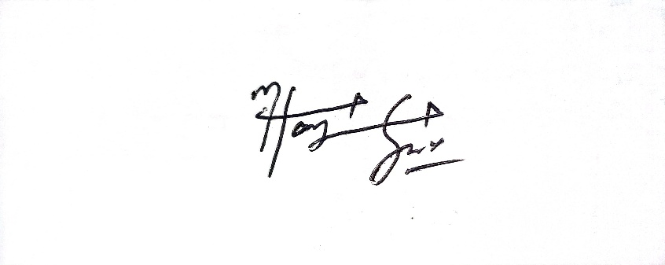

___________________________________
Project Member Signature

Supervisor’s Comments (if any):



___________________________________
Supervisor’s Signature

