Personal Fitness Tracker
Documentation (First Deliverable Updated)

Version 1.0



Group Id: F25PROJECTD5783

Supervisor Name : Muhammad Zafar Nazir

Revision History
Date (dd/mm/yyyy) | Version | Description | Author
19/11/2025 | 1.0 | Introduction of the project | Bc230411896

Table of Contents

- Introduction of document
- Scope (of the project)
- Functional Requirements Non-Functional requirements
- Use Case Diagarm
- Work Plan
- Entity Relationship Diagram (ERD)
- Database Design
- Interface Design

- Introduction of Document
In this document, I describe the Personal Fitness Tracker system in an organized manner. It begins with a brief introduction to the system and its importance. Then, it outlines the main goals of the project, who will use it, and the problems it aims to solve.
I have listed the functional requirements, which include what the system should do, like tracking workouts, diet, and water intake, as well as non-functional requirements, such as ease of use, performance, and security. The document also includes diagrams, including use case diagrams, DFDs, and an ER diagram. These visuals show how users interact with the system, how data flows, and how the database is structured. These diagrams help turn concepts into a clearer design that can eventually be implemented in code.
The purpose of this phase in a software development project is to understand the system well before building it. By documenting everything and planning the structure ahead of time, we reduce confusion, avoid rework, and make sure that it provides clear understanding. This phase also helps identify issues, missing features, or conflicts early on when they are still easy and inexpensive to fix.

Overall, this document serves as a link between the idea and the actual implementation. It provides developers with a clear guide, helps reviewers to visualize what will be built, and makes the entire project more organized, predictable, and manageable.

- Scope (of the project)
The goal of this project is to create a user-friendly Personal Fitness Tracker. It will help individuals keep track of their daily health activities in one spot. Users will be able to create an account, log in securely, and manage their profiles. Within the application, they can record their workouts, including the type of exercise, duration, and intensity. They can also track their daily food intake, calories, water consumption, and basic measurements like weight. Over time, the system will provide summaries and progress reports to help users see how their habits are changing and if they are reaching their fitness goals.

This project targets individual users rather than gyms or trainers, so it won't include complex features like membership management or advanced coaching tools. Instead, it focuses on providing a clean and easy experience for everyday use. The system will be designed for regular users who may not have technical expertise, ensuring that screens and options are clear and simple. In short, the project includes user registration and login, health and activity tracking, basic data storage, and simple progress visualization, all aimed at helping people stay aware of their lifestyles and make better health choices.

- Functional Requirements Non-Functional requirements
Functional requirements:
For this project, the main functional requirements are
1. User account management
The system must allow a new user to register by providing basic details like name, email, and password. They will also add their username to be used in future. It must also let existing users log in and log out safely. Users should be able to update their personal information as needed.

2. Activity and workout tracking
The system must let users record their daily physical activities. For example, they should be able to enter the type of workout, the duration, and any other basic details such as distance or intensity. Each activity should be saved so the user can review it later.

- Nutrition and water intake tracking
The system must allow users to log into what they eat and drink in a day. This includes adding meals with basic calorie information, if available, and recording the number of glasses or liters of water they consume.

4. Progress and history viewing
The system must provide a way for users to view their past data. They should be able to see summaries of their activities, nutrition, and weight over a selected period, like a week or a month. Simple charts or tables can help users track their progress over time.

5. Data storage and retrieval
All user data, such as profiles, activities, meals, and measurements, must be stored in a database and retrieved properly when the user logs in. The system should display the correct information for each user every time.

6. Basic feedback
The system should provide straightforward feedback messages. For example, it should confirm when data is saved, show error messages if required fields are missing, and guide the user if something goes wrong during login or data entry.

Nonfunctional requirements:
Nonfunctional requirements describe how the system should behave and the quality of the user experience instead of specific features. For this project, the main nonfunctional requirements are:
1. Usability
The system should be easy to understand and use, even for people who are not very technical. The screens should be clear, with simple labels and a clean layout. Users should be able to complete common tasks, like adding a workout or checking their progress, without confusion.
2. Performance
The system should respond in a timely manner. Pages should load quickly, and saving or retrieving data shouldn't keep the user waiting long. With a normal amount of data, the system should feel smooth and responsive.

3. Reliability
The system should work consistently without crashing. User data should not be lost unexpectedly, and the system should behave the same way during normal use each time the user logs in.

4. Security
User accounts and personal health data must be protected. Passwords should be stored securely, and users should only be able to view and edit their own information. The system should not display private data to others.

5. Compatibility
The system should function on common web browsers and standard devices like laptops and desktops and possibly tablets. The layout should adjust reasonably to ensure that the main features remain usable on different screen sizes.

6. Maintainability
The system should be built in a clean and organized way so that future changes, bug fixes, or new features can be added without much difficulty. A clear structure and comments in the code will help other developers understand and maintain the system.

- Use Case Diagarm
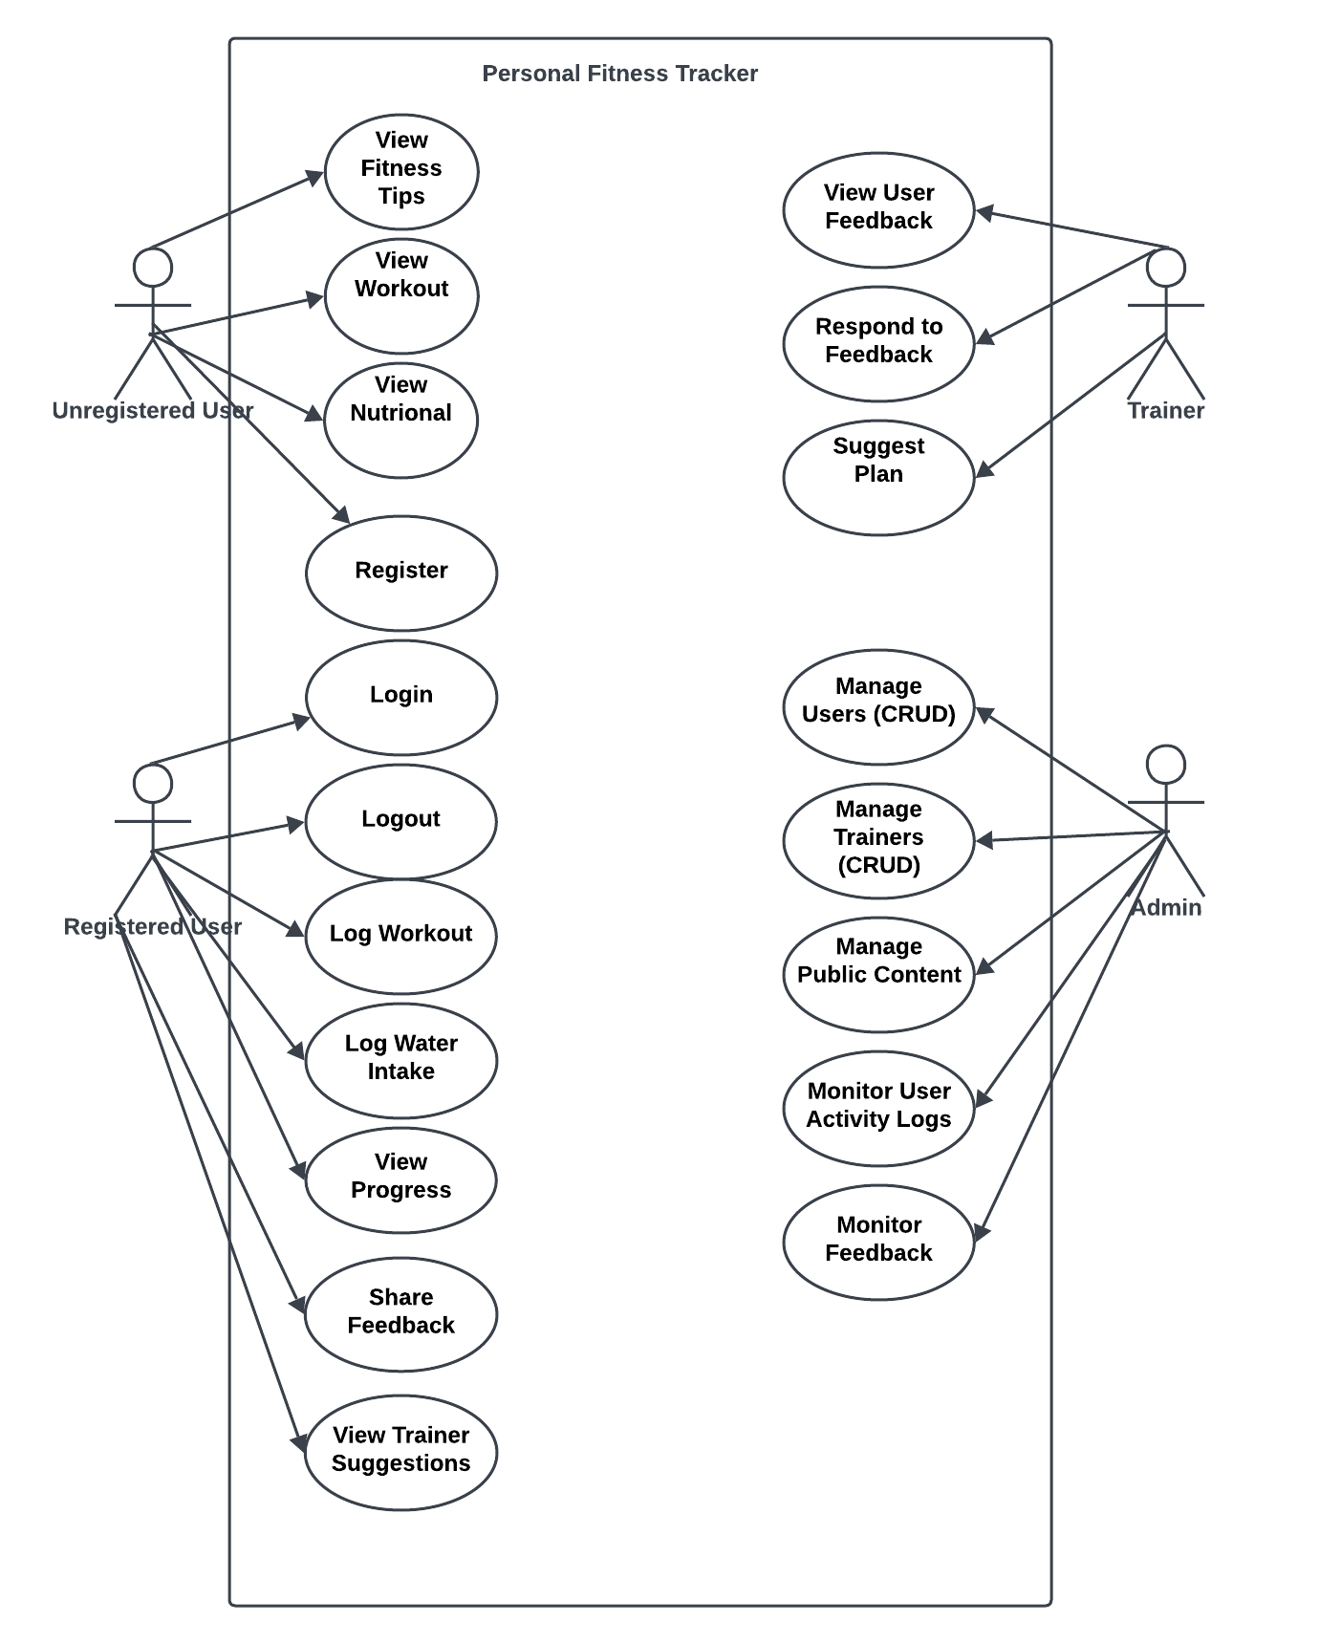

- Work Plan
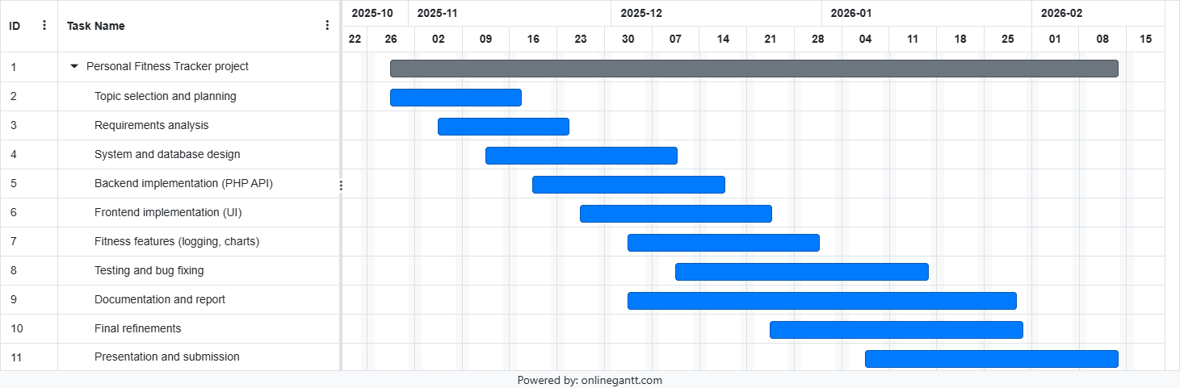

- Entity Relationship Diagram (ERD) (To be developed using Microsoft Visio or any other drawing software of your choice
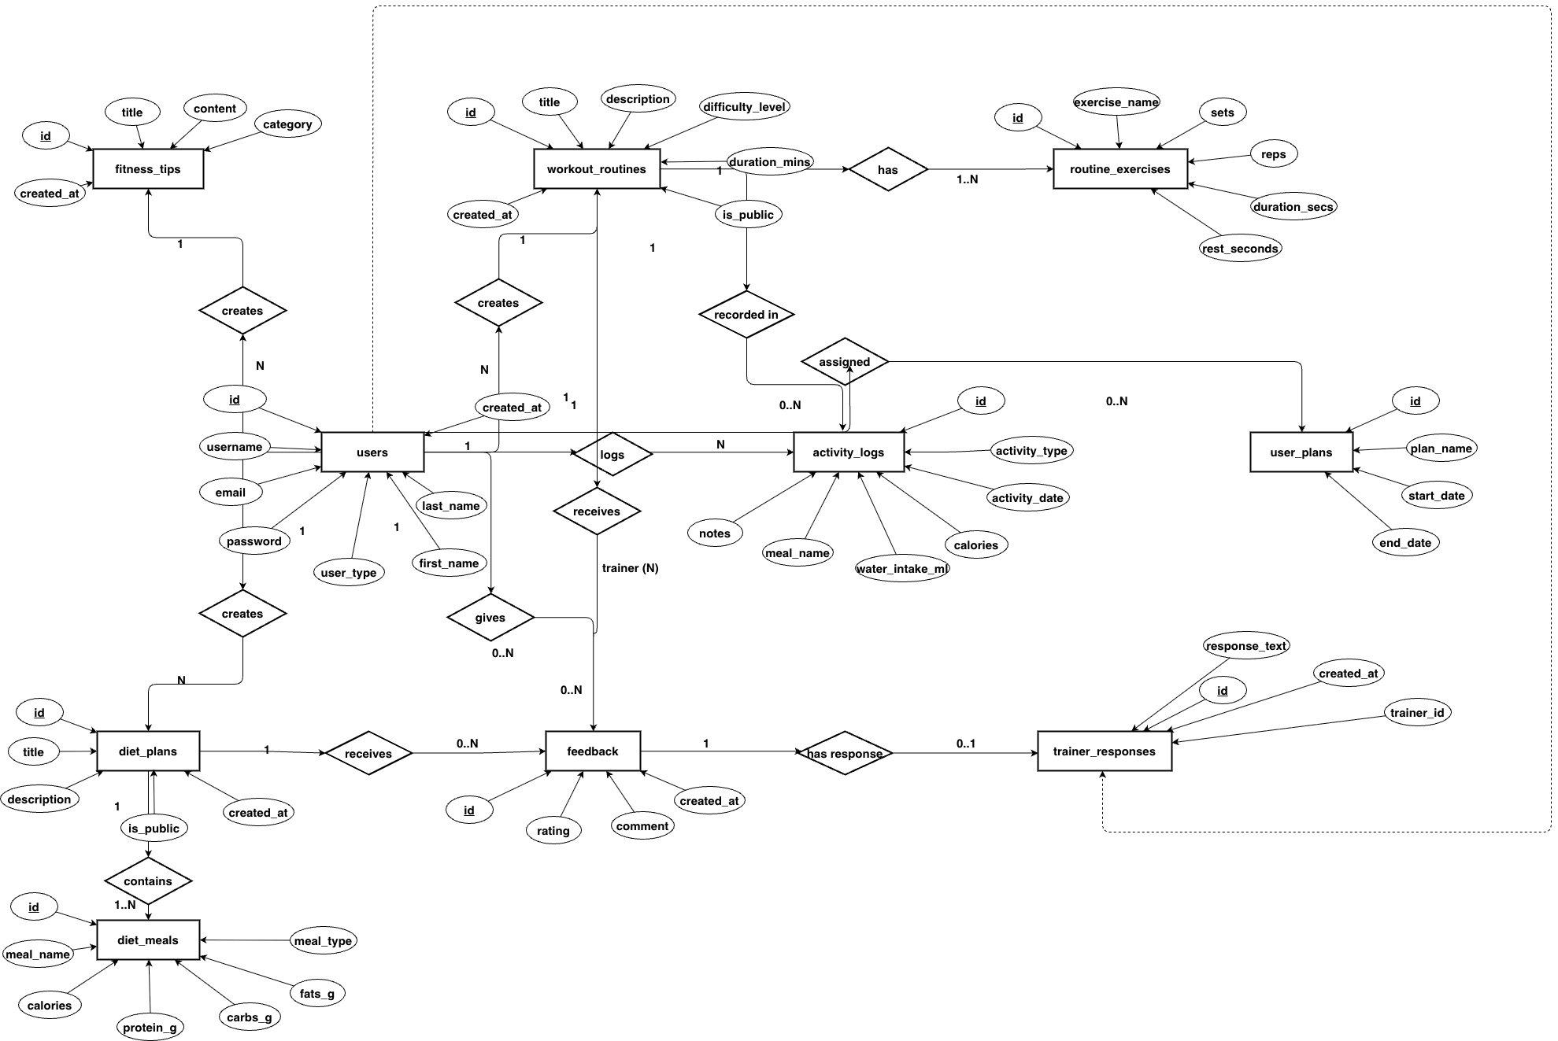

- Database Design

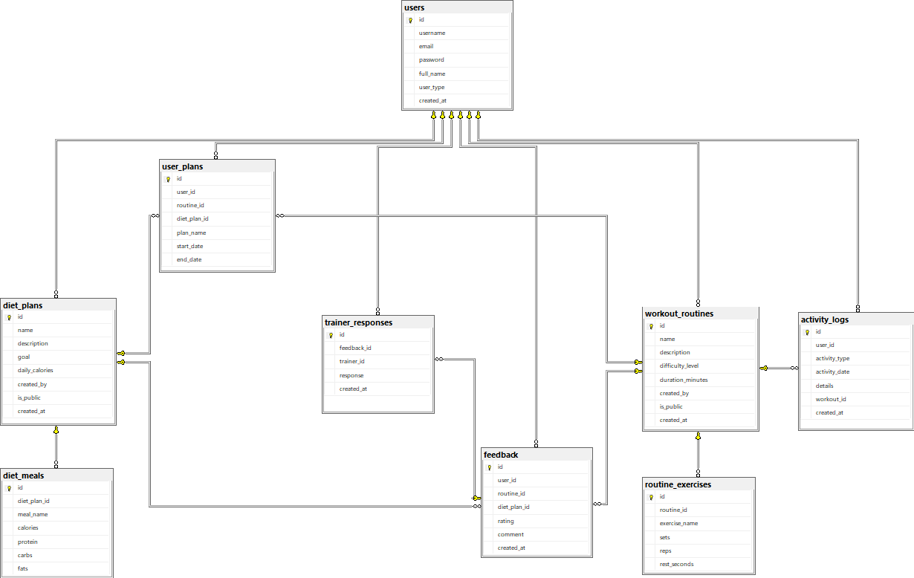

- Interface Design

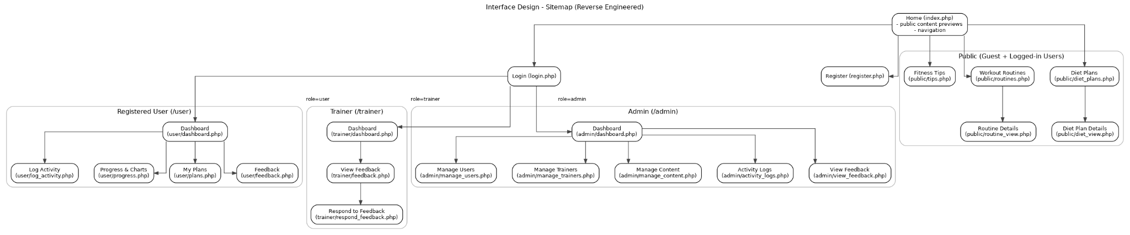

- Main Welcome Page:

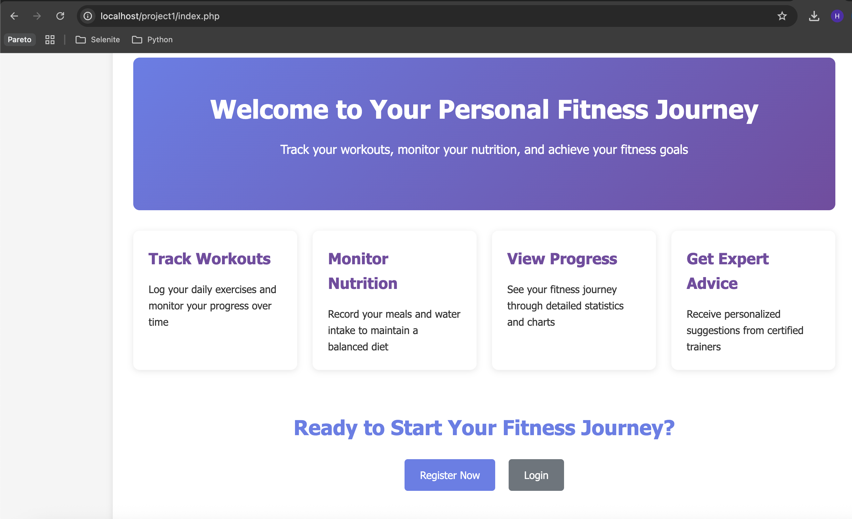

- Register and Log-in:

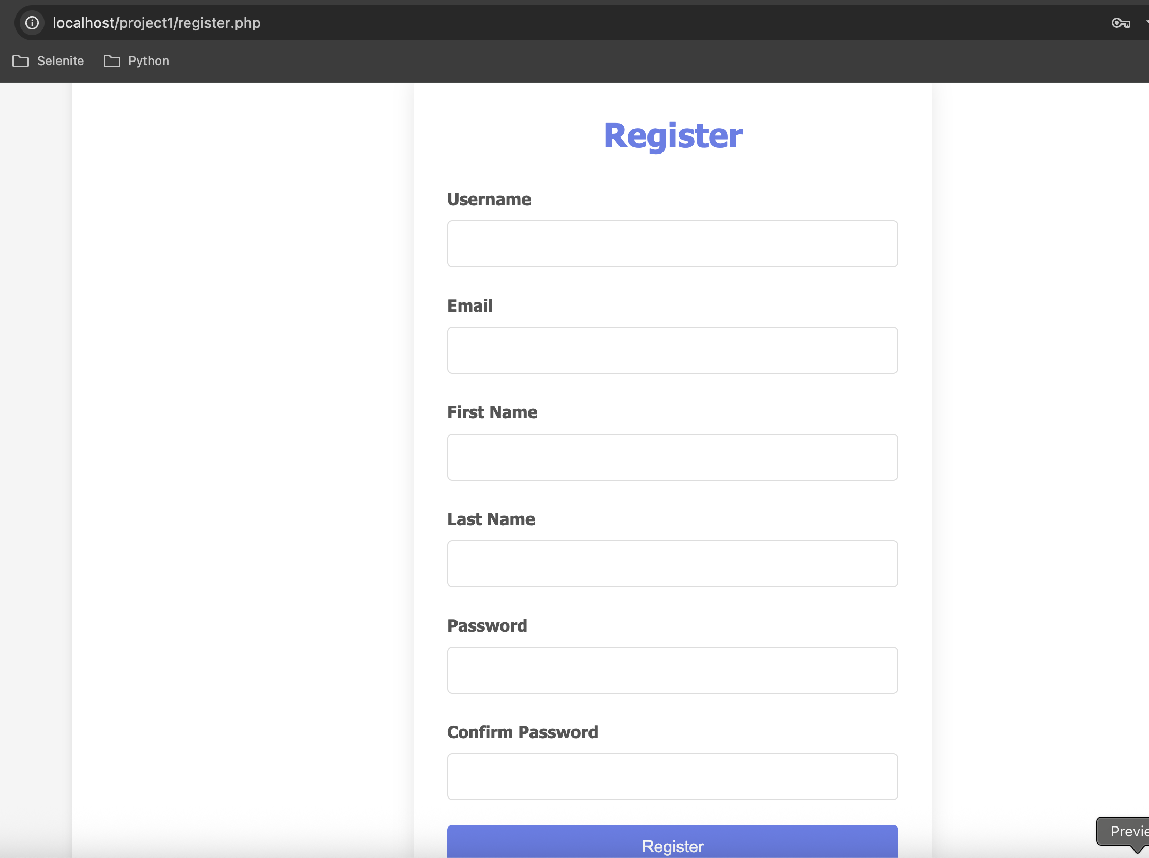
- User Dashboard:

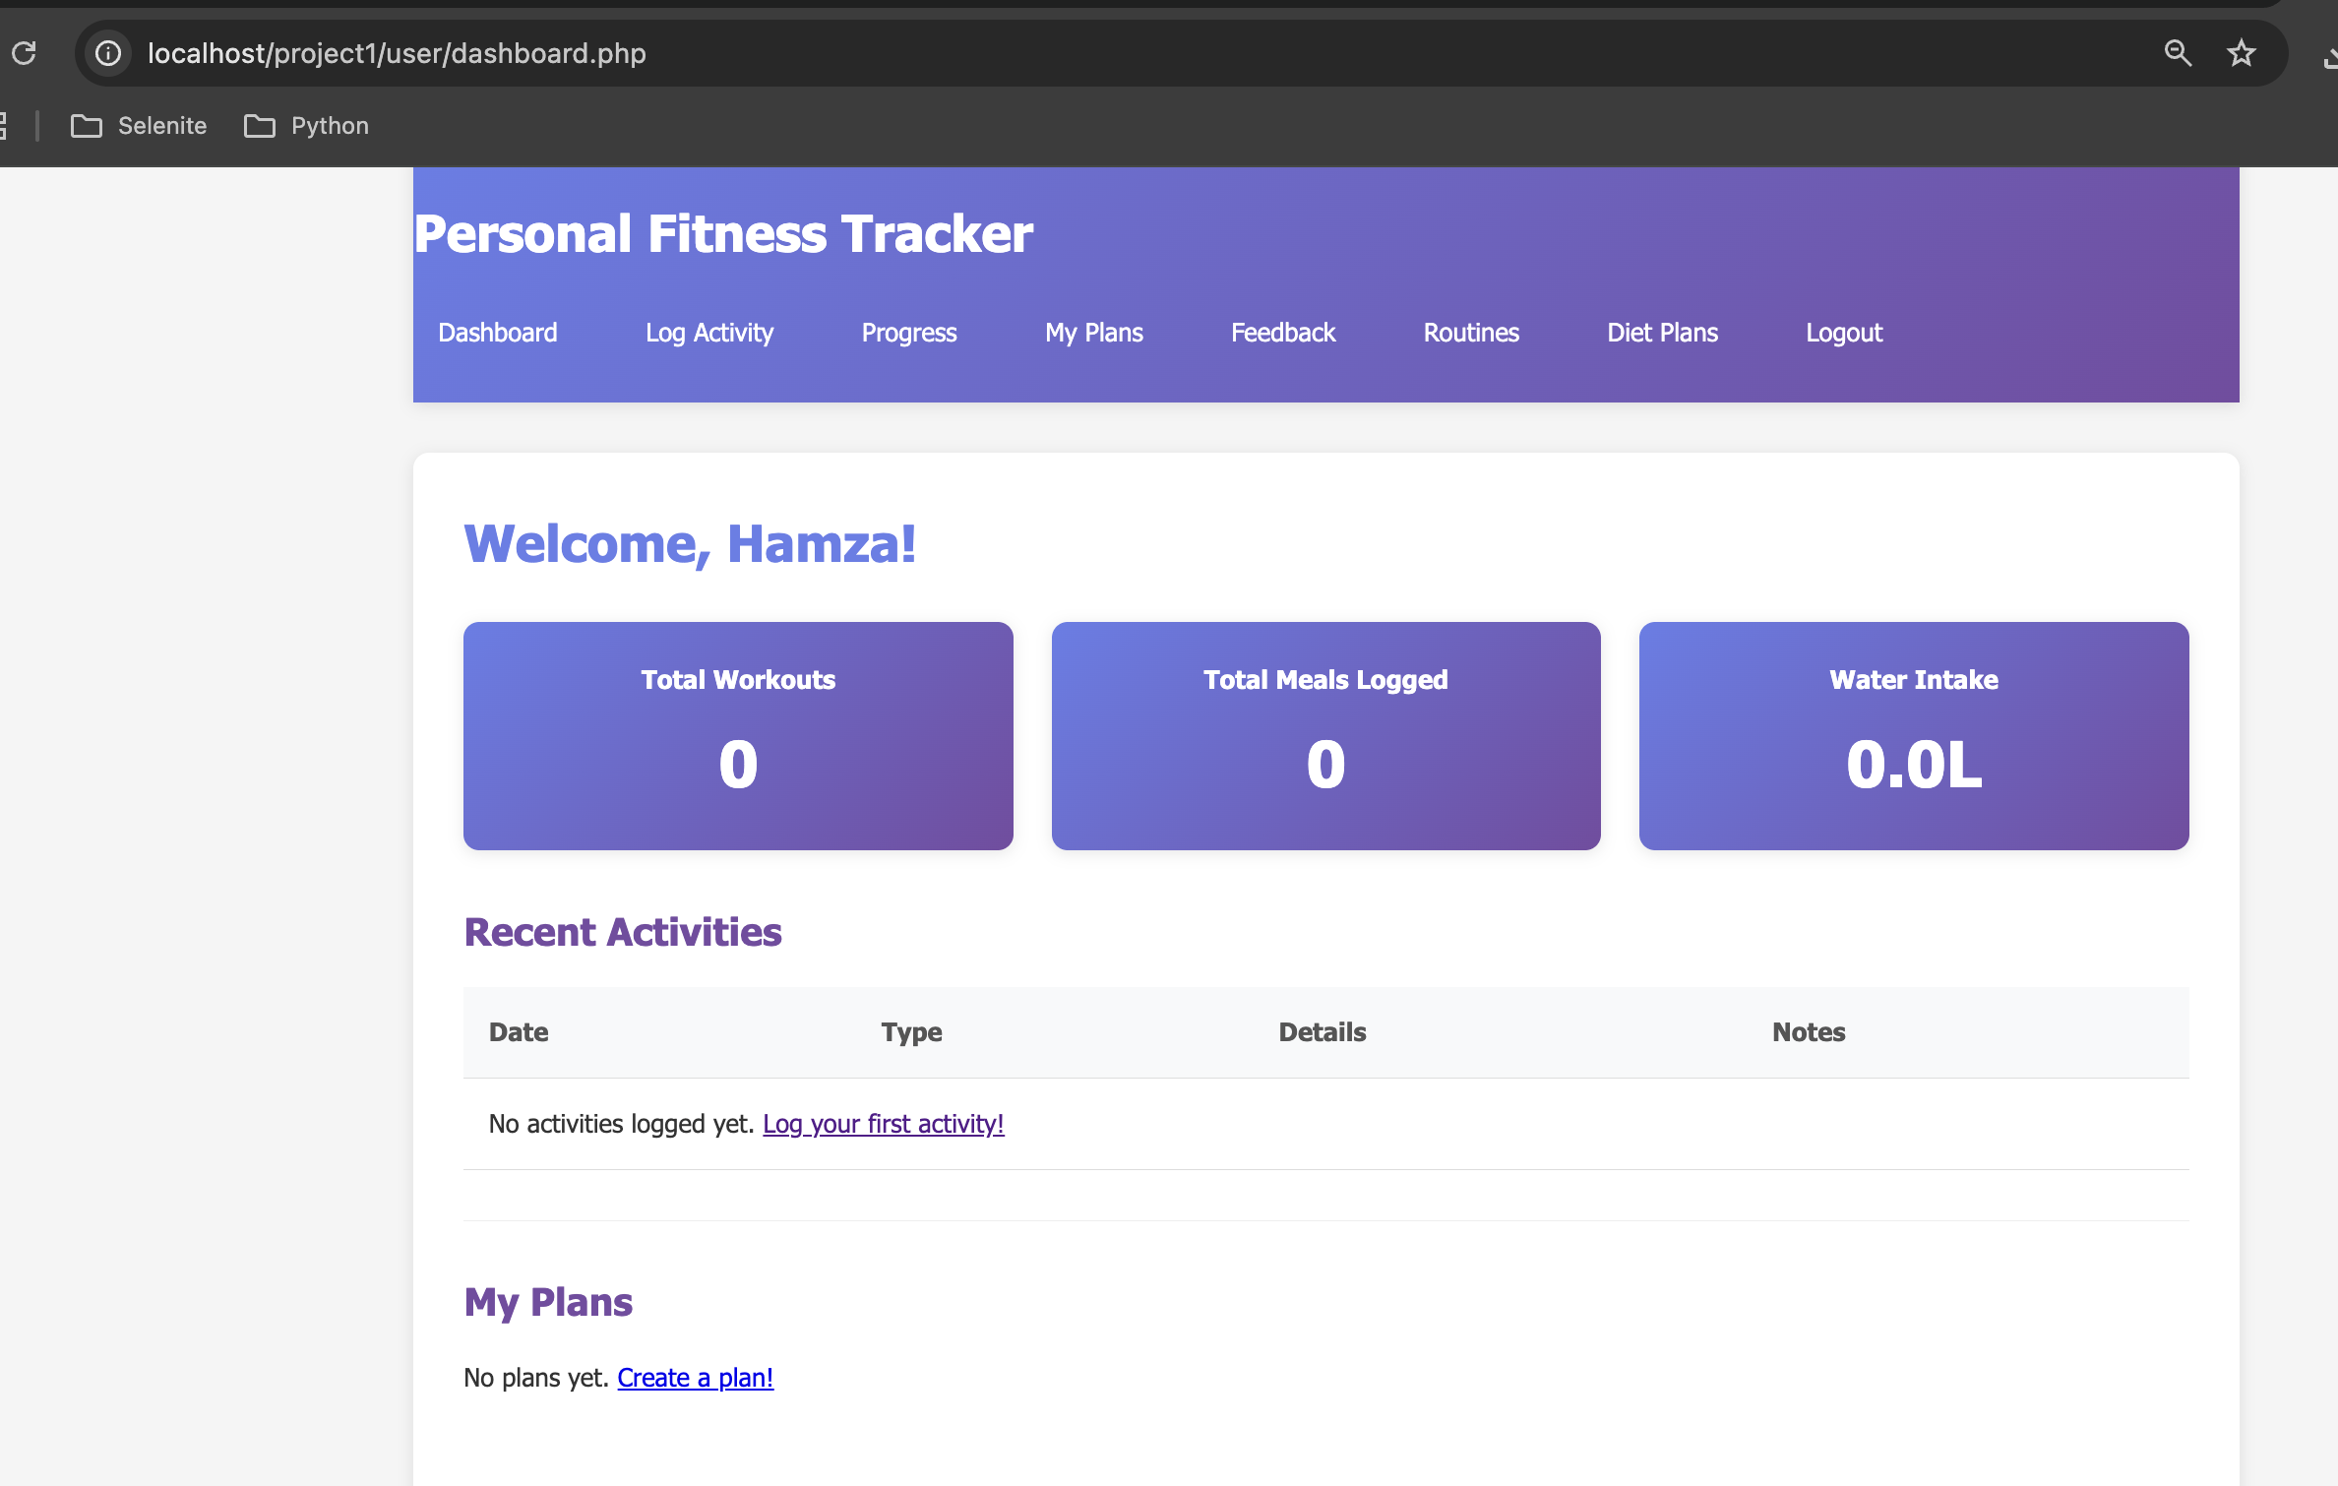

- Log Activity:

