Untitled

Marian Hudson

6/19/2022

Load in data

ames_student <- read_csv("C:/Users/m698f/Downloads/ames_student.csv")

## Rows: 2053 Columns: 81  
## -- Column specification --------------------------------------------------------  
## Delimiter: ","  
## chr (47): MS_SubClass, MS_Zoning, Street, Alley, Lot_Shape, Land_Contour, Ut...  
## dbl (34): Lot_Frontage, Lot_Area, Year_Built, Year_Remod_Add, Mas_Vnr_Area, ...  
##   
## i Use `spec()` to retrieve the full column specification for this data.  
## i Specify the column types or set `show_col_types = FALSE` to quiet this message.

View(ames_student)  
ames <- ames_student

Review and clean up

ames<- ames %>% mutate_if(is.character, as_factor)  
summary(ames)

## MS_SubClass MS_Zoning   
## One_Story_1946_and_Newer_All_Styles :772 Residential_Low_Density :1600   
## Two_Story_1946_and_Newer :383 Residential_High_Density : 20   
## One_and_Half_Story_Finished_All_Ages:204 Floating_Village_Residential: 87   
## One_Story_PUD_1946_and_Newer :129 Residential_Medium_Density : 326   
## One_Story_1945_and_Older : 98 C_all : 17   
## Two_Story_1945_and_Older : 95 A_agr : 2   
## (Other) :372 I_all : 1   
## Lot_Frontage Lot_Area Street Alley   
## Min. : 0.00 Min. : 1300 Pave:2046 No_Alley_Access:1914   
## 1st Qu.: 43.00 1st Qu.: 7500 Grvl: 7 Paved : 45   
## Median : 62.00 Median : 9548 Gravel : 94   
## Mean : 57.38 Mean : 10258   
## 3rd Qu.: 78.00 3rd Qu.: 11600   
## Max. :313.00 Max. :215245   
##   
## Lot_Shape Land_Contour Utilities Lot_Config   
## Slightly_Irregular : 714 Lvl:1833 AllPub:2052 Corner : 359   
## Regular :1275 HLS: 94 NoSewr: 1 Inside :1495   
## Moderately_Irregular: 53 Bnk: 81 CulDSac: 135   
## Irregular : 11 Low: 45 FR2 : 56   
## FR3 : 8   
##   
##   
## Land_Slope Neighborhood Condition_1 Condition_2 Bldg_Type   
## Gtl:1951 North_Ames : 327 Norm :1771 Norm :2027 OneFam :1706   
## Mod: 89 College_Creek: 183 Feedr : 113 Feedr : 12 TwnhsE : 157   
## Sev: 13 Old_Town : 181 Artery : 67 PosA : 4 Twnhs : 67   
## Edwards : 129 RRAn : 35 Artery : 4 Duplex : 76   
## Somerset : 119 PosN : 24 PosN : 3 TwoFmCon: 47   
## Gilbert : 109 RRAe : 19 RRNn : 1   
## (Other) :1005 (Other): 24 (Other): 2   
## House_Style Overall_Qual Overall_Cond   
## One_Story :1052 Average :587 Average :1143   
## Two_Story : 590 Above_Average:518 Above_Average: 376   
## One_and_Half_Fin: 225 Good :411 Good : 286   
## SLvl : 90 Very_Good :237 Very_Good : 98   
## SFoyer : 56 Below_Average:169 Below_Average: 73   
## Two_and_Half_Unf: 19 Excellent : 70 Fair : 35   
## (Other) : 21 (Other) : 61 (Other) : 42   
## Year_Built Year_Remod_Add Roof_Style Roof_Matl Exterior_1st  
## Min. :1875 Min. :1950 Hip : 404 CompShg:2023 VinylSd:705   
## 1st Qu.:1953 1st Qu.:1965 Gable :1607 WdShake: 8 MetalSd:319   
## Median :1972 Median :1993 Mansard: 9 Tar&Grv: 17 Wd Sdng:313   
## Mean :1971 Mean :1984 Gambrel: 14 WdShngl: 3 HdBoard:303   
## 3rd Qu.:2000 3rd Qu.:2004 Shed : 5 Roll : 1 Plywood:151   
## Max. :2010 Max. :2010 Flat : 14 Metal : 1 CemntBd: 90   
## (Other):172   
## Exterior_2nd Mas_Vnr_Type Mas_Vnr_Area Exter_Qual   
## VinylSd:699 Stone : 166 Min. : 0.0 Typical :1272   
## MetalSd:317 None :1231 1st Qu.: 0.0 Good : 682   
## Wd Sdng:302 BrkFace: 638 Median : 0.0 Excellent: 78   
## HdBoard:277 BrkCmn : 17 Mean : 103.8 Fair : 21   
## Plywood:190 CBlock : 1 3rd Qu.: 164.0   
## CmentBd: 90 Max. :1600.0   
## (Other):178   
## Exter_Cond Foundation Bsmt_Qual Bsmt_Cond   
## Typical :1787 CBlock:880 Typical :911 Good : 80   
## Good : 213 PConc :911 Good :849 Typical :1833   
## Fair : 43 Wood : 4 Excellent :178 Poor : 4   
## Excellent: 9 BrkTil:216 No_Basement: 57 No_Basement: 57   
## Poor : 1 Slab : 36 Fair : 57 Fair : 76   
## Stone : 6 Poor : 1 Excellent : 3   
##   
## Bsmt_Exposure BsmtFin_Type_1 BsmtFin_SF_1 BsmtFin_Type_2  
## Gd : 199 BLQ :196 Min. :1.00 Unf :1740   
## No :1331 Rec :216 1st Qu.:3.00 LwQ : 64   
## Av : 284 ALQ :298 Median :3.00 BLQ : 47   
## Mn : 179 GLQ :578 Mean :4.21 Rec : 79   
## No_Basement: 60 Unf :602 3rd Qu.:7.00 GLQ : 23   
## LwQ :106 Max. :7.00 No_Basement: 58   
## No_Basement: 57 ALQ : 42   
## BsmtFin_SF_2 Bsmt_Unf_SF Total_Bsmt_SF Heating   
## Min. : 0.00 Min. : 0.0 Min. : 0 GasA :2019   
## 1st Qu.: 0.00 1st Qu.: 226.0 1st Qu.: 793 GasW : 21   
## Median : 0.00 Median : 460.0 Median : 988 Grav : 6   
## Mean : 52.57 Mean : 561.2 Mean :1055 Wall : 5   
## 3rd Qu.: 0.00 3rd Qu.: 801.0 3rd Qu.:1304 Floor: 1   
## Max. :1526.00 Max. :2336.0 Max. :5095 OthW : 1   
##   
## Heating_QC Central_Air Electrical First_Flr_SF Second_Flr_SF   
## Fair : 61 Y:1916 SBrkr :1887 Min. : 432 Min. : 0.0   
## Typical : 618 N: 137 FuseA : 126 1st Qu.: 882 1st Qu.: 0.0   
## Excellent:1040 FuseF : 33 Median :1088 Median : 0.0   
## Good : 333 FuseP : 6 Mean :1168 Mean : 326.1   
## Poor : 1 Unknown: 1 3rd Qu.:1402 3rd Qu.: 701.0   
## Max. :5095 Max. :1862.0   
##   
## Low_Qual_Fin_SF Gr_Liv_Area Bsmt_Full_Bath Bsmt_Half_Bath   
## Min. : 0.000 Min. : 480 Min. :0.0000 Min. :0.00000   
## 1st Qu.: 0.000 1st Qu.:1137 1st Qu.:0.0000 1st Qu.:0.00000   
## Median : 0.000 Median :1447 Median :0.0000 Median :0.00000   
## Mean : 4.973 Mean :1499 Mean :0.4301 Mean :0.05796   
## 3rd Qu.: 0.000 3rd Qu.:1737 3rd Qu.:1.0000 3rd Qu.:0.00000   
## Max. :1064.000 Max. :5095 Max. :3.0000 Max. :2.00000   
##   
## Full_Bath Half_Bath Bedroom_AbvGr Kitchen_AbvGr   
## Min. :0.000 Min. :0.0000 Min. :0.000 Min. :1.000   
## 1st Qu.:1.000 1st Qu.:0.0000 1st Qu.:2.000 1st Qu.:1.000   
## Median :2.000 Median :0.0000 Median :3.000 Median :1.000   
## Mean :1.564 Mean :0.3751 Mean :2.855 Mean :1.047   
## 3rd Qu.:2.000 3rd Qu.:1.0000 3rd Qu.:3.000 3rd Qu.:1.000   
## Max. :4.000 Max. :2.0000 Max. :6.000 Max. :3.000   
##   
## Kitchen_Qual TotRms_AbvGrd Functional Fireplaces   
## Typical :1070 Min. : 3.000 Typ :1896 Min. :0.000   
## Good : 790 1st Qu.: 5.000 Min2 : 54 1st Qu.:0.000   
## Excellent: 142 Median : 6.000 Min1 : 51 Median :1.000   
## Fair : 50 Mean : 6.442 Mod : 27 Mean :0.603   
## Poor : 1 3rd Qu.: 7.000 Maj1 : 15 3rd Qu.:1.000   
## Max. :15.000 Maj2 : 6 Max. :4.000   
## (Other): 4   
## Fireplace_Qu Garage_Type Garage_Finish Garage_Cars   
## Good :538 Attchd :1204 Fin :509 Min. :0.000   
## No_Fireplace:993 BuiltIn : 127 Unf :872 1st Qu.:1.000   
## Typical :409 Basment : 29 RFn :563 Median :2.000   
## Poor : 36 Detchd : 549 No_Garage:109 Mean :1.774   
## Excellent : 21 No_Garage : 108 3rd Qu.:2.000   
## Fair : 56 CarPort : 15 Max. :5.000   
## More_Than_Two_Types: 21   
## Garage_Area Garage_Qual Garage_Cond Paved_Drive   
## Min. : 0 Typical :1839 Typical :1872 Partial_Pavement: 42   
## 1st Qu.: 320 No_Garage: 109 No_Garage: 109 Paved :1848   
## Median : 478 Fair : 85 Fair : 53 Dirt_Gravel : 163   
## Mean : 472 Good : 16 Excellent: 1   
## 3rd Qu.: 576 Excellent: 2 Poor : 8   
## Max. :1488 Poor : 2 Good : 10   
##   
## Wood_Deck_SF Open_Porch_SF Enclosed_Porch Three_season_porch  
## Min. : 0.00 Min. : 0.00 Min. : 0.00 Min. : 0.000   
## 1st Qu.: 0.00 1st Qu.: 0.00 1st Qu.: 0.00 1st Qu.: 0.000   
## Median : 0.00 Median : 27.00 Median : 0.00 Median : 0.000   
## Mean : 93.52 Mean : 48.17 Mean : 23.02 Mean : 2.799   
## 3rd Qu.: 168.00 3rd Qu.: 72.00 3rd Qu.: 0.00 3rd Qu.: 0.000   
## Max. :1424.00 Max. :742.00 Max. :584.00 Max. :407.000   
##   
## Screen_Porch Pool_Area Pool_QC Fence   
## Min. : 0.00 Min. : 0.000 No_Pool :2047 No_Fence :1661   
## 1st Qu.: 0.00 1st Qu.: 0.000 Excellent: 2 Minimum_Privacy : 225   
## Median : 0.00 Median : 0.000 Typical : 2 Good_Privacy : 81   
## Mean : 16.68 Mean : 1.339 Fair : 1 Good_Wood : 77   
## 3rd Qu.: 0.00 3rd Qu.: 0.000 Good : 1 Minimum_Wood_Wire: 9   
## Max. :576.00 Max. :800.000   
##   
## Misc_Feature Misc_Val Mo_Sold Year_Sold Sale_Type   
## None:1978 Min. : 0.00 Min. : 1.000 Min. :2006 WD :1789   
## Gar2: 5 1st Qu.: 0.00 1st Qu.: 4.000 1st Qu.:2007 New : 163   
## Shed: 66 Median : 0.00 Median : 6.000 Median :2008 COD : 54   
## Othr: 3 Mean : 60.12 Mean : 6.189 Mean :2008 ConLD : 16   
## Elev: 1 3rd Qu.: 0.00 3rd Qu.: 8.000 3rd Qu.:2009 ConLI : 8   
## Max. :17000.00 Max. :12.000 Max. :2010 CWD : 8   
## (Other): 15   
## Sale_Condition Longitude Latitude Above_Median  
## Normal :1712 Min. :-93.69 Min. :41.99 Yes:1043   
## Partial: 169 1st Qu.:-93.66 1st Qu.:42.02 No :1010   
## Family : 30 Median :-93.64 Median :42.03   
## Abnorml: 121 Mean :-93.64 Mean :42.03   
## Alloca : 16 3rd Qu.:-93.62 3rd Qu.:42.05   
## AdjLand: 5 Max. :-93.58 Max. :42.06   
##

Investigating how number of rooms, bedrooms and bathrooms affect sales

g1 = ggplot(ames, aes(x = Bedroom_AbvGr, fill = Above_Median)) + geom_bar(position = "fill") + theme(legend.position = "none")  
   
g2 = ggplot(ames, aes(x = TotRms_AbvGrd, fill = Above_Median)) + geom_bar(position = "fill") + theme(legend.position = "none") #surprisingly little correlation  
g3 = ggplot(ames, aes(x = Full_Bath, fill = Above_Median)) + geom_bar(position = "fill")+ theme(legend.position = "none") #more bathrooms = more above median  
g4 = ggplot(ames, aes(x = Half_Bath, fill = Above_Median)) + geom_bar(position = "fill") + theme(legend.position = "none") #more half baths = more above median  
g5 = ggplot(ames, aes(x = Bsmt_Half_Bath, fill = Above_Median)) + geom_bar(position = "fill") + theme(legend.position = "none") #more half baths in the basement= more above median  
g6 = ggplot(ames, aes(x = Bsmt_Full_Bath, fill = Above_Median)) + geom_bar(position = "fill") + theme(legend.position = "bottom") #more full baths in the basement = more above median  
  
grid.arrange(g1,g2,g3,g4,g5,g6)

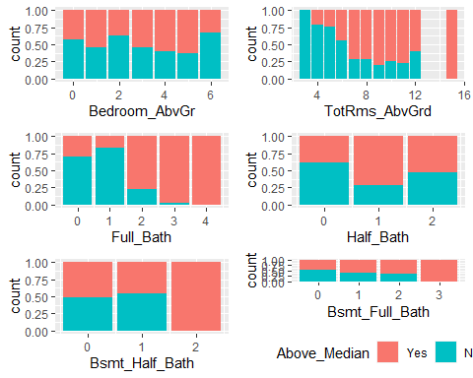

Number of bathrooms independently may not be that important so I am going to investigate if the number of bedrooms per bathroom shows more correlation. I am going to create two new variables. Total_Bath willshow the total number of bathrooms, half plus full plus the basement bathrooms. Bed_per_Bath will show the bedroom to bathroom ratio. I believe this may be important because a house that has 5 beds but only 1 bath is likely to be valued lower than a 5 bed/5 bath home. I expect there will be more houses above average that have a lower or 1:1 Bed/Bath ratio.

#New variables first  
ames$Total_Bath <- with(ames, Full_Bath + Half_Bath)  
ames$Bed_per_Bath <- with(ames, Total_Bath / Bedroom_AbvGr)  
ames$Bed_per_Bath <- round(ames$Bed_per_Bath, 2)  
#Graphs  
g7 = ggplot(ames, aes(x = Bed_per_Bath, fill = Above_Median)) + geom_bar(position = "fill") #This isn't what I expected  
g8 = ggplot(ames, aes(x = Total_Bath, fill = Above_Median)) + geom_bar(position = "fill") #This shows that more bathrooms = more houses above median  
grid.arrange(g7,g8)

## Warning: Removed 7 rows containing non-finite values (stat_count).

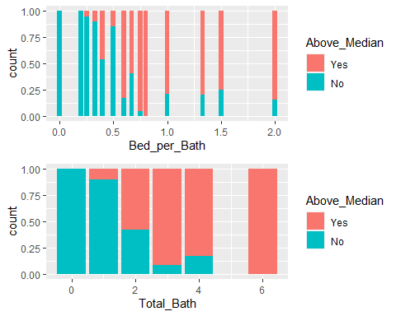 It looks like Bed_per_Bath may have strong correlation. Houses with more than .5 bedrooms per bathroom (2bed/3bath or “better” ratio) were found to be sold above median prices more often than not.

Next let’s look at house size. I want to see how above ground living space affects sales, as well as the basement sqft and the sum of above ground plus basement. I will create a new variable called Total_Inside_SF to represent above ground and basement square footage. I will also make a variable called Total_Outside_SF to represent the sum of wood deck, open porch, screened porch, and three season porch square footage.

#New variable first  
ames$Total_Inside_SF <- with(ames, Total_Bsmt_SF + First_Flr_SF + Second_Flr_SF)  
ames$Total_Outside_SF <- with(ames, Screen_Porch + Open_Porch_SF + Wood_Deck_SF + Three_season_porch)  
  
#Graphs  
g9 = ggplot(ames, aes(x = Total_Inside_SF, fill = Above_Median)) + geom_bar(position = "fill")   
g10 = ggplot(ames, aes(x = Total_Outside_SF, fill = Above_Median)) + geom_bar(position = "fill")   
grid.arrange(g9,g10)

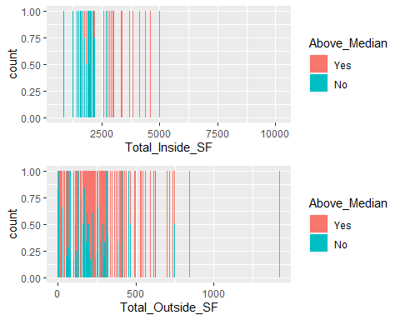

The previous graphs look messy and confusing because there are so many possible square footages available. I’m going to group the possible square footages into 5 categories of lowest, low, medium, high, and highest SF called Inside_Group and Outside_Group.

#New variables first  
ames$Inside_Group <- cut(ames$Total_Inside_SF, breaks = 5, labels = c("Lowest", "Low", "Medium","High", "Highest"))  
ames$Outside_Group <- cut(ames$Total_Outside_SF, breaks = 5, labels = c("Lowest", "Low", "Medium","High", "Highest"))  
#graphs  
  
g11 = ggplot(ames, aes(x = Inside_Group, fill = Above_Median)) + geom_bar(position = "fill") #This is what I expected - higher SF = more homes above median  
  
g12 = ggplot(ames, aes(x = Outside_Group, fill = Above_Median)) + geom_bar(position = "fill") + theme(legend.position = "bottom") #This is what I expected - higher SF = more homes above median  
  
##Compare new groups to old graphs  
  
grid.arrange(g9 +theme(legend.position='hidden'),g10 +theme(legend.position='hidden'),g11 +theme(legend.position='hidden'),g12)

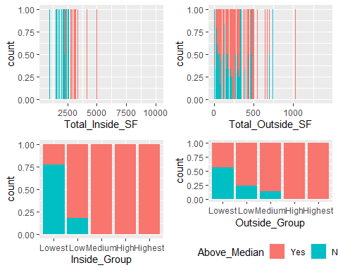

These graphs still aren’t very clear because there appear to be outliers in both data sets. Instead of cutting into 5 chunks, I am going to group the inside SF into a new variable called Inside_Group2 cut by 0-1999, 2000-2999, and 3000+. I chose these break values because there are only 19 homes smaller than 1000 sqft, and only 93 homes larger than 4000 sqft. These groupings will help to minimize the effect of outliers. I will use a similar strategy for Outside_Group2.

summary(ames$Total_Outside_SF)

## Min. 1st Qu. Median Mean 3rd Qu. Max.   
## 0.0 20.0 138.0 161.2 250.0 1424.0

ames$Inside_Group2 <- cut(ames$Total_Inside_SF, breaks = c(0,1999,2999,Inf), labels = c("<1999", "<2999", ">3000"))  
ames$Outside_Group2 <- cut(ames$Total_Outside_SF, breaks = c(-Inf,1,99,199,Inf), labels = c("No Porch", "<99", "<199",">200"))  
  
g13 = ggplot(ames, aes(x = Inside_Group2, fill = Above_Median)) + geom_bar(position = "fill")  
g14 = ggplot(ames, aes(x = Outside_Group2, fill = Above_Median)) + geom_bar(position = "fill")  
  
grid.arrange(g9 +theme(legend.position='hidden'),g10 +theme(legend.position='hidden'),g13 +theme(legend.position='hidden'),g14 +theme(legend.position='bottom'))

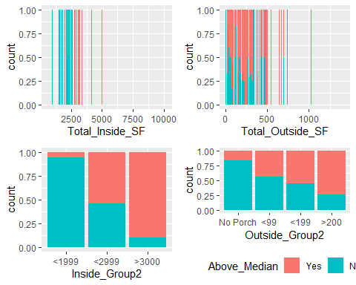 These new groups look better, and we can see that houses greater than 2000 sqft inside are more likely to sell over median price. The outside sq foot does show a trend that homes with bigger porches do tend to sell above the median price.

Next I want to look at the quality of the homes.

g15_order <- c("Very_Poor", "Poor", "Fair","Below_Average","Average", "Above_Average", "Good", "Very_Good", "Excellent", "Very_Excellent")  
g15 = ggplot(ames, aes(x = Overall_Qual, fill = Above_Median)) + scale_x_discrete(limits = g15_order) + geom_bar(position = "fill") + theme(axis.text.x=element_text(angle=90, hjust=1))  
g16_order <-c("Fair", "Typical", "Good", "Excellent")   
g16 = ggplot(ames, aes(x = Exter_Qual, fill = Above_Median)) + scale_x_discrete(limits = g16_order) + geom_bar(position = "fill") + theme(axis.text.x=element_text(angle=90, hjust=1))  
g17_order <- c("No_Basement", "Poor", "Fair", "Typical", "Good", "Excellent")  
g17 = ggplot(ames, aes(x = Bsmt_Qual, fill = Above_Median))+ scale_x_discrete(limits = g17_order) + geom_bar(position = "fill") + theme(axis.text.x=element_text(angle=90, hjust=1))  
g18_order <- c("No_Garage", "Poor", "Fair", "Typical", "Good", "Excellent")  
g18 = ggplot(ames, aes(x = Garage_Qual, fill = Above_Median)) + scale_x_discrete(limits = g18_order) + geom_bar(position = "fill") + theme(axis.text.x=element_text(angle=90, hjust=1))  
g19_order <- c("Poor", "Fair", "Typical", "Good", "Excellent")  
g19 = ggplot(ames, aes(x = Kitchen_Qual, fill = Above_Median)) + scale_x_discrete(limits = g19_order) + geom_bar(position = "fill") + theme(axis.text.x=element_text(angle=90, hjust=1))  
  
grid.arrange(g15)

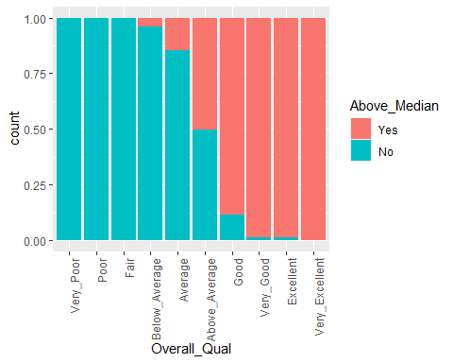

grid.arrange(g16+theme(legend.position='hidden'),g17+theme(legend.position='hidden'),g18+theme(legend.position='hidden'),g19+theme(legend.position='bottom'))

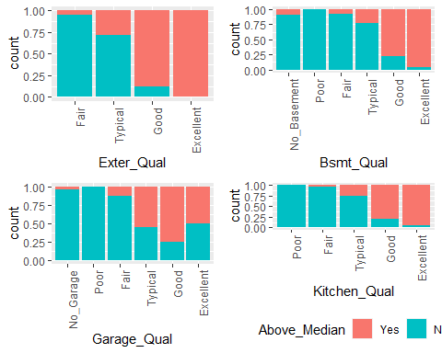

Finally I want to look into the effect of age, neighborhood, and house type. I will make a new variable named Decade to represent the decade that the home was built in.

#new variables first  
ames$Decade <- cut(ames$Year_Built, breaks = c(0,1879,1889,1899,1909,1919,1929,1939,1949,1959,1969,1979,1989,1999,2009,Inf), labels = c("1870s", "1880s", "1890s", "1900s","1910s","1920s","1930s", "1940s", "1950s", "1960s","1970s","1980s","1990s", "2000s", "2010s"))  
#graphs  
g20 = ggplot(ames, aes(x = Decade, fill = Above_Median)) + geom_bar(position = "fill") + theme(axis.text.x=element_text(angle=90, hjust=1))  
grid.arrange(g20)

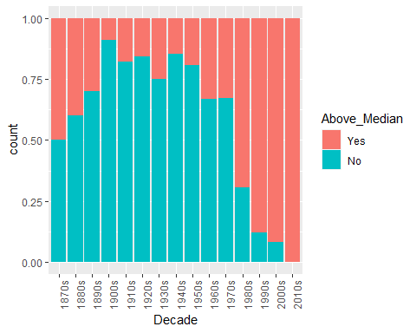

g21 = ggplot(ames, aes(x = Neighborhood, fill = Above_Median)) + geom_bar(position = "fill") + theme(axis.text.x=element_text(angle=90, hjust=1))  
grid.arrange(g21)

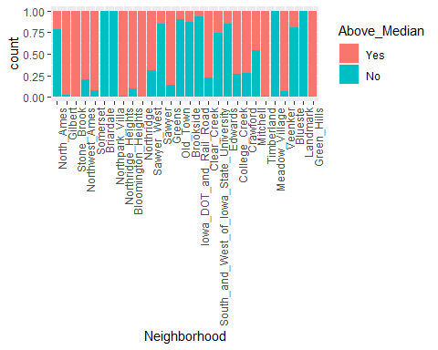

g22_order <- c("One_Story","One_and_Half_Unf", "One_and_Half_Fin","SFoyer","SLvl", "Two_Story","Two_and_Half_Unf","Two_and_Half_Fin")  
g22 = ggplot(ames, aes(x = House_Style, fill = Above_Median)) + scale_x_discrete(limits = g22_order) + geom_bar(position = "fill") + theme(axis.text.x=element_text(angle=90, hjust=1))  
g23 = ggplot(ames, aes(x = MS_Zoning, fill = Above_Median)) + geom_bar(position = "fill") + theme(axis.text.x=element_text(angle=90, hjust=1))  
grid.arrange(g22)

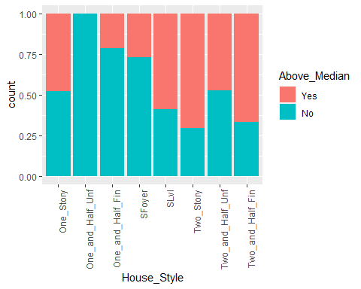

grid.arrange(g23)

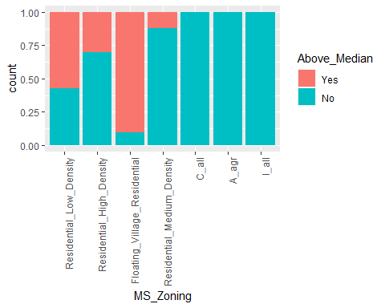

Next I decided to change Decade into Century.

#new variables first  
ames$Century<- cut(ames$Year_Built, breaks = c(0,1899,1999,Inf), labels = c("1800s","1900s", "2000s"))

I created a new data set that is only the “Yes” values for “Above_Median” called ames_over. When We graph century and quality together, it shows us that older homes have to be a higher quality (Very excellent, very good, or good) to be above the median sales price. Newer homes seem to still sell above the median even if they are not of the highest quality. Surprisingly, smaller homes sell above median price even if they are not the highest quality.

#New data source  
ames_over <- ames %>% filter(Above_Median == "Yes")  
  
g24 = ggplot(ames_over, aes(x = Century, fill = Overall_Qual)) + geom_bar(position = "fill") + scale_fill_manual(values=c("#c25757", "#ed9898", "#56B4E9", "#5b56e9", "#7dd4c4", "#238c82", "#2f8c23"))  
g25 = ggplot(ames_over, aes(x = Inside_Group2, fill = Overall_Qual)) + geom_bar(position = "fill") + scale_fill_manual(values=c("#c25757", "#ed9898", "#56B4E9", "#5b56e9", "#7dd4c4", "#238c82", "#2f8c23"))  
grid.arrange(g24,g25 +theme(legend.position='hidden'))

